Death in Space

Ariel Daugherty
Austin Peay State University
Computer Science & Information Technology
Clarksville, United States of America
adaugherty6@my.apsu.edu

Abstract—This paper is about my experience with my senior level computer science and astronomy internship, which required me to go through numerous sources of help throughout the semester to understand and finish my project.
Keywords—Astronomy, White Dwarf, Data Mining, Dark Energy Survey
Nomenclature
MWDD Montreal White Dwarf Database GDR2 Gaia Data Release 2 RHC Rowell & Hambly Catalog
DES Dark Energy Survey TC TopCat ly light years

Introduction
“Sometimes I wish I could boldly go where no man’s gone before.” This quote, from Wayne’s World, was said by Garth after he and his pal Wayne were looking at the sky whistling the Star Trek Theme. Even though this quote comes from a silly movie, the meaning behind this quote still rings a few bells for many people. People want to explore the unknown, and people want to know what is in the big black void of space. This internship granted me the opportunity to program, read, and learn about space, which are the top three items on my list of interests. This paper goes over exactly that. I will give some background information as to what white dwarfs are and examples of white dwarfs. Next, I will explain what my project. After that, I will describe what activities I did to finish the project. Finally, I will tell what I will be doing in the future on this project.

Background Information
The term white dwarf was coined by Willem Luyten (U. Minn.) in 1922 to describe the very faint, yet nearby stellar objects discovered in early proper-motion surveys [1]. These objects were described by Chandrasekhar in 1931 based on degenerate physics calculations. White Dwarfs can be described as Earth sized remnants that are generally composed a degenerate Carbon-Oxygen core with a thin non-degenerate atmosphere, generally Hydrogen and/or Helium. This type of star comes from the evolution of low mass stars according to the 21st Century Astronomy Textbook.
To give a bit more of insight into White Dwarfs, one must recognize that stars can be divided into two categories for the evolution process: low mass and high mass stars. First, all the stars come into existence from “giant clouds of dust and gas,” [2] and the stars continually exist as long as the core continues the nuclear fusion process (which is the process of the star’s core converting the helium into carbon)[3]. Once all the helium is converted to carbon, the star has reached its end. Low mass stars eventually collapse into a shining sphere which are called white dwarfs. The collapse ends once all the electrons are squeezed into the “smallest possible space they can occupy [3]. Once this process occurs and gives off “resulting electron pressure”, gravity is prevented from further shrinking the core [3].
With temperatures over 100,000 K [3], the white dwarfs are “hot balls of glowing matter that shine for billions of years” [4]. During these years, the white dwarf cools because of the “lack of an internal energy source” and the “continued radiation”, and the white dwarf cools to the point where light can no longer be seen. This white dwarf is now called a black dwarf, which is a hypothetical object since no one can see this type of object through telescopes [3]. When looking at stars on the Hertzsprung-Russell diagram (an astronomical graph), most of the white dwarfs are below the main line of trend “due to their high temperatures and small size” [3]. The high mass stars eventually go through the same collapse, only these stars become neutron stars or black holes [2].

Examples of White Dwarfs
A few examples of white dwarf stars are Sirius B, Procyon B, and van Maanen’s Star. These stars are all within 18 ly of Earth. Sirius B, which is 8.58 ly away from Earth, is the counterpart to the brightest star in the sky: Sirius [5]. Sirus B was supposedly “the first white dwarf discovered in 1862” [3] and is in the constellation Canis Major. Procyon B is 11.43 ly away from the Earth and is the counterpart to Procyon. This pair is very similar to the Sirius pair, but Procyon has a higher apparent magnitude by about 2. The Procyon pair is in Canis Minor. Finally, the last example provided of a well-known white dwarf is the van Maanen’s Star. With 14.04 ly away from Earth, this white dwarf’s current temperature is similar to the Sun, but van Maanen is hotter by about 400 K [5]. This white dwarf does not have a counterpart, and van Maanen’s Star can be found in Pisces. Today, more than 57,000 WDs are in the Montreal White Dwarf Database [6].

Initial Research Problem
One hallmark of white dwarfs is they cool slowly after the first 1-2 billion years after the core stops producing energy (the process of nuclear fusion). The Hydrogen atmosphere White Dwarfs are “easy” to model [7] so properly selected Hydrogen White Dwarfs can be used as calibration sources for large surveys. Since energy loss is strictly radiative, and the rate of loss is governed by the size of the remnant, if one can determine the mass and temperature of a WD, you know what its “color” (difference in two magnitudes, in the sense of bluer – redder) is as this is purely a physics solution. Any two WDs of the same mass and temperature must have the same colors. Any deviations from the predicted must be due to observational issues such as interstellar dust along the line of sight, or a circumstellar dust ring. This gives us a method to calibrate other stars in the field (survey region) if we can find an appropriate set of known WDs. [8]

The Dark Energy Survey (DES)
The DES (https://www.darkenergysurvey.org/) is a five-filter photometric survey covering 5000 sq. deg. of the southern celestial hemisphere, roughly one-eighth of the entire sky. [9] My initial problem was to find the DES footprint within the RHC and the GDR2. My project Proposal was to help the Physics, Engineering, and Astronomy Department by data mining through many sources including but not limited to the GDR2, the RHC of presently seen White Dwarfs, and the DES. I had hoped to look through the RHC of white dwarfs and compare those white dwarfs among the list of stars provided by the GDR2. Afterwards, I had hoped to compare the compiled list of White Dwarfs with the DES since I had needed the proper motion and magnitude. Overall, I was supposed to match the white dwarf candidates from the RHC which could be found in the Dark Energy Survey Footprint to the GDR2 to obtain Distance, reddening, and accurate proper motions for the stars. This data was to be linked to the DES database to obtain the DES data for the stars and the 2MASS infrared database.

Activities Done to Solve Project

First Daily Log
When I started the internship, I had just begun Planetary Astronomy. Dr. Smith advised for me to read a couple chapters and watch a few videos before I began the actual project. I had visited seventeen sites and read a few chapters in a few textbooks. I started off my research by researching what a white dwarf was, and I talked to Dr. Smith to confirm that the knowledge that I had gathered was correct.
He told me that in order to understand the longevity of the project, I needed to read a few chapters of Astronomy 1010’s textbook. As I started reading the “assigned” chapters, I realized I needed to read parts of the previous chapter to understand the current chapter. Once I tried reading the previous chapters, I noticed that I still lacked some key information. I continued my search for understanding by approaching Dr. Holovchak with questions about Kepler’s and Newton’s Laws. He pointed me to the College Physics book, which helped explain these laws. Furthermore, I was able to reread these laws in the astronomy textbook, and I understood it. After reading a bit more of the astronomy textbook, I shifted my gears. I explored the Gaia website, looked through a few articles over white dwarfs, and I talked about my understanding with a former classmate who knew a fair bit of astronomy. Finally, I reviewed the information I learned during the past two weeks, and I started looking at Python upon the request of Dr. Smith.

Second Daily Log
As the week began, I met with Dr. Smith to discuss my progress in my research and to discuss the project in more detail. This internship was to help the Dark Energy Survey as well as Austin Peay. I started to look through the catalogs that I would be working with, and I brainstormed possible ways to organize, sort, and compare white dwarf entries to other white dwarf entries. I brainstormed in C++, but Dr. Smith mentioned that Python would be easier for me to program in. I talked to a few fellow Computer Science Majors, and they told me that various sorting algorithms existed. He also told me about the various things that Excel does. I went to Dr. Mayo, and he showed me how to sort data in Excel.
My next step was importing the RHC, GDR2 example, and the MWDD into one Excel file, then sorting the data by right ascension. When I showed Dr. Smith my work, he informed me that the GDR2 was just a fraction of the actual database that exists purely online. He also told me that I would only need to keep the Right Ascension (RA) and Declination (Dec) for all the other catalogs besides the Gaia Database since the Gaia Database (that I would be matching the other catalogs with) has all the other data like proper motion and parallax. Additionally, Dr. Smith presented an application named TC, which is primarily used for astronomical purposes, and it has the ability to manipulate data in many ways. Tables can be made by uploading the white dwarf CSV catalogs, and one can find the common white dwarfs between these catalogs as well as graph them in many ways.
To download the TC application, I had to do a bit of programming since TC is Java-based and my computer did not have Java already installed. TO continue upon my research, I deleted the unnecessary information, and I watched a few videos on how to work TC. Once I experimented with TC, I finally understood the magnitude of how important this application is. I imported the RHC and realized that part of the graph was missing, which I later discovered was the Milky Way. I tried to upload the MWDD, but TC would not accept the file. Dr. Smith told me that I needed to convert the Right Ascension and Declination from sexagesimal notation to decimal notation. I decided that I would separate the positive and negative values in the declination column since the equation to convert the sexagesimal values to decimal values would not take values that started at 00. I continued separating the positive and negative values until the end of the week as well as starting to learn Python.

Third Daily Log
For my third set of two weeks, I continued separating the positive and negative values for the MWDD. I approached Dr. Buckner about how I could make this process go faster since the MWDD has around 57,000 white dwarfs included in the catalog. He reminded me of the fact that Excel was not recognizing that -00 was a negative value, so when I would use the formula to convert from sexagesimal to decimal, the numbers would come back incorrect. Meanwhile, I also continued learning Python with the help of Dr. Mayo, who gave me a textbook called “Python Crash Course: A Hands-on, Project-Based Introduction to Programming.” by Eric Matthas. I looked over a few things to learn Python and coded a few basic programs to get the difference between Python and C++.
I switched back to working on the MWDD in which I consulted Dr. Smith on the formulas to convert the columns of the International Celestial Reference System right ascension and declination. To convert the right ascension, I needed to split the right ascension column into three separate columns named hours, minutes, and degrees. I needed another separate column beside this cluster of data to put the converted decimal equivalence of the sexagesimal number. The formula to complete this conversion was:
f(x) =15*(C#+(D#/60)+E#/3600)
in which the number stands for what row the hours, minutes, and degrees data point was in. Once I was finished with converting the right ascension, I had to face converting the declination column. To help solve my problem, I started separated the values from 00 00 00.00 to 01 00 00.00 and from -00 00 00.00 to -01 00 00.00 from the declination list that goes from 00 00 00.00 to 89.38.15.37 and from -00 00 00.00 to -89 21 29.27. The negative numbers mean that the declination was alluding to the Southern Hemisphere of the celestial sky.
After having many issues with the MWDD, Dr. Smith told me to move on for the time being since I had other matters that I needed to attend to. I decided to shift my gears to working on finding the DES footprint so I could trim down the RHC. Dr. Smith’s associate sent us the code that was supposed to compile and obtain the DES footprint; however, the code did not return any values. I tried downloading multiple compilers such as, PyCharm, Visual Studios, and Anaconda’s version of Spyder to see if the compiler was the reason for the error.
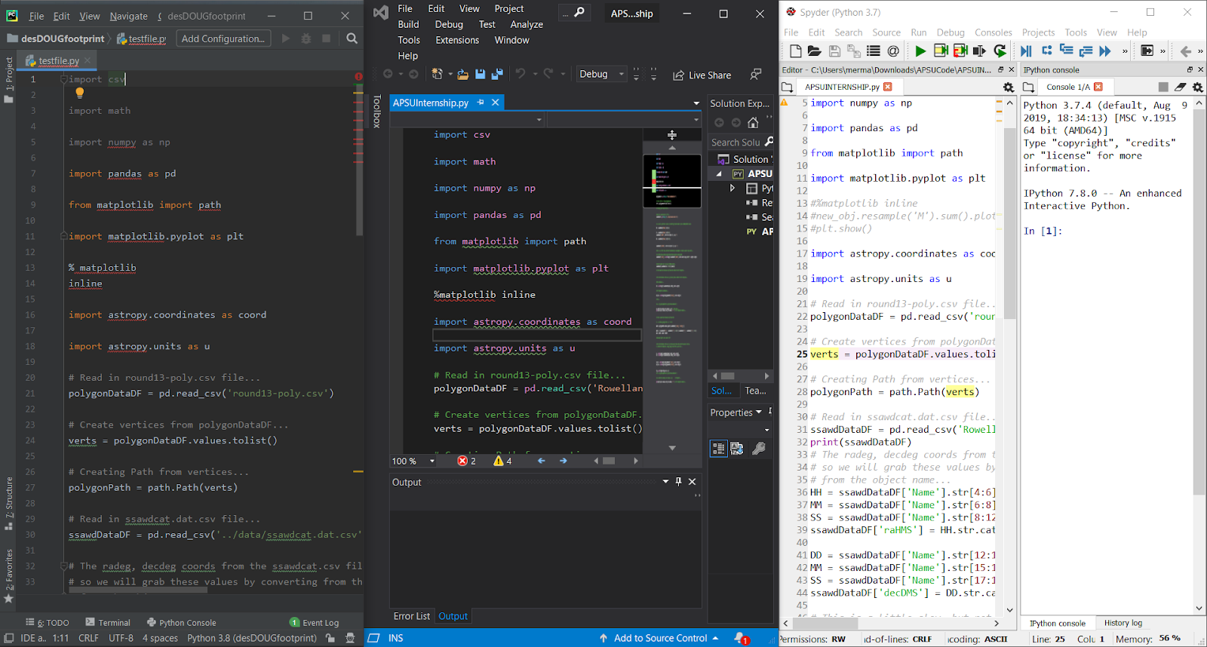
I found that the compiler was partially to blame since Spyder only recognize matplotlib. I tried downloading matplotlib on its own, but I could not get the file to cooperate. This frustration resulted in me erasing the part of code that referenced matplotlib, and I tried running the code again. Finally, I took the code to Dr. Smith, and he told me he would ask a fellow associate on why the code was not running since the code was supposed to run just fine. While waiting for the associate to contact Dr. Smith, I decided to find out what the code does. The code is supposed to read in some files, such as, the white dwarf catalogs, and tell me what the footprint of the white dwarfs are. Upon the ending of the two weeks, I decided that a break was of the essence.

Fourth Daily Log
During the fourth set of two weeks, I took some time to carefully inspect the code while I was waiting on Dr. Smith’s associate to contact us. I took a closer look at the code’s creator’s GitHub. I looked through a few readme files, and I could not come up with why the code was giving me issues. I downloaded a version of Linux to see if Linux had some files that were missing to execute the program. Downloading Linux did not help with this issue, but I did learn a few tricks on how to code in Python in many different areas, such as, different compilers and different operating systems. Along with this, I learned that I could access Linux from Visual Studio Code and from the command prompt on my computer.
I tried running the code on Anaconda’s Spyder, and I still had issues. I ran the code to install matplotlib again, but Anaconda’s Command Prompt said the files were already downloaded and updated fully. Once I saw this. I tried compiling the original code, and I saw that I still had errors. I decided to turn to Stack Overflow, which gave me another way to write “%matplotlib inline.” I tried showing Dr. Smith my other issues with my code on the next day, but Anaconda seized and stopped working. I kept trying to open it, and the file would just open swiftly, then close. Finally, I decided to take some time to redownload Anaconda all together.

Fifth Daily Log
I started the fifth set of two weeks off by tinkering with the astronomical white dwarf databases. As I went to the Gaia site, I found that I could match Gaia white dwarfs with other databases. I matched the GDR2 with the RHC, and I received fewer results than I expected. I showed Dr. Smith, and he said to use TC. I made TC match all the values between the RHC 2Mass, and the GDR2 catalog. I moved these data from the tables that TC into an Excel CSV since I had an easier time understanding Excel.
I eventually tried debugging the DES footprint code another time. I showed Dr. Mayo my issue, and he informed me that my first issue was the fact that the files I had downloaded were not being read by the code. Dr. Mayo suggested that I save all the files used in the code in a new folder that was easily accessible. Next, I tried to erase a few more errors in the code by printing one of the functions results to see if the particular file was being accessed. This was found true; however, numerous errors kept showing up on my screen. I talked to Dr. Smith, and he told me to keep waiting on his associate to email us the necessary results.
While waiting, I took the RHC, GDR2, GDR2 Distances, 2Mass Database, and the 2Mass6X database and graphed and made tables of the matches between these catalogs. I tinkered with the many types of graphs to see if I could find out anything new, but to no avail.
Taking a break from all the coding and tinkering, I decided to look through the Stellarium Application at various things that I had been researching. I came back to coding by learning more about Python. I talked to Dr. Mayo about the uses for Python, and I talked to him about how I needed some other type of reading material to learn Python. Dr. Mayo supplied a textbook called “Python Crash Course: A Hands-on, Project-Based Introduction to Programming” by Eric Matthas. I read a good portion of the book to gain some insight for the code. Also, I went back to working on the MWDD for a while. Finally, I decided to look at the graphs of all the compared catalogs, and I tried to find a way to graph the magnitudes and distances of the three catalogs.

Sixth Daily Log
For my last two weeks, I tried finishing everything I could. I worked on finishing the conversions on the MWDD. I also finished reading the rest of the Python textbook that Dr. Mayo sent me. After waiting for six weeks on Dr. Smith’s associate to send me the DES footprint, I decided to go ahead and prepare everything that was needed to obtain the overall result to finish the project but without the footprint. I remade the table matching the RHC, GDR2, 2Mass, and the MWDD. I also made a table that matched the numbers between the RHC with the GDR2, RHC with the 2Mass, and the RHC with the MWDD. I also graphed these against the nineteenth version of the DES footprint to get an estimate of how many stars would be in the footprint.
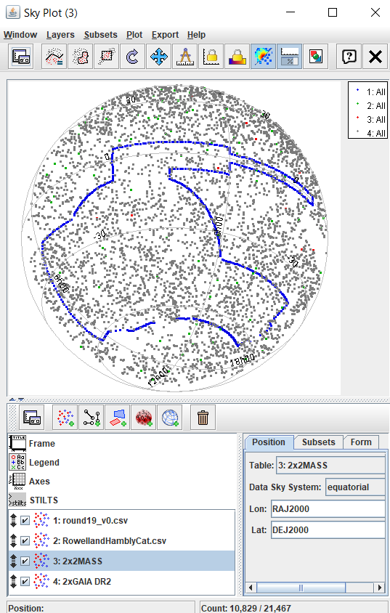
During this time, I talked to Dr. Mayo about my code since I decided to take matters into my own hands. I showed him my code, and he told me that some of my errors were very unusual. We saw about ten errors for the code. Dr. Mayo recognized that the RHC was being analyzed by a function, then everything was stored into a variable named ssawdDataDF. Also, we realized that the RHC was supposed to be split into hours, minutes, and seconds. We pulled up the file and found that the right ascension and declination, (latitude and longitude of a star in the sky) were all in decimal form instead of sexagesimal form. I tried to figure out any type of equation to put in Excel to convert the decimal RA and Dec into sexagesimal notation. I tried splitting the decimal into three columns, then storing the answer of the equation into a new column. However, I could not figure out what I was doing wrong.
Admitting defeat was a tough option. I had hoped to find the number of stars that were in the DES footprint; however, since my expertise was limited and my time was limited, I decided to work on finishing this project in the future. I decided to set everything up, so I would only need the DES footprint and the project would be solved. Knowing that I did not finish crushed me, but I know that I learned and tried a lot. I talked to Dr. Mayo about this, and he told me that most of his research experiences in Grad school resulted in failure due to a mistake or not enough time. He told me that it was okay that I didn’t finish it out. Part of being an adult is admitting when you did not finish. Part of being an adult is telling the truth about not finishing the project. I have decided to talk to Dr. Smith about this project and to show him all the work I did. I will ask him to work for him during winter break and during next semester since I want to see how this project turns out. I talked with Dr. Smith about the semester, and we decided that I will be working with him during the winter break and next semester since I want to see this project through. I showed him all my daily logs, and I showed him all the work I had done. Even though I did not get to finish by the time my sophomore fall semester ended, I still learned numerous lessons.

Future Goals
For the future, I have a few high hopes for this project. I talked with Dr. Smith about the semester, and we decided that I will be working with him during the winter break and next semester since I want to see this project to its finish. I hope to eventually bring the MWDD into this project as well as other catalogs of interest. I want to see which of these white dwarfs in these various catalogs will be in the DES footprint. Finally, I hope to make the proper motion diagram.

Conclusion
Some people say that the destination is not as important as the journey is. I have faith that this is true since the results were important to me, but not as important as what I would learn along the way. I learned how to properly research topics if I did not understand a certain concept. I learned Python, how it can be accessed through many ways, and how much easier Python is that C++. I also learned that asking for help is perfectly acceptable as long as you have put in effort into the matter beforehand. I learned that patience is very important when one works in coding and astronomy. Overall, this experience helped me in so many ways, and I ended up learning so much more than just some coding.

Acknowledgment
Ariel Daugherty gratefully acknowledges the contributions of Kenneth Shenberger, Dr. J. Allyn Smith, and Dr. Daniel Mayo. Many useful sources were presented by the trio to the author, and the trio helped explain many aspects of this project to the reader.
Ariel Daugherty also gratefully acknowledges Dr. James Church, for this internship is for seniors, and he gave Ariel a chance to prove herself.

References
- Holberg, J. B. 2005, "How Degenerate Stars Came to be Known as White Dwarfs". American Astronomical Society Meeting 207. 207: 1503. Bibcode:2005AAS...20720501H
- “Stellar Evolution - The Birth, Life, and Death of a Star,” nasa.gov. [Online].Available:https://www.nasa.gov/audience/forstudents/9-12/features/stellar_evol_feat_912.html. [Accessed: Dec. 4, 2019].
- “White Dwarf” swin.edu. [Online]. Available: http://astronomy.swin.edu.au/cosmos/W/White+Dwarf. [Accessed Dec. 4, 2019].
[3] Socratica, “What are white dwarfs?(Astronomy),” Youtube, August 10, 2016. [Video file]. Available: https://www.youtube.com/watch?v=ITD8s-bLXSk. [Accessed: Dec. 4, 2019].
- “White Dwarf Stars Near the Earth,” northwestern.edu. [Online]. Available: http://faculty.wcas.northwestern.edu/~infocom/The%20Website/plates/WD.pdf. [Accessed: Dec. 4, 2019].
- Dufour, P.; Blouin, S.; Coutu, S.; Fortin-Archambault, M.; Thibeault, C.; Bergeron, P.; & Fontaine, G., 2017, “The Montreal White Dwarf Database: A Tool for the Community,” in the proceedings of the 20th European Workshop on White Dwarfs held July 25-29th, 2016 at the University of Warwick, United Kingdom, 2017ASPC..509....3D (arXiv:1610.00986)
- Giammichele, N.; Bergeron, P.; Dufour, P. 2012, "Know Your Neighborhood: A Detailed Model Atmosphere Analysis of Nearby White Dwarfs", The Astrophysical Journal Supplement, 199 (2): 35, arXiv:1202.5581, Bibcode:2012ApJS..199...29G, doi:10.1088/0067-0049/199/2/29
- Holberg, J. B. & Bergeron, P. 2006, “Calibration of Synthetic Photometry Using DA White Dwarfs,” The Astronomical Journal, 132,1221. Bibcode: 2006AJ....132.1221H
- 9Sánchez, E., DES Collaboration 2016, “The Dark Energy Survey: Status and First Results” in Nuclear and Particle Physics Proceedings, doi.org/10.1016/j.nuclphysbps.2015.09.042
- Topcat v. 4.7. [Download]. United Kingdom: Mark Taylor, University of Bristol, 2005. Available: http://www.star.bris.ac.uk/~mbt/topcat/.
- Stellarium v. 0.19.2. [Download] Open Source, 2001. Available: https://stellarium.org/.

