brks=classIntervals(mainesv$E_POV150, n=5, style="jenks", intervalClosure = 'left')  
mainesv$pov <- cut(mainesv$E_POV150, brks$brks)  
  
ggplot() +  
 geom_sf(data = mainesv, aes(fill = pov)) +  
 scale_fill_brewer(palette = "YlOrRd") +  
 coord_sf() +labs(title ="Number of Households Living at 150% Poverty or Less", size=1, fill="Number of Households")

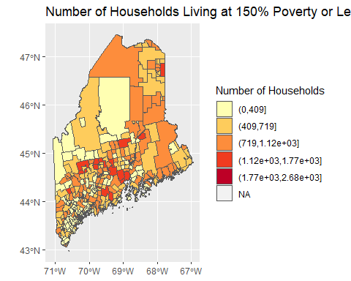

brks=classIntervals(mainesv$E_DISABL, n=5, style="jenks", intervalClosure = 'left')  
mainesv$nohs <- cut(mainesv$E_DISABL, brks$brks)  
  
ggplot() +  
 geom_sf(data = mainesv, aes(fill = nohs)) +  
 scale_fill_brewer(palette = "RdPu") +  
 coord_sf() +labs(title ="Number of Individuals with Documented Disability", size=1, fill="Number of Households")

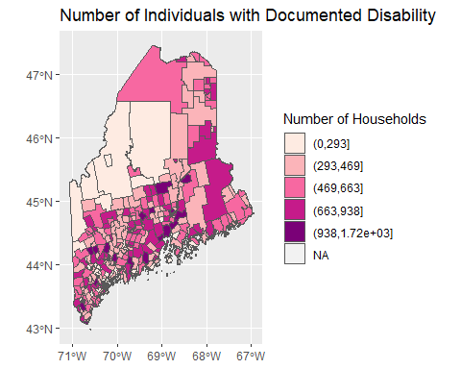

brks=classIntervals(mainesv$E_HBURD, n=5, style="jenks", intervalClosure = 'left')  
mainesv$hburd <- cut(mainesv$E_HBURD, brks$brks)  
  
ggplot() +  
 geom_sf(data = mainesv, aes(fill = hburd)) +  
 scale_fill_brewer(palette = "YlGnBu") +  
 coord_sf() +labs(title ="Number of Households With Housing Cost Burden", size=1, fill="Number of Households")

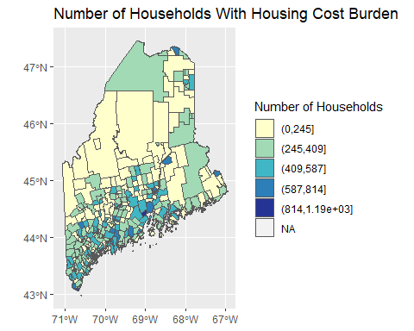

ggplot(data = mainesv, aes(x = E_POV150, y=E_HBURD)) + geom_point(col='red')+geom_smooth(method=lm, se=FALSE)+ labs(title ="Housing Cost Burden Correlated with Number of Individuals in Poverty", x = "Poverty (number of households)", y = "Rate of Housing Burden")+ theme(plot.title = element_text(size=9), axis.text.x=element_text(angle=90, hjust=1, size = 7), axis.title.x =element_text(size =9), axis.text.y=element_text(hjust=1, size = 7), axis.title.y =element_text(size =9))

## `geom_smooth()` using formula 'y ~ x'

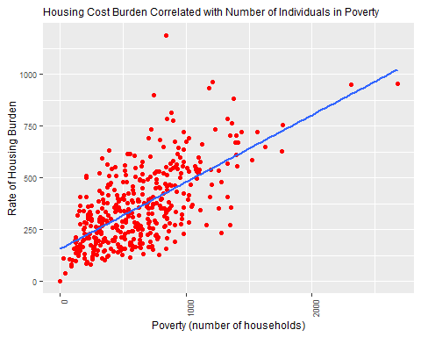

lmpov <- lm(E_HBURD ~ E_POV150, data=mainesv)  
summary(lmpov)

##   
## Call:  
## lm(formula = E_HBURD ~ E_POV150, data = mainesv)  
##   
## Residuals:  
## Min 1Q Median 3Q Max   
## -334.69 -101.79 -16.68 86.20 758.97   
##   
## Coefficients:  
## Estimate Std. Error t value Pr(>|t|)   
## (Intercept) 155.69773 14.16576 10.99 <2e-16 ***  
## E_POV150 0.32344 0.01956 16.53 <2e-16 ***  
## ---  
## Signif. codes: 0 '***' 0.001 '**' 0.01 '*' 0.05 '.' 0.1 ' ' 1  
##   
## Residual standard error: 142.8 on 399 degrees of freedom  
## Multiple R-squared: 0.4066, Adjusted R-squared: 0.4051   
## F-statistic: 273.4 on 1 and 399 DF, p-value: < 2.2e-16

ggplot(data = mainesv, aes(x = E_DISABL, y=E_HBURD)) + geom_point(col='red')+geom_smooth(method=lm, se=FALSE)+ labs(title ="Housing Cost Burden Correlated with Disability Rate", x = "Rate of Individuals with Disability", y = "Rate of Housing Burden")+ theme(plot.title = element_text(size=9), axis.text.x=element_text(angle=90, hjust=1, size = 7), axis.title.x =element_text(size =9), axis.text.y=element_text(hjust=1, size = 7), axis.title.y =element_text(size =9))

## `geom_smooth()` using formula 'y ~ x'

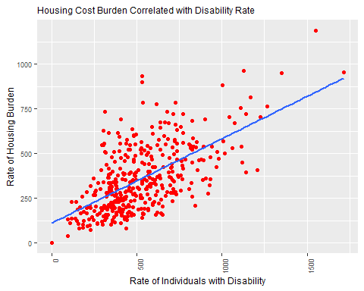

lmnohs <- lm(E_HBURD ~ E_DISABL, data=mainesv)  
summary(lmnohs)

##   
## Call:  
## lm(formula = E_HBURD ~ E_DISABL, data = mainesv)  
##   
## Residuals:  
## Min 1Q Median 3Q Max   
## -301.34 -102.44 -28.51 76.29 573.96   
##   
## Coefficients:  
## Estimate Std. Error t value Pr(>|t|)   
## (Intercept) 110.66502 17.32856 6.386 4.73e-10 ***  
## E_DISABL 0.47230 0.03002 15.730 < 2e-16 ***  
## ---  
## Signif. codes: 0 '***' 0.001 '**' 0.01 '*' 0.05 '.' 0.1 ' ' 1  
##   
## Residual standard error: 145.6 on 399 degrees of freedom  
## Multiple R-squared: 0.3828, Adjusted R-squared: 0.3812   
## F-statistic: 247.4 on 1 and 399 DF, p-value: < 2.2e-16

ols <- lm(E_HBURD ~ E_POV150+E_DISABL, data=mainesv)  
plot(ols)

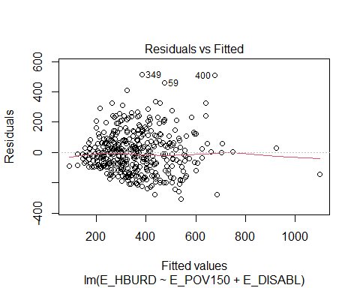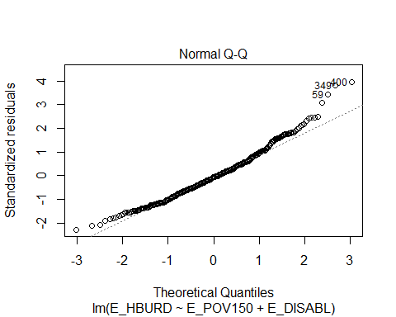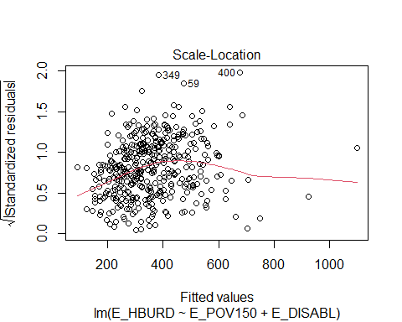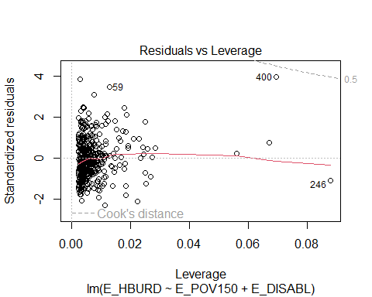

coef(ols)

## (Intercept) E_POV150 E_DISABL   
## 90.0448517 0.2056088 0.2660604

summary(ols)

##   
## Call:  
## lm(formula = E_HBURD ~ E_POV150 + E_DISABL, data = mainesv)  
##   
## Residuals:  
## Min 1Q Median 3Q Max   
## -306.59 -91.91 -9.34 76.63 513.76   
##   
## Coefficients:  
## Estimate Std. Error t value Pr(>|t|)   
## (Intercept) 90.04485 16.20638 5.556 5.06e-08 ***  
## E_POV150 0.20561 0.02473 8.313 1.49e-15 ***  
## E_DISABL 0.26606 0.03722 7.148 4.24e-12 ***  
## ---  
## Signif. codes: 0 '***' 0.001 '**' 0.01 '*' 0.05 '.' 0.1 ' ' 1  
##   
## Residual standard error: 134.6 on 398 degrees of freedom  
## Multiple R-squared: 0.4741, Adjusted R-squared: 0.4715   
## F-statistic: 179.4 on 2 and 398 DF, p-value: < 2.2e-16

bptest(ols)

##   
## studentized Breusch-Pagan test  
##   
## data: ols  
## BP = 16.872, df = 2, p-value = 0.0002169

jarque.bera.test(ols$residuals)

##   
## Jarque Bera Test  
##   
## data: ols$residuals  
## X-squared = 36.587, df = 2, p-value = 1.135e-08

nbscali=poly2nb(mainesv, queen = TRUE)  
W <- nb2listw(nbscali, style = "W", zero.policy=TRUE)  
  
lm.morantest(ols, W, zero.policy=TRUE)

##   
## Global Moran I for regression residuals  
##   
## data:   
## model: lm(formula = E_HBURD ~ E_POV150 + E_DISABL, data = mainesv)  
## weights: W  
##   
## Moran I statistic standard deviate = 13.078, p-value < 2.2e-16  
## alternative hypothesis: greater  
## sample estimates:  
## Observed Moran I Expectation Variance   
## 0.4052065868 -0.0032494078 0.0009754505

moran.test(ols$residuals, W, randomisation = FALSE, zero.policy=TRUE)

##   
## Moran I test under normality  
##   
## data: ols$residuals   
## weights: W n reduced by no-neighbour observations  
##   
##   
## Moran I statistic standard deviate = 13.028, p-value < 2.2e-16  
## alternative hypothesis: greater  
## sample estimates:  
## Moran I statistic Expectation Variance   
## 0.4052065868 -0.0025125628 0.0009794059

moran.test(ols$residuals, W, randomisation = TRUE, zero.policy=TRUE)

##   
## Moran I test under randomisation  
##   
## data: ols$residuals   
## weights: W n reduced by no-neighbour observations  
##   
##   
## Moran I statistic standard deviate = 13.04, p-value < 2.2e-16  
## alternative hypothesis: greater  
## sample estimates:  
## Moran I statistic Expectation Variance   
## 0.4052065868 -0.0025125628 0.0009775584

moran.mc(ols$residuals, W, 99, zero.policy=TRUE)

##   
## Monte-Carlo simulation of Moran I  
##   
## data: ols$residuals   
## weights: W   
## number of simulations + 1: 100   
##   
## statistic = 0.40521, observed rank = 100, p-value = 0.01  
## alternative hypothesis: greater

moran.test(ols$residuals, W, randomisation = FALSE, zero.policy = TRUE)

##   
## Moran I test under normality  
##   
## data: ols$residuals   
## weights: W n reduced by no-neighbour observations  
##   
##   
## Moran I statistic standard deviate = 13.028, p-value < 2.2e-16  
## alternative hypothesis: greater  
## sample estimates:  
## Moran I statistic Expectation Variance   
## 0.4052065868 -0.0025125628 0.0009794059

logLik(ols)

## 'log Lik.' -2533.202 (df=4)

BIC(ols)

## [1] 5090.38

lmtests=lm.LMtests(ols, W, zero.policy = T, test='all')  
lstat=unlist(c(lmtests$LMerr[1],lmtests$LMlag[1], lmtests$RLMerr[1],lmtests$RLMlag[1], lmtests$SARMA[1]))  
pval=(c(lmtests$LMerr[3],lmtests$LMlag[3], lmtests$RLMerr[3],lmtests$RLMlag[3], lmtests$SARMA[3]))  
  
summary(lmtests)

## Lagrange multiplier diagnostics for spatial dependence  
## data:   
## model: lm(formula = E_HBURD ~ E_POV150 + E_DISABL, data = mainesv)  
## weights: W  
##   
## statistic parameter p.value   
## LMerr 166.997 1 < 2.2e-16 ***  
## LMlag 62.357 1 2.887e-15 ***  
## RLMerr 116.640 1 < 2.2e-16 ***  
## RLMlag 12.001 1 0.0005317 ***  
## SARMA 178.998 2 < 2.2e-16 ***  
## ---  
## Signif. codes: 0 '***' 0.001 '**' 0.01 '*' 0.05 '.' 0.1 ' ' 1

serror<- errorsarlm(E_HBURD ~ E_POV150 + E_DISABL, data = mainesv, listw=W, zero.policy = T)  
summary(serror)

##   
## Call:errorsarlm(formula = E_HBURD ~ E_POV150 + E_DISABL, data = mainesv,   
## listw = W, zero.policy = T)  
##   
## Residuals:  
## Min 1Q Median 3Q Max   
## -345.139 -67.405 -12.635 56.047 443.534   
##   
## Type: error   
## Regions with no neighbours included:  
## 162 343   
## Coefficients: (asymptotic standard errors)   
## Estimate Std. Error z value Pr(>|z|)  
## (Intercept) 65.113054 17.937467 3.6300 0.0002834  
## E_POV150 0.237907 0.021707 10.9599 < 2.2e-16  
## E_DISABL 0.279476 0.031521 8.8663 < 2.2e-16  
##   
## Lambda: 0.56285, LR test value: 108.78, p-value: < 2.22e-16  
## Asymptotic standard error: 0.053446  
## z-value: 10.531, p-value: < 2.22e-16  
## Wald statistic: 110.91, p-value: < 2.22e-16  
##   
## Log likelihood: -2478.812 for error model  
## ML residual variance (sigma squared): 12766, (sigma: 112.99)  
## Number of observations: 401   
## Number of parameters estimated: 5   
## AIC: 4967.6, (AIC for lm: 5074.4)

slag<- lagsarlm(E_HBURD ~ E_POV150 + E_DISABL, data = mainesv, listw=W, zero.policy = T)  
summary(slag)

##   
## Call:lagsarlm(formula = E_HBURD ~ E_POV150 + E_DISABL, data = mainesv,   
## listw = W, zero.policy = T)  
##   
## Residuals:  
## Min 1Q Median 3Q Max   
## -300.152 -85.296 -15.787 71.345 503.094   
##   
## Type: lag   
## Regions with no neighbours included:  
## 162 343   
## Coefficients: (asymptotic standard errors)   
## Estimate Std. Error z value Pr(>|z|)  
## (Intercept) -38.500599 20.416091 -1.8858 0.05932  
## E_POV150 0.196379 0.023175 8.4736 < 2.2e-16  
## E_DISABL 0.266364 0.034358 7.7527 9.104e-15  
##   
## Rho: 0.37376, LR test value: 51.403, p-value: 7.524e-13  
## Asymptotic standard error: 0.048814  
## z-value: 7.6567, p-value: 1.9096e-14  
## Wald statistic: 58.625, p-value: 1.9096e-14  
##   
## Log likelihood: -2507.501 for lag model  
## ML residual variance (sigma squared): 15367, (sigma: 123.96)  
## Number of observations: 401   
## Number of parameters estimated: 5   
## AIC: 5025, (AIC for lm: 5074.4)  
## LM test for residual autocorrelation  
## test value: 43.172, p-value: 5.0146e-11

p <- c(AIC(ols), AIC(slag), AIC(serror))  
q <- c(BIC(ols), BIC(slag), BIC(serror))  
r <- c(logLik(ols), logLik(slag), logLik(serror))  
  
labdata <- data.frame(p,q,r)  
names(labdata) <- c("AIC", "BIC", "Log Likelihood")  
rownames(labdata) <-c("OLS Model", "Spatial Lag Model", "Spatial Error Model")  
print(labdata)

## AIC BIC Log Likelihood  
## OLS Model 5074.404 5090.380 -2533.202  
## Spatial Lag Model 5025.002 5044.972 -2507.501  
## Spatial Error Model 4967.624 4987.594 -2478.812

summary(labdata)

## AIC BIC Log Likelihood   
## Min. :4968 Min. :4988 Min. :-2533   
## 1st Qu.:4996 1st Qu.:5016 1st Qu.:-2520   
## Median :5025 Median :5045 Median :-2508   
## Mean :5022 Mean :5041 Mean :-2507   
## 3rd Qu.:5050 3rd Qu.:5068 3rd Qu.:-2493   
## Max. :5074 Max. :5090 Max. :-2479