**Combinatorics TEST**

**Fayol Ateufack**

**I have neither given or received, nor have I tolerated other’s use of unauthorized aid.**

**Homework 10** consisted of manually deriving the test cases for some given circuits. However, that is time consuming and intellectually boring. I used another approach which is **summarized as follows:**

* Create a tree representing the circuit where each node consists of inputs (generic input, not the input to the circuits) and an operation
* The leaf nodes of the tree will have the inputs to the circuits as their inputs and their operation will just be returning those inputs
* Non-leaf nodes will have the outputs of their children’s nodes as their inputs. Their operation will be one of the logic operations (AND, OR, NAND, NOR, NOT, XOR, and XNOR)
* Generate all the possible set of inputs and evaluate the output of the circuit
* For each set of inputs, for each node on the tree, force a value of 0, freeze all the genealogy of nodes beneath it, and revaluate the output. If it matches the expected output for that set of inputs, mark 0 on the priority matrix, otherwise mark 1. Force a value of 1 and repeat the process. Then unforce the node
* Reduce the priority matrix until there is no uncovered test case
* Return the set of rows used reduce the priority matrix to a zero matrix

The code has not been thoroughly reviewed but it gave the correct answers to the in class problems, and here are the answers to homework 10:

**Problem 11.1 (result, function, generated graph in that order)**

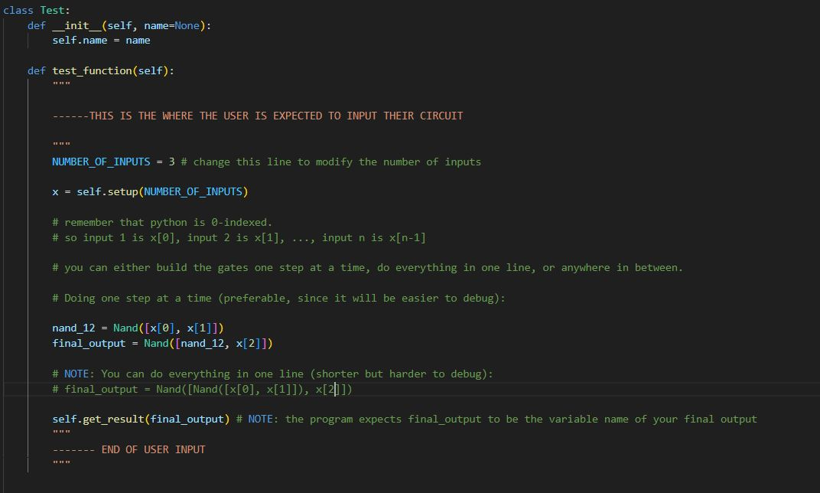

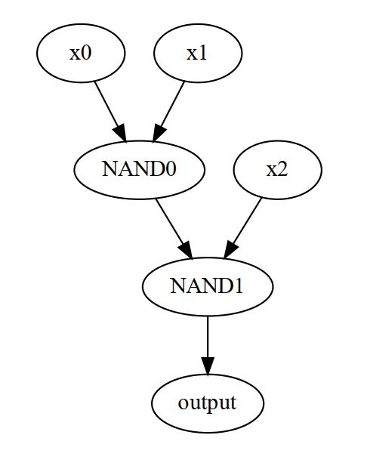

**Problem 11.2 (result, function, generated graph in that order)**



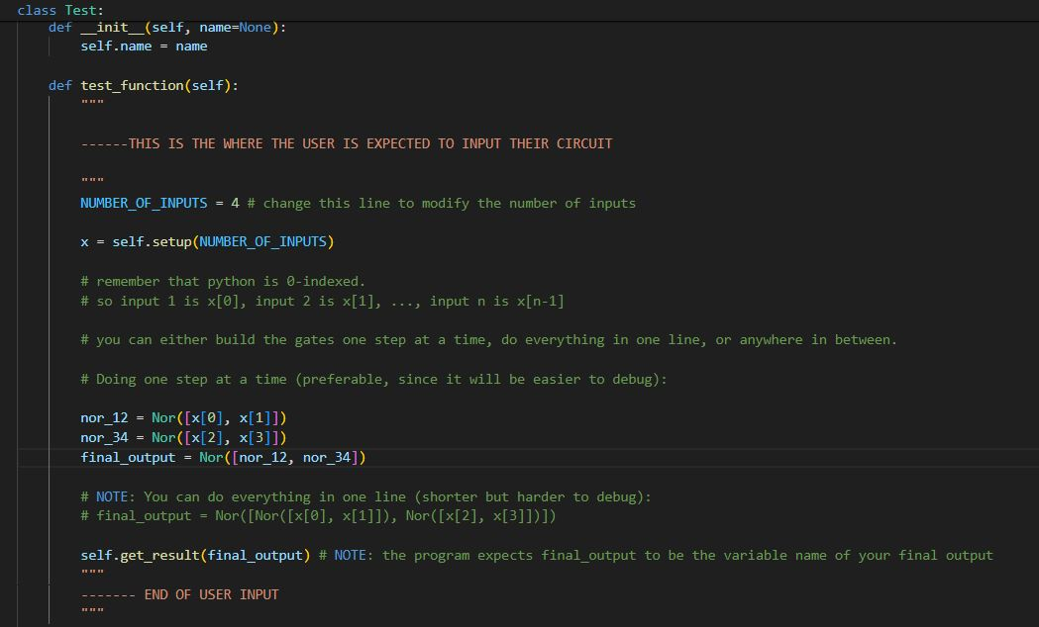

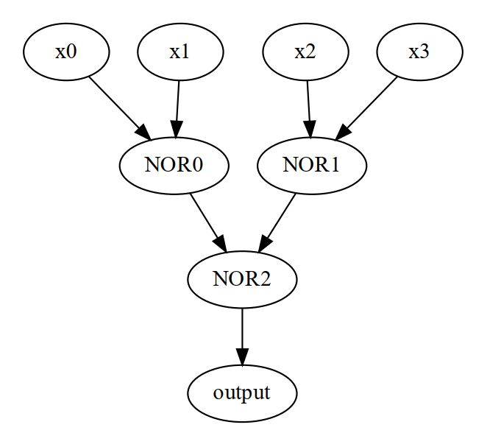

**Problem 11.4 (result, function, generated graph in that order)**



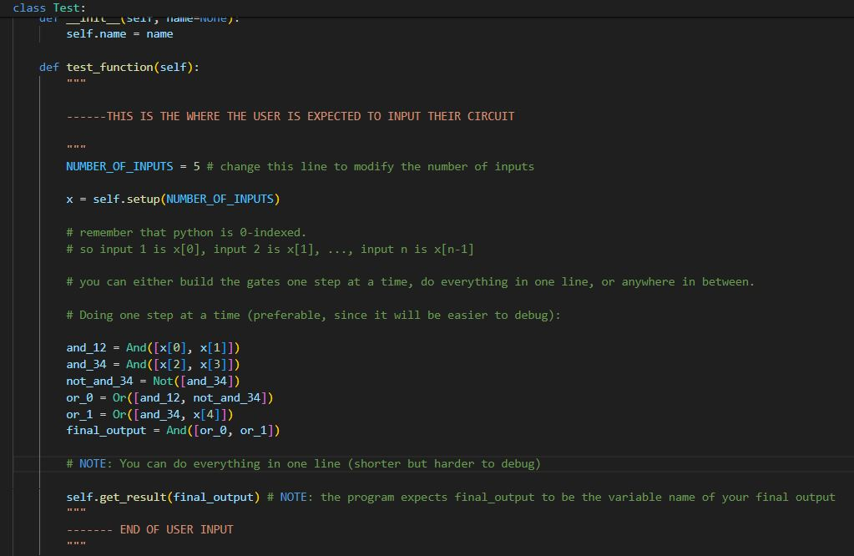

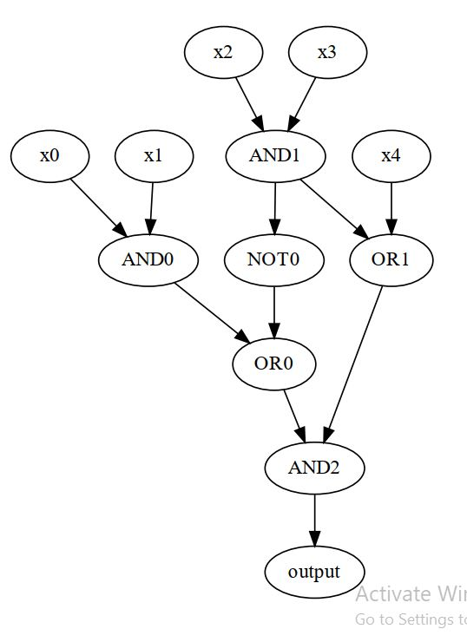

**The full code is attached with the submission.**