209 File Services

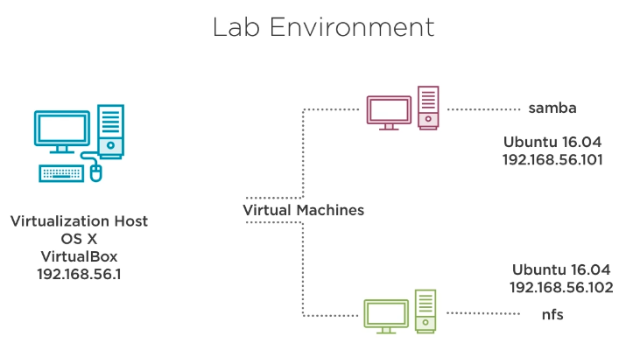

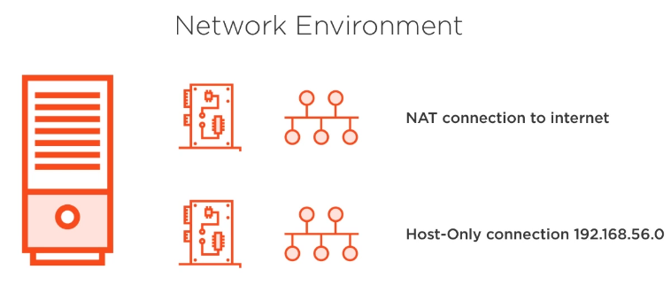

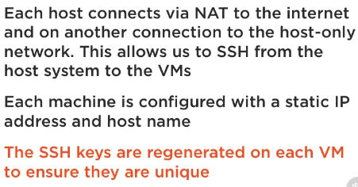

1.Installing SAMBA

ubuntu@samba:~$ apt-cache show samba → implements the SMB/CIFS protocol on Linux, so it can participate on Windows shares and domains.
ubuntu@samba:~$ apt-cache show smbclient → allow us connect to windows shares and printers.
ubuntu@samba:~$ apt-cache show winbind → will allow me to become a member in a Windows
domain.

ubuntu@samba:~$ sudo apt-get install samba smbclient winbind

3.Checking for ACL Support

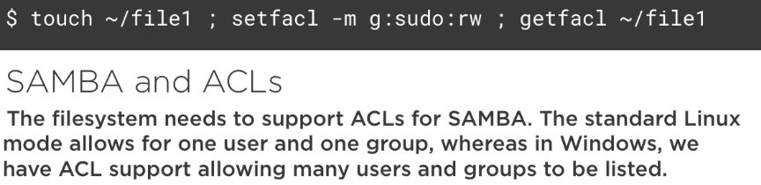

So, in order to verify if system supports ACLs:

ubuntu@samba:~$ touch file1
ubuntu@samba:~$ ls -l file1
-rw-rw-r-- 1 ubuntu ubuntu 0 Aug 11 00:58 file1
ubuntu@samba:~$ setfacl -m g:sudo:rw file1

ubuntu@samba:~$ ls -l file1
-rw-rw-r--+ 1 ubuntu ubuntu 0 Aug 11 00:58 file1
ubuntu@samba:~$ getfacl file1
# file: file1
# owner: ubuntu
# group: ubuntu
user::rw-
group::rw-
group:sudo:rw-
mask::rw-
other::r--

ubuntu@samba:~$ rm file1

4.SAMBA Services and Systemctl

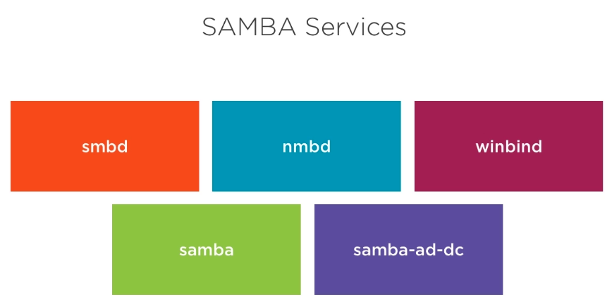

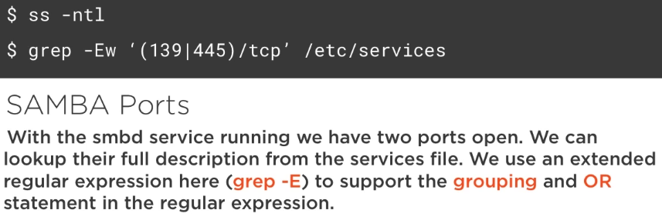

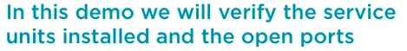

ubuntu@samba:~$ sudo systemctl status smbd nmbd winbind

All the above services should be active and enable. Note that, samba.service is like an alias for services smbd and nmdb. And, the service samba-ad-dc, wich is new in Samba 4, should also be active and enables (despite not used and configured – yet).

ariel@frozza:~$ grep -Ew '(139|445)/tcp' /etc/services
netbios-ssn 139/tcp # NETBIOS session service
microsoft-ds 445/tcp # Microsoft Naked CIFS

5. Manage Services Internally with SAMBA Tools

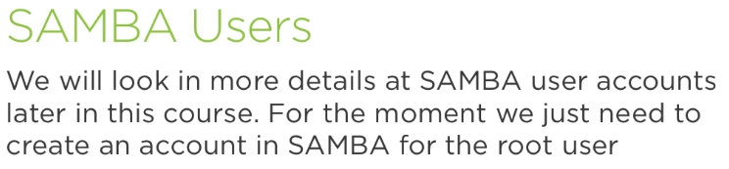

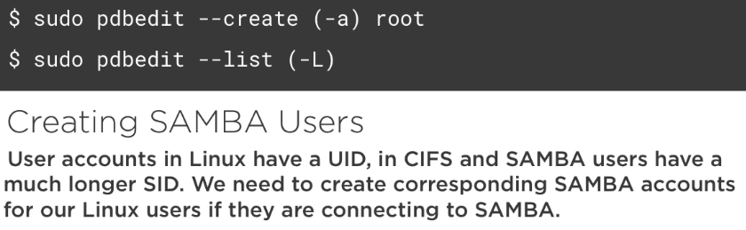

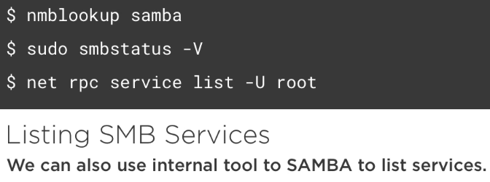

ubuntu@samba:~$ sudo pdbedit -L
ubuntu@samba:~$ sudo pdbedit -a root
new password: <toor>
retype new password: <toor>

ubuntu@samba:~$ sudo pdbedit -L
root:0:root

ubuntu@samba:~$ nmblookup samba
10.0.2.15 samba<00>

ubuntu@samba:~$ sudo smbstatus -V
Version 4.3.11-Ubuntu

ubuntu@samba:~$ net rpc service list -U root
Enter root's password:
Spooler "Print Spooler"
NETLOGON "Net Logon"
RemoteRegistry "Remote Registry Service"
WINS "Windows Internet Name Service (WINS)"

05.Creating and Listing Users
5.1.Configuring Backend Authentication

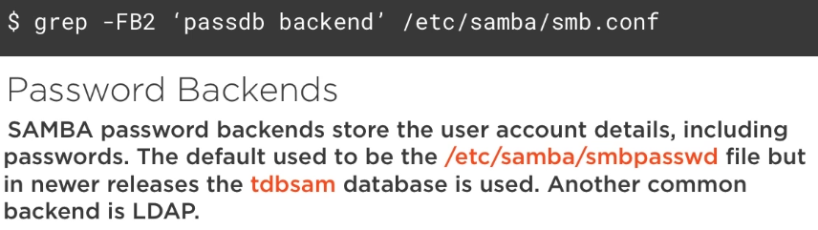

pdbedit Main Functions: List Users, Create users, Delete users, Modify users and Import users.

ubuntu@samba:~$ grep -FB2 "passdb backend" /etc/samba/smb.conf
# If you are using encrypted passwords, Samba will need to know what
# password database type you are using.
passdb backend = tdbsam

2.Listing Users Accounts

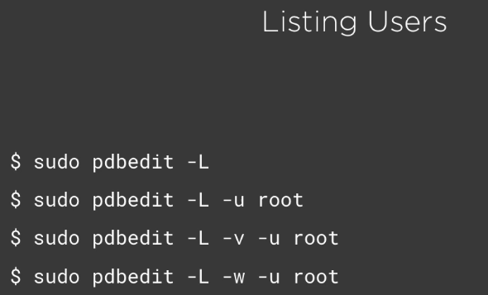

3.Creating and Deleting User Accounts

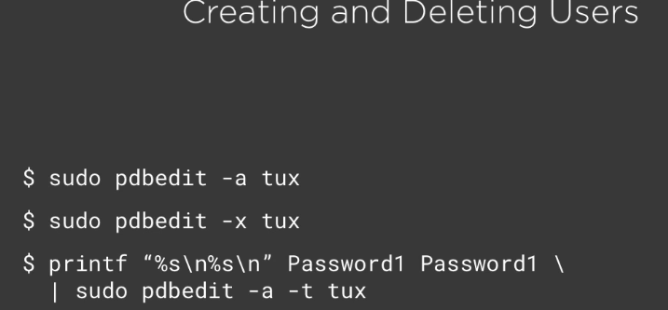

ubuntu@samba:~$ sudo pdbedit -a ubuntu
new password: ubuntu
retype new password: ubuntu

NOTE: the user has to exist in Linux.

ubuntu@samba:~$ sudo pdbedit -x ubuntu
ubuntu@samba:~$ printf "%s\n%s\n" ubuntupass ubuntupass | sudo pdbedit -a -t ubuntu

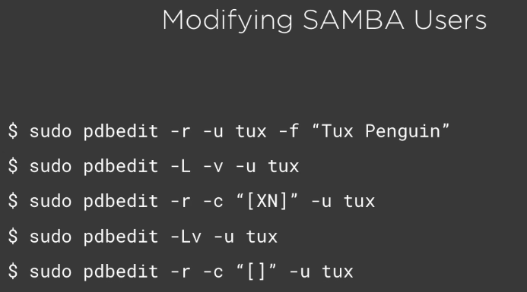
4.Modifying Users

-r to edit/modify
-f to set full name

-c “[XN]” change Account Flags, where X means the password doesn’t expire and N the password doesn’t need to be set.

-c “[]” resets Flags to defaults.

5.Configuring Account Policies

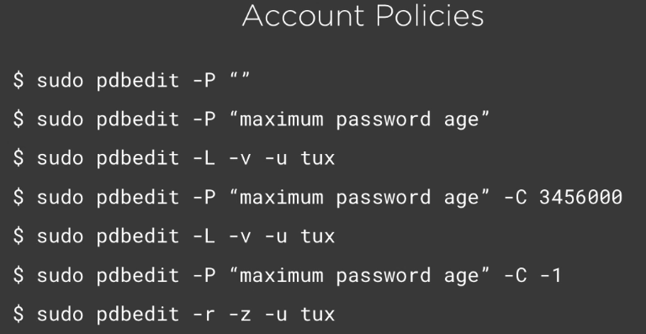

-P for managing Account Policies
-C value in seconds (-1 = never expire)
-z resets password counts

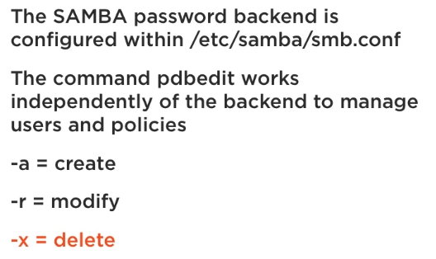

06.Managing Shares
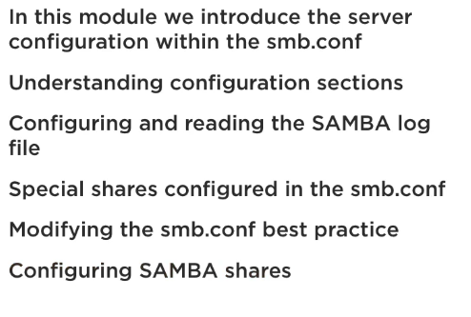

6.1.Using the Command Testparm

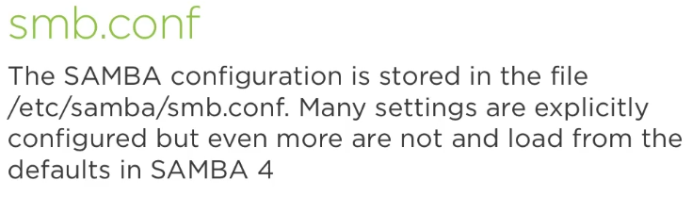

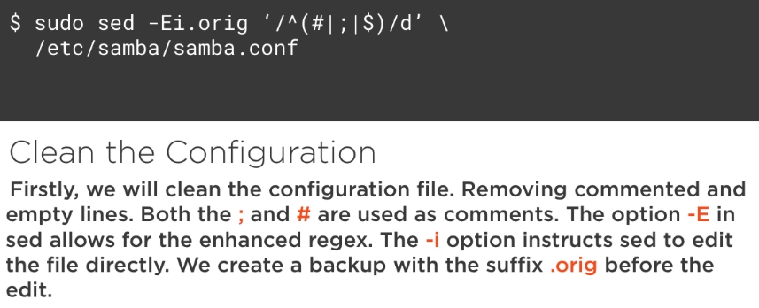

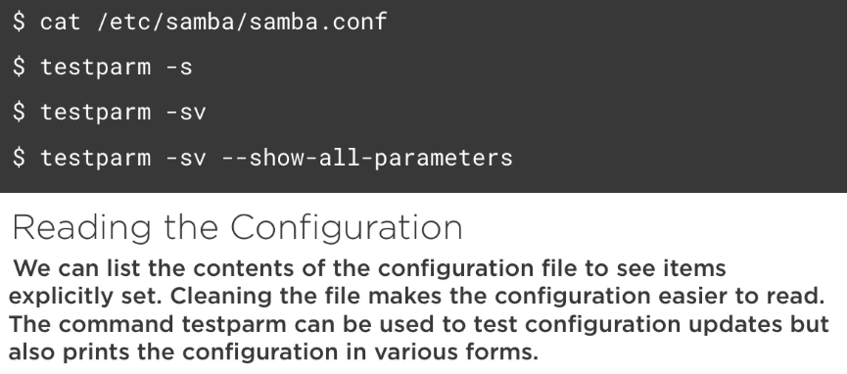

6.2.Using Sed to Clean the Configuration

ubuntu@samba:~$ sudo sed -Ei.orig '/^(#|;|$)/d' /etc/samba/smb.conf

ubuntu@samba:~$ testparm
ubuntu@samba:~$ testparm -s
ubuntu@samba:~$ testparm -sv
ubuntu@samba:~$ testparm -sv --show-all-parameters

3.Global Settings in SAMBA
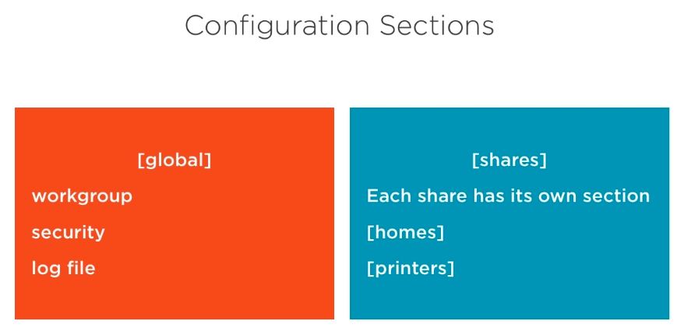

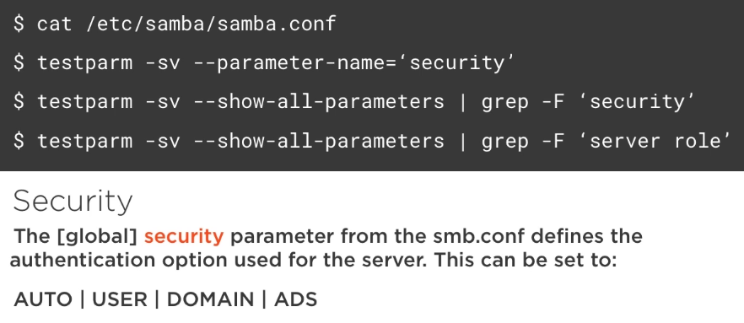

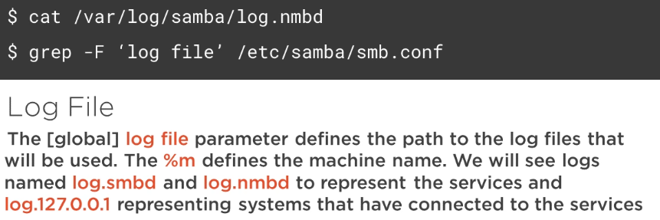

ubuntu@samba:~$ testparm -sv --parameter-name='security'
[...]
AUTO

ubuntu@samba:~$ testparm -sv --parameter-name='server role'
[…]
standalone server

ubuntu@samba:~$ testparm -sv --show-all-parameters | grep security
ubuntu@samba:~$ testparm -sv --show-all-parameters | grep 'server role'

ubuntu@samba:~$ ls /var/log/samba/
ubuntu@samba:~$ tail /var/log/samba/log.smbd
ubuntu@samba:~$ grep 'log file' /etc/samba/smb.conf
log file = /var/log/samba/log.%m

6.4.Special SAMBA Shares

[homes] is a special share designed to automatically share out the home directory of each user on the system. In Ubuntu configuration this is commented by default.

The keywords “browsable” or “browseable” are acceptable in the smb.conf
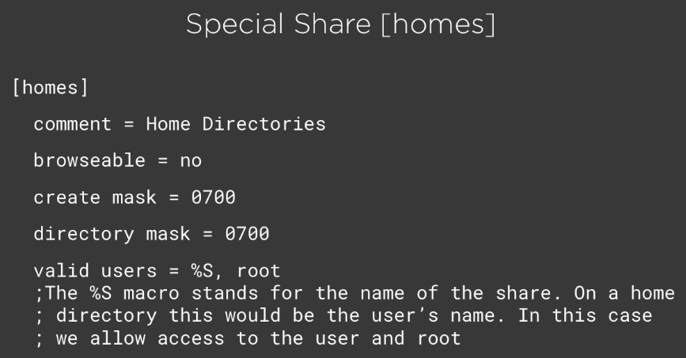

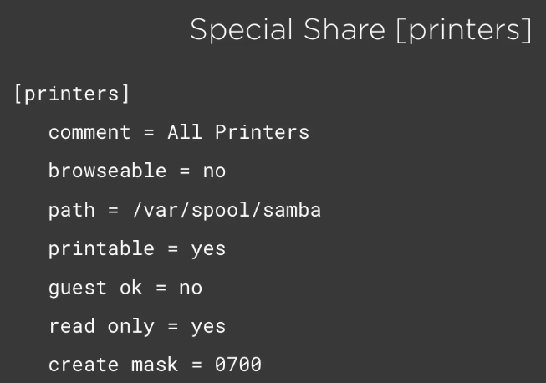

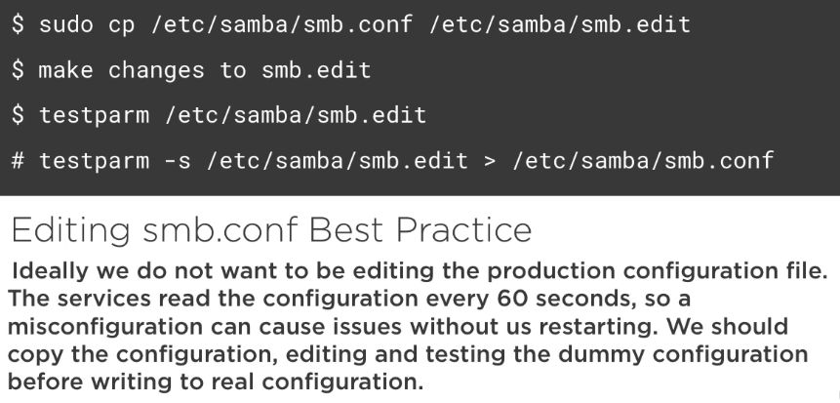

5.Working with Special Shares

ubuntu@samba:~$ net share
Enter ubuntu's password:
print$
IPC$

ubuntu@samba:~$ sudo vim /etc/samba/smb.conf
[…]
[homes]
comment = Home Dirs
browseable = no
create mask = 0700
directory mask = 0700
valid users = %S,root

ubuntu@samba:~$ net share
Enter ubuntu's password:
print$
IPC$
ubuntu

6.Creating a New Share

ubuntu@samba:~$ sudo -i
root@samba:~# mkdir -m 770 /data
root@samba:~# chgrp sudo /data
root@samba:~# cd /etc/samba/
root@samba:/etc/samba# vi smb.conf
[…]
[data-share]
comment = Test Share
path = /data
valid users = ubuntu, root, +sudo
writeable = true
read list = ubuntu
write list = root

root@samba:/etc/samba# testparm -s smb.conf
Load smb config files from smb.conf
rlimit_max: increasing rlimit_max (1024) to minimum Windows limit (16384)
WARNING: The "syslog" option is deprecated
Processing section "[printers]"
Processing section "[print$]"
Processing section "[homes]"
Processing section "[data-share]"
Loaded services file OK.

root@samba:/etc/samba# net share
Enter root's password: toor
print$
IPC$
data-share
root

07.Connecting to Shares

7.1.Understanding Share Authentication

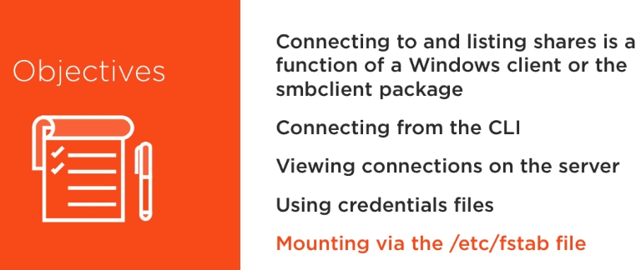

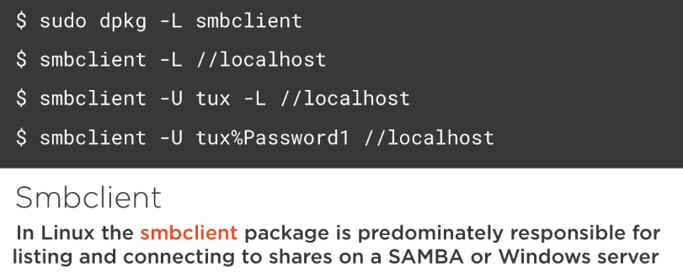

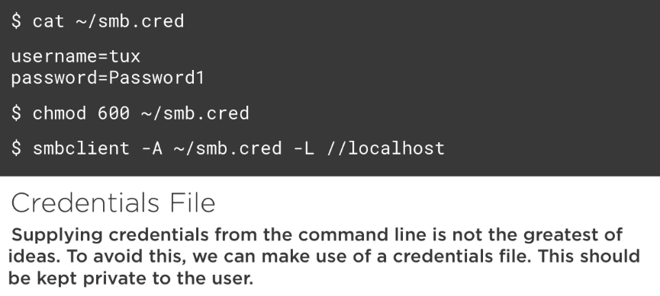

7.2.Listing Shares and Credentials

ubuntu@samba:~$ sudo dpkg -L smbclient
[...]
/usr/bin/cifsdd
/usr/bin/smbspool
/usr/bin/smbget
/usr/bin/smbtar
/usr/bin/rpcclient
/usr/bin/smbclient
/usr/bin/smbtree
/usr/bin/smbspool_krb5_wrapper
/usr/bin/smbcacls
/usr/bin/smbcquotas
[…]

ubuntu@samba:~$ smbclient -L //localhost
WARNING: The "syslog" option is deprecated
Enter ubuntu's password:
Domain=[WORKGROUP] OS=[Windows 6.1] Server=[Samba 4.3.11-Ubuntu]

Sharename Type Comment
--------- ---- -------
print$ Disk Printer Drivers
IPC$ IPC IPC Service (samba server (Samba, Ubuntu))
data-share Disk Test Share
ubuntu Disk Home Dirs
Domain=[WORKGROUP] OS=[Windows 6.1] Server=[Samba 4.3.11-Ubuntu]

Server Comment
--------- -------
SAMBA samba server (Samba, Ubuntu)

Workgroup Master
--------- -------
WORKGROUP SAMBA

ubuntu@samba:~$ smbclient -U root -L //localhost

ubuntu@samba:~$ smbclient -U root%toor -L //localhost

ubuntu@samba:~$ sudo vim /etc/samba/smb.cred
username=ubuntu
password=ubuntupass

ubuntu@samba:~$ sudo chmod 600 /etc/samba/smb.cred
ubuntu@samba:~$ sudo smbclient -A /etc/samba/smb.cred -L //localhost

7.3 Using the smbclient to connect to shares

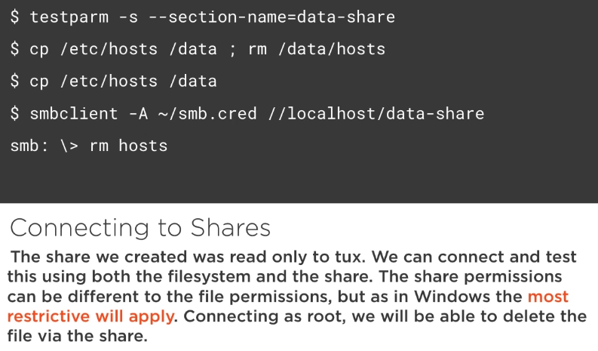

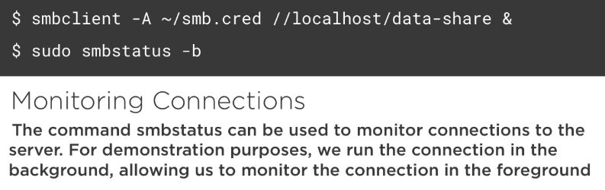

7.4.Understanding Mounting of SAMBA Shares
and
7.5.Mounting Remote Shares and Connecting to Windows 7

We will mount the share using the /etc/fstab file. We will also connect to a local Windows 7 share.
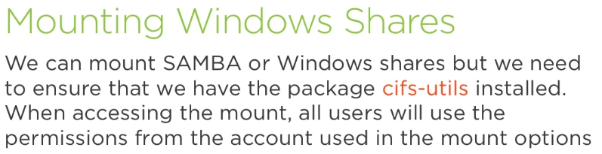

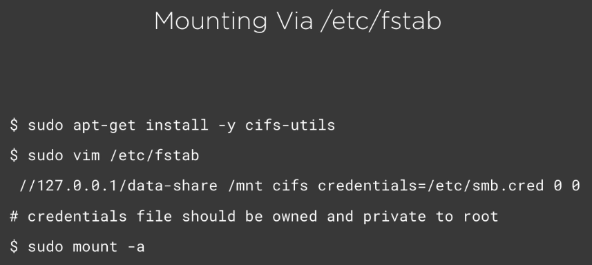

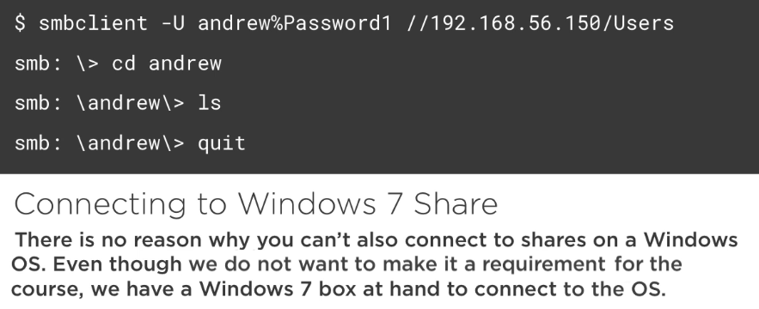

The 192.168.56.150 is the Windows system.

08.Linux and Active Directory

- Creating SAMBA 4 Active Directory server
- Integrating SAMBA 4 with Active Directory Domains

Active Directory: Microsoft’s Active Directory uses an LDAP directory to store user account data and Kerberos for authentication. With SAMBA 4 we can create our own Active Directory domain or join an existing AD domain.

8.1.Configuring Time on Your Server

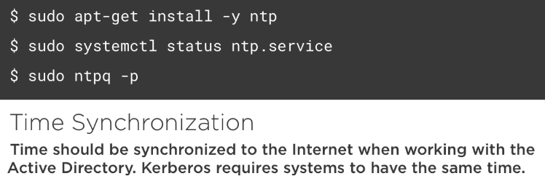

No matter if we are joining an AD domain or creating our own Linux based AD we will want time synchronized on the network. We will install NTP on our SAMBA host.

8.2.Understanding How to Deploy Active Directory with SAMBA 4

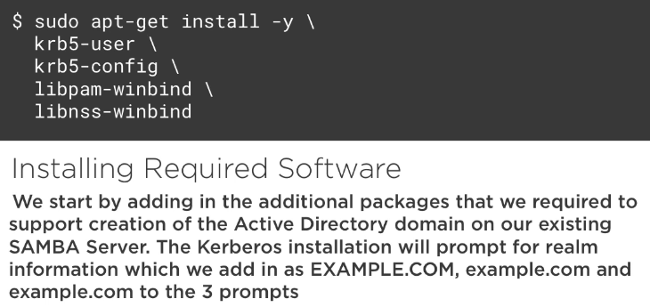

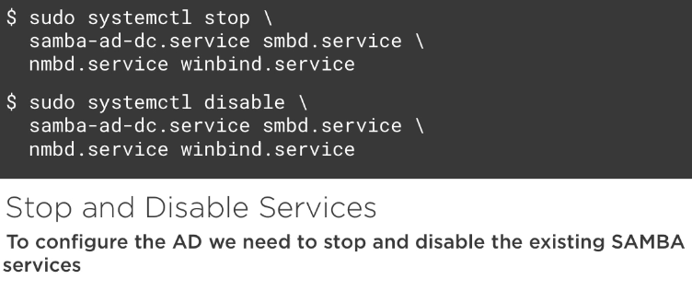

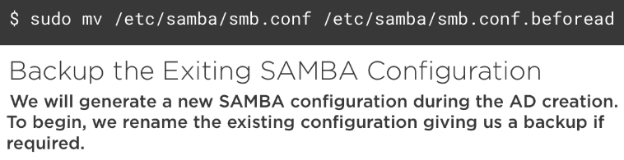

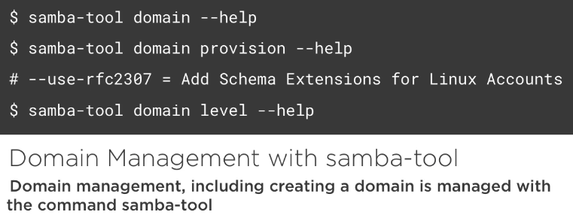

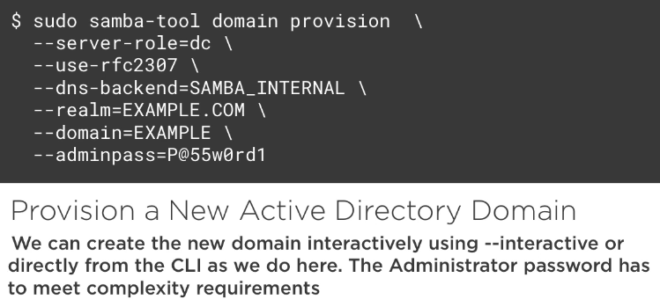

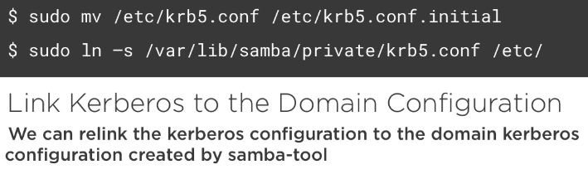

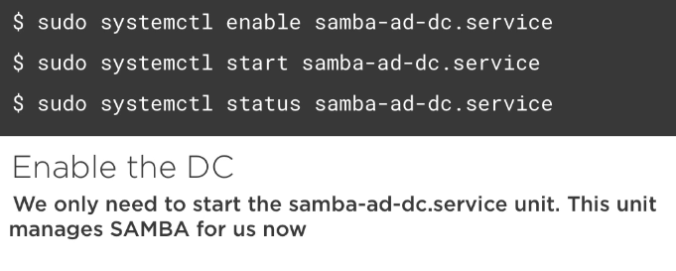

8.3.Deploying Active Directory in SAMBA 4

ubuntu@samba:~$ sudo apt-get install krb5-config krb5-user libpam-winbind libnss-winbind

Default Kerberos version 5 realm: FROZZA.COM
Kerberos servers for your realm: frozza.com
Administrative server for your Kerberos realm: frozza.com

ubuntu@samba:~$ sudo systemctl stop samba-ad-dc smbd nmbd winbind
ubuntu@samba:~$ sudo systemctl disable samba-ad-dc smbd nmbd winbind
ubuntu@samba:~$ sudo mv /etc/samba/smb.conf /etc/samba/smb.old
ubuntu@samba:~$ sudo samba-tool domain --help
ubuntu@samba:~$ sudo samba-tool domain provision --help
ubuntu@samba:~$ sudo samba-tool domain level --help
ubuntu@samba:~$ sudo samba-tool domain provision --server-role=dc --use-rfc2307 --dns-backend=SAMBA_INTERNAL --realm=FROZZA.com --domain=FROZZA --adminpass=P@55w0rd1
ubuntu@samba:~$ sudo ln -s /var/lib/samba/private/krb5.conf /etc/
ubuntu@samba:~$ ls -l /etc/krb5.conf
lrwxrwxrwx 1 root root 32 Aug 20 18:51 /etc/krb5.conf -> /var/lib/samba/private/krb5.conf

ubuntu@samba:~$ sudo systemctl enable samba-ad-dc
ubuntu@samba:~$ sudo systemctl start samba-ad-dc
ubuntu@samba:~$ sudo systemctl status samba-ad-dc

The red collor might frighten a little bit, but it doesn’t imply in errors necessarily. All output will be in red.

8.4.Configuring and Testing Kerberos Authentication

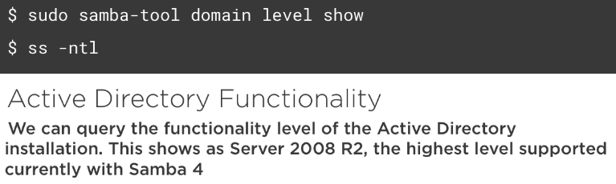

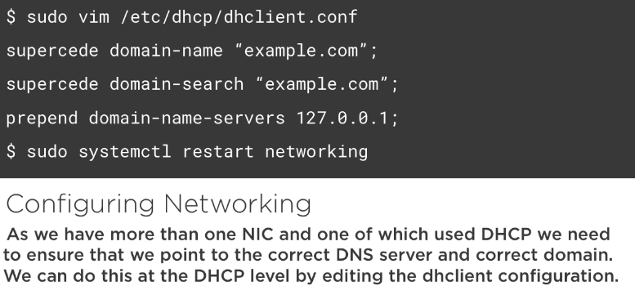

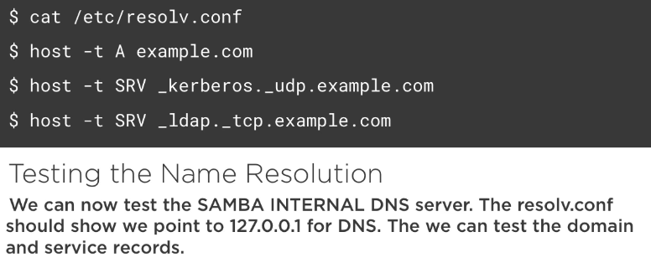

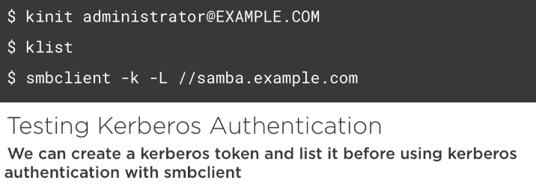

testing the domain we created:

ubuntu@samba:~$ sudo samba-tool domain level show
ubuntu@samba:~$ sudo vim /etc/dhcp/dhclient.conf
[…]
supersede domain-name "frozza.com";
supersede domain-search "frozza.com";
prepend domain-name-servers 127.0.0.1;
[…]

ubuntu@samba:~$ sudo systemctl restart networking
ubuntu@samba:~$ cat /etc/resolv.conf
# Dynamic resolv.conf(5) file for glibc resolver(3) generated by resolvconf(8)
# DO NOT EDIT THIS FILE BY HAND -- YOUR CHANGES WILL BE OVERWRITTEN
nameserver 127.0.0.1
search frozza.com

ubuntu@samba:~$ host -t SRV _ldap._tcp.frozza.com
_ldap._tcp.frozza.com has SRV record 0 100 389 samba.frozza.com.

Testing getting a Kerberos tiket for ourselves:

ubuntu@samba:~$ kinit administrator@FROZZA.COM
Password for administrator@FROZZA.COM:
Warning: Your password will expire in 40 days on Mon Oct 1 18:50:02 2018

ubuntu@samba:~$ klist
Ticket cache: FILE:/tmp/krb5cc_1000
Default principal: administrator@FROZZA.COM

Valid starting Expires Service principal
08/21/18 19:10:32 08/22/18 05:10:32 krbtgt/FROZZA.COM@FROZZA.COM
renew until 08/22/18 19:10:01

ubuntu@samba:~$ smbclient -k -L //samba.frozza.com

8.5.Understanding Linux and AD Integration

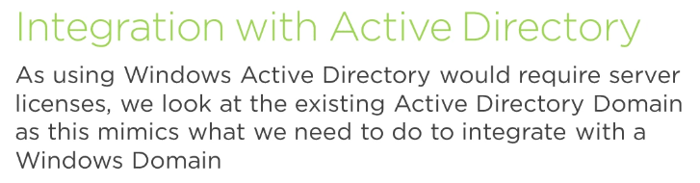

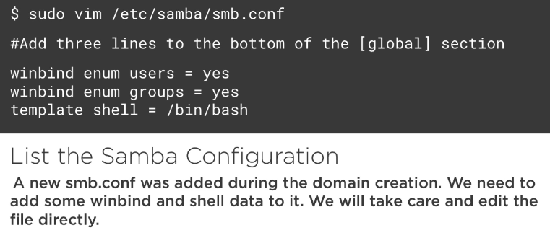

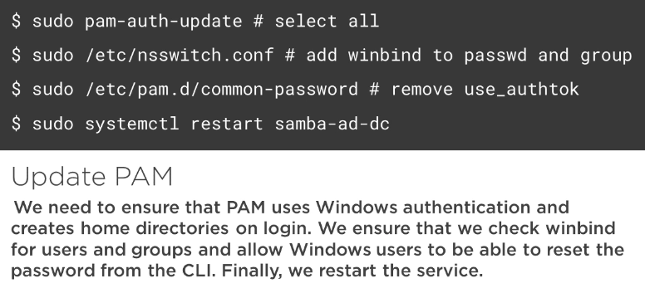

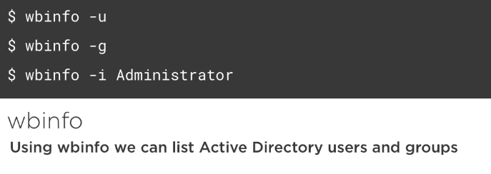

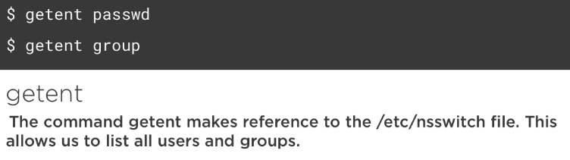

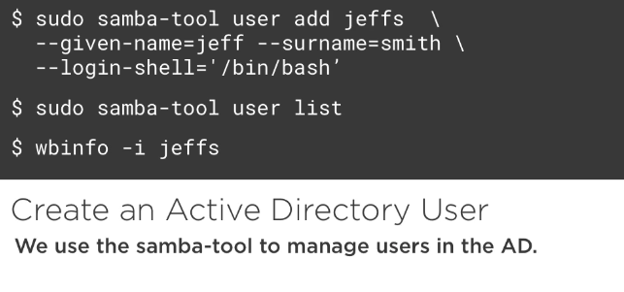

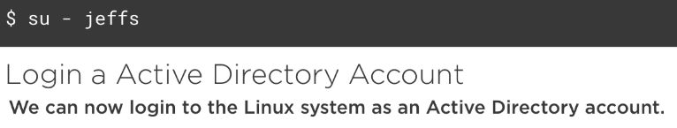

8.6.Integrating Linux into the AD

ubuntu@samba:~$ sudo vi /etc/samba/smb.conf
# Global parameters
[global]
workgroup = FROZZA
realm = FROZZA.com
netbios name = SAMBA
server role = active directory domain controller
dns forwarder = 10.0.2.3
idmap_ldb:use rfc2307 = yes
winbind enum users = yes
winbind enum groups = yes
template shell = /bin/bash

ubuntu@samba:~$ sudo pam-auth-update
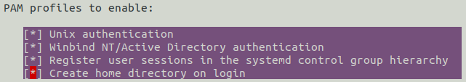

ubuntu@samba:~$ sudo vim /etc/nsswitch.conf
[…]
passwd: compat winbind
group: compat winbind
[…]

ubuntu@samba:~$ sudo vim /etc/pam.d/common-password (remove “use_authok”)
password [success=2 default=ignore] pam_unix.so obscure sha512
password [success=1 default=ignore] pam_winbind.so try_first_pass
[…]

ubuntu@samba:~$ sudo systemctl restart samba-ad-dc

ubuntu@samba:~$ wbinfo -u
FROZZA\administrator
FROZZA\krbtgt
FROZZA\guest

ubuntu@samba:~$ wbinfo -g
FROZZA\cert publishers
FROZZA\ras and ias servers
FROZZA\allowed rodc password replication group
FROZZA\denied rodc password replication group
FROZZA\dnsadmins
FROZZA\enterprise read-only domain controllers
FROZZA\domain admins
FROZZA\domain users
FROZZA\domain guests
FROZZA\domain computers
FROZZA\domain controllers
FROZZA\schema admins
FROZZA\enterprise admins
FROZZA\group policy creator owners
FROZZA\read-only domain controllers
FROZZA\dnsupdateproxy

ubuntu@samba:~$ wbinfo -i administrator
FROZZA\administrator:*:0:100::/home/FROZZA/administrator:/bin/bash

ubuntu@samba:~$ getent passwd
[…]
FROZZA\administrator:*:0:100::/home/FROZZA/administrator:/bin/bash
FROZZA\krbtgt:*:3000017:100::/home/FROZZA/krbtgt:/bin/bash
FROZZA\guest:*:3000011:100::/home/FROZZA/guest:/bin/bash

ubuntu@samba:~$ getent group
ubuntu@samba:~$ sudo samba-tool user add jeffs --given-name=jeff --surname=smith --login-shell=/bin/bash
New Password: <Ilove-linux2017>
Retype Password: <Ilove-linux2017>
User 'jeffs' created successfully

ubuntu@samba:~$ wbinfo -i jeffs
FROZZA\jeffs:*:3000043:100:jeff smith:/home/FROZZA/jeffs:/bin/bash

ubuntu@samba:~$ su - jeffs
Password: <Ilove-linux2017>
Creating directory '/home/FROZZA/jeffs'.
FROZZA\jeffs@samba:~$ id
NFS

9.1.Installing NFS

The Network File System – NFS is the traditional way of sharing or exporting file systems in UNIX and Linux.Often, home directories in Linux are centralized on a single server with other systems mounting the remote file systems.

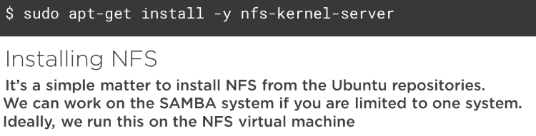

ubuntu@nfs:~$ sudo apt-get install -y nfs-kernel-server

ubuntu@nfs:~$ ss -ntl
State Recv-Q Send-Q Local Address:Port Peer Address:Port
LISTEN 0 128 *:54488 *:*
LISTEN 0 64 *:39514 *:*
LISTEN 0 64 *:2049 *:*
LISTEN 0 128 *:56751 *:*
LISTEN 0 128 *:111 *:*
LISTEN 0 128 *:22 *:*
LISTEN 0 128 *:36471 *:*
LISTEN 0 128 :::53144 :::*
LISTEN 0 128 :::60190 :::*
LISTEN 0 64 :::2049 :::*
LISTEN 0 128 :::43751 :::*
LISTEN 0 64 :::37389 :::*
LISTEN 0 128 :::111 :::*
LISTEN 0 128 :::22 :::*

ubuntu@nfs:~$ systemctl status nfs-server

9.2.A Look at the Configuration

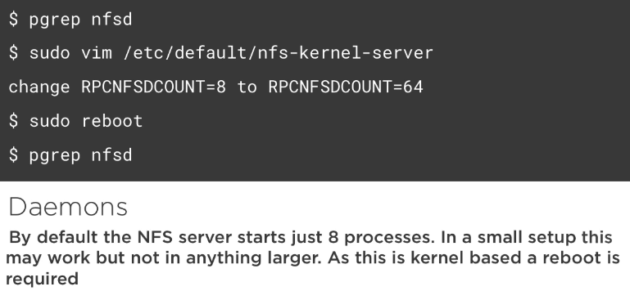

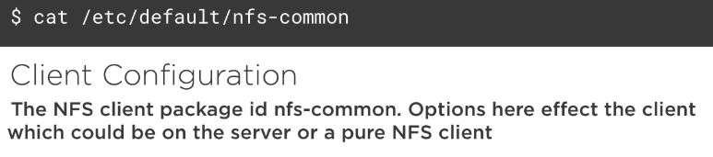

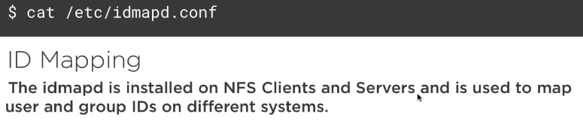

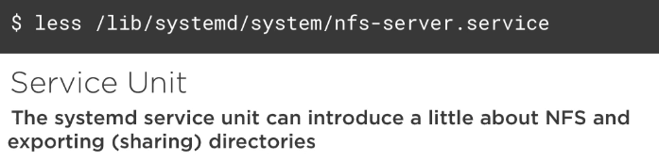

ubuntu@nfs:~$ pgrep nfsd
13652 → master process
13655 + 8 children
13656
13657
13658
13659
13660
13661
13662

ubuntu@nfs:~$ sudo vim /etc/default/nfs-kernel-server
# Number of servers to start up
RPCNFSDCOUNT=64

ubuntu@nfs:~$ cat /etc/default/nfs-common

10.Creating Exports in NFS

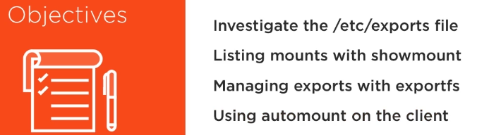

10.1.NFS Exports

In NFS shares are referred to as exports. These are configured in the fle /etc/exports.
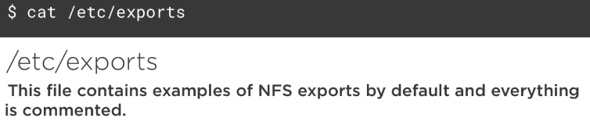

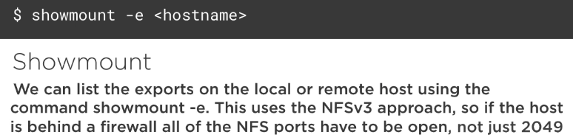

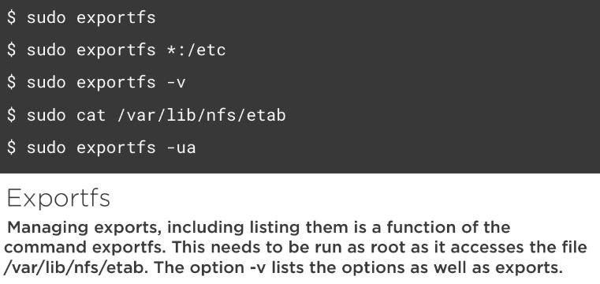

10.2.Listing Exports

ubuntu@nfs:~$ sudo exportfs *:/tmp
ubuntu@nfs:~$ showmount -e
Export list for nfs:
/tmp *

ubuntu@nfs:~$ sudo exportfs -v
/tmp <world>(ro,wdelay,root_squash,no_subtree_check,sec=sys,ro,root_squash,no_all_squash)

ubuntu@nfs:~$ sudo cat /var/lib/nfs/etab

ubuntu@nfs:~$ sudo exportfs -u *:/tmp ( or -ua to un-export all shares)
ubuntu@nfs:~$ sudo exportfs

10.3.Sharing with Exports

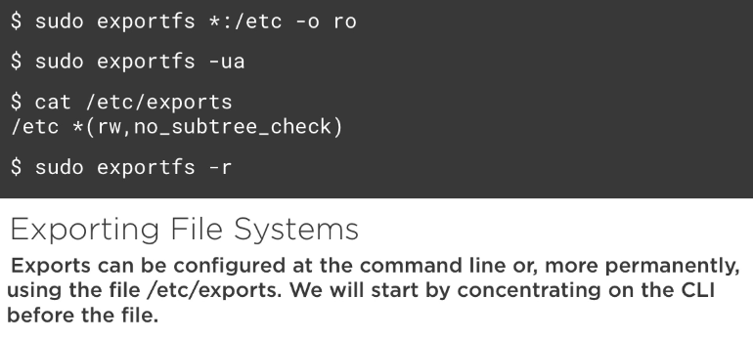

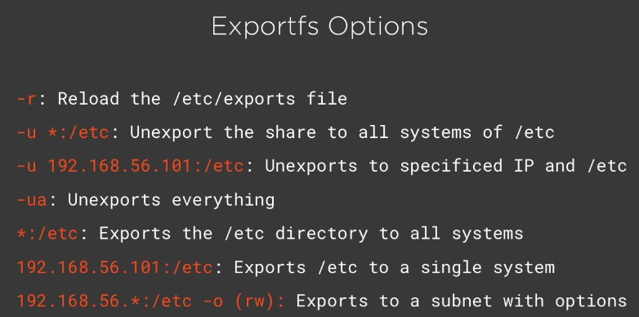

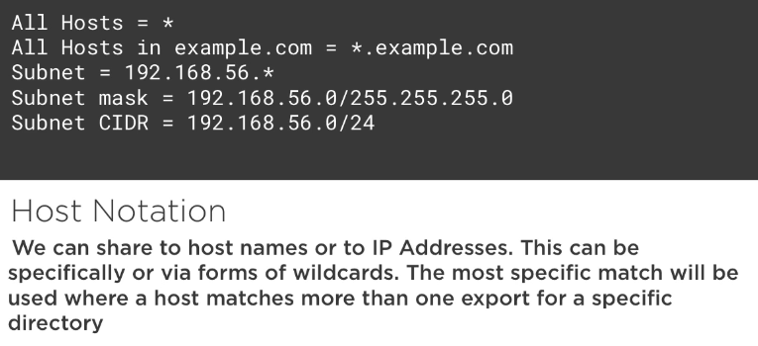

10.4.Creating Permanent Exports Using the Configuration File

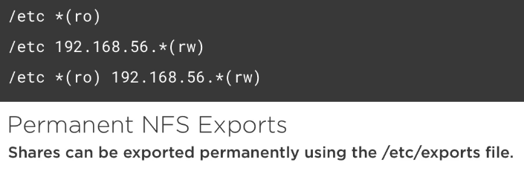

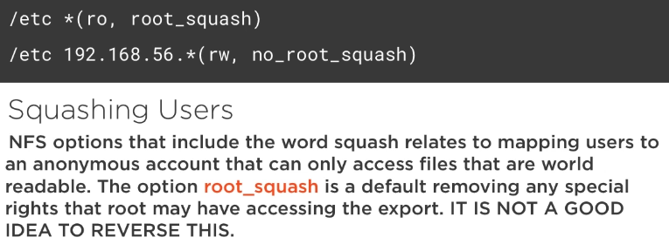

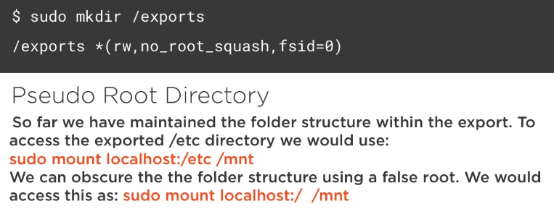

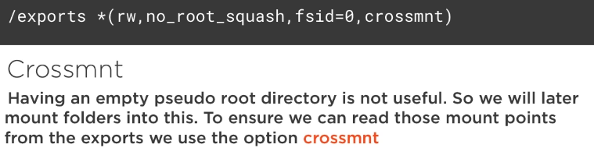

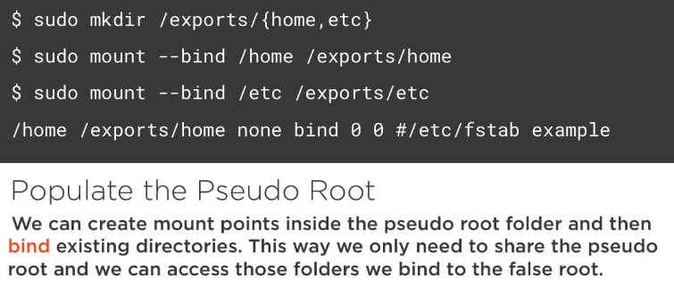

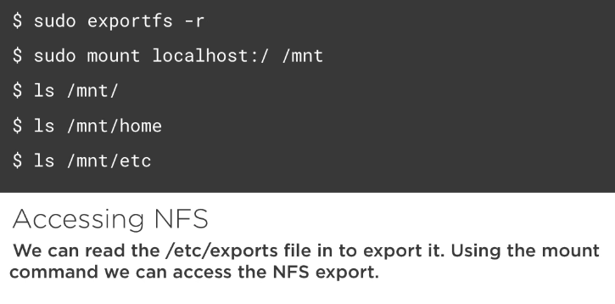

10.5.Writing NFSv4 Exports

it is about managing the /etc/exports

ubuntu@nfs:~$ sudo mkdir -p /exports/{home,etc}
ubuntu@nfs:~$ sudo vim /etc/fstab
[…]
/home /exports/home none bind 0 0
/etc /exports/etc none bind 0 0

ubuntu@nfs:~$ sudo mount -a
ubuntu@nfs:~$ sudo vim /etc/exports
[…]
/exports *(rw,no_root_squash,crossmnt,fsid=0)

ubuntu@nfs:~$ sudo exportfs -r

ubuntu@nfs:~$ sudo exportfs -v
/exports <world>

ubuntu@nfs:~$ sudo mount 127.0.0.1:/ /mnt
ubuntu@nfs:~$ ls /mnt
etc home

10.6,Using the Auto Mount Service
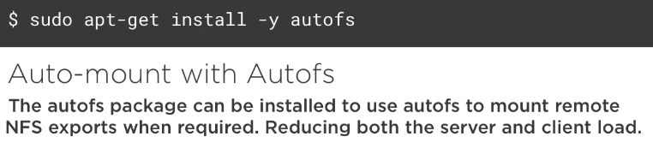

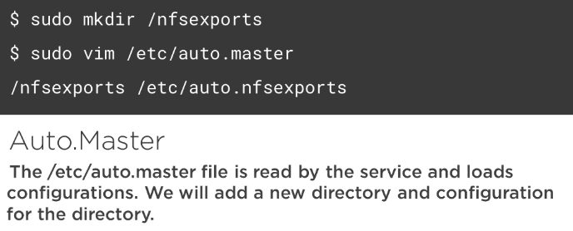

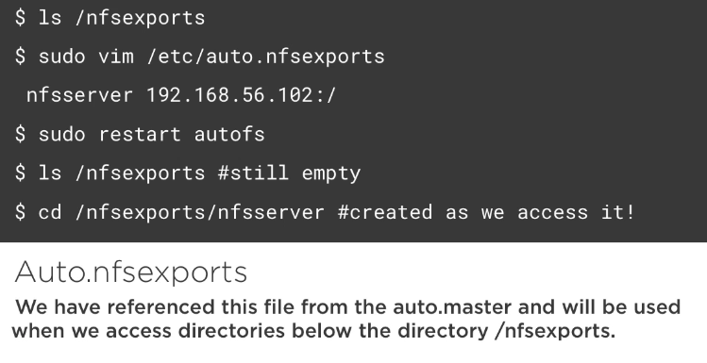

ubuntu@nfs:~$ sudo umount /mnt
ubuntu@nfs:~$ sudo apt-get install autofs

ubuntu@nfs:~$ sudo mkdir /nfsexports
ubuntu@nfs:~$ sudo vim /etc/auto.master
[…]
#/misc /etc/auto.misc
/nfsexports /etc/auto.misc (the file name doesn’t need to match the directory exported)

ubuntu@nfs:~$ sudo vi /etc/auto.misc
#cd -fstype=iso9660,ro,nosuid,nodev :/dev/cdrom
s1 -fstype=nfs4 nfs:/exports (s1 doesn’t need to be preiously created. “nfs” is the server name)

ubuntu@nfs:~$ sudo systemctl restart autofs
ubuntu@nfs:~$ ls /nfsexports/
ubuntu@nfs:~$

ubuntu@nfs:~$ ls /nfsexports/s1
etc home
11.Securing NFS

11.1.Introducing TCP Wrappers

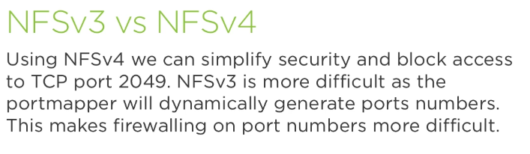

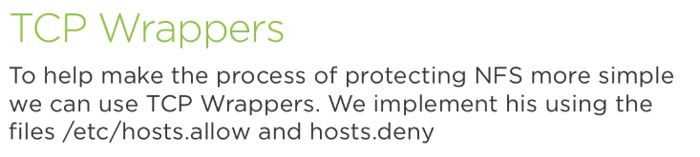

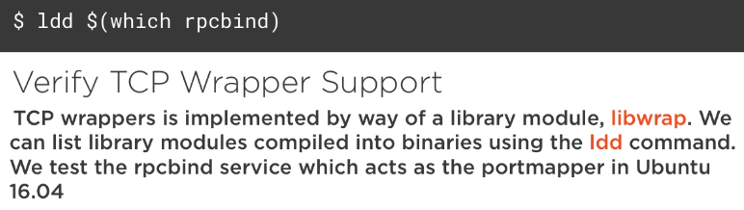

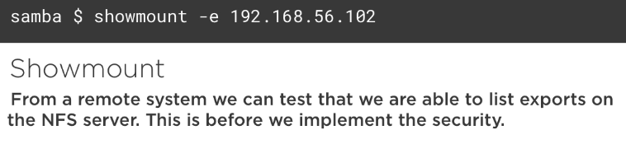

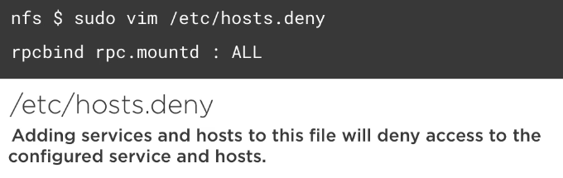

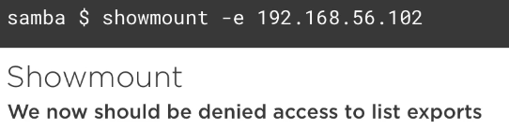

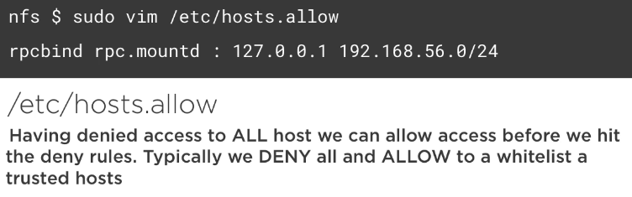

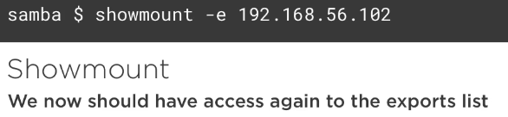

11.2.Implementing TCP Wrappers to secure NFSv3 and NFSv4

ubuntu@nfs:~$ ldd $(which rpcbind) | grep libwrap

ubuntu@samba:~$ sudo apt-get install nfs-common
ubuntu@samba:~$ showmount -e nfs
Export list for nfs:
/exports *

ubuntu@nfs:~$ sudo vi /etc/hosts.deny
rpcbind rpc.mountd: ALL

ubuntu@samba:~$ showmount -e nfs
clnt_create: RPC: Port mapper failure - Authentication error

ubuntu@nfs:~$ sudo vi /etc/hosts.allow
rpcbind rpc.mountd: 127.0.0.1 192.168.56.0/24

ubuntu@samba:~$ showmount -e nfs
Export list for nfs:
/exports *

ubuntu@nfs:~$ sudo vi /etc/hosts.allow
rpcbind rpc.mountd: 127.0.0.1 192.168.56.0/24 EXCEPT 92.168.56.101

ubuntu@samba:~$ showmount -e nfs
clnt_create: RPC: Port mapper failure - Authentication error


