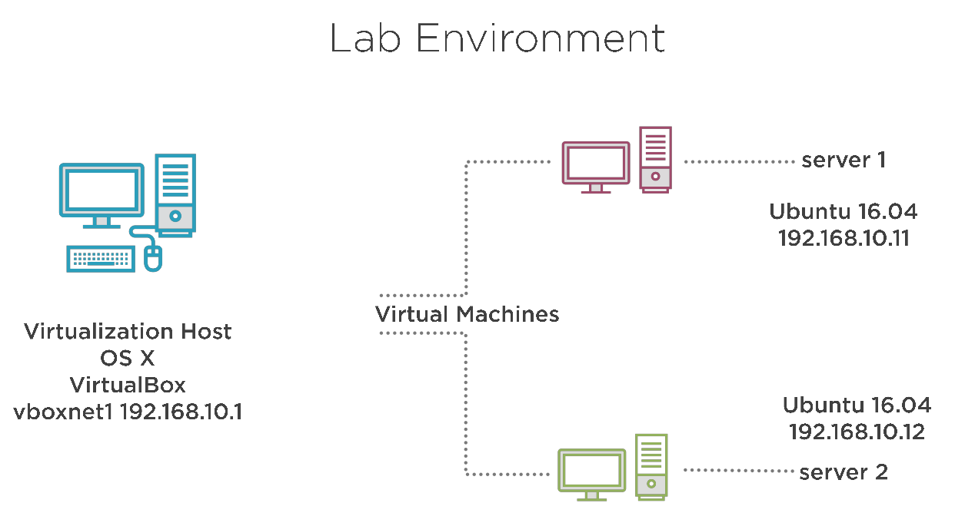
210 - The Lab Environment

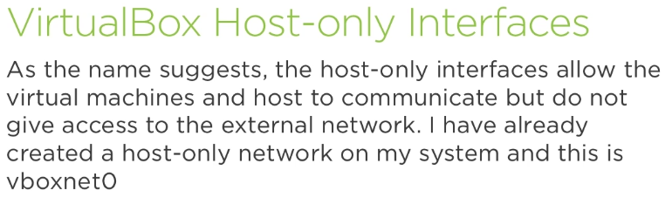

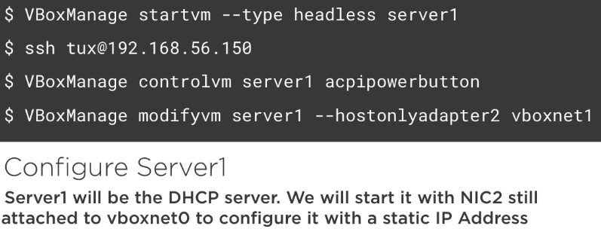

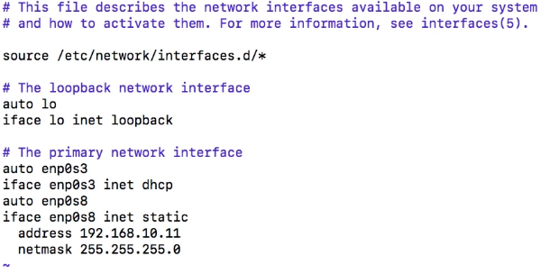

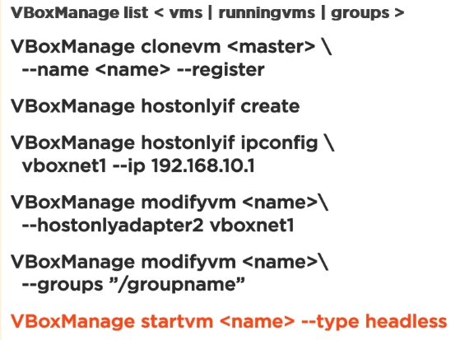

210.1 ISC DHCP

Installing the DHCP Server

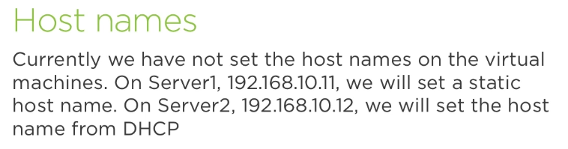

we’ll work with DNS in two different ways: 1) with DNSmasq as DHCP server to configure the hostname of server2. 2) Use ISC DHCP. A dedicated tool to do DHCP.

1) Installing and Configuring DNSMasq as a DHCP Server

@server1 sudo apt-get install dnsmasq

We only want work with the hostonly interface, so, first step is to configure dnsmasq to listen only on that hostonly interface:

ubuntu@dhcp:~$ sudo rm /etc/dnsmasq.conf
ubuntu@dhcp:~$ id -4 a s

ubuntu@dhcp:~$ sudo vi /etc/dnsmasq.conf
interface=enp0s8
dhcp-range=192.168.1.90,192.168.1.99,12h
dhcp-host=08:00:27:a1:d3:3d,server2.frozza.com,192.168.1.109,24h

ubuntu@dhcp:~$ sudo systemctl restart dnsmasq

ubuntu@dhcp:~$ ss -nul (should now also show port 67 as LISTEN on UDP)

Working on client side:

ubuntu@client01:~$ cat /etc/hostname
client01
ubuntu@client01:~$ sudo hostnamectl set-hostname ""
ubuntu@client01:~$ cat /etc/hostname
cat: /etc/hostname: No such file or directory

ubuntu@client01:~$ hostname
localhost

ubuntu@client01:~$ sudo dhclient -i enp0s8
RTNETLINK answers: File exists
ubuntu@client01:~$ hostname
server2

2) Installing and Configuring the ISC DHCP Server

@server1~$ sudo hostnamectl set-hostname server1.example.com

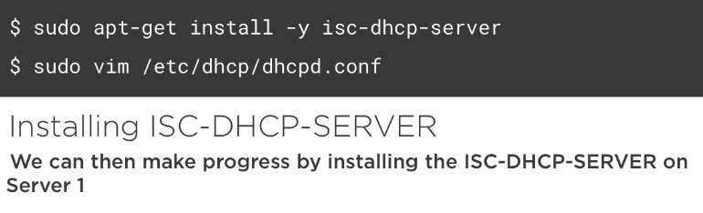

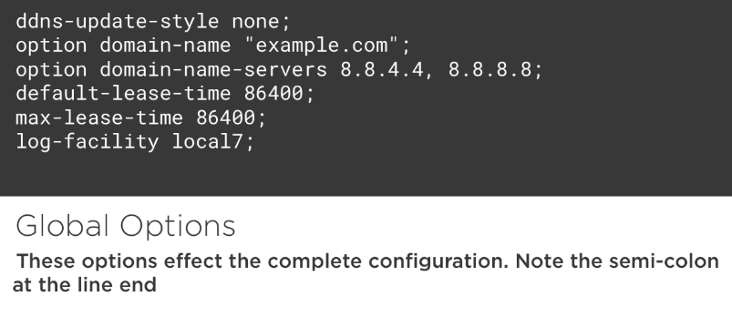

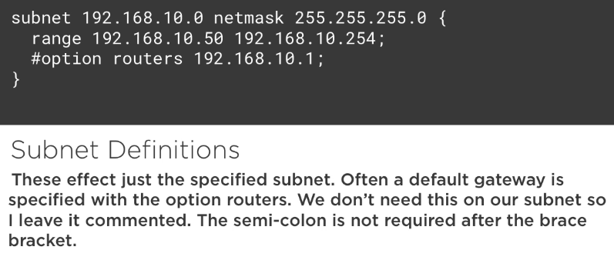

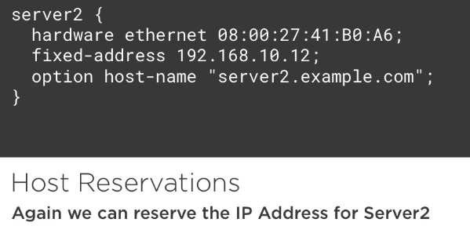

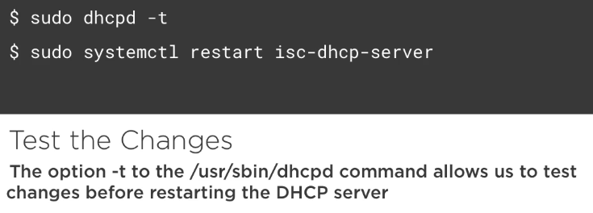

@server1~$ sudo systemctl disable dnsmasq
dhcp ~$ sudo systemctl stop dnsmasq
@server1~$ sudo apt-get install isc-dhcp-server
dhcp ~$ sudo systemctl status isc-dhcp-server

dhcp ~$ sudo vi /etc/default/isc-dhcp-server
[…]
INTERFACES="enp0s8"
[…]

@server1~$ sudo vi /etc/dhcp/dhcpd.conf
ddns-update-style none;
option domain-name "frozza.com";
option domain-name-servers 8.8.8.8, 8.8.4.4;
default-lease-time 86400;
max-lease-time 86400;
log-facility local7;
subnet 192.168.1.0 netmask 255.255.255.0 {
range 192.168.1.90 192.168.1.99;
}
host server2 {
hardware ethernet 08:00:27:a1:d3:3d;
fixed-address 192.168.1.99;
option host-name "server2-new.frozza.com";
}

@server1~$ sudo dhcpd -t
@server1~$ sudo systemctl restart isc-dhcp-server
@server1~$ sudo systemctl status isc-dhcp-server

@server2 ~$ hostname -f
@server2 ~$ sudo ip a s enp0s8
server2 ~$ sudo hostnamectl set-hostname ""
server2 ~$ sudo dhclient -i enp0s8
server2 ~$ hostname
server2 ~$ sudo ip a s enp0s8

Summary:
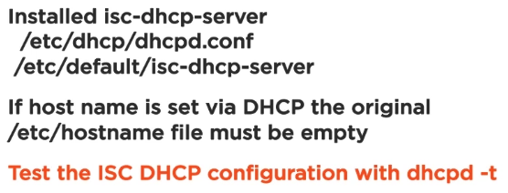

Undestanding DHCP Logs and Ipv6

Read logs files related to DHCP
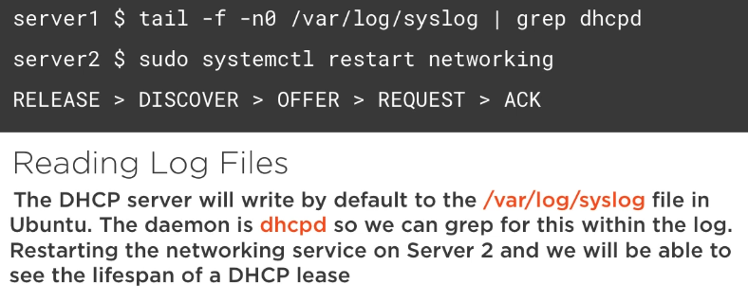

Use journalctl to read DHCP logs

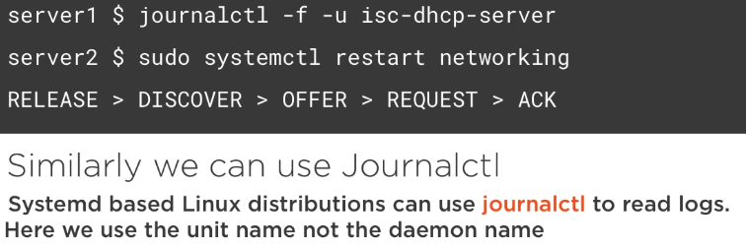

View server and client leases

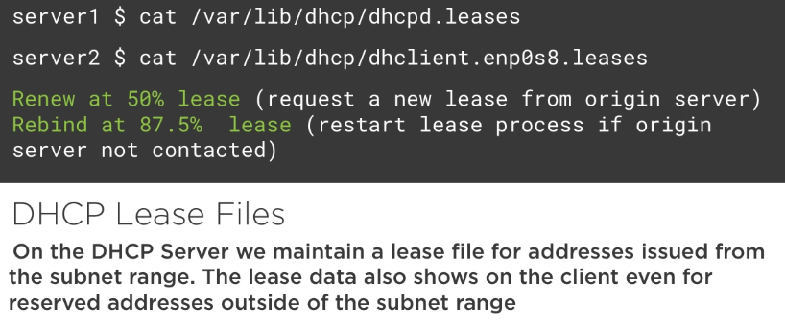

Understanding Ipv6 Address ranges

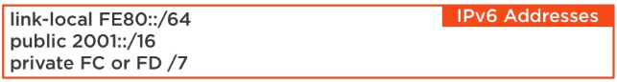

Configure static Ipv6 Addresses
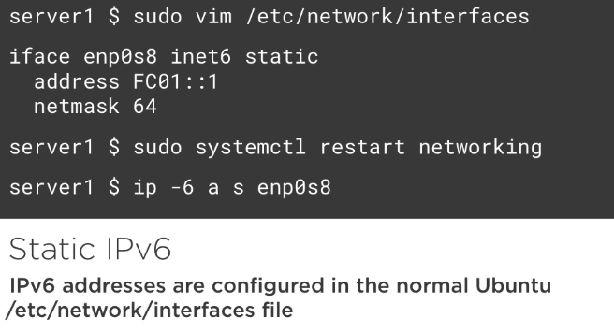

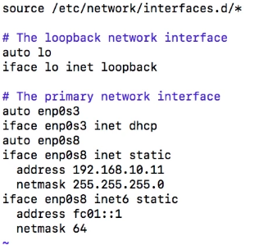

Use radvd to alloe for Ipv6 autoconfiguration

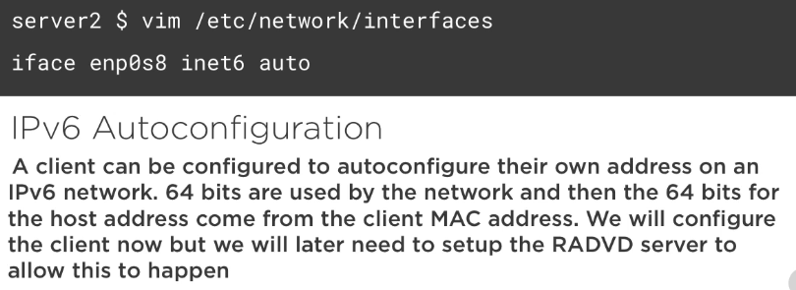

Turn on routing on server1 for ipv6 uncomenting ipv6 forwarding in sysctl:

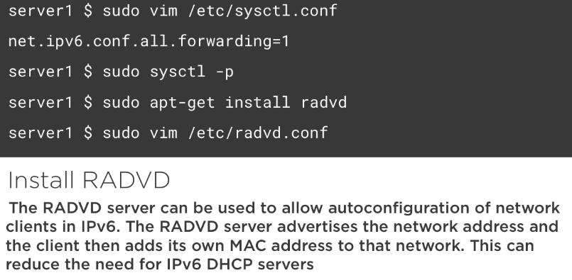

server1 $ sudo cp usrshare/doc/radvd/examples/simple-radvd.conf /etc/radvd.conf
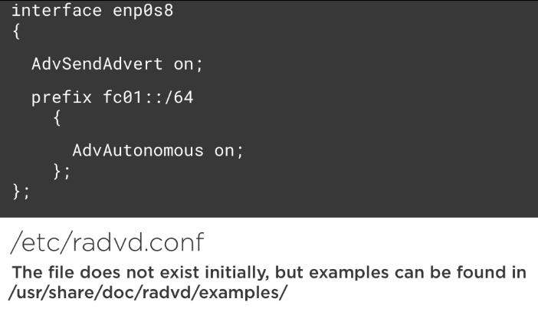

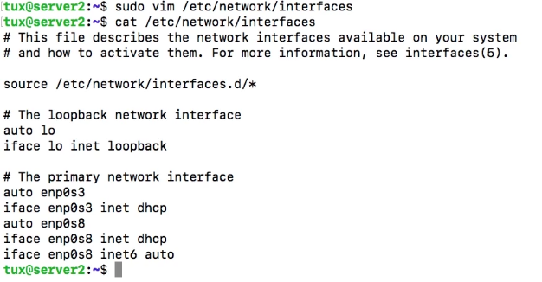

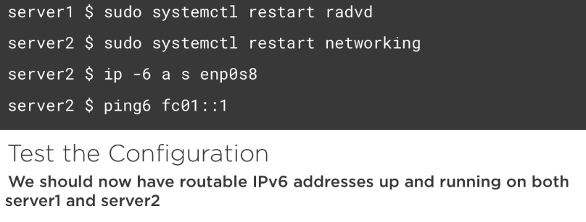

210.2 LDAP

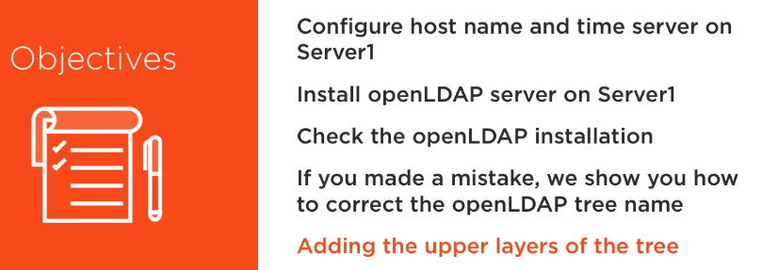

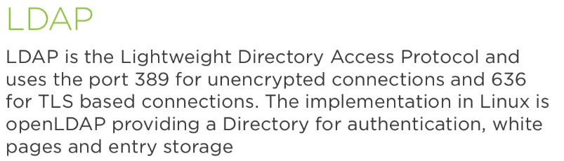

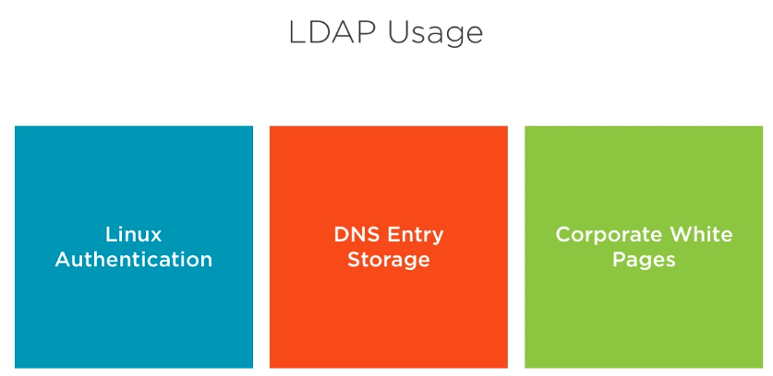

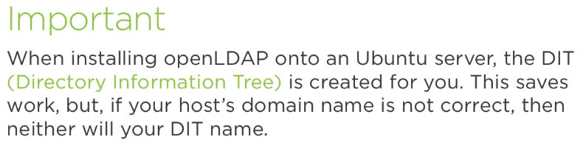

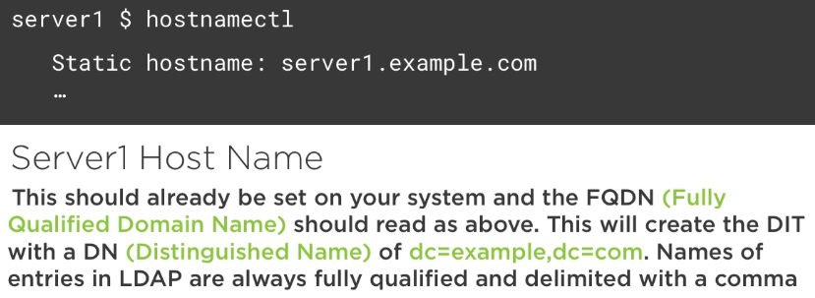

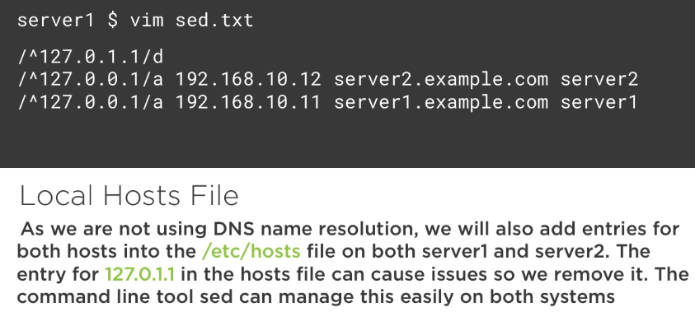

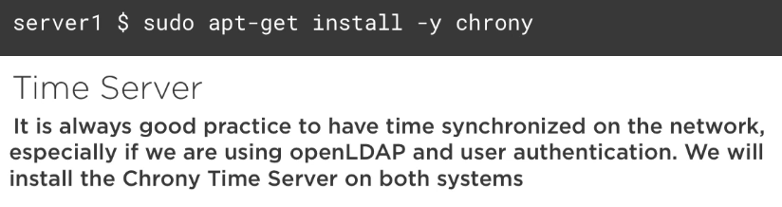

make sure NTP is working on both servers

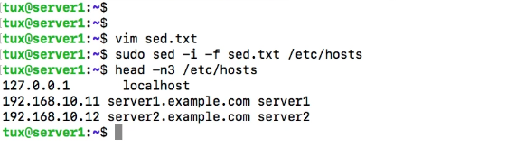
Same on clients (server2)

3.Installing openLDAP

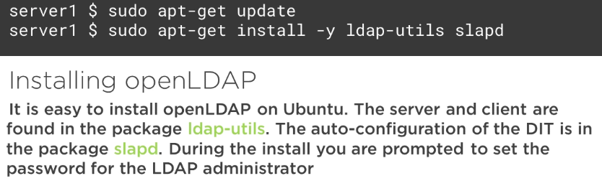

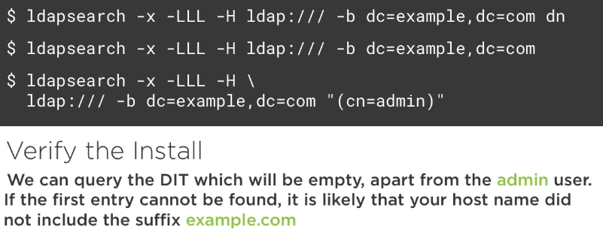

5.Reconfigure the Tree and Create Upper Layers
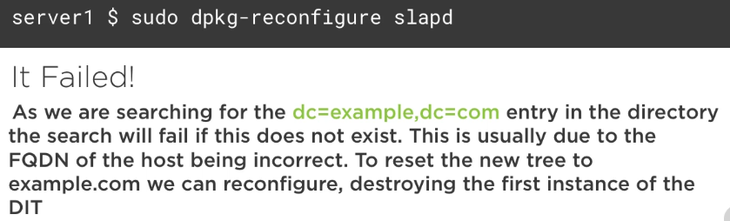

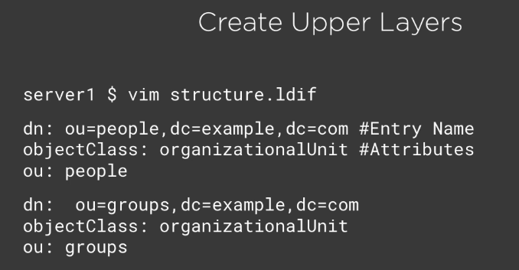

1.Managing openLDAP Servers

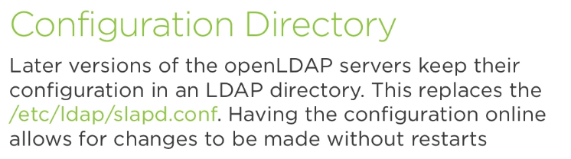

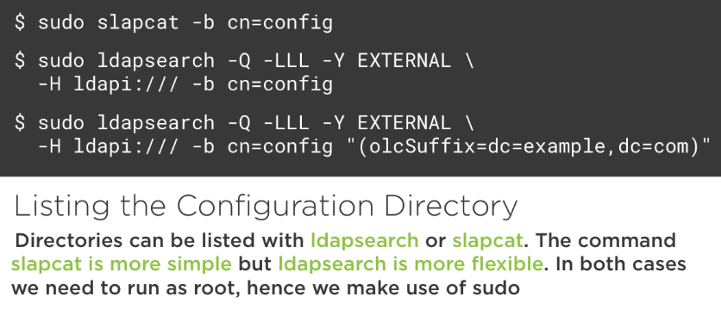

3.Understanding LDAP Logging Levels
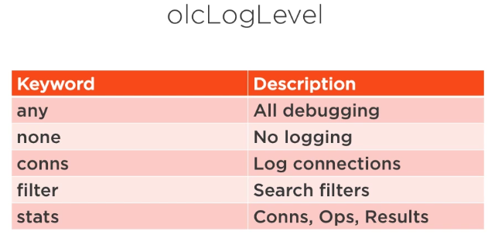

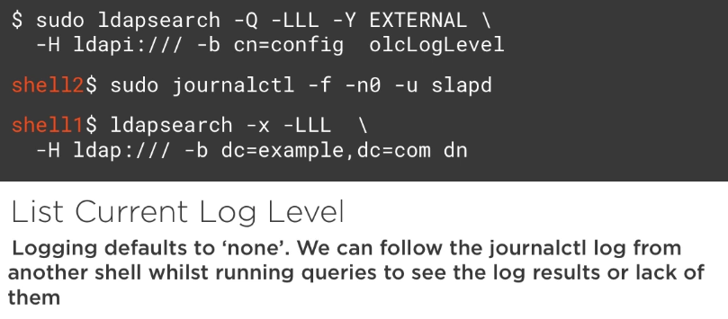

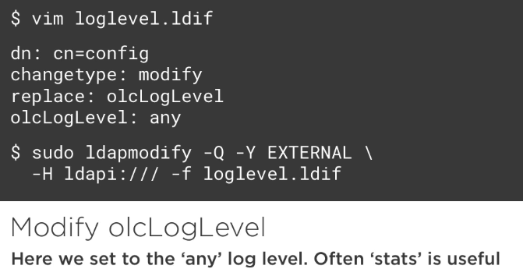

5.Indexing openLDAP Directories
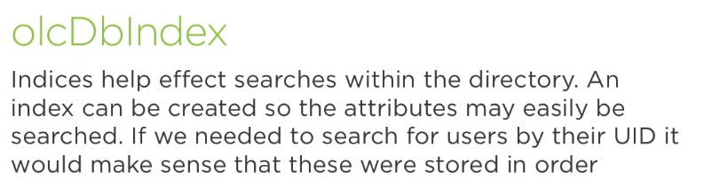

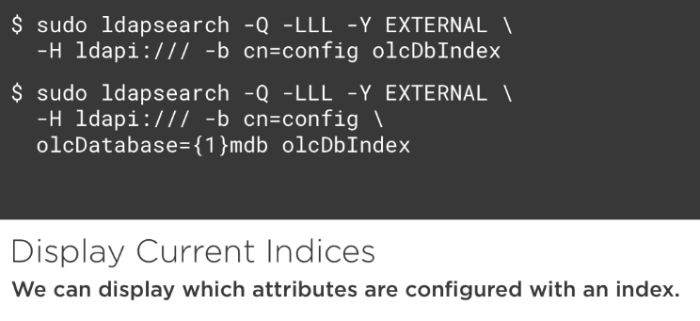

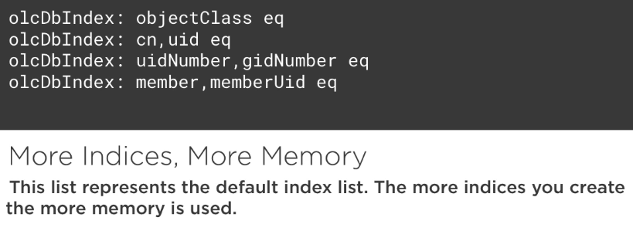

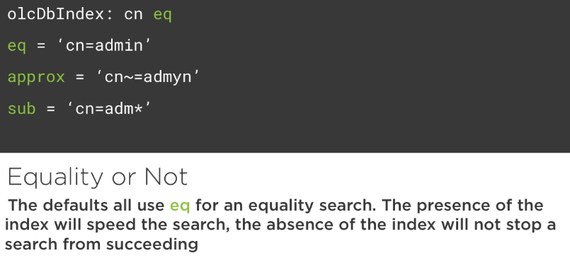

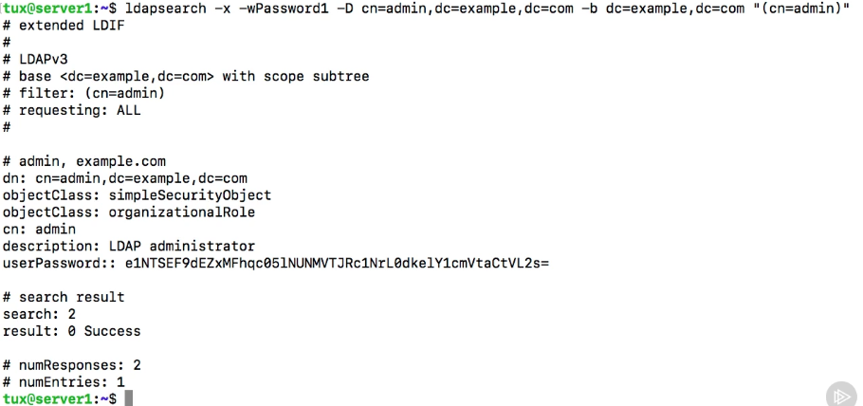
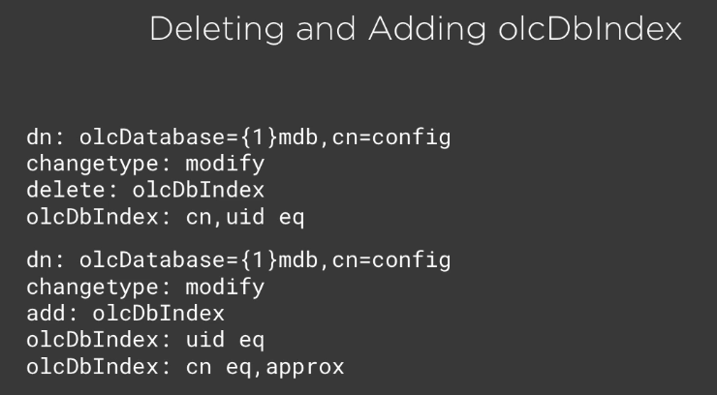

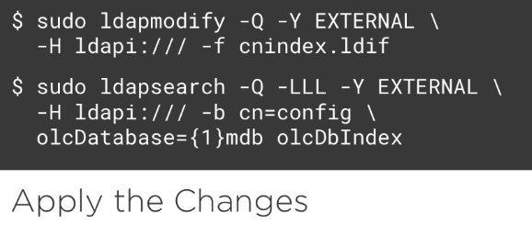

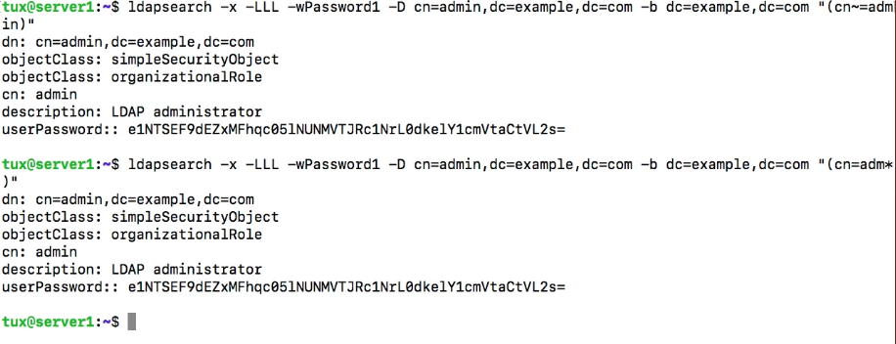
6.Understanding User Management in openLDAP

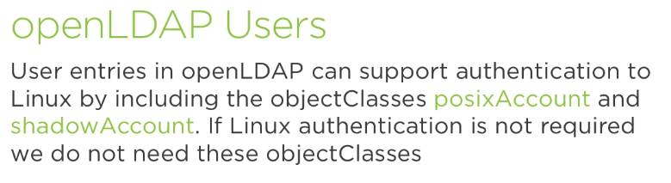

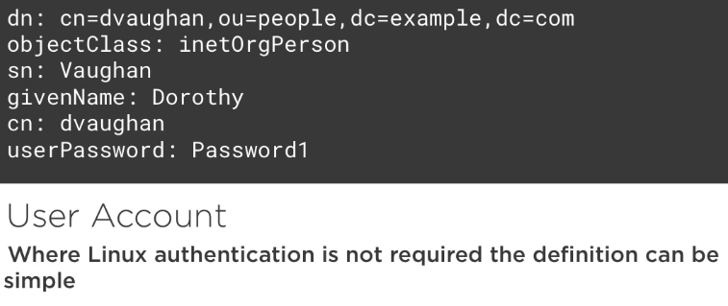

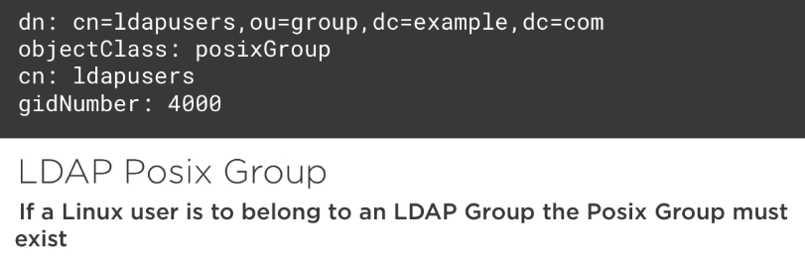

A User that can login to Linux:

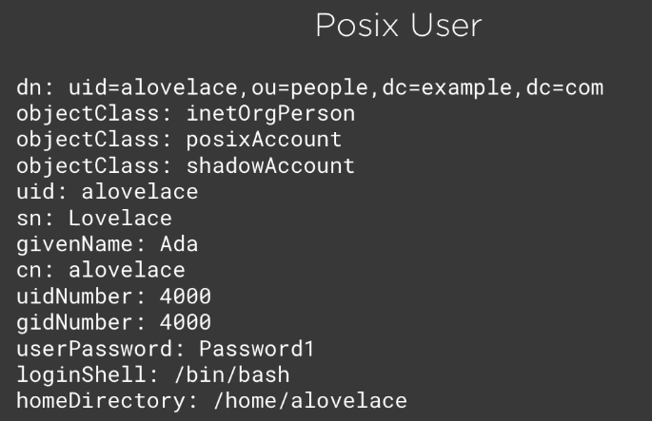

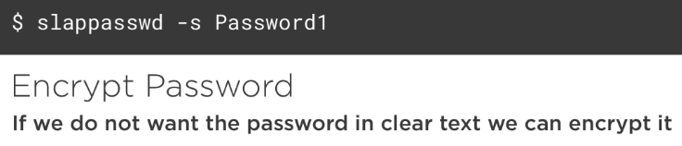

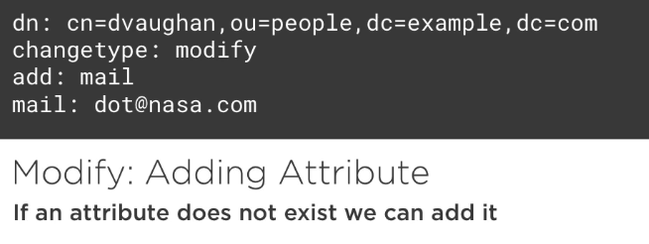

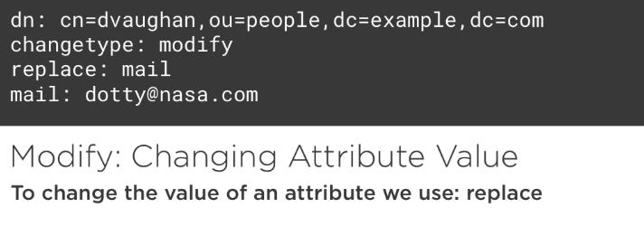

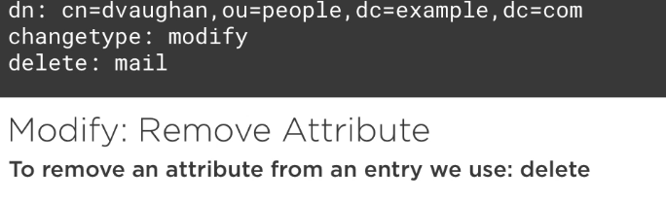

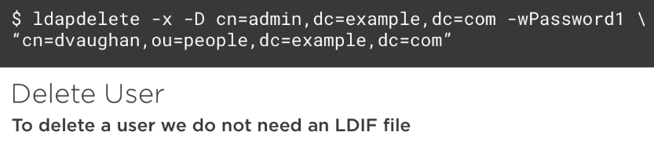

8. Sharing LDAP Accounts

1.Authenticating Using openLDAP

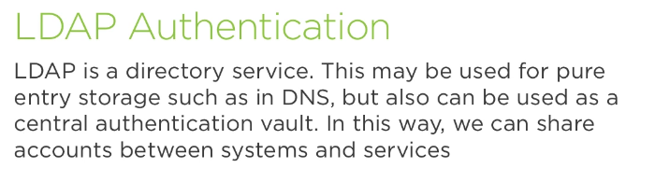

2.Apache Authentication to openLDAP

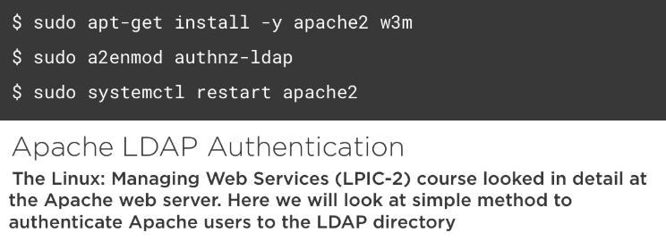

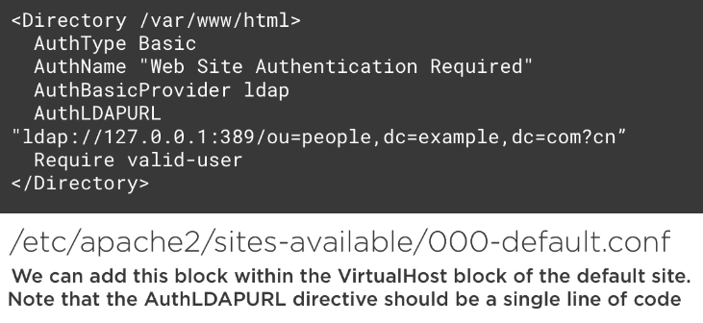

ubuntu@ldap01:~$ sudo apt-get install -y apache2 w3m
ubuntu@ldap01:~$ sudo a2enmod
authnz_ldap

ubuntu@ldap01:~$ sudo systemctl restart apache2
ubuntu@ldap01:~$ sudo vim /etc/apache2/sites-available/000-default.conf
[…]
ServerAdmin webmaster@localhost
DocumentRoot /var/www/html
<Directory /var/www/html>
AuthType Basic
AuthName "Authentication Required"
AuthBasicProvider ldap
AuthLDAPURL "ldap://127.0.0.1:389/ou=People,dc=frozza,dc=com?cn"
Require valid-user
</Directory>

ubuntu@ldap01:~$ sudo apachectl configtest
Syntax OK

ubuntu@ldap01:~$ sudo systemctl restart apache2
ubuntu@ldap01:~$ w3m localhost (should be able to authenticate with ldap user)

3.Linux and openLDAP Authentication
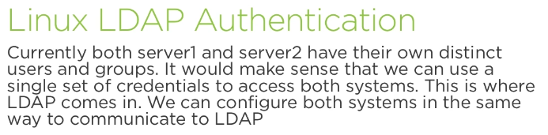

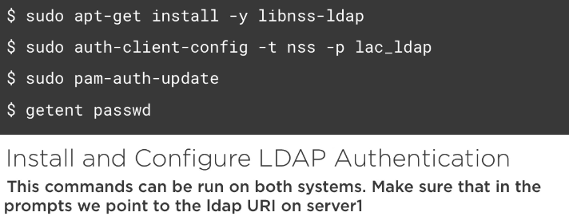

@ldap01:~$ sudo apt-get install -y libnss-ldap

LDAP server Uniform Resource Identifier: ldap://192.168.1.101
Distinguished name of the search base: dc=frozza,dc=com
LDAP version to use: 3
Make local root Database admin: <Yes>
Does the LDAP database require login? <No>
LDAP account for root: cn=admin,dc=frozza,dc=com
LDAP root account password: frozza

@ldap01:~$ sudo auth-client-config -t nss -p lac_ldap
@ldap01:~$ sudo pam-auth-update

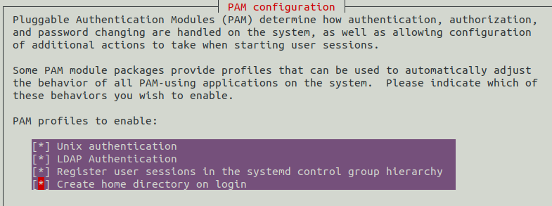

ubuntu@ldap01:~$ getent passwd (should see both local and ldap users)

(try to authenticate with a ldap user)

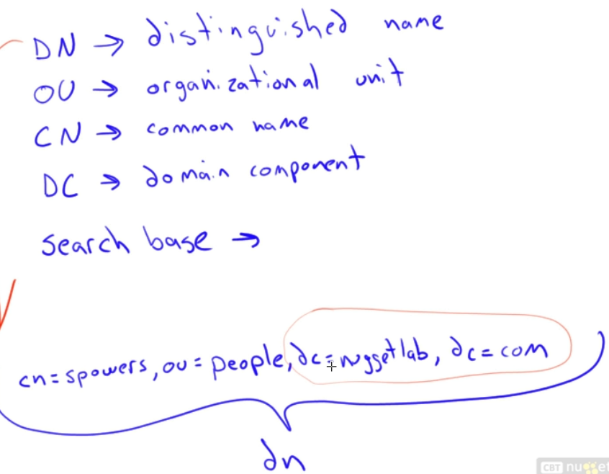

210.3 Managing PAM

1.Understanding NSS

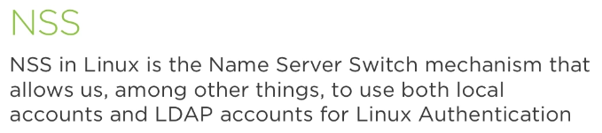

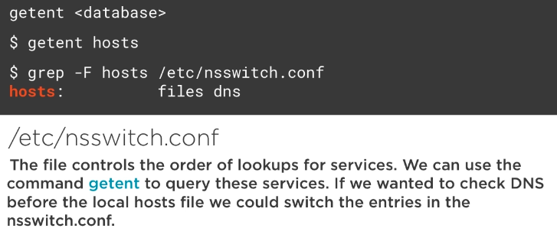

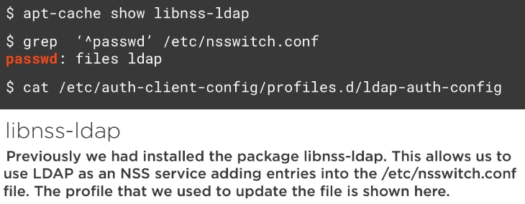

ubuntu@router1:~$ sudo apt-cache show libnss-ldap
ubuntu@router1:~$ grep passwd /etc/nsswitch.conf
ubuntu@router1:~$ sudo getent passwd

ubuntu@router1:~$ cat /etc/auth-client-config/profile.d/ldap-auth-config
#
# Clients should be able to authenticate with this profile if following
# Network Authentication in the Ubuntu Server guide. Please note that
# these settings are not suitable for sometimes disconnected (eg laptop)
# systems. The example is taken from LDAPClientAuthentication at:
# https://help.ubuntu.com/community/LDAPClientAuthentication
#
[lac_ldap]
nss_passwd=passwd: files ldap
nss_group=group: files ldap
nss_shadow=shadow: files ldap
nss_netgroup=netgroup: nis

2.A Quick Look at SSSD

Limitations of NSS: There is no ability within NSS to specify more than one LDAP Directory Tree to use for authentication. More than one LDAP server can be used for failover but they must be services the same Directory.

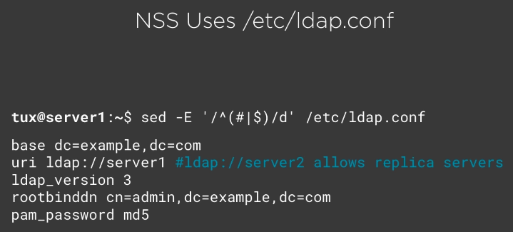

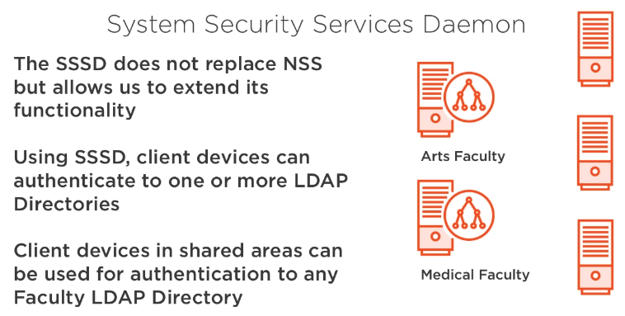

Here, Arts and Medical Faculty represent different domains inside a University.

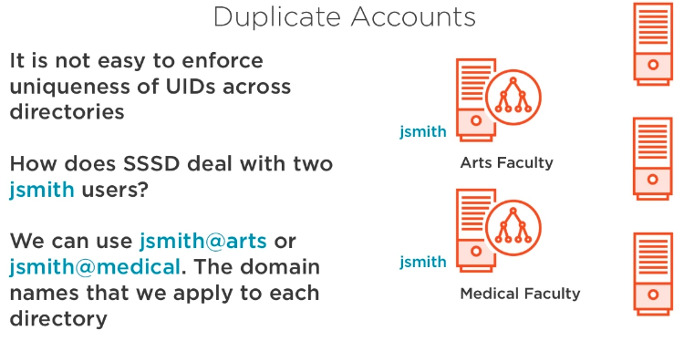

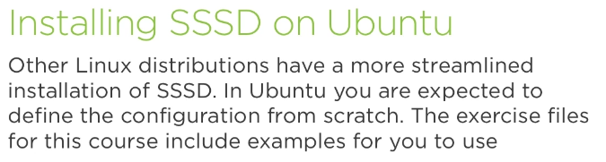

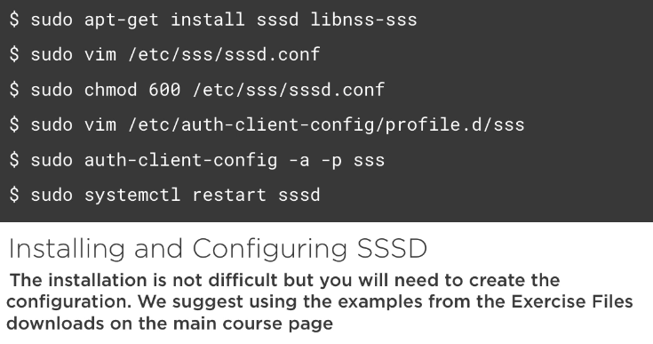

3.Configuring SSSD to Access LDAP Domains

ubuntu@ldap01:~$ sudo apt-get install -y sssd libnss-sss
ubuntu@ldap01:~$ vim /etc/sssd/sssd.conf
[sssd]
config_file_version = 2
services = nss, pam
domains = EXAMPLE

[nss]

[pam]

[domain/EXAMPLE]
id_provider = ldap
auth_provider = ldap
ldap_schema = rfc2307
ldap_uri = ldap://server1
ldap_default_bind_dn = cn=admin,dc=example,dc=com
ldap_default_authtok = Password1
ldap_default_authtok_type = password
ldap_search_base = dc=example,dc=com
ldap_user_search_base = ou=people,dc=example,dc=com
ldap_group_search_base = ou=groups,dc=example,dc=com
ldap_user_object_class = inetOrgPerson
ldap_user_gecos = cn
override_shell = /bin/bash
cache_credentials = true
enumerate = true

ubuntu@ldap01:~$ sudo chmod 600 /etc/sssd/sssd.conf

ubuntu@ldap01:~$ sudo vi /etc/auth-client-config/profile.d/sss
[sss]
nss_passwd= passwd: compat sss
nss_group= group: compat sss
nss_shadow= shadow: compat
nss_netgroup= netgroup: nis

pam_auth= auth [success=3 default=ignore] pam_unix.so nullok_secure try_first_pass
auth requisite pam_succeed_if.so uid >= 500 quiet
auth [success=1 default=ignore] pam_sss.so use_first_pass
auth requisite pam_deny.so
auth required pam_permit.so

pam_account= account required pam_unix.so
account sufficient pam_localuser.so
account sufficient pam_succeed_if.so uid < 500 quiet
account [default=bad success=ok user_unknown=ignore] pam_sss.so
account required pam_permit.so

pam_password= password sufficient pam_unix.so obscure sha512
password sufficient pam_sss.so use_authtok
password required pam_deny.so

pam_session= session required pam_mkhomedir.so skel=/etc/skel/ umask=0077
session optional pam_keyinit.so revoke
session required pam_limits.so
session [success=1 default=ignore] pam_sss.so
session required pam_unix.so

ubuntu@ldap01:~$ sudo auth-client-config -a -p sss
ubuntu@ldap01:~$ sudo pam-auth-update
Override Yes
PAM profiles to enable: All

ubuntu@ldap01:~$ getent passwd

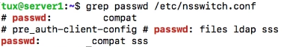

4.Understanding PAM

PAM is a central, modular authentication framework.
a. Obviates the need for separate authentication schemes. i.e. application auth.
b. Supports mumerous dynamically loaded modules and methods. i.e. SiteMinder, Apache, SSH, etc. Of course, PAM requires that application supports PAM (PAM-aware) – coded into application.
c. Exports methods of the various libraries under its auspices to calling applications.

PAM abstracts underlying authentication methods. It separates application authentication from auth mechanisms.
a. MD5, Blowfish – Encryption
b. LDAP
c. /etc/passwd and shadow
d. others, - SiteMinder
PAM Authentication Flow:

a. Application (e.g. user/password) → PAM → Underlying Authentication Source (local/LDAP/etc)

PAM does 4 thing to you. It handles 4 tyoes of managements tasks:
1. Authentication: Proving identity (username/password (credentials), biometrics, etc.)
2. Account Management: Object access check, expiracy, etc.
3. Password Management: Facilitates password Management, i.e. change, updates, etc.
4. Session Management: Before and after user connectsto service.

Example, PAM can Authenticate you successfuly but can deny access to an accout or resources due to object access rules.

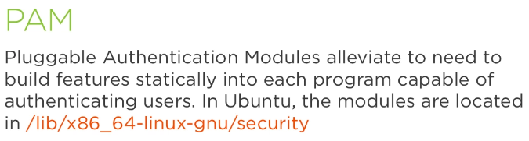

Popular PAM Modules:
a. pam_warn.so – logs to Syslog using “auth.notice” facility.level.
b. pam_deny.so – denies access without logging.
c. pam_unix*.so – provides /etc/password, /etc/shadow or LDAP lookups/authentication against. It uses /etc/security/pam_unix2.conf, which contains the global configuration directives.

d.
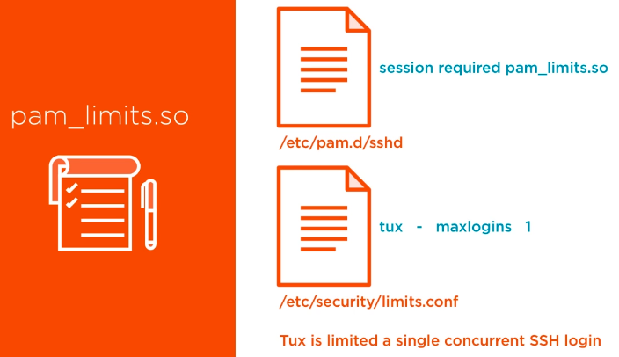

e.
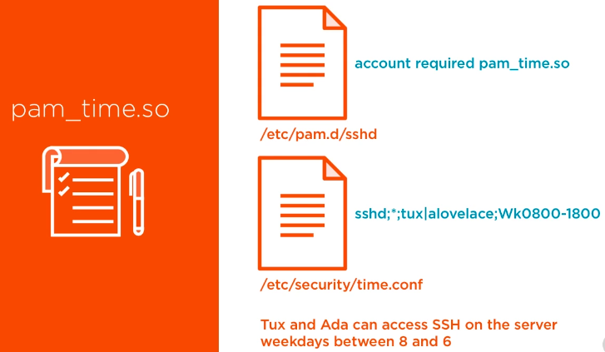

f.
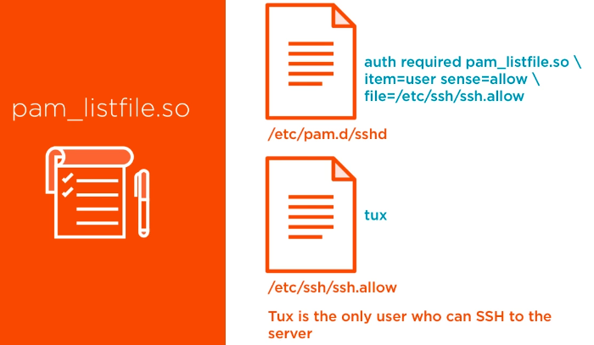

g. pam_echo: prints a message.
Ex. of a line to put in /etc/pam.d/sshd:
“session optional pam_echo.so file=/etc/pam.d/sshd_text”

h. pam_env: (un)sets environmental variables. It uses /etc/security/pam_env.conf by default.

For more information on any module: $ man <module name>

i. pam_nologin: prevents non-root access to the system.

If we grep “pam_nologin” inside pam,d, we’ll notice that few services check for the presence of /etc/nologin file, which, if present (just touch /etc/nologin) it will deny access to any user (except root).

root@frozza:/etc/pam.d# grep pam_nologin *
gdm-autologin:auth requisite pam_nologin.so
gdm-launch-environment:auth requisite pam_nologin.so
gdm-password:auth requisite pam_nologin.so
login:auth requisite pam_nologin.so
ppp:auth required pam_nologin.so

5.Working with PAM

Each application (SSH, VSFTP, Telnet, Login, etc) has its own configuration file beneath /etc/pam.d (i.e. /etc/pam.d/login).

Note: /etc/pam.d/other handles authentication for services not described by any file inside /etc/pam.d. It’s default configuration denies access/auth.

Note: Some files can be included or refenced by others vi @include directive (ex. /etc/pam.d/other).

Format of PAM files:

Each file in /etc/pam,d contais 4 tokens:

module_interface(type) control_flag module_name(and path) module_arguments

module_interface(type):
1. account
2. auth
3. password
4. session

control_flag:
1. include
2. requisite
3. required
4. sufficient

module_name(and path):
is relative to /lib/security (or /lib64) and indicates the module to be loaded.

module_arguments
argumentos to be passed tp PAM module. Generaly denoted by “name=value” and separated by whitespace. Can use brakets to wrap the value as in “[name=value 1]”.

@ldap01:~$ ls /lib/x86_64-linux-gnu/security

All .so listed are PAM plugins that can be used by programs. The configuration of these programs you find in /etc/pam.d :

@ldap01:~$ ls /etc/pam.d/

@ldap01:~$ vim /etc/pam.d/sshd
[…]
# Set up user limits from /etc/security/limits.conf.
session required pam_limits.so
[…]

… among many other plugins, sshd uses pam_limits, and it’s behaviour com be controled by limits.conf:

@ldap01:~$ sudo vim /etc/security/limits.conf
[…]
#@student - maxlogins 4
ubuntu - maxlogins 1

… try to ssh twice with ubuntu user … you shold expect to be not allowed.. only once.

Let’s another module to control sshd:

@ldap01:~$ sudo vim /etc/pam.d/sshd
# PAM configuration for the Secure Shell service

#Added by Ariel
account required pam_time.so
[…]

@ldap01:~$ sudo vim /etc/security/time.conf
# End of example file.
#
sshd;*;ubuntu;Wk0800-1700

*** NOTE: changes are dynamic. No restart needed.

Now, we can add access controll by allowing (or dennying) access to only file listed users:

@ldap01:~$ sudo vim /etc/pam.d/sshd
#Added by Ariel
account required pam_time.so
auth required pam_listfile.so item=user sense=allow file=/etc/ssh/ssh.allow
[…]

@ldap01:~$ sudo vim /etc/ssh/ssh.allow
ubuntu

Test it logging with “ubuntu” and with any other user … which sould be denied access.

======

let’s examine the crom file:

root@frozza:/etc/pam.d# cat cron
@include common-auth

# Sets the loginuid process attribute
session required pam_loginuid.so

# Read environment variables from pam_env's default files, /etc/environment
# and /etc/security/pam_env.conf.
session required pam_env.so

# In addition, read system locale information
session required pam_env.so envfile=/etc/default/locale

@include common-account
@include common-session-noninteractive

# Sets up user limits, please define limits for cron tasks
# through /etc/security/limits.conf
session required pam_limits.so

So, for example, for authentication, it will check waht’s in common-auth file:
root@frozza:/etc/pam.d# cat common-auth | grep -v ^#

auth [success=1 default=ignore] pam_unix.so nullok_secure
auth requisite pam_deny.so
auth required pam_permit.so
auth optional pam_cap.so

