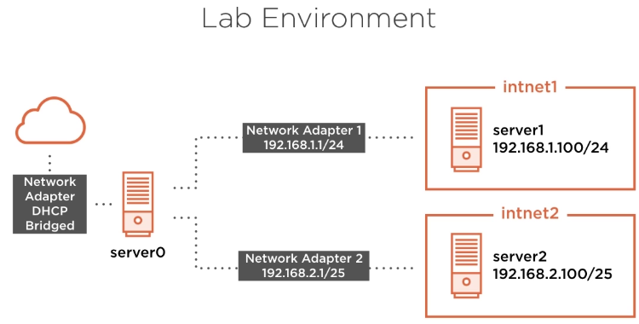

0204.Demo Lab Network Configuration Review

Server0:
Adapter0: Bridged Adapter

Set the hosts file like this (if you can’t properly configure DNS MX records):

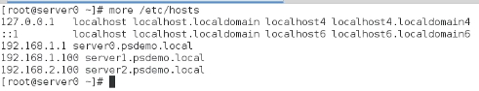

Cofigure this server to act as a gateway:

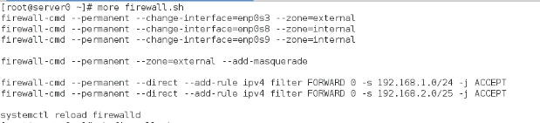
Test connectivity from one e-mail server node to another and out to internet.

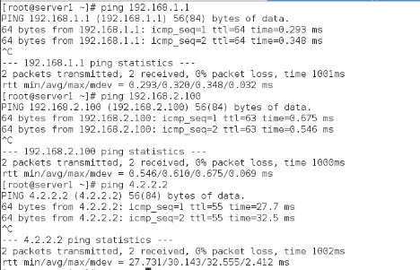

03.Understanding Email Architecture


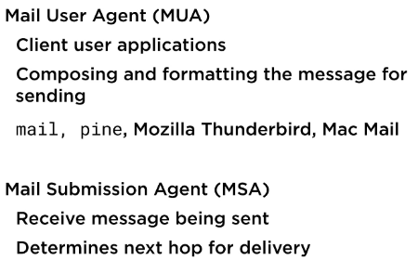

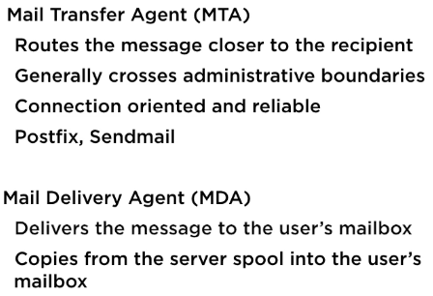

0304.Sending an Email

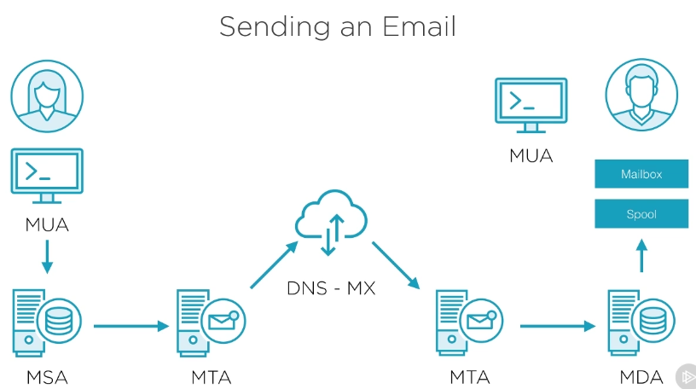

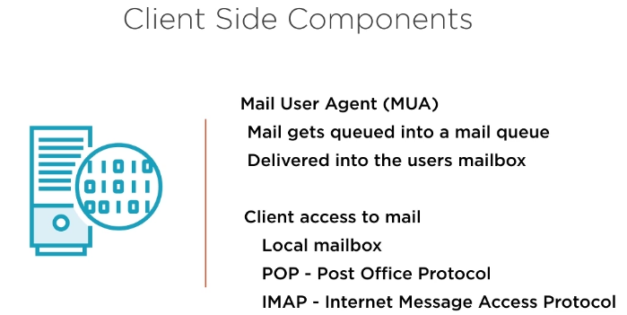

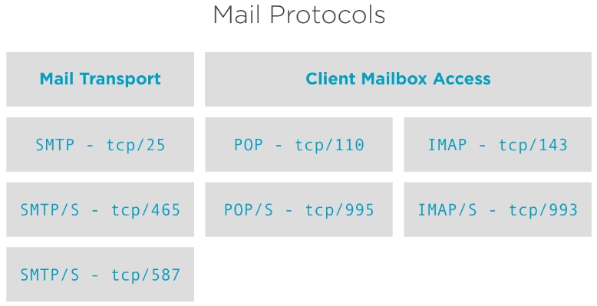

04.Implementing Email Services

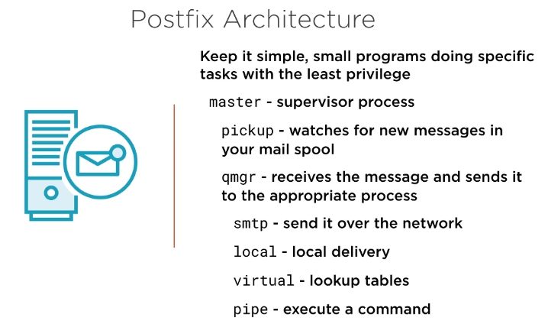

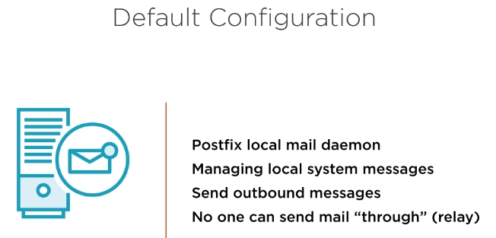

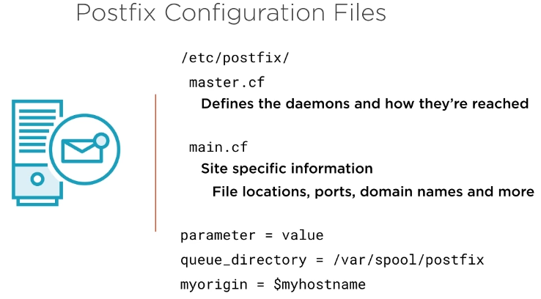

0404.Installing Postfix, Configuration Overview, and Sending Mail to a Local User

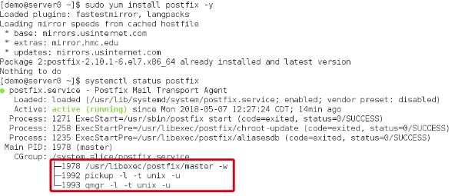
[@server0 ~]# yum mailx

[@server0 ~]# mail demo
This the text body.
.

[demo@server0 ~]$ mail (you should be able to see the message from root).

05.Configuring and Securing Email Services

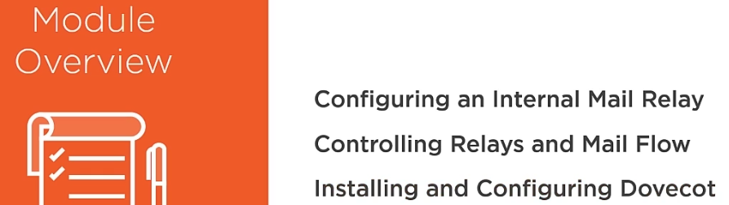

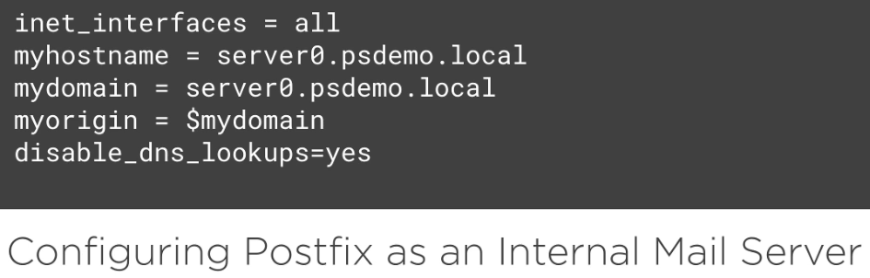

NOTE: “disable_dns_lookpups” is only relevant if you are using hosts file to resolve names and no DNS MX record is available.

0505.Controlling Mail Flow with Postfix Tables

