6.1 - Securing SMTP with TLS

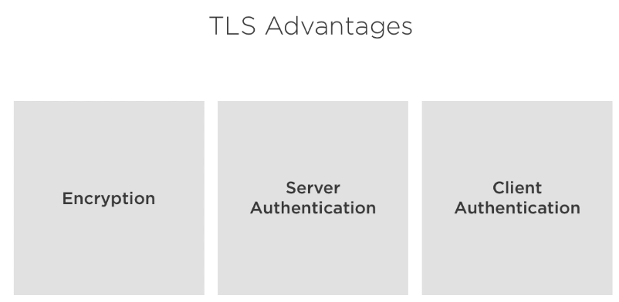

6.2 - Reading and Regenerating Default Certificates and Keys


The package ssl-cert is installed in Ubuntu along with Postfix. It contais sub-commands to create or manipulate certificates at ease.

smtp2:~$ openssl x509 -in /etc/ssl/certs/ssl-cert-snakeoil.pem -text

(will exibit the certificate and all metadata associated with it.
The “Issuer: CN=smtp2.example.com” indicates it’s self signed certificate.
The “Subject: CN=smtp2.example.com” indicates the host the certificate was issued to.)

That’s how we read the Private key:

smtp2:~$ openssl rsa -in /etc/ssl/private/ssl-cert-snakeoil.key -text

6.3 - Creating Self-signed Certificates

smtp2:~$ openssl req -x509 -nodes -newkey rsa:4096 -keyout key.pem -out cert.pem -days 365 -subj “/CN=smtp2.example.com”

To read/check it:

smtp2:~$ openssl x509 -in cert.pem

To read the private key:

smtp2:~$ openssl rsa-in key.pem

6.4 - Postfix TLS Settings
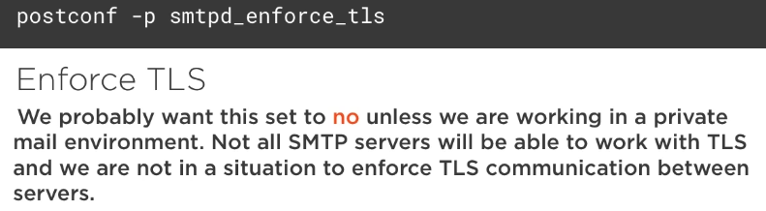

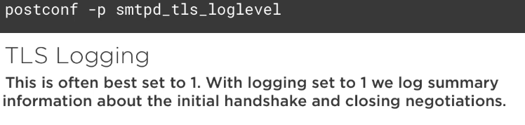

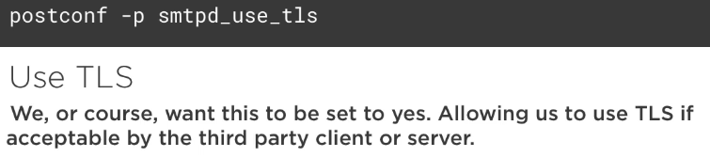

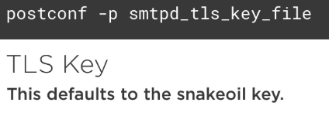

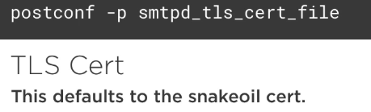

6.5 - Working with STARTTLS

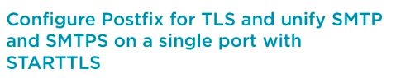

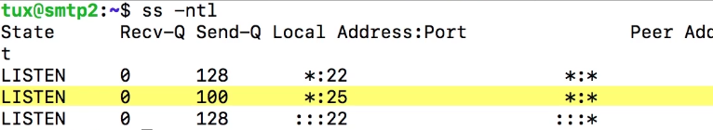
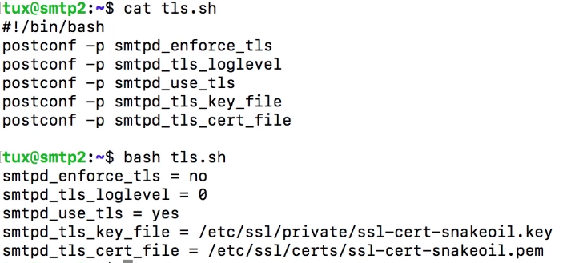

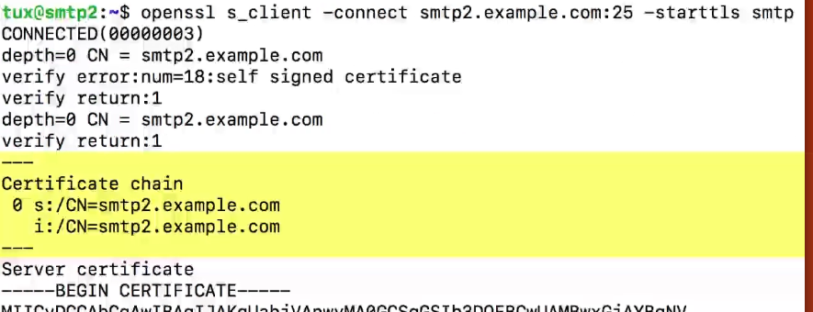
Note that we are able to use TLS (self signed) out of the box, but logging is set to zero.

Now, increase the verbosity of logs and execute the s_client again and check the logs (with tail -f for example)

6.6 - Configuring an Independent SMTPS Port

Uncomment the following block in master.cf:

smtp2:~$ sudo vi /etc/postfix/master.cf

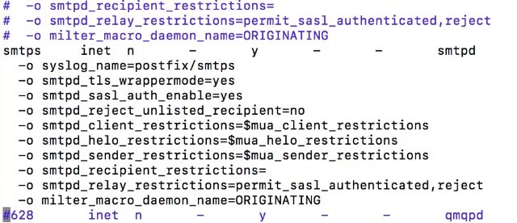

This change requires a service restart. And after that, the port 465 can be seen as openned:

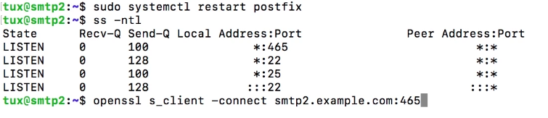
Just type “ehlo smtp2.example.com” and Postfix should return with some options:
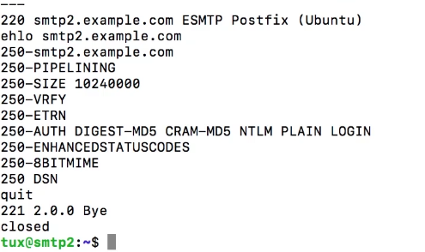

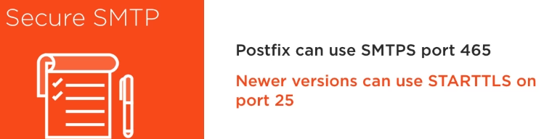

3 - Using Mutt to View Mail Remotely

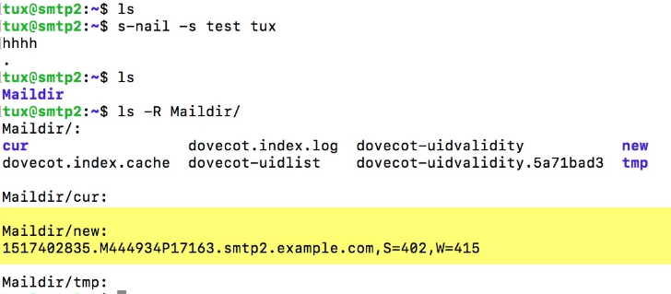
tux@smtp1:~$ sudo apt-get install mutt

tux@smtp1:~$ vi .muttrc
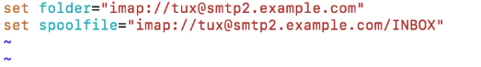

tux@smtp1:~$ mutt (you should be abl to see the test message)

