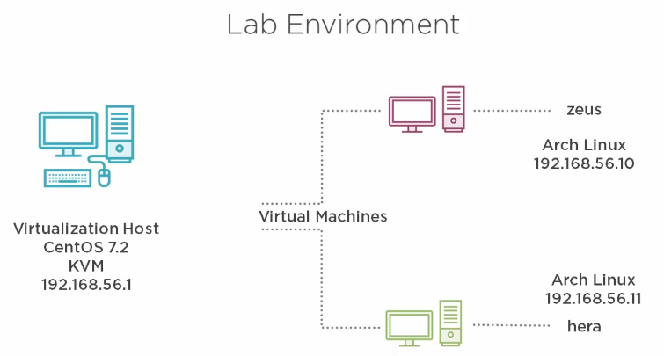

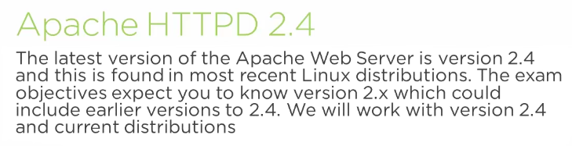

5.Installing Apache

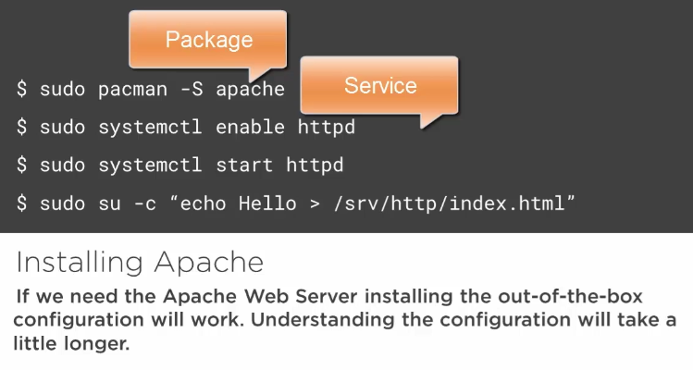
[vagrant@zeus ~]$ sudo pacman -S apache

[vagrant@zeus ~]$ sudo systemctl enable httpd
[vagrant@zeus ~]$ sudo systemctl start httpd
[vagrant@zeus ~]$ ss -ntl
[vagrant@zeus ~]$ sudo su -c "echo hello > /srv/http/index.html"

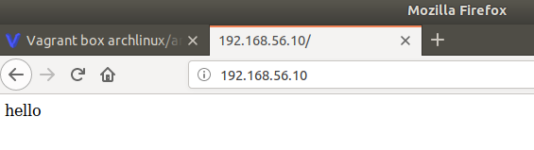
3.Apache HTTPD Minimal Configuration

1.Apache Configuration


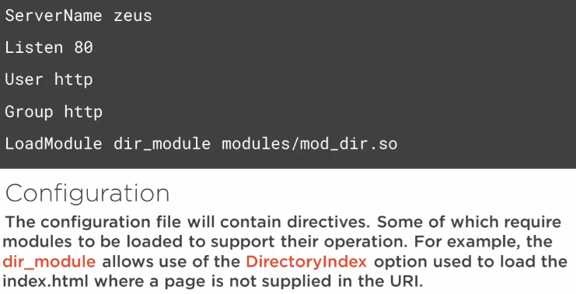
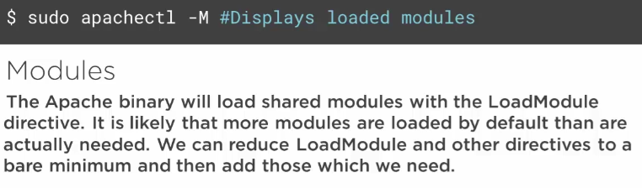

2.Creating a Minimal Configuration

[vagrant@zeus ~]$ sudo apachectl -M

[vagrant@zeus ~]$ sudo pacman -S lynx tree

[vagrant@zeus ~]$ lynx localhost (you should see the “hello” message)

[vagrant@zeus ~]$ tree /etc/httpd/
/etc/httpd/
├── conf
│ ├── extra
│ │ ├── httpd-autoindex.conf
│ │ ├── httpd-dav.conf
│ │ ├── httpd-default.conf
│ │ ├── httpd-info.conf
│ │ ├── httpd-languages.conf
│ │ ├── httpd-manual.conf
│ │ ├── httpd-mpm.conf
│ │ ├── httpd-multilang-errordoc.conf
│ │ ├── httpd-ssl.conf
│ │ ├── httpd-userdir.conf
│ │ ├── httpd-vhosts.conf
│ │ └── proxy-html.conf
│ ├── httpd.conf
│ ├── magic
│ └── mime.types
└── modules -> /usr/lib/httpd/modules

3 directories, 15 files

[vagrant@zeus conf]$ cd /etc/httpd/conf/
[vagrant@zeus conf]$ sudo mv httpd.conf httpd.conf.orig

[vagrant@zeus conf]$ sudo vi httpd.conf
ServerName zeus
ServerRoot "/etc/httpd"
DocumentRoot "/srv/http"
Listen 80
User http
Group http
DirectoryIndex "index.html"
ErrorLog "/var/log/httpd/error_log"
LogFormat "%h %u %t %s %b" common
CustomLog "/var/log/httpd/access_log common

LoadModule authz_core_module modules/mod_authz_core.so
LoadModule mime_module modules/mod_mime.so
LoadModule log_config_module modules/mod_log_config.so
LoadModule mpm_event_module modules/mod_mpm_event.so
LoadModule unixd_module modules/mod_unixd.so
LoadModule dir_module modules/mod_dir.so

<Directory />
AllowOverride none
Require all denied
</Directory>
<Directory "/srv/http">
AllowOverride none
Require all granted
</Directory>
<Files ~ "^\.ht">
Require all denied
</Files>

4.Testing the Apache Configuration

[vagrant@zeus conf]$ sudo apachectl configtest
Syntax OK
[vagrant@zeus conf]$ sudo systemctl restart httpd
[vagrant@zeus conf]$ sudo systemctl status httpd

[vagrant@zeus ~]$ lynx localhost (you should see the “hello” message)

[vagrant@zeus conf]$ sudo apachectl -M

5.Understanding Virtual Hosts



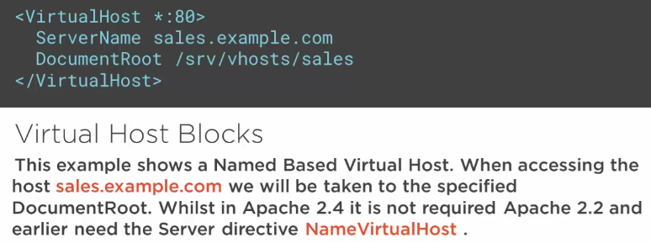

6.Creating Named Based Virtual Hosts

[vagrant@zeus ~]$ cd /etc/httpd/conf/
[vagrant@zeus conf]$ sudo vi httpd.conf

[…]
Include conf/extra/vhost-*.conf

[vagrant@zeus conf]$ cat extra/httpd-vhosts.conf
[vagrant@zeus conf]$ sudo cp extra/httpd-vhosts.conf extra/vhost-sales.com.conf

[vagrant@zeus conf]$ sudo vi extra/vhost-sales.frozza.com.conf
<VirtualHost *:80>
ServerAdmin root@sales.com
DocumentRoot "/srv/vhosts/sales"
ServerName sales
ServerAlias www.sales.com
<Directory /srv/vhosts/sales>
Require all granted
</Directory>
</VirtualHost>

[vagrant@zeus conf]$ sudo mkdir -p /srv/vhosts/sales
[vagrant@zeus conf]$ sudo echo Sales > /srv/vhosts/sales/index.html
[vagrant@zeus conf]$ sudo apachectl configtest
Syntax OK
[vagrant@zeus conf]$ sudo systemctl restart httpd
[vagrant@zeus conf]$ sudo su -
[root@zeus ~]# echo "127.0.0.1 sales.com sales" >> /etc/hosts

[root@zeus extra]# lynx sales

[root@zeus extra]# lynx localhost (you shold see the “Sales” message, and its not good as sales.com became the default site. We need to adjust this – later).

7.Creating Port Based and IP Based Virtual Hosts

[root@zeus extra]# cp vhost-sales.com.conf vhost-localhost.conf

[root@zeus extra]# vi vhost-localhost.conf
Listen 9000
<VirtualHost *:9000>
ServerAdmin root@zeus.com
DocumentRoot "/srv/vhosts/zeus"
<Directory /srv/vhosts/zeus>
Require all granted
</Directory>
</VirtualHost>

[root@zeus extra]# mkdir /srv/vhosts/zeus
[root@zeus extra]# echo zeus > /srv/vhosts/zeus/index.html

[root@zeus extra]# apachectl configtest
Syntax OK
[root@zeus extra]# systemctl restart httpd

[root@zeus extra]# lynx localhost:9000

4.Apache Access Control

1.Introduction to Apache Authorization and Authentication

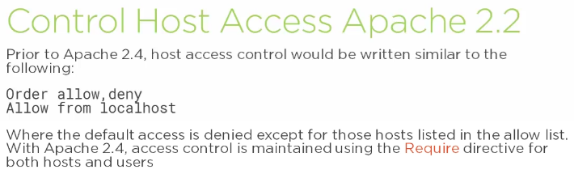


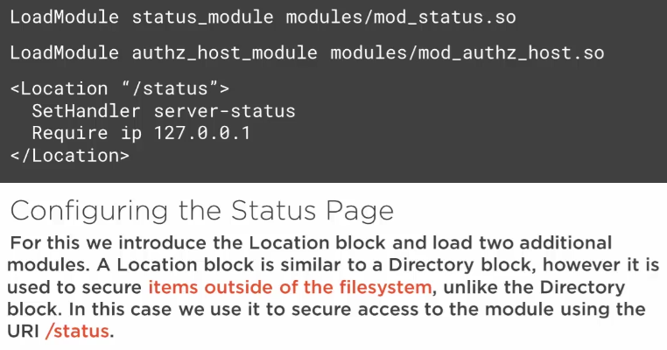
2.Displaying and Securing the Server Status Page

[root@zeus conf]# pwd
/etc/httpd/conf
[root@zeus conf]# vi httpd.conf
[…]
LoadModule authz_host_module modules/mod_authz_host.so
LoadModule status_module modules/mod_status.so
[…]

[root@zeus conf]# vi extra/vhost-localhost.conf
Listen 9000
<VirtualHost *:9000>
ServerAdmin root@zeus.com
DocumentRoot "/srv/vhosts/zeus"
<Directory /srv/vhosts/zeus>
Require all granted
</Directory>
<Location "/status">
SetHandler server-status
Require ip 127.0.0.1
Require ip 192.168.56.1
</Location>
</VirtualHost>

[root@zeus conf]# apachectl configtest
Syntax OK

[root@zeus conf]# systemctl restart httpd
[root@zeus conf]# lynx http://zeus:9000/status (should work)

[root@zeus conf]# lynx http://192.168.56.10:9000/status (should be denied)

It should work from the host as it was allowed:
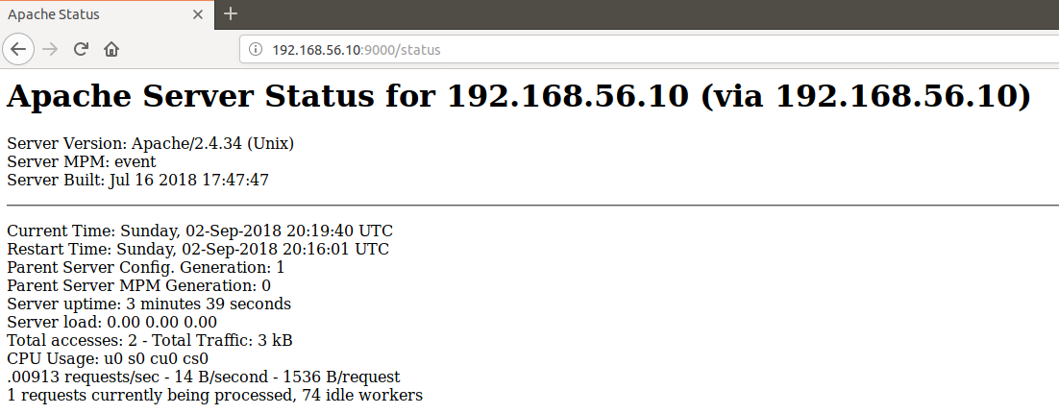

3.Understanding User Authentication

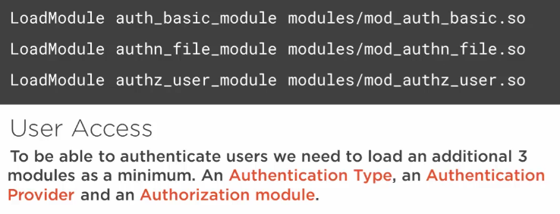

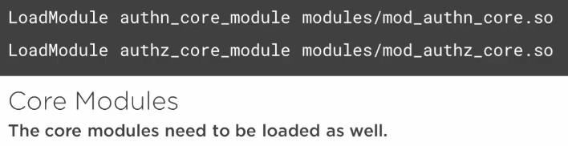

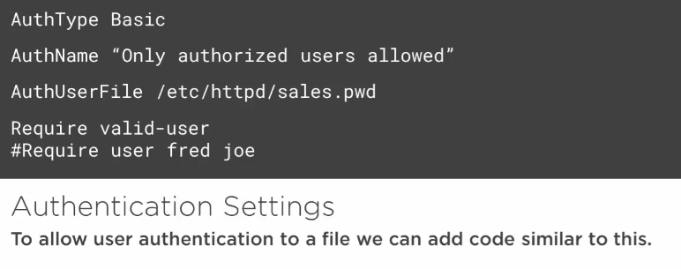
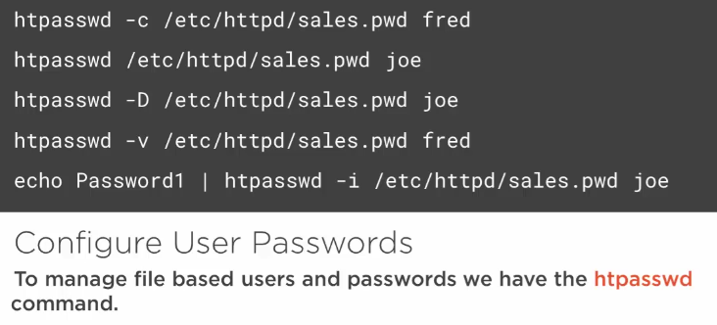

4.Additional Modules for User Authentication

