LPIC 212



Lab uses Ubuntu 16.04.
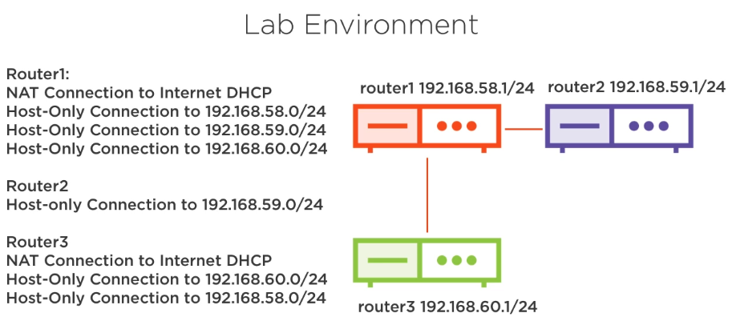
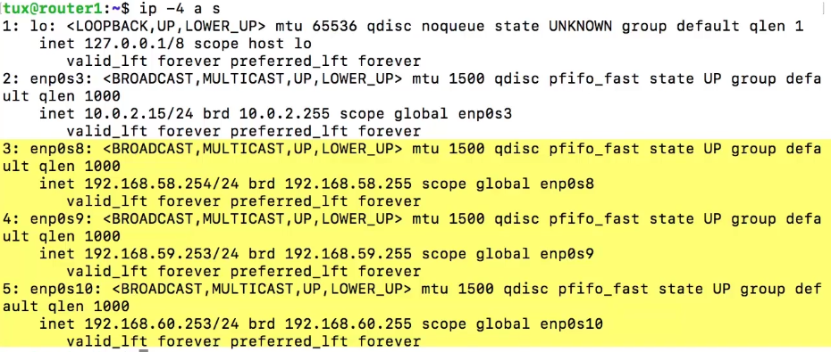
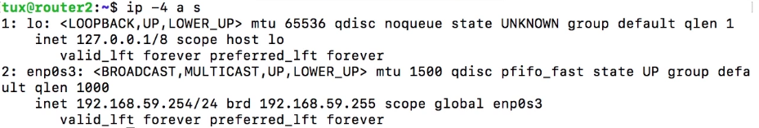
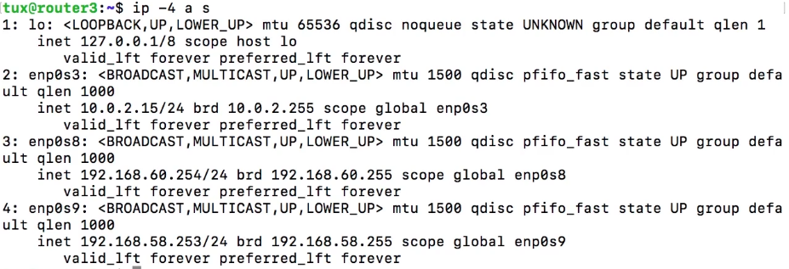
08 - Introduction to Routing

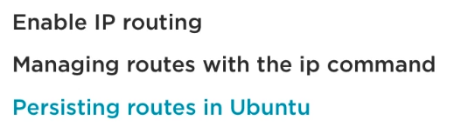

09 - Routing Tables

@router3:~$ ip r s (= ip route show)
default via 10.0.2.2 dev enp0s3
10.0.2.0/24 dev enp0s3 proto kernel scope link src 10.0.2.15
192.168.58.0/24 dev enp0s8 proto kernel scope link src 192.168.58.253
192.168.60.0/24 dev enp0s9 proto kernel scope link src 192.168.60.254

@router3:~$ sudo ip route add 192.168.59.0/24 via 192.168.60.253
@router3:~$ ip r s
default via 10.0.2.2 dev enp0s3
10.0.2.0/24 dev enp0s3 proto kernel scope link src 10.0.2.15
192.168.58.0/24 dev enp0s8 proto kernel scope link src 192.168.58.253
192.168.59.0/24 via 192.168.60.253 dev enp0s9
192.168.60.0/24 dev enp0s9 proto kernel scope link src 192.168.60.254

10 - Enabling IP Forwarding and the procfs

@router1:~$ sudo cat /proc/sys/net/ipv4/ip_forward
0
@router1:~$ sudo cat /proc/sys/net/ipv6/conf/all/forwarding
0
@router1:~$ sudo sysctl -w net.ipv4.ip_forward=1 (not permanent)

@router1:~$ sudo vim /etc/sysctl.conf
# Uncomment the next line to enable packet forwarding for IPv4
net.ipv4.ip_forward=1

@router1:~$ sudo sysctl -p

@router2:~$ ping router3 (should work now, as TCP is being routed trough router1)

11 - Persisting Routing Tables (Ubuntu)

@router3:~$ sudo vim /etc/network/interfaces
[…]
auto enp0s9
iface enp0s9 inet static
address 192.168.60.254
netmask 255.255.255.0
up ip route replace 192.168.59.0/24 via 192.168.60.253

@router3:~$ sudo systemctl restart networking

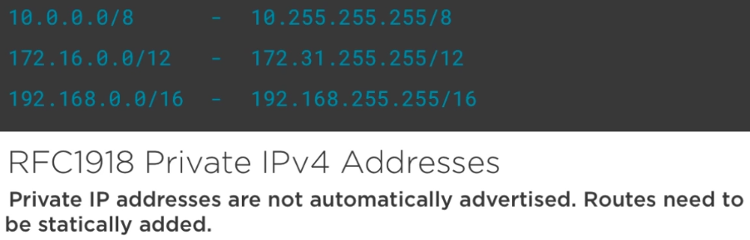

13 - Firewalls in Linux

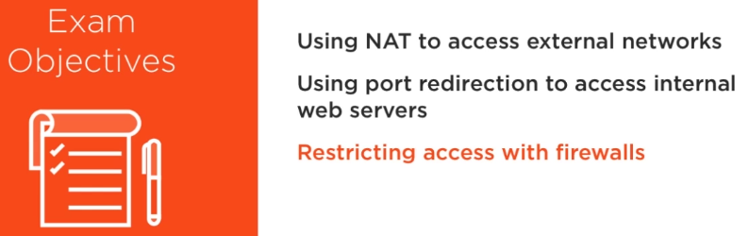

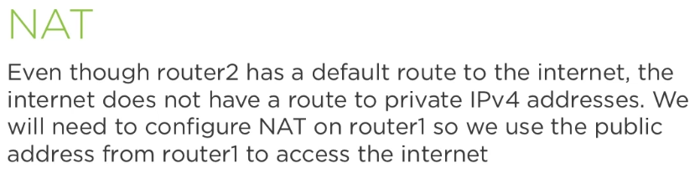



@router2:~$ ip r
default via 192.168.59.253 dev enp0s8 onlink
192.168.59.0/24 dev enp0s8 proto kernel scope link src 192.168.59.254

@router2:~$ cat /etc/network/interfaces
# This file describes the network interfaces available on your system
# and how to activate them. For more information, see interfaces(5).

# The loopback network interface
auto lo
iface lo inet loopback

# Source interfaces
# Please check /etc/network/interfaces.d before changing this file
# as interfaces may have been defined in /etc/network/interfaces.d
# See LP: #1262951
source /etc/network/interfaces.d/*.cfg
#VAGRANT-BEGIN
# The contents below are automatically generated by Vagrant. Do not modify.
auto enp0s8
iface enp0s8 inet static
address 192.168.59.254
netmask 255.255.255.0
gateway 192.168.59.253
#VAGRANT-END

@router2:~$ ping 8.8.8.8 (should fail)
@router1:~$ sudo iptables -t nat -A POSTROUTING -o enp0s3 -j MASQUERADE

@router2:~$ ping 192.168.60.254
PING 192.168.60.254 (192.168.60.254) 56(84) bytes of data.
64 bytes from 192.168.60.254: icmp_seq=1 ttl=63 time=1.95 ms
64 bytes from 192.168.60.254: icmp_seq=2 ttl=63 time=1.68 ms

@router2:~$ ping 8.8.8.8
PING 8.8.8.8 (8.8.8.8) 56(84) bytes of data.
64 bytes from 8.8.8.8: icmp_seq=1 ttl=61 time=39.4 ms

15 - Port Forwarding in Linux

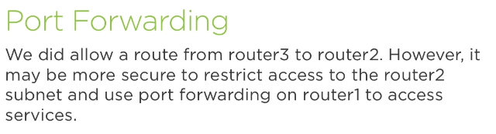



@router2:~$ sudo apt-get install -y nginx
@router2:~$ ss -lt (should listen at 80)

Install a light weight browser to check comunication with router2 on port 80:

@router3:~$ sudo apt-get install w3m
@router3:~$ w3m 192.168.59.254 (and you should see NGINX’ welcome page)
@router3:~$ sudo ip route del 192.168.59.0/24 (it will block access to router2’ network)

@router1:~# iptables -t nat -A PREROUTING -i enp0s10 -p tcp --dport 80 -j DNAT --to 192.168.59.254:80

@router3:~$ w3m 192.168.60.253 (and you should see NGINX’ welcome page again)

16 - Listing Firewall Rules

@router1:~# sudo iptables -t filter -L (-t filter is the default, so, it’s equal to “iptables -L”)
@router1:~# sudo iptables -t nat -L
@router1:~# sudo iptables -t nat -nvL (use interface names and verbose)

17 - Building Firewall Rules (protecting router2)

@router2:~$ sudo iptables -L (should be empty by now)
@router2:~$ sudo iptables -A INPUT -p tcp --dport 80 -j ACCEPT
@router2:~$ sudo iptables -A INPUT -p tcp --dport 22 -j ACCEPT
@router2:~$ sudo iptables -L (should show to rules)

Better than changing the default ACCEPT policy to DROP for the INPUT chain, is to explicitly deny all other ports:

@router2:~$ sudo iptables -I INPUT 1 -m state --state ESTABLISHED,RELATED -j ACCEPT (allow connections on dinamic (usualy high ports) ports initiated localy)

@router2:~$ sudo iptables -I INPUT 1 -i lo -j ACCEPT

@router2:~$ sudo iptables -A INPUT -j DROP
@router2:~$ sudo iptables -vL

@router3:~$ w3m 192.168.60.253 (and you should see NGINX’ welcome page)
18 - Persisting Firewall Rules

@router2:~$ sudo iptables-save > fw_rules
@router2:~$ sudo iptables -F
@router2:~$ sudo iptables -L
@router2:~$ sudo iptables-restore < fw_rules
@router2:~$ sudo iptables -L

Generaly, you can create a method to restore the rules each time the server goes on reboot. On Ubuntu, there’s a tool that does that:

@router2:~$ sudo apt-get install iptables-persistent
@router2:~$ cat /etc/iptables/rules.v4

20 - What Is Fail2ban

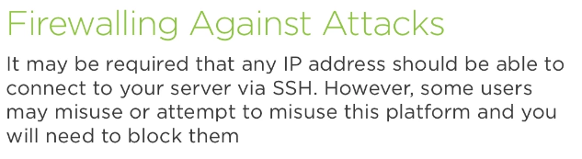



21 - Listing Failed SSH Logins



@router2:~$ sudo grep sshd /var/log/auth.log

22 - Installing Fail2ban and Creating Jails

@router2:~$ sudo apt-get install fail2ban
@router2:~$ cd /etc/fail2ban/ && ls
@router2:/etc/fail2ban$ sudo vim jail.local
[sshd]
enable = true
port = ssh
filter = sshd
logpath = /var/log/auth.log
maxretry = 3
findtime = 300
bandtime = 86400 #if user tries 3 times in 300s, he'll be locked for a whole day.
ignore = 172.0.0.1 #never block this IP

@router2:/etc/fail2ban$ sudo systemctl restart fail2ban

@router3:~$ ssh root@192.168.59.254
root@192.168.59.254's password: <wrong password>
Permission denied, please try again.
root@192.168.59.254's password: <wrong password>
Permission denied, please try again.
root@192.168.59.254's password: <wrong password>
Connection to 192.168.59.254 closed by remote host.
Connection to 192.168.59.254 closed.
@router3:~$ ssh root@192.168.59.254
ssh: connect to host 192.168.59.254 port 22: Connection refused

@router2:/etc/fail2ban$ sudo iptables -L
Chain INPUT (policy ACCEPT)
target prot opt source destination
f2b-sshd tcp -- anywhere anywhere multiport dports ssh

Chain FORWARD (policy ACCEPT)
target prot opt source destination

Chain OUTPUT (policy ACCEPT)
target prot opt source destination

Chain f2b-sshd (1 references)
target prot opt source destination
REJECT all -- 192.168.60.254 anywhere reject-with icmp-port-unreachable

23 - Working with the Fail2ban Client

@router2:~$ sudo fail2ban-client status
@router2:~$ sudo fail2ban-client status sshd
@router2:~$ sudo fail2ban-client set sshd unbanip 192.168.60.254

@router3:~$ ssh root@192.168.59.254
root@192.168.59.254's password: (should work this time)

25 - OpenSSH Servers and Clients



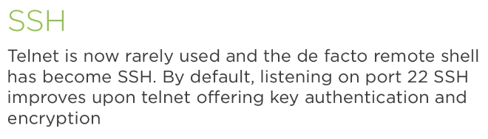

26 - SSH Server Configuration Files



@router1:~$ ssh ubuntu@router2

@router1:~$ cd .ssh/
@router1:~/.ssh$ vim config
# Custom SSH client configuration file
Host * # it apllies to all hosts I connect to
ServerAliveInterval 300
ServerAliveCountMax 3
Host r2 # alias definition for specific host
Hostname 192.168.59.254
User ubuntu

@router1:~/.ssh$ ssh r2
ubuntu@192.168.59.254's password:

@router1:~/.ssh$ cd /etc/ssh
@router1:/etc/ssh$ ls *config
ssh_config → central/global client configuration file
sshd_config → server configuration file

27 - Authenticating Servers


@router1:~$ grep StrictHostKeyChecking /etc/ssh/ssh_config
# StrictHostKeyChecking ask

@router1:~$ vim .ssh/config
Host *
ServerAliveInterval 300
ServerAliveCountMax 3
Host r2
Hostname 192.168.59.254
User ubuntu
StrictHostKeyChecking no

@router1:~$ rm .ssh/known_hosts
@router1:~$ ssh r2
Warning: Permanently added '192.168.59.254' (ECDSA) to the list of known hosts.
ubuntu@192.168.59.254's password:

@router1:~$ rm .ssh/known_hosts
@router1:~$ ssh -o StrictHostKeyChecking=yes r2
No ECDSA host key is known for 192.168.59.254 and you have requested strict checking.
Host key verification failed.

This way you can set a “known_hosts” globaly available to all users:
@router1:~$ ssh-keyscan 192.168.59.254 | sudo tee /etc/ssh/ssh_known_hosts

Hierarchy of Client Configuration Options:
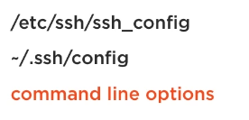

28 - Restricting Root and User Access

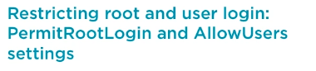

@router2:~$ sudo passwd root
@router2:~$ grep -F /etc/ssh/sshd_config
PermitRootLogin prohibit-password

Change it to “yes” to permit to login as root (it’s insecure). Change to “no” and it will be denied to login as root at all.

The “AllowUsers vagrant bob” will allow only listed users to log in.

Need to restart the sshd server every time a change is made to that file.

29 - Authenticating Clients


@router2:~$ sudo grep PubkeyAuth /etc/ssh/sshd_config
PubkeyAuthentication yes

@router1:~$ ssh-keygen -t rsa
Generating public/private rsa key pair.
Enter file in which to save the key (/home/ubuntu/.ssh/id_rsa):
Enter passphrase (empty for no passphrase): passphrase
Enter same passphrase again: passphrase
Your identification has been saved in /home/ubuntu/.ssh/id_rsa.
Your public key has been saved in /home/ubuntu/.ssh/id_rsa.pub.

@router1:~$ ssh-copy-id -i .ssh/id_rsa.pub ubuntu@192.168.59.254 (router2)

@router1:~$ ssh-agent bash
@router1:~$ ssh-add
Enter passphrase for /home/ubuntu/.ssh/id_rsa:
Identity added: /home/ubuntu/.ssh/id_rsa (/home/ubuntu/.ssh/id_rsa)
@router1:~$ ssh r2

@router2:~$ logout
Connection to 192.168.59.254 closed.

31 - Linux FTP Servers



** discuss active and passive FTP

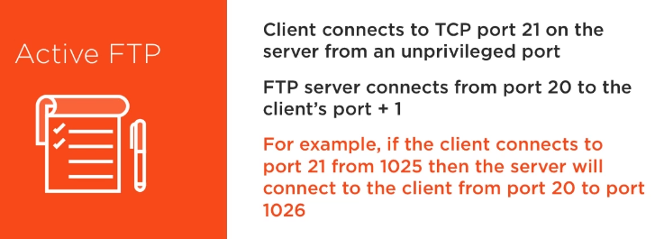
Active FTP, the server initiates the DATA connection.

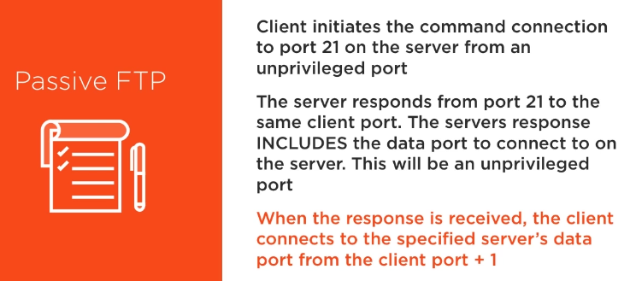
Passive FTP is often used by web servers.

32 - Firewalling FTP Servers

@router2:~$ sudo modprobe ip_conntrack_ftp

We use positions 6, 7 and 8 so the rules are placed above the final DROP rule:

@router2:~$ sudo iptables -I INPUT 6 -p tcp -m tcp --dport 21 -m conntrack --ctstate ESTABLISHED,NEW -j ACCEPT

@router2:~$ sudo iptables -I INPUT 7 -p tcp -m tcp --dport 20 -m conntrack --ctstate ESTABLISHED,RELATED -j ACCEPT

@router2:~$ sudo iptables -I INPUT 8 -p tcp -m tcp --dport 1024: --sport 1024: -m conntrack --ctstate ESTABLISHED -j ACCEPT

33 - Installing and Configuring Pure-FTPD Server

@router2:~$ ss -4 state listening
Netid Recv-Q Send-Q Local Address:Port Peer Address:Port
tcp 0 128 *:http *:*
tcp 0 128 *:ssh *:*

@router2:~$ ss -4 state established
Netid Recv-Q Send-Q Local Address:Port Peer Address:Port
tcp 0 0 192.168.59.254:ssh 192.168.59.1:55962

@router2:~$ sudo apt-get install -y pure-ftpd
@router2:~$ ss -4 state listening
Netid Recv-Q Send-Q Local Address:Port Peer Address:Port
tcp 0 128 *:http *:*
tcp 0 9 *:ftp *:*
tcp 0 128 *:ssh *:*

@router2:~$ cd /etc/pure-ftpd/conf/
@router2:/etc/pure-ftpd/conf$ ls
AltLog FSCharset MinUID NoAnonymous PAMAuthentication PureDB TLSCipherSuite UnixAuthentication
@router2:/etc/pure-ftpd/conf$ cat NoAnonymous
yes
@router2:/etc/pure-ftpd/conf$ sudo vim IPV4Only
yes

@router2:/etc/pure-ftpd/conf$ sudo systemctl restart pure-ftpd
@router2:~$ ss -ntl (note Ipv6 is no longer listening)

@router1:~$ ftp 192.168.59.254

34 - Installing and Configuring VSFTPD

@router1:~$ sudo apt-get install vsftpd

@router1:~$ ss -ntl

@router1:~$ sudo vim /etc/vsftpd.conf
listen=YES (as we run standalone)
listen_ipv6=NO
anonymous_enable=YES (if you wish)

@router1:~$ grep ftp /etc/passwd
@router1:~$ sudo touch /srv/ftp/file1
@router1:~$ sudo systemctl restart vsftpd

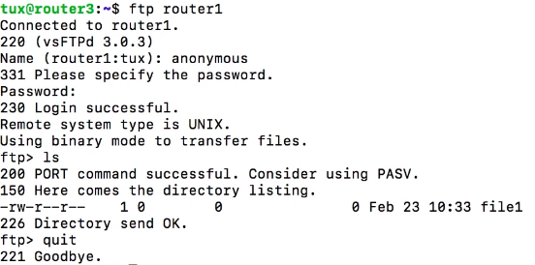

36 - Why Monitor Your System



37 - Using the Port Scanner Nmap

@router3:~$ sudo apt-get install nmap
@router3:~$ nmap scanme.nmap.org

@router3:~$ nmap -A scanme.nmap.org
(‘-A’ enables aggressive options: OS detection (-O), version scanning (-sV), script scanning (-sC) and traceroute (--traceroute))

@router3:~$ nmap 192.168.60.0/24
@router3:~$ nmap -A 192.168.60.253

38 - Vulnerability Scanning with OpenVAS



Assess known vulnerabilities on your systems with OpenVAS.

@router3:~$ sudo add-apt-repository ppa:mrazavi/openvas

@router3:~$ sudo apt-get update
@router3:~$ sudo apt-get install openvas

YES to connect to redis base.

@router3:~$ sudo apt-get install sqlite3
@router3:~$ sudo openvas-nvt-sync
*@router3:~$ sudo openvas-scapdata-sync
*@router3:~$ sudo openvas-certdata-sync

*@router3:~$ sudo service openvas-scanner restart
*@router3:~$ sudo service openvas-manager restart
*@router3:~$ sudo openvasmd --rebuild --progress

* need to be run on a regular basis to get updates from internet.

Login into https://192.168.60.254 with "admin" as username and password.
Perform scan to 127.0.0.1

It might take 1 hour or more.

39 - Snort Intruder Detection System



@router3:~$ sudo apt-get install snort

Interface(s) which Snort should listen on: enp0s3 (usualy is the interface connected to Internet)
Address range for the local network: 192.168.58.0/24, 192.168.59.0/24, 192.168.60.0/24

@router3:~$ snort -V

All Snort rules are in /etc/snort/rules/

@router3:~$ less /etc/snort/rules/icmp.rules
@router3:~$ sudo vi /etc/snort/rules/local.rules
alert icmp any any -> $HOME_NET any (msg: 'Ping'; sid:1000001; rev:1;)

@router3:~$ sudo snort -A console -c /etc/snort/snort.conf -i enp0s8

@router1:~$ ping router3

At router3 terminal, you should be able no see all trafic being logged.

41 - Creating Virtual Private Networks







42 - Installing OpenVPN


@router1:~$ sudo apt-get install openvpn
@router1:~$ sudo openvpn --genkey --secret /etc/openvpn/secret.key

@router3:~$ sudo apt-get install openvpn

@router1:~$ sudo scp /etc/openvpn/secret.key ubuntu@192.168.59.254:

@router3:~$ sudo mv secret.key /etc/openvpn/secret.key
@router3:~$ sudo chown root.root /etc/openvpn/secret.key
@router3:~$ sudo chmod 600 /etc/openvpn/secret.key

43 - Creating VPN Connections

Router1 is the entry point of our network. “home” users will connect to it via VPN.

@router1:~$ sudo vim /etc/openvpn/server.conf
dev tun (tun is tunel devices, alternativaly can use tap, which is a layer 2 device, that works with DHCP)
ifconfig 192.168.1.1 10.0.1.1 (server has ip 192.168.1.1 and client is 10.0.1.1 )
keepalive 10 60
ping-timer-rem
persist-tun
persist-key
secret /etc/openvpn/secret.key

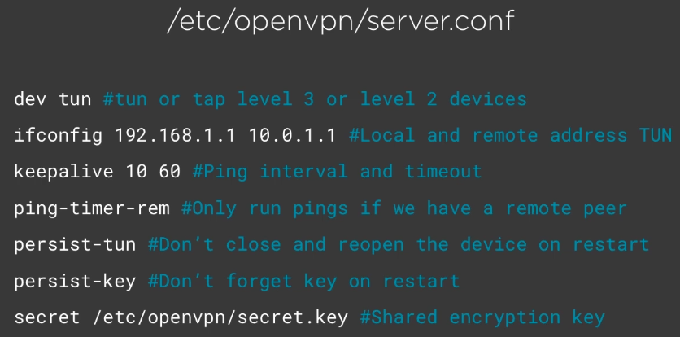

@router1:~$ sudo openvpn /etc/openvpn/server.conf

@router1:~$ ip a s tun0
6: tun0: <POINTOPOINT,MULTICAST,NOARP,UP,LOWER_UP> mtu 1500 qdisc pfifo_fast state UNKNOWN group default qlen 100
link/none
inet 192.168.1.1 peer 10.0.1.1/32 scope global tun0
valid_lft forever preferred_lft forever

@router3:~$ sudo vim /etc/openvpn/client.conf
remote 192.168.58.254 (adress of the remote server to connect – router1 in this case)
dev tun
ifconfig 10.0.1.1 192.168.1.1
persist-tun
persist-key
secret /etc/openvpn/secret.key

@router3:~$ sudo openvpn /etc/openvpn/client.conf

@router3:~$ ping 192.168.1.1 (should be able to ping)

Hint:


