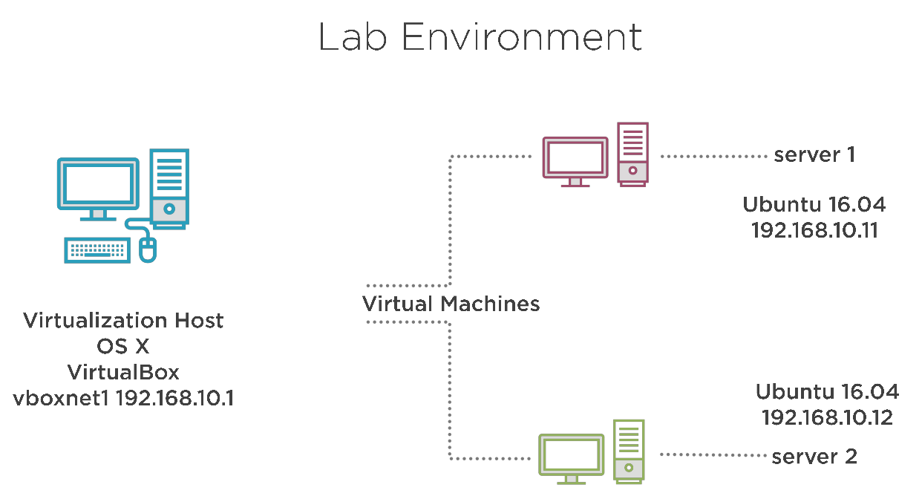
ISC DHCP

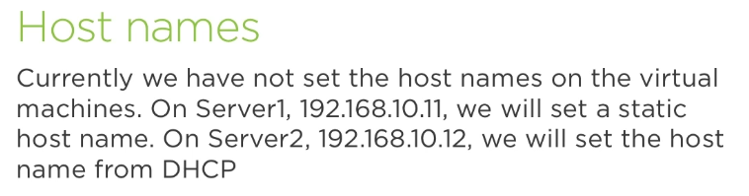

we’ll work with DNS in two different ways: 1) with DNSmasq as DHCP server to configure the hostname of server2. 2) Use ISC DHCP. A dedicated tool to do DHCP.

1) Installing and Configuring DNSMasq as a DHCP Server

@server1 sudo apt-get install dnsmasq

We only want work with the hostonly interface, so, first step is to configure dnsmasq to listen only on that hostonly interface:

ubuntu@dhcp:~$ sudo rm /etc/dnsmasq.conf
ubuntu@dhcp:~$ id -4 a s

ubuntu@dhcp:~$ sudo vi /etc/dnsmasq.conf
interface=enp0s8
dhcp-range=192.168.1.90,192.168.1.99,12h
dhcp-host=08:00:27:a1:d3:3d,server2.frozza.com,192.168.1.109,24h

ubuntu@dhcp:~$ sudo systemctl restart dnsmasq

ubuntu@dhcp:~$ ss -nul (should now also show port 67 as LISTEN on UDP)

Working on client side:

ubuntu@client01:~$ cat /etc/hostname
client01
ubuntu@client01:~$ sudo hostnamectl set-hostname ""
ubuntu@client01:~$ cat /etc/hostname
cat: /etc/hostname: No such file or directory

ubuntu@client01:~$ hostname
localhost

ubuntu@client01:~$ sudo dhclient -i enp0s8
RTNETLINK answers: File exists
ubuntu@client01:~$ hostname
server2

2) Installing and Configuring the ISC DHCP Server

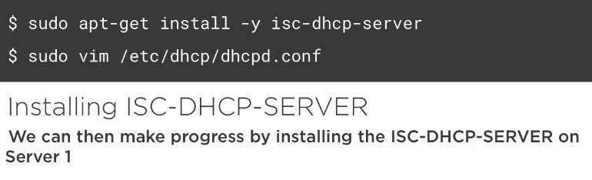

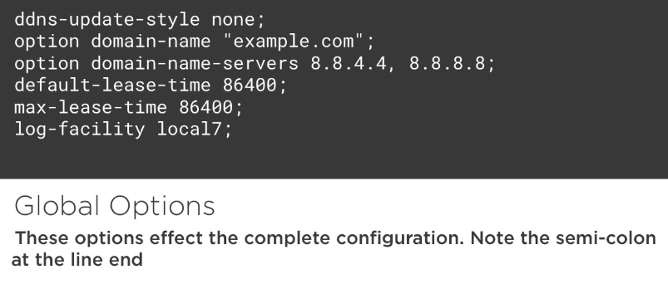

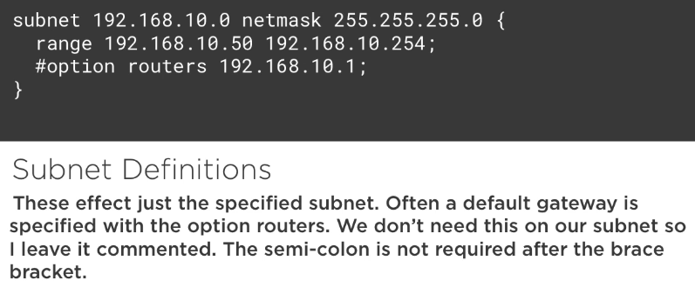

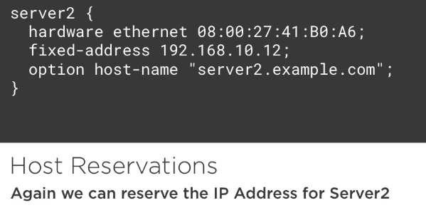

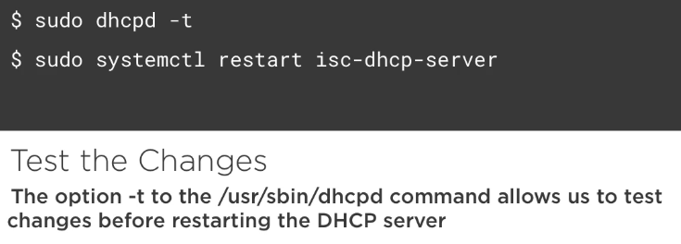

dhcp ~$ sudo systemctl disable dnsmasq
dhcp ~$ sudo systemctl stop dnsmasq
dhcp ~$ sudo apt-get install isc-dhcp-server
dhcp ~$ sudo systemctl status isc-dhcp-server

dhcp ~$ sudo vi /etc/default/isc-dhcp-server
[…]
INTERFACES="enp0s8"
[…]

dhcp ~$ sudo vi /etc/dhcp/dhcpd.conf
ddns-update-style none;
option domain-name "frozza.com";
option domain-name-servers 8.8.8.8, 8.8.4.4;
default-lease-time 86400;
max-lease-time 86400;
log-facility local7;
subnet 192.168.1.0 netmask 255.255.255.0 {
range 192.168.1.90 192.168.1.99;
}
host server2 {
hardware ethernet 08:00:27:a1:d3:3d;
fixed-address 192.168.1.99;
option host-name "server2-new.frozza.com";
}

dhcp:~$ sudo systemctl restart isc-dhcp-server
dhcp:~$ sudo systemctl status isc-dhcp-server

server2 ~$ hostname
server2 ~$ sudo ip a s enp0s8
server2 ~$ sudo hostnamectl set-hostname ""
server2 ~$ sudo dhclient -i enp0s8
server2 ~$ hostname
server2 ~$ sudo ip a s enp0s8

dhcp:~$ ping 192.168.1.99
dhcp:~$ arp

Undestanding DHCP Logs and Ipv6

Read logs files related to DHCP
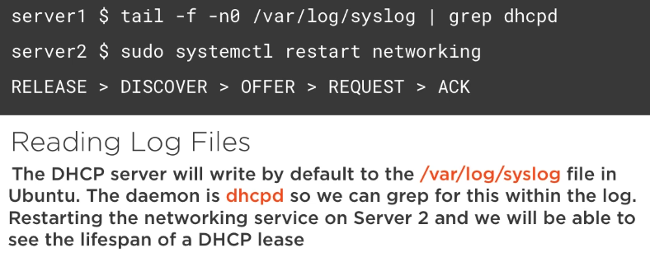

Use journalctl to read DHCP logs

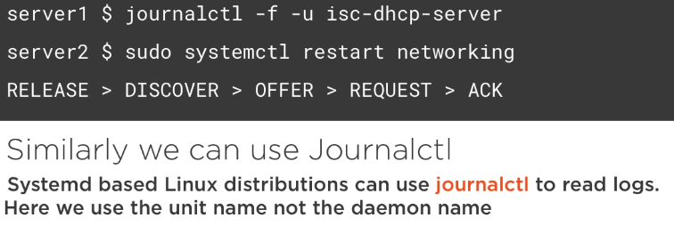

View server and client leases

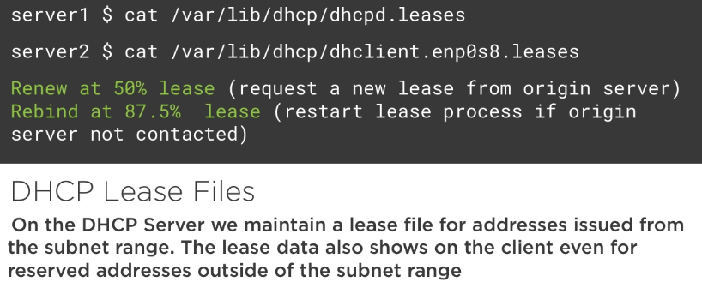

Understanding Ipv6 Address ranges

TODO

Configure static Ipv6 Addresses
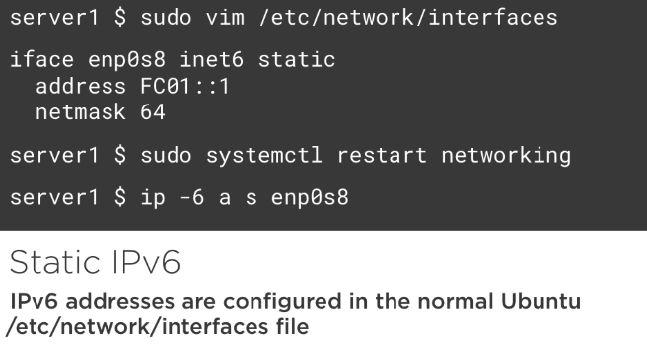

Use radvd to alloe for Ipv6 autoconfiguration

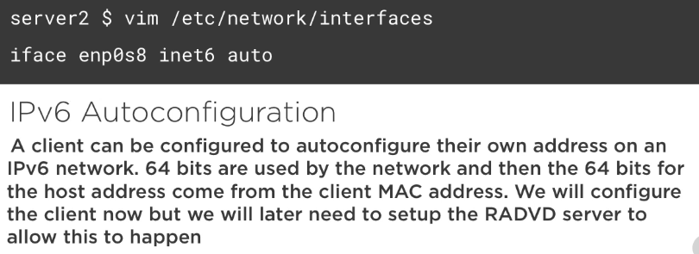

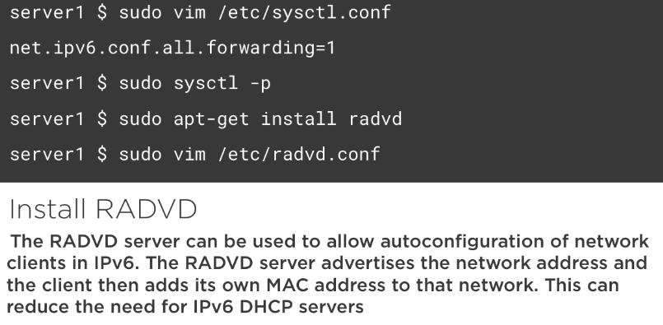

server1 $ sudo cp usrshare/doc/radvd/examples/simple-radvd.conf /etc/radvd.conf

