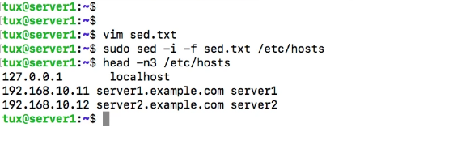

Same on clients

make sure NTP is working on both servers

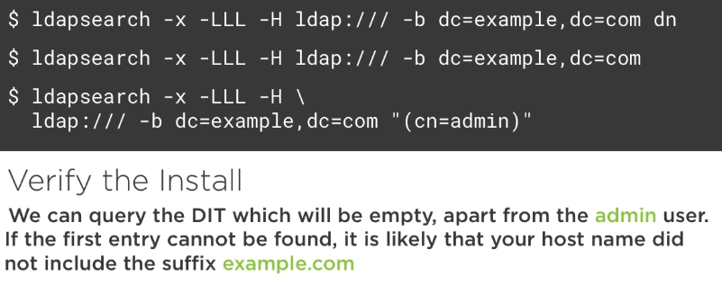

1.Authenticating Using openLDAP

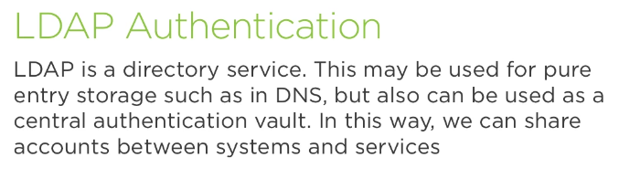

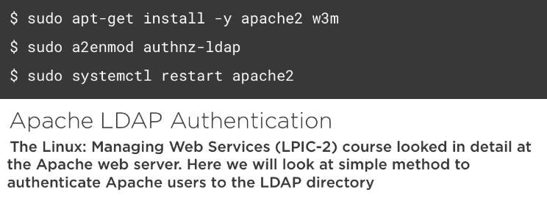

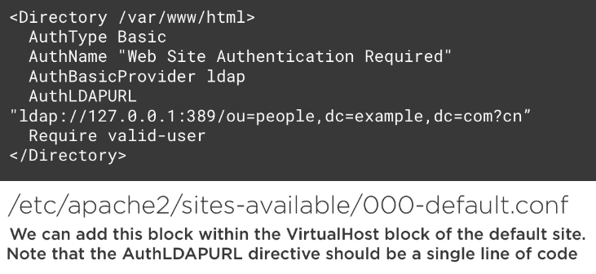

2.Apache Authentication to openLDAP

ubuntu@ldap01:~$ sudo apt-get install -y apache2 w3m
ubuntu@ldap01:~$ sudo a2enmod
authnz_ldap

ubuntu@ldap01:~$ sudo systemctl restart apache2
ubuntu@ldap01:~$ sudo vim /etc/apache2/sites-available/000-default.conf
[…]
ServerAdmin webmaster@localhost
DocumentRoot /var/www/html
<Directory /var/www/html>
AuthType Basic
AuthName "Authentivation Required"
AuthBasicProvider ldap
AuthLDAPURL "ldap://127.0.0.1:389/ou=People,dc=frozza,dc=com?cn"
Require valid-user
</Directory>

ubuntu@ldap01:~$ sudo apachectl configtest
Syntax OK

ubuntu@ldap01:~$ sudo systemctl restart apache2

ubuntu@ldap01:~$ w3m localhost

3.Linux and openLDAP Authentication.mp4


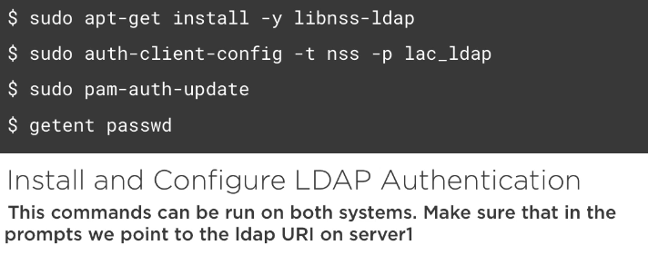

ubuntu@ldap01:~$ sudo apt-get install -y libnss-ldap

LDAP server Uniform Resource Identifier: ldap://192.168.1.101
Distinguished name of the search base: dc=frozza,dc=com
LDAP version to use: 3
Make local root Database admin: <Yes>
Does the LDAP database require login? <No>
LDAP account for root: cn=admin,dc=frozza,dc=com
LDAP root account password: frozza

ubuntu@ldap01:~$ sudo auth-client-config -t nss -p lac_ldap
ubuntu@ldap01:~$ sudo pam-auth-update

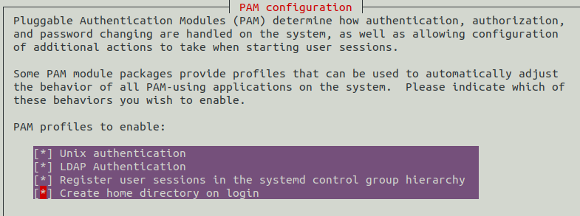

ubuntu@ldap01:~$ getent passwd (should see both local and ldap users)

(try to authenticate with a ldap user)

