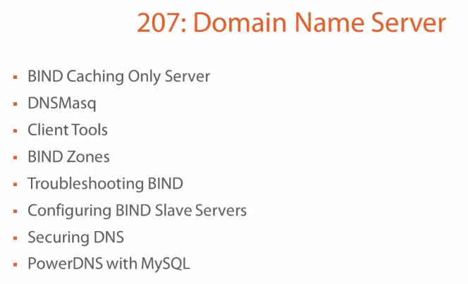

Master server running on Ubuntu 14.04 and a slave server running on Centos 7.

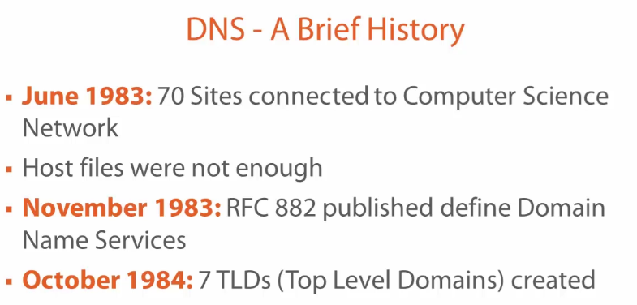

DNS server (BIND9)
Esse artigo mostra os passos básicos para instalação e configuração do servidor de DNS BIND no CentOS 7.
Neste tutorial vamos configurar um servidor master e um slave com os informações:

 | DNS Master | DNS Slave
Hostname: | dns01.frozza.com | dns02.frozza.com
IP: | 192.168.1.121 | 192.168.1.122
SO: | Ubuntu 16.04 | Centos 7 minimal
DNS Software: | Bind 9 | Bind 9

Primeiro passo é instalar os pacotes necessários, como root:

DNS Master (dns01.frozza.com)
# lsb_release -d
# apt-get install bind9
# systemctl enable bind9
# systemctl start bind9
# netstat -ltnp
# dig www.uol.com.br @127.0.0.1 # by now, it’s a caching only DNS server. You should see an ANSWER section.

# dpkg -L bind9 (important configuration files):
/etc/bind/maned.conf
/etc/bind/rndc.key

# named -v (to check the server version)

Configurando o BIND

O arquivo de configuração principal do BIND é o /etc/named.conf. No caso do Ubuntu, ele sá faz os “inclusions” de outros arquivos que compõem a configuração do DNS. A maior parte da configuração útil, no caso do Ubuntu está em /etc/bind/named.conf.default-zones.

Undestanding Zone Files

cd /etc/bind/
ls db*
cat db.local
grep local /etc/bind/named.conf.default-zones

Chrooting DNS

A ‘chroot’ jail can protect against malicious attack. The directory that ‘named’ daemon runs from appears as the root of the filesystem. Create the directory structure first. Use option ‘-t’ in /etc/default/bind9

In /etc/default/bind9, ‘ OPTIONS=”-t bind” ’

Controlling the DNS Server

The command ‘rndc’ can be used to control the ‘named’ service

# sudo -u bind rndc status

# sudo -u bind rndc-confgen (we use it to grand other systems to control our server)

rndc uses TCP Port 953

Additional Server tools

We can syntax checks on the configuration file and on zone files:
20 sudo named-checkconf
21 # no output is good ... means everything is OK
23 sudo named-checkzone localhost /etc/bind/db.local
24 # named-checkzone <zone-name> <file-name>

Client Tools: the pack dnsutils provides client such as dig and nslookup:
$ dig -t A www.pluralsight.com @127.0.0.1

-t A is the record-type
@127.0.0.1 is the DNS-server

So far we have installed BIND on Ubuntu, now we look at it on CentOS7.
Later this will become a ‘slave’ server to the zones we create on the ‘master’.

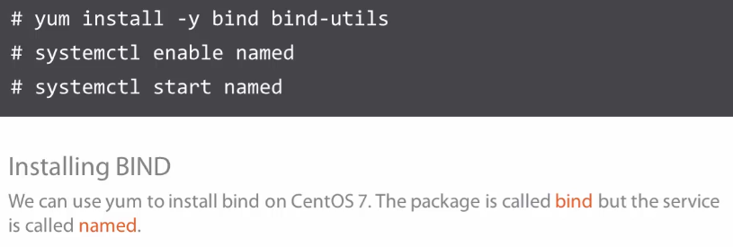

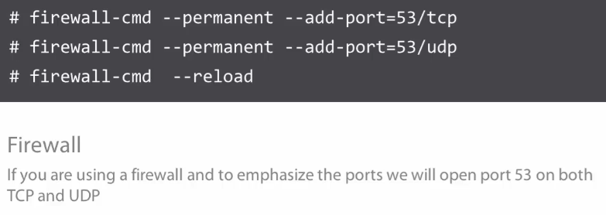

Installing and Testing BIND on Centos7

3 sudo yum install bind bind-utils

6 sudo systemctl start named
7 sudo systemctl enable named
15 sudo yum install net-tools
16 sudo netstat -ltnp
17 sudo firewall-cmd --permanent --add-port=53/tcp
18 sudo firewall-cmd --permanent --add-port=53/udp
19 sudo firewall-cmd --reload
20 dig www.pluralsight.com @127.0.0.1
21 sudo systemctl status named

Files and Locations

ls /etc/named* → files are directly placed inside /etc.

ls /var/named/ → contains zone files. Note it’s owned by root:named

sudo rndc status

Modes and Configuration

Caching-only Is the default congif mode
Forwarding
Master Is responsible (rw) for a zone and responds queries about that.
Slave Have a (ro) copy of the zone files.

Config:
listen-on Determines the interfaces listening for queries
allow-query Determines who can query to that server.

Client Tools – Resolving DNS Issues

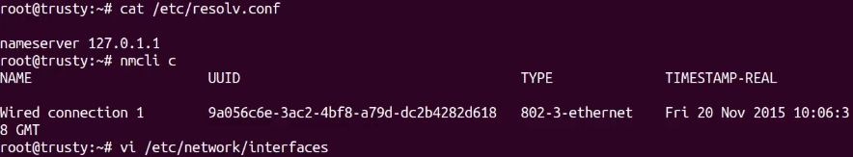

Interfaces configuradas dentro do arquivo não são administradas pelo NetworkManager!

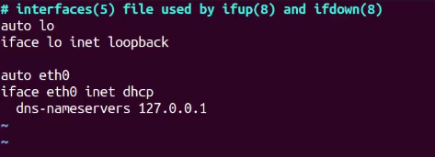

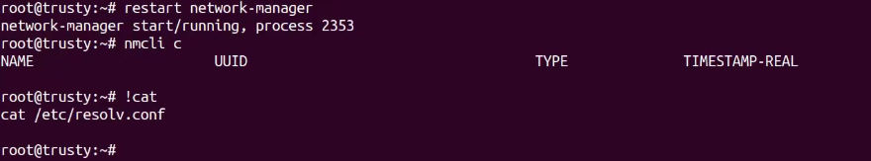

05. Client Tools Resolving DNS Issues

05_03-Common Client Tools

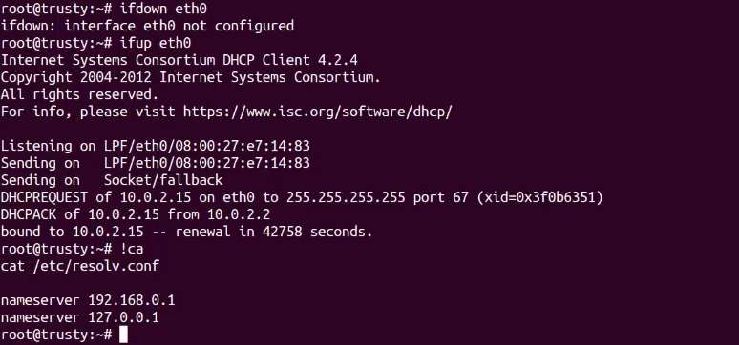

05. Client Tools Resolving DNS Issues
05_03-Common Client Tools

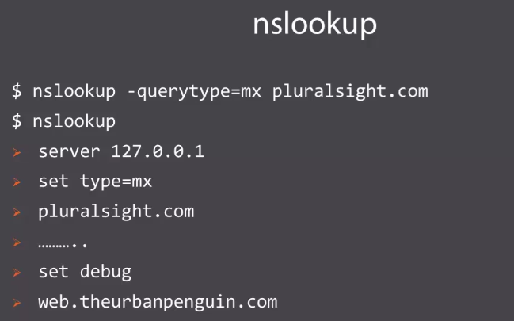

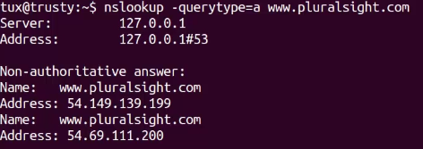

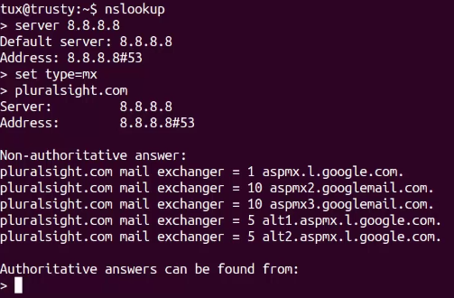

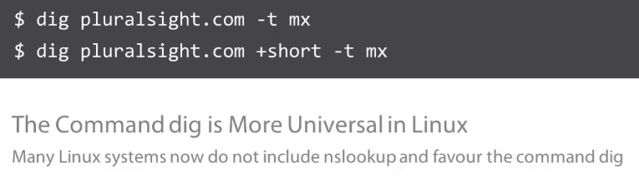

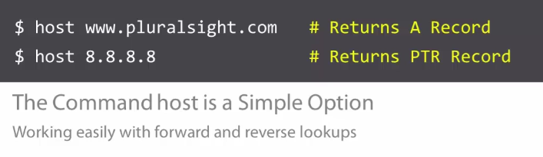

Extending DNS to Host Zones
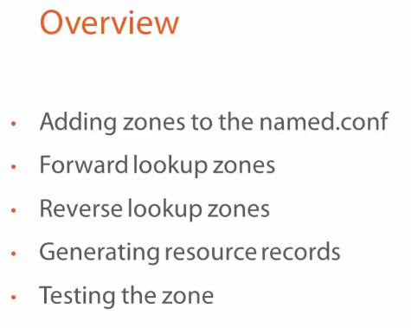

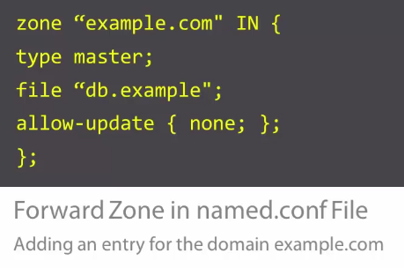

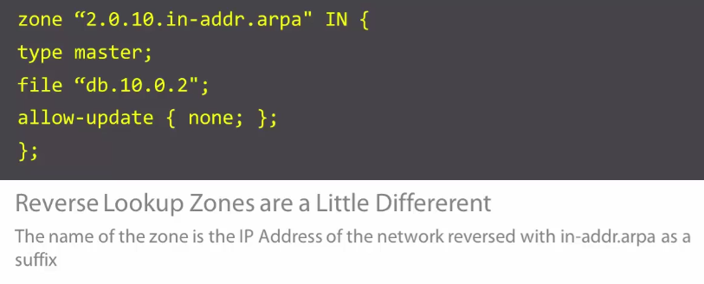

Adding Zones to our Configuration

2 cd /etc/bind
3 cat named.conf
4 cat named.conf.options
5 cat named.conf.local
6 cat named.conf.default-zones
7 vi named.conf.local

// Do any local configuration here
//

zone "frozza.com" IN {
type master;
file "db.frozza";
allow-update { none; };
};

zone "2.0.10.in-addr.arpa" IN {
type master;
file "db.10.0.2";
allow-update { none; };
};

8 named-checkconf

Creating the Zone Files

10 cd /var/cache/bind/
11 vi db.frozza

$TTL 3h
$ORIGIN frozza.com.
frozza.com. IN SOA dns01.frozza.com. root.frozza.com. (
2018072101 ; Serial
8h ; Refresh
4h ; Retry
1W ; Expire
1h ; Negative TTL
)

frozza.com. IN NS dns01.frozza.com.
dns01 IN A 10.0.2.4
gw IN A 10.0.2.1
mail IN A 10.0.2.2

; Aliases
ns1 IN CNAME dns01.frozza.com.

; Mail servers
frozza.com. IN MX 5 mail.frozza.com.

12 named-checkzone frozza.comdb.frozza
13 named-checkzone frozza.com db.frozza

15 chgrp bind db.frozza

18 vi db.10.0.2
$TTL 3h
$ORIGIN 2.0.10.in-addr.arpa.
2.0.10.in-addr.arpa. IN SOA dns01.frozza.com root.frozza.com. (
2018072101 ; Serial
8h ; Refresh
4h ; Retry
1w ; Expire
1h ; Negative TTL
)
2.0.10.in-addr.arpa. IN NS dns01.frozza.com.
1 IN PTR gw.frozza.com.
2 IN PTR mail.frozza.com.
4 IN PTR dns01.frozza.com.

24 chgrp bind db.10.0.2
19 named-checkzone 2.0.10.in-addr.arpa db.10.0.2
21 named-checkconf -z
25 rndc reload
29 host mail.frozza.com
30 host 10.0.2.2

07. Troubleshooting DNS and Log Files

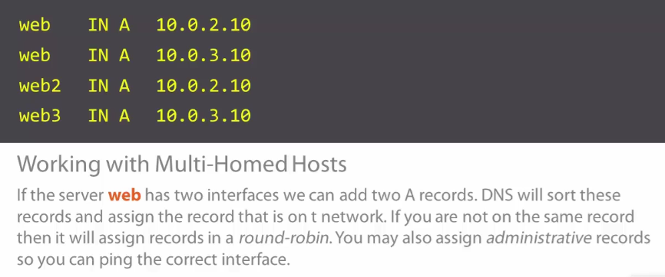

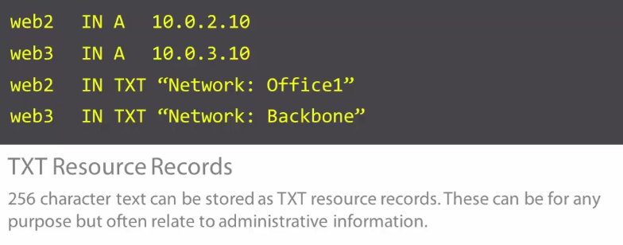

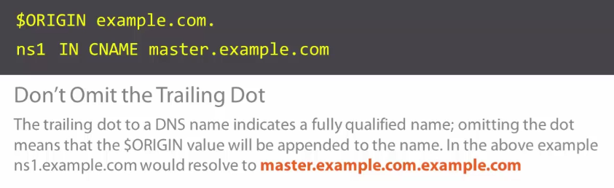

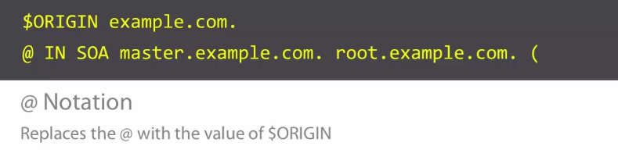

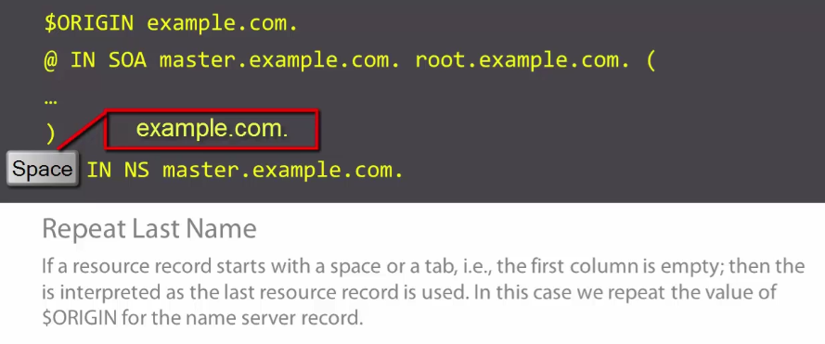

Log Files in DNS
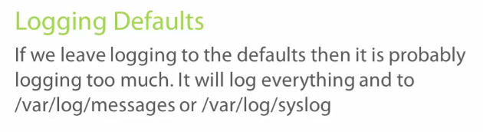

It’s possible to bypass the syslog loging by adding this to Bind Configuration (Bind Direc Logging):

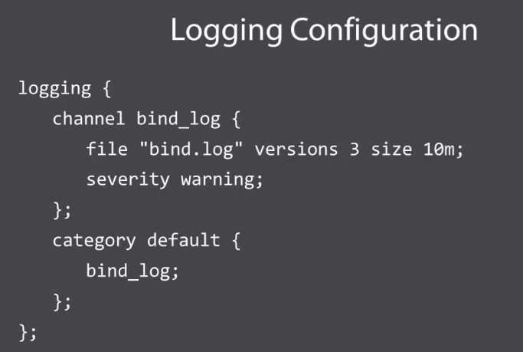

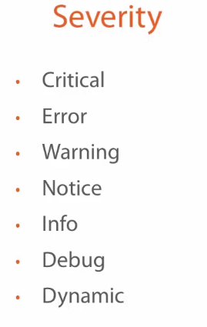

# rndc status
# rndc querylog (to enable client’s queries) … and ‘rndc querylog’ to dible it.

Custom Log Configuration

# vi /etc/bind/named.conf.options

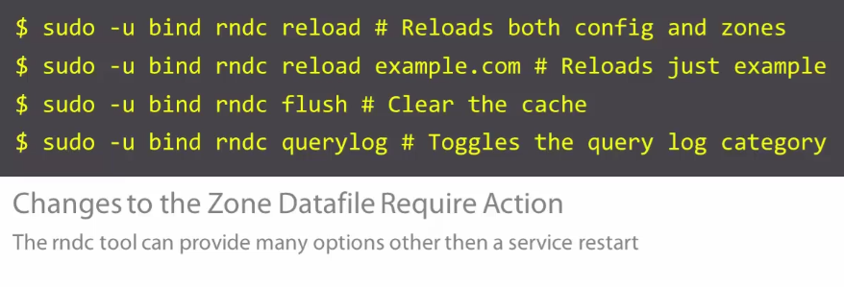

08.1 Zone Transfers

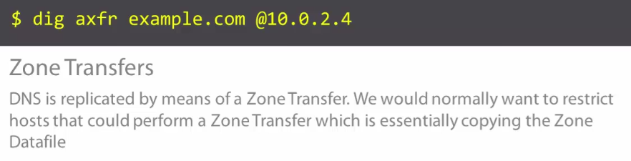

Slave servers use the zone transfer mechanism to replicate the zone at the in “interval value” from the SOA record. Replication only takes place if the “serial number” has been incremented.
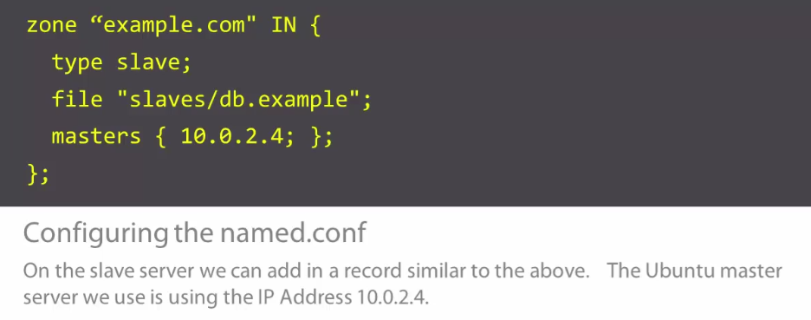

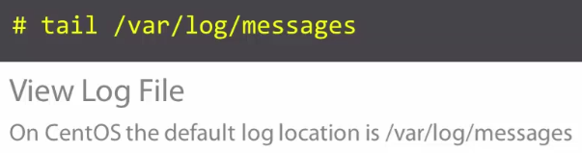

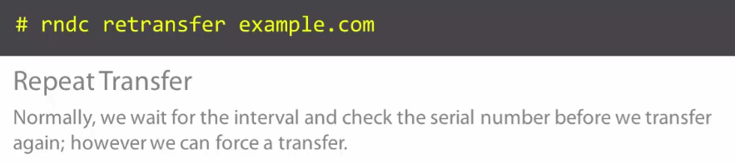

08.2 Implementing Slave DNS Servers

at that point, zone transfers isn’t secured.

42 dig axfr frozza.com @192.168.1.121
43 sudo su -
1 vi /etc/named.conf
[…]
logging {
channel default_debug {
file "data/named.run";
severity dynamic;
};
};

zone "1.168.192.in-addr.arpa" IN {
type slave;
file "slaves/db.192.168.1.in-addr.arpa";
masters { 192.168.1.121; };
};

zone "frozza.com" IN {
type slave;
file "slaves/db.frozza";
masters { 192.168.1.121; };
};

zone "." IN {
[…]

2 systemctl restart named
3 tail /var/log/messages
4 ls /var/named/slaves/

08_03-Adding Records and Synchronizing

Name Servers: We will need at add a name server record for the secondary server. This is added to the master, don’t forget to increment serial number.

ubuntu@dns01:~$ sudo vi /var/cache/bind/db.frozza

$TTL 3h
$ORIGIN frozza.com.
frozza.com. IN SOA dns01.frozza.com. root.frozza.com. (
2018072102 ; Serial
8h ; Refresh
4h ; Retry
1W ; Expire
1h ; Negative TTL
)

frozza.com. IN NS dns01.frozza.com.
frozza.com. IN NS dns02.frozza.com.
dns01 IN A 192.168.1.121
gw IN A 192.168.1.1
mail IN A 192.168.1.253
dns02 IN A 192.168.1.122

; Aliases
ns1 IN CNAME dns01.frozza.com.
ns2 IN CNAME dns02.frozza.com.

; Text Descriptors
dns01 IN TXT "Master DNS Server"
dns02 IN TXT "Slave DNS Server"

; Mail servers
frozza.com. IN MX 5 mail.frozza.com.

ubuntu@dns01:~$ sudo rndc reload frozza.com
ubuntu@dns01:~$ sudo vi /var/cache/bind/db.10.0.2 (na verdade é db.192.168.1)
$TTL 3h
$ORIGIN 1.168.192.in-addr.arpa.
1.168.192.in-addr.arpa. IN SOA dns01.frozza.com root.frozza.com. (
2018072102 ; Serial
8h ; Refresh
4h ; Retry
1w ; Expire
1h ; Negative TTL
)
1.168.192.in-addr.arpa. IN NS dns01.frozza.com.
1.168.192.in-addr.arpa. IN NS dns02.frozza.com.
1 IN PTR gw.frozza.com.
253 IN PTR mail.frozza.com.
121 IN PTR dns01.frozza.com.
122 IN PTR dns01.frozza.com.

ubuntu@dns01:~$ sudo rndc reload 2.0.10.in-addr.arpa

Forcing to re-synchonize as we don’t want to wait for 8h!

[vagrant@dns02 ~]$ sudo rndc retransfer frozza.com
[vagrant@dns02 ~]$ sudo rndc retransfer 1.168.192.in-addr.arpa
[vagrant@dns02 ~]$ sudo tail /var/log/messages
[root@dns02 ~]# ls -l /var/named/slaves/

[root@dns02 ~]# dig -t NS frozza.com @127.0.0.1

; <<>> DiG 9.9.4-RedHat-9.9.4-61.el7 <<>> -t NS frozza.com @127.0.0.1
;; global options: +cmd
;; Got answer:
;; ->>HEADER<<- opcode: QUERY, status: NOERROR, id: 2647
;; flags: qr aa rd ra; QUERY: 1, ANSWER: 2, AUTHORITY: 0, ADDITIONAL: 3

;; OPT PSEUDOSECTION:
; EDNS: version: 0, flags:; udp: 4096
;; QUESTION SECTION:
;frozza.com. IN NS

;; ANSWER SECTION:
frozza.com. 10800 IN NS dns02.frozza.com.
frozza.com. 10800 IN NS dns01.frozza.com.

09_01-DNS Security

Overview:
Using ACLs
Using TSIG or Transaction Signatures
Using DNSSEC to Sign Zones

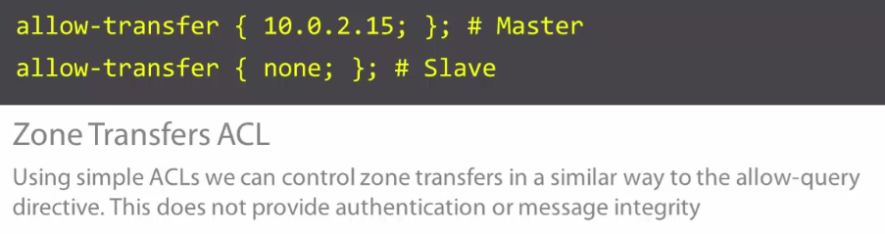

09_02-Using Simple ACLs

root@dns01:~# vi /etc/bind/named.conf.local
zone "frozza.com" IN {
type master;
file "db.frozza";
allow-update { none; };
allow-transfer { 192.168.1.122; };
};

zone "1.168.192.in-addr.arpa" IN {
type master;
file "db.10.0.2";
allow-update { none; };
allow-transfer { 192.168.1.122; };
};

root@dns01:~# rndc reload

** before that, try to put { none;} and test (from centos7) with “dig axfr frozza.com @192.168.1.121” to check the server will not allow the transfer.

[vagrant@dns02 ~]$ dig axfr frozza.com @192.168.1.121

; <<>> DiG 9.9.4-RedHat-9.9.4-61.el7 <<>> axfr frozza.com @192.168.1.121
;; global options: +cmd
; Transfer failed.

For security, none should copy slave’s Dbs:

[vagrant@dns02 ~]$ sudo vi /etc/named.conf
[…]
options {
listen-on port 53 { 127.0.0.1; };
listen-on-v6 port 53 { ::1; };
directory "/var/named";
dump-file "/var/named/data/cache_dump.db";
statistics-file "/var/named/data/named_stats.txt";
memstatistics-file "/var/named/data/named_mem_stats.txt";
allow-query { localhost; 192.168.1/24; };
allow-transfer { none; };
[…]

[vagrant@dns02 ~]$ sudo rndc reload

09_03-Understanding TSIG Keys
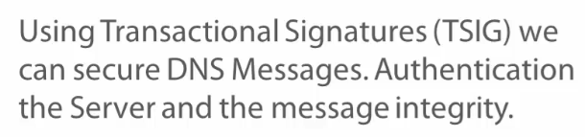

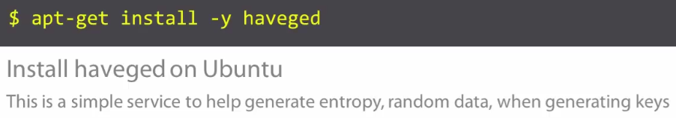

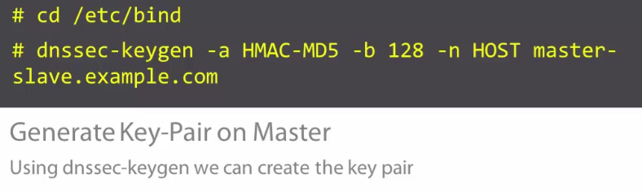

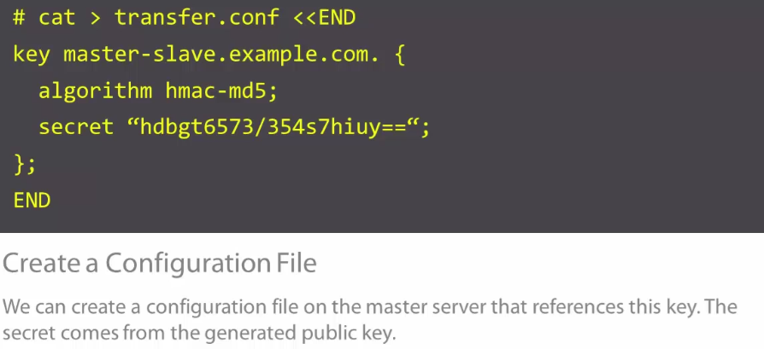

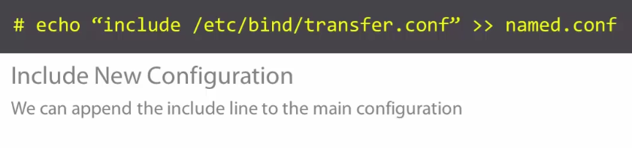

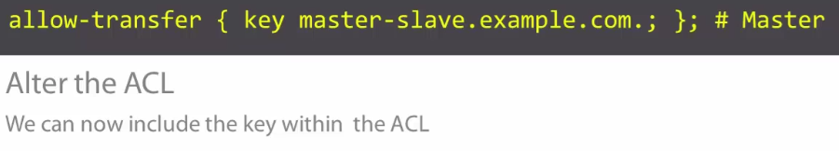

09_04-Implementing Security Using TSIG Keys

28 sudo apt-get install haveged
29 cd /etc/bind
30 sudo dnssec-keygen -a HMAC-MD5 -b 128 -n HOST master-slave.frozza.com
33 sudo cat Kmaster-slave.frozza.com.+157+09973.key

ubuntu@dns01:/etc/bind$ sudo vi transfer.conf
key master-slave.frozza.com. {
algorithm hmac-md5;
secret "O7N8Fuj0WyNlReh3xDEThw==";

};

ubuntu@dns01:/etc/bind$ sudo chown bind.bind transfer.conf
ubuntu@dns01:/etc/bind$ sudo chmod 600 transfer.conf
ubuntu@dns01:/etc/bind$ sudo chmod 600 transfer.conf
ubuntu@dns01:/etc/bind$ sudo chmod 600 Kmaster-slave.frozza.com.+157+09973.*
ubuntu@dns01:/etc/bind$ sudo chown bind.bind Kmaster-slave.frozza.com.+157+09973.*

ubuntu@dns01:/etc/bind$ sudo vi named.conf
include "/etc/bind/named.conf.options";
include "/etc/bind/named.conf.local";
include "/etc/bind/named.conf.default-zones";
include "/etc/bind/transfer.conf";

ubuntu@dns01:/etc/bind$ sudo vi named.conf.local
zone "frozza.com" IN {
type master;
file "db.frozza";
allow-update { none; };
allow-transfer { key master-slave.frozza.com.; };
};

zone "1.168.192.in-addr.arpa" IN {
type master;
file "db.10.0.2";
allow-update { none; };
allow-transfer { key master-slave.frozza.com.; };
};

ubuntu@dns01:/etc/bind$ sudo named-checkconf
ubuntu@dns01:/etc/bind$ sudo service bind9 reload
09_05-Completing TSIG Security on the Slave

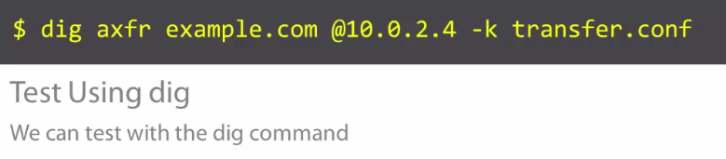

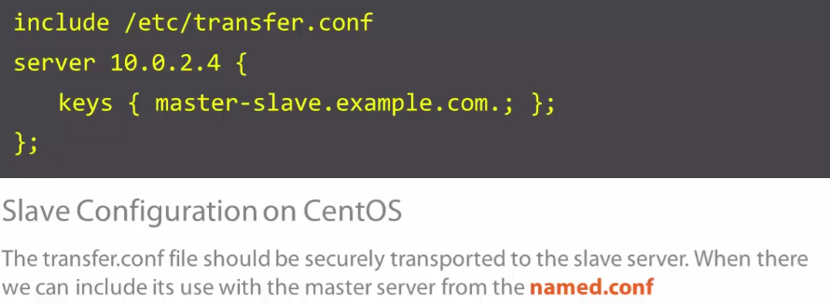

é necessário que a data e hora nos dois servidores estejam sincronizadas para que o TSIG funcione, caso necessário:

@dns02 etc]$ sudo timedatectl set-time '2018-08-01 14:47:00'

@dns02 etc]$ sudo vi /etc/transfer.conf
key master-slave.frozza.com. {
algorithm hmac-md5;
secret "O7N8Fuj0WyNlReh3xDEThw==";
};

@dns02 etc]$ sudo chmod 640 transfer.conf
@dns02 etc]$ sudo chown named.named /etc/transfer.conf
@dns02 etc]$ sudo dig axfr frozza.com @192.168.1.121 -k /etc/transfer.conf
@dns02 etc]$ sudo vi /etc/transfer.conf
key master-slave.frozza.com. {
algorithm hmac-md5;
secret "O7N8Fuj0WyNlReh3xDEThw==";
};

server 192.168.1.121 {
keys { master-slave.frozza.com.; };
};

@dns02 etc]$ sudo vi named.conf
[…]
include "/etc/named.rfc1912.zones";
include "/etc/named.root.key";
include "/etc/transfer.conf";

@dns02 etc]$ sudo systemctl restart named
@dns02 etc]$ sudo rndc retransfer frozza.com
@dns02 etc]$ sudo tail /var/log/messages

09_06-Understanding Signed Zones

DNSSEC: we can further our security by signing each Resource Record in the zone with an RRSIG. For DNSSEC capable resolves they can validate the integrity of the query.

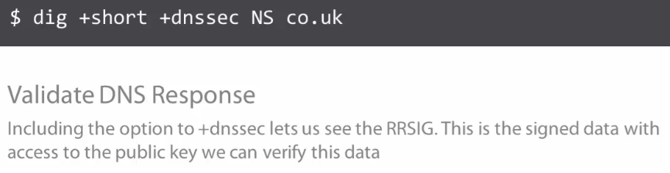

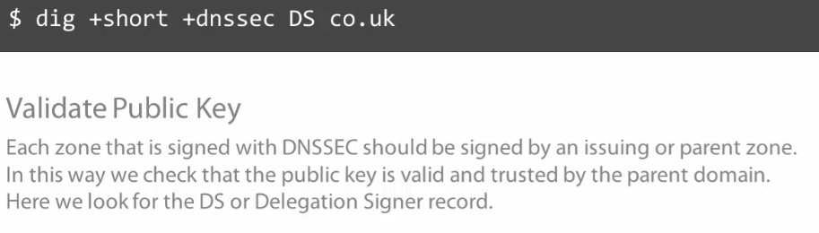

09_07-Steps in Zone Signing

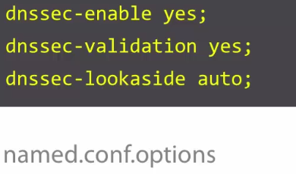

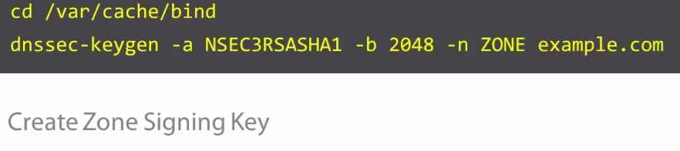

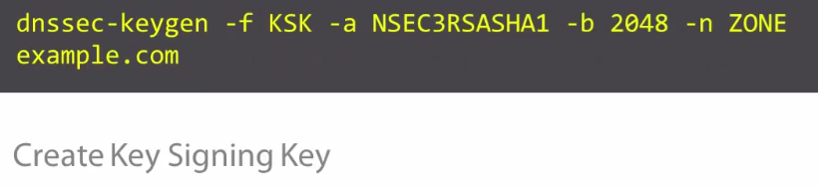

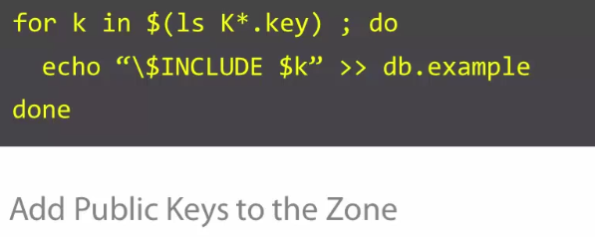

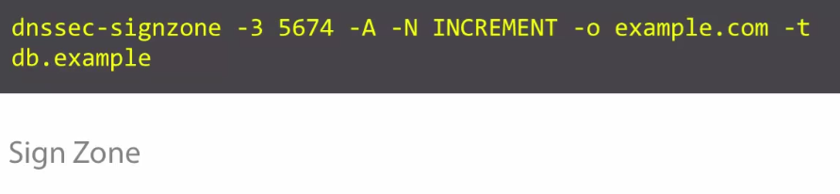

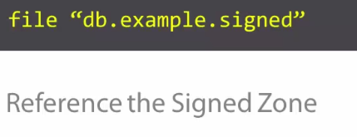

09_08-Signing Your Zone

@dns01:/etc/bind$ sudo vi named.conf.options
dnssec-validation yes;
dnssec-enable yes;
dnssec-lookaside auto;

@dns01:/etc/bind$ cd /var/cache/bind
@dns01:/var/cache/bind$ sudo dnssec-keygen -a NSEC3RSASHA1 -b 2048 -n ZONE frozza.com
@dns01:/var/cache/bind$ sudo su -

@dns01:/var/cache/bind# for K in $(ls K*.key); do echo “\$INCLUDE $K” >> db.frozza; done

@dns01:/var/cache/bind# tail db.frozza

@dns01:/var/cache/bind# dnssec-signzone -3 5674 -A -N INCREMENT -o frozza.com -t db.frozza

@dns01:/var/cache/bind# cd /etc/bind

@dns01:/etc/bind# vi named.conf.local

zone "frozza.com" IN {
type master;
file "db.frozza.signed";
allow-update { none; };
allow-transfer { key master-slave.frozza.com.; };
};

root@dns01:/etc/bind# named-checkconf
@dns01:/etc/bind# systemctl restart bind9

