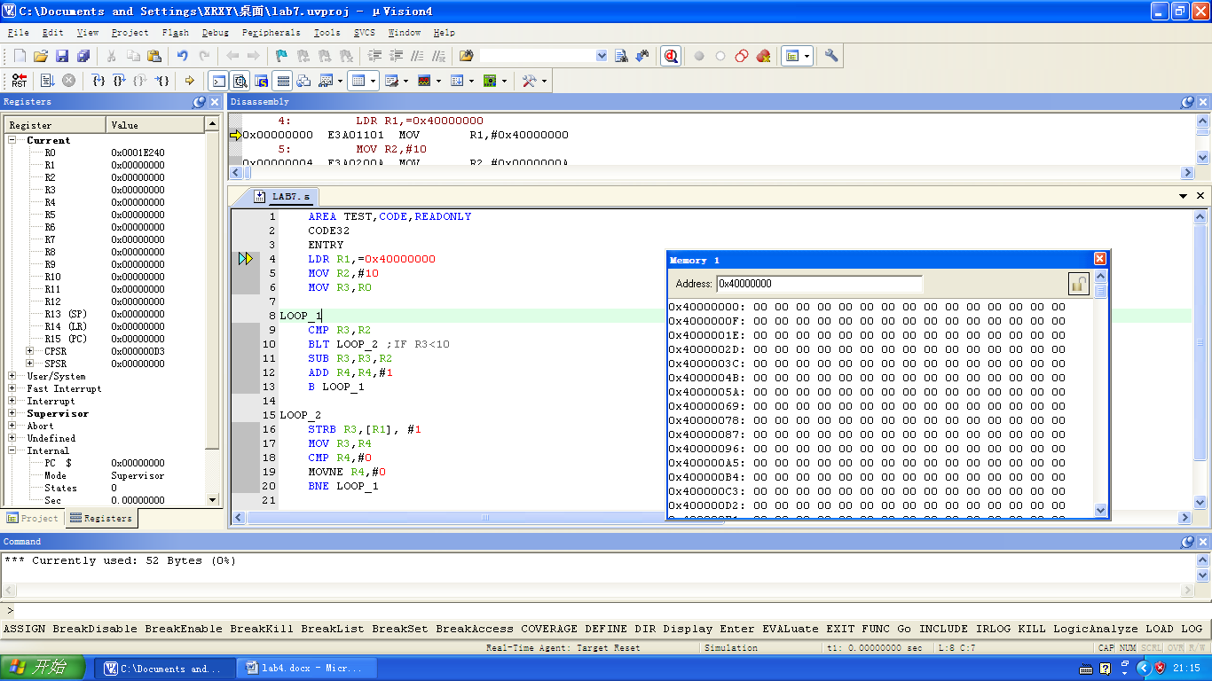

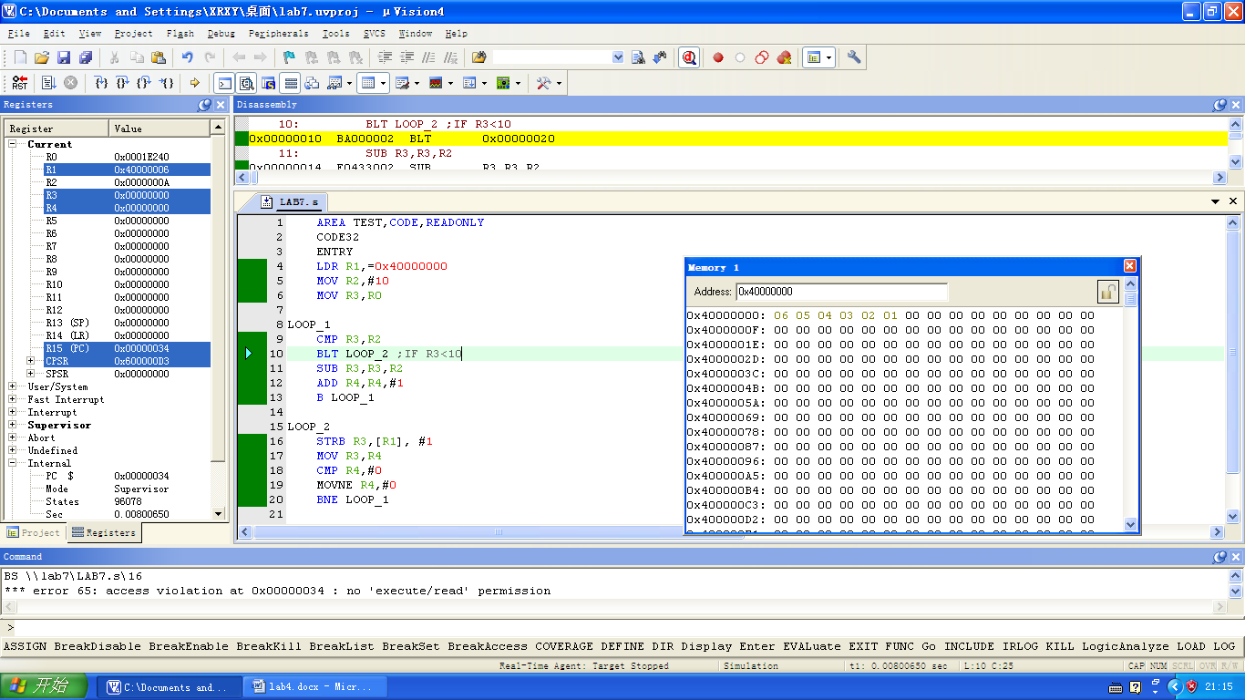

AREA TEST,CODE,READONLY

CODE32

ENTRY

LDR R1,=0x40000000

MOV R2,#10

MOV R3,R0

LOOP_1

CMP R3,R2

BLT LOOP_2 ;IF R3<10

SUB R3,R3,R2

ADD R4,R4,#1

B LOOP_1

LOOP_2

STRB R3,[R1],#1

MOV R3,R4

CMP R4,#0

MOVNE R4,#0

BNE LOOP_1

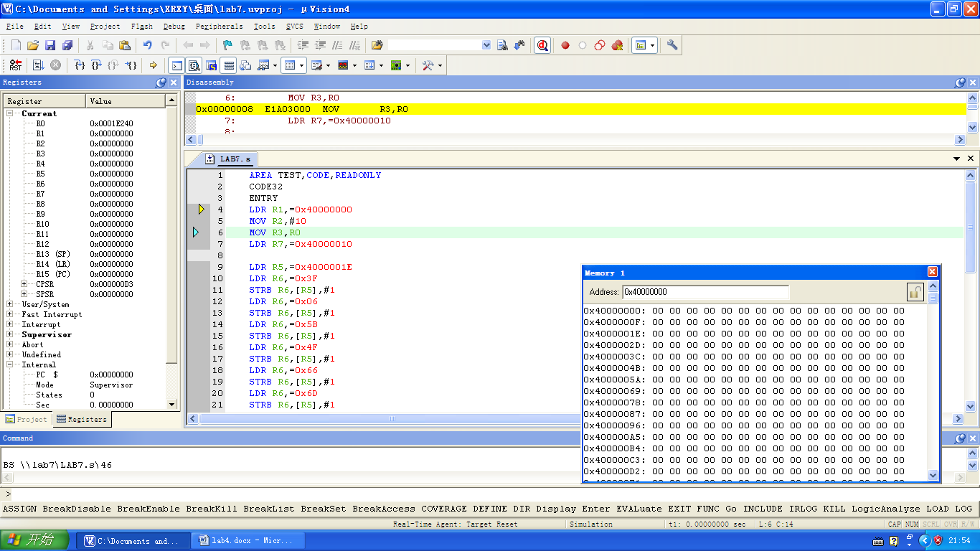

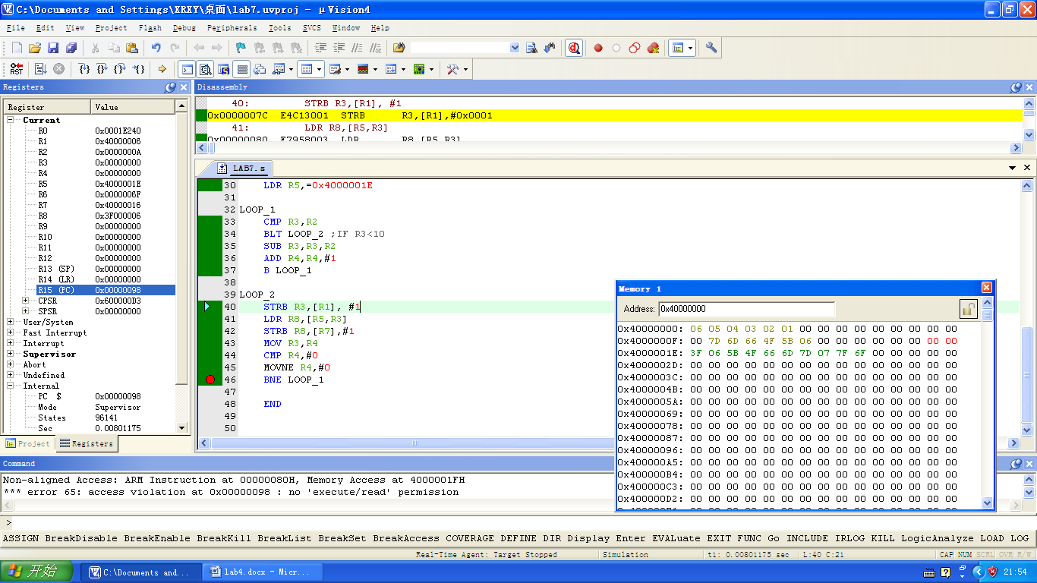

AREA TEST,CODE,READONLY

CODE32

ENTRY

LDR R1,=0x40000000

MOV R2,#10

MOV R3,R0

LDR R7,=0x40000010

LDR R5,=0x4000001E

LDR R6,=0x3F

STRB R6,[R5],#1

LDR R6,=0x06

STRB R6,[R5],#1

LDR R6,=0x5B

STRB R6,[R5],#1

LDR R6,=0x4F

STRB R6,[R5],#1

LDR R6,=0x66

STRB R6,[R5],#1

LDR R6,=0x6D

STRB R6,[R5],#1

LDR R6,=0x7D

STRB R6,[R5],#1

LDR R6,=0x07

STRB R6,[R5],#1

LDR R6,=0x7F

STRB R6,[R5],#1

LDR R6,=0x6F

STRB R6,[R5],#1

LDR R5,=0x4000001E

LOOP_1

CMP R3,R2

BLT LOOP_2 ;IF R3<10

SUB R3,R3,R2

ADD R4,R4,#1

B LOOP_1

LOOP_2

STRB R3,[R1], #1

LDR R8,[R5,R3]

STRB R8,[R7],#1

MOV R3,R4

CMP R4,#0

MOVNE R4,#0

BNE LOOP_1

END