LDR STR

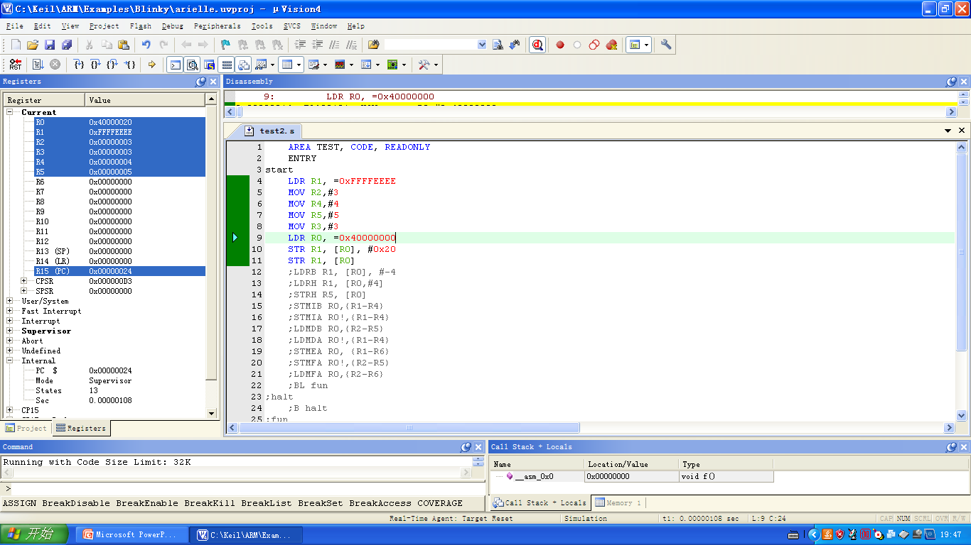

LDRB LDRH STRH

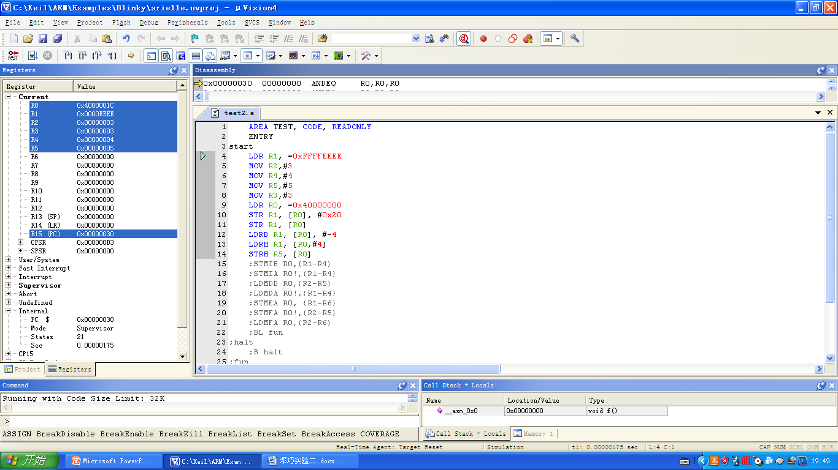

STMIB

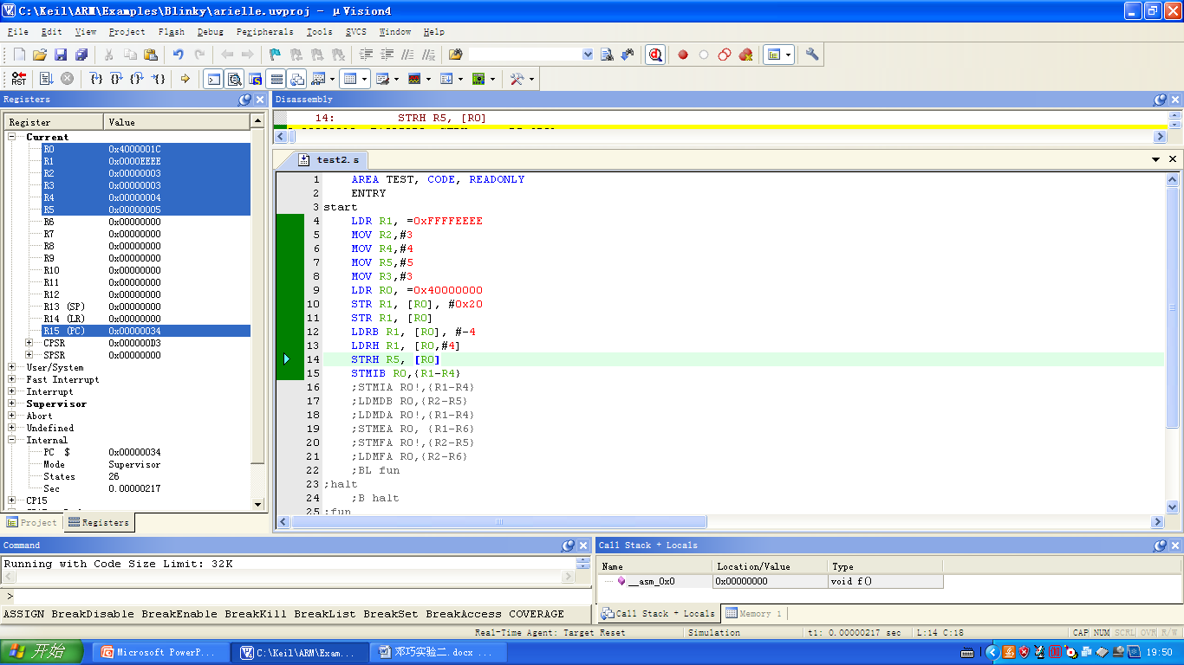

STMIA

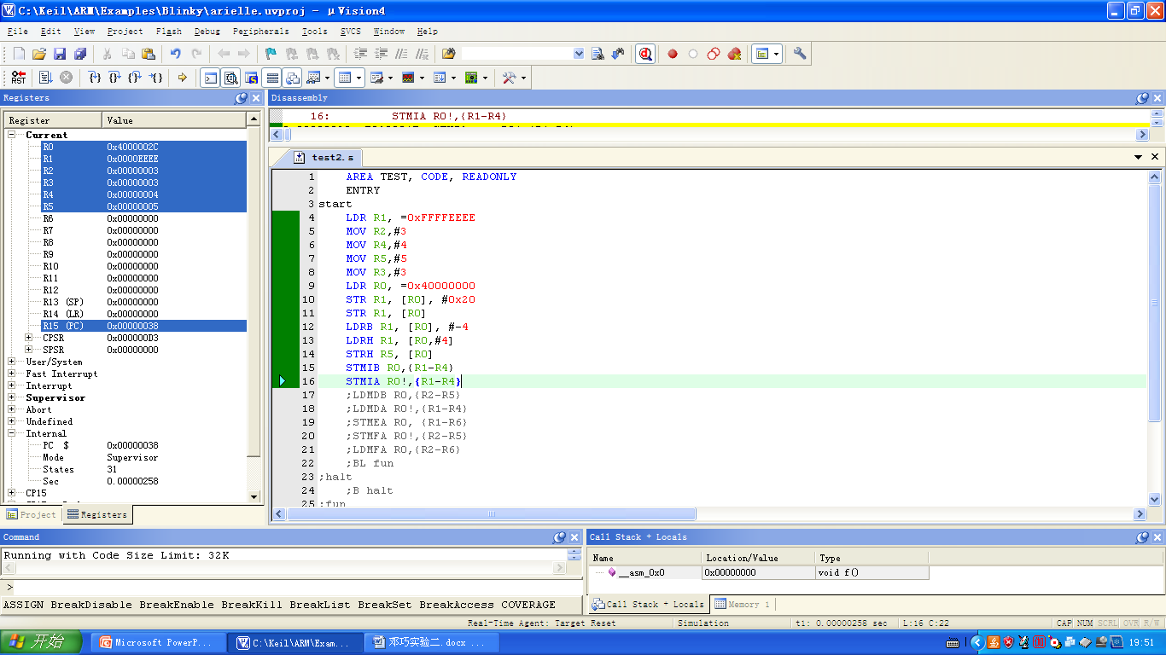

LDMDA LDMDB

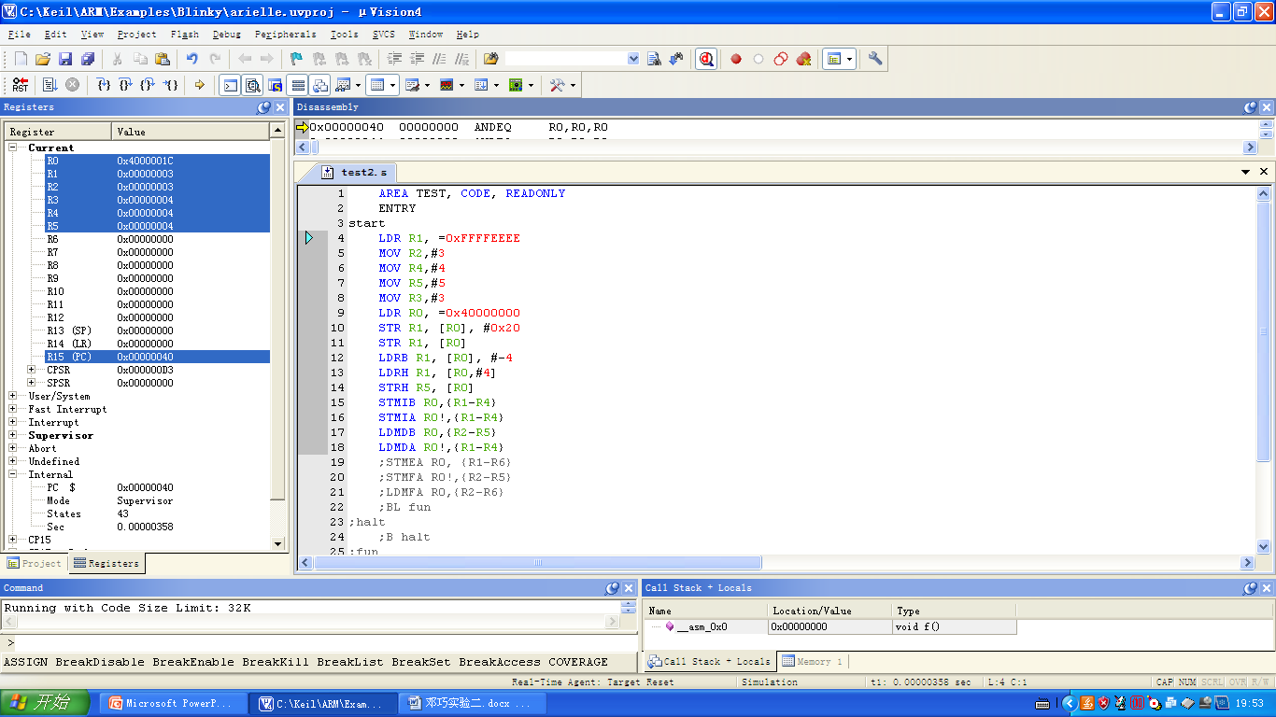

STMFA

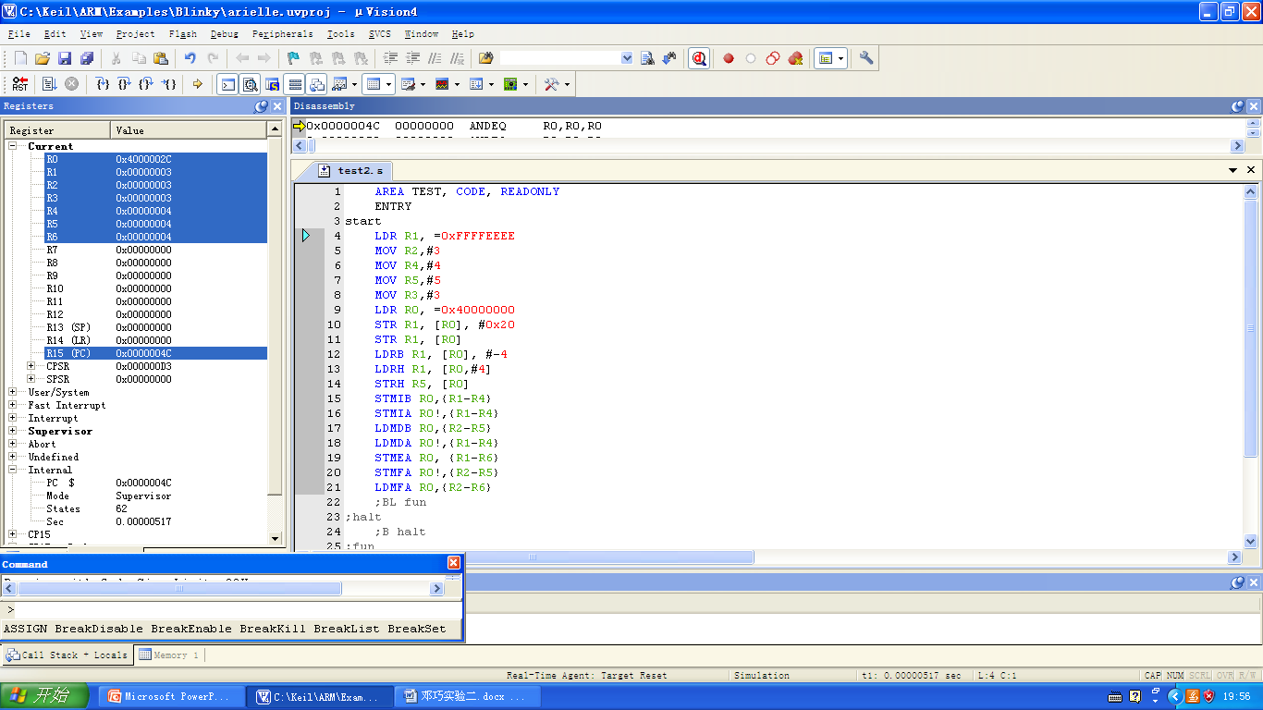

BL B MSR

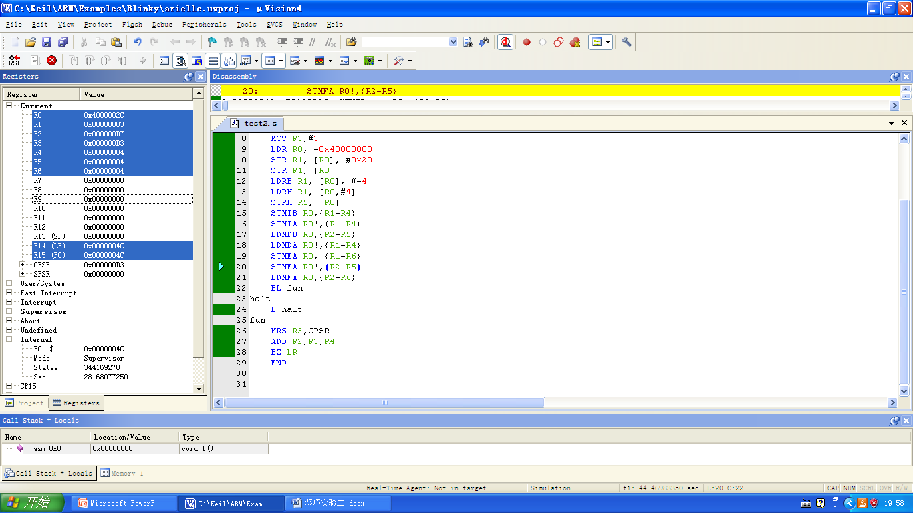

AREA TEST, CODE, READONLY

ENTRY

start

LDR R1, =0xFFFFEEEE

MOV R2,#3

MOV R4,#4

MOV R5,#5

MOV R3,#3

LDR R0, =0x40000000

STR R1, [R0], #0x20

STR R1, [R0]

LDRB R1, [R0], #-4

LDRH R1, [R0,#4]

STRH R5, [R0]

STMIB R0,{R1-R4}

STMIA R0!,{R1-R4}

LDMDB R0,{R2-R5}

LDMDA R0!,{R1-R4}

STMEA R0, {R1-R6}

STMFA R0!,{R2-R5}

LDMFA R0,{R2-R6}

BL fun

halt

B halt

fun

MRS R3,CPSR

ADD R2,R3,R4

BX LR

END

ARM调用子程序

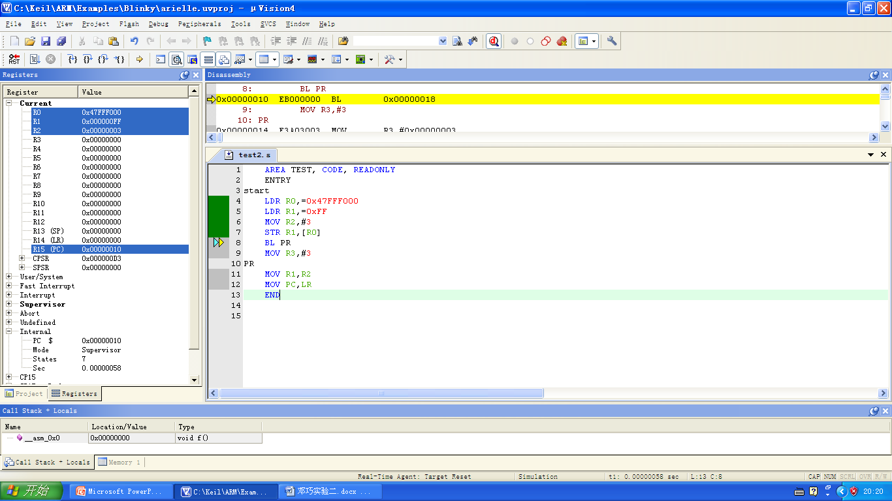

AREA TEST, CODE, READONLY

ENTRY

start

LDR R0,=0x47FFF000

LDR R1,=0xFF

MOV R2,#3

STR R1,[R0]

BL PR

MOV R3,#3

PR

MOV R1,R2

MOV PC,LR

END

ARM调用C

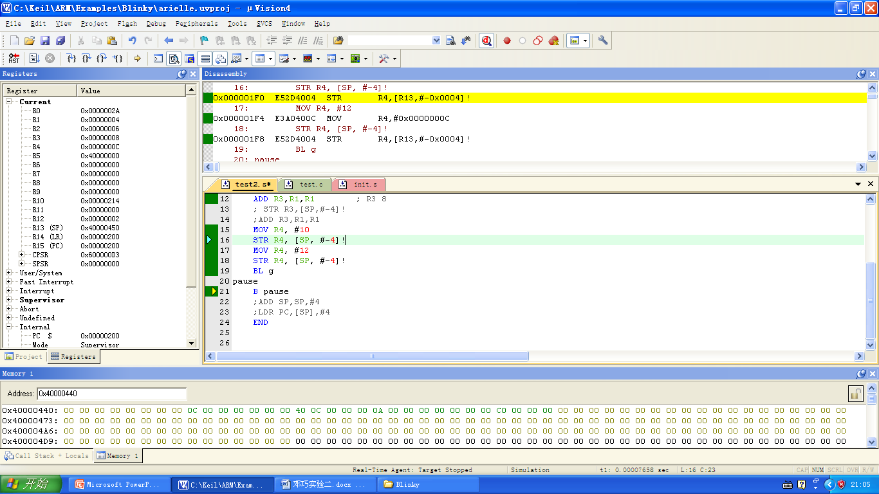

PRESERVE8

EXPORT f

AREA TEST, CODE, READONLY

code32

IMPORT g

ENTRY

f

MOV R0,#2 ; R0 2

ADD R1,R0,R0 ; R1 4

ADD R2,R1,R0 ; R2 6

ADD R3,R1,R1 ; R3 8

MOV R4, #10

STR R4, [SP, #-4]!

MOV R4, #12

STR R4, [SP, #-4]!

BL g

pause

B pause

END

int g(int a, int b, int c, int d, int e, int f);

extern void f(void);

int main(){

f();

return 0;

}

int g(int a,int b,int c,int d,int e,int f){

return a + b + c + d + e + f;

}

C调用arm

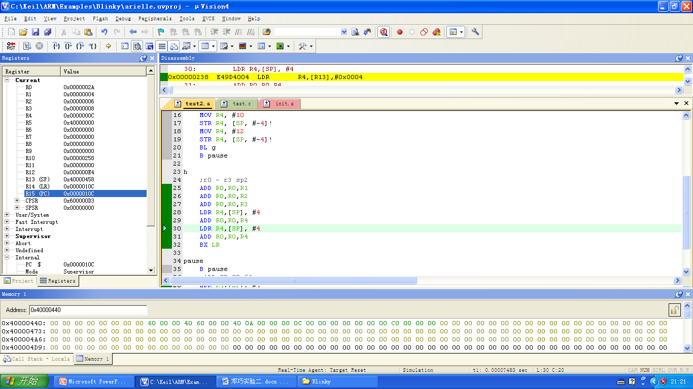

PRESERVE8

EXPORT f

EXPORT h

AREA TEST, CODE, READONLY

code32

IMPORT g

ENTRY

f

MOV R0,#2 ; R0 2

; STR LR,[SP,#-4]!

ADD R1,R0,R0 ; R1 4

ADD R2,R1,R0 ; R2 6

ADD R3,R1,R1 ; R3 8

; STR R3,[SP,#-4]!

;ADD R3,R1,R1

MOV R4, #10

STR R4, [SP, #-4]!

MOV R4, #12

STR R4, [SP, #-4]!

BL g

B pause

h

;r0 - r3 sp2

ADD R0,R0,R1

ADD R0,R0,R2

ADD R0,R0,R3

LDR R4,[SP], #4

ADD R0,R0,R4

LDR R4,[SP], #4

ADD R0,R0,R4

BX LR

pause

B pause

;ADD SP,SP,#4

;LDR PC,[SP],#4

END

int g(int a, int b, int c, int d, int e, int f);

extern void f(void);

extern int h(int a, int b, int c, int d, int e, int f);

int main(){

h(2,4,6,8,10,12);

return 0;

}

int g(int a,int b,int c,int d,int e,int f){

return a + b + c + d + e + f;

}