**电子科技大学信息与软件学院**

**实 验 报 告**

学 号 2016220304031

姓 名 邓巧

（实验） 课程名称 计算机网络

理论教师 傅翀

实验教师 文淑华

**电子科技大学教务处制表**

**电 子 科 技 大 学**

**实 验 报 告**

**学生姓名：邓巧 学 号：2016220304031 指导教师：文淑华**

**实验地点：信软楼304 实验时间：2018-6-12**

**一、实验室名称：信息与软件工程学院机房**

**二、实验项目名称：路由器的基本操作和路由配置练习**

**三、实验学时：4**

**四、实验原理：**

路由器的管理方式基本分为两种：带内管理和带外管理。通过路由器的Console口管理路由器属于带外管理，不占用路由器的网络接口，但特点是线缆特殊，需要近距离配置。第一次配置路由器时必须利用Console进行配置，使其支持telnet远程管理。

路由器的命令行操作模式，主要包括：用户模式、特权模式、全局配置模式、端口模式等等几种。

* 用户模式 进入路由器后得到的第一个操作模式，该模式下可以简单查看路由器的软、硬件版本信息，并进行简单的测试。用户模式提示符为Red-Giant>
* 特权模式 由用户模式进入的下一级模式，该模式下可以对路由器的配置文件进行管理，查看路由器的配置信息，进行网络的测试和调试等。特权模式提示符为Red-Giant#
* 全局配置模式 属于特权模式的下一级模式，该模式下可以配置路由器的全局性参数（如主机名、登录信息等）。在该模式下可以进入下一级的配置模式，对路由器具体的功能进行配置。全局模式提示符为Red-Giant (config)#
* 端口模式 属于全局模式的下一级模式，该模式下可以对路由器的端口进行参数配置。

Exit命令是退回到上一级操作模式，

end命令是直接退回到特权模式

路由器命令行支持获取帮助信息、命令的简写、命令的自动补齐、快捷键功能。

配置路由器的设备名称和路由器的描述信息必须在全局配置模式下执行。

Hostname配置路由器的设备名称即命令提示符的前部分信息。

当用户登录路由器时，你可能需要告诉用户一些必要的信息。你可以通过设置标题来达到这个目的。你可以创建两种类型的标题：每日通知和登录标题。

Banner motd配置路由器每日提示信息motd message of the day。

Banner login配置路由器远程登录提示信息，位于每日提示信息之后。

锐捷路由器接口Fastethernet接口默认情况下是10M/100M自适应端口，双工模式也为自适应。

在路由器的物理端口可以灵活配置带宽，但最大值为该端口的实际物理带宽。

查看路由器的系统和配置信息命令要在特权模式下执行。

Show version查看路由器的版本信息，可以查看到路由器的硬件版本信息和软件版本信息，用于进行路由器操作系统升级时的依据。

Show ip route 查看路由表信息。

Show running-config查看路由器当前生效的配置信息。

路由器属于网络层设备，能够根据IP包头的信息，选择一条最佳路径，将数据包转发出去。实现不同网段的主机之间的互相访问。

路由器是根据路由表进行选路和转发的。而路由表里就是由一条条的路由信息组成。路由表的产生方式一般有3种：

* 直连路由 给路由器接口配置一个IP地址，路由器自动产生本接口IP所在网段的路由信息。
* 静态路由 在拓扑结构简单的网络中，网管员通过手工的方式配置本路由器未知网段的路由信息，从而实现不同网段之间的连接。

动态路由协议学习产生的路由 在大规模的网络中，或网络拓扑相对复杂的情况下，通过在路由器上运行动态路由协议，路由器之间互相自动学习产生路由信息。

**五、实验目的：**

理解路由器的工作原理，掌握路由器的基本操作。

理解静态路由的工作原理，掌握如何配置静态路由。

理解动态路由的工作原理，掌握如何配置动态路由RIP协议

**六、实验内容：**

假设校园网分为2个区域，每个区域内使用1台路由器连接2个子网，现要在路由器上做适当配置，实现校园网内各个区域子网之间的相互通信。

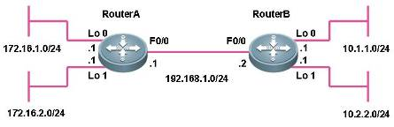

图1 静态路由和动态路由的配置网络图

**七、实验器材（设备、元器件）：**

网络模拟器软件一套

**八、实验步骤：**

**1、路由器基本配置**

**第一步：路由器命令行的基本功能**

RSR20>**?**

！使用？显示当前模式下所有可执行的命令

Exec commands:

<1-99> Session number to resume

disable Turn off privileged commands

disconnect Disconnect an existing network connection

enable Turn on privileged commands

exit Exit from the EXEC

help Description of the interactive help system

lock Lock the terminal

ping Send echo messages

ping6 ping6

show Show running system information

start-terminal-service Start terminal service

telnet Open a telnet connection

traceroute Trace route to destination

RSR20>**e?**

enable exit

！显示当前模式下所有以e开头的命令

RSR20>**en <tab>**

！按键盘的Tab键自动补齐命令，路由器支持命令的自动补齐

RSR20>**enable**

！使用enable命令从用户模式进入特权模式

RSR20#**copy ?**

！显示copy命令后可执行的参数

flash: Copy from flash: file system

running-config Copy from current system configuration

startup-config Copy from startup configuration

tftp: Copy from tftp: file system

xmodem: Copy from xmodem: file system

RSR20#copy

**% Incomplete command.**

！提示命令未完，必须附带可执行的参数

RSR20#**conf t**

！路由器支持命令的简写，该命令代表configure terminal

！进入路由器的全局配置模式

Enter configuration commands, one per line. End with CNTL/Z.

RSR20(config)#**interface fastEthernet 0/0**

！进入路由器端口Fa0/0的接口配置模式

RSR20(config-if)#

RSR20(config-if)#**exit**

！使用exit命令返回上一级的操作模式

RSR20(config)#interface fastEthernet 0/0

RSR20(config-if)#**end**

！使用end命令直接返回特权模式

RSR20#

RSR20(config)#interface fastEthernet 0/0

RSR20(config-if)#**^Z**

！使用快捷键ctrl+Z直接退回到特权模式

RSR20#

RSR20#ping 1.1.1.1

Sending 5, 100-byte ICMP Echoes to 1.1.1.1, timeout is 2 seconds:

< press Ctrl+C to break >

..**^C**

Success rate is 0 percent (0/3)

！在路由器特权模式下执行ping 1.1.1.1命令，发现不能ping通目标地址，路由器默认情况下需要发送5个数据包，若不想等到5个数据包均不能ping通目标地址时才认为目的地址不可到达，可在数据包未发出5个之前通过快捷键Ctrl+C终止当前操作。

**第二步：配置路由器的名称和每日提示信息**

RSR20>enable

RSR20#configure terminal

Enter configuration commands, one per line. End with CNTL/Z.

RSR20(config)#**hostname RouterA**

！将路由器的名称设置为RouterA

RouterA(config)#

RouterA(config)#**banner motd** &

！设置路由器的每日提示信息，motd后面的参数为设置的终止符

Enter TEXT message. End with the character '&'.

Welcome to RouterA, if you are admin, you can config it.

If you are not admin, please EXIT.

&

RouterA(config)#

**验证测试：**

RouterA#exit

RouterA CON0 is now available

Press RETURN to get started

Welcome to RouterA, if you are admin, you can config it.

If you are not admin, please EXIT.

RouterA>

**第三步：配置路由器的接口并查看接口配置**

RouterA#configure terminal

Enter configuration commands, one per line. End with CNTL/Z.

RouterA(config)#interface fastEthernet 0/0

！进入端口Fa0/0的接口配置模式

RouterA(config-if)#**ip address** 192.168.1.1 255.255.255.0

！配置接口的IP地址

RouterA(config-if)#**no shutdown**

！开启该端口

RouterA(config-if)#end

RouterA#**show interfaces** fastEthernet 0/0

！查看端口Fa0/0的状态是否为UP，地址配置和流量统计等信息

Index(dec):1 (hex):1

**FastEthernet 0/0 is UP , line protocol is UP**

Hardware is MPC8248 FCC FAST ETHERNET CONTROLLER FastEthernet, address is 00d0.f86b.3832 (bia 00d0.f86b.3832)

**Interface address is: 192.168.1.1/24**

ARP type: ARPA,ARP Timeout: 3600 seconds

MTU 1500 bytes, BW 100000 Kbit

Encapsulation protocol is Ethernet-II, loopback not set

Keepalive interval is 10 sec , set

Carrier delay is 2 sec

RXload is 1 ,Txload is 1

Queueing strategy: FIFO

Output queue 0/40, 0 drops;

Input queue 0/75, 0 drops

Link Mode: 100M/Full-Duplex

5 minutes input rate 1 bits/sec, 0 packets/sec

5 minutes output rate 1 bits/sec, 0 packets/sec

1 packets input, 60 bytes, 0 no buffer, 0 dropped

Received 1 broadcasts, 0 runts, 0 giants

0 input errors, 0 CRC, 0 frame, 0 overrun, 0 abort

1 packets output, 42 bytes, 0 underruns , 0 dropped

0 output errors, 0 collisions, 2 interface resets

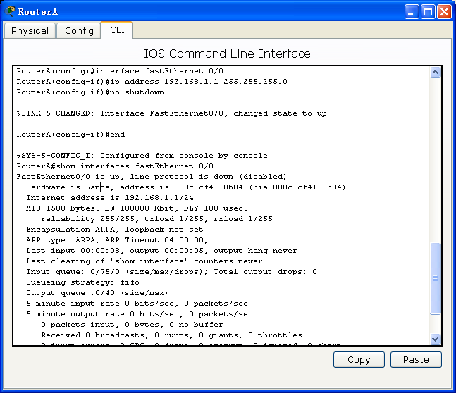

**第四步：查看路由器的配置**

RouterA#s**how version**

！查看路由器的版本信息

System description : Ruijie Router(RSR20-04) by Ruijie Network

System start time : 2009-8-16 5:37:38

System hardware version : 1.01

！硬件版本号

System software version : RGNOS 10.1.00(4), Release(18443)

！软件版本号

System boot version : 10.2.24515

System serial number : 1234942570135

RouterA#**show ip route**

！查看路由表信息

Codes: C - connected, S - static, R - RIP B - BGP

O - OSPF, IA - OSPF inter area

N1 - OSPF NSSA external type 1, N2 - OSPF NSSA external type 2

E1 - OSPF external type 1, E2 - OSPF external type 2

i - IS-IS, L1 - IS-IS level-1, L2 - IS-IS level-2, ia - IS-IS inter area

* - candidate default

Gateway of last resort is no set

C 192.168.1.0/24 is directly connected, FastEthernet 0/0

C 192.168.1.1/32 is local host.

RouterA#**show running-config**

！查看路由器当前生效的配置信息

Building configuration...

Current configuration : 540 bytes

!

version RGNOS 10.1.00(4), Release(18443)(Tue Jul 17 20:50:30 CST 2007 -ubu1server)

hostname RouterA

!

!

interface FastEthernet 0/0

ip address 192.168.1.1 255.255.255.0

duplex auto

speed auto

!

interface FastEthernet 0/1

duplex auto

speed auto

!

line con 0

line aux 0

line vty 0 4

login

!

banner motd ^C

Welcome to RouterA, if you are admin, you can config it.

If you are not admin, please EXIT.

^C

!

End

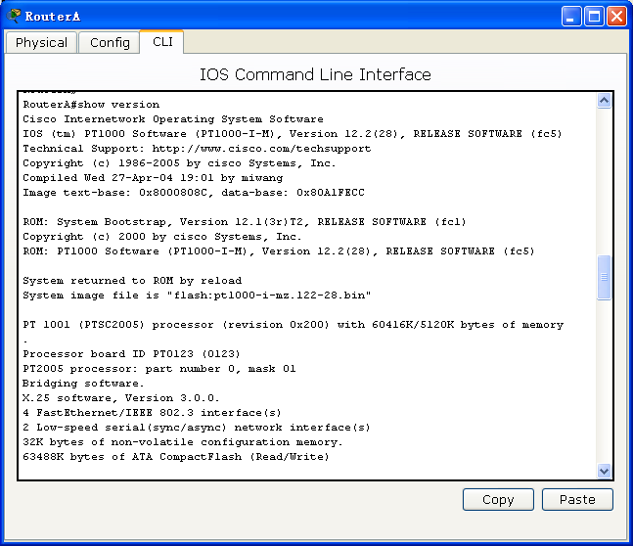

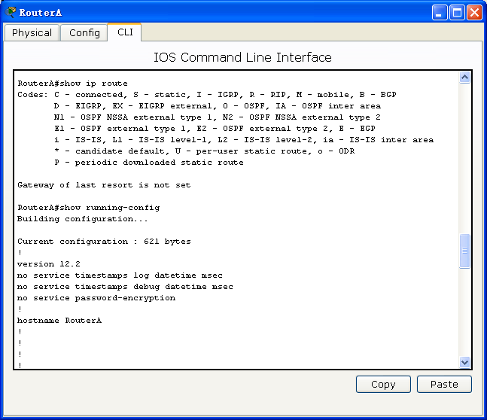

**2、路由器静态路由配置**

**第一步：配置路由器的名称、接口IP地址和时钟**

R3740#configure terminal

Enter configuration commands, one per line. End with CNTL/Z.

R3740(config)**#hostname** RouterA

！配置路由器的名称

RouterA(config)#

RouterA(config)#**interface serial 4/0**

！进入端口S4/0的接口配置模式

RouterA(config-if)#**clock rate** 512000

！设置串口的时钟

RouterA(config-if)#**ip address** 192.168.1.1 255.255.255.0

！设置端口的IP地址

RouterA(config-if)#no shutdown

！开启端口

RouterA(config-if)#exit

RouterA(config)#

RouterA(config)**#interface loopback 0**

！设置Loopback端口用于测试

RouterA(config-if)#Sep 15 01:05:02 RouterA %7:%LINE PROTOCOL CHANGE: Interface Loopback 0, changed state to UP

RouterA(config-if)#**ip address** 172.16.1.1 255.255.255.0

RouterA(config-if)#exit

RouterA(config)#

RouterA(config)#**interface loopback 1**

RouterA(config-if)#Sep 15 01:05:31 RouterA %7:%LINE PROTOCOL CHANGE: Interface Loopback 1, changed state to UP

RouterA(config-if)#**ip address** 172.16.2.1 255.255.255.0

RouterA(config-if)#exit

R3740#configure terminal

Enter configuration commands, one per line. End with CNTL/Z.

R3740 (config)#**hostname** RouterB

RouterB(config)#

RouterB(config)#**interface serial 4/0**

RouterB(config-if)#**ip address** 192.168.1.2 255.255.255.0

RouterB(config-if)#no shutdown

RouterB(config-if)#exit

RouterB(config)#

RouterB(config)#**interface loopback 0**

RouterB(config-if)#Aug 22 03:03:36 RouterB %7:%LINE PROTOCOL CHANGE: Interface Loopback 0, changed state to UP

RouterB(config-if)#**ip address** 10.1.1.1 255.255.255.0

RouterB(config-if)#exit

RouterB(config)#

RouterB(config)#**interface loopback 1**

RouterB(config-if)#Aug 22 03:04:03 RouterB %7:%LINE PROTOCOL CHANGE: Interface Loopback 1, changed state to UP

RouterB(config-if)#**ip address** 10.2.2.1 255.255.255.0

RouterB(config-if)#exit

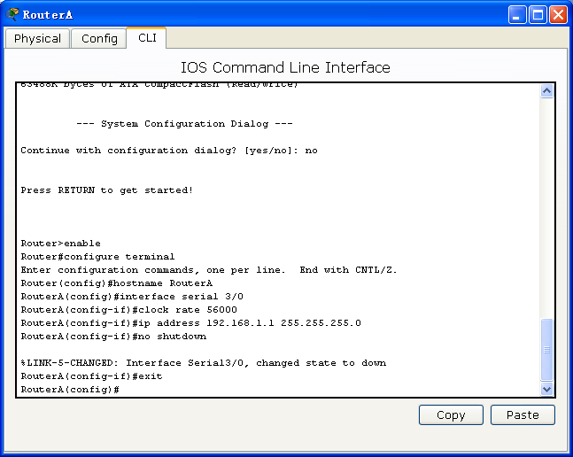

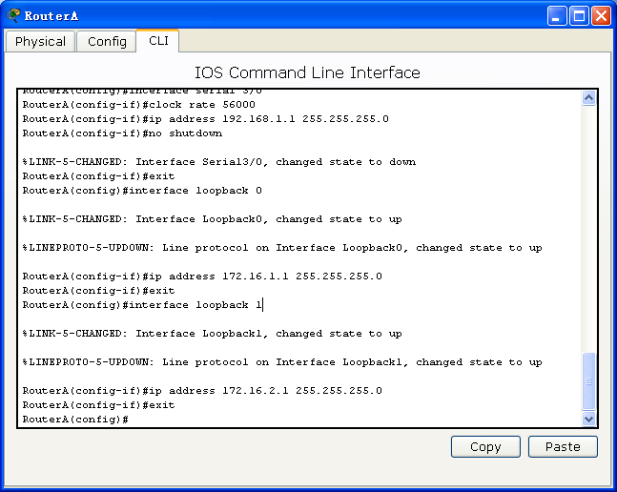

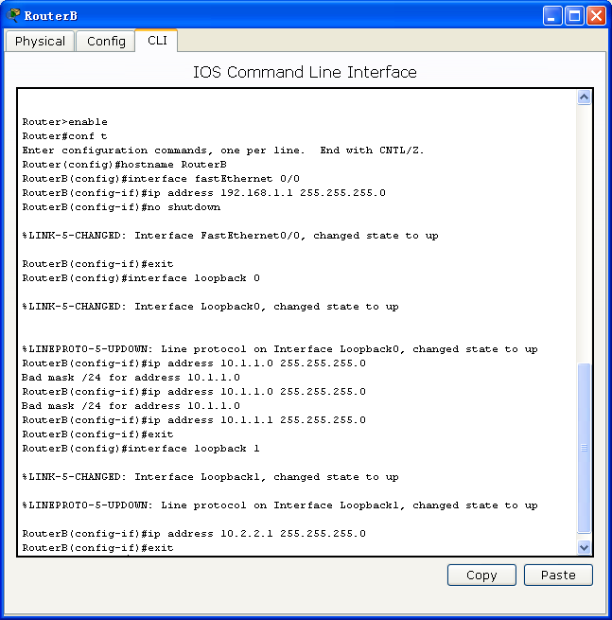

**第二步：配置静态路由**

RouterA(config)#**ip route 10.1.1.0 255.255.255.0 192.168.1.2**

！设置到子网10.1.1.0的静态路由，采用下一跳的方式

RouterA(config)#**ip route 10.2.2.0 255.255.255.0 s4/0**

！设置到子网10.2.2.0的静态路由，采用出站端口的方式

RouterB(config)#**ip route 172.16.1.0 255.255.255.0 192.168.1.1**

RouterB(config)#**ip route 172.16.2.0 255.255.255.0 s4/0**

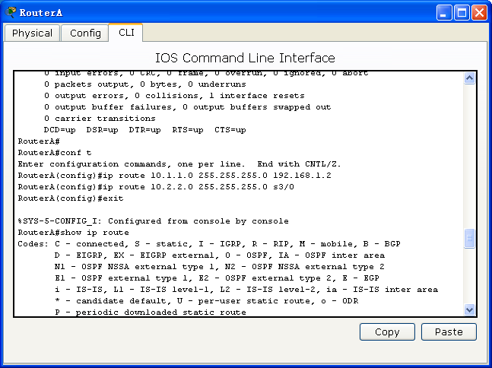

**第三步：查看路由表和接口配置**

**RouterA#show ip route**

Codes: C - connected, S - static, R - RIP B - BGP

O - OSPF, IA - OSPF inter area

N1 - OSPF NSSA external type 1, N2 - OSPF NSSA external type 2

E1 - OSPF external type 1, E2 - OSPF external type 2

i - IS-IS, L1 - IS-IS level-1, L2 - IS-IS level-2, ia - IS-IS inter area

* - candidate default

Gateway of last resort is no set

**S 10.1.1.0/24 [1/0] via 192.168.1.2**

**S 10.2.2.0/24 is directly connected, serial 4/0**

C 172.16.1.0/24 is directly connected, Loopback 0

C 172.16.1.1/32 is local host.

C 172.16.2.0/24 is directly connected, Loopback 1

C 172.16.2.1/32 is local host.

C 192.168.1.0/24 is directly connected, serial 4/0

C 192.168.1.1/32 is local host.

！可以看到以下一跳方式配置的静态路由和以出站端口方式配置的静态路由，在路由表中的显示方式是不一样的

**RouterA#show interfaces serial 4/0**

Index(dec):1 (hex):1

**serial 4/0 is UP , line protocol is UP**

Hardware is Infineon DSCC4 PEB20534 H-10 serial

Interface address is: 192.168.1.1/24

MTU 1500 bytes, BW 2000 Kbit

Encapsulation protocol is HDLC, loopback not set

Keepalive interval is 10 sec , set

Carrier delay is 2 sec

RXload is 1 ,Txload is 1

Queueing strategy: WFQ

11421118 carrier transitions

V35 DCE cable

DCD=up DSR=up DTR=up RTS=up CTS=up

5 minutes input rate 19 bits/sec, 0 packets/sec

5 minutes output rate 19 bits/sec, 0 packets/sec

95 packets input, 4134 bytes, 0 no buffer, 1 dropped

Received 69 broadcasts, 0 runts, 0 giants

0 input errors, 0 CRC, 0 frame, 0 overrun, 0 abort

94 packets output, 4118 bytes, 0 underruns , 0 dropped

0 output errors, 0 collisions, 0 interface resets

**RouterB#show ip route**

Codes: C - connected, S - static, R - RIP B - BGP

O - OSPF, IA - OSPF inter area

N1 - OSPF NSSA external type 1, N2 - OSPF NSSA external type 2

E1 - OSPF external type 1, E2 - OSPF external type 2

i - IS-IS, L1 - IS-IS level-1, L2 - IS-IS level-2, ia - IS-IS inter area

* - candidate default

Gateway of last resort is no set

C 10.1.1.0/24 is directly connected, Loopback 0

C 10.1.1.1/32 is local host.

C 10.2.2.0/24 is directly connected, Loopback 1

C 10.2.2.1/32 is local host.

**S 172.16.1.0/24 [1/0] via 192.168.1.1**

**S 172.16.2.0/24 is directly connected, serial 4/0**

C 192.168.1.0/24 is directly connected, serial 4/0

C 192.168.1.2/32 is local host.

**RouterB#show interfaces serial 4/0**

Index(dec):1 (hex):1

**serial 4/0 is UP , line protocol is UP**

Hardware is Infineon DSCC4 PEB20534 H-10 serial

**Interface address is: 192.168.1.2/24**

MTU 1500 bytes, BW 2000 Kbit

Encapsulation protocol is HDLC, loopback not set

Keepalive interval is 10 sec , set

Carrier delay is 2 sec

RXload is 1 ,Txload is 1

Queueing strategy: WFQ

11421118 carrier transitions

V35 DTE cable

DCD=up DSR=up DTR=up RTS=up CTS=up

5 minutes input rate 74 bits/sec, 0 packets/sec

5 minutes output rate 74 bits/sec, 0 packets/sec

86 packets input, 3942 bytes, 0 no buffer, 0 dropped

Received 61 broadcasts, 0 runts, 0 giants

0 input errors, 0 CRC, 0 frame, 0 overrun, 0 abort

87 packets output, 3964 bytes, 0 underruns , 0 dropped

0 output errors, 0 collisions, 1 interface resets



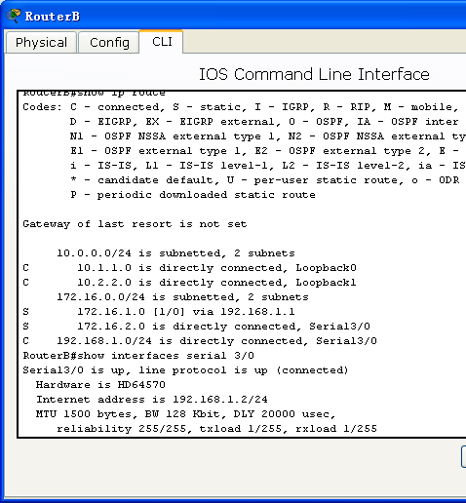

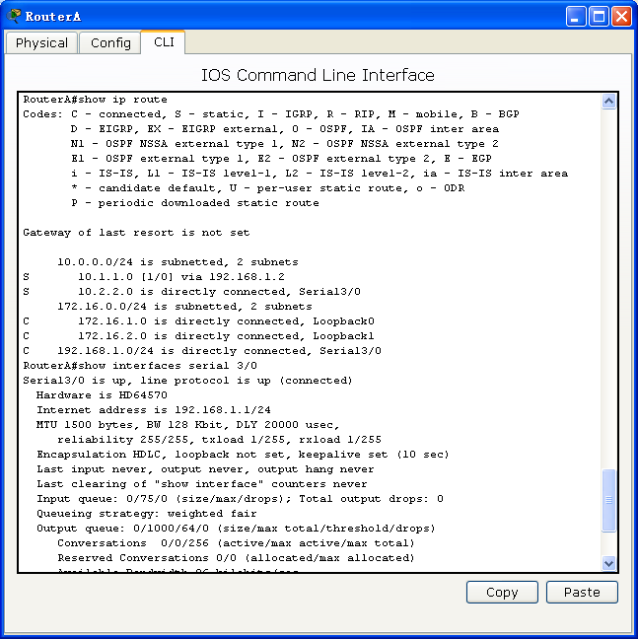

3.配置动态路由RIP协议

**第一步：配置两台路由器的主机名、接口IP地址**

RSR20#configure terminal

Enter configuration commands, one per line. End with CNTL/Z.

RSR20(config)#hostname RouterA

RouterA(config)#

RouterA(config)#interface fastEthernet 0/0

RouterA(config-if)#ip address 192.168.1.1 255.255.255.0

RouterA(config-if)#no shutdown

RouterA(config-if)#exit

RouterA(config)#

RouterA(config)#interface loopback 0

RouterA(config-if)#Aug 15 23:46:32 RouterA %7:%LINE PROTOCOL CHANGE: Interface Loopback 0, changed state to UP

RouterA(config-if)#ip address 172.16.1.1 255.255.255.0

RouterA(config-if)#exit

RouterA(config)#

RouterA(config)#interface loopback 1

RouterA(config-if)#Aug 15 23:47:00 RouterA %7:%LINE PROTOCOL CHANGE: Interface Loopback 1, changed state to UP

RouterA(config-if)#ip address 172.16.2.1 255.255.255.0

RouterA(config-if)#exit

RSR20#configure terminal

Enter configuration commands, one per line. End with CNTL/Z.

RSR20(config)#hostname RouterB

RouterB(config)#

RouterB(config)#interface fastEthernet 0/0

RouterB(config-if)#ip address 192.168.1.2 255.255.255.0

RouterB(config-if)#no shutdown

RouterB(config-if)#exit

RouterB(config)#

RouterB(config)#interface loopback 0

RouterB(config-if)#Aug 8 21:00:00 RouterB %7:%LINE PROTOCOL CHANGE: Interface Loopback 0, changed state to UP

RouterB(config-if)#ip address 10.1.1.1 255.255.255.0

RouterB(config-if)#exit

RouterB(config)#

RouterB(config)#interface loopback 1

RouterB(config-if)#Aug 8 21:00:28 RouterB %7:%LINE PROTOCOL CHANGE: Interface Loopback 1, changed state to UP

RouterB(config-if)#ip address 10.2.2.1 255.255.255.0

RouterB(config-if)#exit

**第二步：在两台路由器上配置RIP路由协议**

RouterA(config)#router rip

RouterA(config-router)#network 192.168.1.0

RouterA(config-router)#network 172.16.1.0

RouterA(config-router)#exit

RouterB(config)#router rip

RouterB(config-router)#network 192.168.1.0

RouterB(config-router)#network 10.0.0.0

RouterB(config-router)#exit

**第三步：查看RIP配置信息，路由表**

**RouterA#show ip route**

Codes: C - connected, S - static, R - RIP B - BGP

O - OSPF, IA - OSPF inter area

N1 - OSPF NSSA external type 1, N2 - OSPF NSSA external type 2

E1 - OSPF external type 1, E2 - OSPF external type 2

i - IS-IS, L1 - IS-IS level-1, L2 - IS-IS level-2, ia - IS-IS inter area

* - candidate default

Gateway of last resort is no set

**R 10.0.0.0/8 [120/1] via 192.168.1.2, 00:00:17, FastEthernet 0/0**

C 172.16.1.0/24 is directly connected, Loopback 0

C 172.16.1.1/32 is local host.

C 172.16.2.0/24 is directly connected, Loopback 1

C 172.16.2.1/32 is local host.

C 192.168.1.0/24 is directly connected, FastEthernet 0/0

C 192.168.1.1/32 is local host.

RouterA#

**Routing Protocol is "rip"**

**Sending updates every 30 seconds**, next due in 21 seconds

**Invalid after 180 seconds, flushed after 120 seconds**

Outgoing update filter list for all interface is: not set

Incoming update filter list for all interface is: not set

Default redistribution metric is 1

Redistributing:

Default version control: send version 1, receive any version

Interface Send Recv Key-chain

**FastEthernet 0/0 1 1 2**

**Loopback 0 1 1 2**

**Loopback 1 1 1 2**

Routing for Networks:

172.16.0.0

192.168.1.0

Distance: (default is 120)

RouterA#

**RouterB#show ip route**

Codes: C - connected, S - static, R - RIP B - BGP

O - OSPF, IA - OSPF inter area

N1 - OSPF NSSA external type 1, N2 - OSPF NSSA external type 2

E1 - OSPF external type 1, E2 - OSPF external type 2

i - IS-IS, L1 - IS-IS level-1, L2 - IS-IS level-2, ia - IS-IS inter area

* - candidate default

Gateway of last resort is no set

C 10.1.1.0/24 is directly connected, Loopback 0

C 10.1.1.1/32 is local host.

C 10.2.2.0/24 is directly connected, Loopback 1

C 10.2.2.1/32 is local host.

**R 172.16.0.0/16 [120/1] via 192.168.1.1, 00:00:12, FastEthernet 0/0**

C 192.168.1.0/24 is directly connected, FastEthernet 0/0

C 192.168.1.2/32 is local host.

**RouterA#show ip rip database**

10.0.0.0/8 auto-summary

10.0.0.0/8

[1] via 192.168.1.2 FastEthernet 0/0 00:09

172.16.0.0/16 auto-summary

172.16.1.0/24

[1] directly connected, Loopback 0

172.16.2.0/24

[1] directly connected, Loopback 1

192.168.1.0/24 auto-summary

192.168.1.0/24

[1] directly connected, FastEthernet 0/0

**RouterA#show ip rip interface**

**FastEthernet 0/0 is up, line protocol is up**

**Routing Protocol: RIP**

**Receive RIPv1 and RIPv2 packets**

**Send RIPv1 packets only**

Passive interface: Disabled

**Split horizon: Enabled**

V2 Broadcast: Disabled

Multicast registe: Registed

Interface Summary Rip:

Not Configured

IP interface address:

192.168.1.1/24

FastEthernet 0/1 is down, line protocol is down

RIP is not enabled on this interface

Null 0 is up, line protocol is up

RIP is not enabled on this interface

**Loopback 0 is up, line protocol is up**

**Routing Protocol: RIP**

**Receive RIPv1 and RIPv2 packets**

**Send RIPv1 packets only**

Passive interface: Disabled

**Split horizon: Enabled**

V2 Broadcast: Disabled

Multicast registe: Registed

Interface Summary Rip:

Not Configured

IP interface address:

172.16.1.1/24

**Loopback 1 is up, line protocol is up**

**Routing Protocol: RIP**

**Receive RIPv1 and RIPv2 packets**

**Send RIPv1 packets only**

Passive interface: Disabled

**Split horizon: Enabled**

V2 Broadcast: Disabled

Multicast registe: Registed

Interface Summary Rip:

Not Configured

IP interface address:

172.16.2.1/24

**RouterB#show ip rip**

Routing Protocol is "rip"

**Sending updates every 30 seconds,** next due in 21 seconds

**Invalid after 180 seconds, flushed after 120 seconds**

Outgoing update filter list for all interface is: not set

Incoming update filter list for all interface is: not set

Default redistribution metric is 1

Redistributing:

Default version control: send version 1, receive any version

Interface Send Recv Key-chain

**FastEthernet 0/0 1 1 2**

**Loopback 0 1 1 2**

**Loopback 1 1 1 2**

Routing for Networks:

10.0.0.0

192.168.1.0

Distance: (default is 120)

**RouterB#show ip rip database**

10.0.0.0/8 auto-summary

10.1.1.0/24

[1] directly connected, Loopback 0

10.2.2.0/24

[1] directly connected, Loopback 1

172.16.0.0/16 auto-summary

172.16.0.0/16

[1] via 192.168.1.1 FastEthernet 0/0 00:08

192.168.1.0/24 auto-summary

192.168.1.0/24

[1] directly connected, FastEthernet 0/0

**RouterB#show ip rip interface**

**FastEthernet 0/0 is up, line protocol is up**

**Routing Protocol: RIP**

**Receive RIPv1 and RIPv2 packets**

**Send RIPv1 packets only**

Passive interface: Disabled

**Split horizon: Enabled**

V2 Broadcast: Disabled

Multicast registe: Registed

Interface Summary Rip:

Not Configured

IP interface address:

192.168.1.2/24

FastEthernet 0/1 is down, line protocol is down

RIP is not enabled on this interface

Null 0 is up, line protocol is up

RIP is not enabled on this interface

**Loopback 0 is up, line protocol is up**

**Routing Protocol: RIP**

**Receive RIPv1 and RIPv2 packets**

**Send RIPv1 packets only**

Passive interface: Disabled

**Split horizon: Enabled**

V2 Broadcast: Disabled

Multicast registe: Registed

Interface Summary Rip:

Not Configured

IP interface address:

10.1.1.1/24

**Loopback 1 is up, line protocol is up**

**Routing Protocol: RIP**

**Receive RIPv1 and RIPv2 packets**

**Send RIPv1 packets only**

Passive interface: Disabled

**Split horizon: Enabled**

V2 Broadcast: Disabled

Multicast registe: Registed

Interface Summary Rip:

Not Configured

IP interface address:

10.2.2.1/24

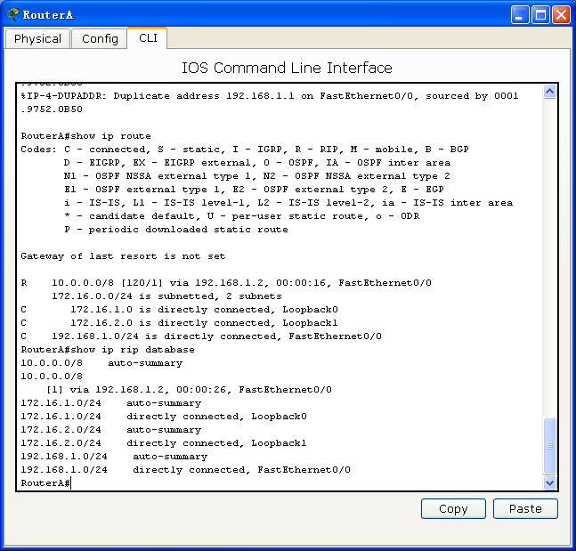

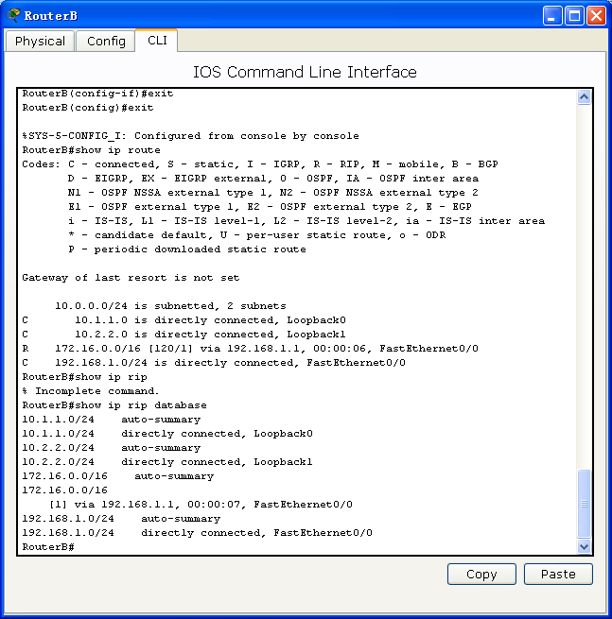

**九、实验数据及结果分析：**

**1、测试网络连通性**

**RouterA#ping 10.1.1.1**

Sending 5, 100-byte ICMP Echoes to 10.1.1.1, timeout is 2 seconds:

< press Ctrl+C to break >

!!!!!

Success rate is 100 percent (5/5), round-trip min/avg/max = 1/4/10 ms

**RouterA#ping 10.2.2.1**

Sending 5, 100-byte ICMP Echoes to 10.2.2.1, timeout is 2 seconds:

< press Ctrl+C to break >

!!!!!

Success rate is 100 percent (5/5), round-trip min/avg/max = 1/4/10 ms

路由器A能够ping通路由器B上所连接的主机。

* 静态路由：

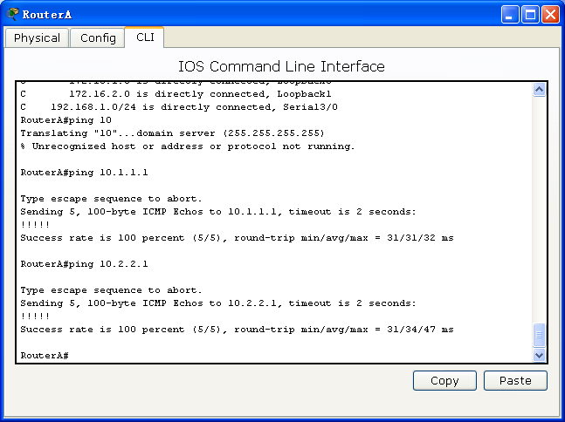

* 动态路由：

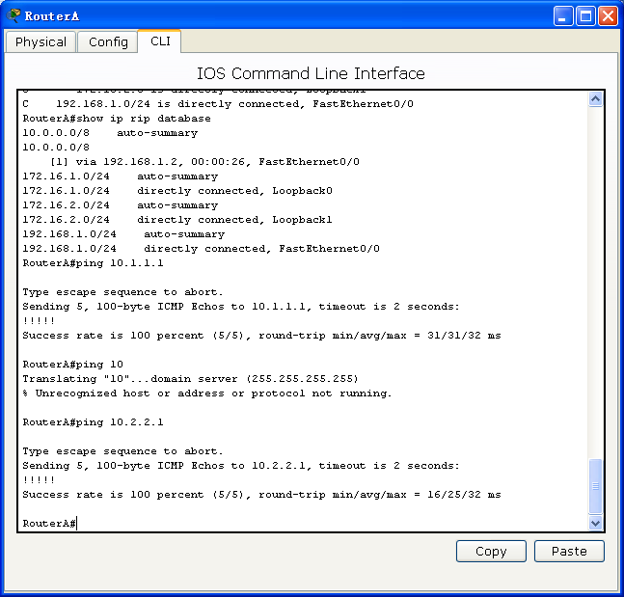

**RouterB#ping 172.16.1.1**

Sending 5, 100-byte ICMP Echoes to 172.16.1.1, timeout is 2 seconds:

< press Ctrl+C to break >

!!!!!

Success rate is 100 percent (5/5), round-trip min/avg/max = 1/4/10 ms

**RouterB#ping 172.16.2.1**

Sending 5, 100-byte ICMP Echoes to 172.16.2.1, timeout is 2 seconds:

< press Ctrl+C to break >

!!!!!

Success rate is 100 percent (5/5), round-trip min/avg/max = 1/4/10 ms

路由器B能够ping通路由器A上所连接的主机。

* 静态路由：

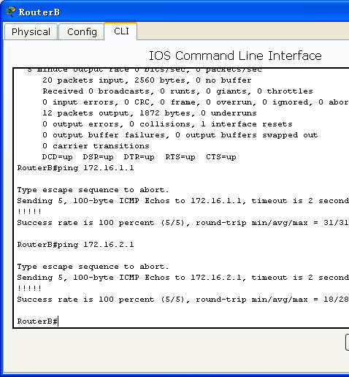

* 动态路由：

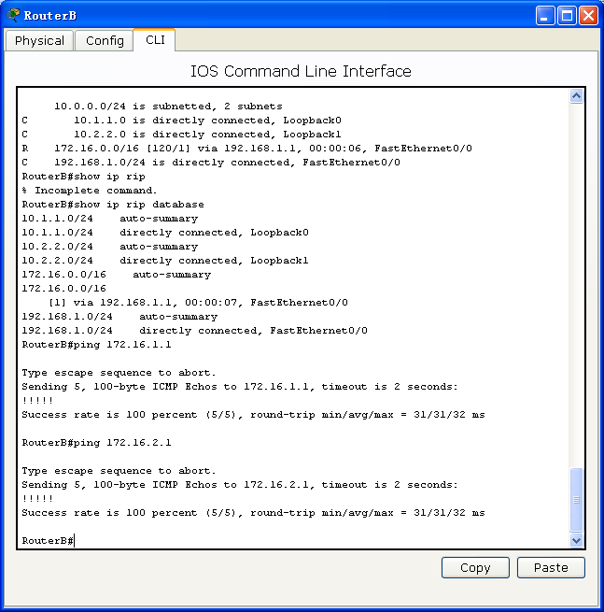

**2、用debug命令观察路由器接收和发生路由更新的情况**

下面是一个完整的RIP路由器接收更新和发送更新的过程，从中可以看到RouterB接收到了RouterA发送的更新，其中包含一条路由信息172.16.0.0（可以看到水平分割原则的作用），然后刷新了路由表。

RouterB本身发送的更新报文则在Fa0/0、Lo0和Lo1三个端口发出，采用广播的方式，广播地址分别为192.168.1.255，10.1.1.255，10.2.2.255，使用UDP 的520端口。在水平分割的原则下，每个端口发送的路由信息均不相同。

**RouterB#debug ip rip**

Aug 8 21:06:08 RouterB %7: [RIP] RIP recveived packet, sock=2125 src=192.168.1.1 len=24

Aug 8 21:06:08 RouterB %7: [RIP] Cancel peer remove timer

Aug 8 21:06:08 RouterB %7:[RIP] Peer remove timer shedule...

**Aug 8 21:06:08 RouterB %7: route-entry: family 2 ip 172.16.0.0 metric 1**

**Aug 8 21:06:08 RouterB %7: [RIP] Received version 1 response packet**

Aug 8 21:06:08 RouterB %7: [RIP] Translate mask to 16

Aug 8 21:06:08 RouterB %7: [RIP] Old path is: nhop=192.168.1.1 routesrc=192.168.1.1 intf=1

Aug 8 21:06:08 RouterB %7: [RIP] New path is: nhop=192.168.1.1 routesrc=192.168.1.1

**Aug 8 21:06:08 RouterB %7: [RIP] [172.16.0.0/16] RIP route refresh!**

Aug 8 21:06:08 RouterB %7: [RIP] [172.16.0.0/16] RIP distance apply from 192.168.1.1!

Aug 8 21:06:08 RouterB %7: [RIP] [172.16.0.0/16] ready to refresh kernel...

**Aug 8 21:06:08 RouterB %7: [RIP] NSM refresh: IPv4 RIP Route 172.16.0.0/16 distance=120 metric=1 nexthop_num=1 distance=120 nexhop=192.168.1.1 ifindex=1**

Aug 8 21:06:08 RouterB %7: [RIP] [172.16.0.0/16] cancel route timer

Aug 8 21:06:08 RouterB %7: [RIP] [172.16.0.0/16] route timer schedule...

Aug 8 21:06:23 RouterB %7: [RIP] Output timer expired to send reponse

Aug 8 21:06:23 RouterB %7: [RIP] Prepare to send BROADCAST response...

**Aug 8 21:06:23 RouterB %7: [RIP] Building update entries on FastEthernet 0/0**

**Aug 8 21:06:23 RouterB %7: network 10.0.0.0 metric 1**

Aug 8 21:06:23 RouterB %7: [RIP] **Send packet to 192.168.1.255 Port 520 on FastEthernet 0/0**

Aug 8 21:06:23 RouterB %7: [RIP] Prepare to send BROADCAST response...

**Aug 8 21:06:23 RouterB %7: [RIP] Building update entries on Loopback 0**

**Aug 8 21:06:23 RouterB %7: network 10.2.2.0 metric 1**

**Aug 8 21:06:23 RouterB %7: network 172.16.0.0 metric 2**

**Aug 8 21:06:23 RouterB %7: network 192.168.1.0 metric 1**

Aug 8 21:06:23 RouterB %7: [RIP] **Send packet to 10.1.1.255 Port 520 on Loopback 0**

Aug 8 21:06:23 RouterB %7: [RIP] Prepare to send BROADCAST response...

**Aug 8 21:06:23 RouterB %7: [RIP] Building update entries on Loopback 1**

**Aug 8 21:06:23 RouterB %7: network 10.1.1.0 metric 1**

**Aug 8 21:06:23 RouterB %7: network 172.16.0.0 metric 2**

**Aug 8 21:06:23 RouterB %7: network 192.168.1.0 metric 1**

Aug 8 21:06:23 RouterB %7: [RIP] **Send packet to 10.2.2.255 Port 520 on Loopback 1**

Aug 8 21:06:23 RouterB %7: [RIP] Schedule response send timer

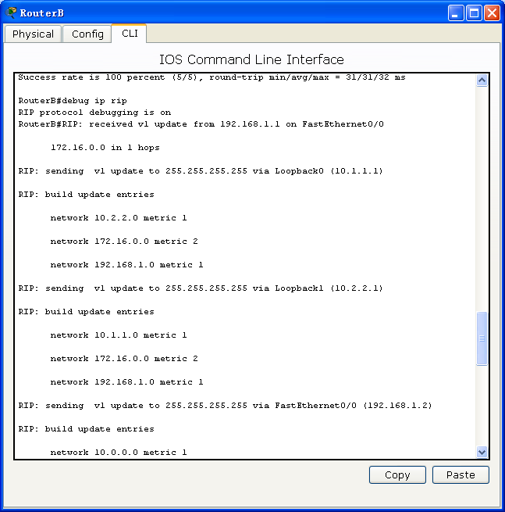

**十、实验结论：**

1. 通过静态路由或者动态路由方式可以配置路由器的路由表，实现网络互通。

**十一、总结及心得体会：**

1. 在拓扑结构简单的网络中，可以通过静态路由的方式（手动配置路由）来配置路由表。

2. 大规模的网络中，或网络拓扑相对复杂的情况下，可以通过在路由器上运行动态路由协议，路由器之间互相自动学习产生路由信息来配置路由器。

**十二、对本实验过程及方法、手段的改进建议：**

附加实验难度有点高，老师可以讲解一下。

**报告评分：**

**指导教师签字：**