Author’s Guide for Preparing a Paper for the Journal of Computer Science & Technology

Guía para Autores que Preparen un Artículo para Journal of Computer Science & Technology

First Author1,2, Second Author2 and Last Author1

1*University Department, University Name, City, State ZIP/Zone, Country*

{firstauthor, lastauthor}@mail.dom

2 *Group, Company, City, State ZIP/Zone, Country*

secondauthor@mail.dom

Abstract [1]

These instructions give you guidelines for preparing papers for the Journal of Computer Science & Technology. The abstract should summarize the content of the paper. Try to keep the abstract below 200 words. Do not make references nor display equations in the abstract. The journal will be printed by photo-offset from the same-sized copy prepared by you. Your manuscript should be printed on A4 paper (21.0 cm x 29.7 cm). It is imperative that the margins and style described below be adhered to carefully. This will enable us to keep uniformity in the final printed copies of the Journal. Please keep in mind that the manuscript you prepare will be printed practically as it is received. Readability of copy is of paramount importance.

Keywords: Enter key words or phrases in alphabetical order (5 maximum), separated by commas.

Resumen [2]

This section should be a properly Spanish translated version of the Abstract. The limit of 200 words remains as in the previous section.

Palabras claves: Enter previous key words or phrases in alphabetical order in Spanish, separated by commas.

1. Important information

The submitted papers must be original. Do not submit a reworked version of a paper you have submitted or published elsewhere. Do not publish “preliminary” data or results. The submitting author is responsible for obtaining agreement of all coauthors and any consent required from sponsors before submitting a paper. The authors must cite relevant prior work. There is a limit of 12 pages for each paper in the Journal, but authors can ask for additional pages (if required). Each submission should be a .pdf file submitted through the JCS&T management system.

1. Preparation of manuscript
   1. General appearance

The text must be in English. The submitted typeset scripts of each contribution must be in their final form and of good appearance since they will be printed directly with minor edition. It is essential that the *camera-ready copies* be absolutely clean and unfolded.

Your paper must be printed in two columns. Columns should be balanced in the last page. The document you are reading is printed in the format that should be used in your paper.

* 1. Specification

To ensure uniformity of appearance for the Journal, your paper should conform to the following specifications. If your paper deviates from these specifications, the printer may not be able to include your paper in the Journal.

1. The top, bottom, left, and right margins should be 2.5 cm, except for the first page where the top margin should be 3.5 cm.
2. The distance between the two columns of text should be 1cm.
3. Font size

The font size must be 10 points. This document is set in 10-point Times. Some technical formatting programs print mathematical formulas in italic type, with subscripts and superscripts in a slightly smaller font size. This is acceptable.

1. Major headings

Major headings are to be left-aligned in a bold font without underline. They must be numbered. For example, the text **4. Major headings** at the top of this paragraph is a major heading.

* 1. Subheadings

Subheadings should be in a bold font and start at the left-hand margin on a separate line.

* + 1. Sub-subheadings

Sub-subheadings should be in a bold font and left-aligned too.

1. Illustrations

The illustrations can be in color. However, because printed version will be in black and white, you must ensure a clear view in grayscale. All illustrations must have a DPI of 200 or more. The caption must be placed *after* the graphic. All figures must be mentioned in text, like this Fig. 1.

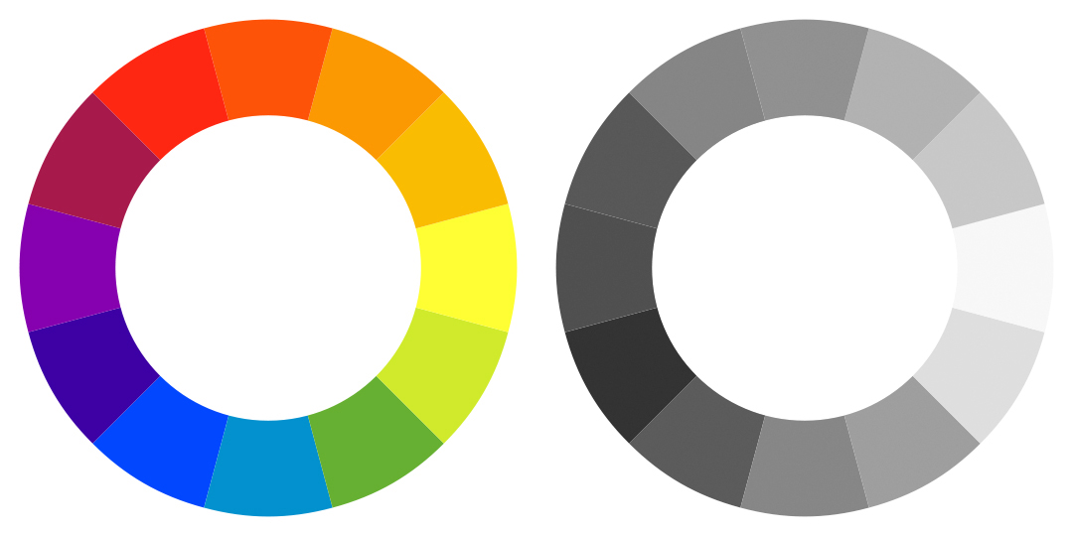

Fig. 1 Sample image.

1. Algorithms

Algorithms must be in black and white. The caption must be placed before the algorithm and is obligatory. All algorithms must be mentioned in text, like this Algorithm 1.

**Algorithm 1** Sample algorithm

1. *sum =* 0 ► Initialize *sum*
2. **for** *i ≤ n* **do**
3. **if** *i %* 2 *==* *0* **then**
4. *sum += i*
5. **end if**
6. **end for**
7. print(*sum*)
8. Equations

All equations must be typed or written neatly in black. They should be numbered consecutively throughout the text. Equation numbers should be enclosed in parentheses and flushed right. Equations should be referred to as Eq (1) in the text where (1) in this case is the equation number.

${\left(1+x\right)}^{n}=1+\frac{nx}{1!}+\frac{n\left(n-1\right)x^{2}}{2!}+…$ (Eq. 1)

In multiple-line equations, the number should be given on the last line.

${\left(1+x\right)}^{n}=1+\frac{nx}{1!}+\frac{n\left(n-1\right)x^{2}}{2!}+…$

$=\sum_{i=0}^{n}{\left(\begin{matrix}n \\ i\end{matrix}\right)x^{i}}$ (Eq. 2)

If you are using Word, use either the Microsoft Equation Editor or the MathType add-on (http://www.mathtype.com) for equations in your paper.

1. Tables

Tables must be in black and white. The caption must be placed before the table and is obligatory. The table must not contain vertical lines or borders. All tables must be mentioned in text, like this Table 1.

Table 1 Sample table.

|  |  |  |  |
| --- | --- | --- | --- |
| ***D***  **(in)** |  | ***Pu***  **(lbs)** | ***σN***  **(psi)** |
| 5 | test 1 | 285 | 38.00 |
|  | test 2 | 287 | 38.27 |
|  | test 3 | 230 | 30.67 |
| 10 | test 1 | 430 | 28.67 |
|  | test 2 | 433 | 28.87 |
|  | test 3 | 431 | 28.73 |
|  |  | | |

1. Page numbering

Please do NOT number your pages.

1. Footnotes

Should be typed in singled-line spacing at the bottom of the page and column where it is cited. Footnotes should be rare.

1. Conclusions

The better you look, the better we all look. Thanks for your cooperation and contribution.

1. References

The reference style employed is *IEEEtran*. For the sake of clarity, this document presents example of this style for books [1], journal articles [2], technical reports [3], papers from conference proceedings [4], M.S. thesis or Ph.D. dissertations [5] and Internet [6].

Remember that all bibliographical references must be numbered according to its appearance order in the text. When referenced in the text, enclose the citation number in square brackets, for example [1] for single reference or [2,3,4,5] for multiple references.

The preferred citing package in LaTeX is *bibtex*. In case you use the MS Word template, we strongly recommend using a reference manager, like Zotero, EndNoteTM or Mendeley ©.

Acknowledgements

This paragraph is optional and is meant to acknowledgements and support/funding information.

Competing interests

This paragraph is required and authors must declare their competing interesting here. If no competing interests exist, the next phrase is accepted: “The authors have declared that no competing interests exist.”

References

1. R. Pressman, *Software Engineering: A Practitioner’s Approach.* New York, NY, USA: McGraw-Hill, Inc., 7 ed., 2010.
2. T. Smith and M. Waterman, “Identification of common molecular subsequences,” *Journal of Molecular Biology*, vol. 147, no. 1, pp. 195–197, 1981.
3. F. Long, P. Amidon, and M. Rinard, “Automatic inference of code transforms and search spaces for automatic patch generation systems,” tech. rep., CSAIL Lab, MIT, 07 2016. MIT-CSAIL-TR-2017-008.
4. F. Song and J. Dongarra, “Scaling up matrix computations on shared-memory manycore systems with 1000 cpu cores,” in *ICS ’14 Proceedings of the 28th ACM international conference on Supercomputing*, pp. 333–342, 2014.
5. J. Nash, *Non-Cooperative Games*. PhD thesis, Princeton University, 1950.
6. “Journal of Computer Science & Technology.” Available at: <http://journal.info.unlp>.edu.ar/. Accessed on 2017-05-15.

1. **Citation:** F. Author, S. Author and L. Author. “*Author’s Guideline for Preparing a Paper for the Journal of Computer Science & Technology”,* Journal of Computer Science & Technology, vol. 18, no. 2, pp. 1–3, 2018

   **DOI:** 10.24215/16666038.18.e01

   **Received:** April 8, 2016 **Accepted:** August 15, 2017

   **Copyright:** This article is distributed under the terms of the Creative Commons License CC-BY-NC.
2.