C’e’ una discrepanza di 1.749 mm fra il punto del cas-focus in zemax e quello calcolato in approx parassiale.

M2 thicknes (approx parassiale): 1331.249 mm
M2 thickness zemax: 1329.500 mm

Il motivo e’ la curvatura del piano focale che risulta in esattamente una differenza di 1.749 fra il fuoco in asse e quello a 0.1deg

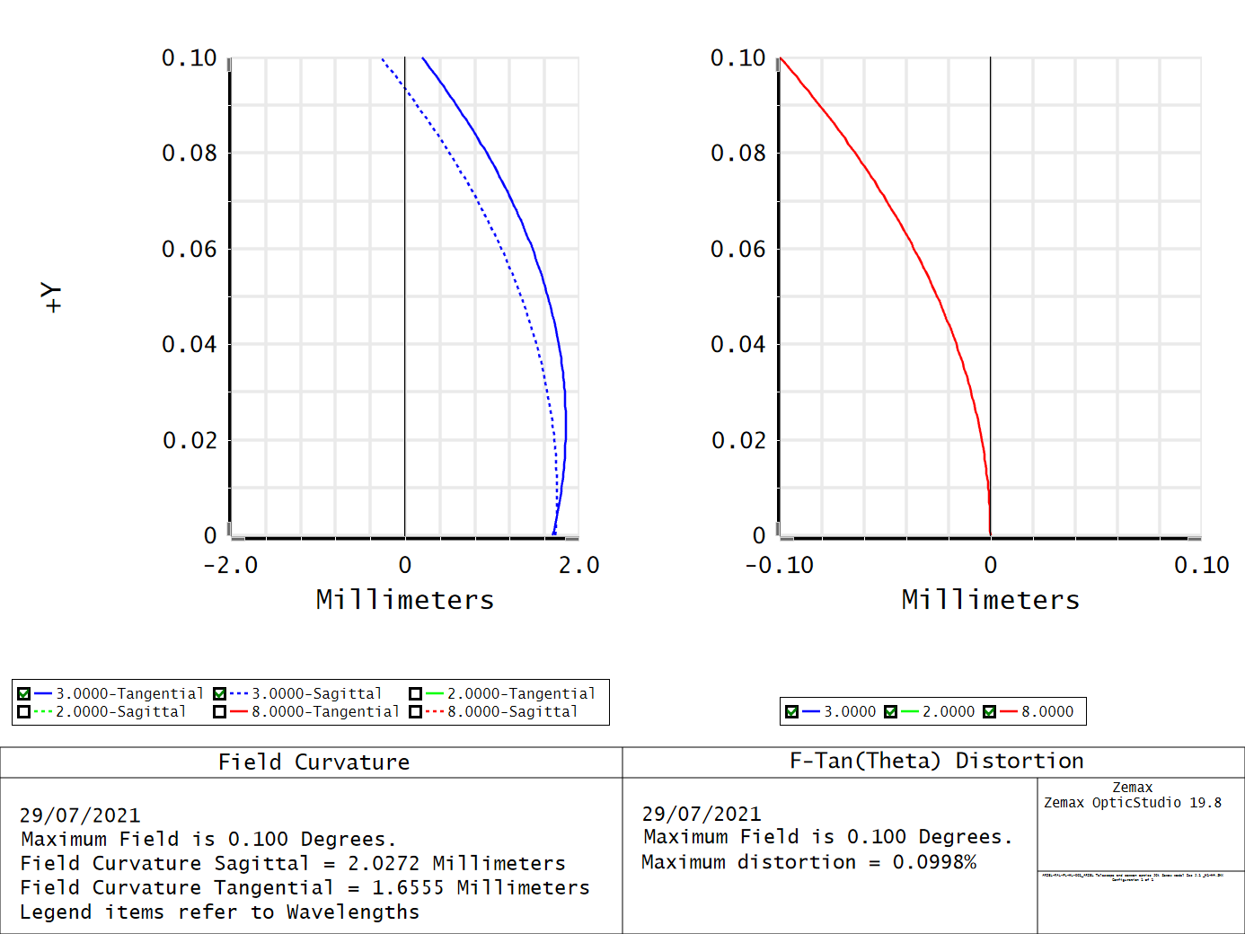

Come scritto nell’articolo di proper
It cannot, for instance, predict the effects of multiple conic optics except in the purely paraxial case.

Perche’

A lens operator, representing a thin refractive or reflective surface with power, is used to impart a radially-quadratic phase change. This has the effect of altering the curvature of the wavefront, causing the beam to converge or diverge with additional propagation distance. Any real systems that might contain conic, aspheric, or other non-parabolic lenses or mirrors must be represented using these simple lenses. Future versions of the library may integrate ray tracing to support other lens types.

Quindi, PROPER non e’ in grado di simulare correttamente un telescopio fuori asse.

A questo si aggiunge

cannot handle phase aberrations that are large enough to cause aliasing in the
computational grid

Che gia’ sappiamo

Cosa fare ora.
Vedere se si riesce a risolvere il problema dell’aliasing. Cosi’ almeno riusciamo a utilizzare le aperture….

Optical coordinates
Optical coordinates are defined as in the diagram below
z1
z2
u1
u2
z
y
y
where:
- z₁ is the coordinate of the object (negative in the diagram)
- z₂ is the coordinate of the image (positive in the diagram)
- u₁ is the slope, i.e. the tangent of the angle = angle in paraxial approximation; u₁ is positive in the diagram.
- u₂ is the slope, i.e. the tangent of the angle = angle in paraxial approximation; u₂ is negative in the diagram.
- y is the coordinate where the rays intersect the thin lens (coloured in red n the diagram).
The lens (of focal length f) equation is
(1)

The tangential plane is the YZ plane
The sagittal plane is the XZ plane

ABCD ray tracing
Paraxial ray tracing in the tangential plane can be done defining the vector , describing a ray propagating in the tangential plane.
Paraxial ray tracing can be done using ABCD matrices
In the sagittal plane, same equation apply, modified when necessary when cylindrical symmetry is violated. The relevant vector s

Propagation
Either in free space or in a refractive medium, propagation over a distance T (positive left → right) is given by

(2)

Thin lenses
A thin lens changes the slope and this is given by

(3)

Where φ = 1/f is the lens power

Dioptre
When light propagating from a medium with refractive index n₁ enters in a dioptre of refractive index n₂, the slope varies as

(4)

with the dioptre power , where R is the radius of curvature. R is positive if the centre of curvature is at the right of the dioptre, and negative if at the left.

Medium change
The case of a dioptre with R → ∞, represents a change of medium

(5)

Think/thin lenses
A real (thick) lens is modelled as
(6)
i.e. propagation through the dioptre a (first encountered by the ray), then a propagation in the medium, followed by the exit dioptre b.
Note that when the thickness of the dioptre, T, is negligible and can be set to zero, this gives back the thin lens ABCD matrix.

Prism
The prism changes the slope and the magnification. The ABCD matrices for the tangential and sagittal transfer are reported by Tache’ (Applied Optics, 26, 3, 1987) and reported below.
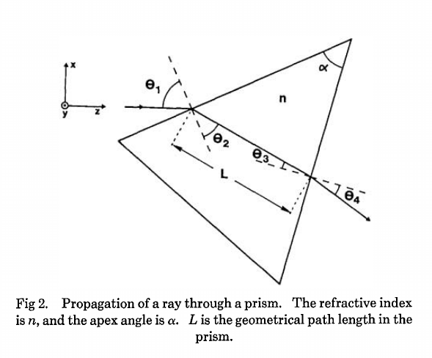
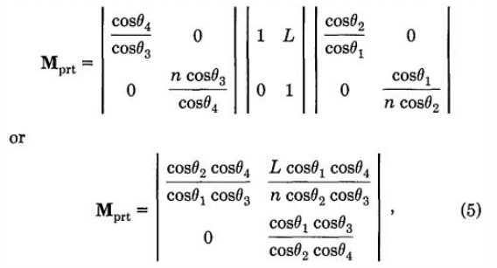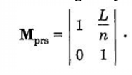

Optical system equivalent
Any optical system can be considered a black box described by an effective ABCD matrix.
This black box and its matrix can be decomposed into 4 , non-commuting primitives such as

(7)
where T, φ, n₁/n₂, M are, respectively, the effective thickness, power, refractive index ratio, and magnification. Not to be confused with thickness, power, refractive index ratio, and magnification, of the optical system under study and its components.

From the POP point of view, this can be implemented as a series of operations, when needed
- Apply optical magnification (TBD). Modifies u and y
- Apply change of medium. Modifies u
- Apply thin lens. Modifies y
- Applies propagation. Modifies y

The parameters are estimated as follows

(8)

Thick lens equivalent
A thick lens can be implemented as two spherical surfaces separated by some distance, and a medium change. The ABCD matrix is

(9)
This is equivalent to two thin lenses separated by some distance, described by the ABCD matrix

(10)
where

(11)
The curvature radii, R₁ and R₂, follow the usual sign convention: positive if the centre lies in the image space, and negative if it lies in the object space.

With the factorisation of Equation (7),

(12)

Coordinate breaks
Zemax defines coordinate breaks as follow:
Decenter by Xdec, Ydec
Rotation XYZ (first X, then Y, then Z). It is not clear from the manual if the rotation is extrinsic (relative to the parent frame) or intrinsic (X, then around new Y, then around new Z).
I am assuming intrinsic and I want to transform the sagittal coordinates (x, u_{x}), and the tangential coordinates (y, u_{y}).
Define the position vector and the unit vector of the light ray where z is an appropriate projection of the unit vector such that u_{x} and u_{y} are the tangent of the angles (although we are in paraxial approximation and these subtleties might not be necessary). Note that z does not need to be calculated, because gets normalised away.
The position on the rotated x’-y’ plane would be and the relation is
(13)
That can be solved as

(14)

Gaussian beam propagation
For a Gaussian beam, a complex parameter q(z) can be defined as

(15)

Propagating through an ABCD element gives the following transformation

(16)

Magnification
For magnification, A = M, D = 1/M, B=C=0.
Therefore q₂ = M² q₁.

It follows that
- R₂ = M²R₁,
- w₂ = Mw₁
- z_{R,2} = M² z_{R,1} (Rayleigh distance)
- w_{0,2} = Mw_{0,1}
- z₂ = M² z₁ (distance to focus)

In Paos, the Gaussian beam width is set along x. So, only the sagittal magnification changes the Gaussian beam properties. A tangential magnification changes only the curvature of the propagating wavefront.

Change of medium
For medium change (from n1 to n2) , A = 1, B = 0, C=0, D=n1/n2
Therefore q₂ = q₁ n₂/n₁
- R₂ = R₁ n₂/n₁ ,
- w₂ = w₁
- z_{R,2} = z_{R,1} n₂/n₁(Rayleigh distance)
- w_{0,2} = w_{0,1}
- z₂ = z₁ n₂/n₁ (distance to focus)

Wavefront phase from a thin lens
A lens modifies the phase of an incoming beam.
Consider a monochromatic collimated beam travelling with slope u = 0, incident on a paraxial lens, orthogonal to the direction of propagation of the beam.
The planar beam is transformed into a converging or diverging beam. That means, a spherical wavefront with positive curvature for a converging beam, or a negative curvature for a diverging beam. The convergent beam situation is described by the diagram below.

f
θ
z
y
y
Δz
The sag, Δz, depends from the x and y coordinates, and it introduces a delay in the complex wavefront (z=0 can be assumed) incident on the lens:

(17)

The sag can be estimated using the Pythagoras theorem and evaluated in small angle approximation, that is

(18)

The phase delay over the whole lens aperture is then

(19)

When the incoming collimated beam has a slope u₁, its phase on the plane of the lens is given by

z
y

u1
to which the lens adds a spherical sag. The total phase delay is then

(20)
Apart from the constant phase term, that can be neglected, this is a spherical wavefront centred in (0, y₀, f), with y₀ = f u₁. Note that in this approximation, the focal plane is planar.

The case of off-axis optics is described in the diagram below.
z
y

u2
The beam centre is at y_{c}. Let δy be a displacement from y_{c} along y. The lens induced phase change is then
(21)
If the incoming beam as a slope u₁, then

(22)
Apart from constant phase terms, that can be neglected, this is equivalent to a beam that is incident on-axis on the lens. The overall slope shifts the focal point in a planar focal plane. No aberrations are introduced.

Wavefront propagation through a prism
The propagation through the prism can be implemented in two steps. A beam magnification through the first surface, a medium change and a propagation in the medium, followed by the magnification occurring at the second interface. There is a difference in the tangential and sagittal planes.

The Tangential and Sagittal ABCD matrices are, respectively
(23)

where M₁ and M₂ are the magnifications (see section on prism), and n₁ = 1.
Let u(x,y) be the complex field
- Magnification by M₁
- Change of medium
- Propagation by a distance L in the medium
- Change of medium
- Magnification by M₂
By a simple change of integration variable, the same expression can be written as
The latter equation shows that the propagation through the prism is equivalent to
- Magnification by M₁M₂
- Propagation by a distance Ln₁/n₂ and L n₁/n₂ M₂² in the sagittal and tangential planes, respectively.
Indeed, point b) is in agreement with the full ABCD transformation. The elementary transformations from Equation (23) are
- Tangential:
  - Magnification: M₁M₂
  - Propagation: L n₁/n₂ M₂²
- Sagittal
  - Magnification: 1
  - Propagation: L n₁/n₂

POP propagation in PROPER
Initialize the beam at the centre of the aperture, annotate y_{c}, u, then repeat in a loop:
- Project aperture on the plane orthogonal to the beam. If the aperture is (y_{s}, phi_{x}, phi_{y}), the aperture should be set as .
- Apply aperture
- Apply lens
- Apply propagate
- Apply ABDS matrix and uodate
- Apply M1 ABCD matrix and update y_{c}, u
- Apply M2 thickness ABCD matrix and update y_{c}, u
- Apply PROPER lens
- repeat over all optical elements

lens file definition
Units
Type | Units
Angles | degrees
Lens units | meters
Wavelengths | micron

Lens file sections
[DEFAULT]
Section required, but not used.
[general]
keyword | type | description
project | string | A string defining the project name
version | string | Project version (e.g. 1.0)
grid_size | int | Grid size for simulation. Must be in [64, 128, 512, 1024]
zoom | int | Zoom size. Must be in [1, 2, 4, 8, 16]

[wavelengths]
keyword | type | description
w1 | float | First wavelength
w2 | float | Second wavelength
… | … | ...

[fields]
keyword | type | description
f1 | float, float | Field 1, sagittal (x) angle and tangential (y) angle, respectively
f2 | float, float | Field 2, sagittal (x) angle and tangential (y) angle, respectively
… | … | ...

[lens_xx]
SurfaceType | Comment | Radius | Thickness | Material | Save | Ignore | Stop | aperture | Par1..N
INIT | String,  this surface name | None | None | None | None | None | None | list | None
Coordinate Break | String,  this surface name | None | float | None | Bool | Bool | Bool | None | Xtilt,Ytilt,Xdecenter, Ydecenter
Standard | String,  this surface name | float | float | MIRROR  others | Bool | Bool | Bool | list | None
Paraxial Lens | String,  this surface name | None | float | None | Bool | Bool | Bool | list | Pat1=focal length (float)
ABCD | String,  this surface name | None | float | None | Bool | Bool | Bool | list | Par1..4 = Ax, Bx, Cx, Dx (sagittal)  Par5..8 = Ay, By, Cy, Dy (tangential)
Zernike | String,  this surface name | None | None | None | Bool | Bool | Bool | TBD | TBD

Note: the aperture keyword is a list with the following format
- aperture=shape type, wx, wy, xc, yc
- shape: either ‘elliptical’ or ‘rectangular’
- type: either ‘aperture’ or ‘obscuration’
- wx, wy: semi-axis of elliptical shapes, or full length of rectangular shape sides
- xc, yc: coordinates of aperture centre
example:
aperture = elliptical aperture, 0.5, 0.3, 0.0, 0.0

