


Deployment Manual
Project Evaluation | Cloud Chief Architect
by Ariel Sepulveda (cascompany@gmail.com)

The project include 5 files :
- Deployment_manual.docx
- Design_Document.docx
- README.TXT
- Diagrama.jpg
- solucion.json

To deploy this project, you only need, the last one : solucion.json

Now, this can be done in 2 ways, in a simple way using a browser, or in the hard way using the console, I will focus one the simple way, for a human being that don’t have all developer tools installed, because if he do, he probably already know how to do this.

THE EASY WAY

- Using any web browser, go to and login in AWS Console :
https://aws.amazon.com
- If you don’t have an account, create one from here:
https://portal.aws.amazon.com/gp/aws/developer/registration/index.html
Once you have your account setup, make sure you login on it, and look at TOP-RIGHT corner, select one of this Regions (This is because this are the 3 zones that supports both EFS and Multi-AZ features of AWS)
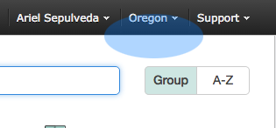
  - US East (N.Virginia)
  - US West (Oregon)
  - EU (Ireland)

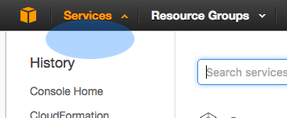
Before continue, you need to setup a Key Pair.
Now, go to TOP-LEFT, and click on Services, and then search for EC2
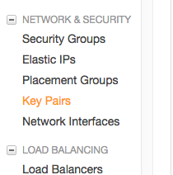
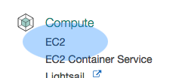
Is under Compute section.

Then, you will see a menu on the left, you need to look for NETWORK & SECURITY Group, and click on
Key Pairs.
Or you can just, follow this link :
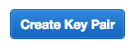
https://console.aws.amazon.com/ec2/v2/home?region=us-east-1#KeyPairs:

Now, click on the Create Key Pairs Button

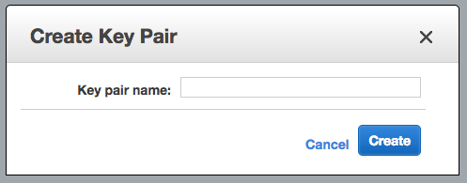
Choose a Name, keep
It simple.

Then click, Create, it will
Download a .PEM file, save this file for future use. (Login to Servers)

Now that we have the KEY PAIR, we move on the interesting part, go to Services Button Again, and now, choose “CloudFormation”
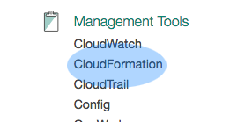

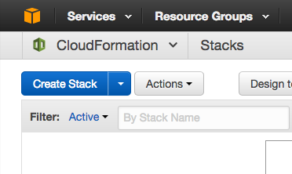
Now you are in the CloudFormation Service, with a bright blue button that says “Create Stack”

Yes, Click on it.

Now, in the next screen you need to upload the template file “solucion.json” using the Upload button (choose file) as pictured.

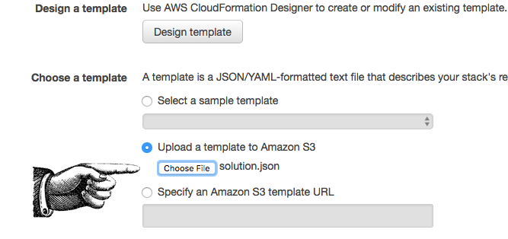
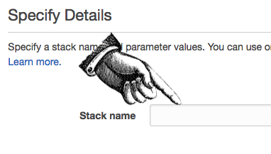
Now, you need to put all the parameters for the build, is not hard, most of them can be left as default for a test install. First, choose a Stack Name, do not use spaces or special characters, just alphanumeric.

Then, click on KeyName and it will show you the available key (the one you have registered).
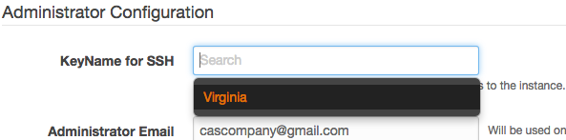

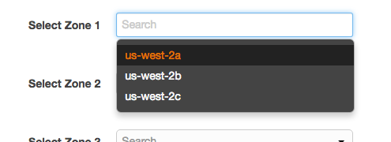
All the other options, and the RDS Database Configuration part, speaks for themselves, and you can leave them as default. However, you may want to enable Multi-AZ Option.
On the Availability Zone, just like you did in KeyName for SSH, you need to click, and select one of the Availability Zones, in each, select all different when possible.

In EFS configuration, you can change the Name and Mount Point of the Elastic File System, it will also change the Apache Document Root to this Dir.

Then, just click
You go to the OPTIONS page, you can again, click


Finally, to the Review, just scroll to the bottom, click on the “I acknowledge that…”
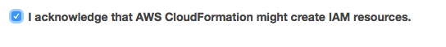
And Then, just

You will see a screen like this, with a PENDING status, wait until it´s COMPLETE.
Note: This may take 20 to 30 minutes, so, be patient.
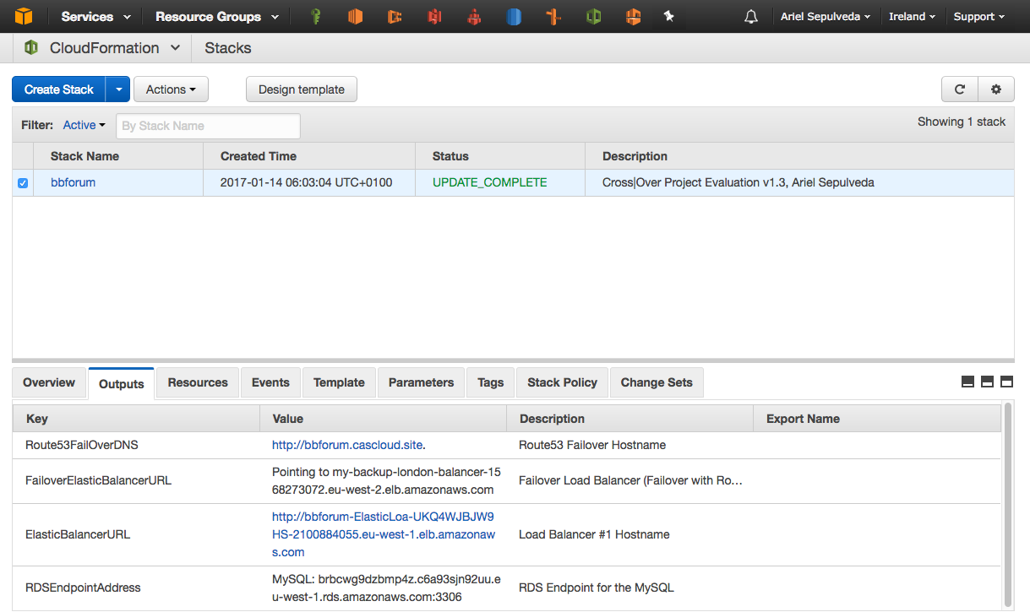

When this process finish, you can view in the Output, a link to the ElasticBalancer where you can view the website, as well as the MySQL endpoint, and as a example, a registered Route53 DNS Name and a second Balancer URL in another VPC (this are just for reference, not intended to be used to load the website.)
RESULT
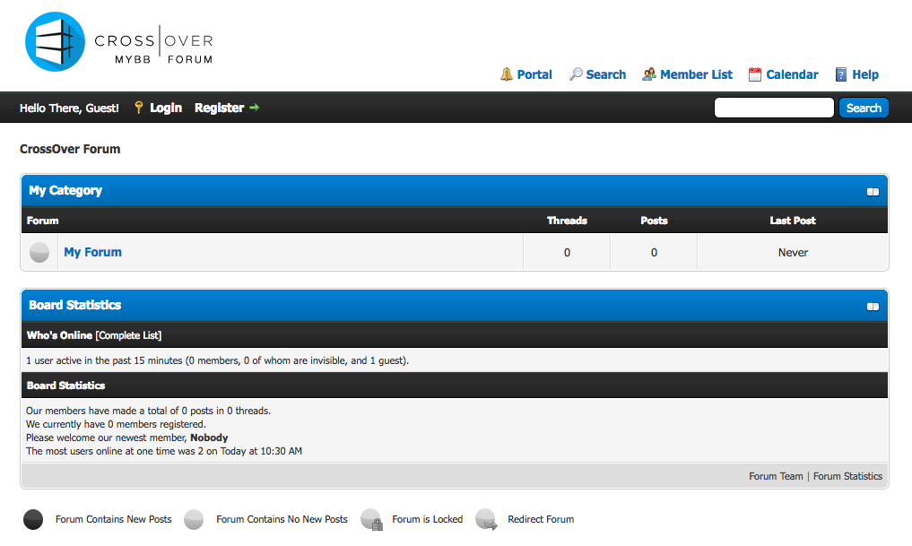

TIP: If you want to login as the Admin, use the Username and Password you provided for the RDS Database.

KNOW THE POWER

Install AWS CLI if you don’t have it.
Follow instructions here : http://docs.aws.amazon.com/cli/latest/userguide/installing.html
Once you get your “ACCESS KEY” and “SECRET ACCESS KEY”, you may configure, and run commands on the console.

$ aws configure –profile myuser
This will Configure, set Default Region as us-east-1, us-west-2 or eu-west-1 and text for output.

$ aws ec2 create-key-pair --query "KeyMaterial" --key-name myKey --output text > ./myKey.pem
This command, will create a keypair for you, you can use later to deploy, etc.

For full command reference, please check on Amazon Docs :
http://docs.aws.amazon.com/cli/latest/userguide/cli-chap-using.html

Deployment Manual V1.0 – Ariel Sepulveda (cascompany@gmail.com) - +34 663429244

