


Design Document
Project Evaluation | Cloud Chief Architect
by Ariel Sepulveda (cascompany@gmail.com)

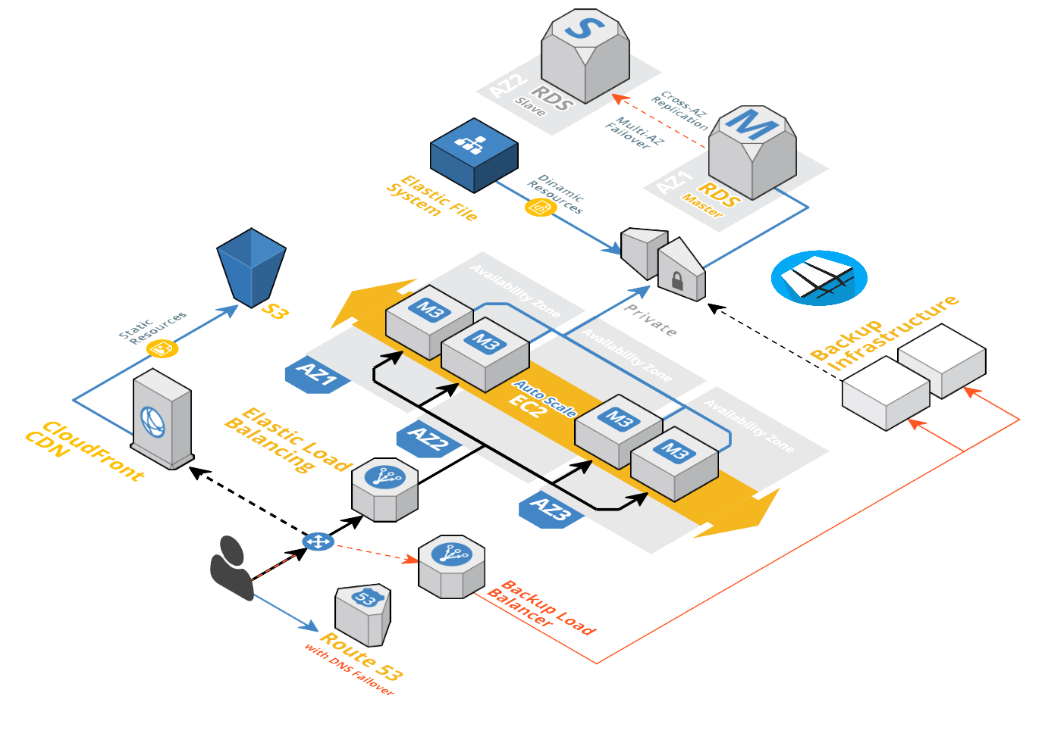
The project consists on the architecture & design of a High Availability application on the Amazon Web Services, to operate a MyBB Forum Board.

In this picture, we can see all the main
Components of the infrastructure
that operate to provide the maximum
possible uptime and scalability.

It starts, right here >>
The user makes a request
for domain, and is sent to >>
Route53 DNS.

What happens next ?

- Route53: Haves two records for this zone, with two Load Balancers, main one, and backup one, if everything is okey, the user will get the IP for the Elastic Load Balancer #1. Route53 checks all the time if the first balancer is healthy, and If it’s not, it will send the requests inmediatly to the Backup Load Balancer. (Another infrastructure build, maybe in another location, with a similar configuration to this one to hold the traffic, OR, a simple web server with a “We are working on this site” web page, that at least, will not look so bad as a 404 or 500 error.

- Route 53: Sends the Elastic Balancer IP Address, because it’s healthy.

- Client then, requests the webpage to this IP, the load balancer, have a Auto Scaling group behind, with minimum of 2 instances running, and it checks them for being healthy as well, or they are removed from the balancer, or even, terminated to create a new one that works.

- So the request, will reach one of the servers for a specified file, each EC2 instance, is running a Elastic File System mounted as a NFS disk on the Apache Document Root, so every in the site is there, and all the servers, will share the same files, removing sync problems on servers running cron tasks or similar methods. However, there is an option to add a S3 bucket, to store image, js and css files (static content) and add a CloudFront CDN to this files. (This is done by using apache rewrites for example) so its transparent to the final client, and will be faster.
If the request includes dynamic content from PHP and MySQL, the servers will call RDS, using the internal network in the VPC. All changes made to the database, are also replicated to a second DB server in another availability zone thanks to the Multi-AZ option of the RDS Server, in case of MySQL fail, the backup server will take place, and all this absolutely transparent for the client as well. There is also an option to build Read only Replicas, on zones where Multi-AZ is not available, as they will be able to be converted to R/W DB in case of a fail or primary DB, and all data is already replicated on them, they will also help with an extra “read” speed on the setup.

- Security, In this setup, the servers in the AutoScale group, are in a Public subnet (there are 3 subnets defined, so it can have servers on 3 different availabilities zones at the same time), and the RDS Databases are in a private network, also, 2 subnets to choose from for 2 different availabilities zones. This makes impossible to access the Database Servers from outside, because this subnets, does’t have Gateway out, so they are only running inside the VPC, the EFS Server, is also runs the same configuration.

- Better Security, with this same infrastructure, and adding a bastion server, we can even make the webservers private, and that everything goes thought the Load Balancer, being only the Load Balancer the one accessible from the public network (internet).

AutoScale Group: It will add more server when the CPU is at 90%, and remove when the CPU goes down to 60% again, with a maximum and minimum defined at deploy time.
And it will do this, on 3 diff. AZ in the same Region, which is already a lof of redundancy.

- The Backup infrastructure, in case we could want to connect it to the main one, can be done using a VPC to VPC network, so it keeps everything as secure as possible.
There is also an option to run a active-active configuration from Route53 that will send traffic to both infrastructures (or as many as they are), making it scalable over regions.

The basic requirement of a HA architecture is to minimize all possible “1 point of failure”, this design however, could be configured easily to be fault tolerant as well.
Thanks to the Amazon Web Services, and having this “Virtual Infrastructure” that can be programmed as code, is very easy to get to levels that were impossible years ago (without million dollars).

Infrastructure Template in AWS Cloudformation:

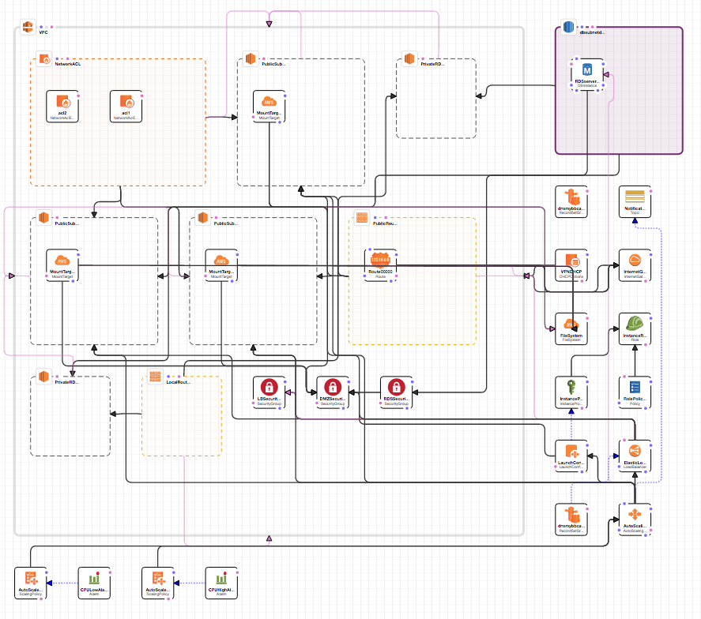

Technical Specs / Parts of the infrastructure:

VPC : Including 3 public subnets for (EC2), and 2 private subnets (for RDS)
EFS : One EFS Drive, with 3 mount points for each availability zone
Routes : 2, one is local, and one allowing internet, applied to the public subnets.
Security Groups : 3, one for the ELB, one for WEB, one for RDS, this makes very easy to change how can do what on what port, easily setup a Bastion Server for example.
DHCP : For having own FQDN for the servers, easily configured with a domain name.
Launch Configurations: One, for web servers, configurable at deploy time.
Auto Scaling Setup : By default, 2 to 10 servers, configured at deploy time as well, with alarms set on CPU usage, it will add/remove servers as needed, there is also a SNS notification configured by email for this actions.

Launch Configuration Detail :

It uses many of the features of CloudFormation template, and this is why the deploy and whole
Infrastructure is based on ONE single file.
There are no external scripts, just the .zip file with the contents of the website and .sql base to run the
forum, wich is downloaded from a S3 bucket, and could be changed to be anything else without.
The Launch will create the instance, and run necessary commands to do the following:
- Update packages (yum)
- Install required packages (yum)
- Mount the EFS system on Apache Root (aws CF)
- Download and install the Web .ZIP (aws CF)
- Configure the Forum options (Database User, Pass, Name, etc)
- Check for existing MySQL tables, if they exist, it continue, if no, it will install base MySQL dump.
- Misc configs, permissions, etc.
- AWS tools install, with Update Support (the instances will update if the config is changed)

I´m running out of time, need to make the video yet!

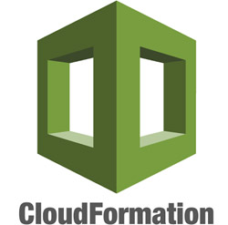

Design Document V1.0 – Ariel Sepulveda (cascompany@gmail.com) - +34 663429244

