Chapter 5: Solar System
1. The Sun (Our Star) ☀️
- Definition: A yellow dwarf star located at the absolute center of our solar system.⁵⁷
- Key Idea: It contains $99.8\%$ of all the mass in the entire solar system. Its immense gravity holds all the planets and other bodies in orbit.
- Process: Generates light and heat through nuclear fusion in its core, converting hydrogen into helium.⁵⁸
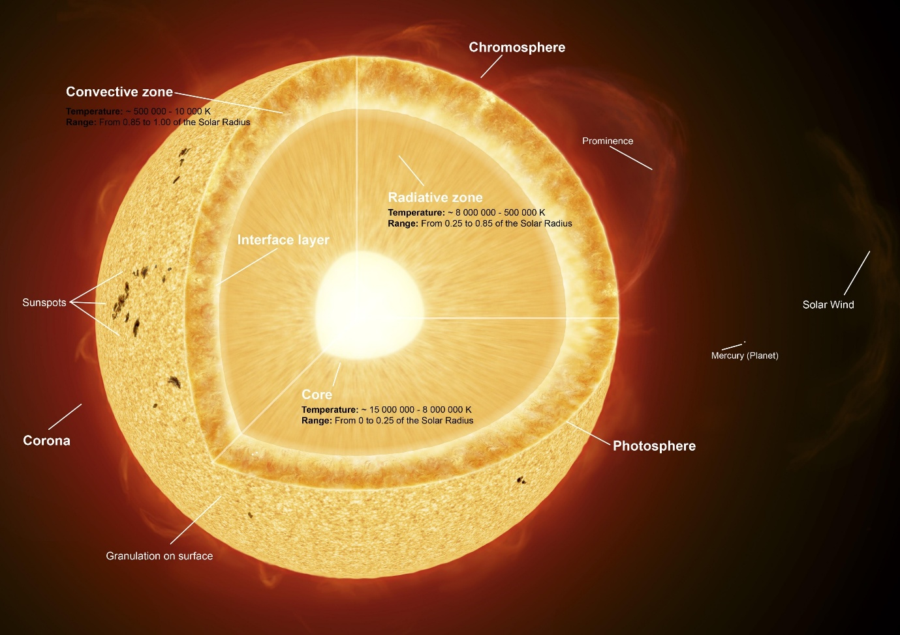
Shutterstock
2. The Inner Planets (Terrestrial)
- Description: The four planets closest to the Sun. They are small, dense, and composed mainly of rock and metal.
- Mercury: The smallest and closest planet to the Sun. Has a heavily cratered surface and extreme temperature swings.⁵⁹
- Venus: Earth's "sister planet" in size, but the hottest planet.⁶⁰ Its thick $\text{CO}_2$ atmosphere causes a runaway greenhouse effect.
- Earth: Our home. The only known body in the universe to harbor liquid water on its surface and support life.
- Mars: The "Red Planet."⁶¹ Has polar ice caps, the largest volcano in the solar system (Olympus Mons), and strong evidence of past liquid water.
3. The Asteroid Belt
- Location: A ring of debris found in the large gap between the orbits of Mars and Jupiter.⁶²
- Composition: Contains millions of asteroids (rocky remnants from the early solar system) and one dwarf planet, Ceres.
4. The Outer Planets (Gas & Ice Giants) 🪐
- Description: The four large planets beyond the asteroid belt.⁶³ They are massive, have low density, and are composed mostly of gas (hydrogen, helium) and "ices" (water, methane, ammonia). All four have ring systems.
- Jupiter: The largest planet. Famous for its Great Red Spot (a storm larger than Earth) and its many moons (including the four large Galilean moons).⁶⁴
- Saturn: The second-largest planet, famous for its vast and prominent ring system made of ice and rock particles.⁶⁵
- Uranus: An "ice giant."⁶⁶ It is tilted completely on its side, causing it to "roll" around the Sun and leading to extreme seasons.
- Neptune: The farthest recognized planet, also an "ice giant." Known for its deep blue color and the fastest winds in the solar system.
5. Trans-Neptunian Objects (TNOs)
- Definition: Any object orbiting the Sun at a greater average distance than Neptune.
- Kuiper Belt: A disc-shaped region of icy bodies beyond Neptune.⁶⁷ This is the "home" of many comets.
- Dwarf Planets:
  - Definition: Celestial bodies that orbit the Sun, are massive enough to be nearly round, but have not "cleared their orbital neighborhood" of other debris.⁶⁸
  - Examples: Pluto (the most famous), Eris, Haumea, and Makemake.
6. Other Celestial Bodies ☄️
- Comets: "Dirty snowballs."⁶⁹ Lumps of ice, dust, and rock that orbit the Sun. When they get close to the Sun, the ice vaporizes, creating a glowing coma (head) and a long tail.⁷⁰
- Meteors & Meteorites:
  - Meteoroid: A small piece of rock or debris in space.
  - Meteor: A meteoroid that enters Earth's atmosphere and burns up, creating a "shooting star."⁷¹
  - Meteorite: A meteoroid that survives its passage through the atmosphere and impacts the Earth's surface.⁷²
- Oort Cloud: A theoretical, immense, spherical "cloud" of icy bodies believed to exist at the outermost edge of our solar system, far beyond the Kuiper Belt.

