CHAPTER TWO: PROJECT DESIGN AND MODELING
2.1 Introduction
This chapter presents the design and modeling phase of the Food Expiry Tracking System. System design is a critical phase in software development that bridges the gap between the problem analysis conducted in Chapter One and the actual implementation carried out in Chapter Three. In this chapter, the logical structure of the system is communicated through two primary types of design models: logic models, which include the class diagram and entity relationship diagram, and user interface models in the form of wireframes. The class diagram illustrates the object-oriented structure of the system's core components and their relationships. The entity relationship diagram defines the data structure and how different entities within the MySQL database are related to one another. The wireframes provide a visual blueprint of each key interface page, showing the layout and placement of interface elements before actual development begins. Together, these models served as the guiding reference during the implementation phase of the project.
2.2 Design Diagrams
2.2.1 Class Diagram
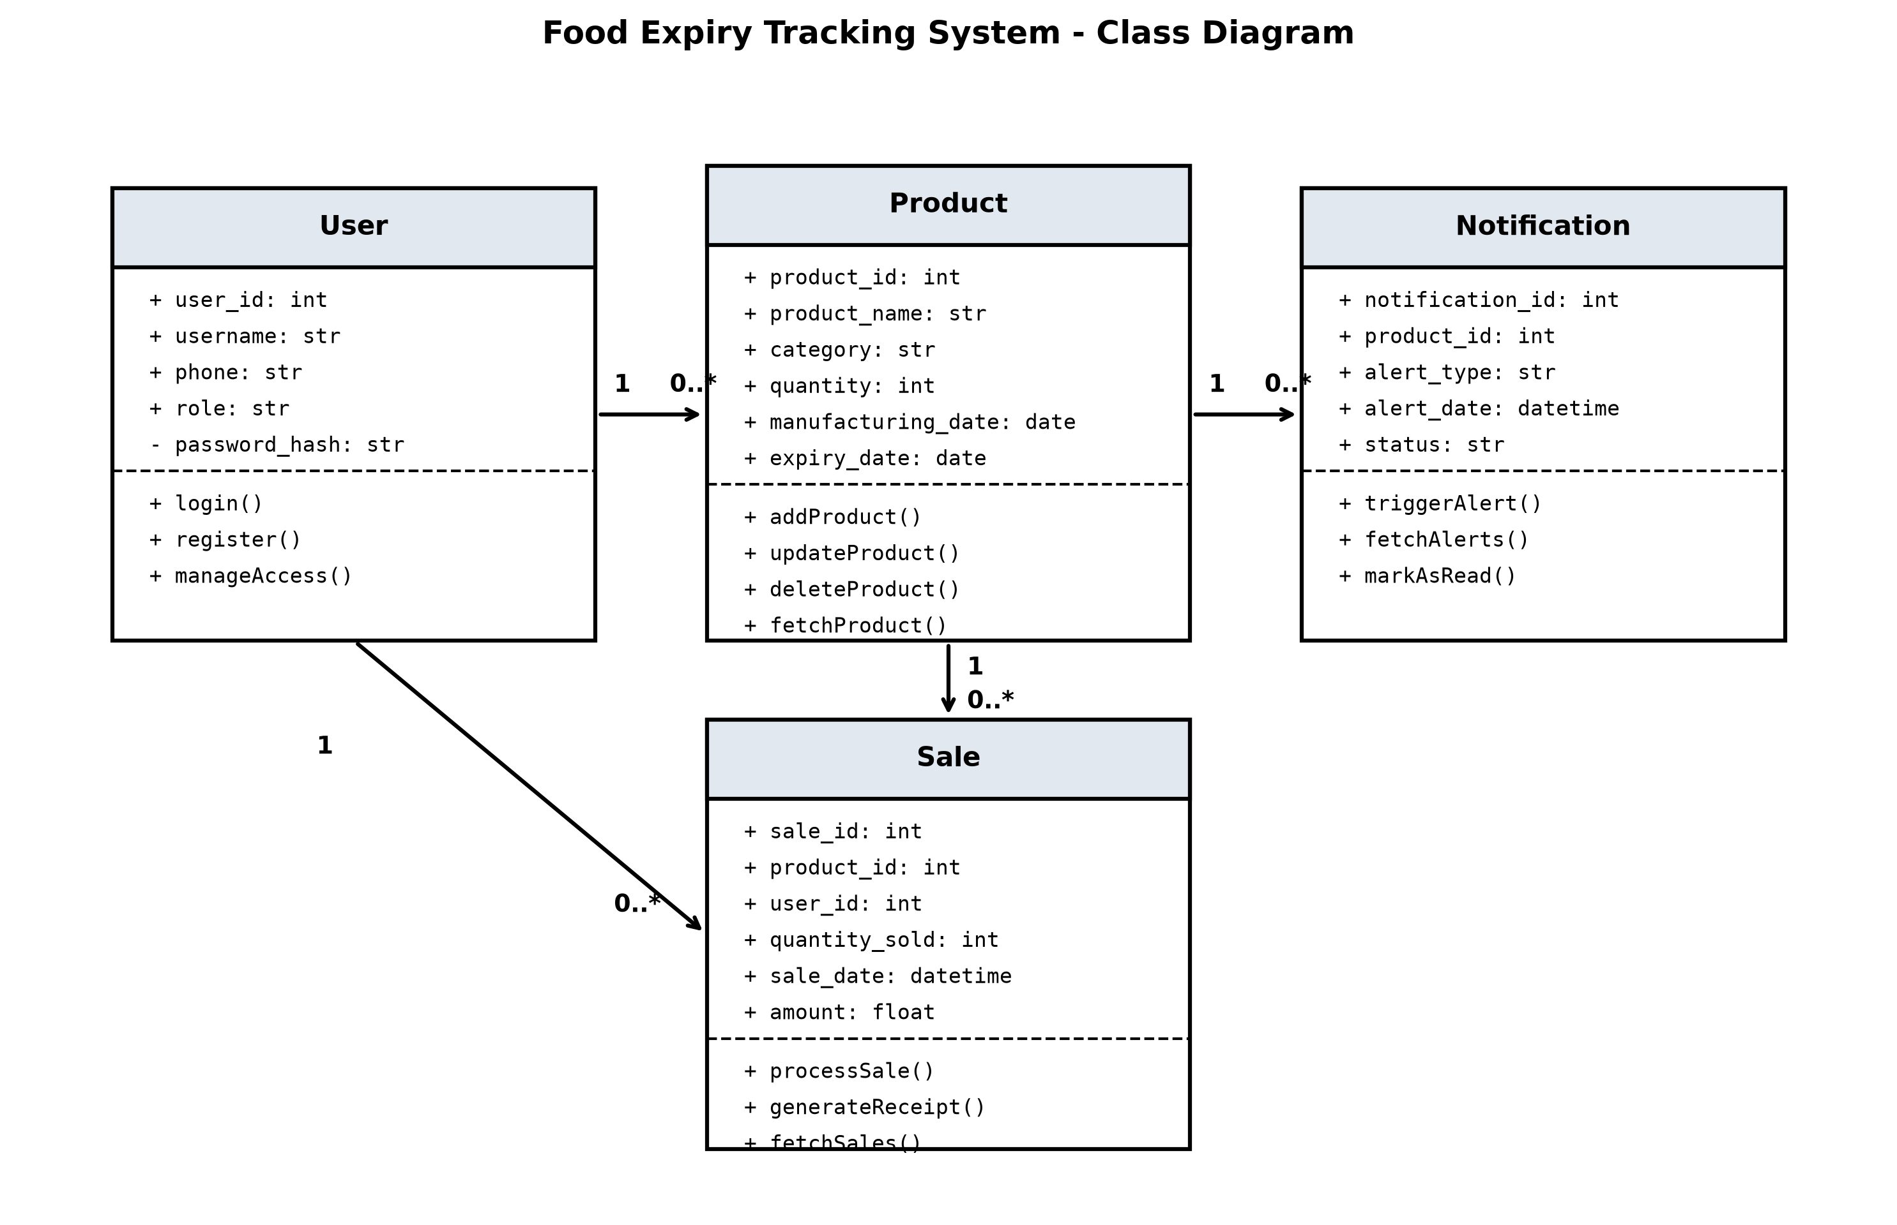
Fig 2.2.1 Class Diagram
The class diagram for the Food Expiry Tracking System illustrates four primary classes: Product, Sale, Notification, and User. The Product class holds attributes such as product_id, product_name, category, quantity, manufacturing_date, and expiry_date, and contains methods for adding, updating, deleting, and fetching product records. The Sale class references the Product class through a product_id foreign key and carries attributes including sale_id, quantity_sold, sale_date, and amount. The Notification class is generated by the Product class whenever a product's expiry date falls within the alert threshold, carrying a notification_id, product_id, alert_type (expired or nearly expired), and alert_date. The User class manages system access and contains user_id, username, password_hash, and role (manager or attendant). The User class is associated with the Sale and Product classes, as it is the user who performs all CRUD operations on those entities.
2.2.2 Entity Relationship Diagram
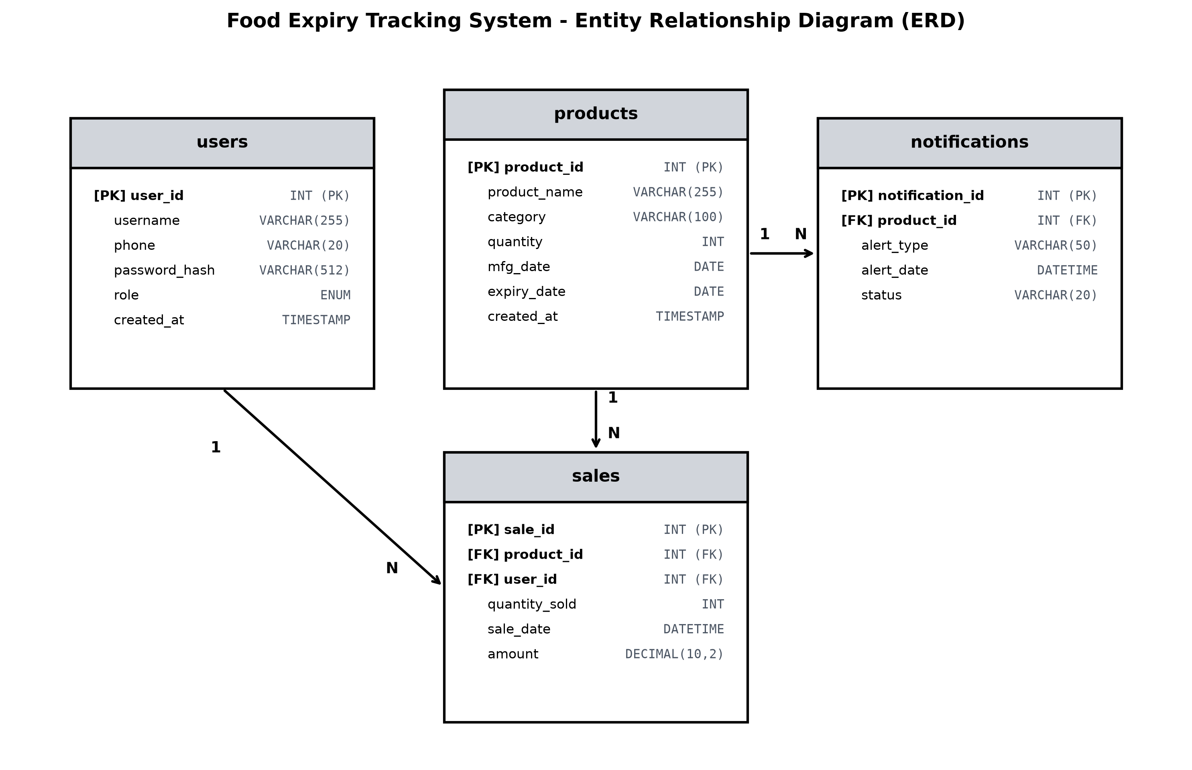
Fig 2.2.2 Entity Relationship Diagram
The Entity Relationship Diagram (ERD) illustrates how the four main database tables relate to each other. The products table is the central entity and stores all food product records with product_id as the primary key. It is linked to the sales table through a one-to-many relationship, since one product can have many sale records over time. The notifications table has a one-to-many relationship with the products table, as one product may trigger multiple alerts over different time periods. The users table is related to the sales table to track which user processed each sale transaction. All foreign key relationships are enforced within the MySQL database to maintain referential integrity.
2.2.3 System Flowchart
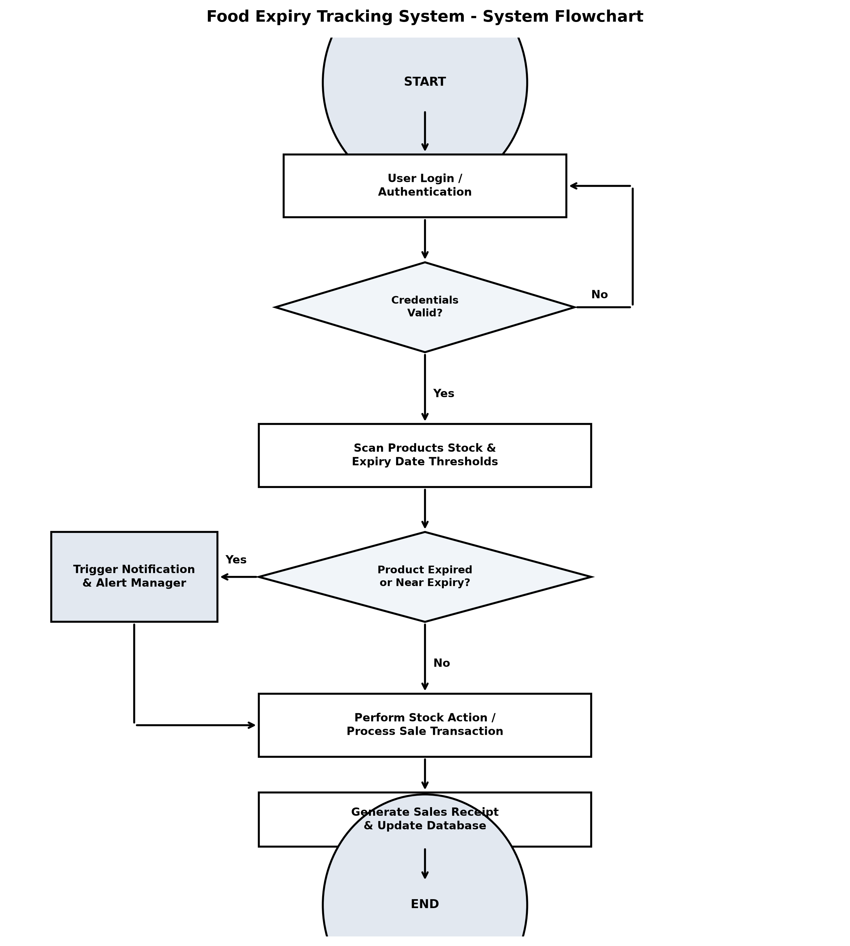
Fig 2.2.3 System Flowchart
The System Flowchart depicts the complete operational logic and execution flow of the Food Expiry Tracking System from system entry to process completion. Upon launching the application, the system prompts the user for authentication credentials. Once validated against the user table, the system grants role-based access. In the main operation loop, the system automatically scans the product inventory table and evaluates shelf-life expiration dates against defined threshold parameters. If a food item is detected to be expired or nearing expiration, an alert notification process is immediately executed, logging an entry in the notifications table and displaying an urgent visual warning. Concurrently, attendants can perform sales transactions or stock adjustments, which trigger inventory deduction, update sales records, and generate automated sales receipts before concluding the process.
2.3 User Interface Models (Wireframes)
The wireframes below represent the visual layouts designed for each major interface screen of the Food Expiry Tracking System prior to actual development.
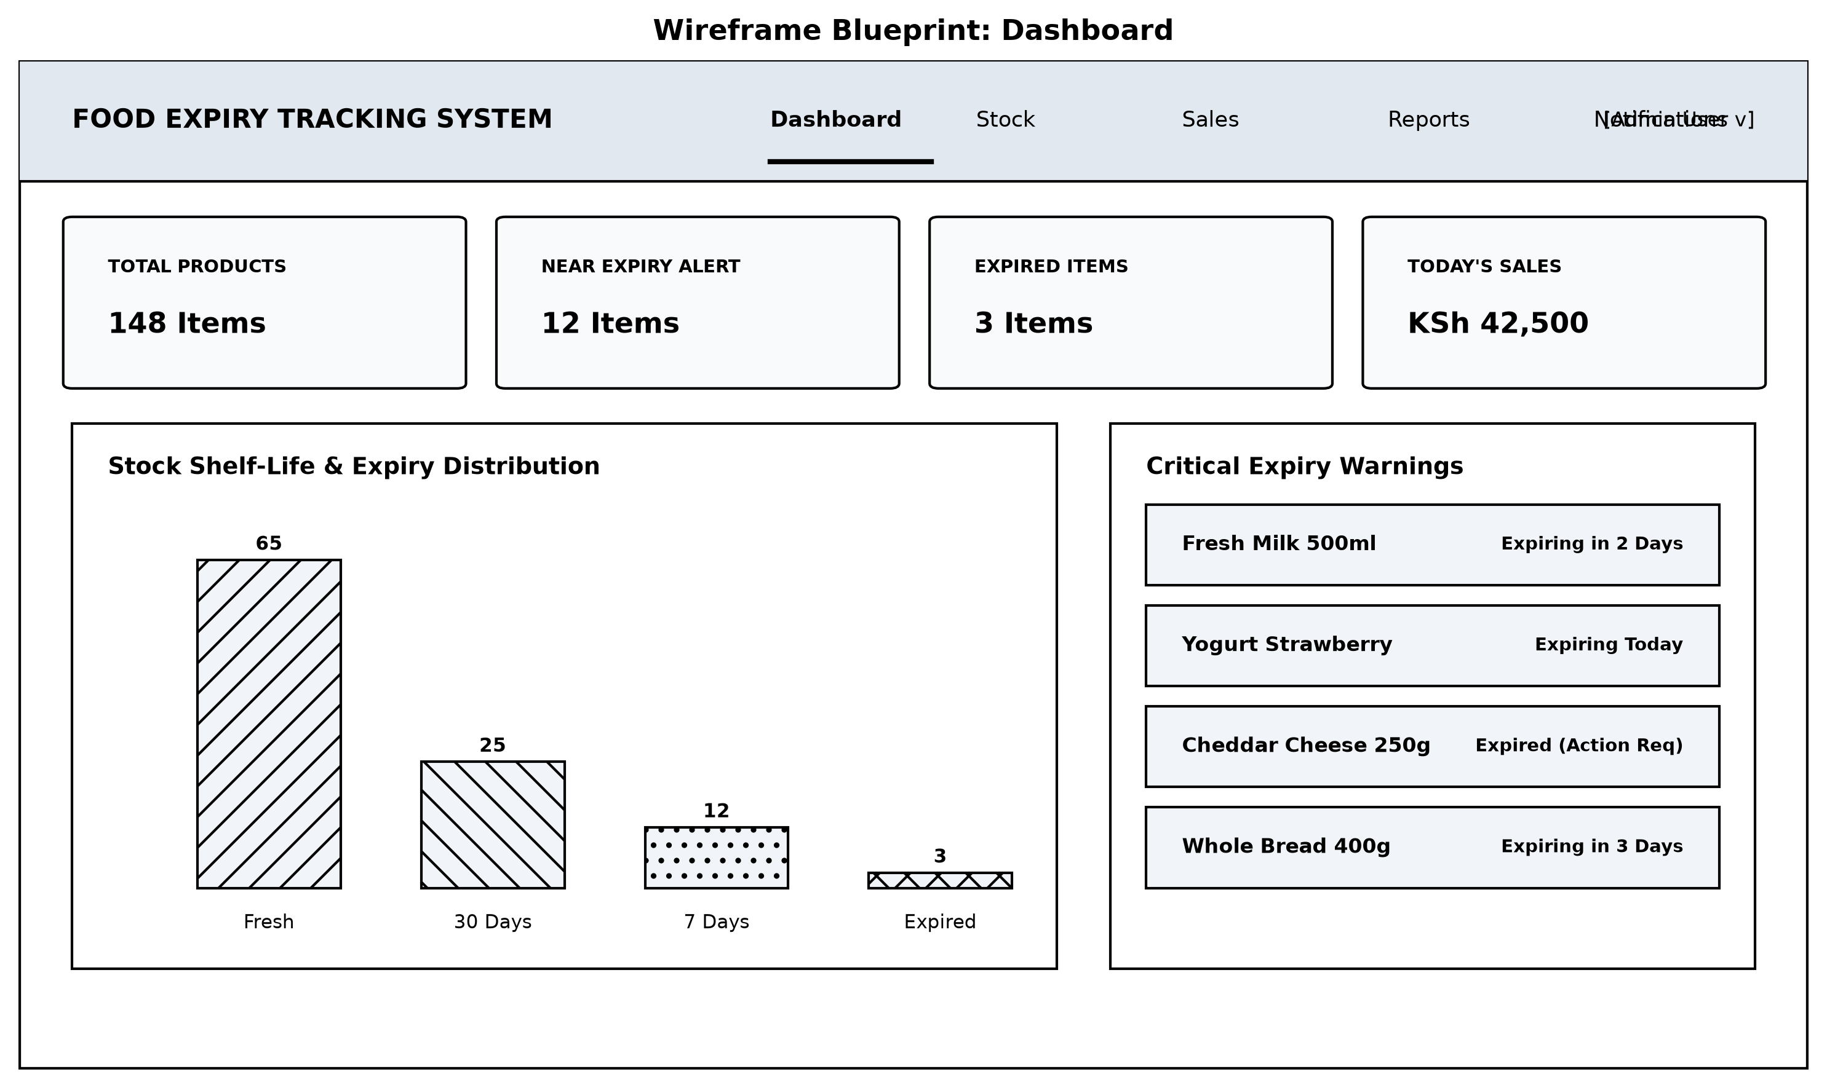
Fig 2.3.1 Dashboard Wireframe
The Dashboard Wireframe (Fig 2.3.1) displays the high-level operational overview of the Food Expiry Tracking System. It features top summary metric cards showing total product count, near-expiry alerts, expired items count, and today's sales value. A central shelf-life distribution chart provides visual analytics on inventory age, while a dedicated right panel highlights urgent expiry alerts requiring immediate manager intervention.
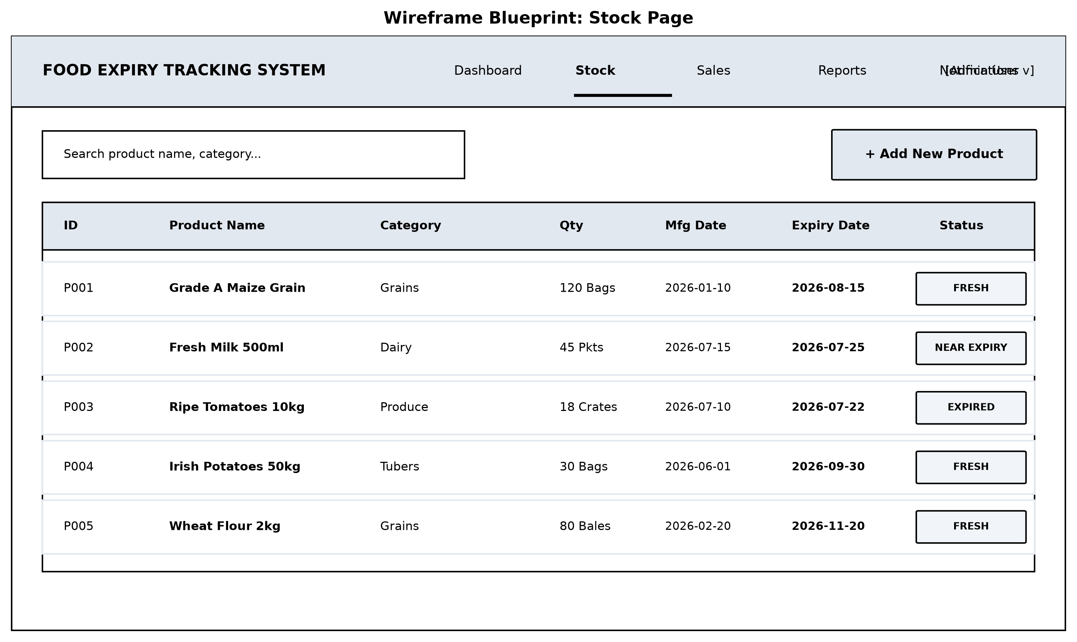
Fig 2.3.2 Stock Page Wireframe
The Stock Page Wireframe (Fig 2.3.2) provides a structured layout for inventory management. It includes a real-time search and category filter bar, a primary stock table displaying product IDs, names, categories, quantities, manufacturing dates, expiry dates, and color-coded status badges ('FRESH', 'NEAR EXPIRY', 'EXPIRED'), along with an action button to open the new product registration modal.
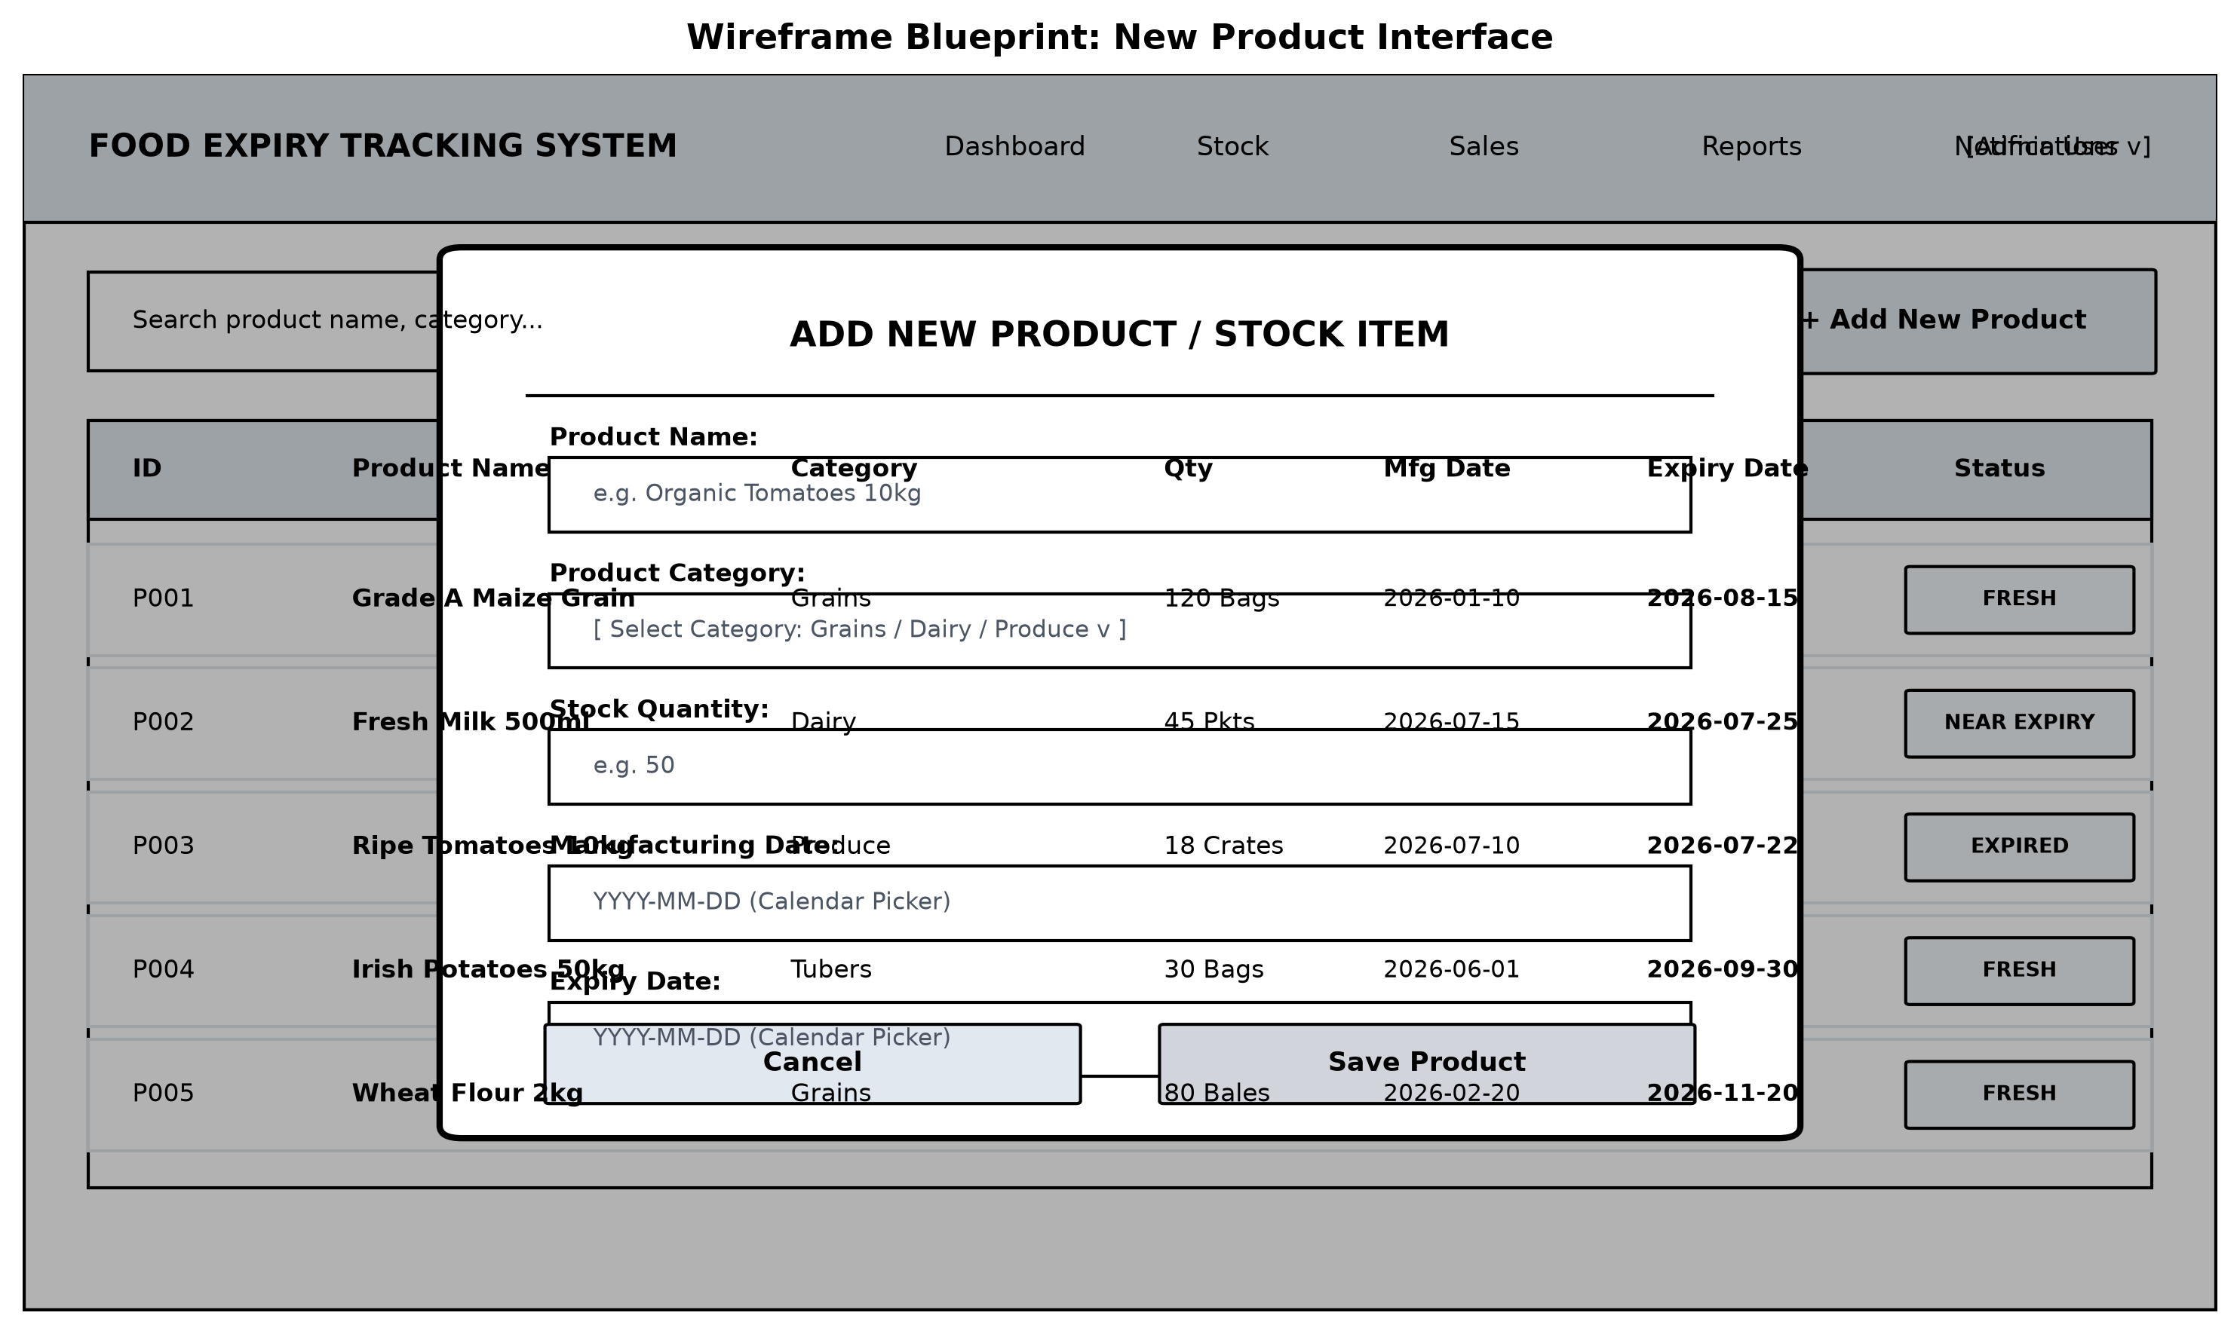
Fig 2.3.3 New Product Interface Wireframe
The New Product Interface Wireframe (Fig 2.3.3) illustrates the popup modal dialog for adding new stock items into the database. It features structured input fields for Product Name, Category selection dropdown, Quantity, Manufacturing Date picker, and Expiry Date picker, with explicit Save and Cancel controls to prevent partial data entry.
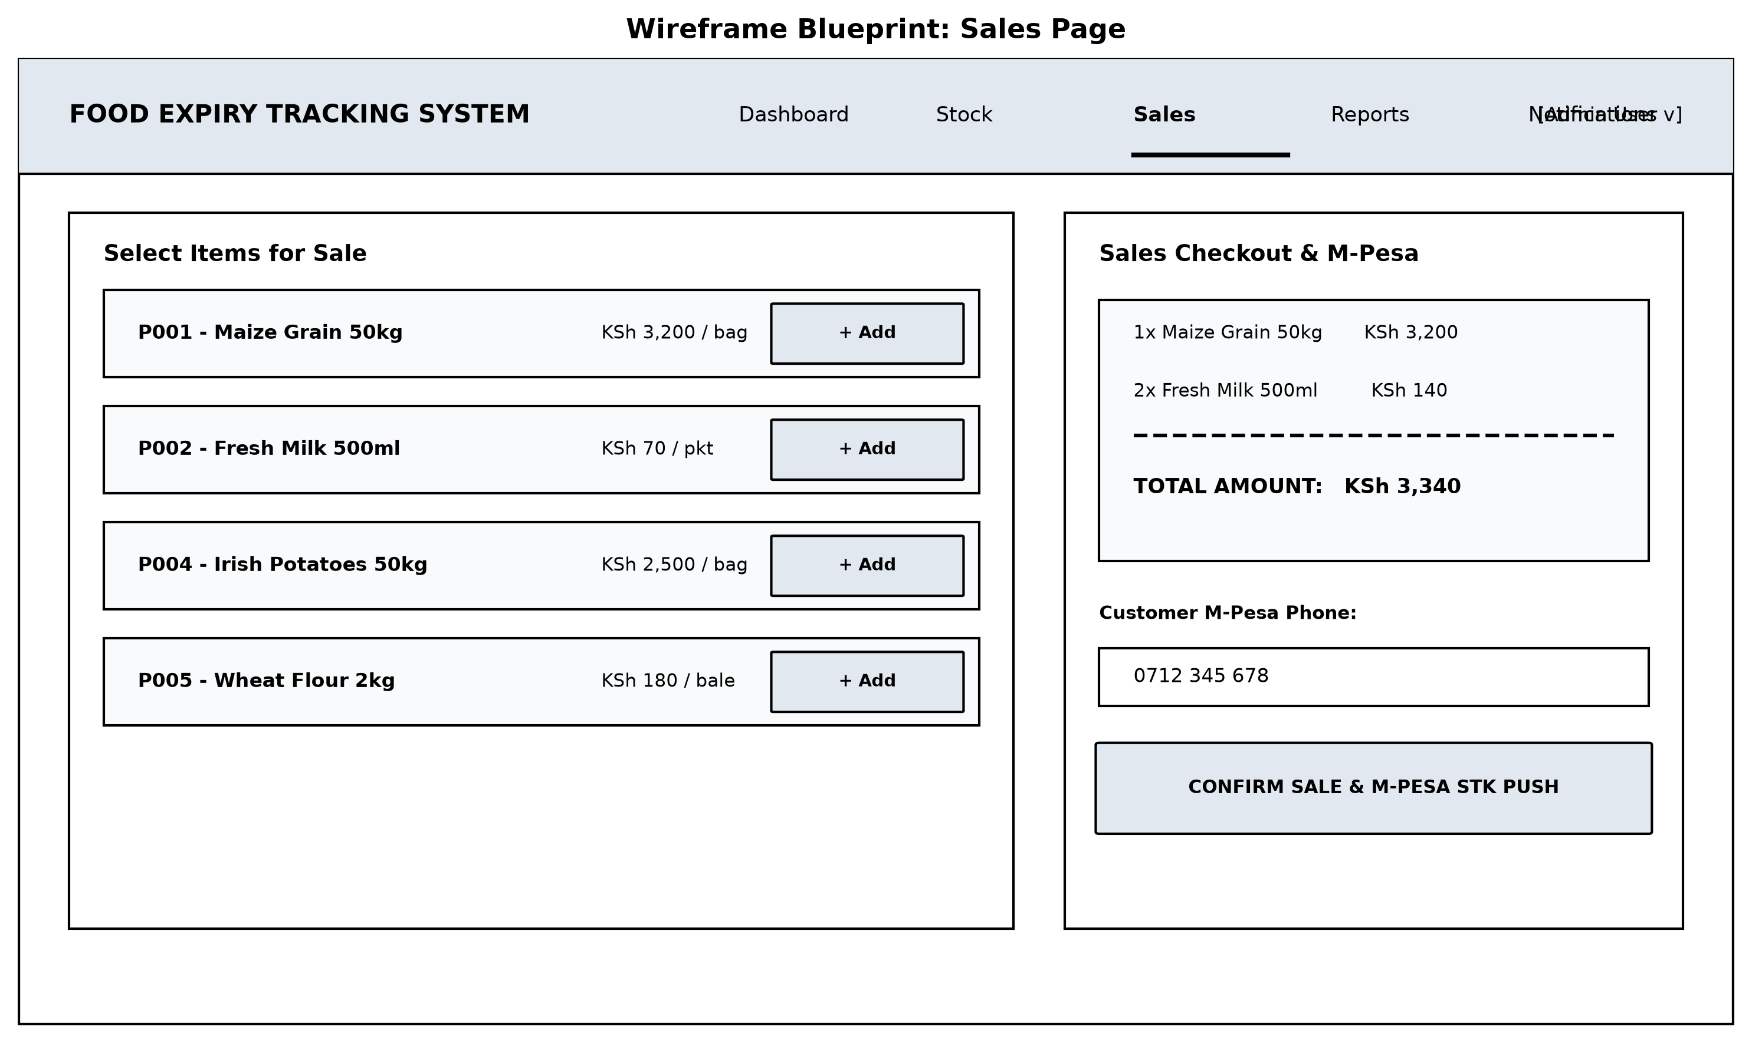
Fig 2.3.4 Sales Page Wireframe
The Sales Page Wireframe (Fig 2.3.4) showcases the point-of-sale transaction layout. The left section allows attendants to browse and select available products to add to cart, while the right checkout panel computes real-time total amounts, captures the customer's M-Pesa phone number, and provides an integrated STK Push payment trigger for receipt generation.
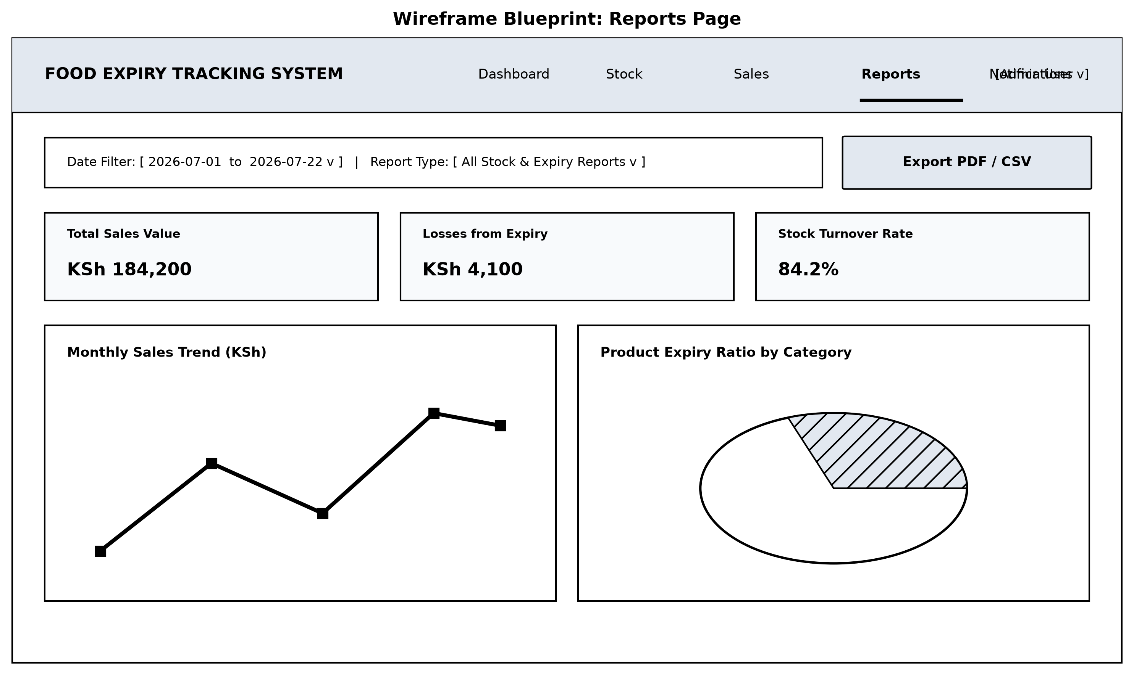
Fig 2.3.5 Reports Page Wireframe
The Reports Page Wireframe (Fig 2.3.5) defines the visual layout for audit and analytics reporting. It offers date range filters, summary cards for revenue and loss metrics, graphical representations of monthly sales trends and category expiry ratios, and a direct export button to generate PDF/CSV audit documentation.
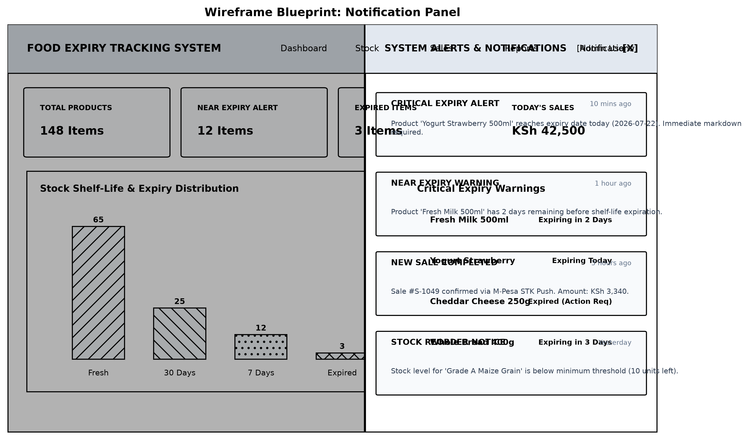
Fig 2.3.6 Notification Panel Wireframe
The Notification Panel Wireframe (Fig 2.3.6) illustrates the slide-over notification drawer layout. It categorizes alerts by urgency (Critical Expiry Alert, Near Expiry Warning, Sale Confirmation, and Reorder Notices) with timestamps, enabling store managers to review and mark alerts as read without leaving their current screen.

