**Requirement:**

This assignment required to write the bus simulation.

Write the bus simulation, as explained in the class and described in the notes. Feel free to look on the web for and then re-use any suitable code for the random number generator or for linked list algorithms. With that, 1) don’t **forget** to include a reference to the source of any code you re-use and 3) remember to test all re-used code as you are the only one responsible for its performance.

The purpose of the simulation is to observe the behavior of the system, and answer the following questions:

*1. Does the distance between the buses keep uniform? If not, what should be done to ensure it is uniform?*

*2. What is the average size of a waiting queue at each stop (and what are its maximum and minimum)? (You may provide this information on an hourly [simulation time] base.)*

Plot the positions of buses as a function of time (you will need to generate periodic snapshots of the system for that). Feel free to change parameters; then observe and document the results.

**Abstract:**

The objective of this programming assignment is to familiarize the discreet simulation and event processing. Constructing the event structure, running mode. Using priority queue and mutual exclusion to make sure the system work well. Finally, based on the output data, analyzing the buses’ distance and give some assumptions about the question. The entire system use C++ language to simulation. Using Visual Studio 2015. The figures are used matlab to generate.

**1.1 System Analysis**

The system has three event: person, arrival and boarding.

The person event is that generate a person comes to stop at random time. This has a requirement that the average number of coming person is 5/min. The random event should Obedience the Exponential Distribution.

The arrival event is that the bus process arrive at a stop, which has two case:

Case 1: If there is no people waiting at the current bus stop, the bus will go to the next stop.

Case 2: If there are some people waiting at the current stop, the bus event will be locked. If there is no other buses at the stop, call the boarding event. Or waiting for the bus which at the current stop.

The boarding event is that people boarding on the bus. Each person boarding on the bus cost 2 seconds. The boarding event has two cases:

Case 1: If the boarding person is the last person at the current stop, the bus will go to the next stop and release the lock.

Case 2: If the boarding person is not the last person, the bus event will call boarding event again.

**1.2 Data Structure**

The system define a class Event, using private member variable: “time”, “stop_number”, “bus_number”, “event_count” and “event_type” to store the event current stop number, current bus number, the number of the event and event type respectively. The system uses double weight priority queue to store the events. Their first and main priority weight is time. Their second priority weight is events happen order. Make them into time ascending order. The system initializes with reading a text file that record the original parameters and will output the system log, bus information and stop information to the txt file.

**1.3 Program Flow Chart**

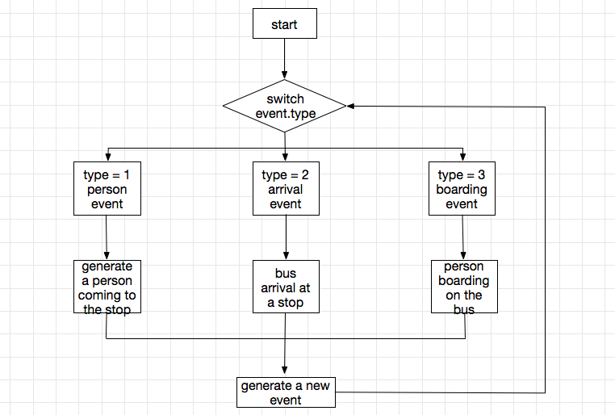

**2.1 System Design**

The system contains 2 header file and 3 cpp file. See table 2.1 below.

Table 2.1 System File Display

|  |  |
| --- | --- |
| Filename | Description |
| Event.h | Define event variables and functions that maybe used |
| Event.cpp | Implement member functions of Event.h |
| Initial.h | Define initial functions and other functions |
| Initial.cpp | Implement functions that define in initial.h |
| Simulation.cpp | The main part of bus simulation. Implement that how the event execute. |
| Stop_waiting_length_hourly.txt | Record the average, max average and min average waiting people number for each stop | |
| Stop_total_average_waiting_info.txt | Record the whole 8 hours average, max average and min average waiting people of each stop | |
| Initial.txt | Initial data for the system | |
| Bus_Stop_waiting_Observe.txt | Record the waiting people number of each bus stop | |
| Bus_number_one.txt | Record bus 1 position at each event time | |
| Bus_number_two.txt | Record bus 2 position at each event time | |
| Bus_number_three.txt | Record bus 3 position at each event time | |
| Bus_number_four.txt | Record bus 4 position at each event time | |
| Bus_number_five.txt | Record bus 5 position at each event time | |
| log.txt | Record the system log (person, arrival, boarding event) | |

**2.2 Design Class Event**

This class should contain all event attributes. According to the homework requirement, the class was designed as figure 2.1

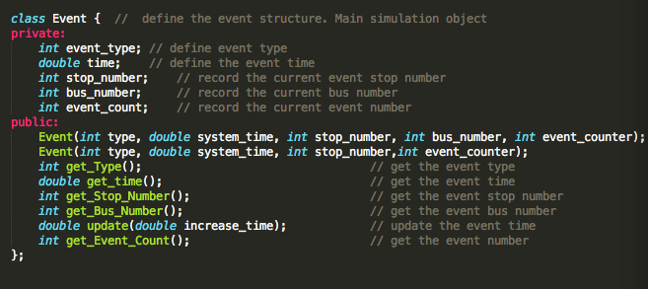

figure 2.1 Class Event

Besides the constructor, there are 5 get functions respond the 5 private member and provide the interface to get these value to outside and another one function update provide the interface to change the event time value.

**2.3 Design Initial and Other Functions**

The initial function includes reading the initial file to the system event and using these data to initialize events. The other functions contain save bus information, save stop information, record sequence length, calculate the average waiting length, generate the random exponential number and compare the events priority. This header file is defined as figure 2.2.

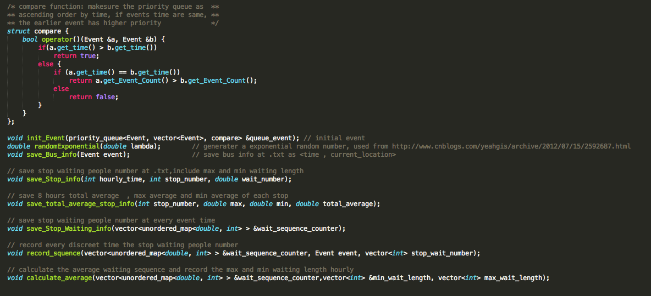

figure 2.2 Initial.h

**2.4 Design the Simulation Process**

The simulation process has a switch action. Choosing the respond action based on event type. The actions have three cases: person, arrival and boarding. Execute every event will generate another event at the following time which means this what the current event do next time. This structure is implemented as figure 2.3.1 and figure 2.3.2.

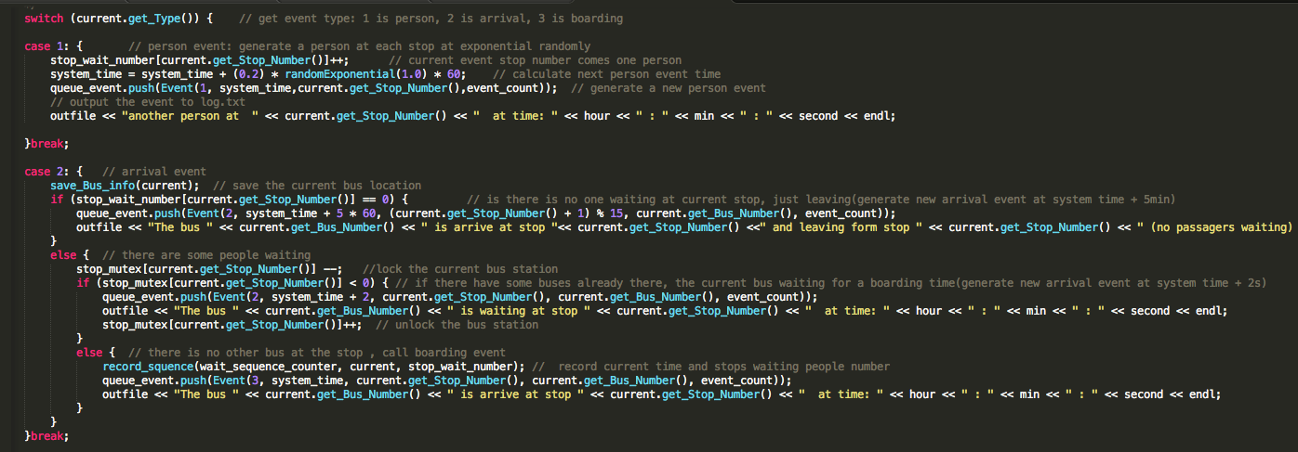

figure 2.3.1 Action Case Implemented_1

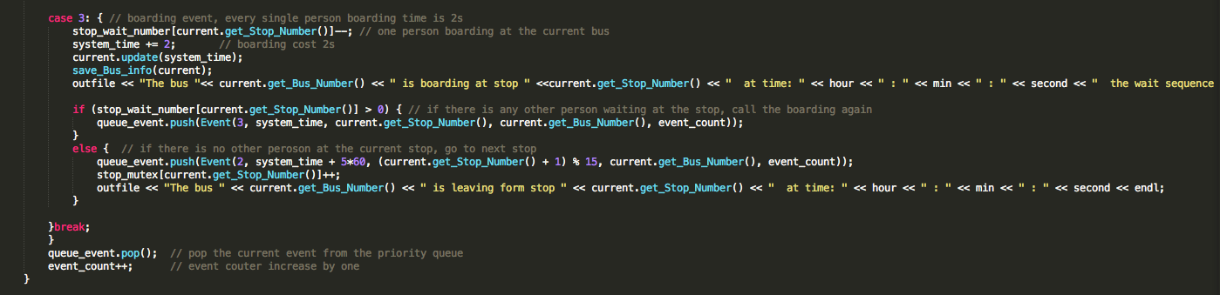

figure 2.3.2 Action Case Implemented_2

**3 Simulation**

The initial parameters are:

Bus: 5

Stops: 15

Boarding time is 2 seconds each person

The bus go to another bus stop need 5 min

**Observation**

At start time, 5 buses are evenly distributed in 15 stops. However, with time increasing and more and more people enter the station, the buses’ distance are reduced. At later time, some buses are going after other buses. Finally, the 5 buses are gathering in one or two of the 15 stops, and keep running. Make the average waiting people number increasing. Thus, the distance between the buses is not uniform. The distance plot shows as figure 3.1. Red, green, black, yellow and blue represent 5 buses respectively. When some buses at the same stop, their plot might be covered by the latest plot, that’s why at later time there are only two obviously color in the figure.

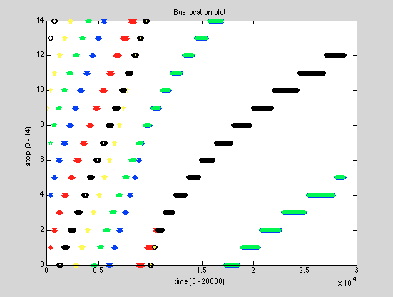

figure 3.1 Bus Location Plot

**Recommendations**

The way to keep the bus distance uniform is make sure all buses stop together and move together. Thus, when one of the five buses first finishes boarding, it goes to the next stop. At the same time, all other buses start to move to next stop to keep the distance uniform. Through simulation, the buses’ location shows as figure 3.2. Red, green, black, yellow and blue represent 5 buses respectively.

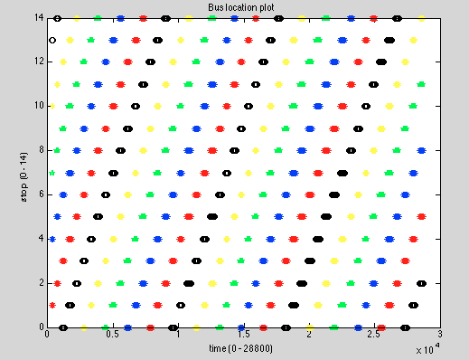

figure 3.2 Bus Location Plot

According to figure 3.2, the five color represent five buses distribute evenly in the figure which means the buses’ distance keep uniform.

**Analyzing Stop Waiting Queue Size**

Before use uniform method, the average waiting people size of each stop in the third hour are described in table 3.1. The rest information is in the Stop_waiting_length_hourly.txt

Table 3.1 The Bus Stop Waiting Information

|  |  |  |
| --- | --- | --- |
| Stop Number | Time/hour | Average |
| 0 | 3 | 102.042 |
| 1 | 3 | 116.625 |
| 2 | 3 | 135.292 |
| 3 | 3 | 107.667 |
| 4 | 3 | 75.125 |
| 5 | 3 | 77.25 |
| 6 | 3 | 82.9583 |
| 7 | 3 | 83.375 |
| 8 | 3 | 86.25 |
| 9 | 3 | 104.708 |
| 10 | 3 | 89.4167 |
| 11 | 3 | 98.25 |
| 12 | 3 | 70.2917 |
| 13 | 3 | 70.2083 |
| 14 | 3 | 91.2917 |

The whole 8 hours’ average waiting people number is described in table 3.2.

Table 3.2 8 Hours Average Waiting Number

|  |  |  |  |
| --- | --- | --- | --- |
| Stop Number | Total Average | Max Average | Min Average |
| 0 | 251.639 | 711.333 | 54.9375 |
| 1 | 234.784 | 508.333 | 52.3667 |
| 2 | 237.646 | 666 | 53.6875 |
| 3 | 271.22 | 712.4 | 60.6333 |
| 4 | 295.681 | 802 | 55.9333 |
| 5 | 340.233 | 994 | 56.75 |
| 6 | 305.957 | 909.667 | 55.6875 |
| 7 | 280.748 | 769.333 | 46.5333 |
| 8 | 249.142 | 590 | 51.25 |
| 9 | 238.844 | 606.25 | 51.8438 |
| 10 | 274.896 | 679.75 | 52.9688 |
| 11 | 269.996 | 779 | 54.8125 |
| 12 | 317.142 | 840.667 | 59.5938 |
| 13 | 323.256 | 979 | 55.3125 |
| 14 | 282.88 | 821.667 | 52.1875 |

After using uniform method, the average waiting people size of each stop in the third hour are described in table 3.3. The rest information is in the Stop_waiting_length_hourly_optimization.txt

Table 3.3 The Bus Stop Waiting Information

|  |  |  |
| --- | --- | --- |
| Stop Number | Time/hour | Average |
| 0 | 3 | 89.2727 |
| 1 | 3 | 149.545 |
| 2 | 3 | 136.545 |
| 3 | 3 | 150.545 |
| 4 | 3 | 119.455 |
| 5 | 3 | 102.364 |
| 6 | 3 | 73 |
| 7 | 3 | 79.9091 |
| 8 | 3 | 92.6364 |
| 9 | 3 | 88.0909 |
| 10 | 3 | 110.636 |
| 11 | 3 | 118.455 |
| 12 | 3 | 113.727 |
| 13 | 3 | 72.1818 |
| 14 | 3 | 75.6364 |

The whole 8 hours’ average waiting people number is described in table 3.2.

Table 3.4 8 Hours Average Waiting Number

|  |  |  |  |
| --- | --- | --- | --- |
| Stop Number | Total Average | Max Average | Min Average |
| 0 | 82.3545 | 91.5 | 65.7 |
| 1 | 131.861 | 168 | 88.25 |
| 2 | 101.726 | 136.545 | 61.8333 |
| 3 | 152.095 | 181.727 | 85.9167 |
| 4 | 140.558 | 184.636 | 78.25 |
| 5 | 91.8254 | 122.909 | 61.75 |
| 6 | 76.141 | 90.9 | 59.8333 |
| 7 | 92.5077 | 115.273 | 50.75 |
| 8 | 76.5169 | 92.6364 | 51.8333 |
| 9 | 108.545 | 151.333 | 68.25 |
| 10 | 145.739 | 204.364 | 61.1667 |
| 11 | 100.543 | 118.455 | 70 |
| 12 | 103.411 | 113.727 | 69.1667 |
| 13 | 70.3247 | 84.5455 | 60.25 |
| 14 | 88.5326 | 117 | 56.0833 |

Figure 3.3 shows the difference between the two methods.

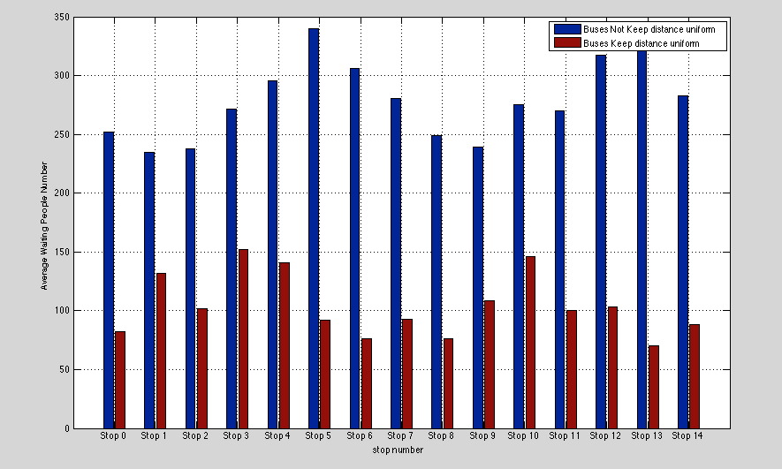

figure 3.3 Difference between two methods

Based on figure 3.3 and table 3.2, 3.4. The uniform method lead the average waiting people sequence size reduced significantly, which means making buses keep uniform distance will let the system work more efficiently.

**4. Conclusions**

The bus simulation runs well. We can draw the conclusion based on the waiting people queue size that the buses’ distance keep uniform is better than they are not uniform to the system. The key keep the distance uniform is make sure every bus moves and stops together. Thus, the system will be more efficiency.

**Reference:**

The system designed idea is learned from lecture3.

The generate random exponential number function uses the code from:

http://www.cnblogs.com/yeahgis/archive/2012/07/15/2592687.html