Name:Prabesh Lama Tamang

1)  
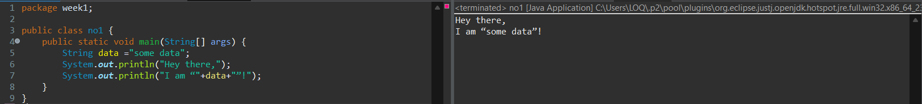

2)

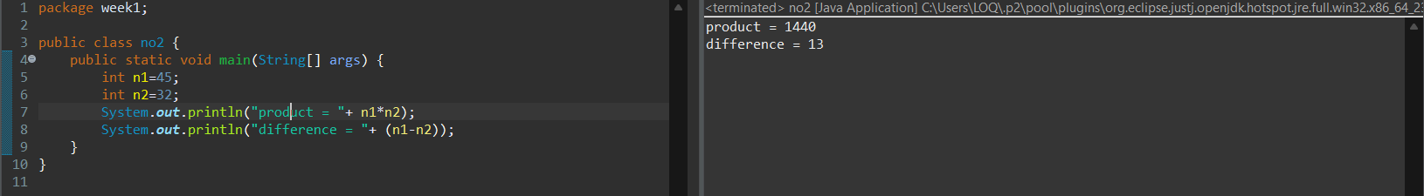

3

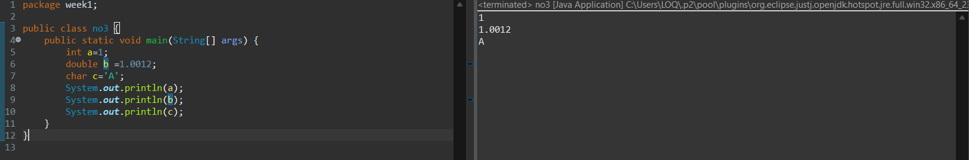

4

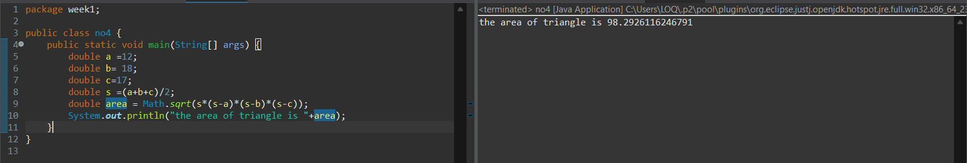

5

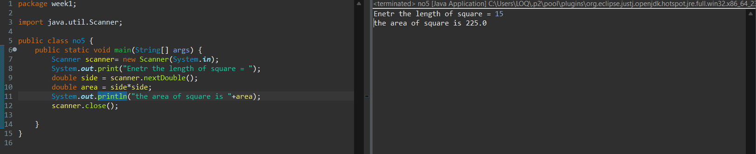

6

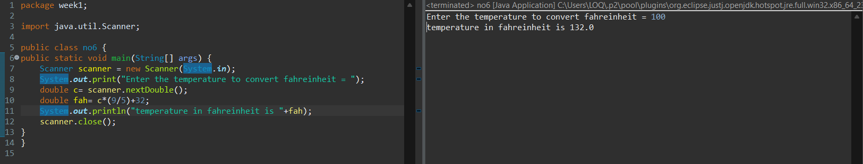

7

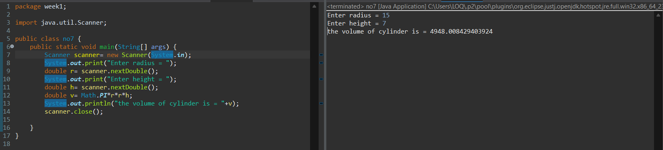

8

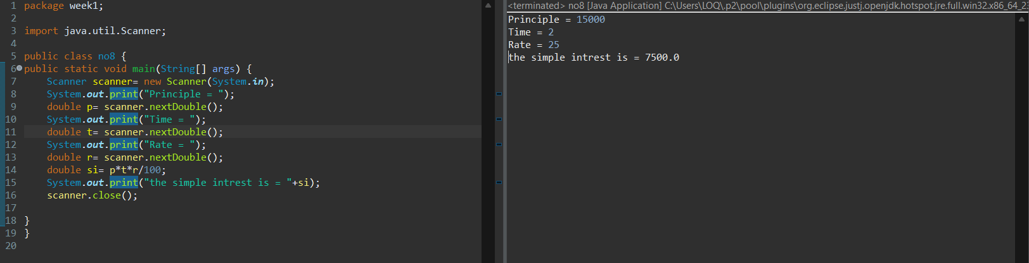

9

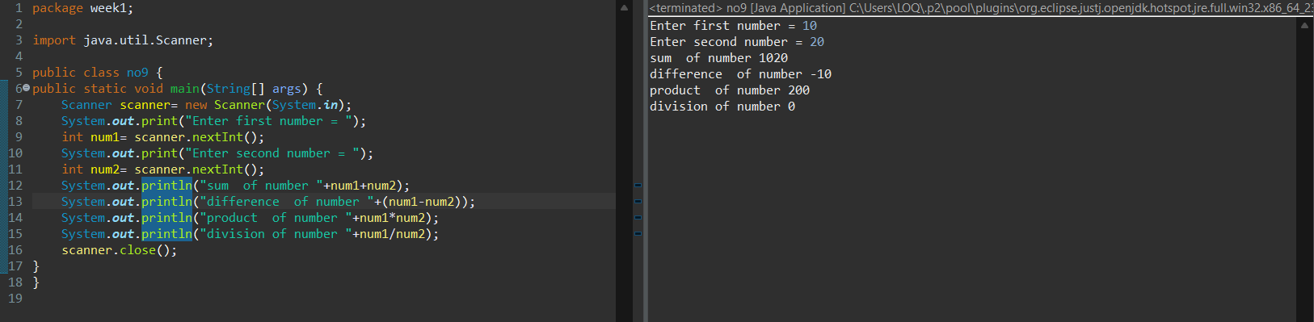

10

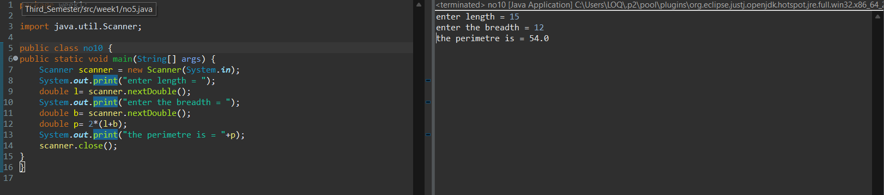

11

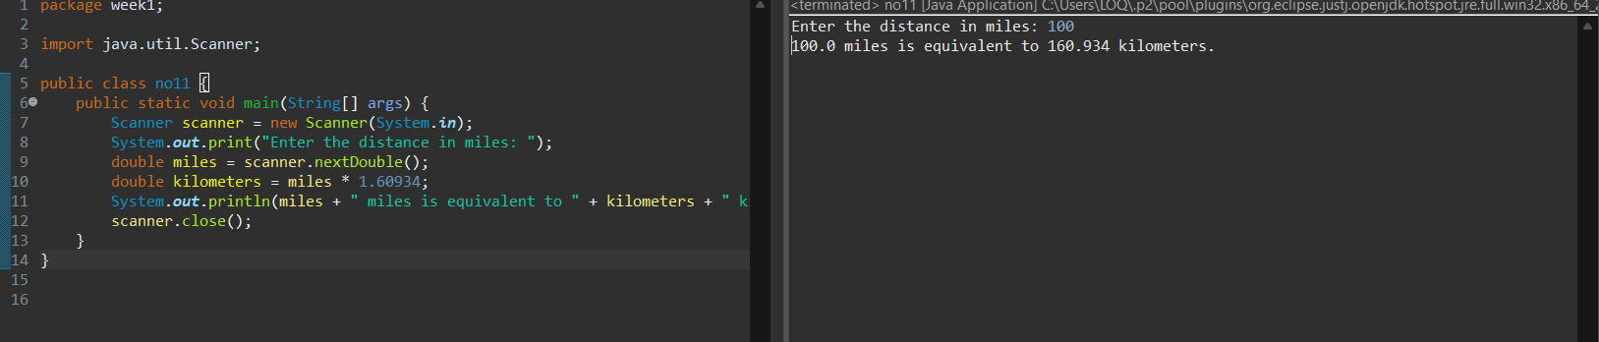

12

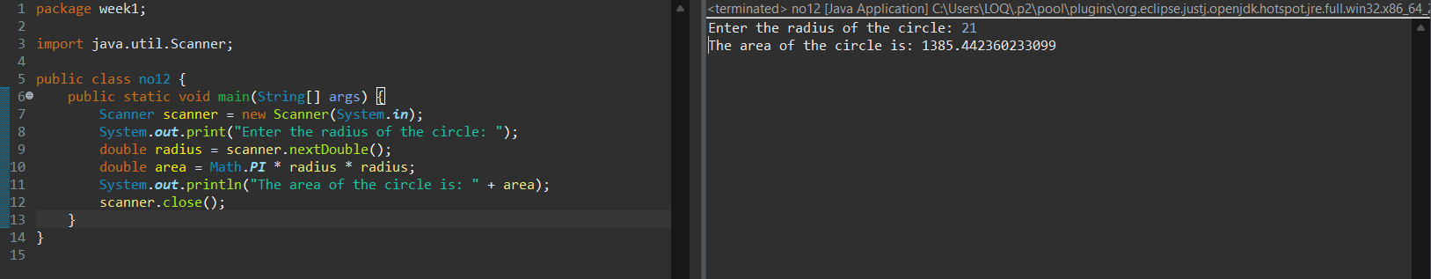

13

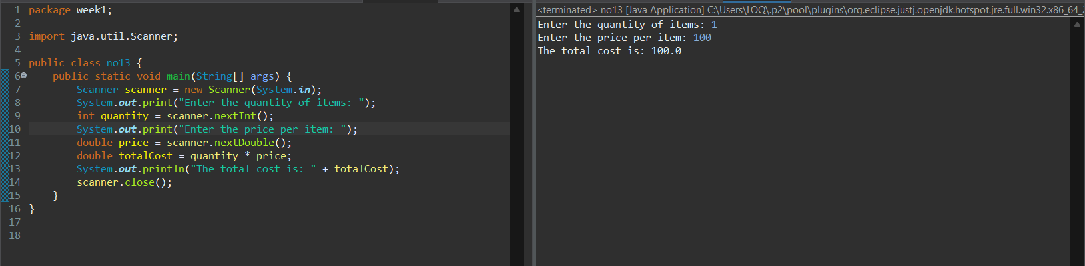

14

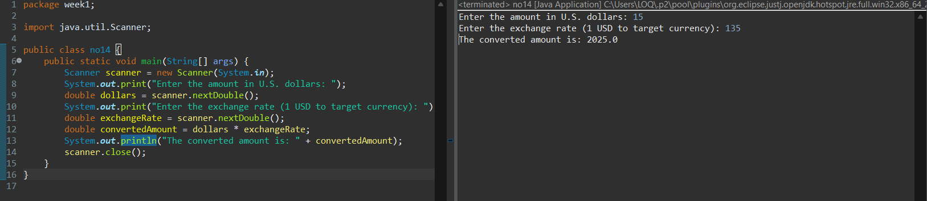

15

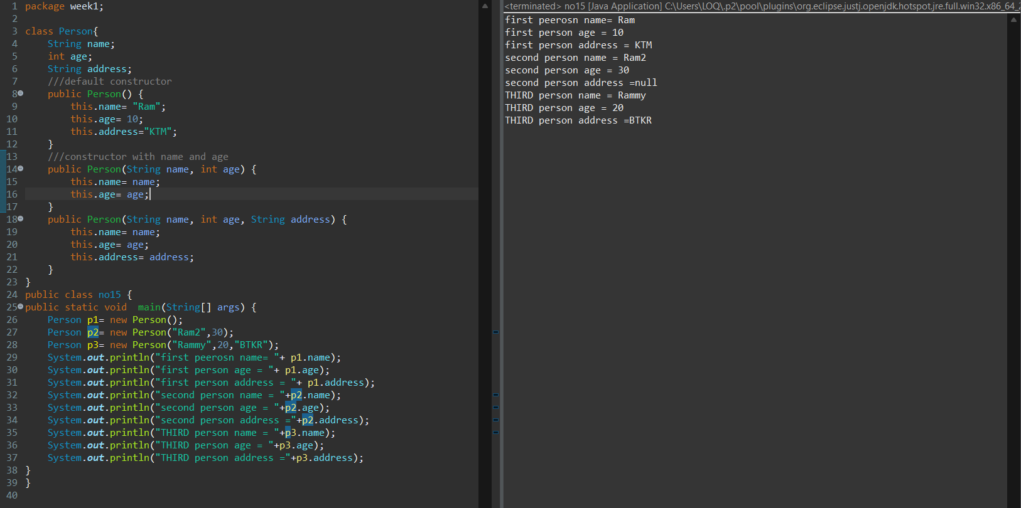

16

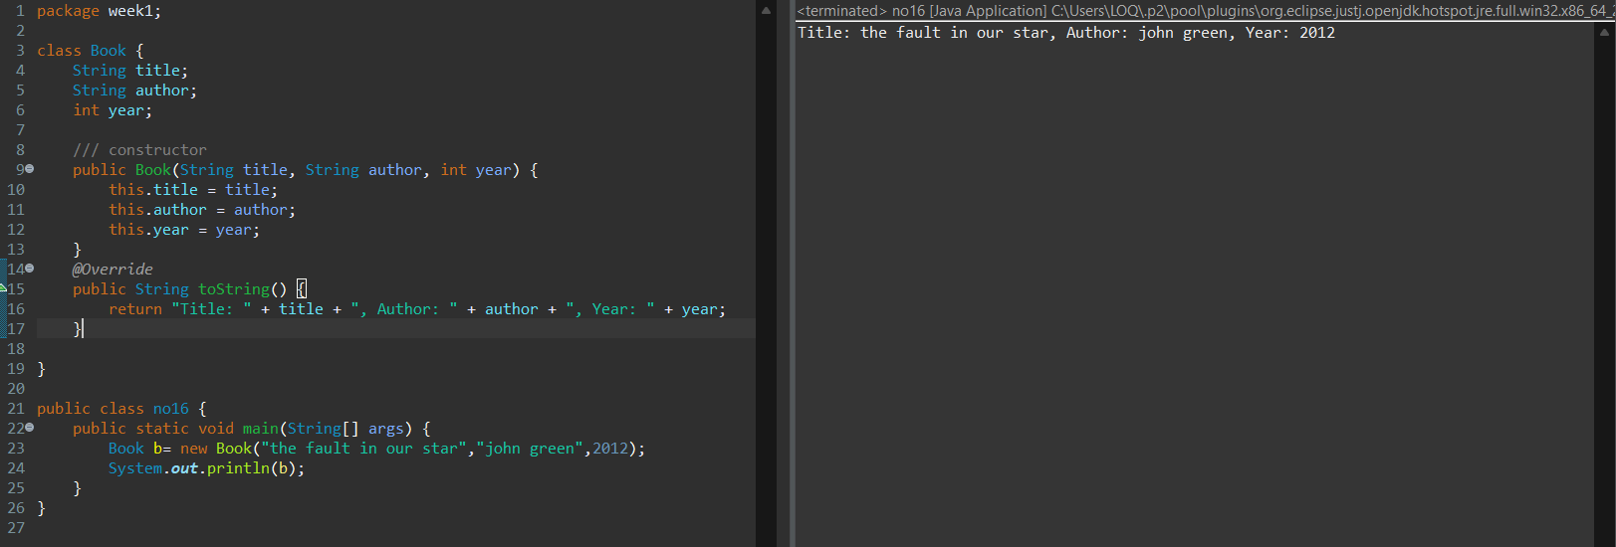

17

