**Git and GitHub Practical Exam Team_04**

Name: Arifur Rahman (Team Leader)  
BJET ID: 24

**Tasks for the Group Leader (with support from group members):**

1. **GitHub Repository Creation:**

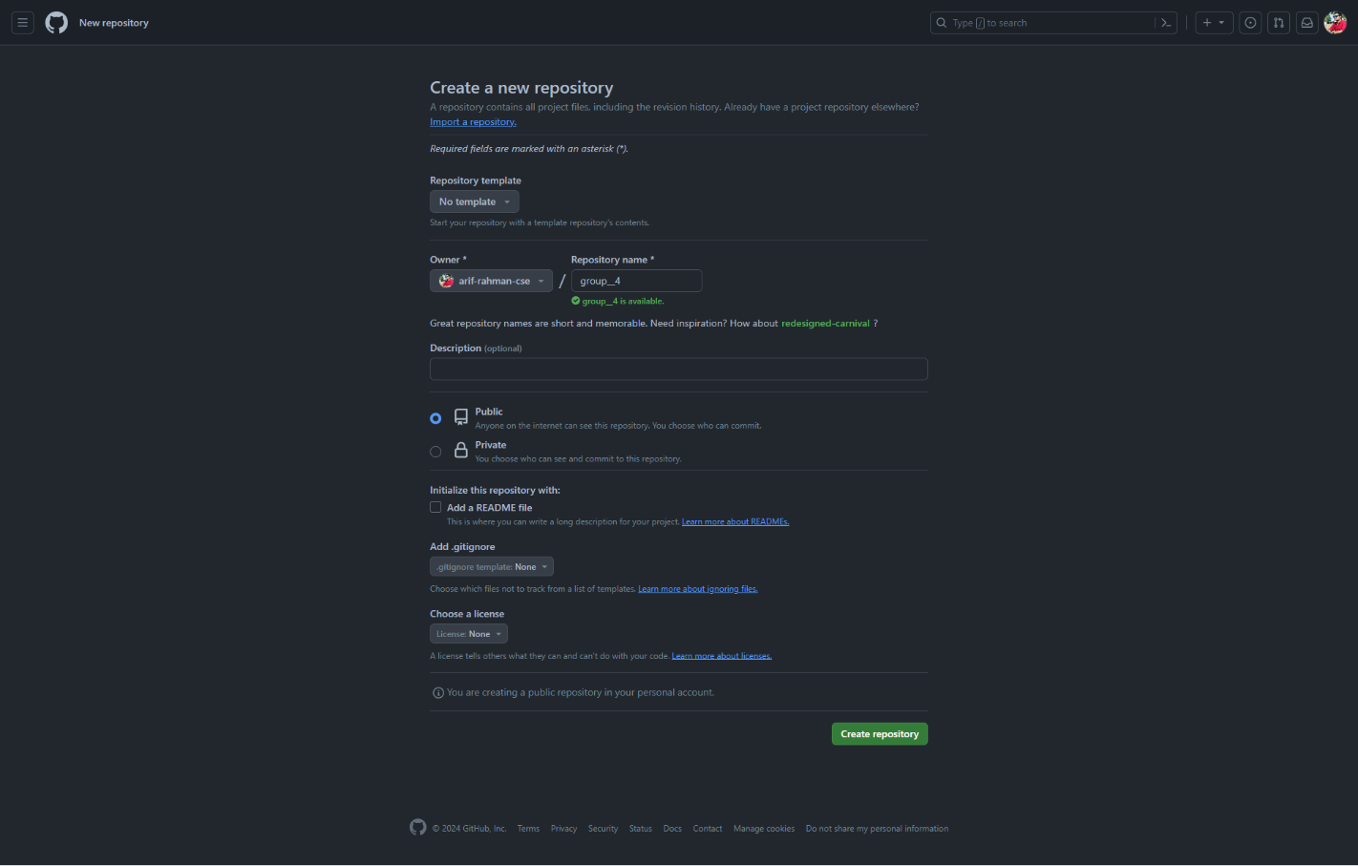

1. **Collaborator Addition:**

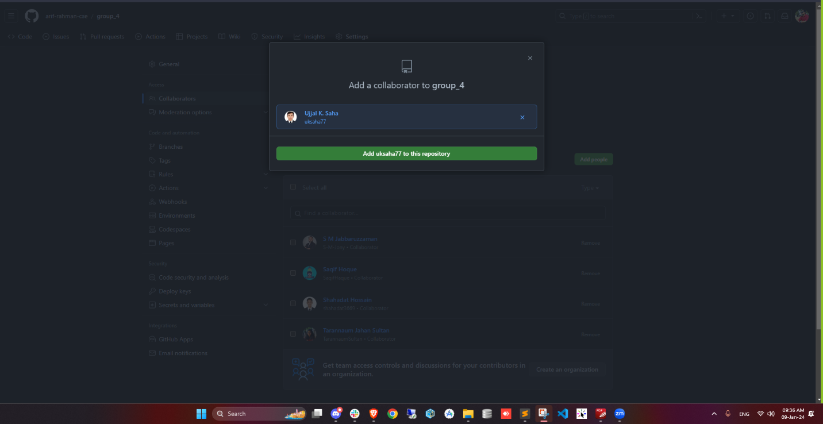

1. **Development Branch Creation**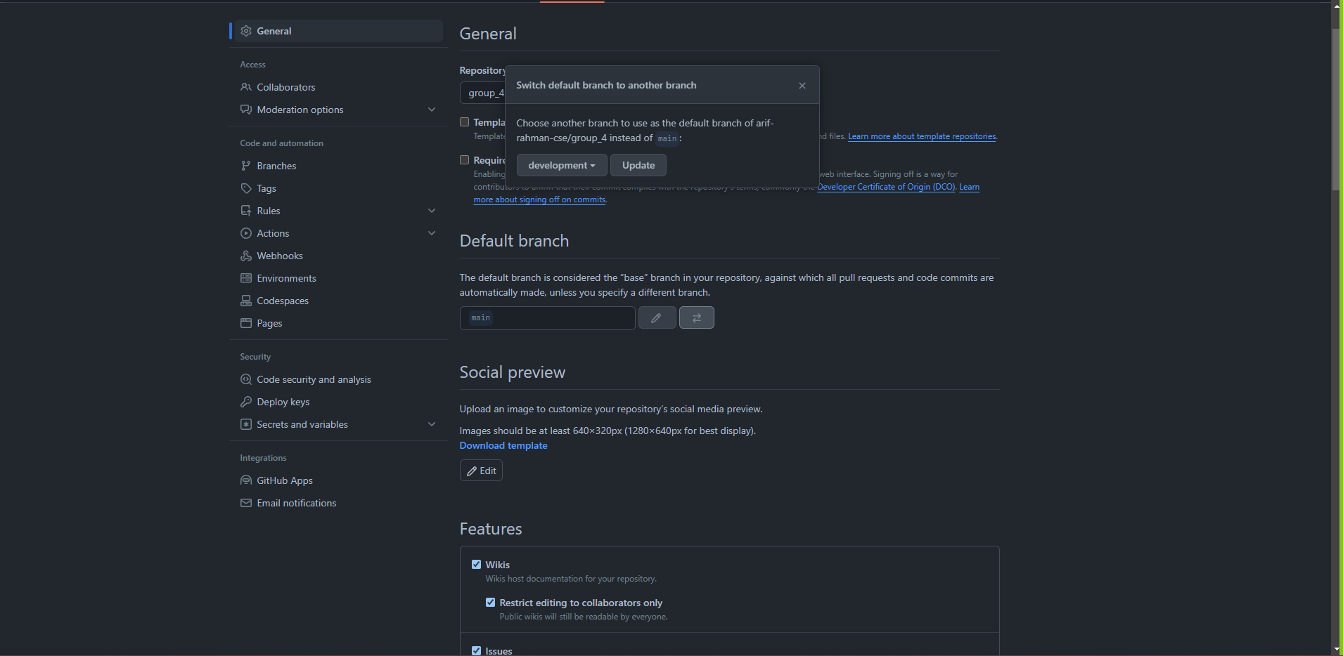
2. 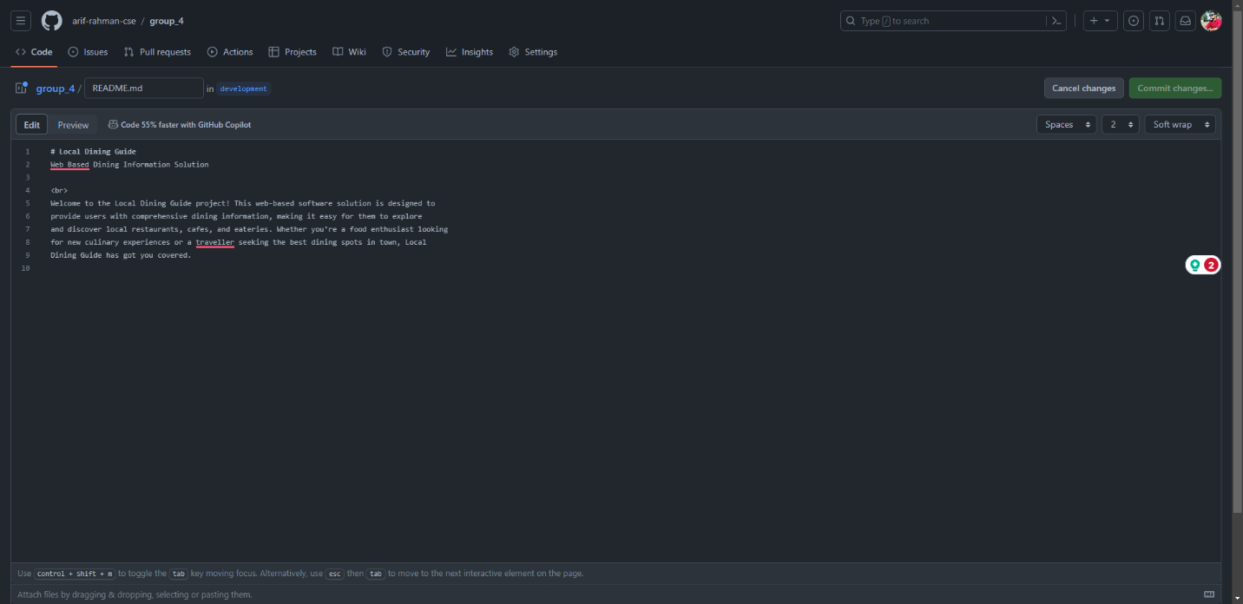**Remote README file Update**
3. **Branch Protection**

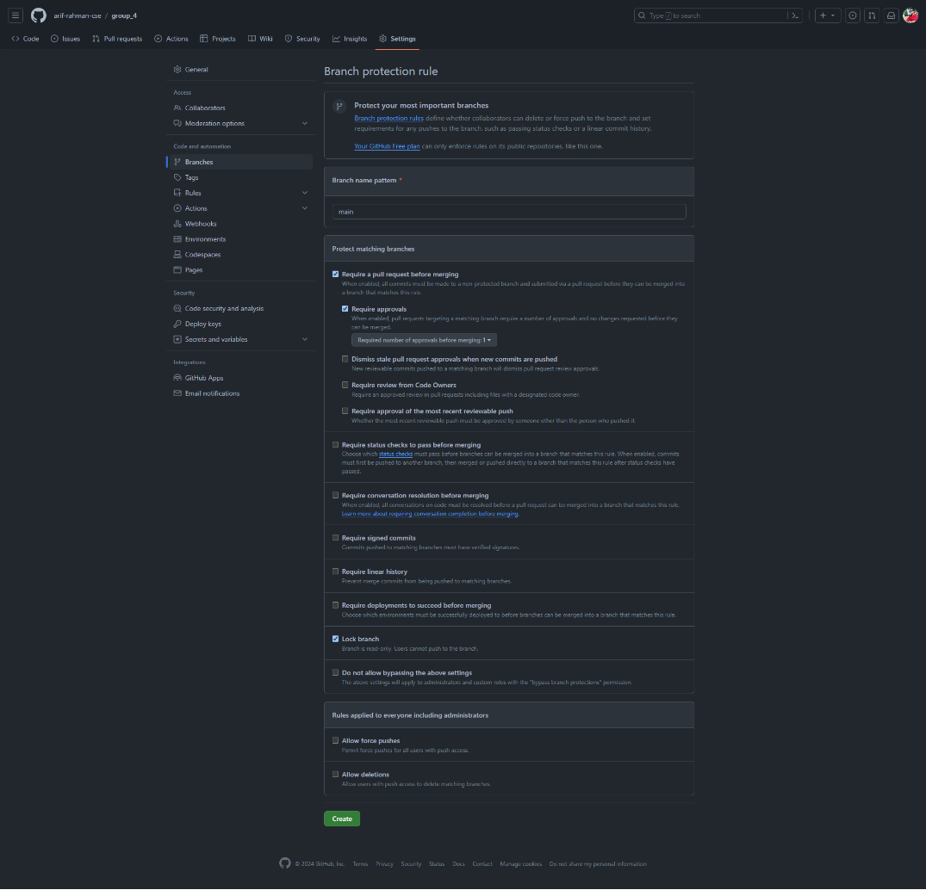

1. **Immediate Merge**

Merge each team member pull request.

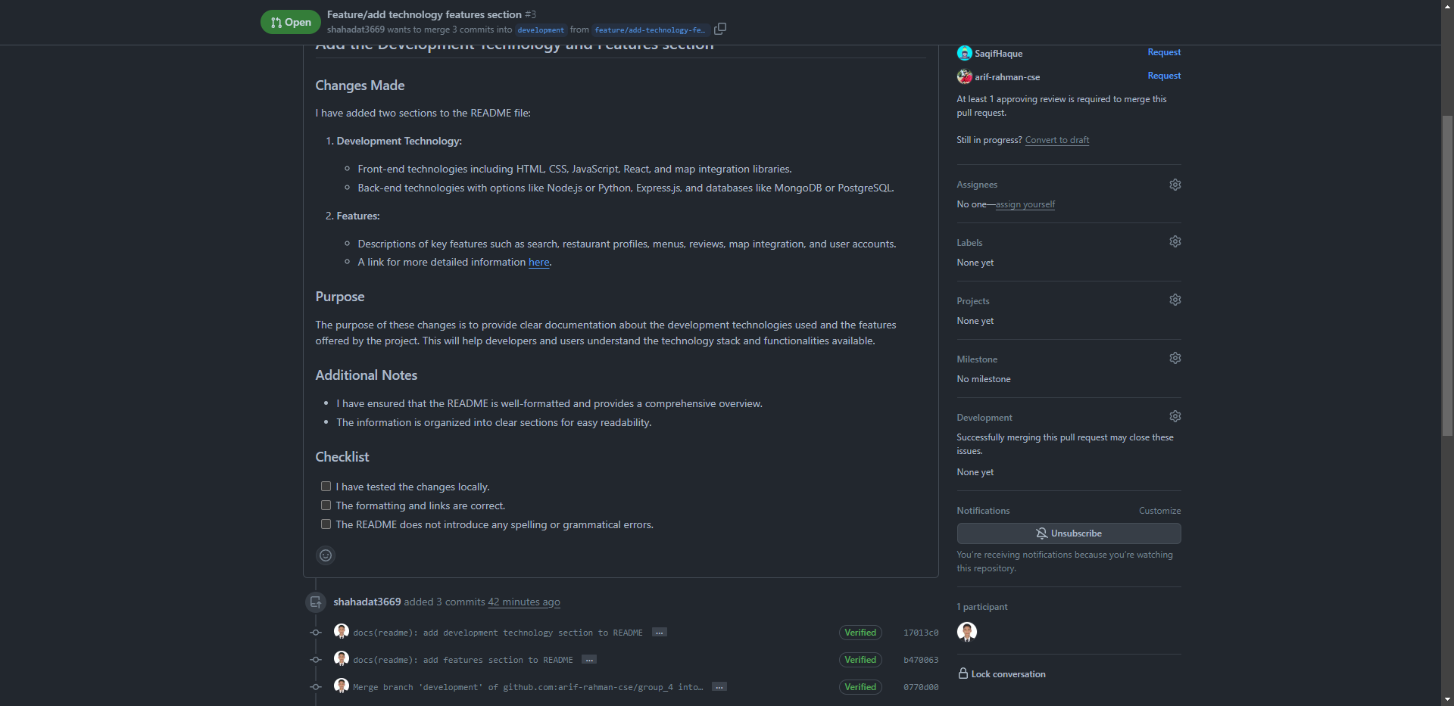

1. **Final Integration:**

Finally create a pull request from development branch to main branch.

**Individual Tasks for Each Trainee/Group Member:**

1. **Repository Cloning:** Clone your group's GitHub repository to your local environment using SSH key.

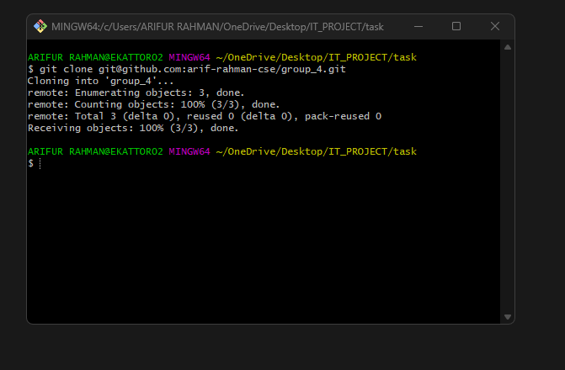

1. **Local Branch Creation:**

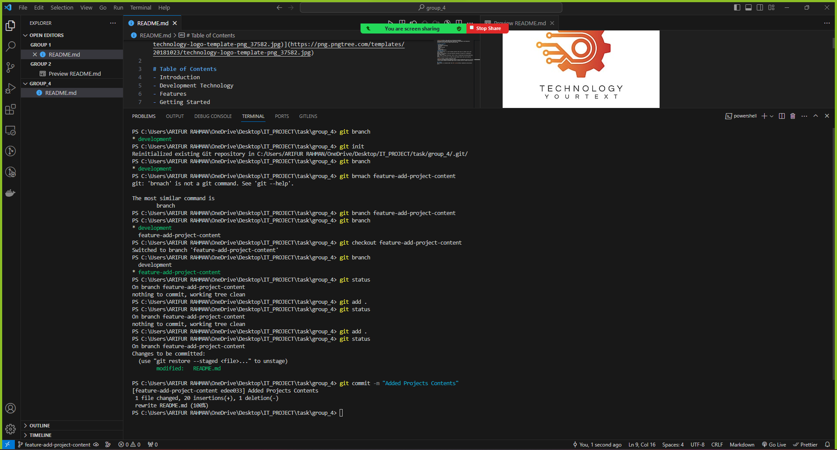

1. **README Content Update:**

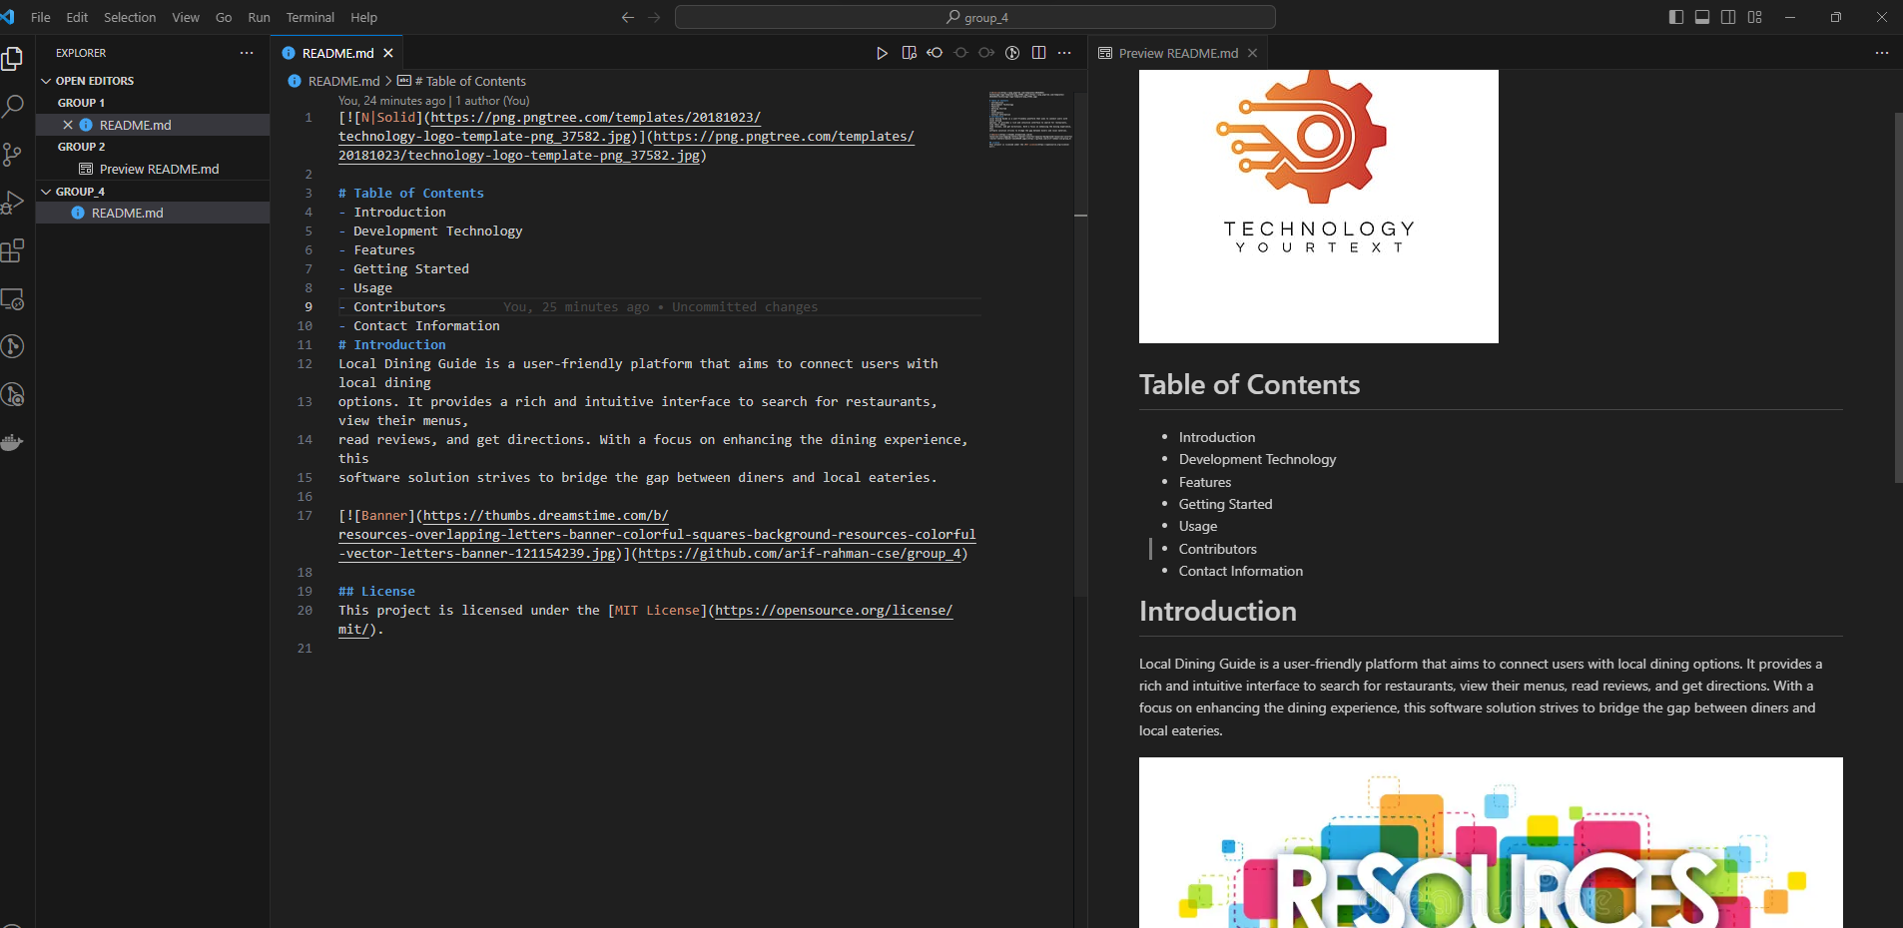

1. **Commit:**

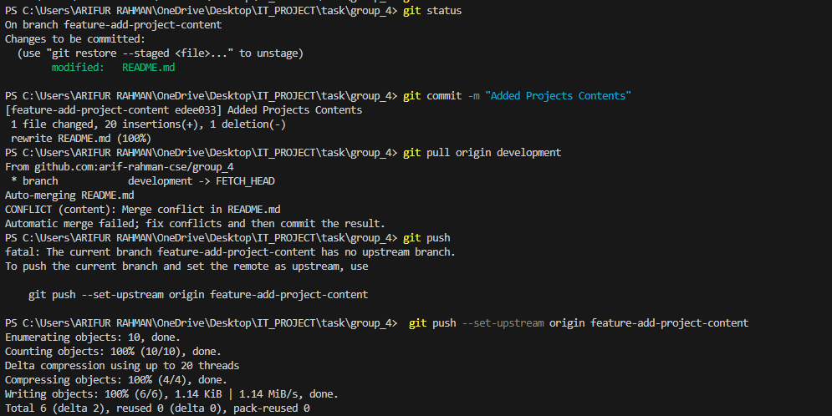

1. **Merge Conflict:**

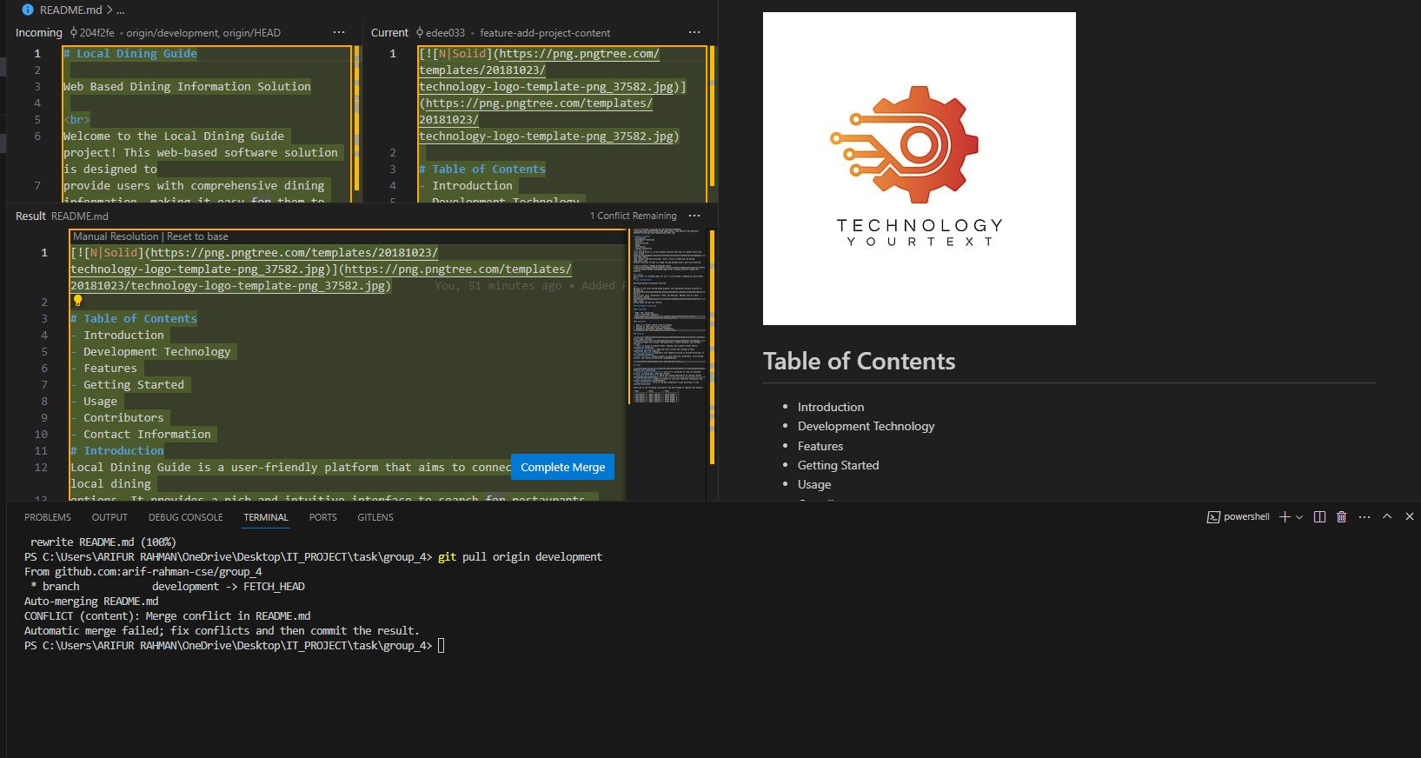

1. **Push:**



1. **Pull request and Task Merge:**



