# Github Exam (Group 4)

Name: Saqif Hoque   
BJET ID: 28  
  
  
Activities

1. Generating ssh key locally. Navigating to the public ssh key folder.  
   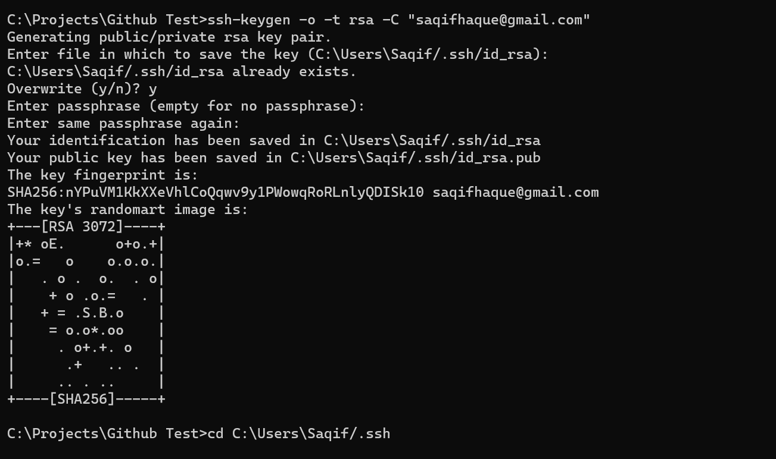  
     
   expose the public key and copy for configuration.  
   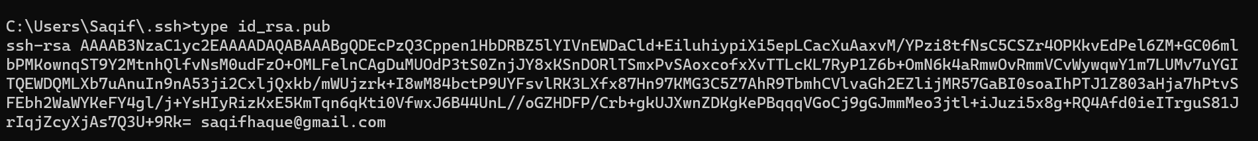  
     
     
     
     
     
     
     
     
     
     
     
     
     
   Add new ssh key  
   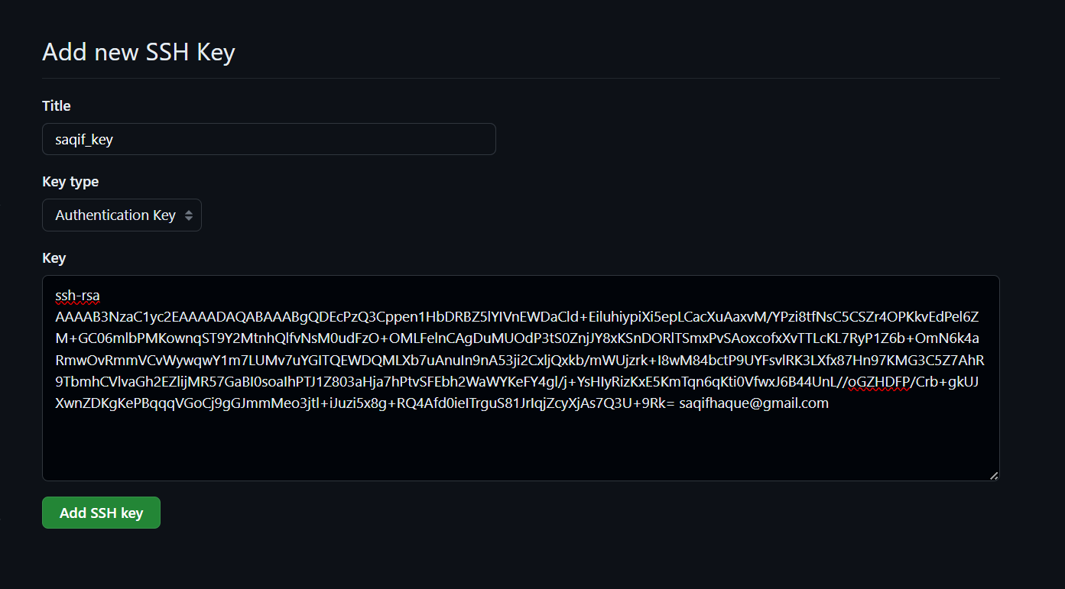
2. Clone remote repository.   
   Navigating to the group_4 folder.   
   Pulling development branch for latest changes.   
   Opening code editor.  
   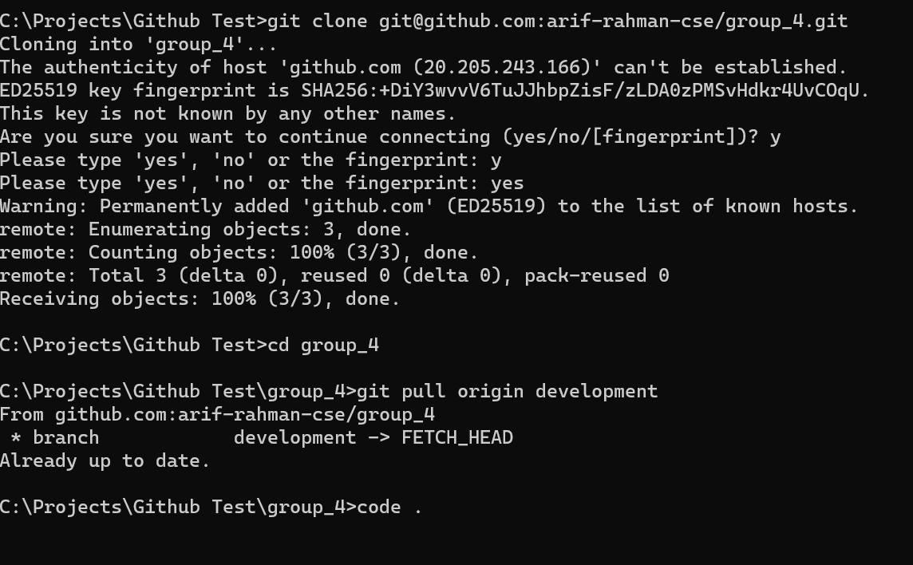

Create a branch locally. Switch to new feature branch.  
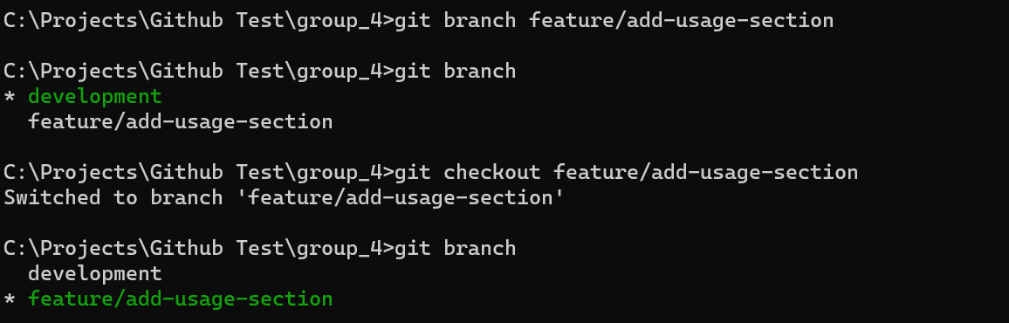

4.

Markdown file updated with the provided details.

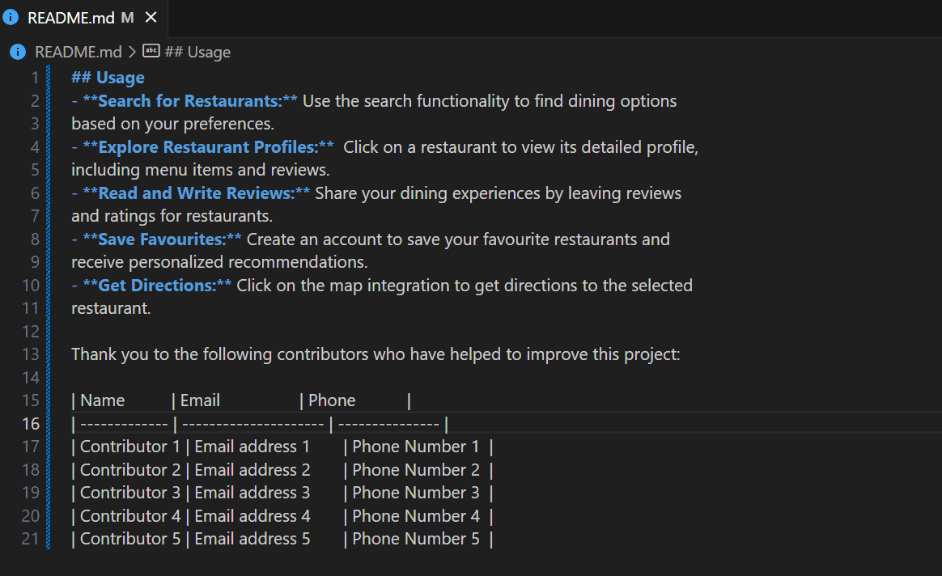

1. add add and commit the new update locally.  
   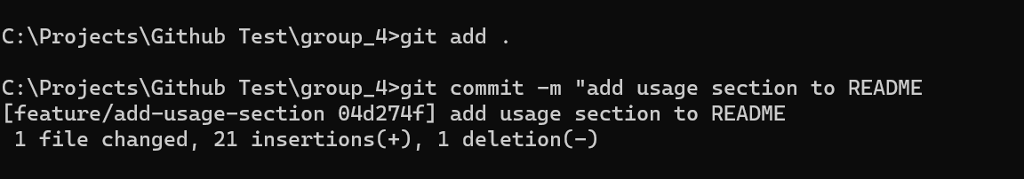

6. Pulling latest changes and we can see a conflict has been created.

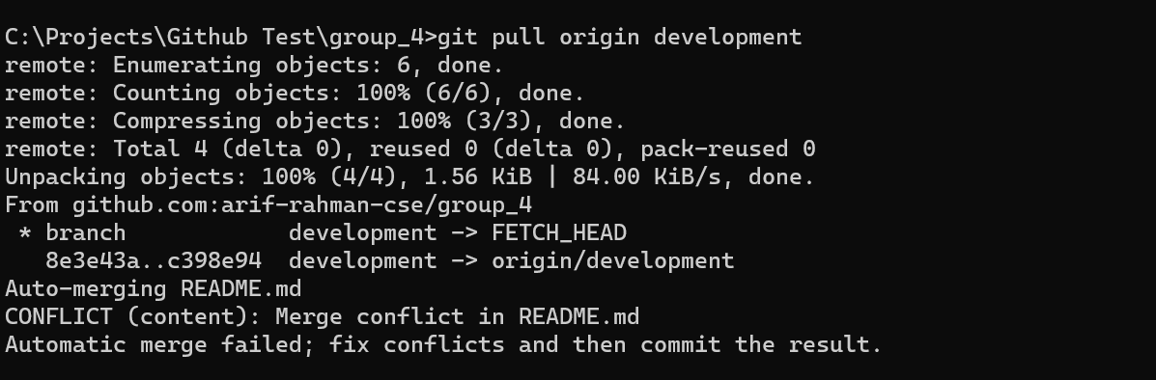

1. Merge conflicts

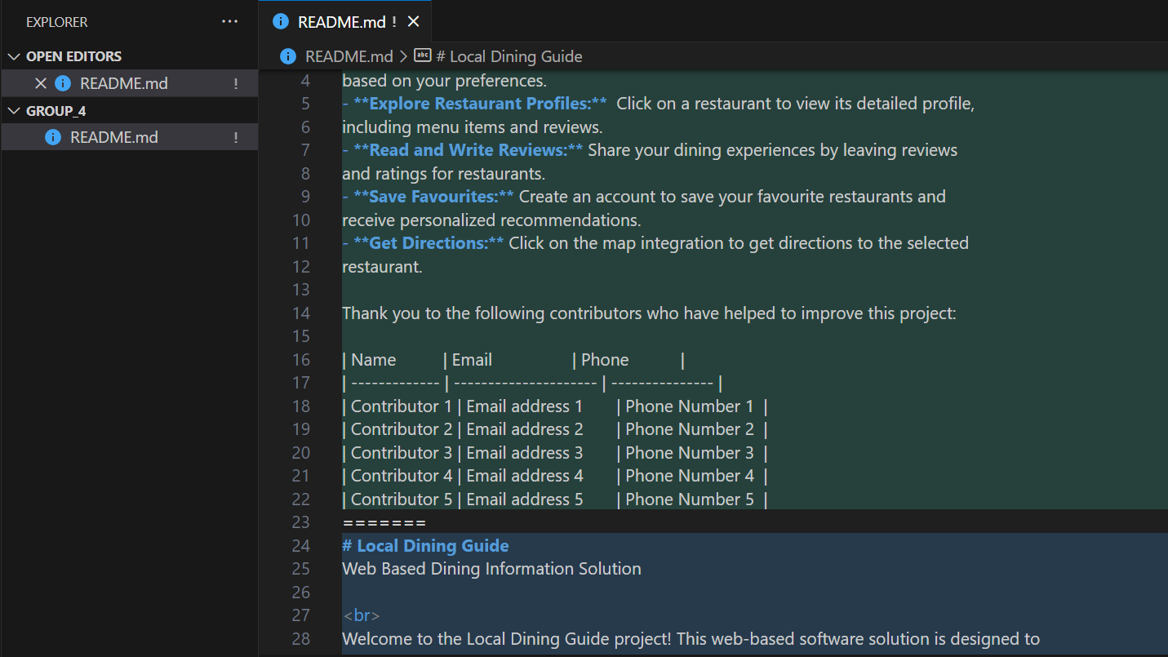

Merge conflicts Resolved.

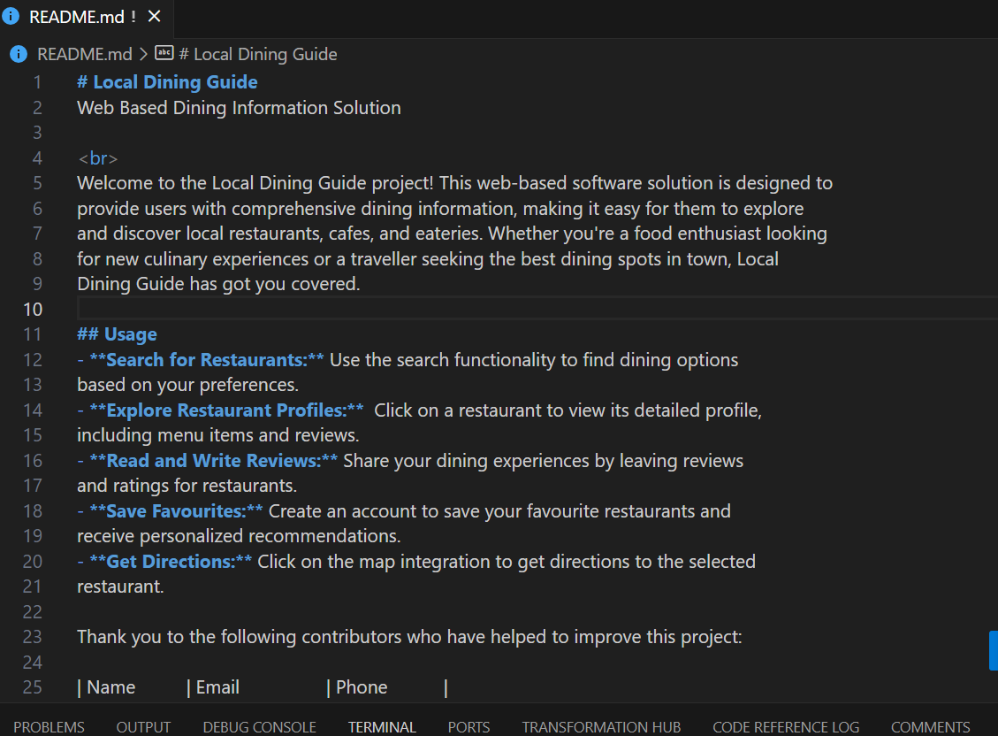

8.

Merge conflict resolved and new commit created  
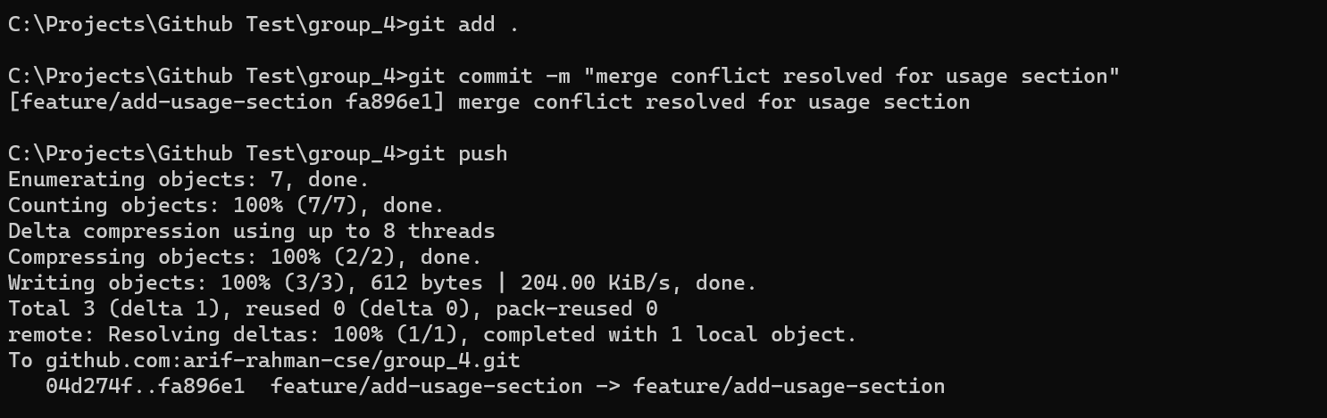

9.Pull request creation  
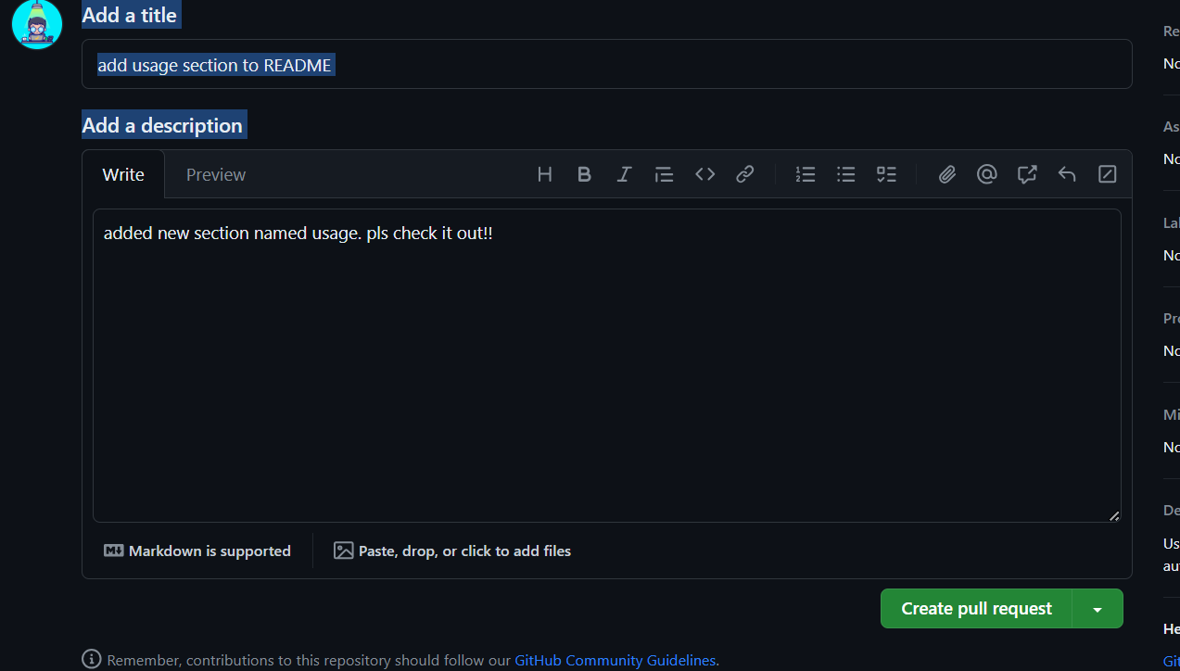  
  
10. pull request accepted

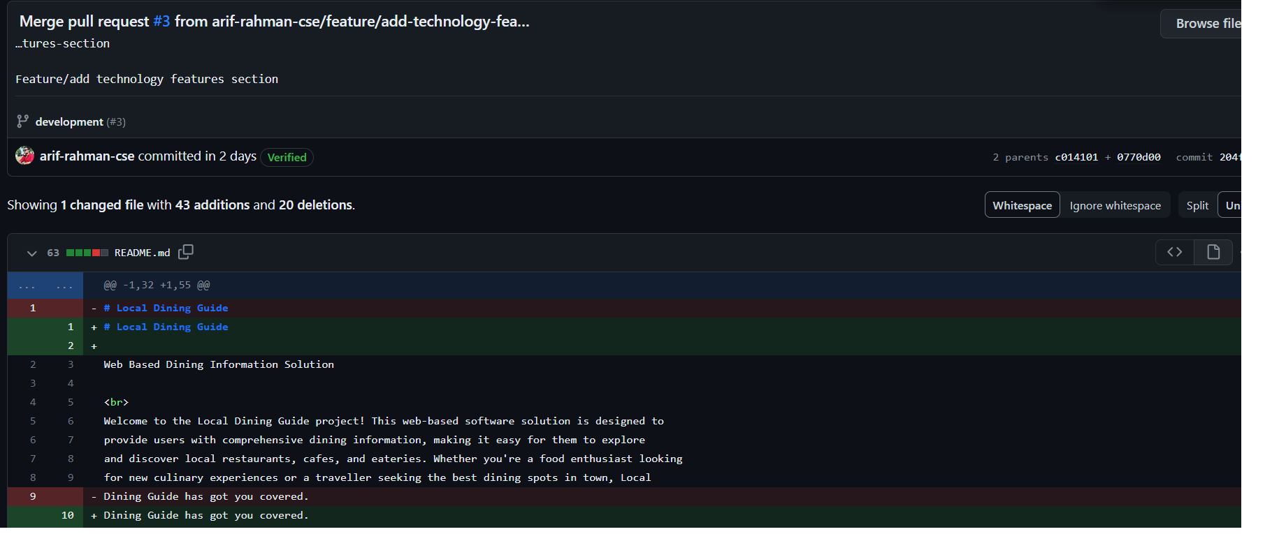

1. New branch created for documentation and pull request created

