**Git and GitHub Practical Exam: Group4  
Member: 33_Tarannaum Jahan Sultan**

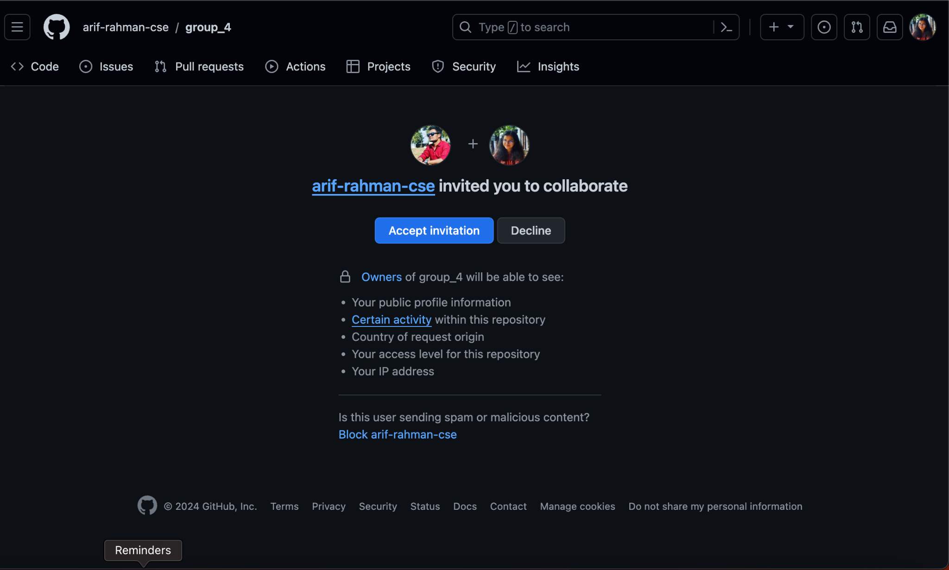1) Accepted team leader’s invitation to collaborate.

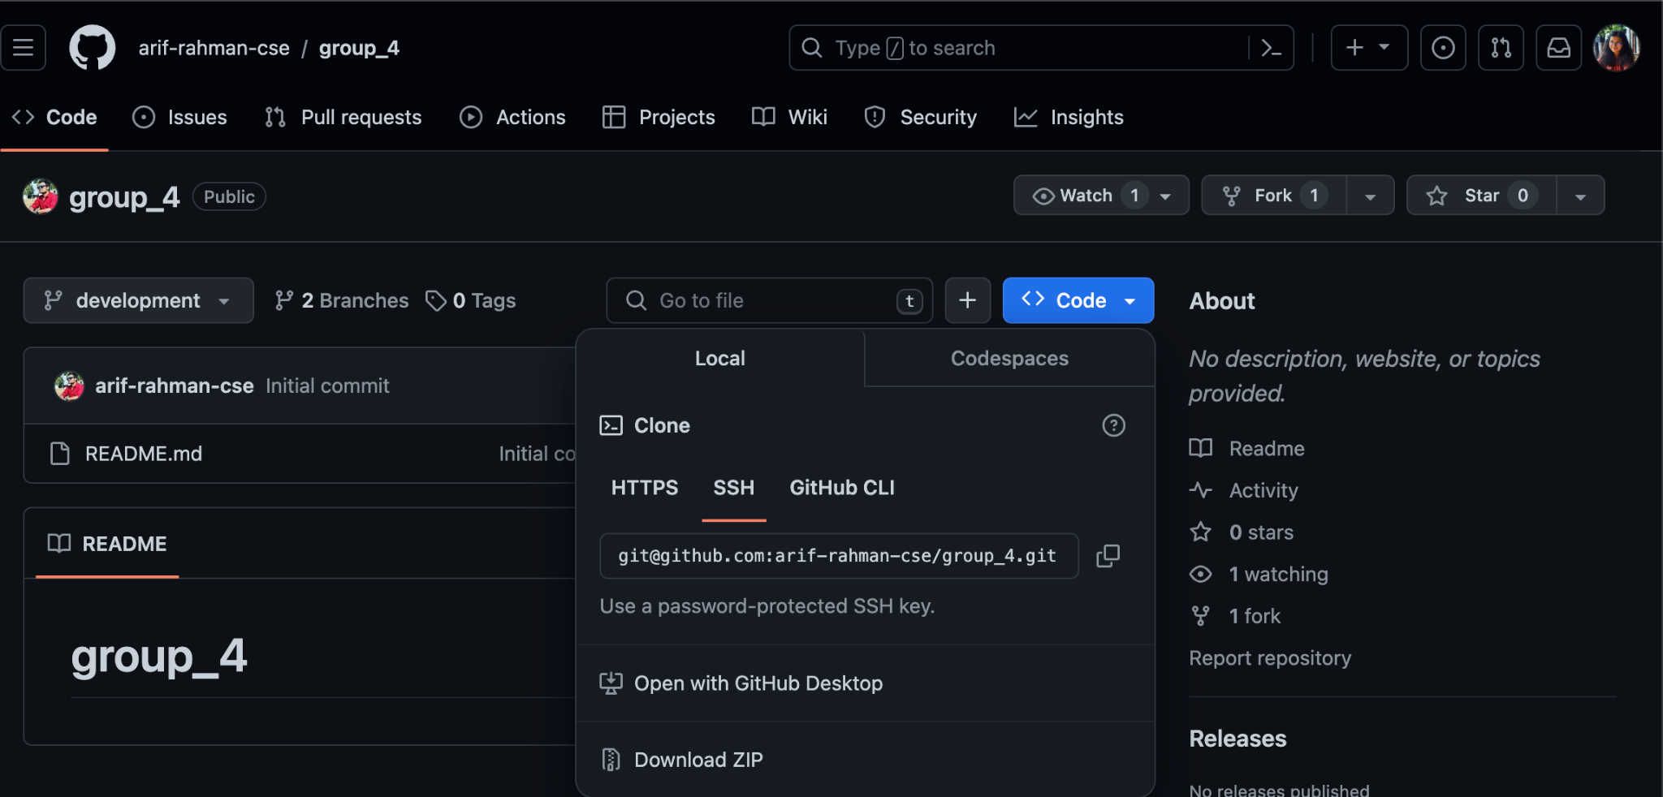  
2) For Repository Cloning, Used SSH key to clone the group's GitHub repository to my local environment.

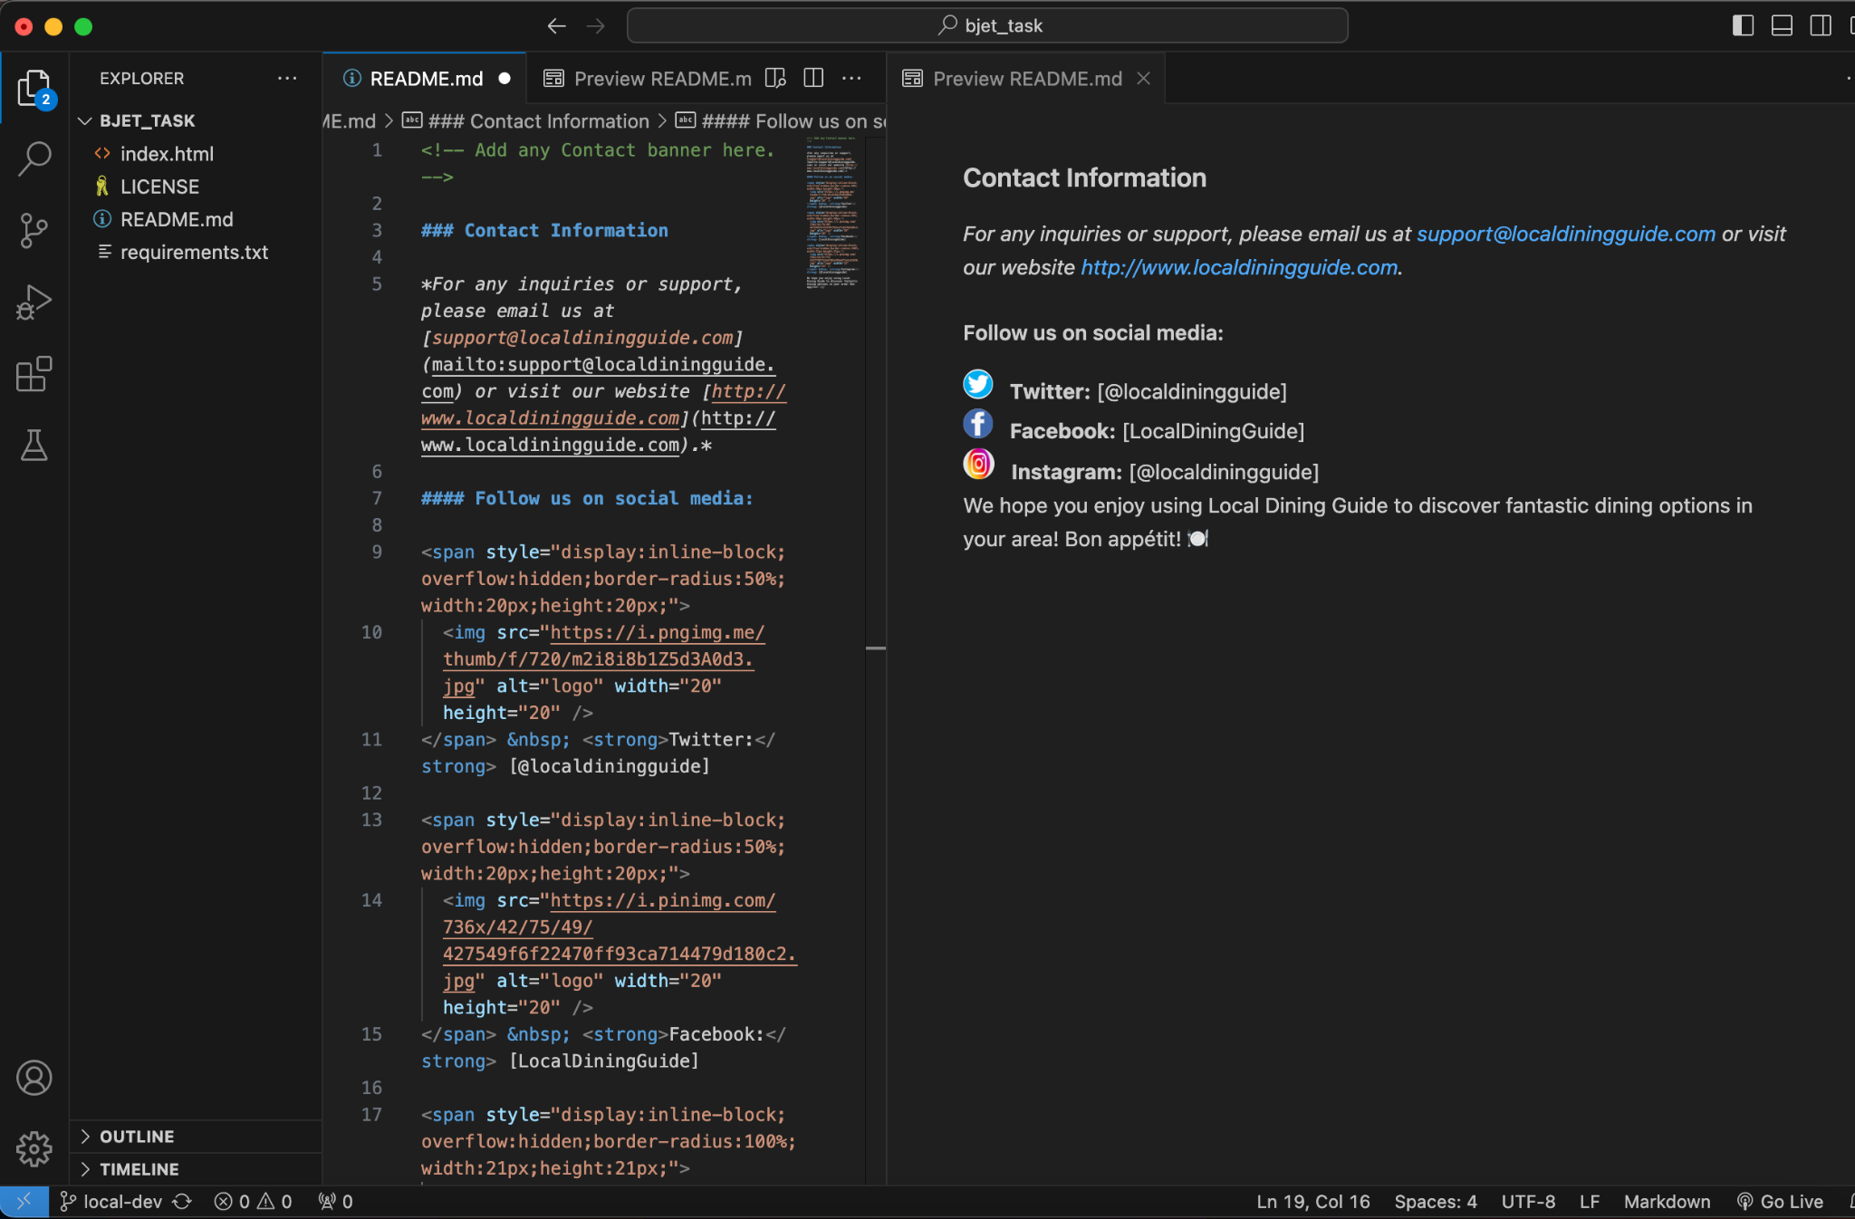

3) Created and added contact information section using markdown and html tags.

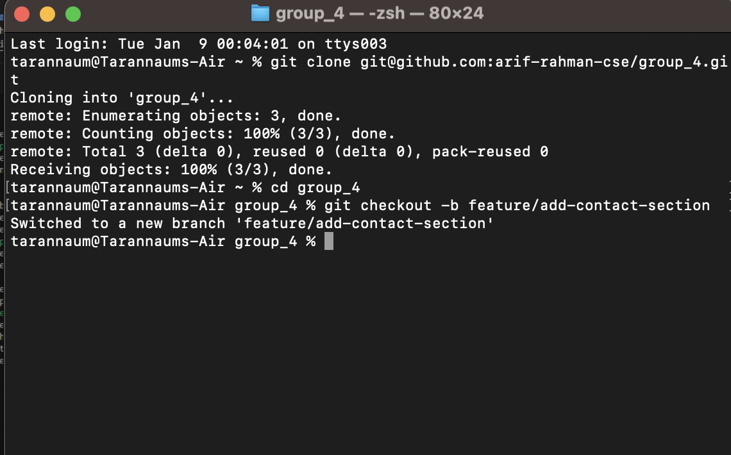

4) Cloned the repository.

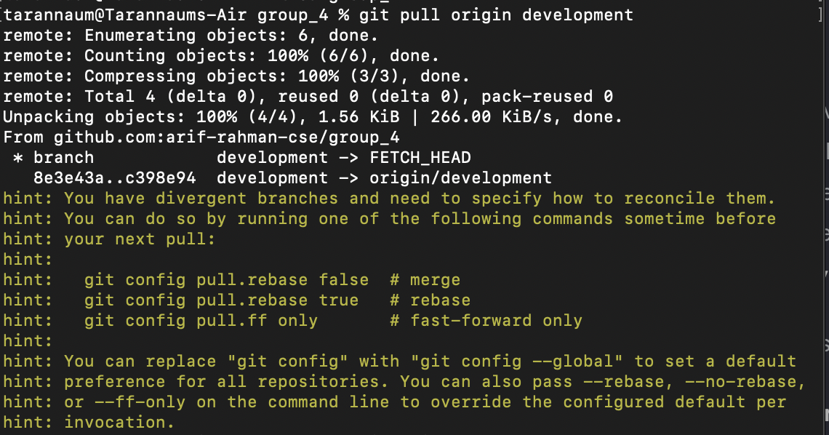  
5) I Pulled the development branch.

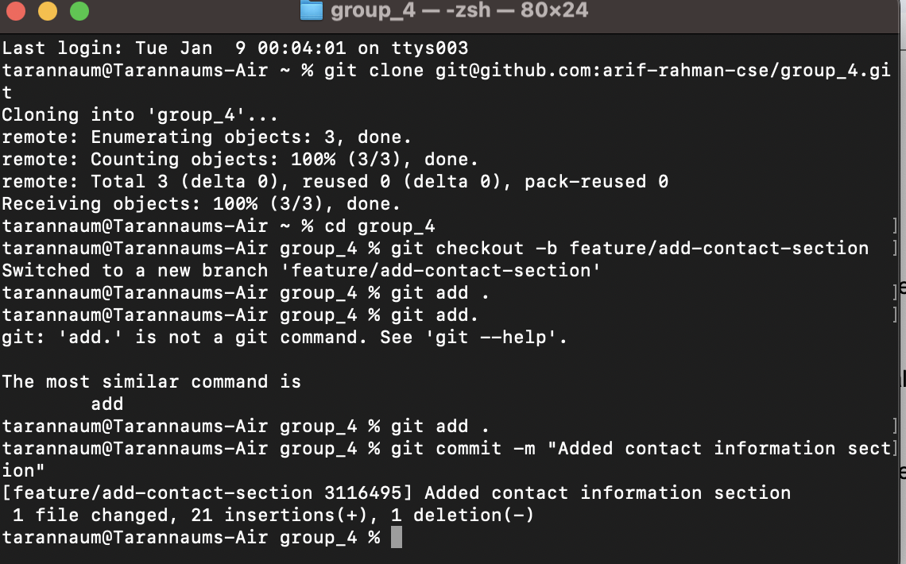

5) I Created a new local branch. Also used add and commit message commands.

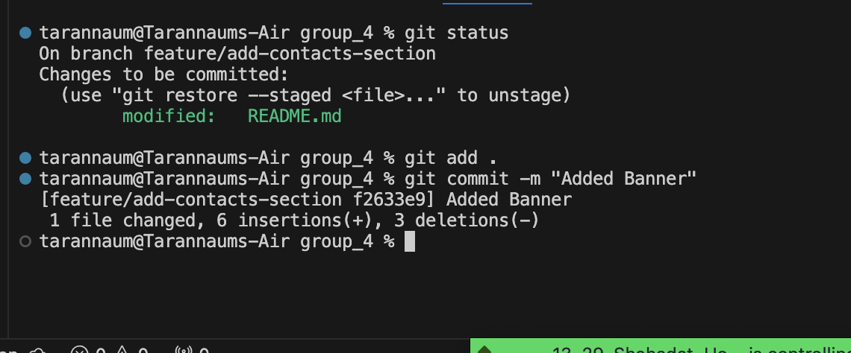  
  
5) updated commit message.

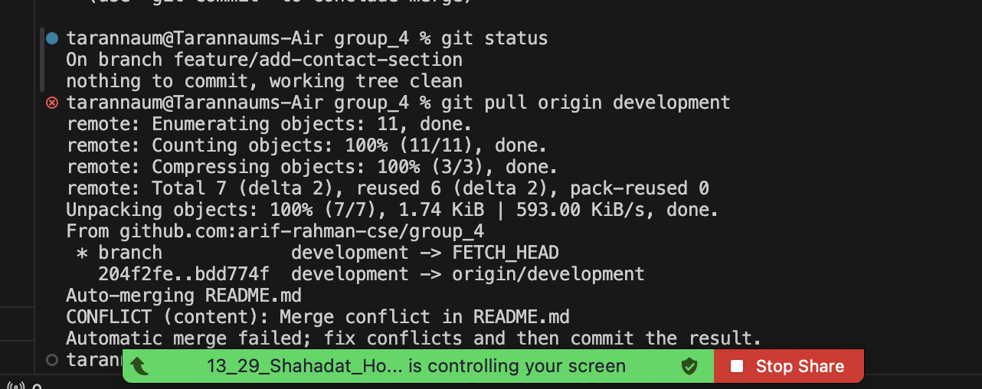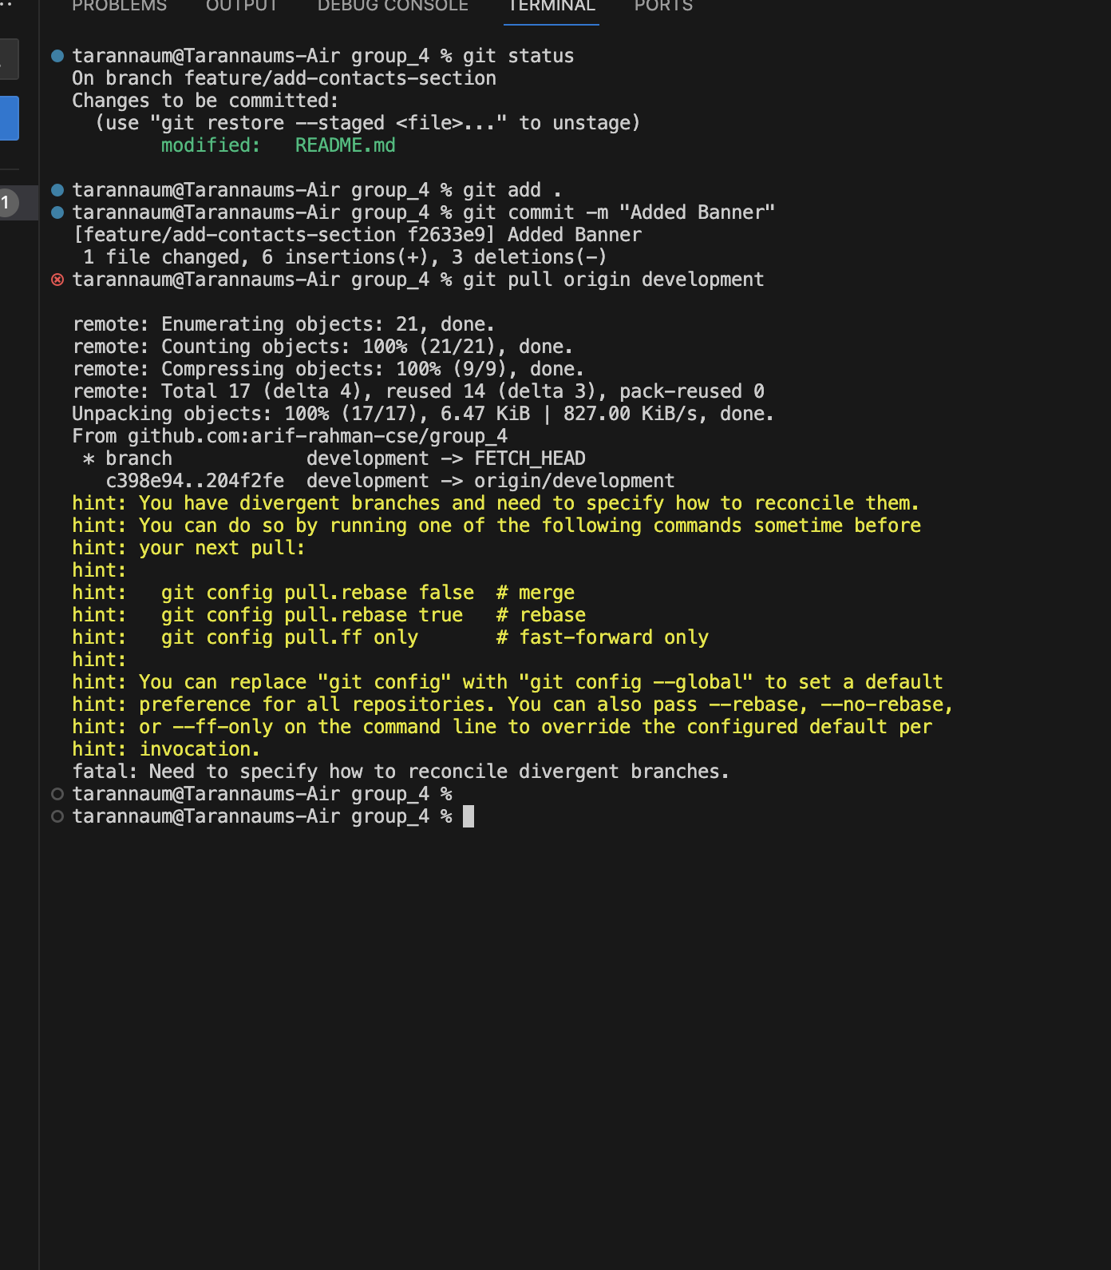  
  
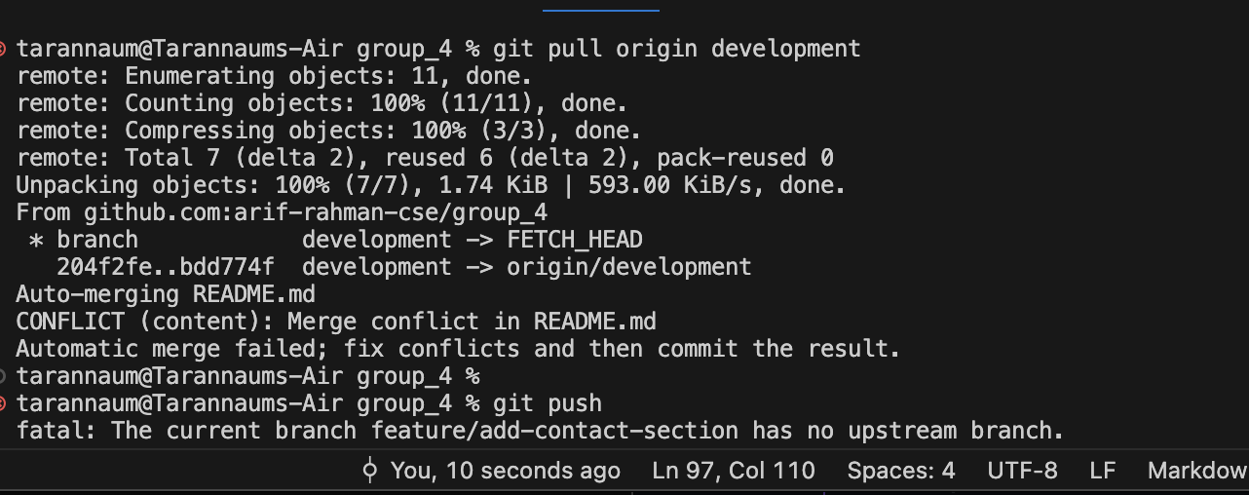  
6) Faced development branch conflict.

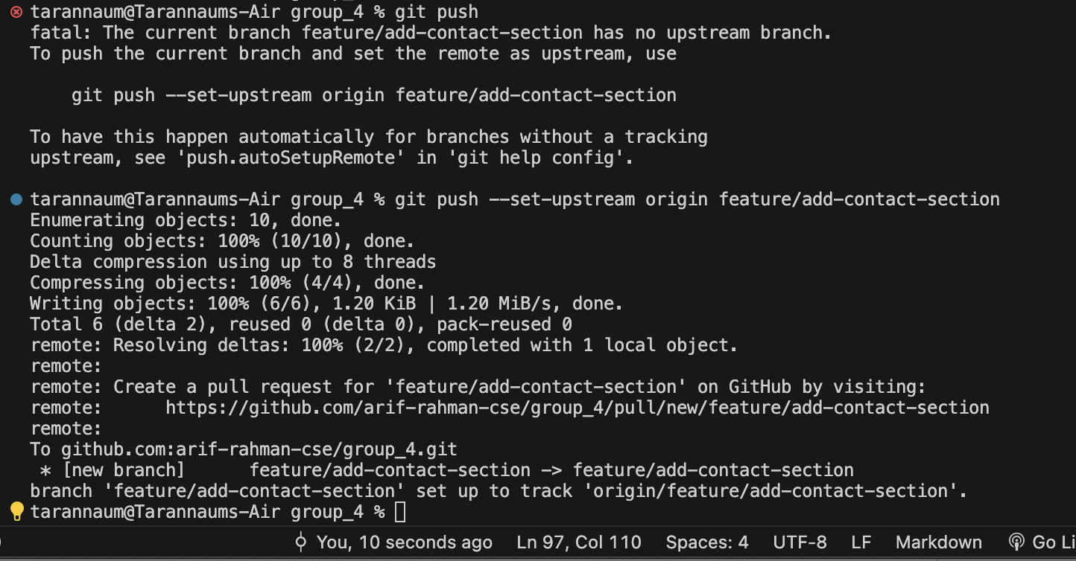  
  
7)Used push command  
  
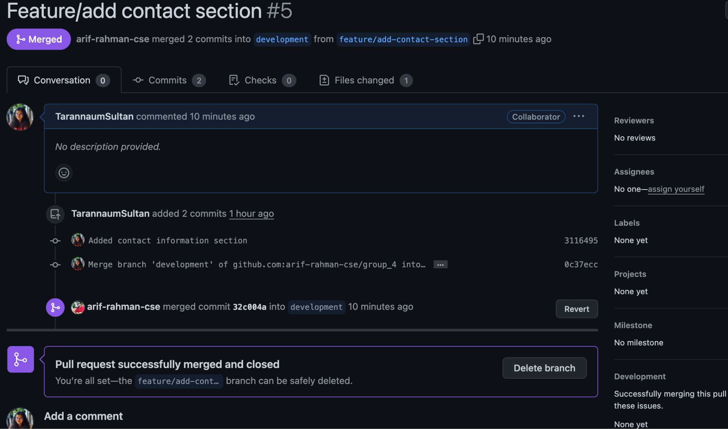  
  
8) Compare pull request to merged