


Patuakhali Science and Technology University
Faculty of Computer Science and Engineering
Project Proposal on
BiteNest: A Smart Food Delivery and Restaurant Management System
Course Code: CIT-222
Submitted By
Name | ID
Faozia Abida Nimmi | 2302019
Meheruneesa Laboni | 2302020
Aditi Gain | 2302059

Date: 28 July, 2026
Submitted To
Muhtasim
Lecturer
Department of Computer Science and Information Technology
Faculty of Computer Science and Engineering
&
Golam Md. Muradul Bashir
Department of Computer and Communication Engineering
Faculty of Computer Science and Engineering

Table of Contents
1. Problem Statement
2. Objectives
3. Feasibility Study
3.1 Technical Feasibility
3.2 Economic Feasibility
3.3 Operational Feasibility
4. Information Gathering
5. Benchmark Analysis
6. Proposed Features
6.1 Customer Module
6.2 Restaurant Module
6.3 Delivery Rider Module
6.4 Administrator Module
6.5 Innovative Features
7. Site Map
8. System Requirements
8.1 Hardware Requirements
8.2 Software Requirements
9. System Architecture
Conclusion

1. Problem Statement
Online food delivery services have become an important part of modern life. Although existing platforms make food ordering convenient, they mainly focus on basic ordering and delivery while lacking intelligent features such as restaurant workload monitoring, optimized delivery management, and cost-effective multi-restaurant ordering.
Customers who order from multiple restaurants often have to place separate orders, pay multiple delivery charges, and wait for different delivery times. Additionally, they have limited information about restaurant availability and estimated delivery time.
To address these limitations, this project proposes a Smart Food Delivery & Restaurant Management System with innovative features such as Smart Queue Status, Customer Preferred Delivery Time, Smart Multi-Restaurant Combined Delivery, leftover discount and meal planning system. The system aims to improve customer experience, reduce delivery costs, optimize delivery operations, and provide efficient management for restaurants, delivery riders, and administrators.

2. Objectives
The main objectives of the proposed system are:
- To develop a secure, user-friendly, and efficient online food delivery platform.
- To enable customers to search restaurants based on their preferred location and easily place food orders.
- To provide restaurants with an effective system for managing menus, customer orders, and daily operations.
- To facilitate delivery riders with an organized order assignment and delivery management system.
- To introduce Smart Queue Status for displaying restaurant workload and improving delivery time estimation.
- To implement Smart Multi-Restaurant Combined Delivery with Meal Planner and Leftover Discount for reducing delivery costs and optimizing rider utilization.
- To provide accurate and realistic estimated delivery times based on restaurant workload and delivery conditions.
- To build a scalable and maintainable RESTful web application using HTML, CSS, Tailwind, ASP.NET Core Web API and MySQL.

3. Feasibility Study
Dimension | Assessment
Technical Feasibility | The proposed system will be developed using modern and reliable technologies, including ASP.NET Core Web API (.NET 8), C#, Entity Framework Core, MySQL, HTML5, CSS3, Bootstrap 5, and JavaScript. These technologies are open-source, well-documented, and suitable for building a secure, scalable, and maintainable web application.
Economic Feasibility | The project can be developed with minimal cost by using free and open-source development tools such as Visual Studio Community, Visual Studio Code, MySQL, GitHub, Postman, and Swagger. Therefore, no commercial software or additional licensing cost is required.
Operational Feasibility | The system is designed to be simple, user-friendly, and easy to operate. Separate dashboards for Customers, Restaurants, Delivery Riders, and Administrators will ensure efficient system management and improve the overall user experience.

4. Information Gathering

5. Benchmark Analysis
The proposed system was designed after analyzing several popular online food delivery platforms. The analysis helped identify the strengths and limitations of existing systems and provided opportunities to introduce innovative features that enhance user experience and operational efficiency.
Existing System | Identified Limitation | Proposed Improvement
Foodpanda | Customers ordering from multiple restaurants must pay separate delivery charges and receive separate deliveries. Also doesn't provide meal planner or leftover discount features. | Introduce Smart Multi-Restaurant Combined Delivery, allowing orders from nearby restaurants to be grouped and delivered by a single rider with optimized delivery charges. Add Meal Planner and Leftover Food Discount features to reduce food waste and improve delivery charges.
Pathao Food | Does not provide customers with a real-time indication of restaurant workload or order queue status. Neither do they provide a meal planner or leftover discount feature. | Implement a Smart Queue Status system (Free, Normal, Busy) to help customers estimate preparation time. Introduce an AI-powered Meal Planner and Leftover Food Discount section.
Uber Eats | Limited customer control over delivery scheduling and optimization. | Provide Customer Preferred Delivery Time with intelligent delivery time estimation based on restaurant workload and rider availability.

6. Proposed Features
The proposed Smart Food Delivery & Restaurant Management System consists of four primary modules along with several innovative features to improve customer experience, restaurant operations, and delivery efficiency.

Customer Module
- User Registration & Login
- Location Selection
- Restaurant & Food Search
- Food Category Browsing
- Shopping Cart & Checkout
- Order Tracking & Order History
- Ratings & Reviews

Restaurant Module
- Restaurant Dashboard
- Menu Management
- Order Management
- Inventory Management
- Sales Report

Delivery Rider Module
- Order Assignment
- Delivery Status Update
- Delivery History

Administrator Module
- User & Restaurant Management
- Category Management
- Rider Management
- Reports & Analytics

Innovative Features
- Smart Queue Status: Displays restaurant availability as Free, Normal, or Busy based on active orders and preparation time.
- Customer Preferred Delivery Time: Allows customers to select a preferred delivery time, which is validated based on restaurant workload and rider availability.
- Smart Multi-Restaurant Combined Delivery: Enables customers to order from up to two nearby restaurants in a single order using one delivery rider, reducing delivery charges and improving delivery efficiency.
- Smart Delivery Recommendation: Recommends combined or separate delivery by analyzing restaurant distance, preparation time, queue status, and rider availability.
- Advanced Meal Planner: Recommends combo or single food items based on customer preferences (e.g., calorie count or budget).
- Leftover Discount: A feature offering discounts on leftover or unsold items.

7. Site Map
Smart Food Delivery & Restaurant Management System
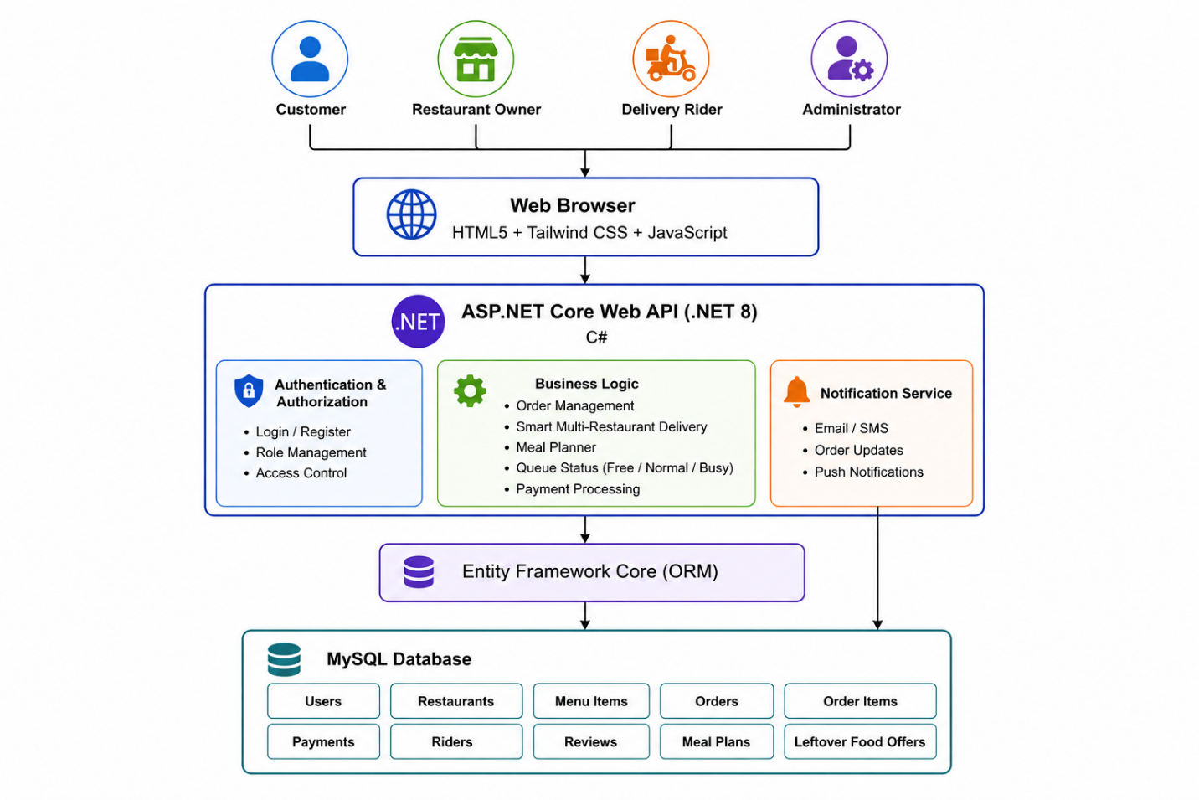

8. System Requirements

8.1 Hardware Requirements
The BiteNest system requires standard computer hardware for development and operation. A computer with an Intel Core i5 processor (or equivalent), 8 GB RAM, 256 GB SSD (or higher), a stable internet connection, and a display with a minimum resolution of 1366 × 768 is sufficient for development, testing, and deployment.

8.2 Software Requirements
The BiteNest system is developed using ASP.NET Core (.NET 8) with C# for the backend, HTML5, Tailwind CSS, and JavaScript for the frontend, and MySQL as the database. Development tools include Visual Studio 2022, Visual Studio Code, Git/GitHub for version control, Postman for API testing, and a modern web browser such as Google Chrome or Microsoft Edge for accessing the application.

9. System Architecture
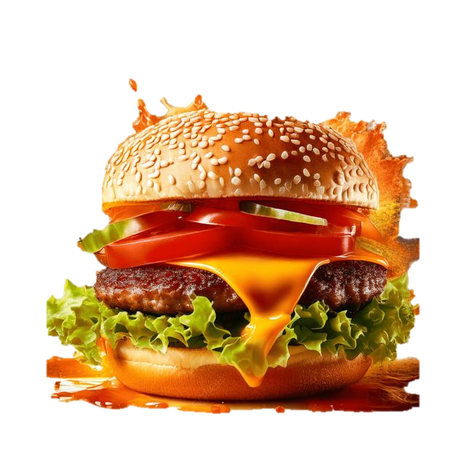

Conclusion
BiteNest is designed to provide a smarter, faster, and more efficient food delivery experience by addressing several limitations of existing platforms. Features such as Smart Multi-Restaurant Combined Delivery, Meal Planner, Restaurant Queue Status, Preferred Delivery Scheduling, and Leftover Food Discounts enhance user convenience while improving operational efficiency. By leveraging modern technologies such as ASP.NET Core, Tailwind CSS, Entity Framework Core, and MySQL, the proposed system is secure, scalable, and easy to maintain. Overall, BiteNest offers an innovative and practical solution that benefits customers, restaurants, delivery riders, and administrators alike.

