🛠️ KajBazar
System Analysis & Design
Diagram Document

Community-Driven Service Provider Directory Platform
A comprehensive collection of 15 system architecture diagrams

━━━━━━━━━━━━━━━━━━━━━━━━━━━━━━━━━━━━━━━━━━━━━━━━━━

Course: CIT-222: System Analysis and Design Sessional
Session: 2023-2024
Institution: PSTU — Faculty of Computer Science & Engineering
Technology: .NET 8 · React 18 · PostgreSQL 15+

📋 Table of Contents

▸ Data Flow Diagrams
Figure 1: Context Diagram
High-level system boundary showing external actors and data flows
Figure 2: Level 0 Data Flow Diagram
Interaction between actors, core process, and data stores
Figure 3: Level 1 Data Flow Diagram
Subsystem decomposition — Processes P1 through P5
Figure 4: Level 2 Data Flow Diagram
Detailed decomposition of Process 3.0 — Directory Search & Direct Contact

▸ Use Case Diagram
Figure 5: Use Case Diagram
Actor interactions — 4 actors, 16 use cases with «includes» relationships

▸ Activity Diagrams
Figure 6: Activity Diagram — User Registration
User registration & authentication workflow (BR-01, BR-13)
Figure 7: Activity Diagram — Worker Verification
Worker profile creation & admin verification flow (BR-02, BR-03, BR-10)
Figure 8: Activity Diagram — Search & Contact
Worker search & direct contact workflow (BR-05, BR-06)
Figure 9: Activity Diagram — Review Submission
Review & rating submission with automatic aggregation (BR-07, BR-08)
Figure 10: Activity Diagram — Community Recommendation
Offline worker recommendation & admin moderation (BR-09)

▸ Class Diagrams
Figure 11: Class Diagram — Domain Model
C# domain entities, value objects, enums, and entity relationships
Figure 12: Class Diagram — Clean Architecture
API Controllers, Service Interfaces, Repository Implementations & DbContext

▸ Entity-Relationship Diagrams
Figure 13: ER Diagram — Conceptual
High-level business concepts, entities, and relationships
Figure 14: ER Diagram — Physical Schema
Complete PostgreSQL 12-table schema with column types, PKs, FKs & constraints

▸ Sequence Diagram
Figure 15: Sequence Diagram
Multi-criteria search & direct contact flow (BR-05, BR-06)

Figure 1: Context Diagram
High-level system boundary showing external actors and data flows
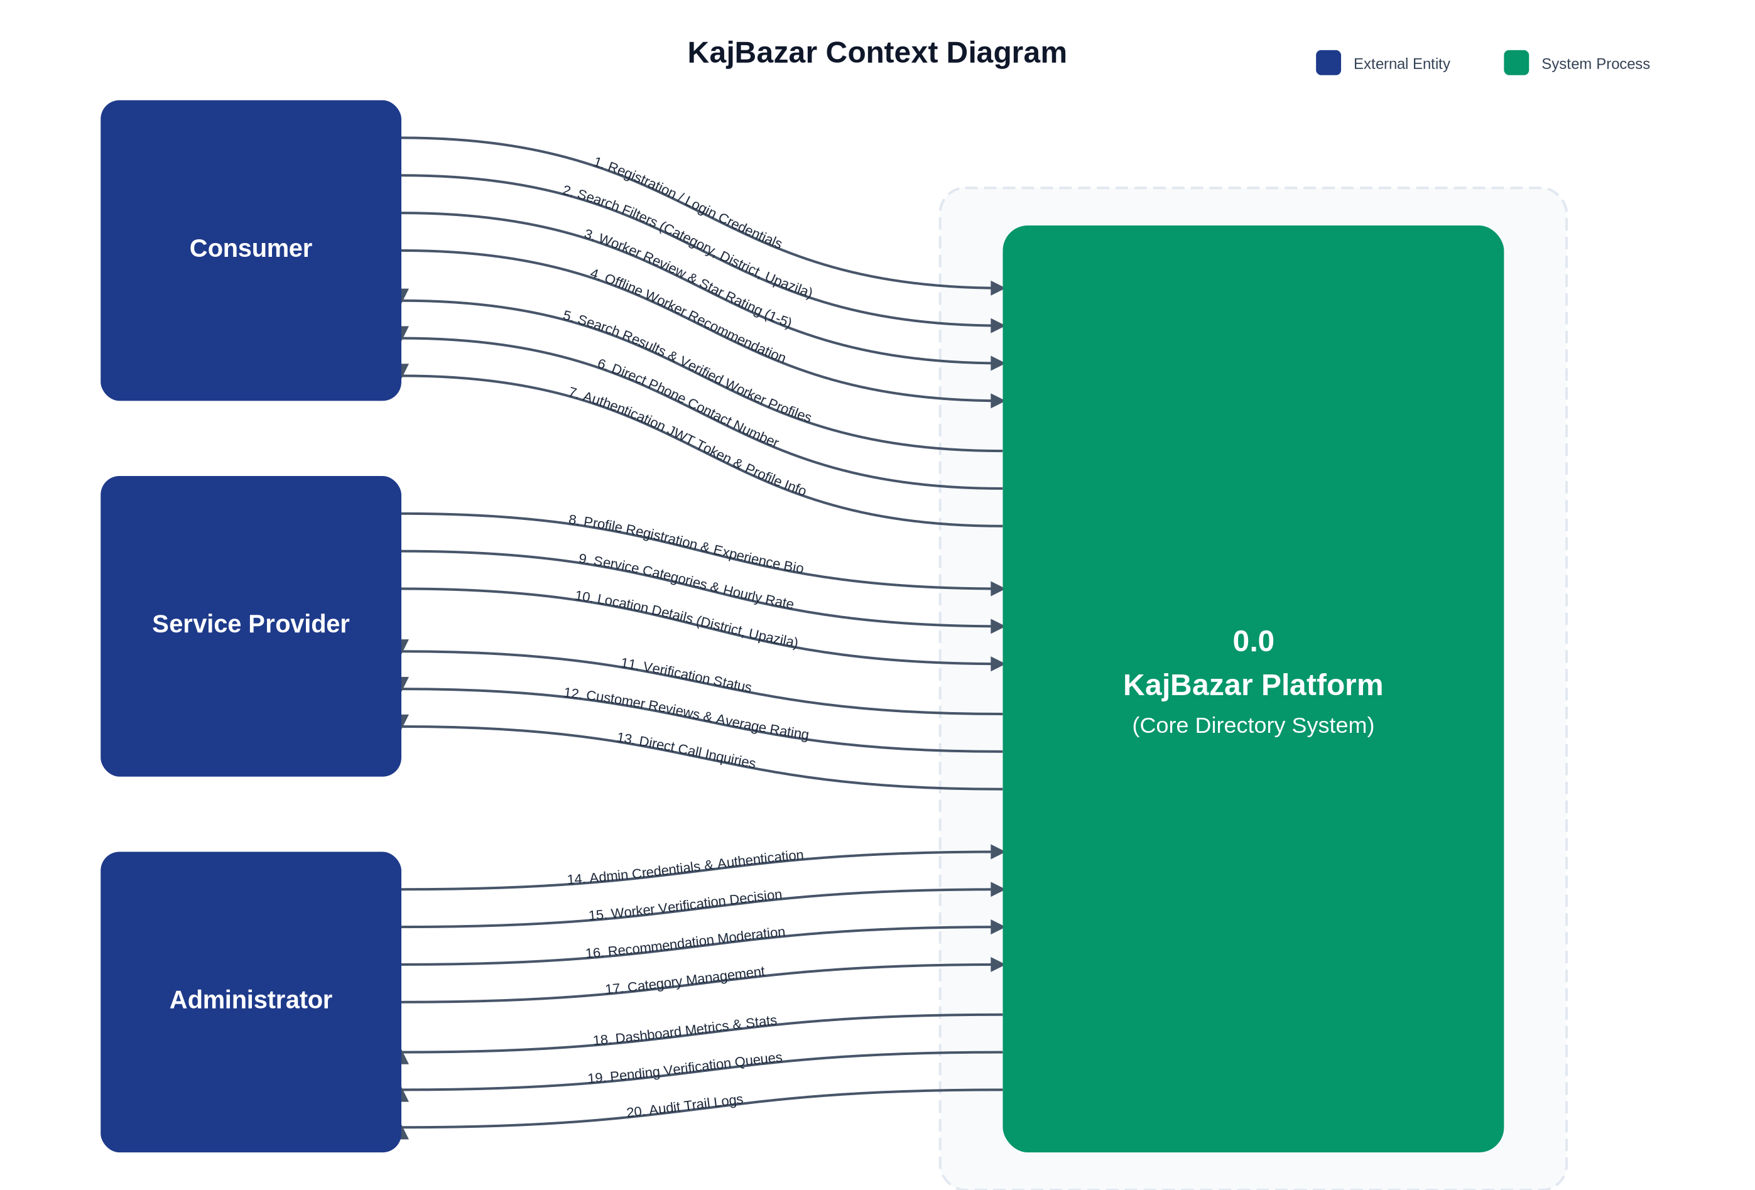

Figure 2: Level 0 Data Flow Diagram
Interaction between actors, core process, and data stores
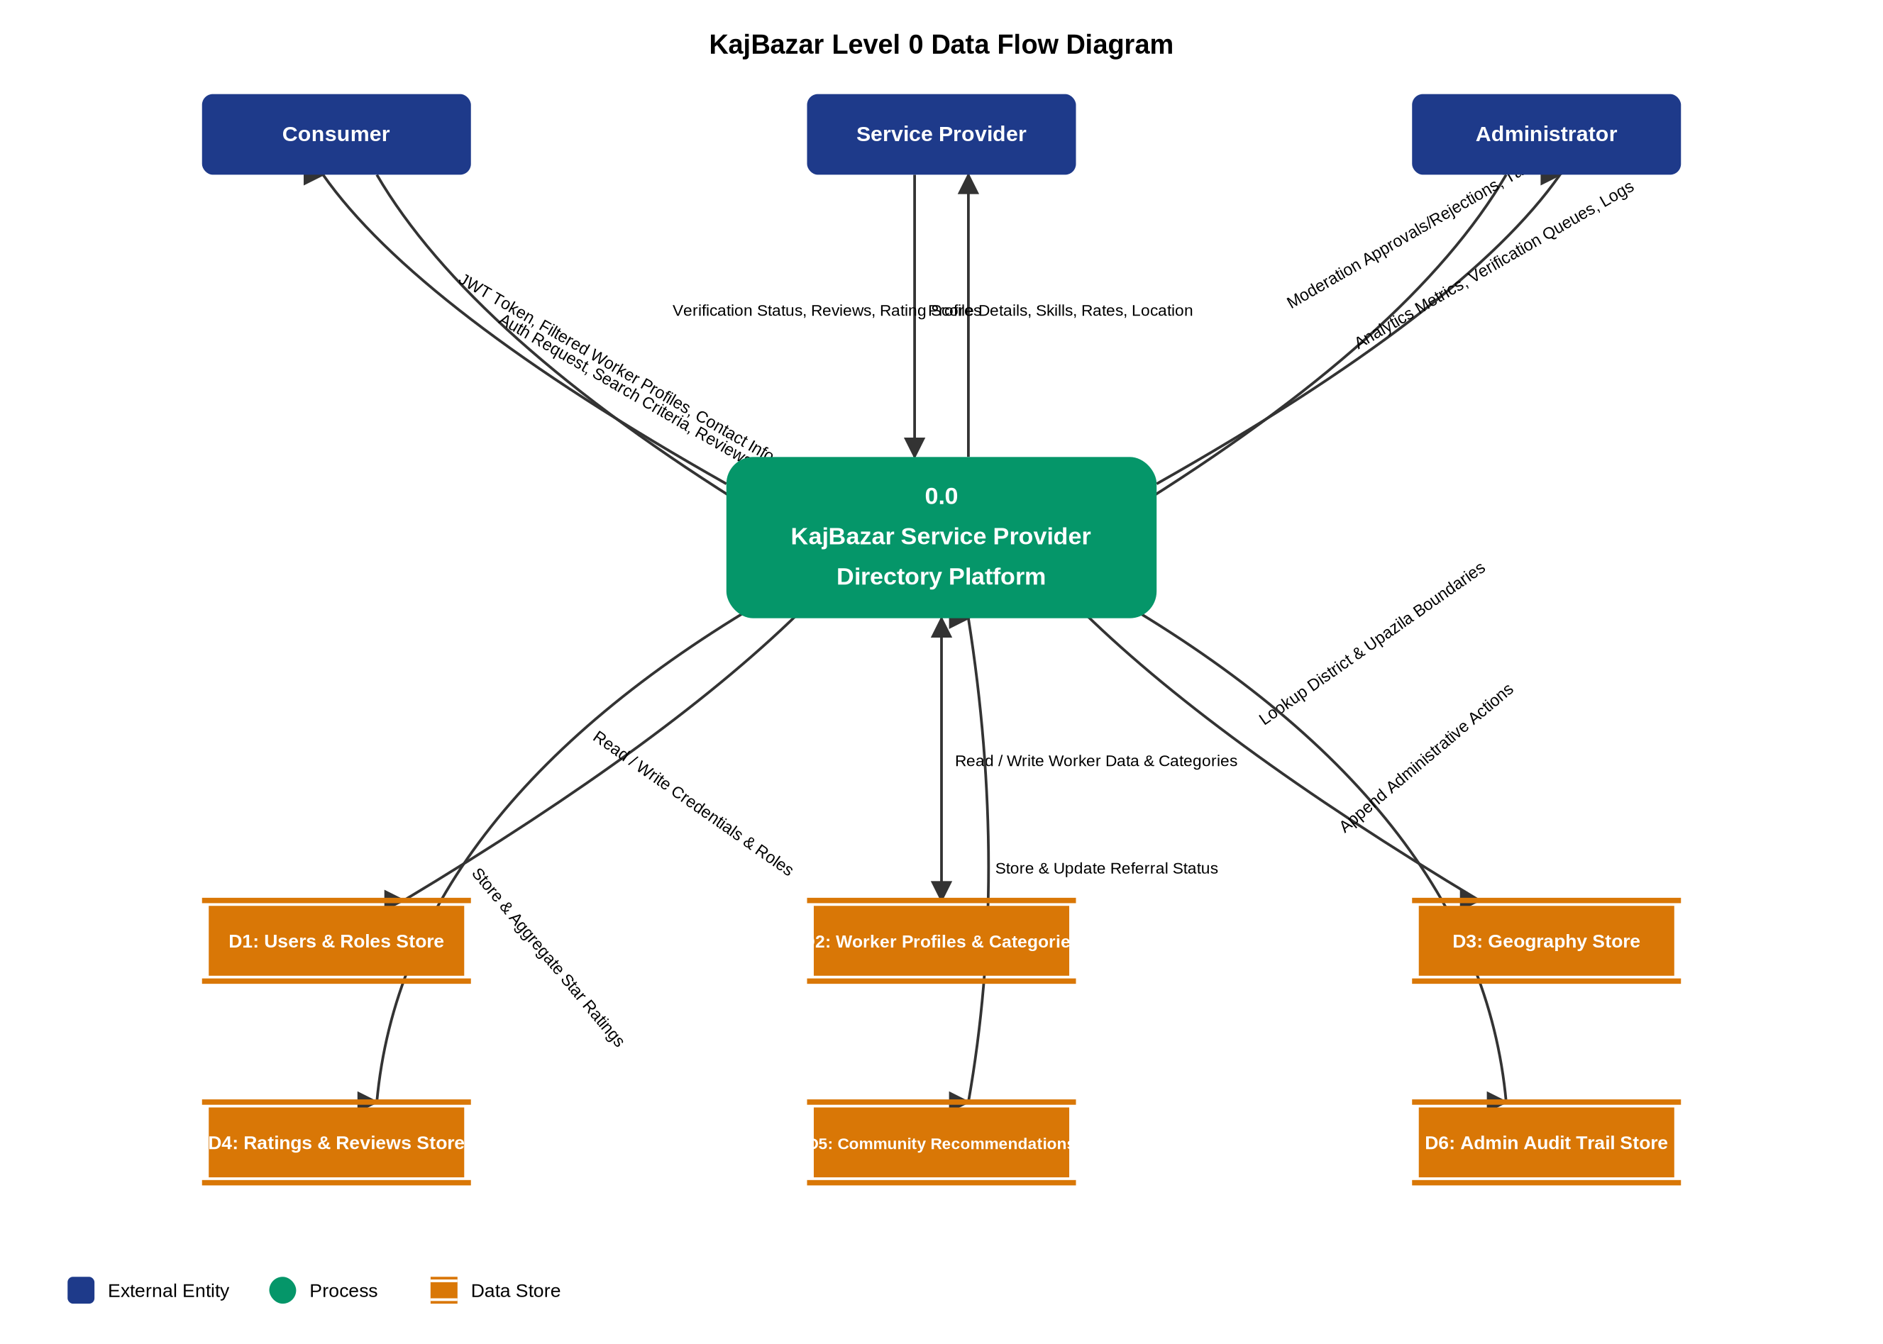

Figure 3: Level 1 Data Flow Diagram
Subsystem decomposition — Processes P1 through P5
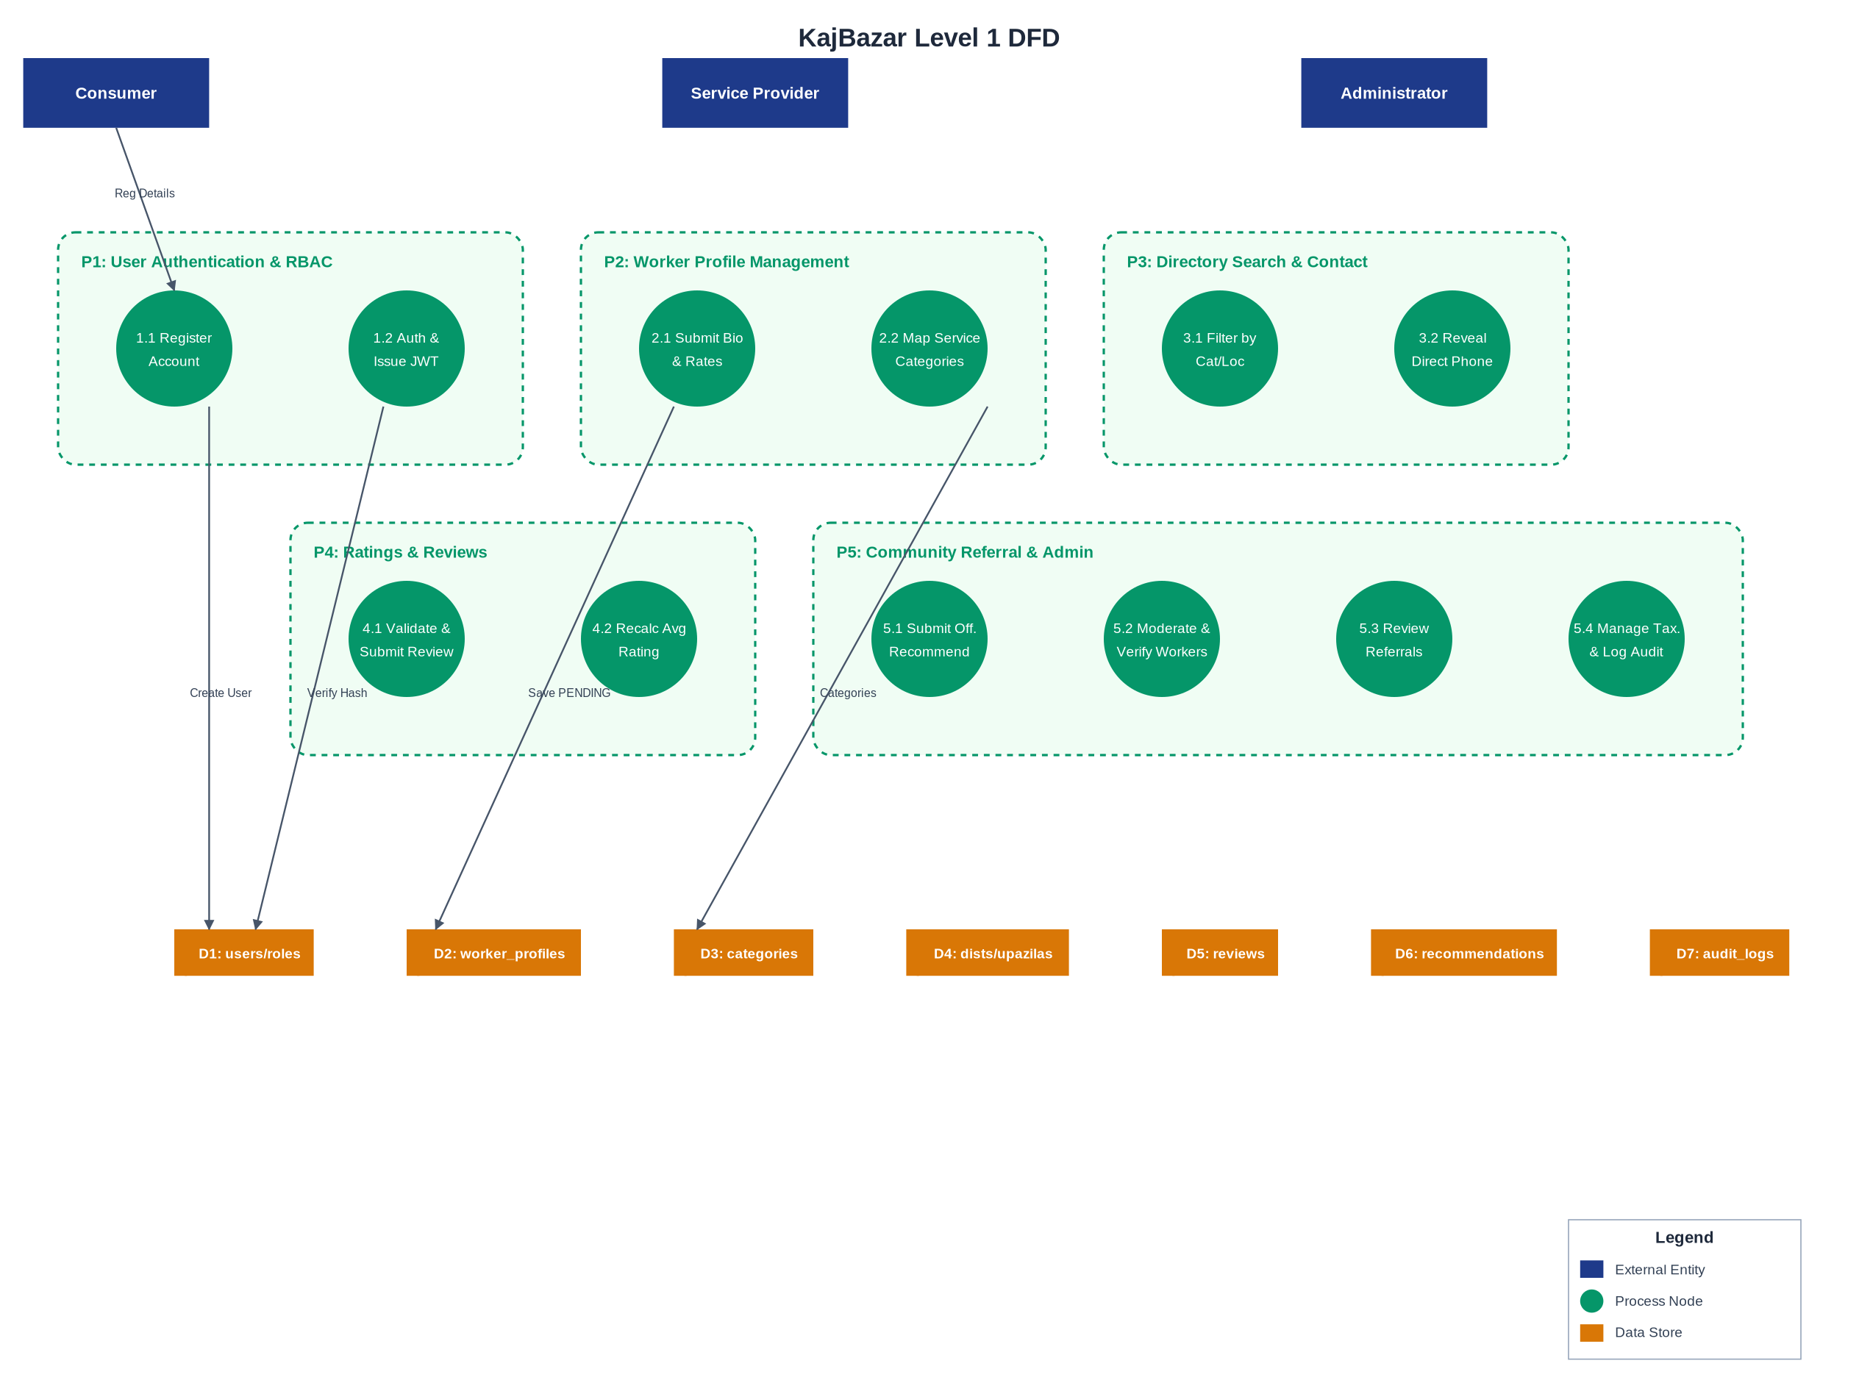

Figure 4: Level 2 Data Flow Diagram
Detailed decomposition of Process 3.0 — Directory Search & Direct Contact
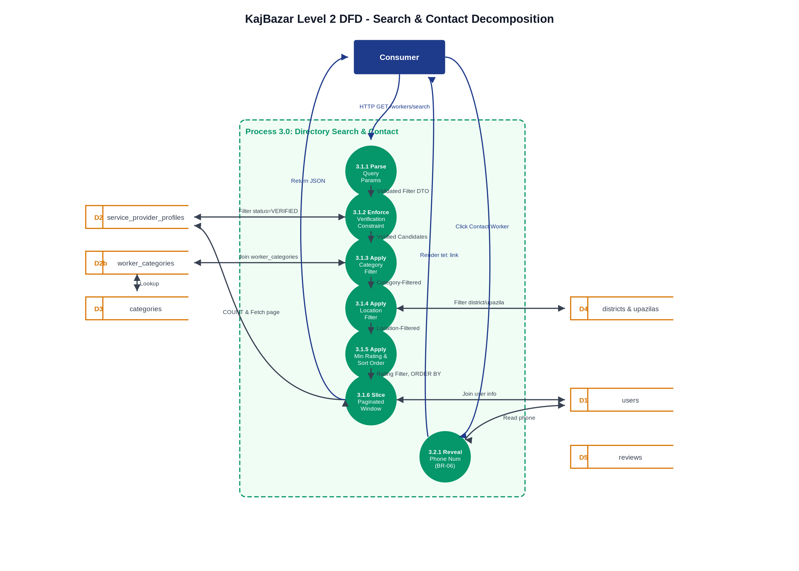

Figure 5: Use Case Diagram
Actor interactions — 4 actors, 16 use cases with «includes» relationships
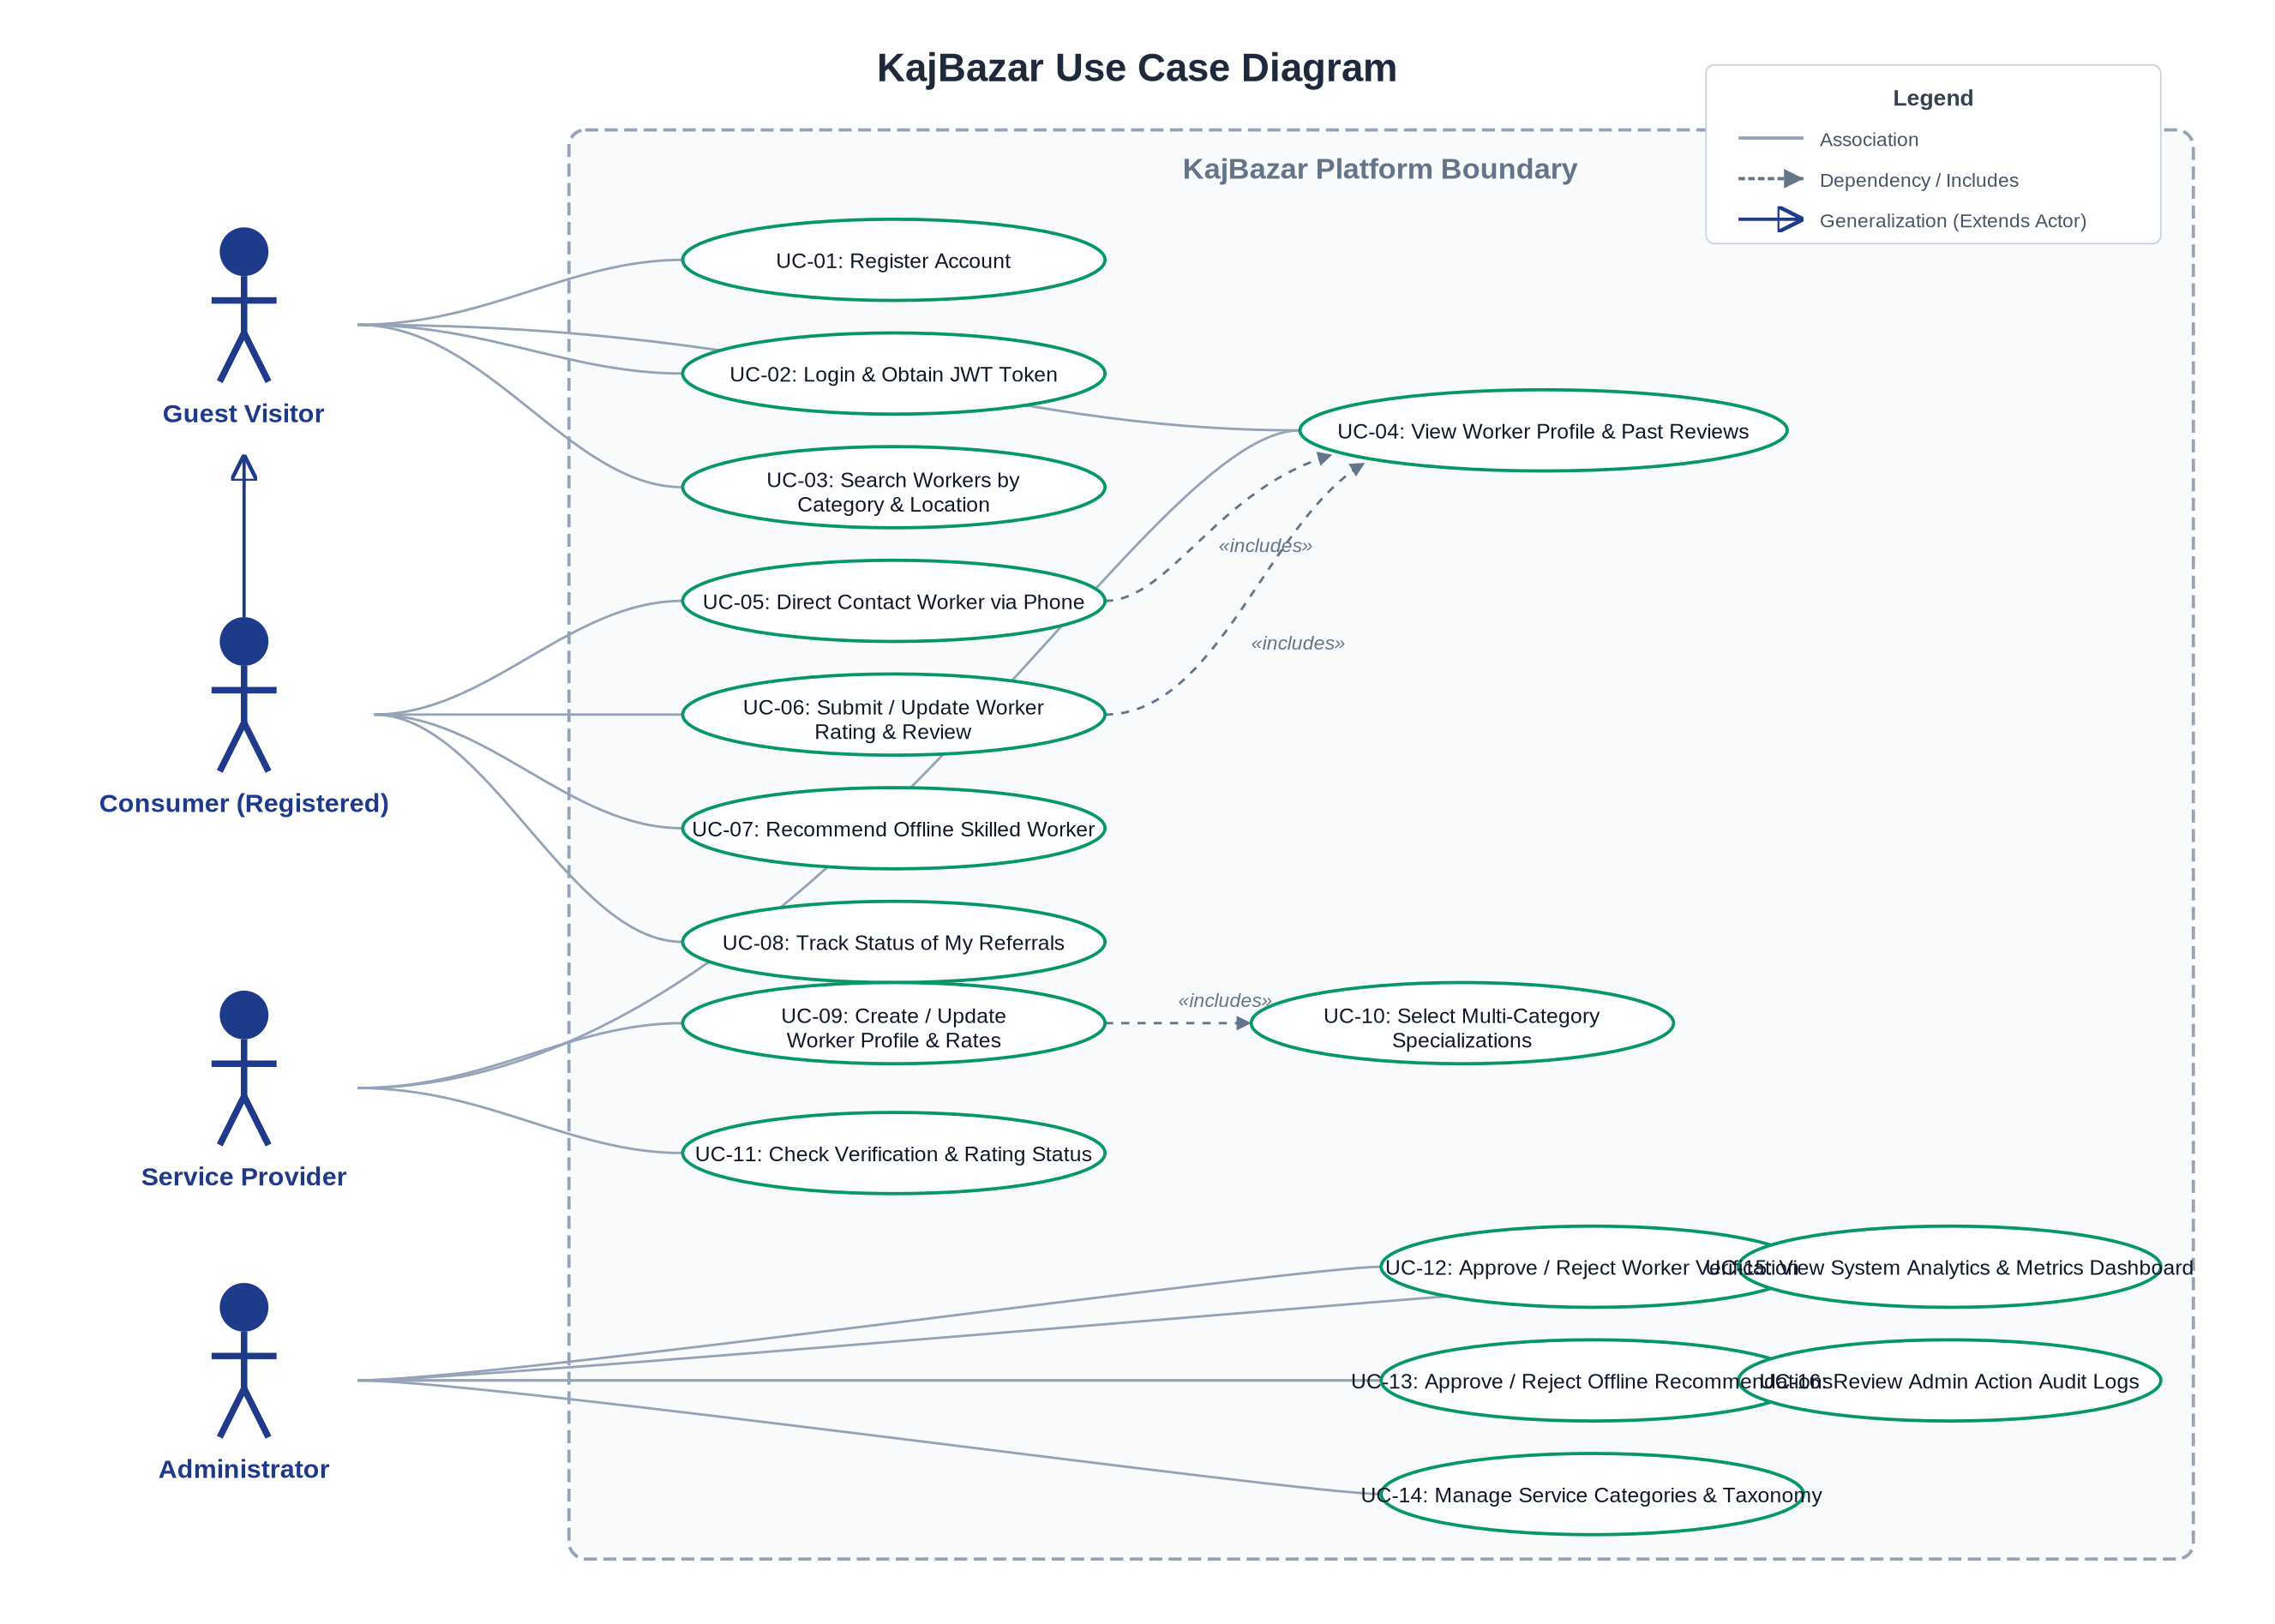

Figure 6: Activity Diagram — User Registration
User registration & authentication workflow (BR-01, BR-13)
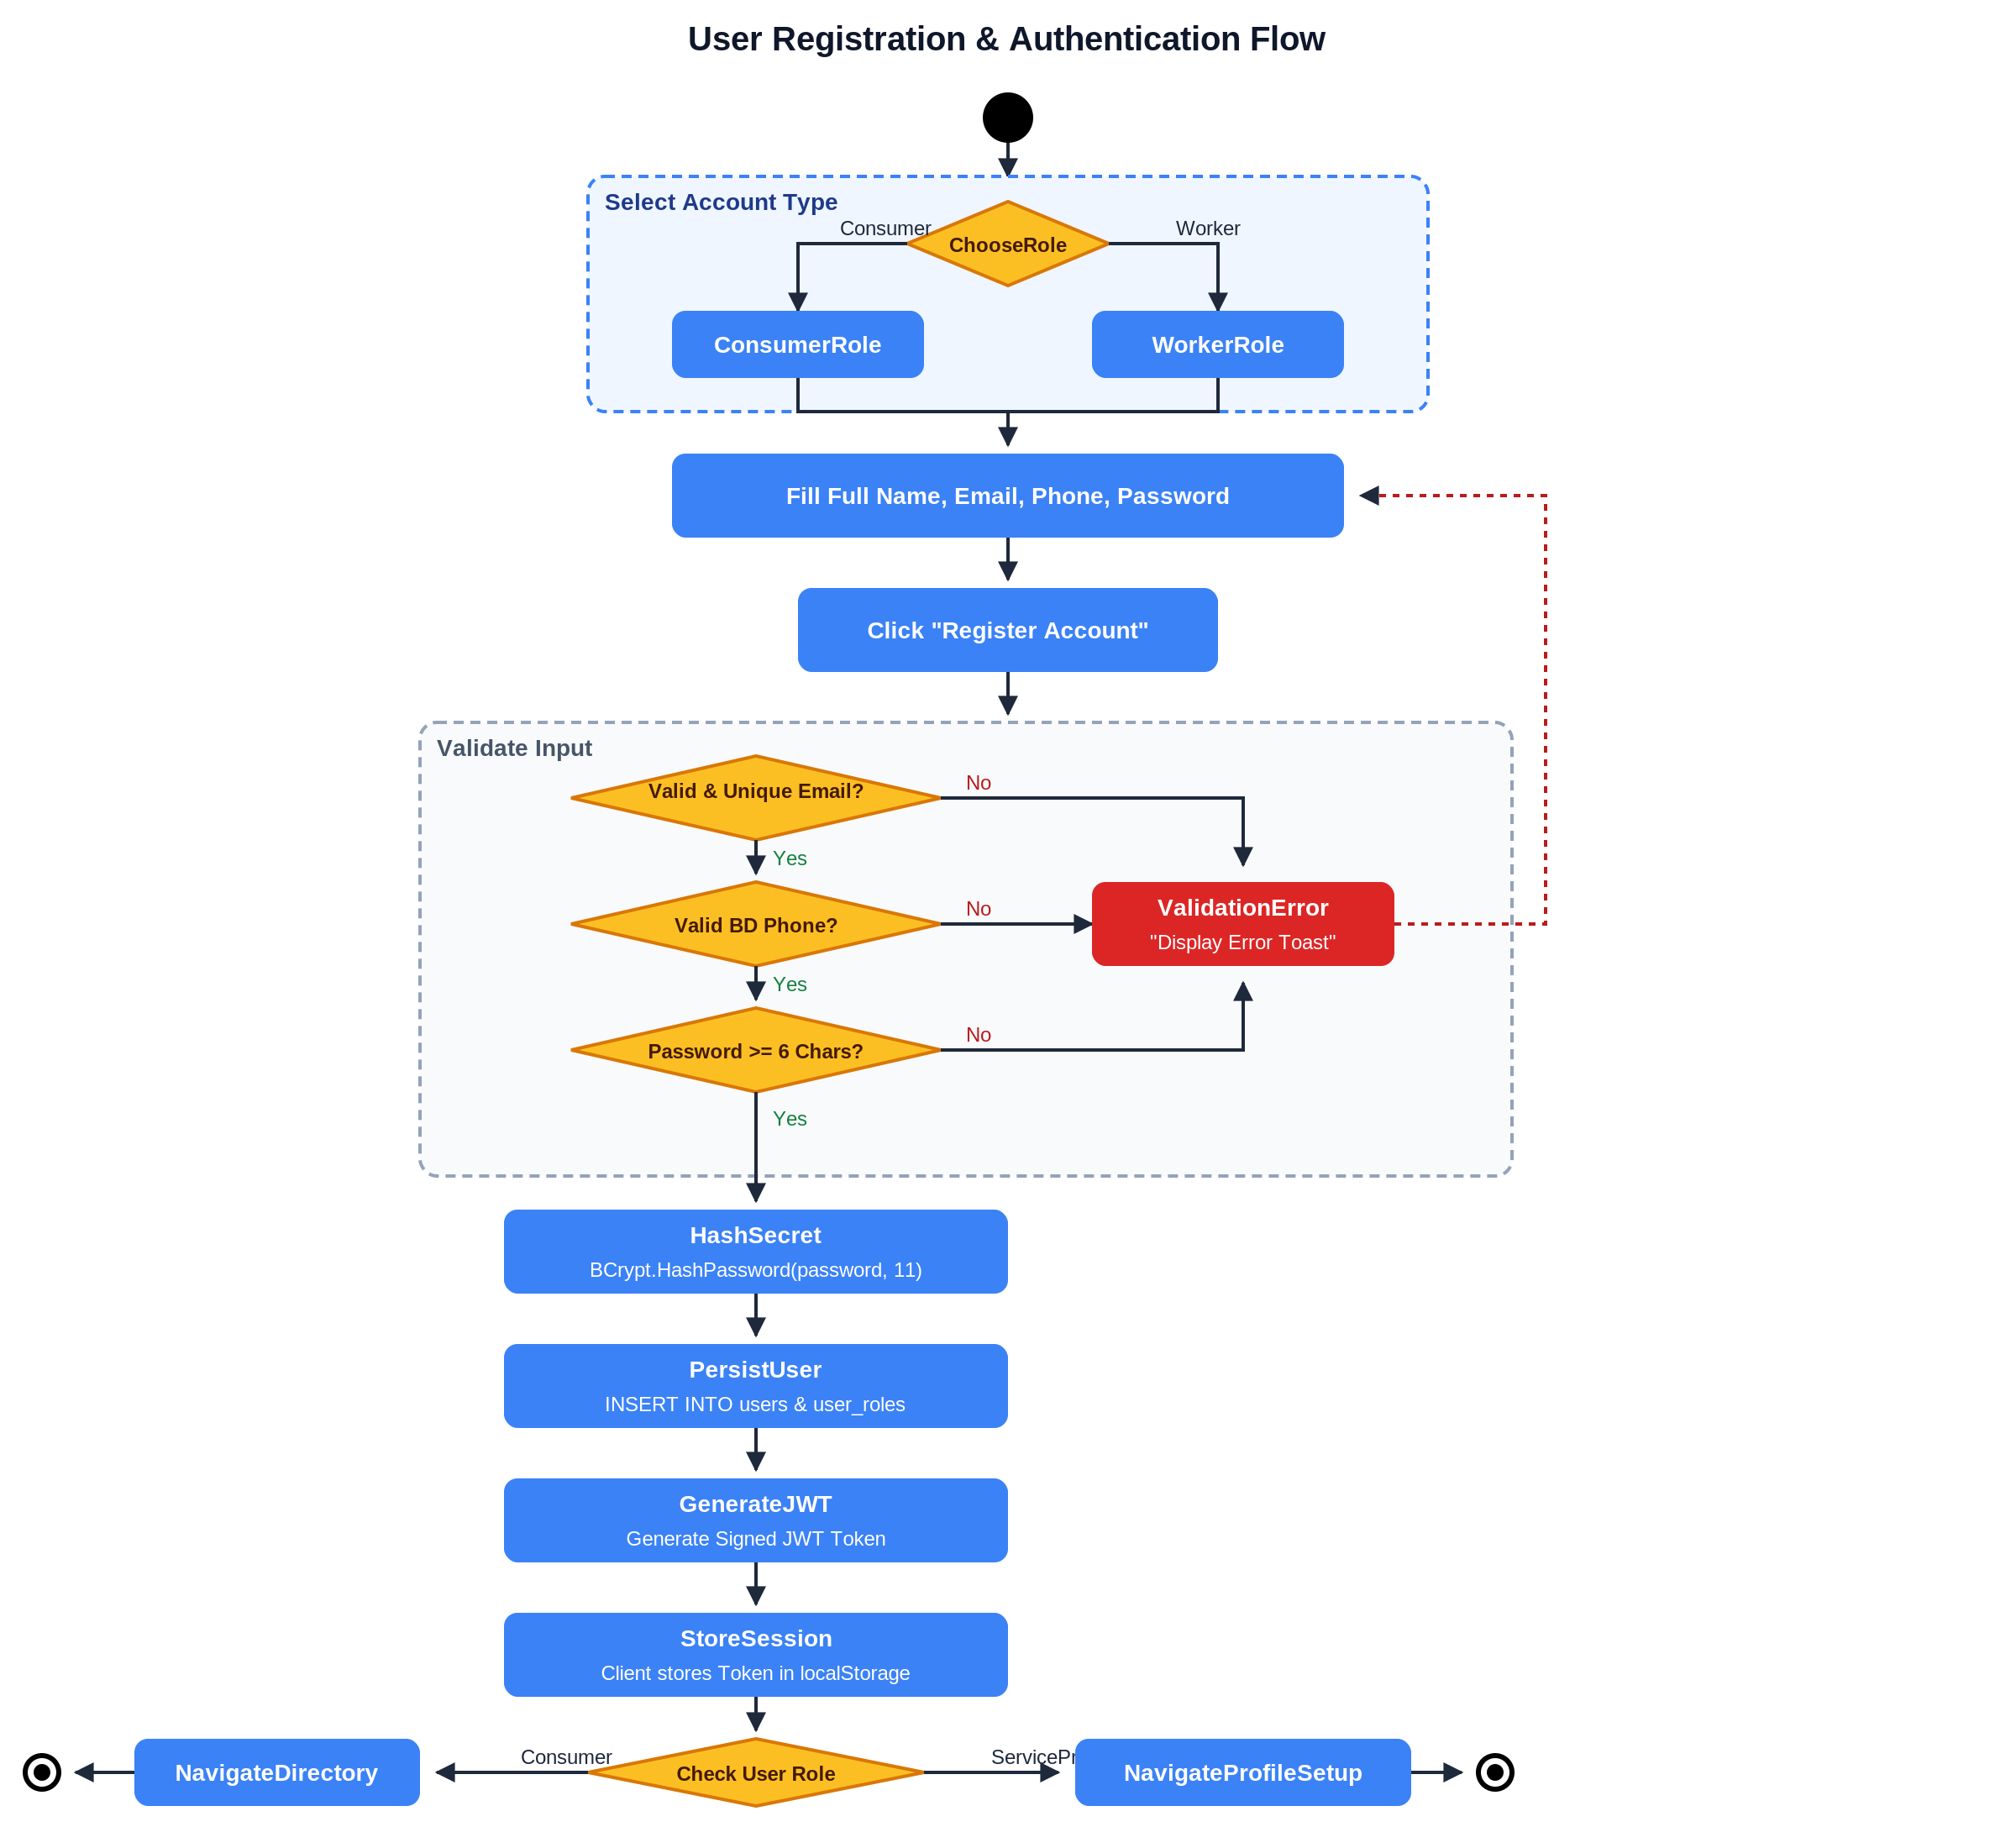

Figure 7: Activity Diagram — Worker Verification
Worker profile creation & admin verification flow (BR-02, BR-03, BR-10)
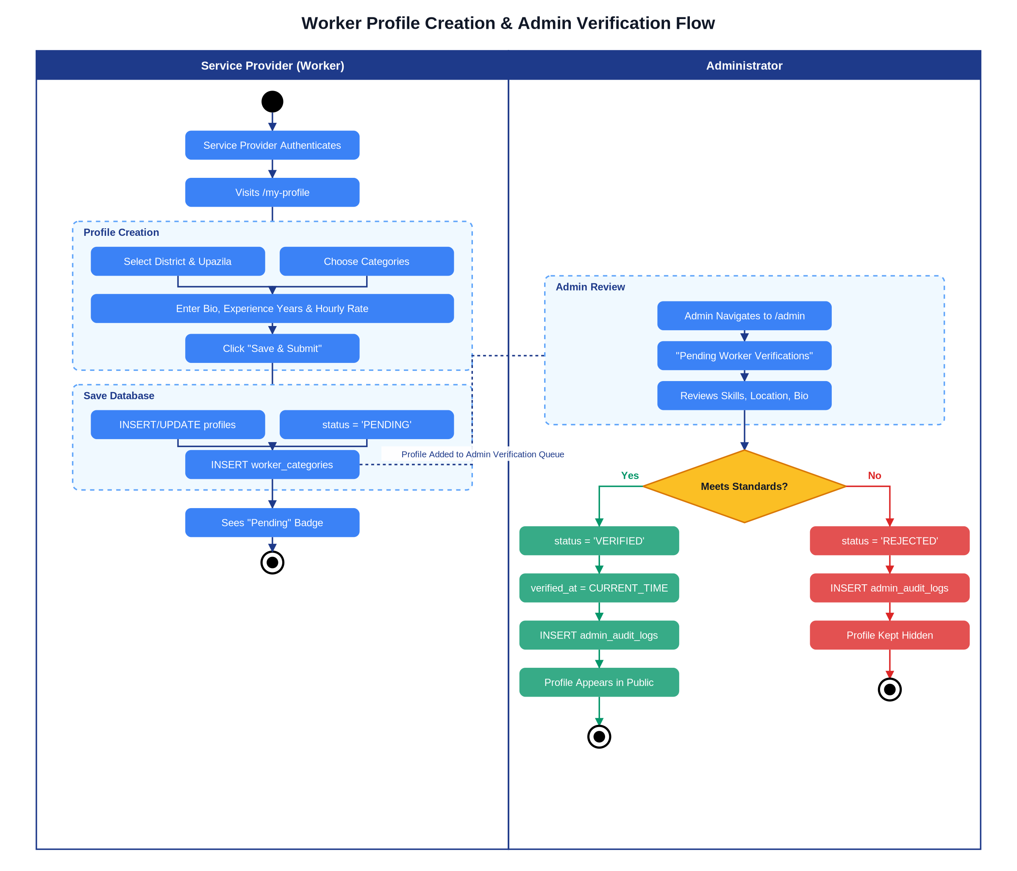

Figure 8: Activity Diagram — Search & Contact
Worker search & direct contact workflow (BR-05, BR-06)
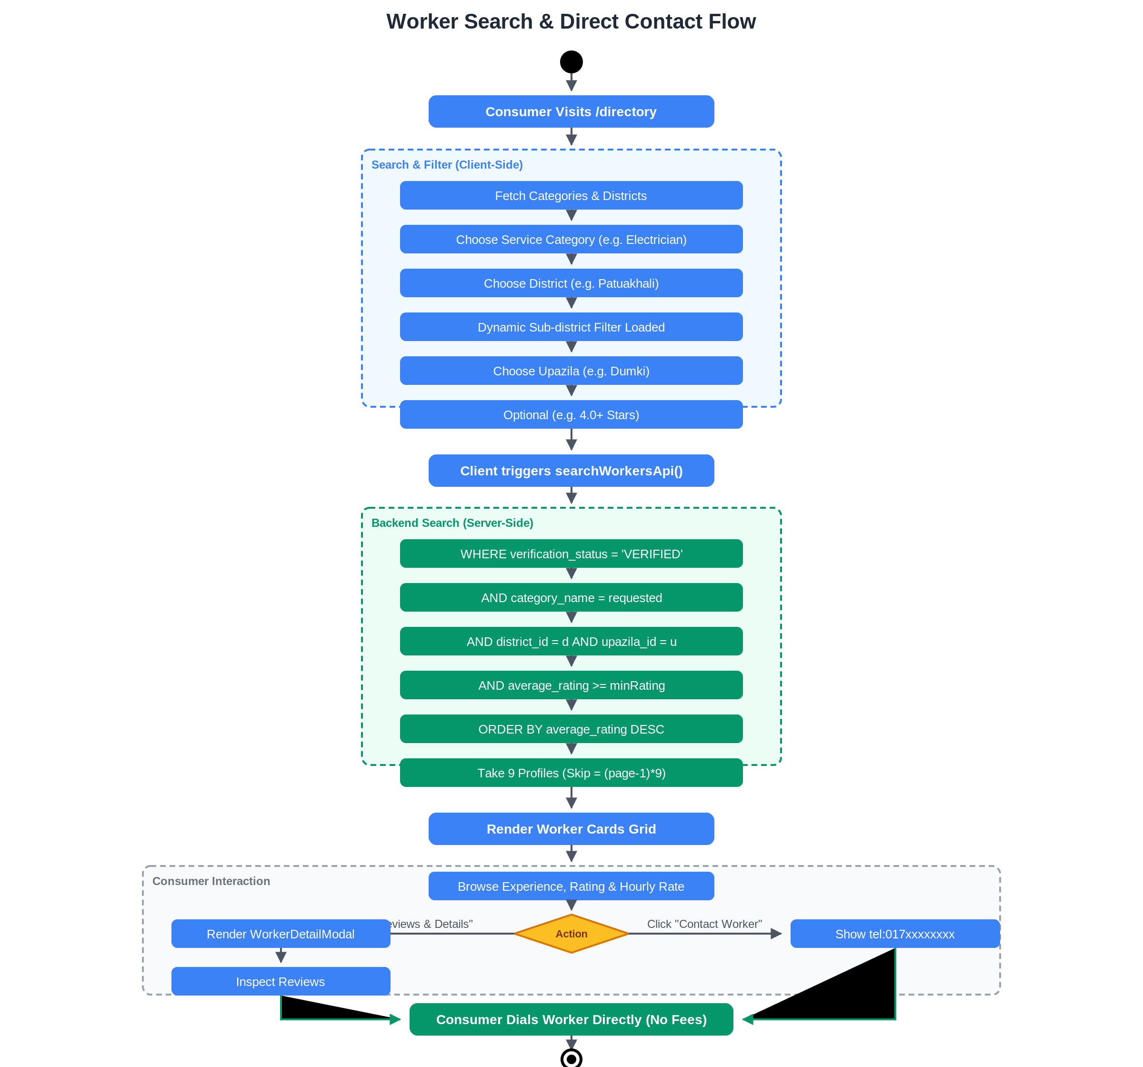

Figure 9: Activity Diagram — Review Submission
Review & rating submission with automatic aggregation (BR-07, BR-08)
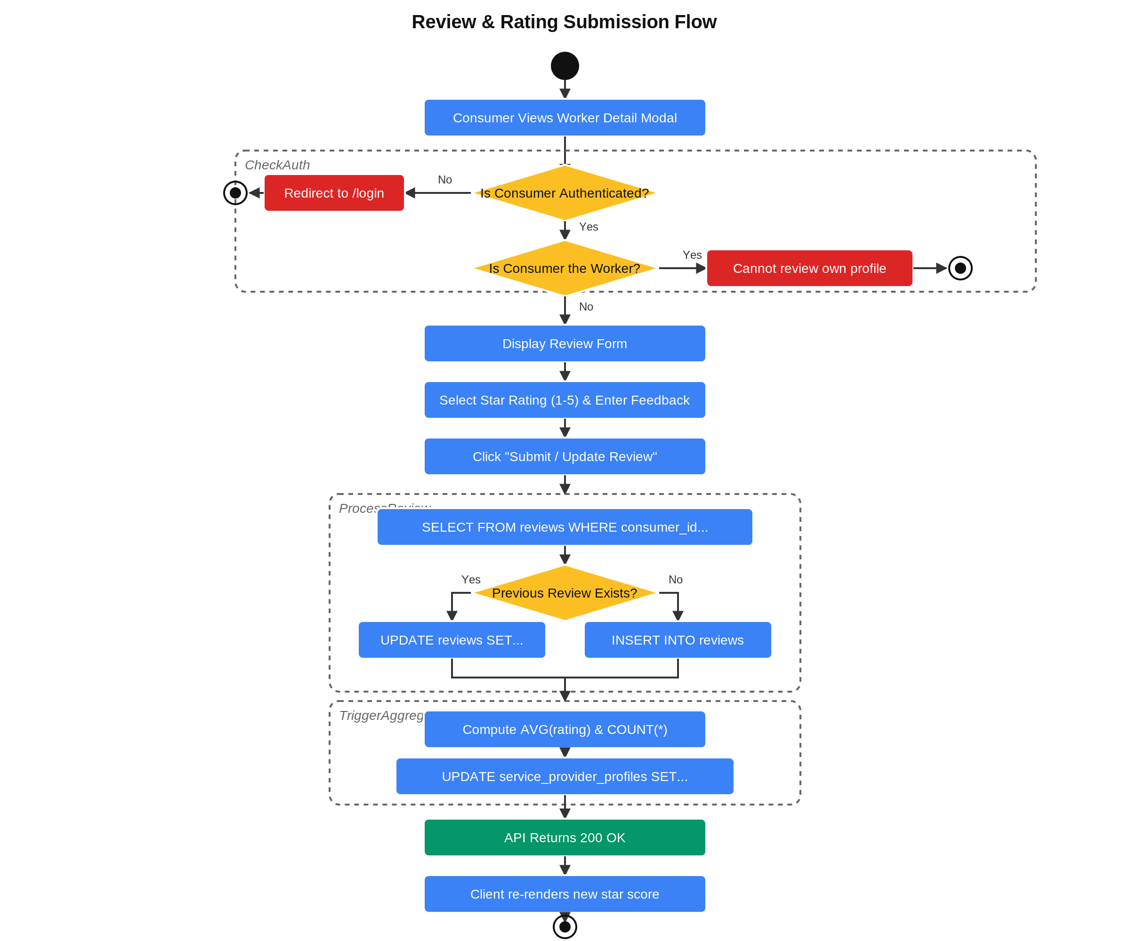

Figure 10: Activity Diagram — Community Recommendation
Offline worker recommendation & admin moderation (BR-09)
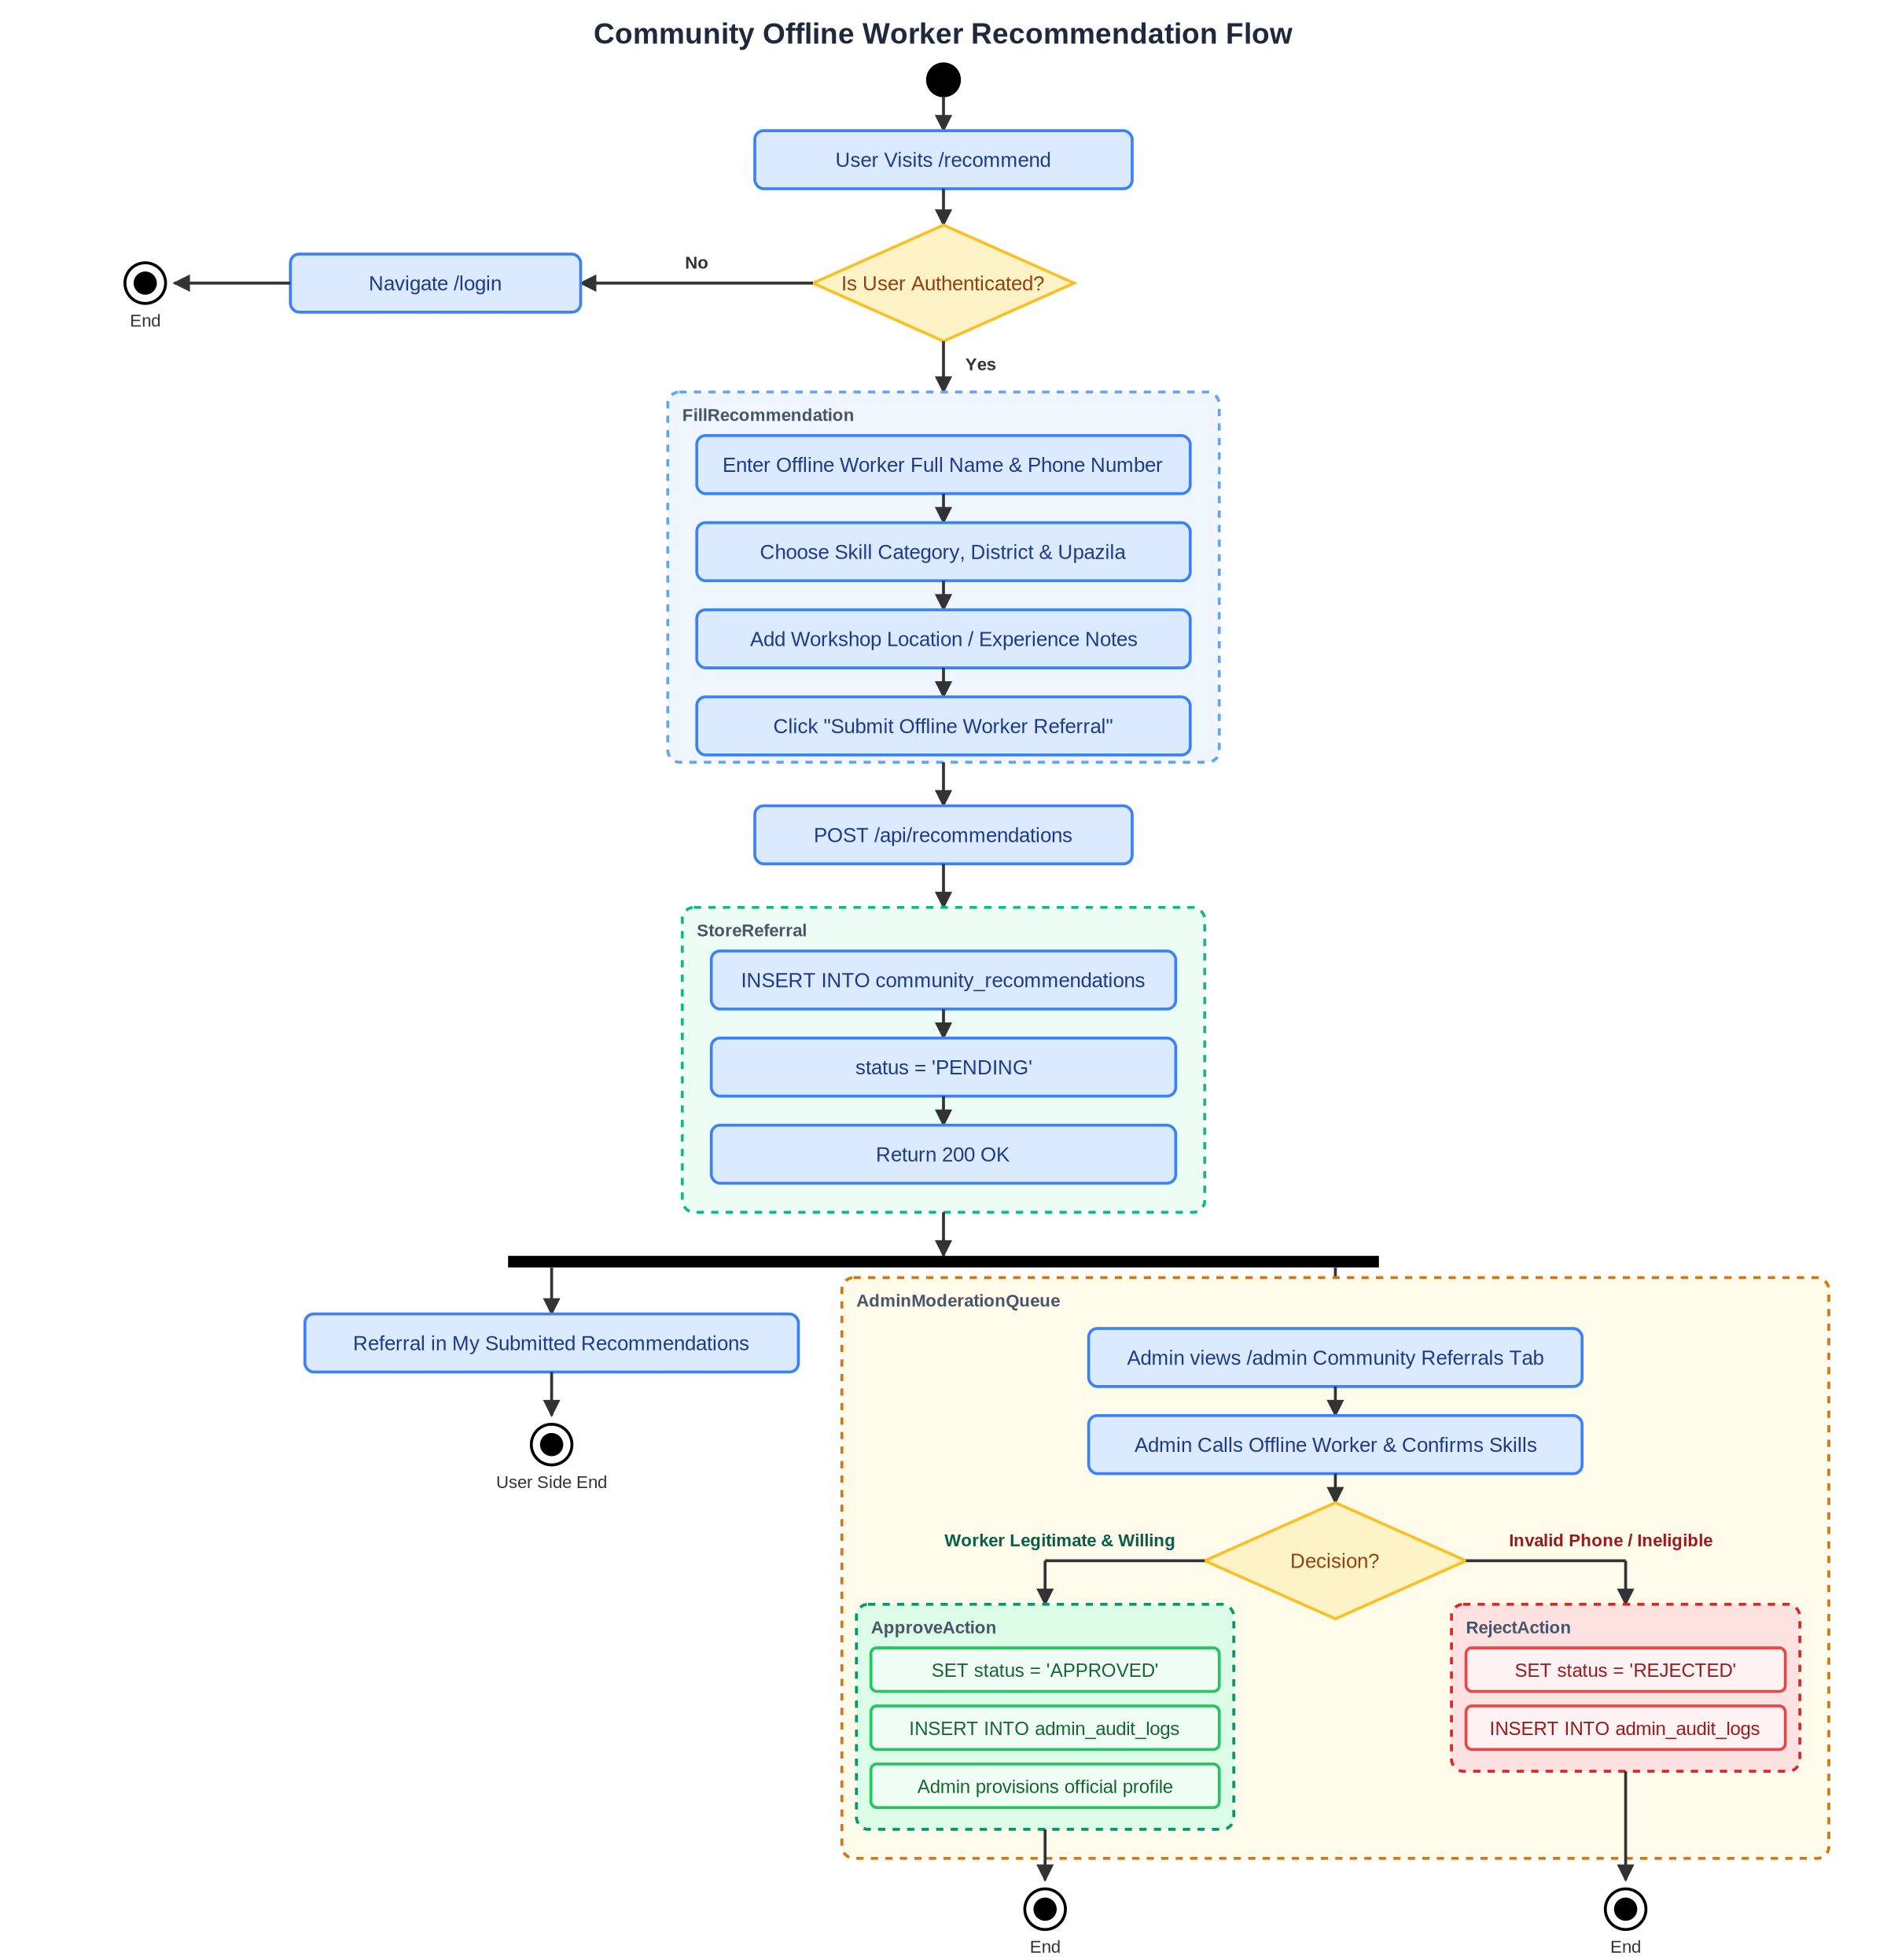

Figure 11: Class Diagram — Domain Model
C# domain entities, value objects, enums, and entity relationships
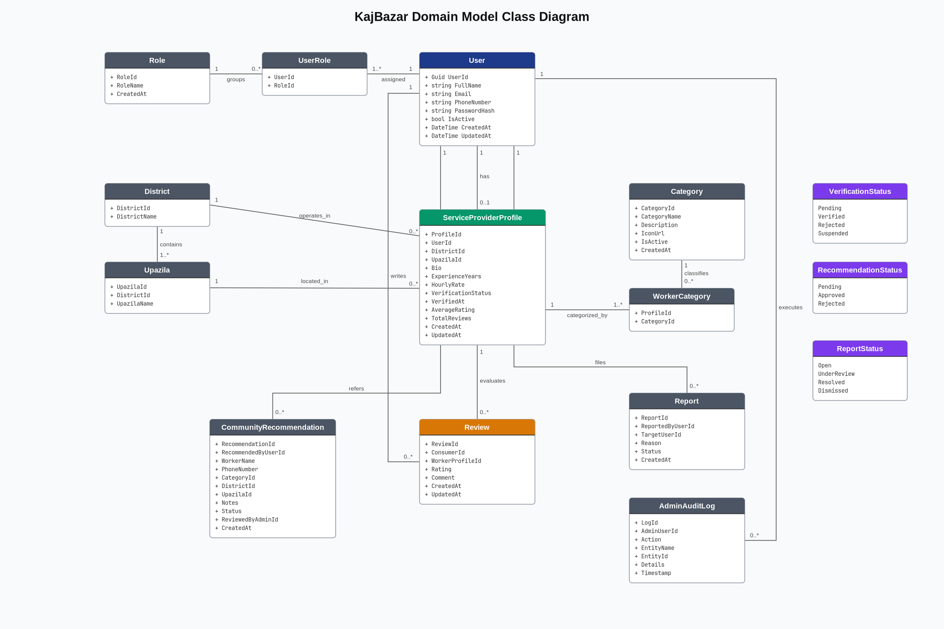

Figure 12: Class Diagram — Clean Architecture
API Controllers, Service Interfaces, Repository Implementations & DbContext
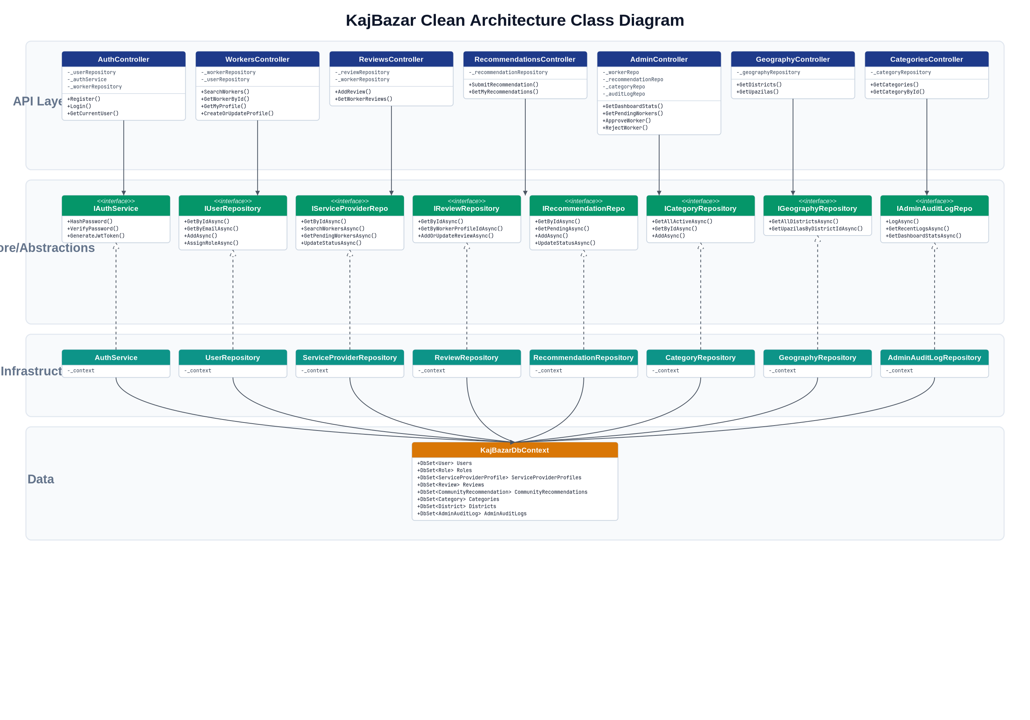

Figure 13: ER Diagram — Conceptual
High-level business concepts, entities, and relationships
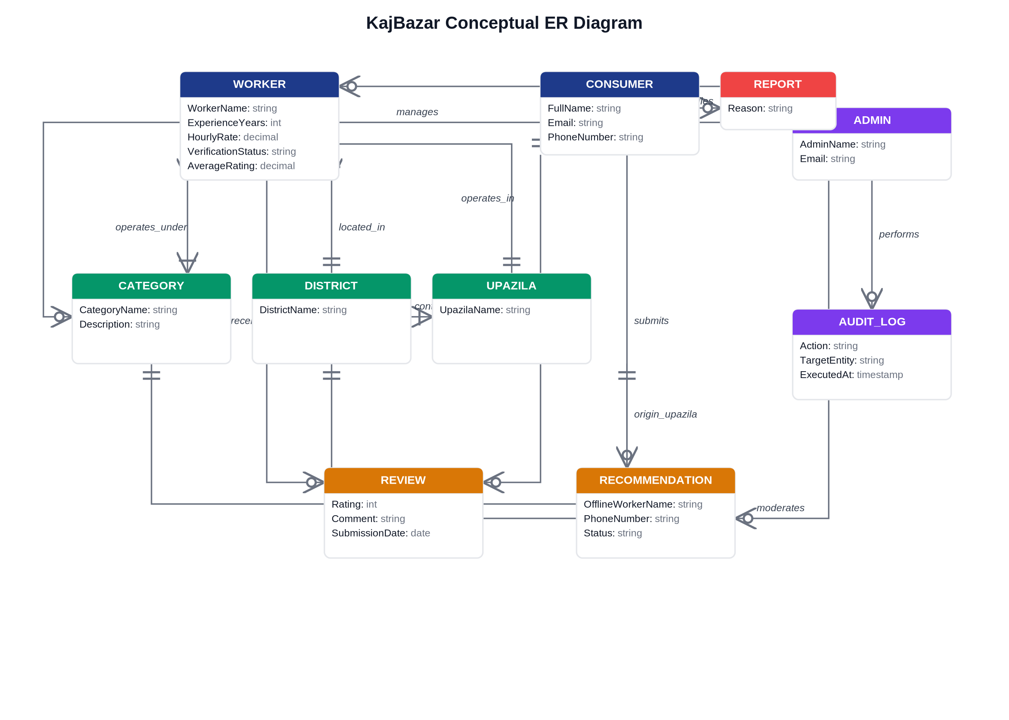

Figure 14: ER Diagram — Physical Schema
Complete PostgreSQL 12-table schema with column types, PKs, FKs & constraints
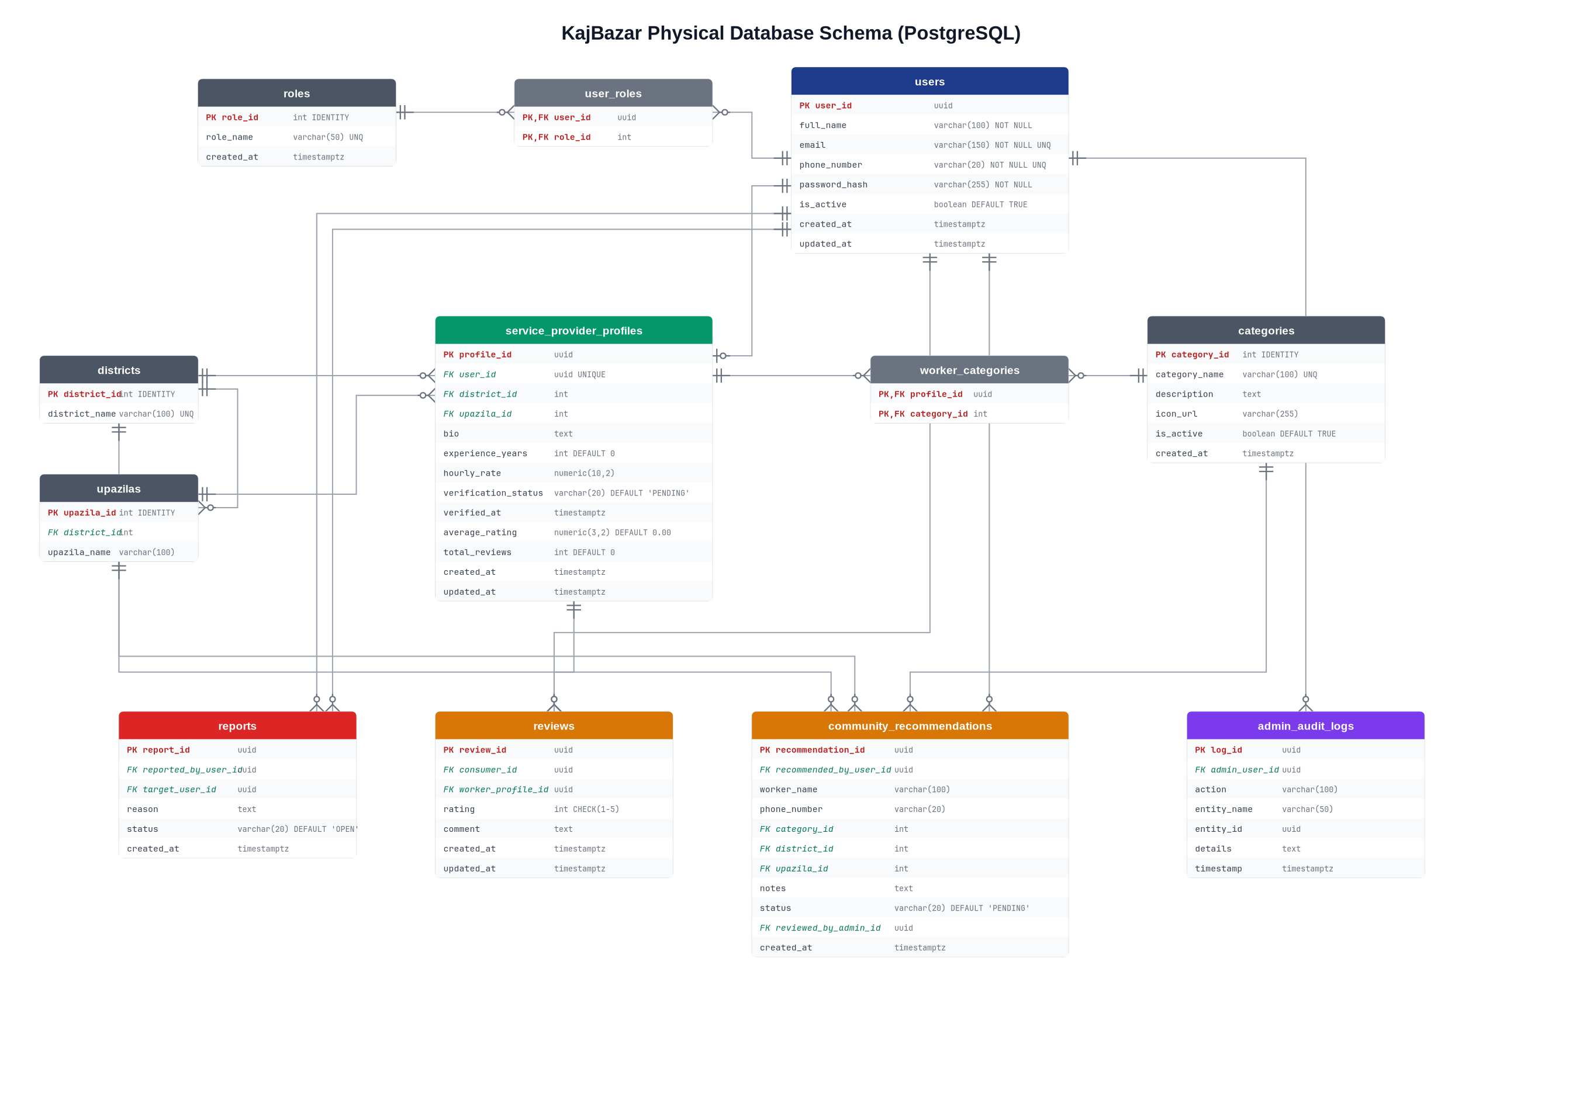

Figure 15: Sequence Diagram
Multi-criteria search & direct contact flow (BR-05, BR-06)
