Objectives:

The **Automatic Railway Gate Control System using IR Sensor & Arduino**focuses on systematic traffic control of railway gates that are both manned and unmanned. This project will not only make the system more reliable & precise, but also save the authorities from hiring man power to do the job. You may take it as a onetime investment. This system helps in avoiding the increased number of the accidents at level crossing in Bangaldesh.This project is more reliable and cost efficient.

Into:

The “Automatic Railway Gate Control” is basically a smart automatic barrier that allows the traffic to cross the railway track when there is no train and blocks the traffic when a train passes through tracks. Make the connections according to the circuit diagram and [upload the Arduino code](https://techatronic.com/how-to-operate-arduino-software-tutorial-1/) both are provided in this article. Set up the toy train and join the tracks and their accessories. Place one of the IR sensors on either side of the track and the other in its opposite direction so that both can easily detect the movement of the train at different positions. Place the servo with a barrier attached to it so it can move up and down easily. Provide the power supply to the Arduino so that project starts working. When the train arrives the first [IR sensor detects](https://techatronic.com/obstacle-detector-by-ir-sensor-with-arduino/) it and the servo barrier blocks the crossing and when the second sensor detects that the train goes away the servo barrier opens. In this way, the system works.

**Components Used:**

| **Components** | **Specification** | **Quantity** |
| --- | --- | --- |
| Arduino | Uno | 1 |
| Servo Motor | G9 | `2 |
| IR LED |  | 2 |
| Adapter | 12V | 1 |
| Jumper wire | Red | 4 |
| Bread board | 10K | 4 |
| Resistors | 330 Ohms | 8 |
| Toy Train |  | 1 |

## Circuit Diagram of the Project

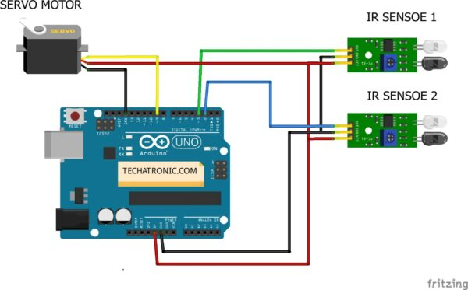

Make connections according to the above diagram. Connect Arduino’s 5V pin with the VCC pin of both the IR sensors and the positive wire of the servo motor. Connect the Arduino’s ground pin with the ground(GND) terminal of both the IR sensors and the negative wire of the servo motor. The output(OUT) terminals of both the IR sensors are connected to the digital 2 and 3 pins of [Arduino](https://techatronic.com/what-is-arduino-brief-description/).

This is a pretty simple project. here we are using only two IR sensors here. all the work done is by the code. combination of both sensor working simultaneously make the project work perfectly. As you can see in the images. but there the location of the sensor is very important. we need to place the sensor opposite to each other and perpendicular to the gates. so the system can work perfectlly.

Code of the project:

#include <Servo.h> // servo library

Servo s1;

int val = 0 ;

int va2 = 0 ;

void setup()

{

Serial.begin(9600); // sensor buart rate

pinMode(2,INPUT); // IR sensor 1

pinMode(3,INPUT); // IR sensor 2

s1.attach(9); // Servo Connect 9 pin

s1.write(0);

}

void loop()

{

val = digitalRead(2); // IR sensor 1 output pin connected

va2 = digitalRead(3); // IR sensor 2 output pin connected

Serial.println(val); // see the value in serial mpnitor in Arduino IDE

Serial.println(va2); // see the value in serial mpnitor in Arduino IDE

delay(10); // Time Delay

if(val == 1 )

{

s1.write(0); // SERVO 0 DEGREE

}

if(va2 == 1 )

{

s1.write(90); // SERVO 90 DEGREE

}

}

Discussion:

 Automatic gate control system offer an effective way to reduce the occurrence of railway accidents. This system can contribute a lot of benefit either to the road users or to the railway management. Since the design is completely automated it can be used in remote villages where no station master or line man is present. Railway sensors are placed at two sides of gate. It is used to sense the arrival and departure of the train. This system uses the DC motor to open and close the gates automatically when it is rotated clockwise or anticlockwise direction. In this system, this is controlled by using ATmega328p microcontroller. Now a day’s automatic system occupies each and every sector of applications as it is reliable and accurate.

Concluson:

This paper we presented is based on Automated Railway Gate opening system using Arduino. Technologies like these have been already done but still they haven’t implemented yet and in process especially in Bangladesh and in some other countries. We have found that as compared to the existing system which have been made already, our system works much efficiently and it is reliable because the whole system is automated. As far as now from the number of accidents occurred and still counting, a proper, safe and durable system is needed. Therefore, to avoid these kind of accidents in the future, we have implemented a new system with IR sensors. The system has been tested and it is working perfectly in all atmospheric conditions without any flaws. Finally, we conclude by saying that the number of accidents will be reduced and many innocent people’s lives could be saved by using this system. Our system will be new as we are using a fully automated system and there are further more ideas on which we can develop this system for the future generation.