**Khulna University of Engineering and Technology**

Lab Report

**Course no:** CSE 3104

**Course Title:** Peripherals and Interfacing Laboratory

**Report on:** Automatic Railway Gate Control System using IR Sensor and Arduino.

**Submitted to:**

Dr. Muhammad Sheikh Sadi

Professor

Department of Computer Science and Engineering

Khulna University of Engineering and Technology, Khulna

&

S.M. Taslim Uddin Raju

Lecturer

Department of Computer Science and Engineering

Khulna University of Engineering and Technology, Khulna

**Submitted by:**

Arifur Rahman

Roll: 1707092

Department of Computer Science and Engineering

Khulna University of Engineering and Technology, Khulna

Submission date: 23-01-2022

**Objectives:**

The Automatic Railway Gate Control System using IR Sensor and Arduino focuses on systematic traffic control of railway gates. This project will not only make the system more reliable and precise, but also save the uthorities from hiring manpower to do the job.This system helps in avoiding the increased number of accidents at level crossing in Bangladesh. This project is more reliable and cost efficient.

**Introduction:**

The “Automatic Railway Gate Control” is basically a smart barrier that allows the traffic to cross the railway track when there is no train and blocks the traffic when a train passes through tracks. We set up the toy train in the rail line and place two IR sensor, one at the point before the train reaches to the gate and another at the point when the train passes the rail gate totally. Then we place the servo with a barrier attached to it so it can move up and down easily. To start the system, we make connection it with the arduino. After starting the toy train, when it comes to the first IR sensor, it detects the train and the servo barrier blocks the crossing and when the second sensor detects the train, the servo barrier opens. In this way, the system works.

**Apparatus:**

1. Arduino Uno

2. Servo Motor

3. IR Sensor

4. Bread Board

5. Resistors

6. Toy train

**Projects Details:**

Circuit diagram:

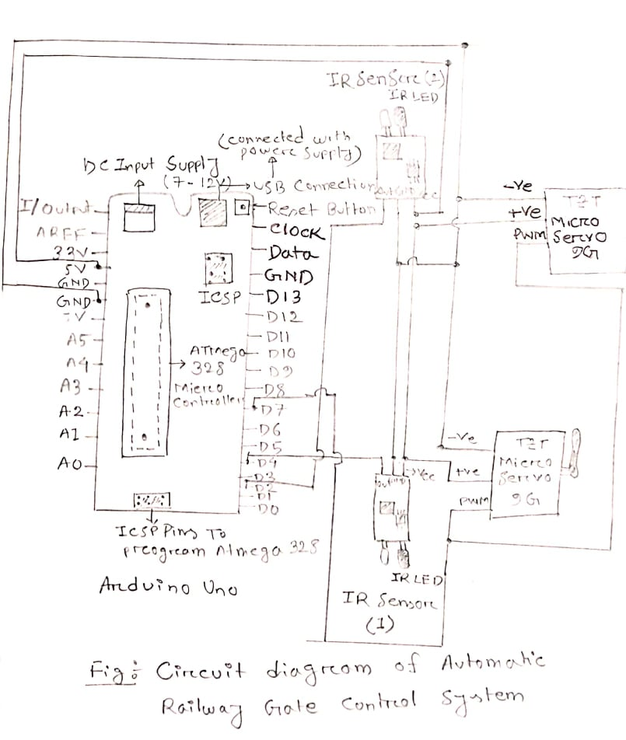

We made connection according to the above diagram. Connect arduino’s 5V pin with the vcc pin of both the IR sensosr and the positive wire of both the servo motors. Connect arduino’s ground pin with the ground pin of both the IR sensosr and the negative wire of both the servo motors. The output terminal of both the IR sensors are connected to the digital 2 and 4 pins of Arduino.

Here we are using two IR sensors. Combination of both sensors working simultaneously make the project work perfectly.

Code of the project:

#include<Servo.h>

Servo servo;

void setup(){

servo.attach(7);

servo.write(0);

pinMode(2,INPUT);

pinMode(4,INPUT);

delay(1000);

}

void loop(){

if(digitalRead(4)==LOW && digitalRead(2)==HIGH){

servo.write(0); //This will close the servo barier

delay(200);

}

if(digitalRead(2)==LOW && digitalRead(4)==HIGH){

servo.write(90); // This will open up the servo barier

delay(200);

}

if(digitalRead(2)==LOW && digitalRead(4)==LOW){

servo.write(0);

delay(200);

}

}

When the train comes near to the gate then the IR sensor which is connected with the arduino’s digital pin 4, it detects the train and gain a LOW signal in its INPUT. When the signal is LOW we make the servo.write(0) in the code, so that it blocks the crossings and the servo barrier is closed.

After that when the train passed through the gate entirely, the other IR sensor detects it, which is connected to the digital 2 pin in Arduino. And the signal in it is LOW, we instruct in the code servo.write(90), that opens the servo barrier. And this process will continue simultaneously.

**Discussion and Conclusion:**

Automatic railway gate control system offer an effective way to reduce the occurance of railway accidents. This system can contribute a lot of benefit either to the road users or to the railway management. Since the design is completely automated it can be used in remote villages where no station master or line man is present. Now a day’s automatic system occupies each and every sector of applications as it is reliable and accurate. Technologies like this have already been done but not yet implemented and especially in Bangladesh and in some other countries. As far as now from the number of accidents occurred and still counting, a proper, safe and durable system is needed. Therefore to avoid these kind of accidents in future we have implemented this projects.