jQuery is a popular JavaScript library that simplifies the process of working with the Document Object Model (DOM), handling events, and making AJAX requests. Here are some steps to help you get started:

1. Download and include jQuery on your web page. You can download jQuery from the jQuery website, or you can use a Content Delivery Network (CDN) to include it in your web page. Here's an example of how to include jQuery from a CDN:

php

• <script src="https://code.jquery.com/jquery-3.6.0.min.js"></script>

• Start with a basic jQuery syntax. Here's an example of a simple jQuery code that selects an element with the ID of "myElement" and changes its text to "Hello, World!":

javascript

• $(document).ready(function() {

$("#myElement").text("Hello, World!");

});

• Learn the basic jQuery selectors. jQuery selectors allow you to select elements from the DOM based on their tag name, ID, class, attribute, or position. Here are some examples:

javascript

• $("p") // selects all <p> elements

$("#myElement") // selects an element with the ID of "myElement"

$(".myClass") // selects all elements with the class of "myClass"

$("input[type='text']") // selects all text input elements

$("ul li:first-child") // selects the first <li> element in a <ul>

• Learn the basic jQuery methods. jQuery provides a wide range of methods to manipulate the DOM, handle events, and make AJAX requests. Here are some examples:

scss

• .text() // gets or sets the text content of an element

.html() // gets or sets the HTML content of an element

.css() // gets or sets the CSS properties of an element

.addClass() // adds one or more classes to an element

.removeClass() // removes one or more classes from an element

.on() // attaches an event handler to an element

.ajax() // makes an AJAX request to a server

• Practice and experiment. The best way to learn jQuery is to practice and experiment. Try out different selectors and methods, and see how they work. You can also refer to the jQuery documentation for more information and examples.

<script>

  $(document).ready(function(){

  });

</script>

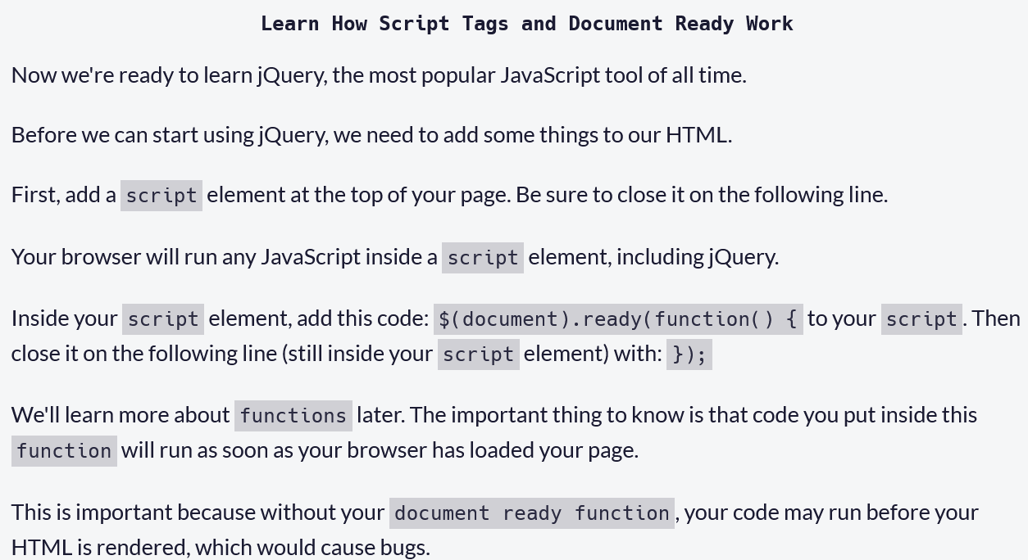

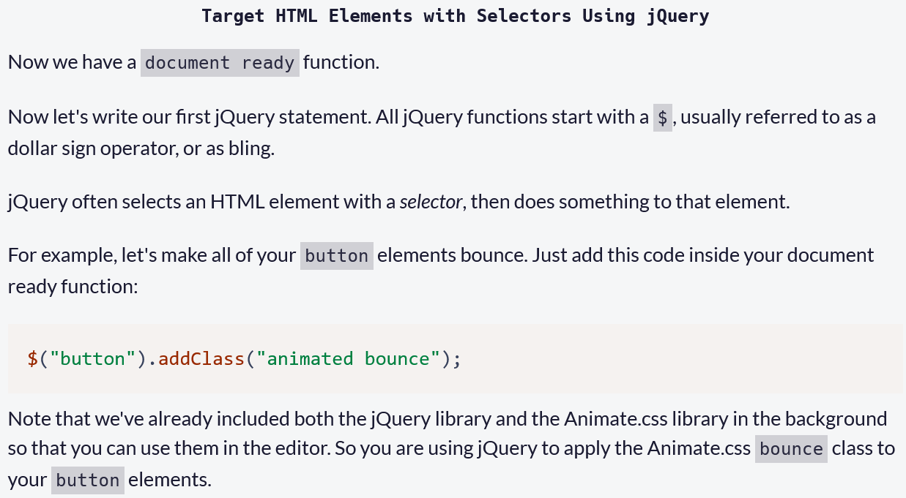

Terget element by using class

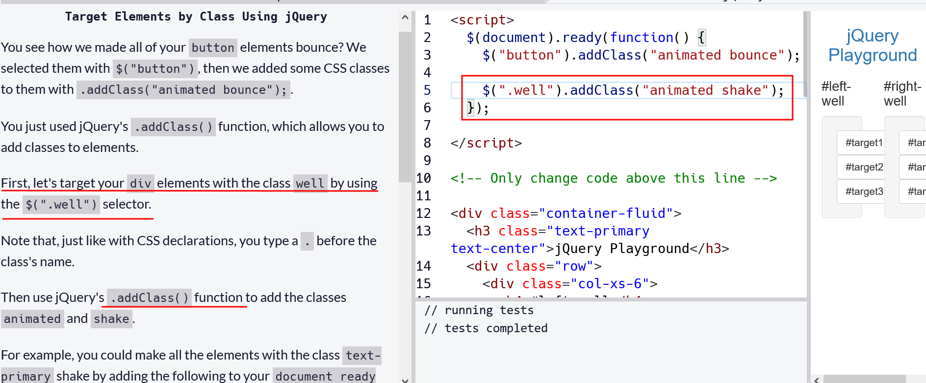

Target elements by using id in JQuary

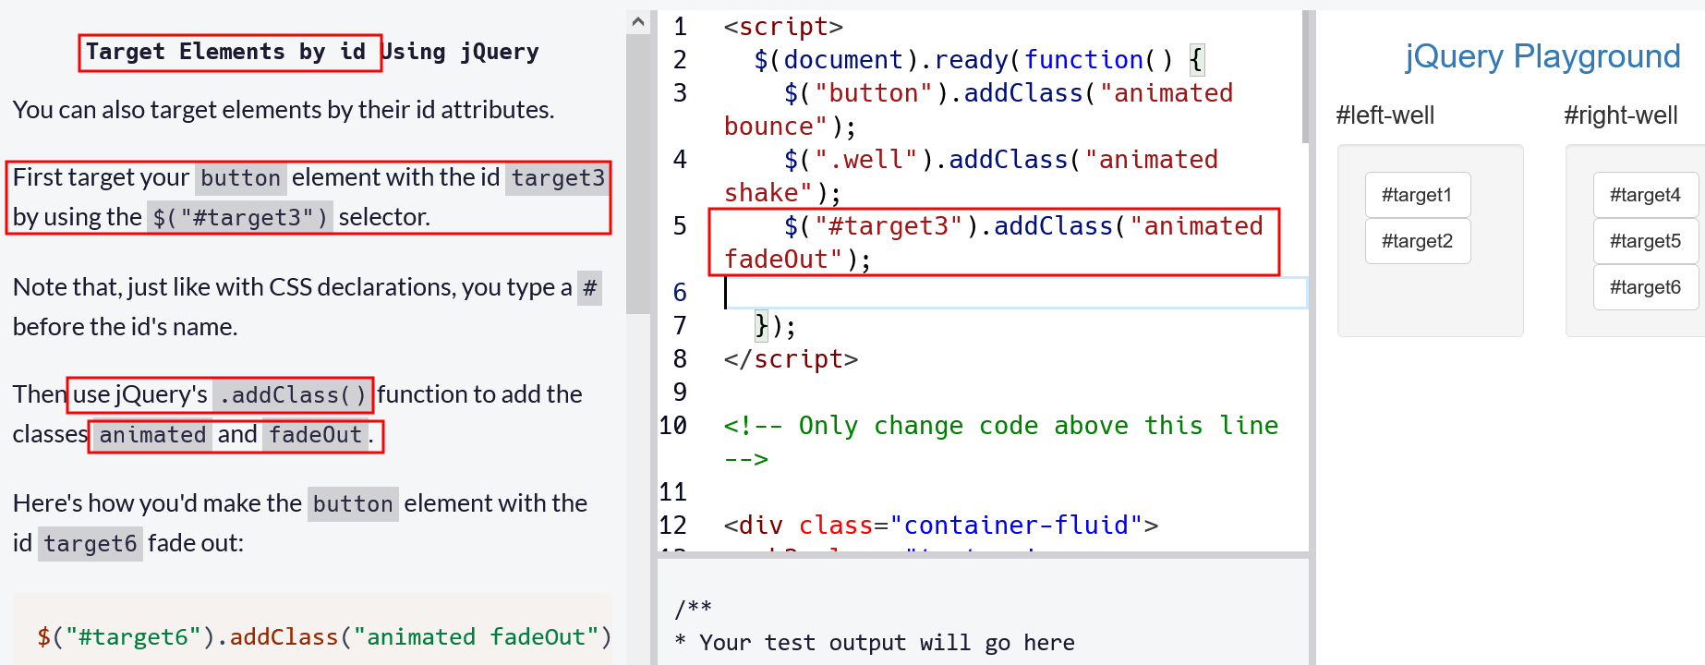

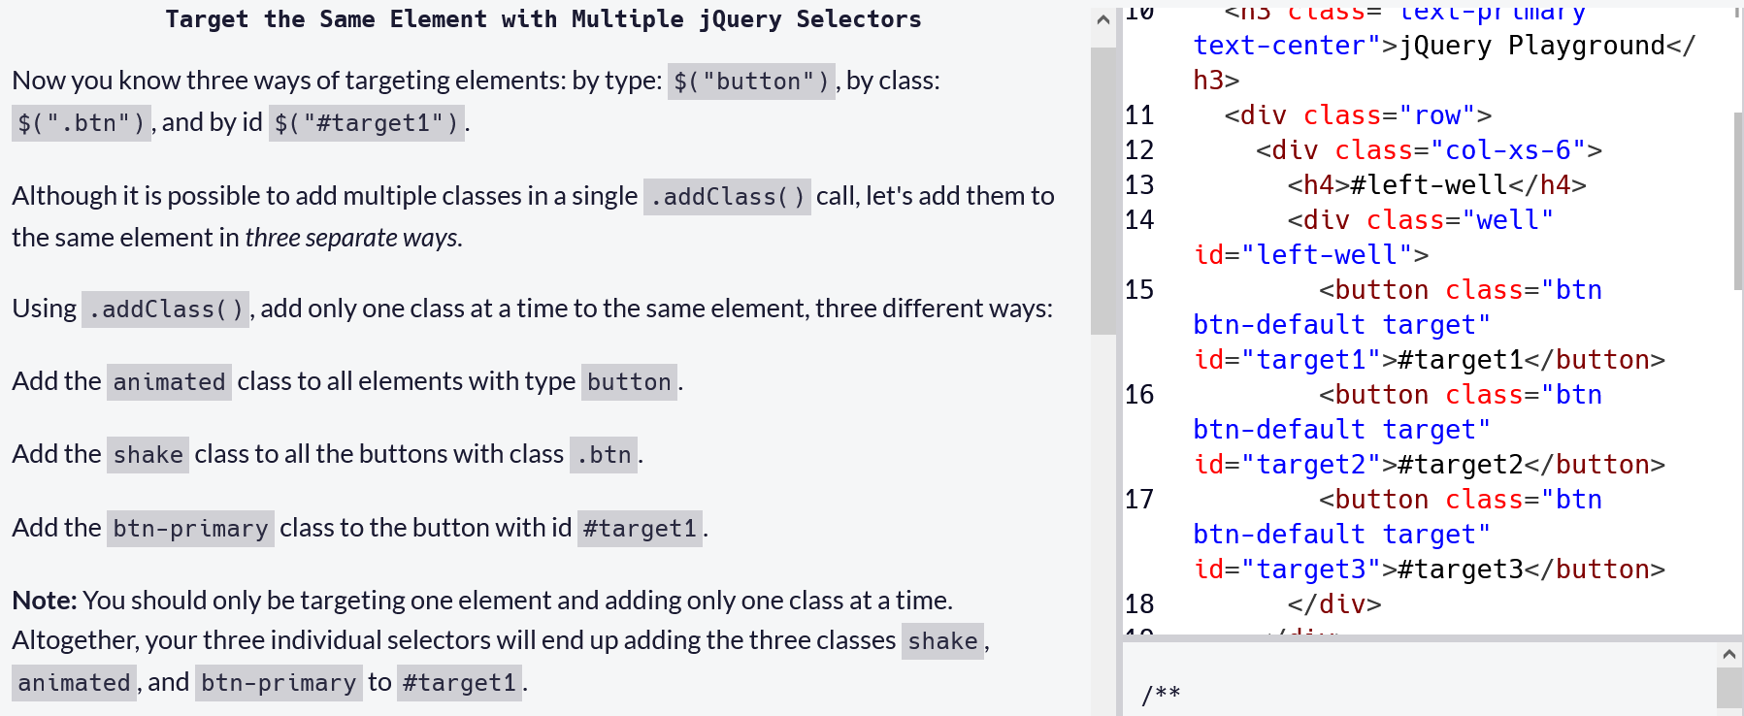

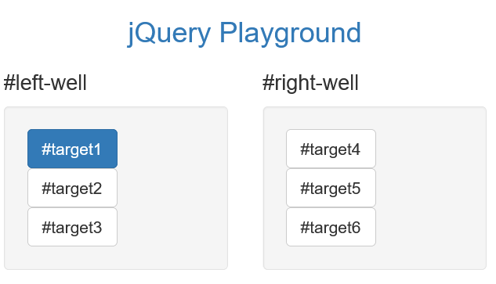

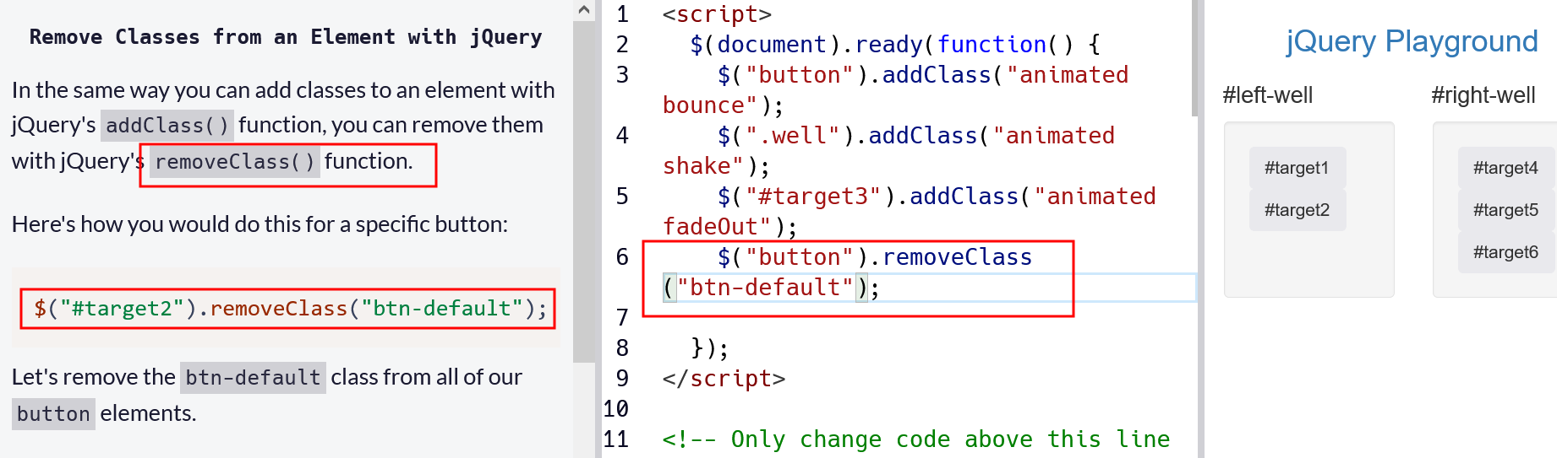

Css property change using Jquarry

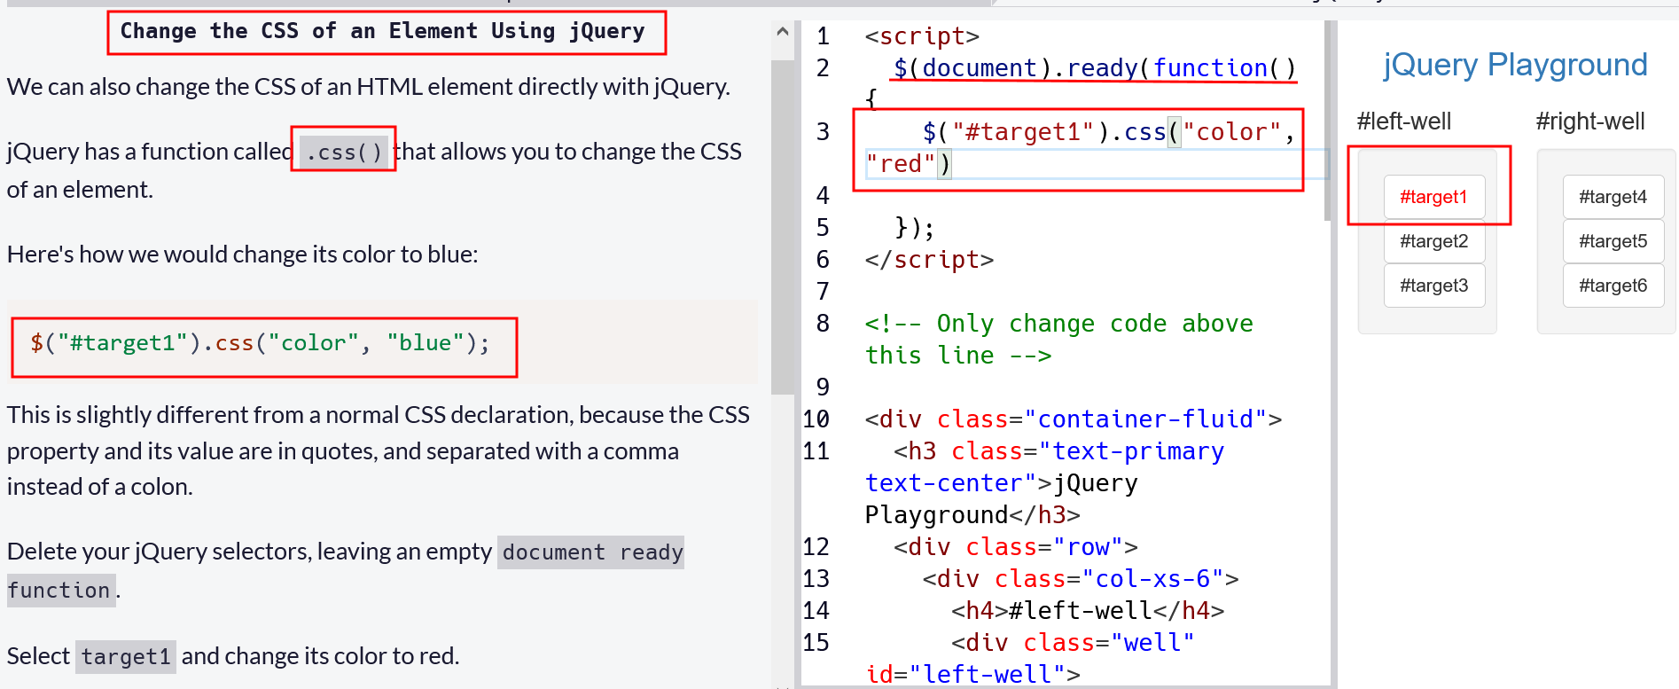

Disable an element by JQuary

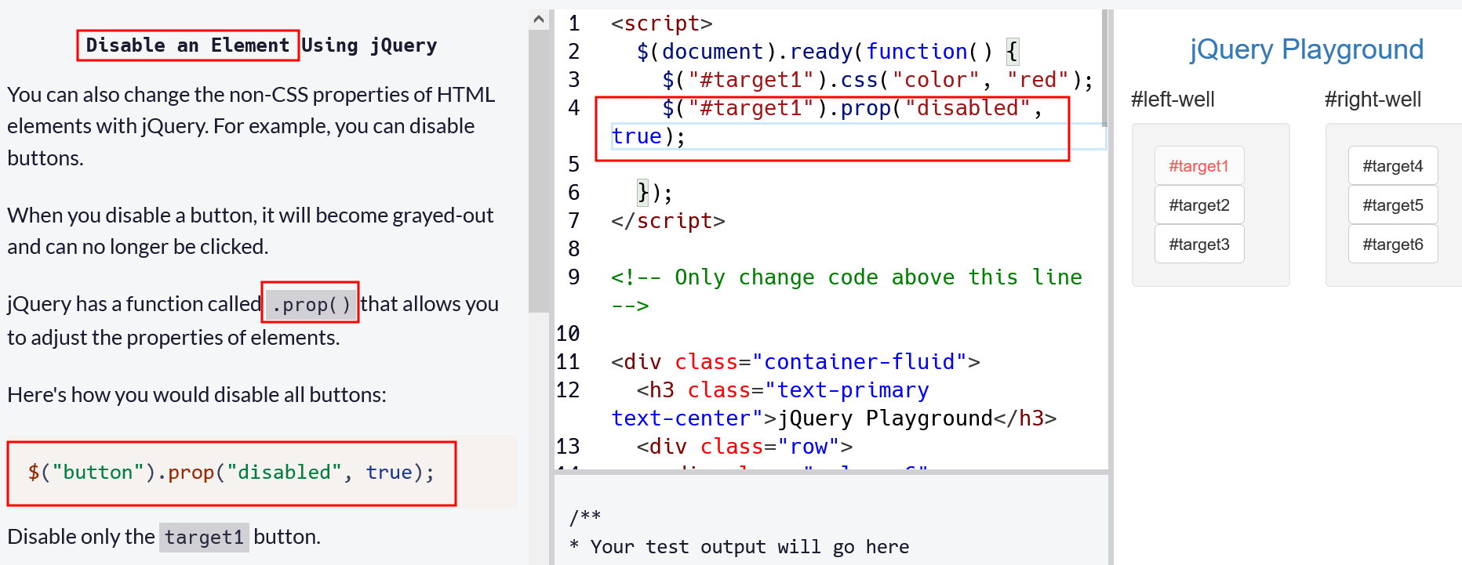

Changing html tags and text inside by JQuery

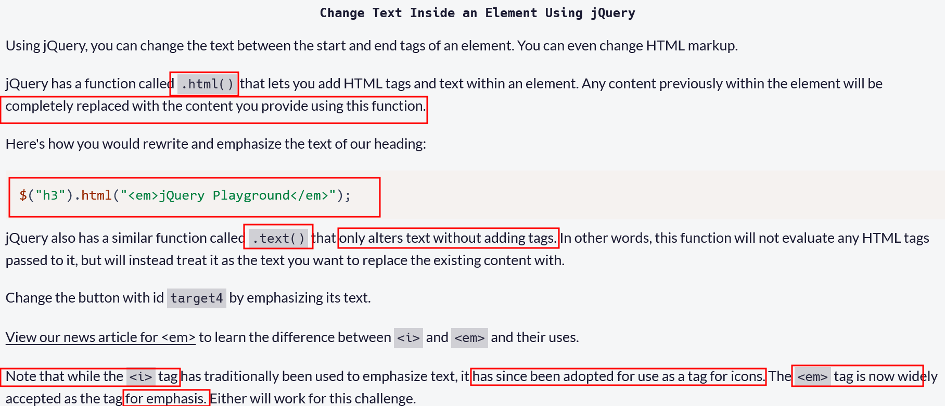

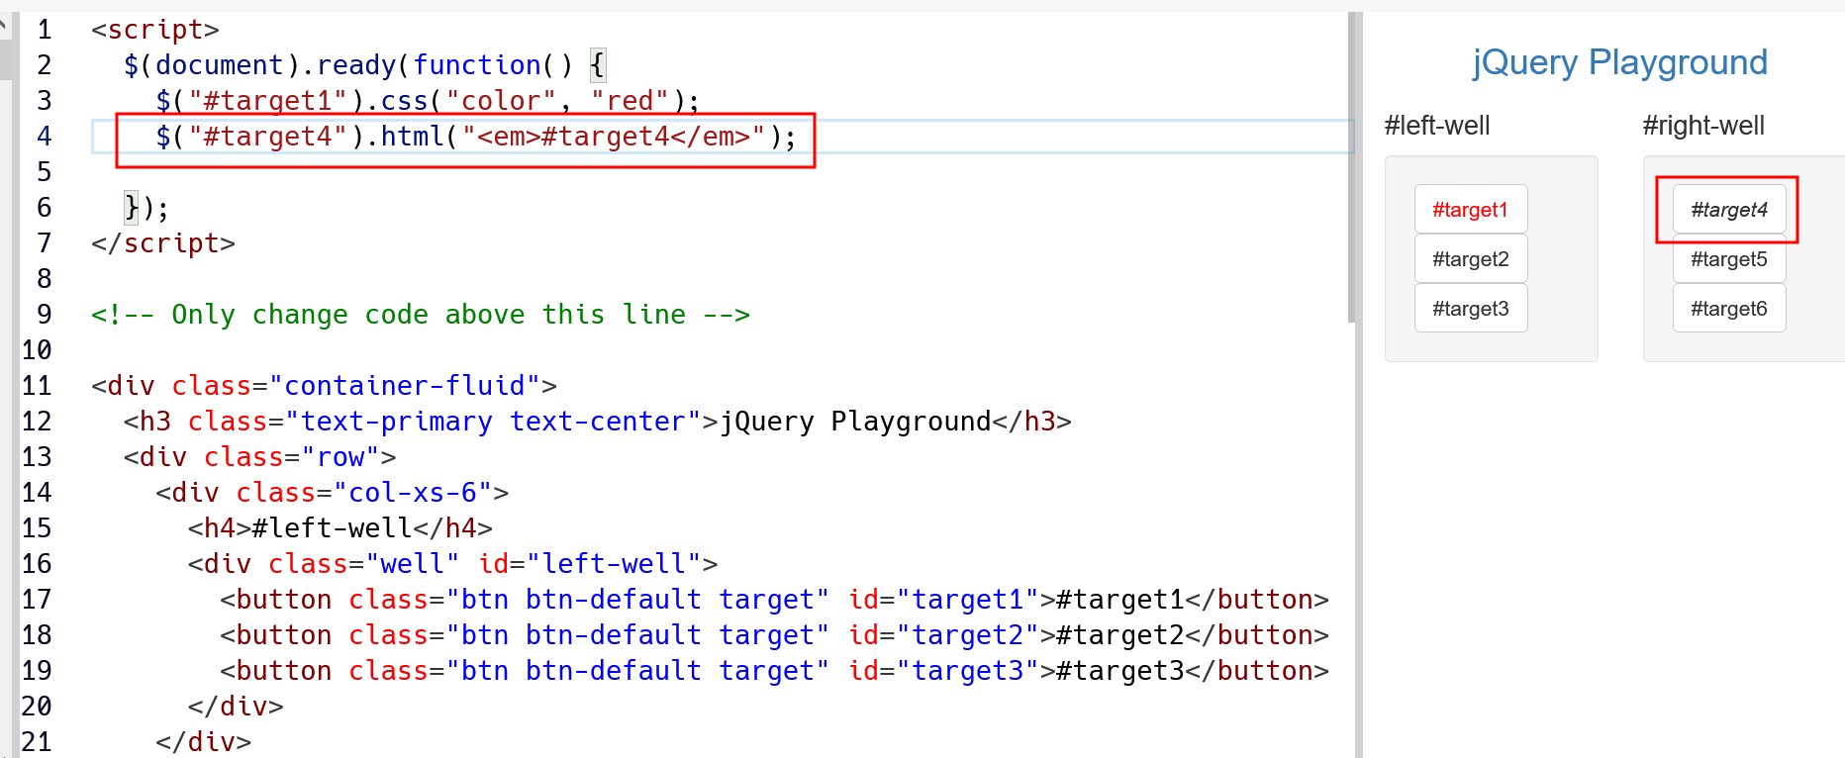

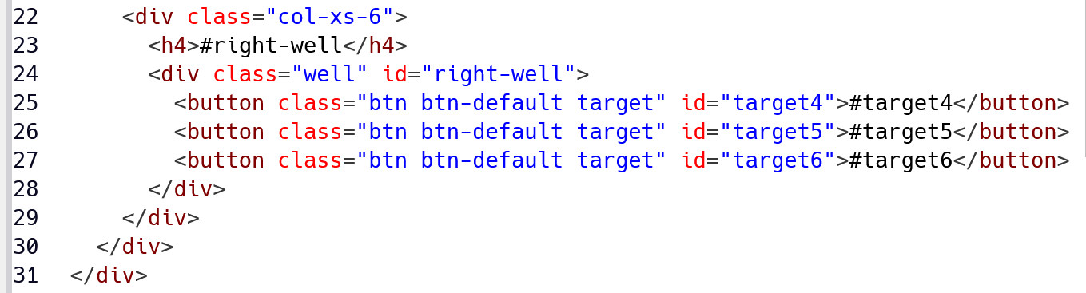

Remove an Element Using jQuery

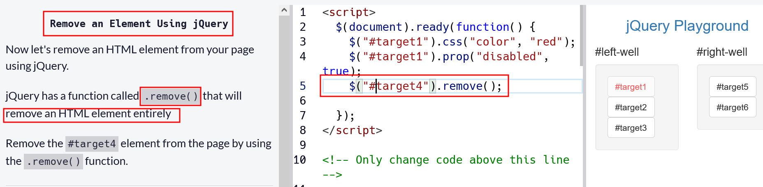

Use appendTo to Move Elements with jQuery

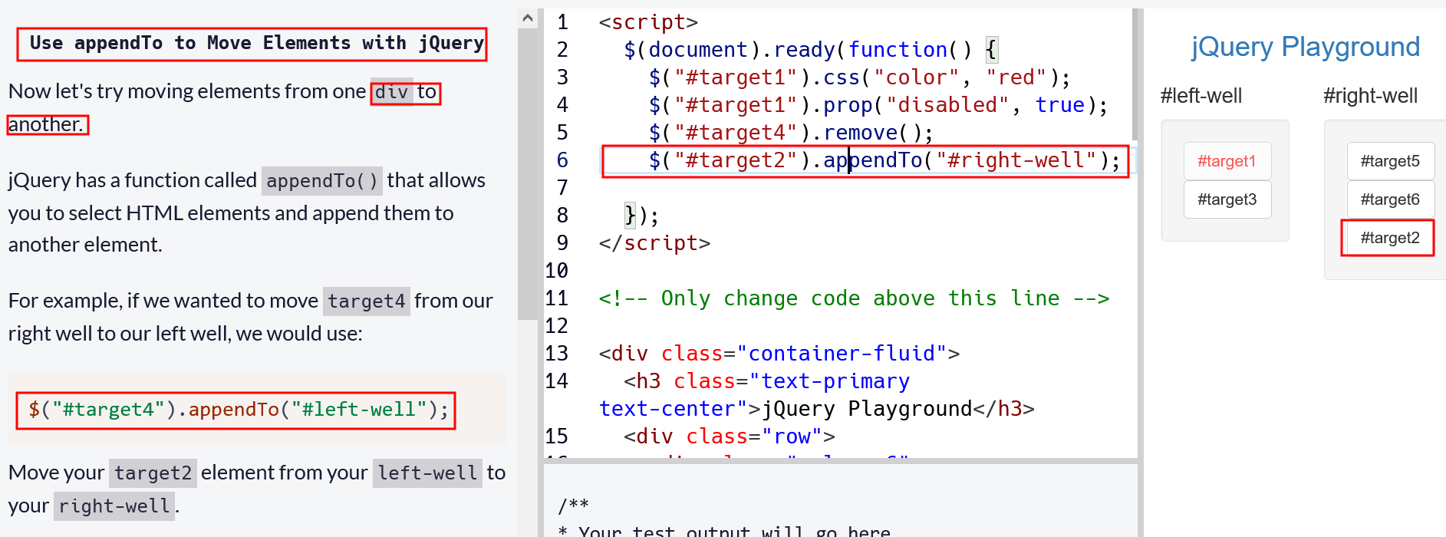

Clone an Element Using jQuery

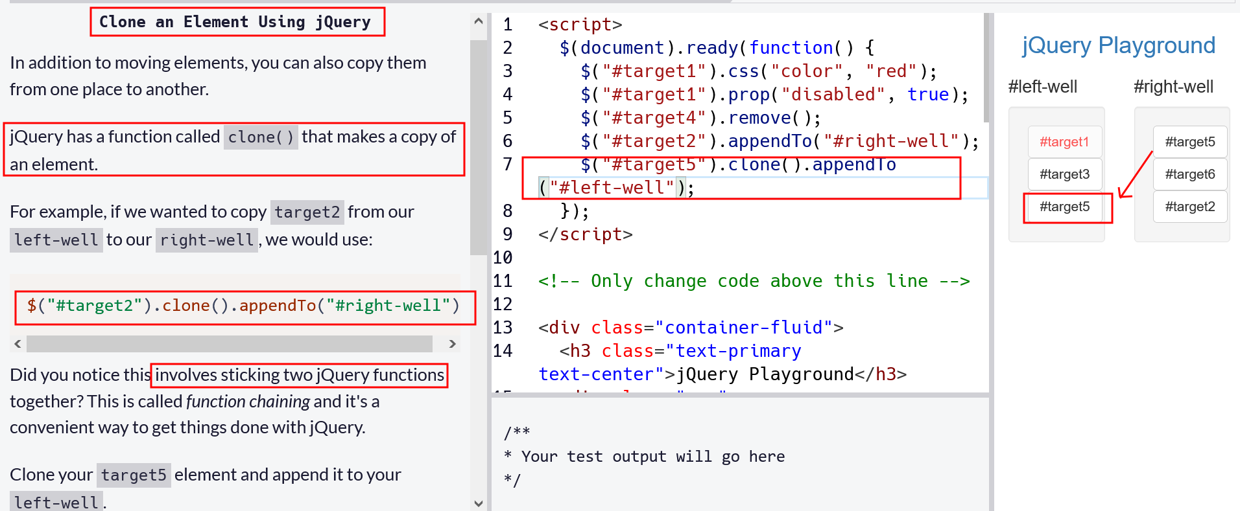

Target the Parent of an Element Using jQuery

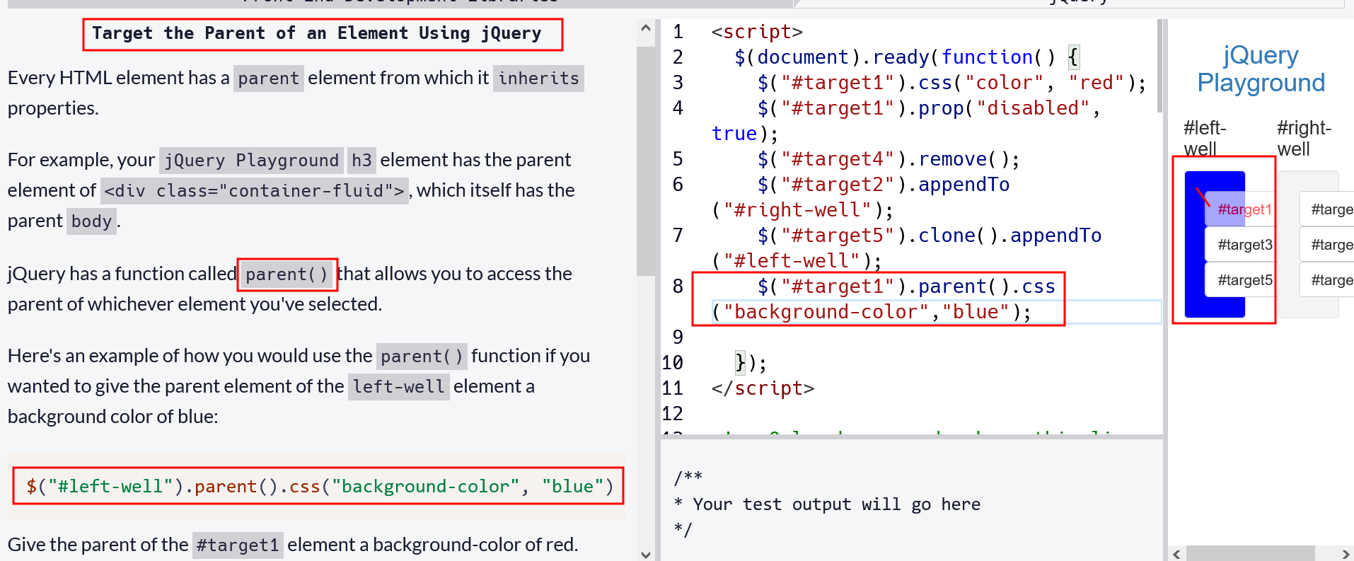

Target the Children of an Element Using jQuery

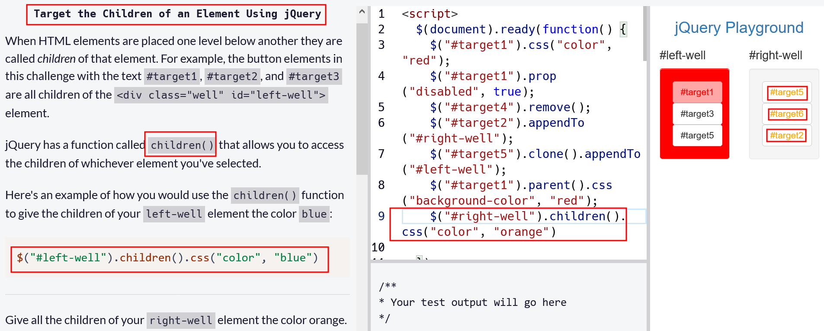

Target a Specific Child of an Element Using jQuery

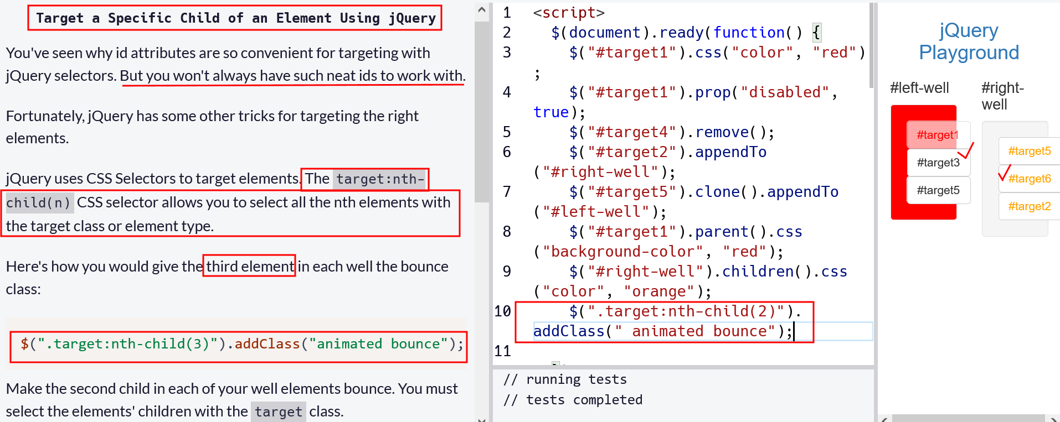

Target Even Elements Using jQuery

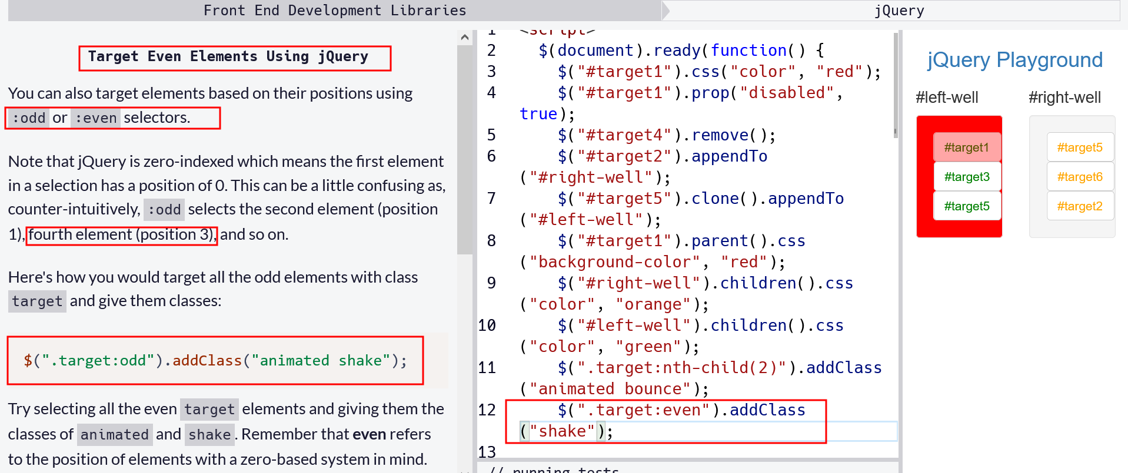

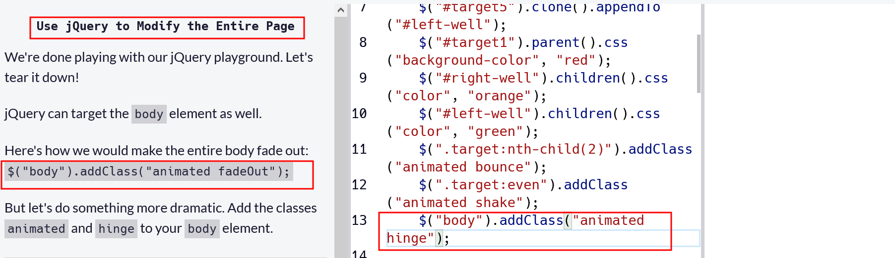

jQuery attribute equals selectors

This concept of attribute value selectors carries over to jQuery. If we want to force a link to a given URL to open in a new tab, we would use the following:

$(document).ready(function(){

$('a[href=http://www.google.com]').click(function(){

window.open(this.href);

return false;

});

});