A few days ago you said to delete the text of  "what is smoking queens?".

So we have deleted the text.

Then the home page design is :

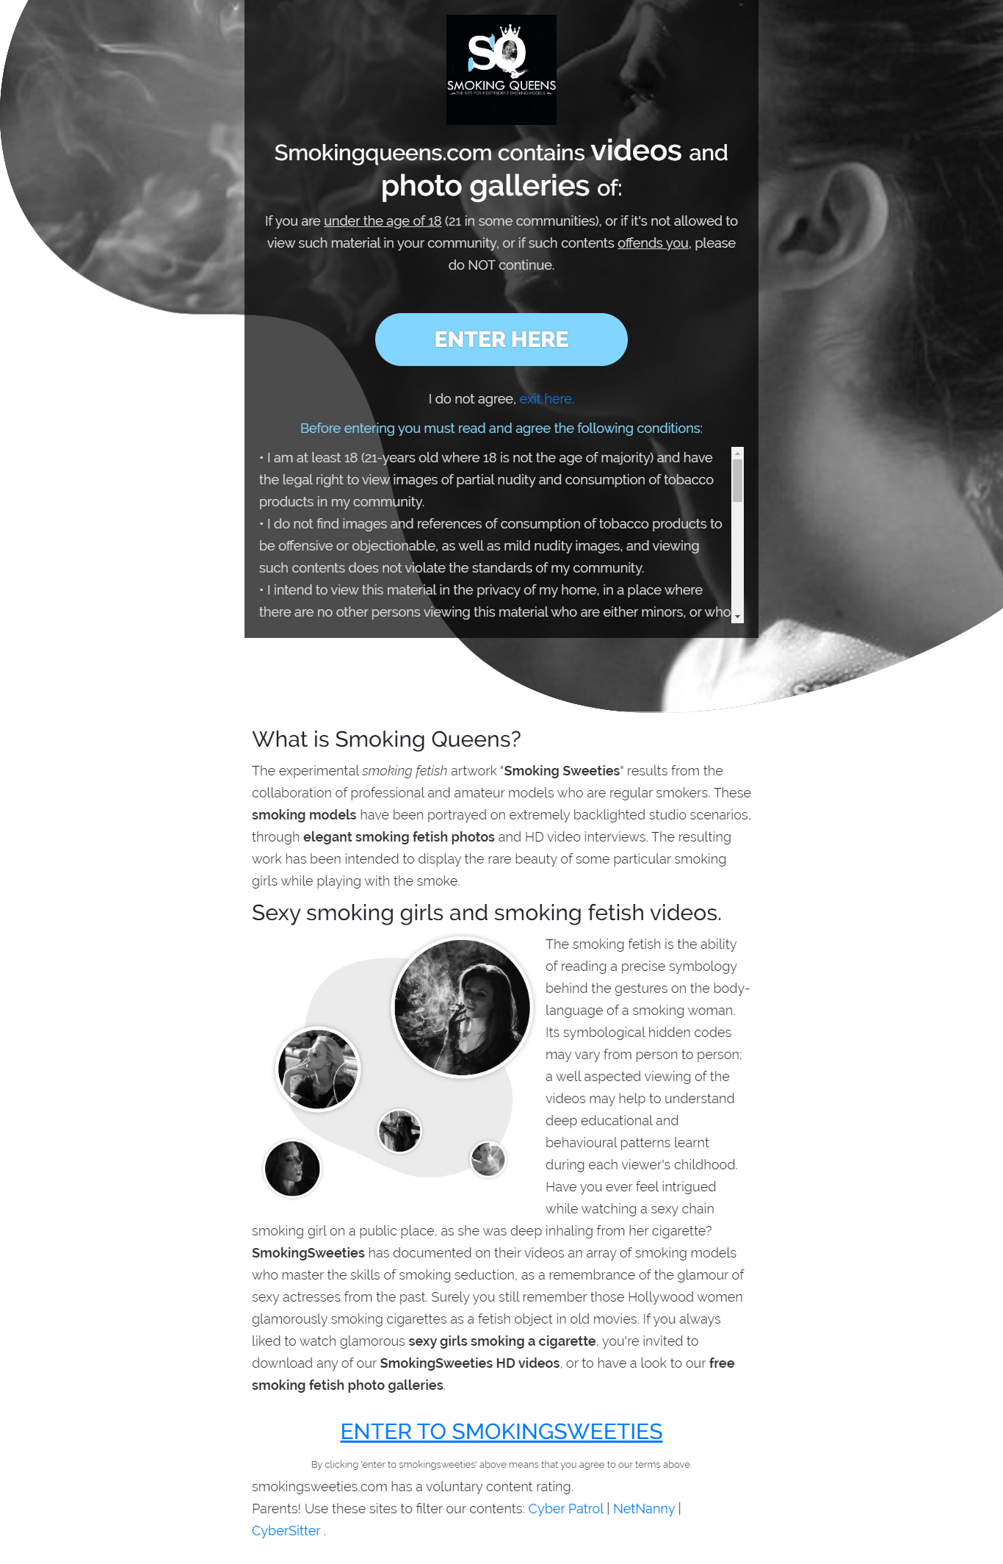

Now the home page design is:

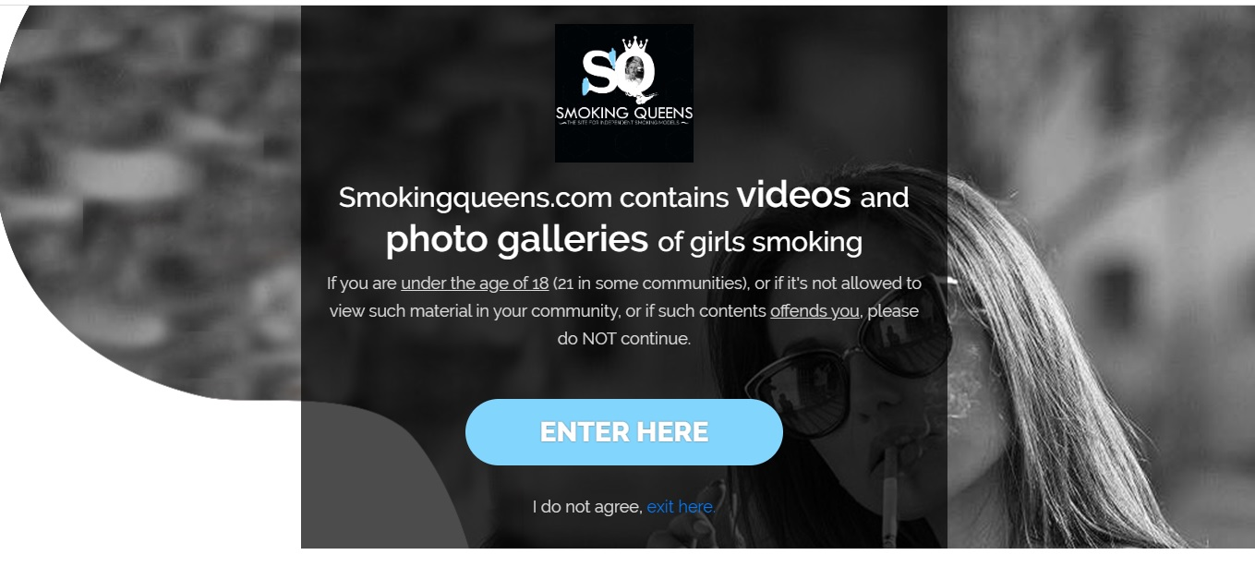

Please write down on the image or mark, what you want for the home page.