CENG421

Project Report

Arif Burak Demiray – 250201022

Server/Client Chat Program

Table of Contents
1. DESCRIPTION 3
2. SCREENSHOTS 4
3. REFERENCES 6

1. DESCRIPTION

This project is a server/client chat program. Users can chat with each other. It is implemented in thread way. The book is the main resource for this project.

Why threads? Because I know them. I know how to implement threads so I used them to make project in a good way. Also, it uses pool mechanism to hold registered users. Server firstly, opens its connection and starts its main function. While accepting connections it starts new threads for the coming clients. And in this thread it receives commands and responds. In client, it creates its connection and creates a thread for receiving and in main takes input and sends to the server.

Why a chat program? I always wanted to make a chat program. I wanted to know its details.

It this project it can be improved by adding DHKE. I wanted to add it. And pool management can be refined.

2. SCREENSHOTS

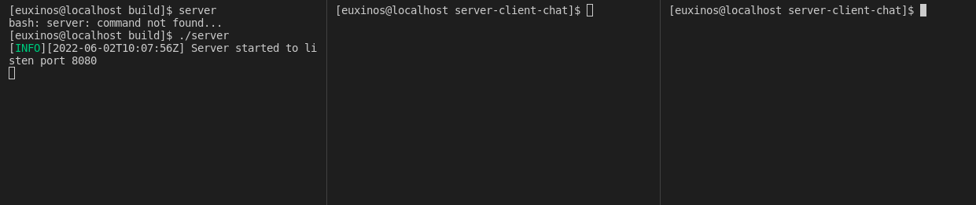
Figure 2.1 Server Start

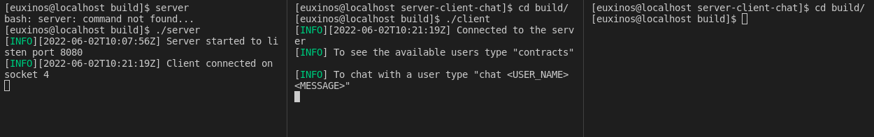
Figure 2.2 Success client connection and instructions

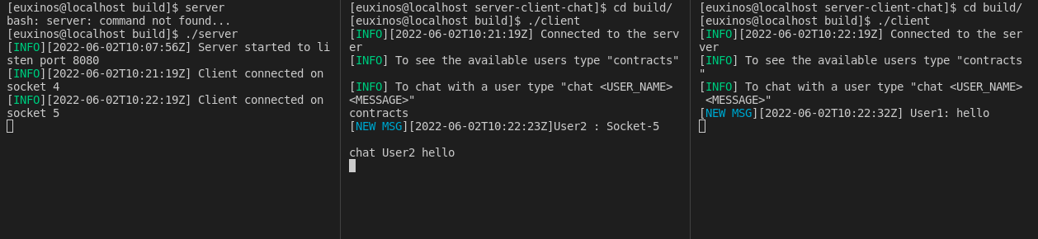
Figure 2.3 contracts command and chat a user

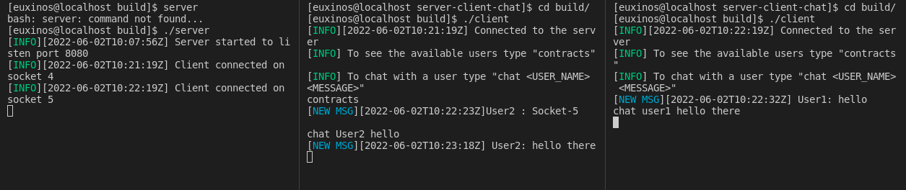
Figure 2.4 Respond to user (user area can be UserX, userx, USERx)
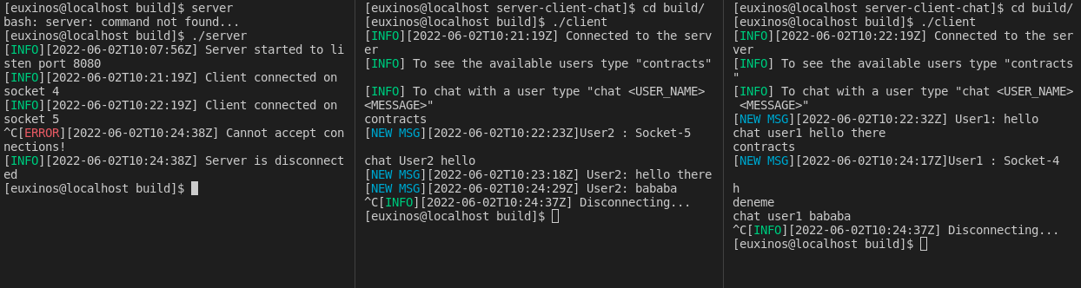
Figure 2.5 Finish connections

3. REFERENCES

[1] K. Davis, J. Turner, and N. Yocom, “The Definitive Guide to Linux Network Programming,” Jan. 2004, doi: 10.1007/978-1-4302-0748-1.

