Chris Do - How to Create a Real Personal Brand
Editable Word version with PDF slide preview + extracted text per page
Source PDF pages: 20

PDF Page 1
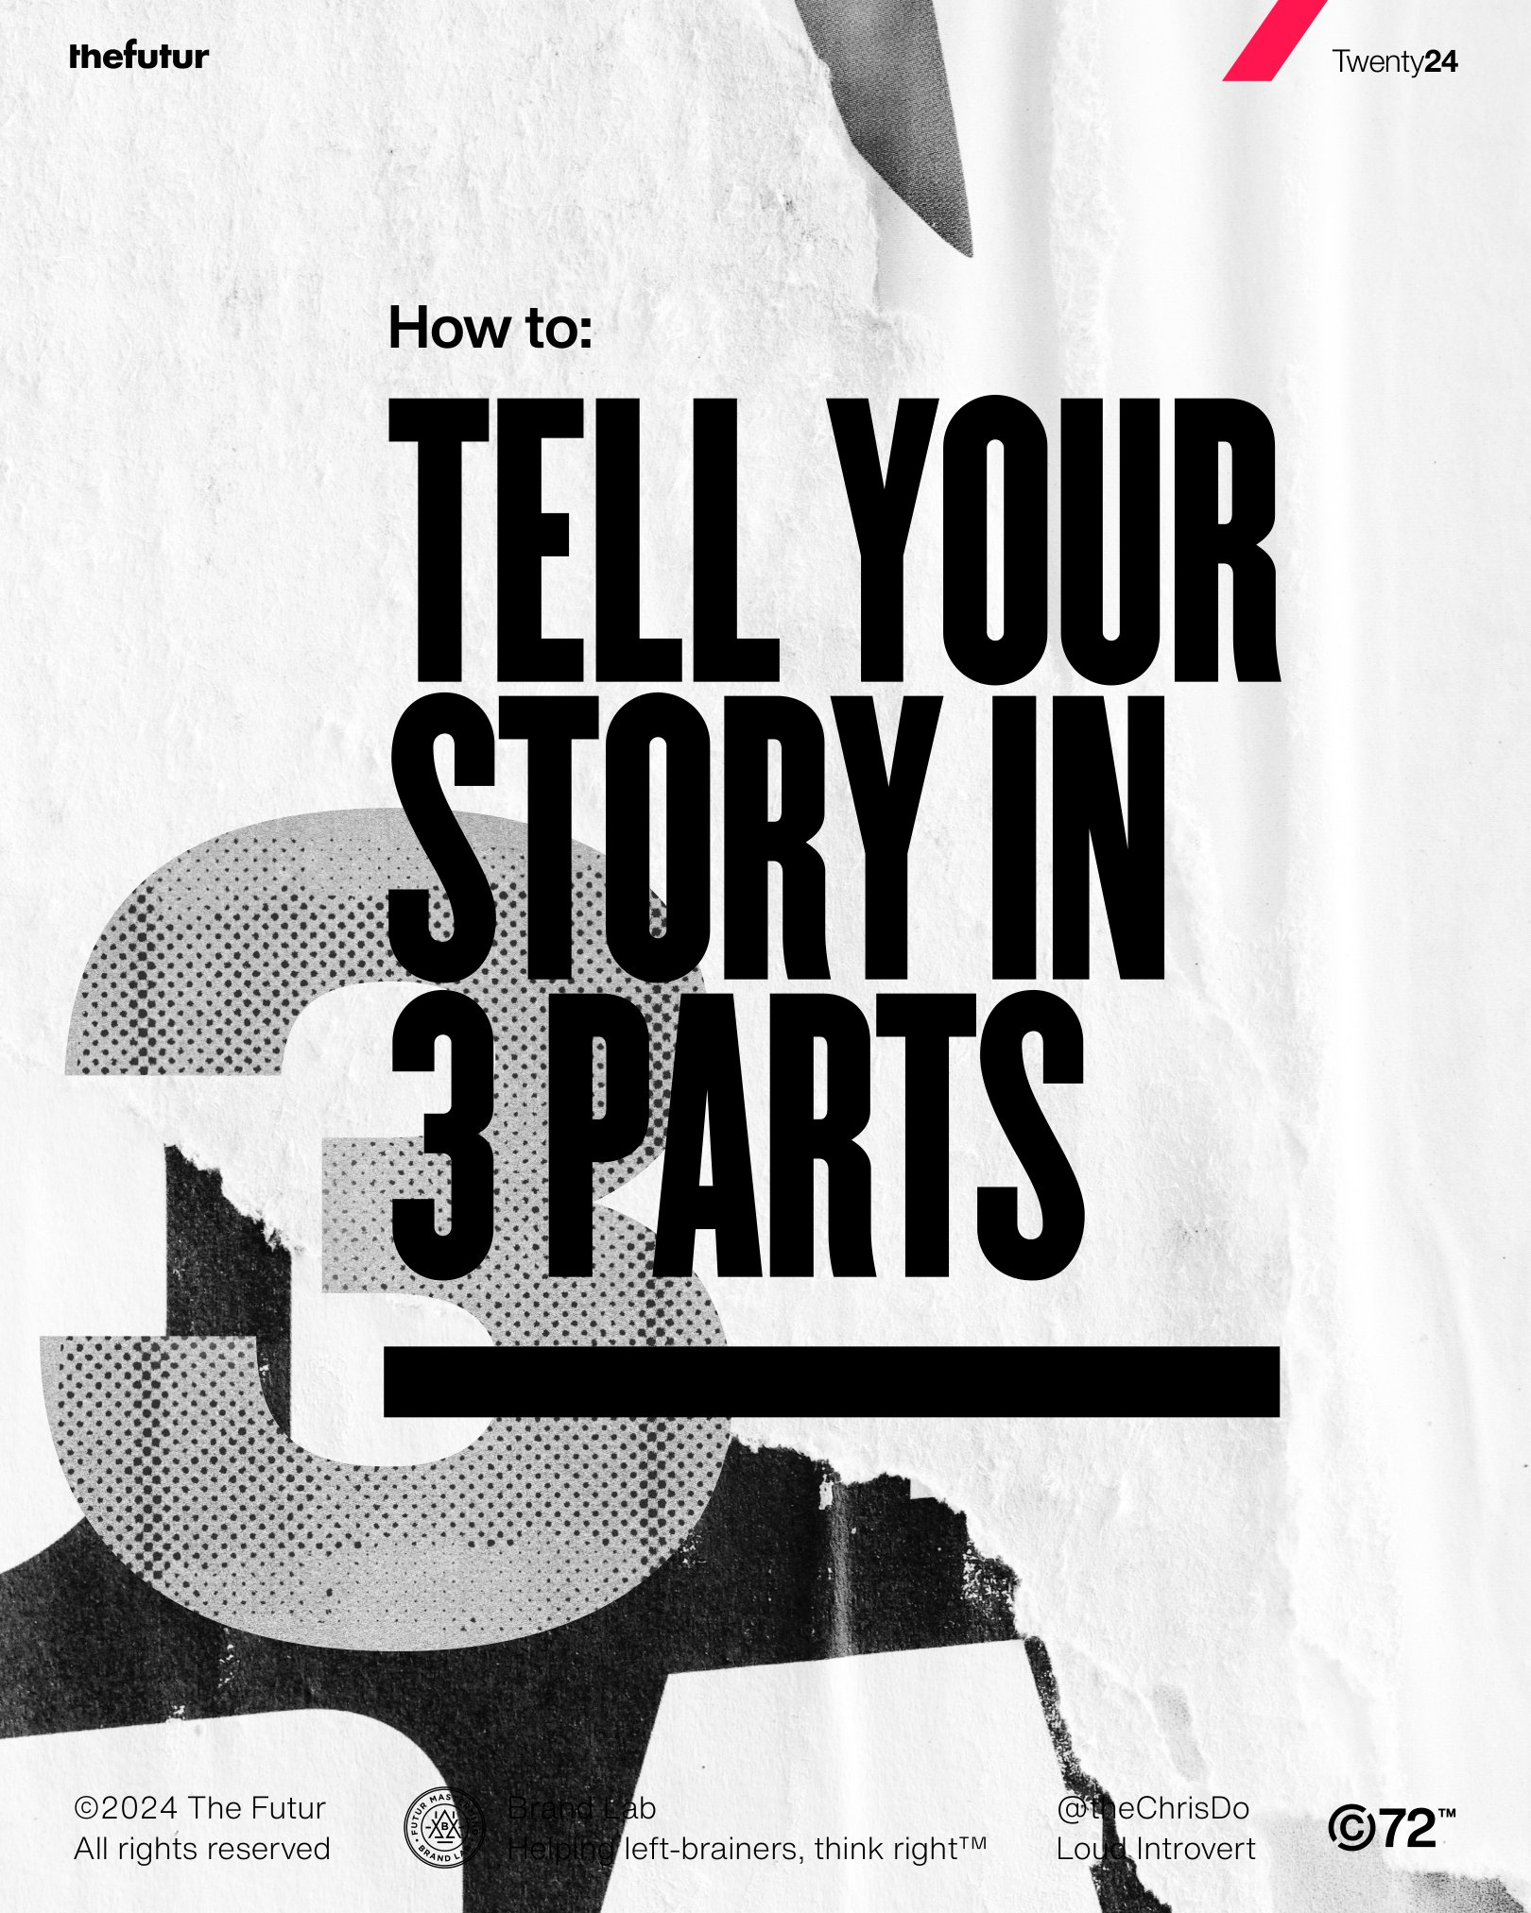 | Extracted editable text  Twenty24  How to:  3  TELL YOUR  STORY IN  3 PARTS  ©2024 The Futur Brand Lab @theChrisDo  All rights reserved Helping left-brainers, think right™ Loud Introvert

PDF Page 2
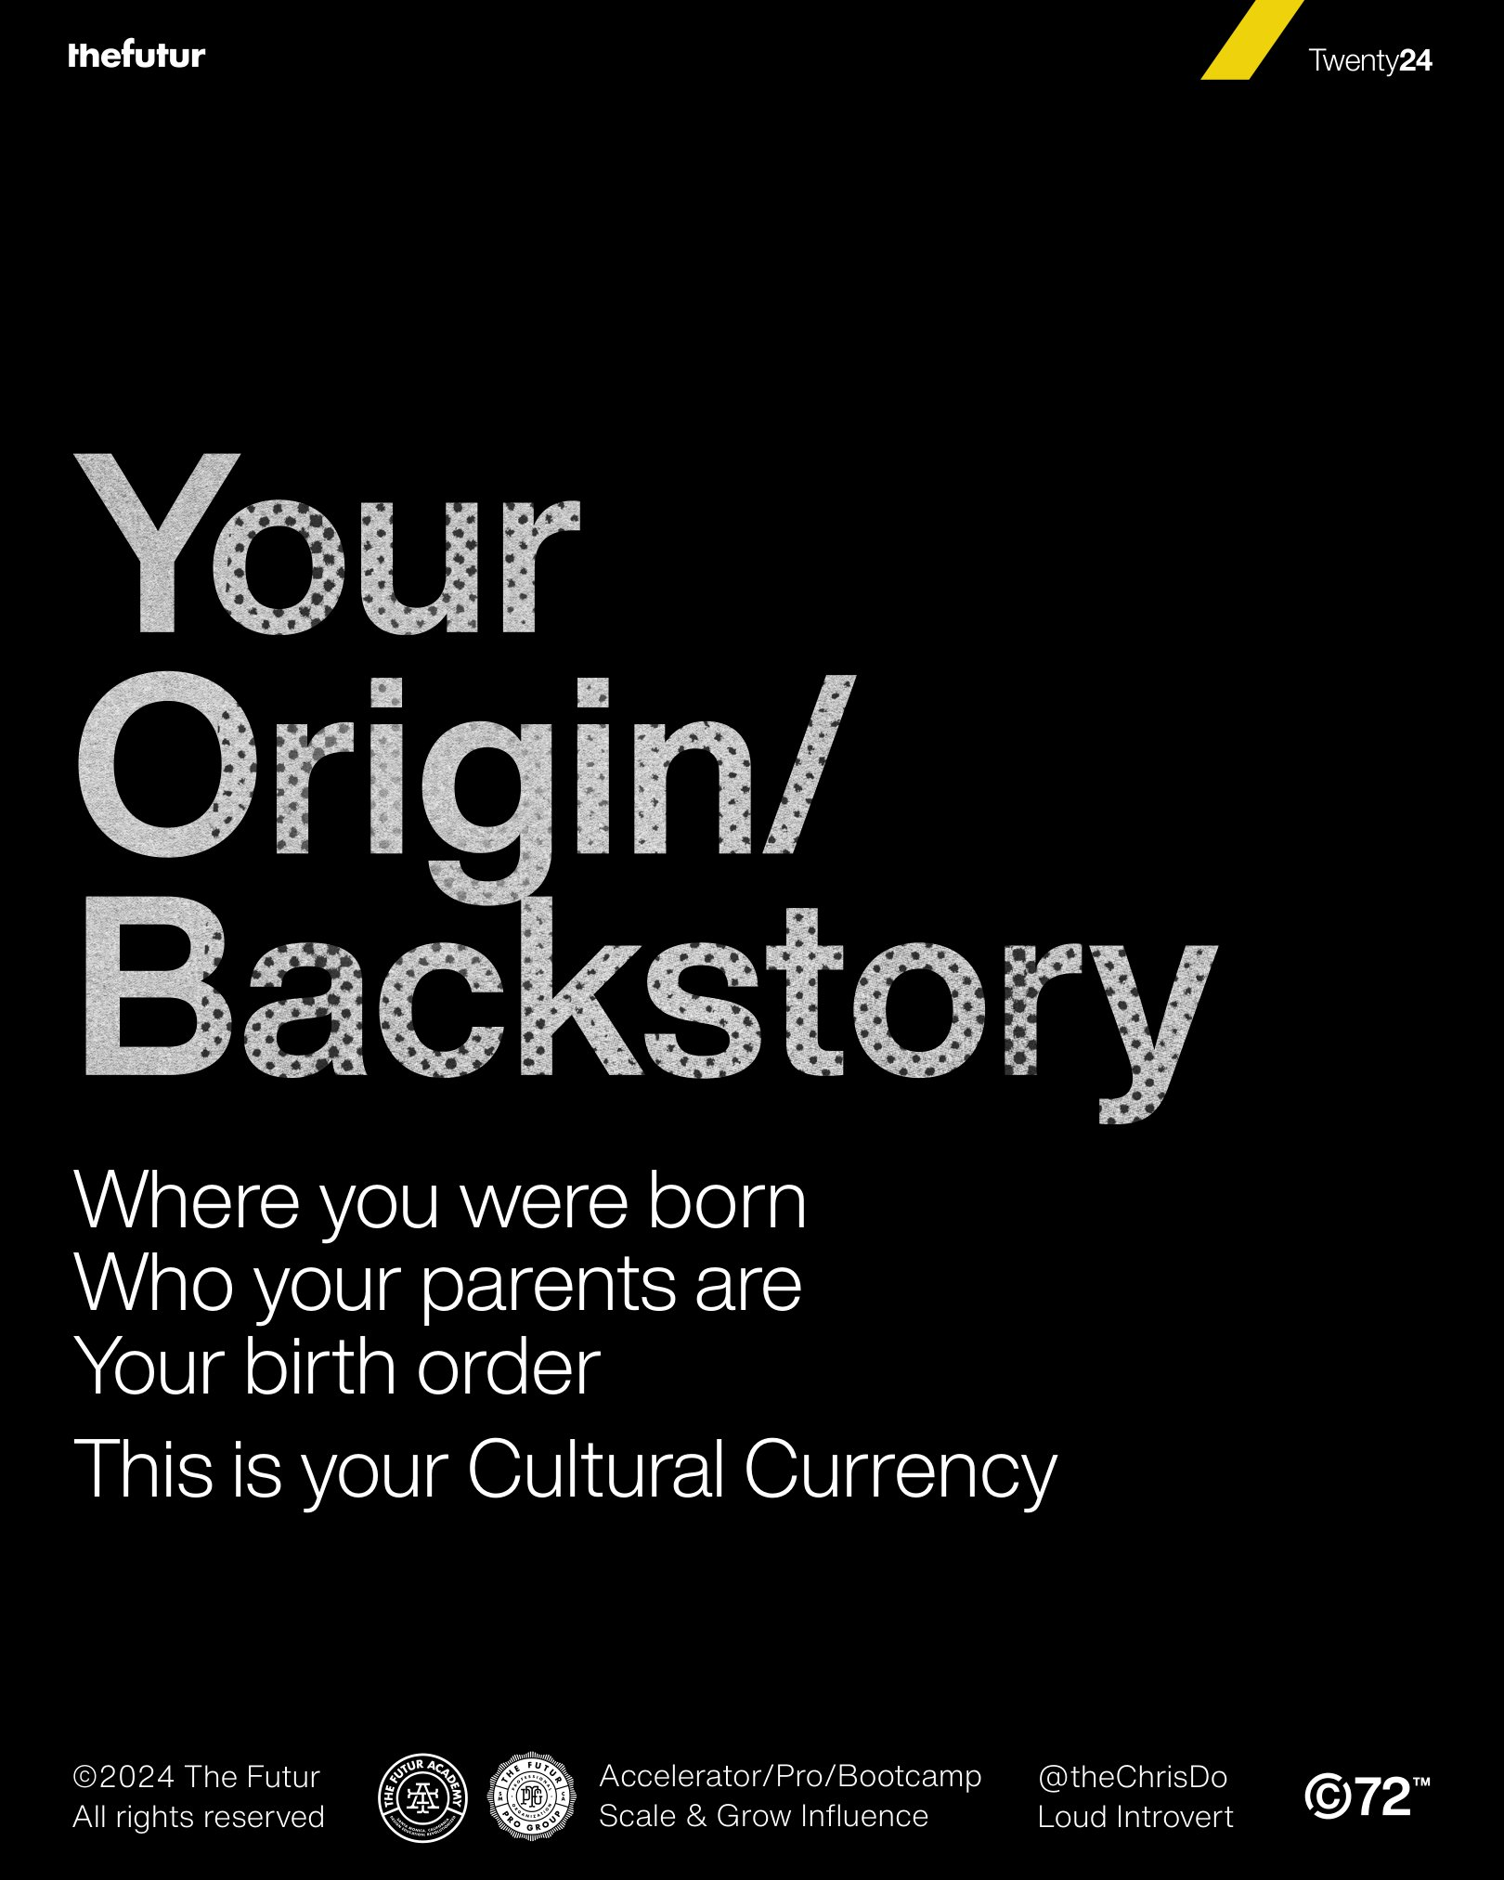 | Extracted editable text  Twenty24  Your  Origin/  Backstory  Where you were born  Who your parents are  Your birth order  This is your Cultural Currency  ©2024 The Futur Accelerator/Pro/Bootcamp @theChrisDo  All rights reserved Scale & Grow Influence Loud Introvert

PDF Page 3
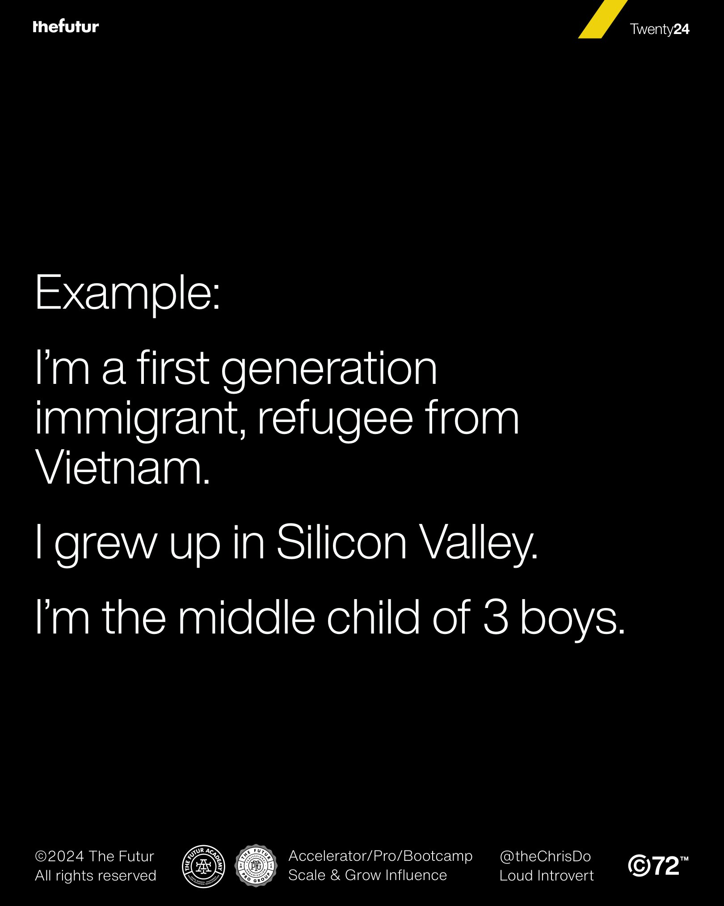 | Extracted editable text  Twenty24  Example:  I’m a first generation  immigrant, refugee from  Vietnam.  I grew up in Silicon Valley.  I’m the middle child of 3 boys.  ©2024 The Futur Accelerator/Pro/Bootcamp @theChrisDo  All rights reserved Scale & Grow Influence Loud Introvert

PDF Page 4
 | Extracted editable text  Twenty24  Inciting  Incident/  Compelling  Event  The moment when  everything changes forever  ©2024 The Futur Accelerator/Pro/Bootcamp @theChrisDo  All rights reserved Scale & Grow Influence Loud Introvert

PDF Page 5
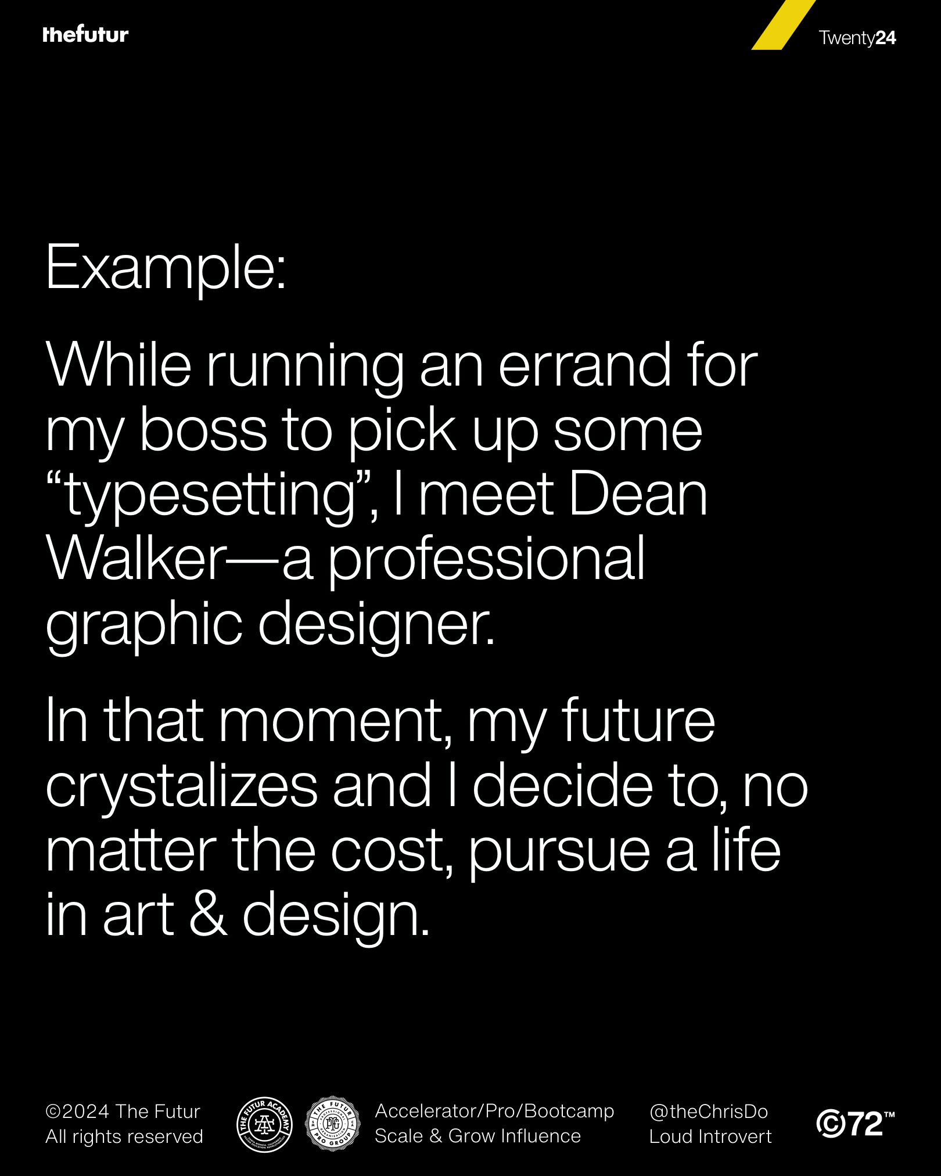 | Extracted editable text  Twenty24  Example:  While running an errand for  my boss to pick up some  “typesetting”, I meet Dean  Walker—a professional  graphic designer.  In that moment, my future  crystalizes and I decide to, no  matter the cost, pursue a life  in art & design.  ©2024 The Futur Accelerator/Pro/Bootcamp @theChrisDo  All rights reserved Scale & Grow Influence Loud Introvert

PDF Page 6
 | Extracted editable text  Twenty24  The  Defining  Moment  The moment when it all  becomes clear as to who you  were meant to be.  ©2024 The Futur Accelerator/Pro/Bootcamp @theChrisDo  All rights reserved Scale & Grow Influence Loud Introvert

PDF Page 7
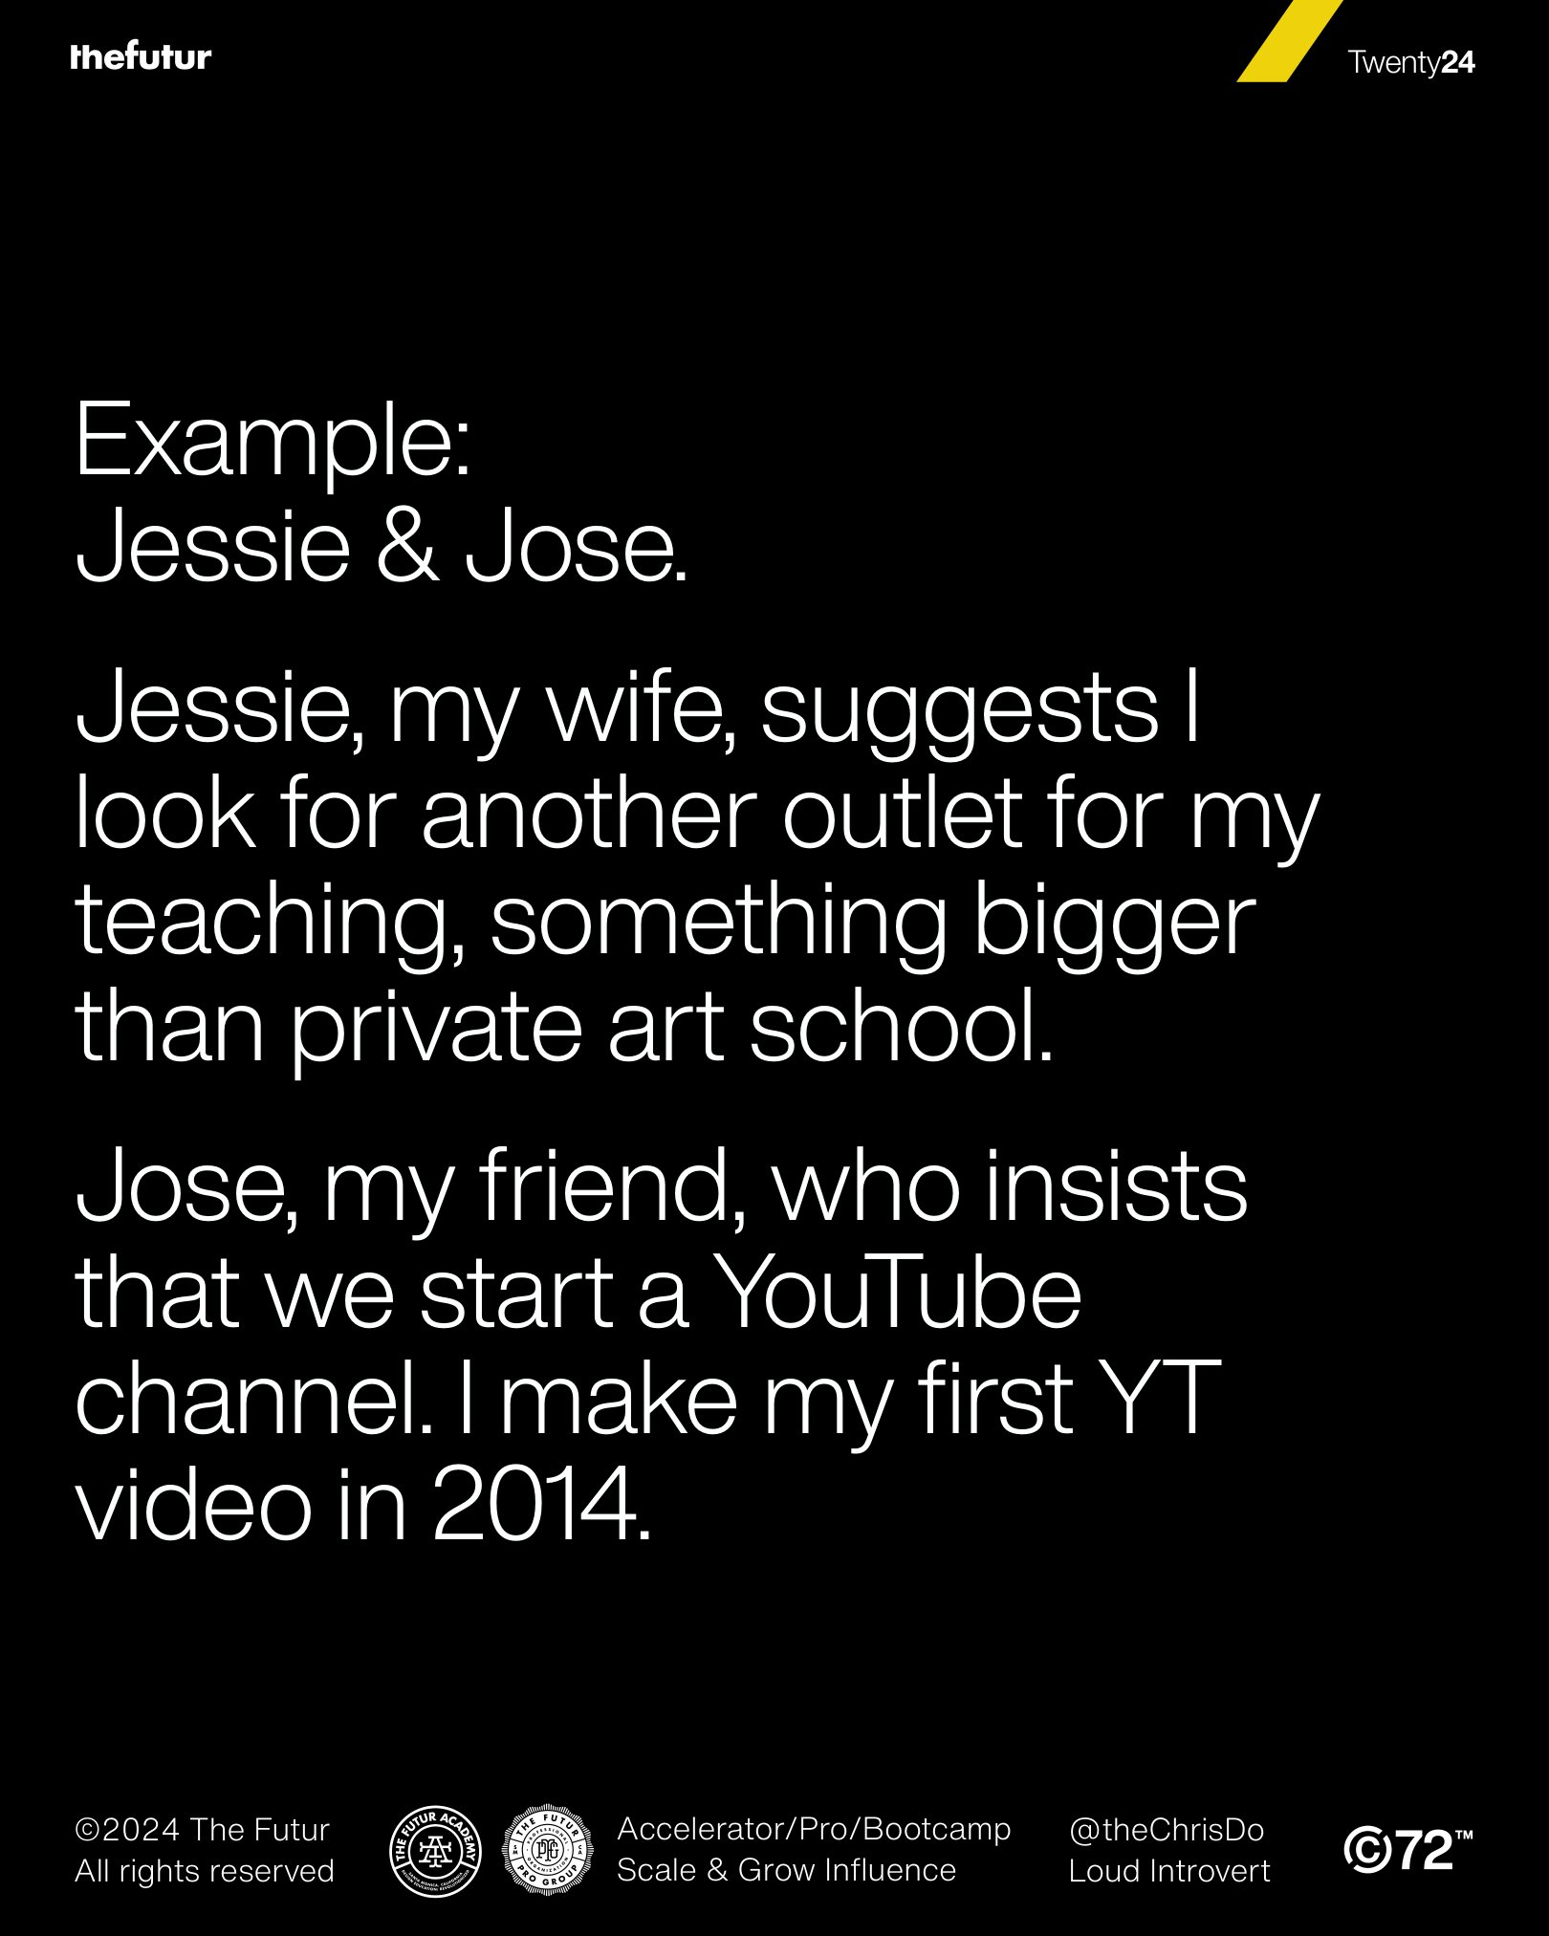 | Extracted editable text  Twenty24  Example:  Jessie & Jose.  Jessie, my wife, suggests I  look for another outlet for my  teaching, something bigger  than private art school.  Jose, my friend, who insists  that we start a YouTube  channel. I make my first YT  video in 2014.  ©2024 The Futur Accelerator/Pro/Bootcamp @theChrisDo  All rights reserved Scale & Grow Influence Loud Introvert

PDF Page 8
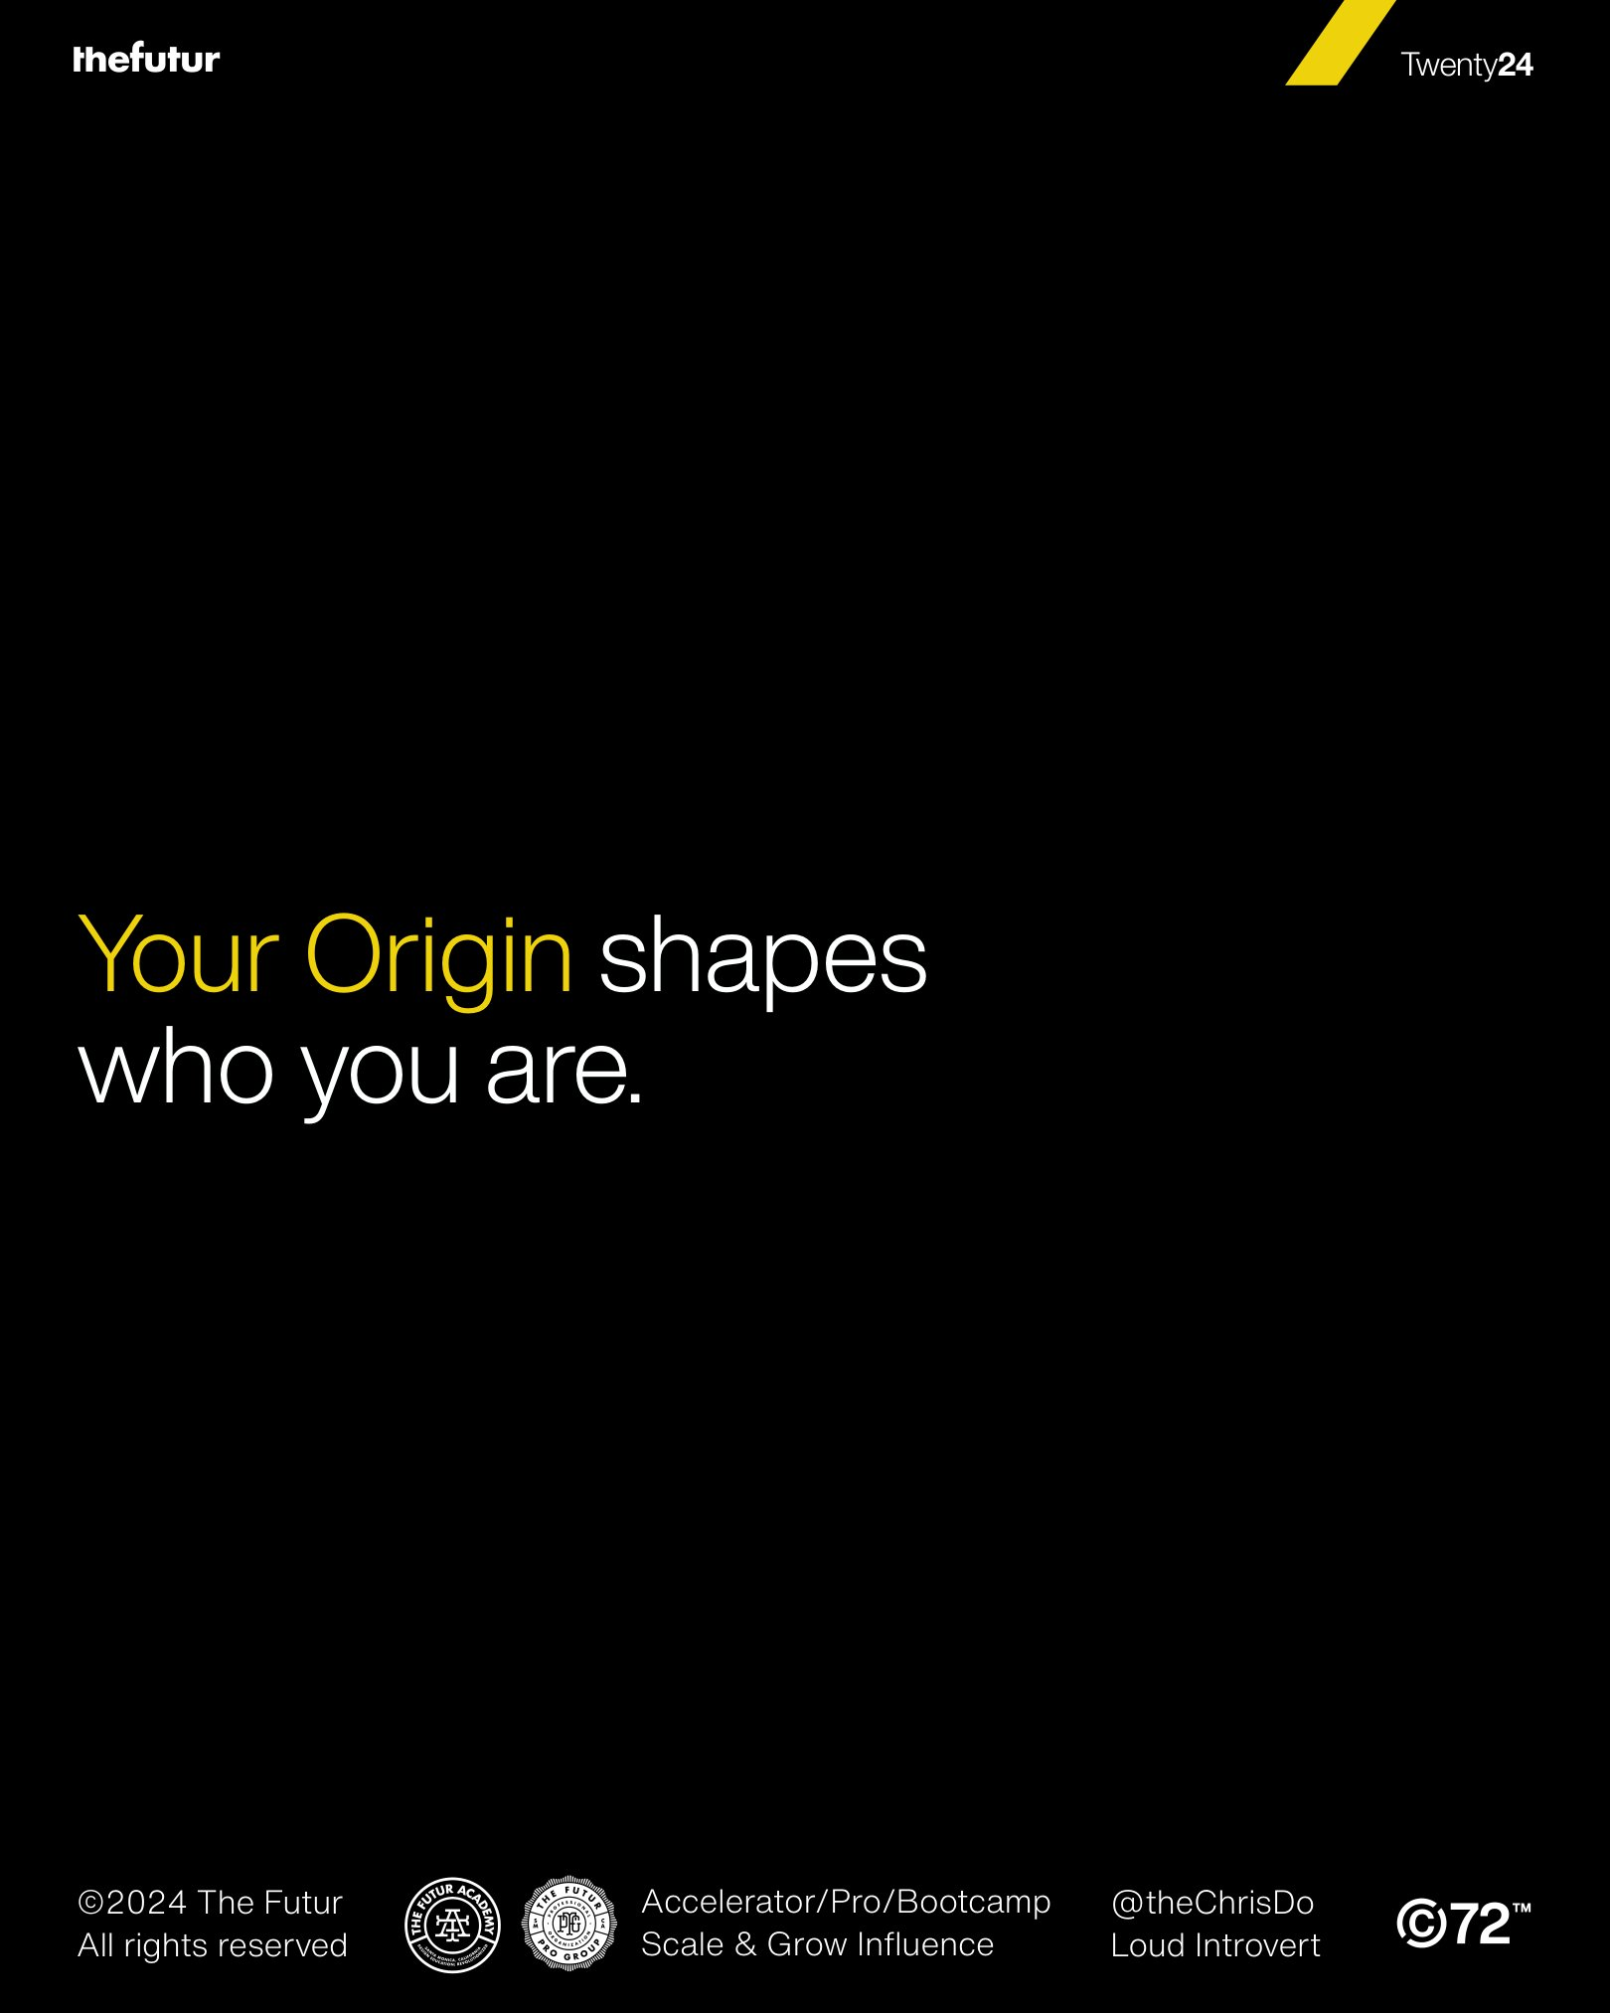 | Extracted editable text  Twenty24  Your Origin shapes  who you are.  ©2024 The Futur Accelerator/Pro/Bootcamp @theChrisDo  All rights reserved Scale & Grow Influence Loud Introvert

PDF Page 9
 | Extracted editable text  Twenty24  Your Inciting Incident  changes how you see  the world and shows  you what’s possible.  ©2024 The Futur Accelerator/Pro/Bootcamp @theChrisDo  All rights reserved Scale & Grow Influence Loud Introvert

PDF Page 10
 | Extracted editable text  Twenty24  Your Defining Moment  shows who you’ll  become.  ©2024 The Futur Accelerator/Pro/Bootcamp @theChrisDo  All rights reserved Scale & Grow Influence Loud Introvert

PDF Page 11
 | Extracted editable text  Twenty24  Find these moments  in your story.  ©2024 The Futur Accelerator/Pro/Bootcamp @theChrisDo  All rights reserved Scale & Grow Influence Loud Introvert

PDF Page 12
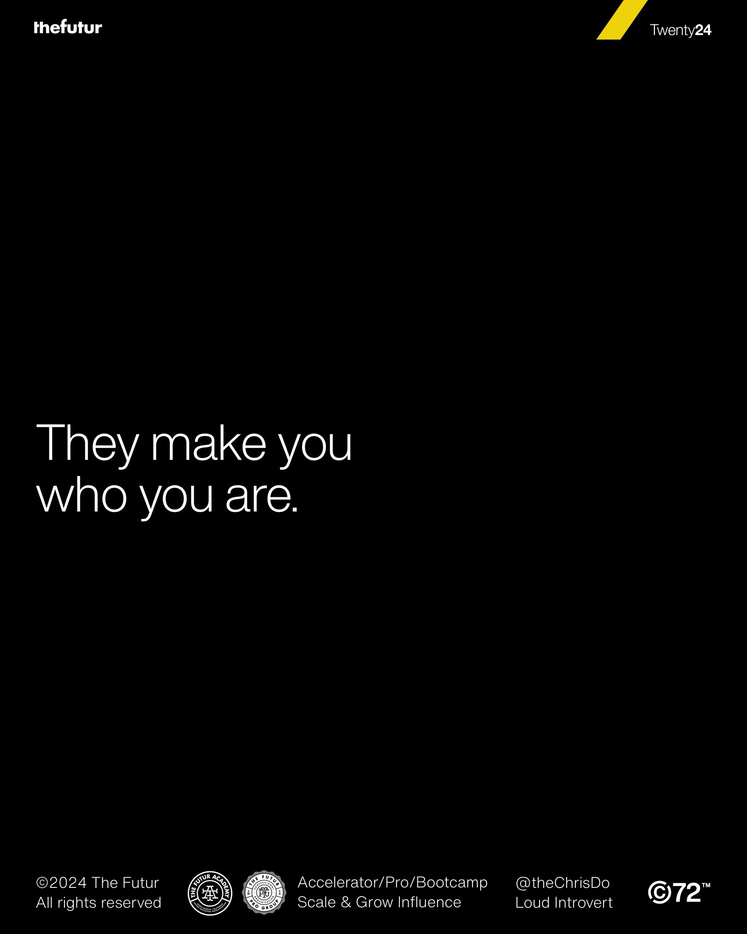 | Extracted editable text  Twenty24  They make you  who you are.  ©2024 The Futur Accelerator/Pro/Bootcamp @theChrisDo  All rights reserved Scale & Grow Influence Loud Introvert

PDF Page 13
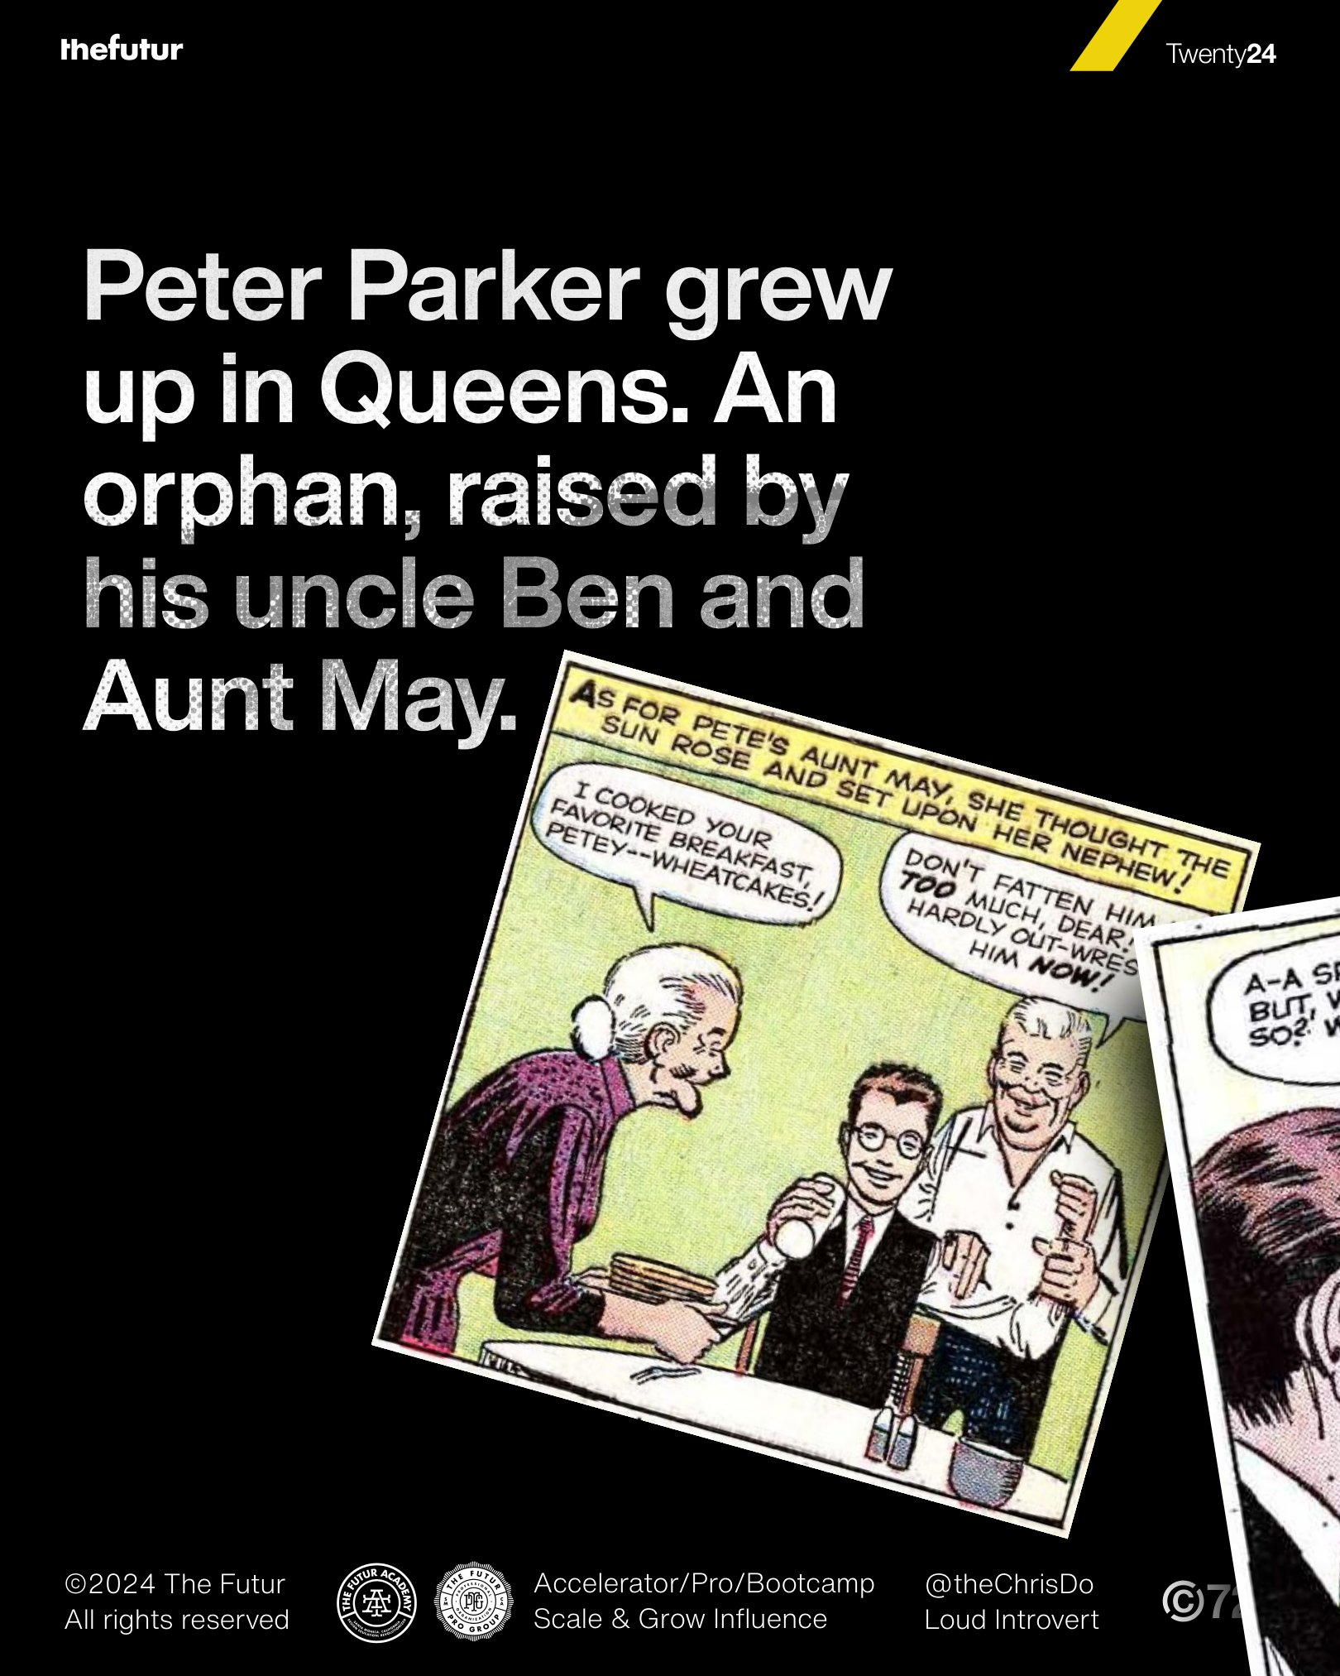 | Extracted editable text  Twenty24  Peter Parker grew  up in Queens. An  orphan, raised by  his uncle Ben and  Aunt May.  ©2024 The Futur Accelerator/Pro/Bootcamp @theChrisDo  All rights reserved Scale & Grow Influence Loud Introvert

PDF Page 14
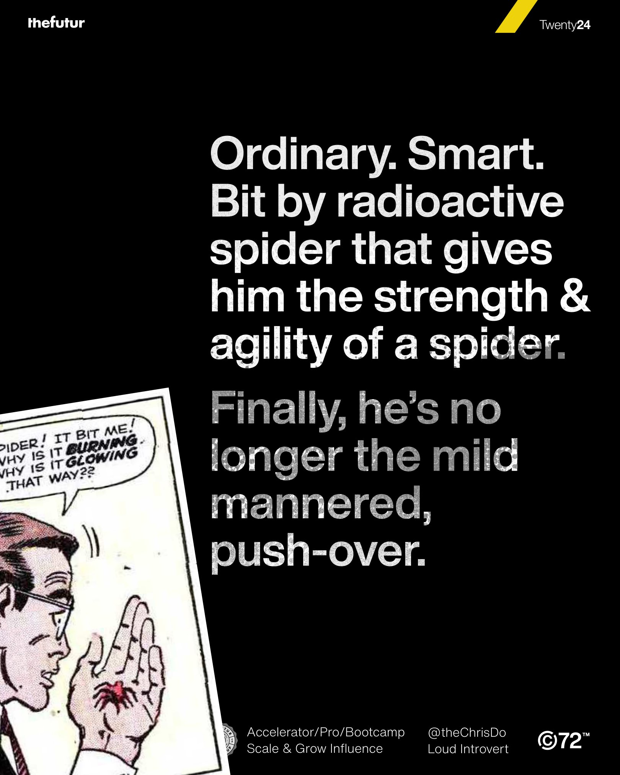 | Extracted editable text  Twenty24  Ordinary. Smart.  Bit by radioactive  spider that gives  him the strength &  agility of a spider.  Finally, he’s no  longer the mild  mannered,  push-over.  ©2024 The Futur Accelerator/Pro/Bootcamp @theChrisDo  All rights reserved Scale & Grow Influence Loud Introvert

PDF Page 15
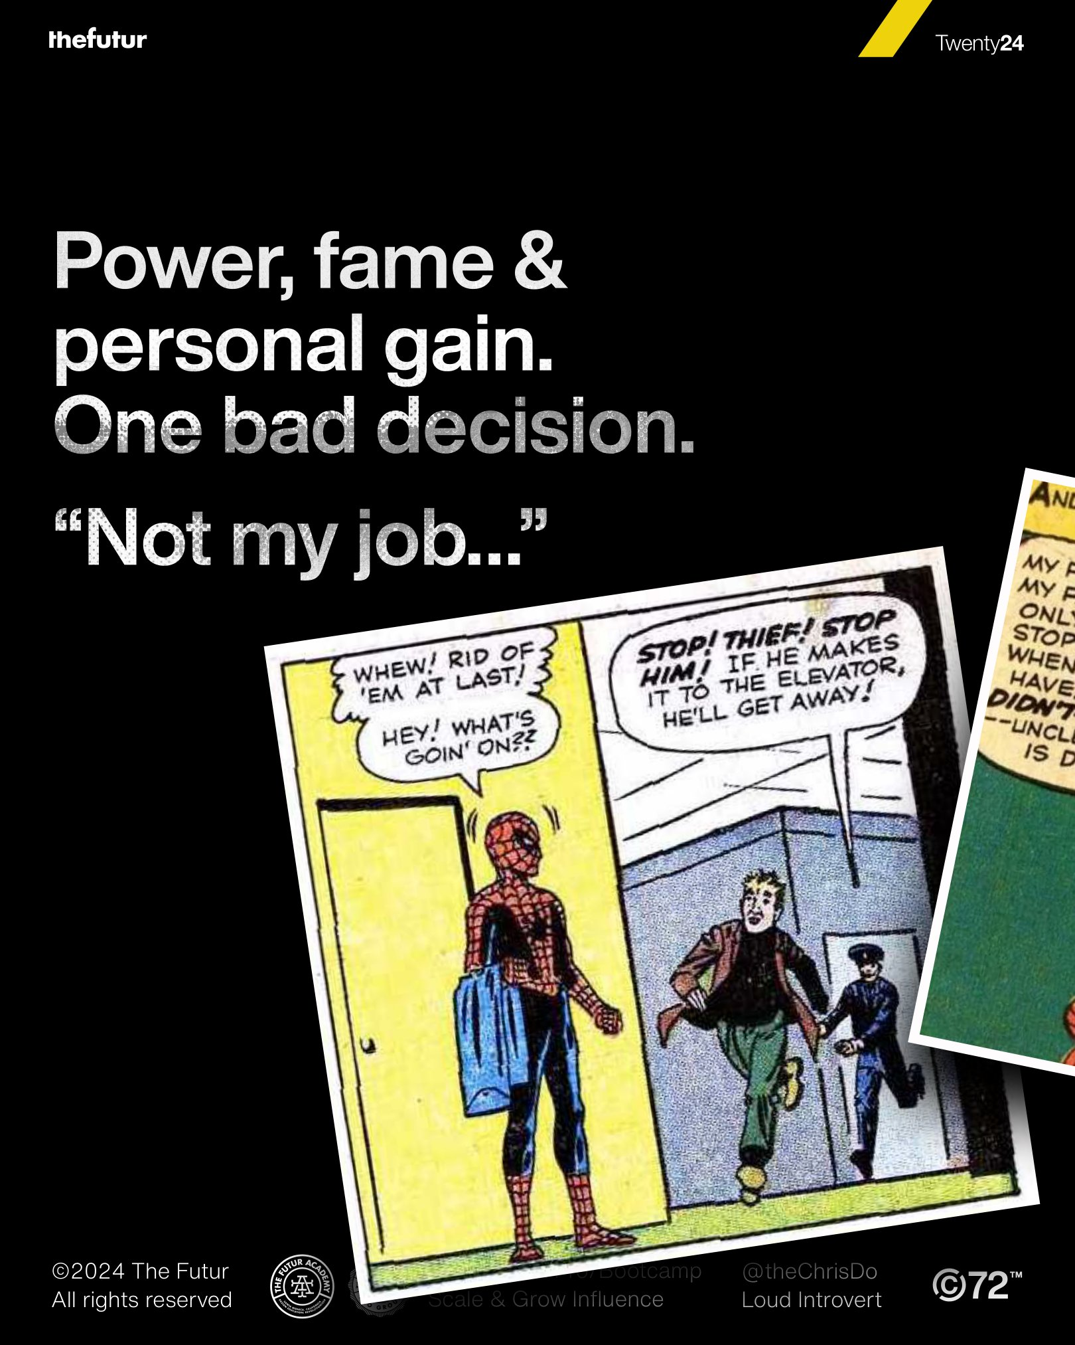 | Extracted editable text  Twenty24  Power, fame &  personal gain.  One bad decision.  “Not my job…”  ©2024 The Futur Accelerator/Pro/Bootcamp @theChrisDo  All rights reserved Scale & Grow Influence Loud Introvert

PDF Page 16
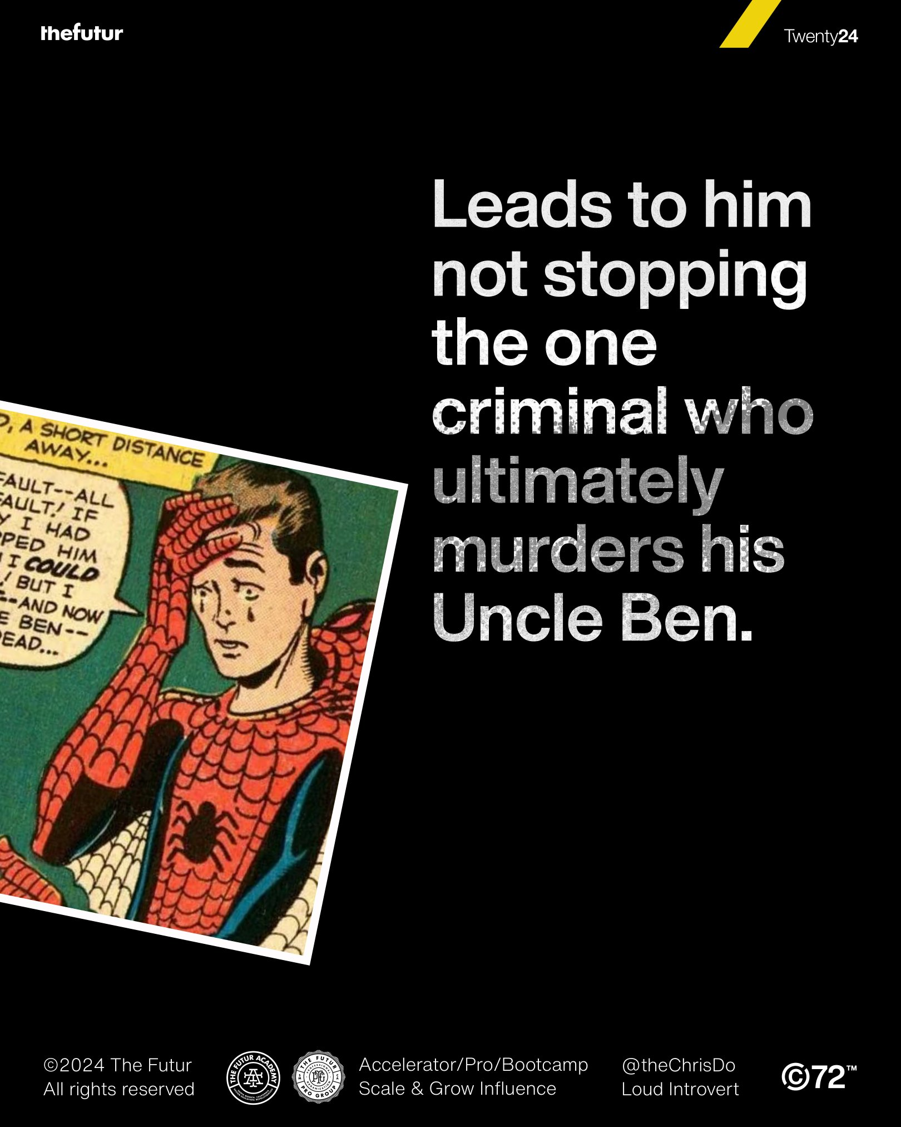 | Extracted editable text  Twenty24  Leads to him  not stopping  the one  criminal who  ultimately  murders his  Uncle Ben.  ©2024 The Futur Accelerator/Pro/Bootcamp @theChrisDo  All rights reserved Scale & Grow Influence Loud Introvert

PDF Page 17
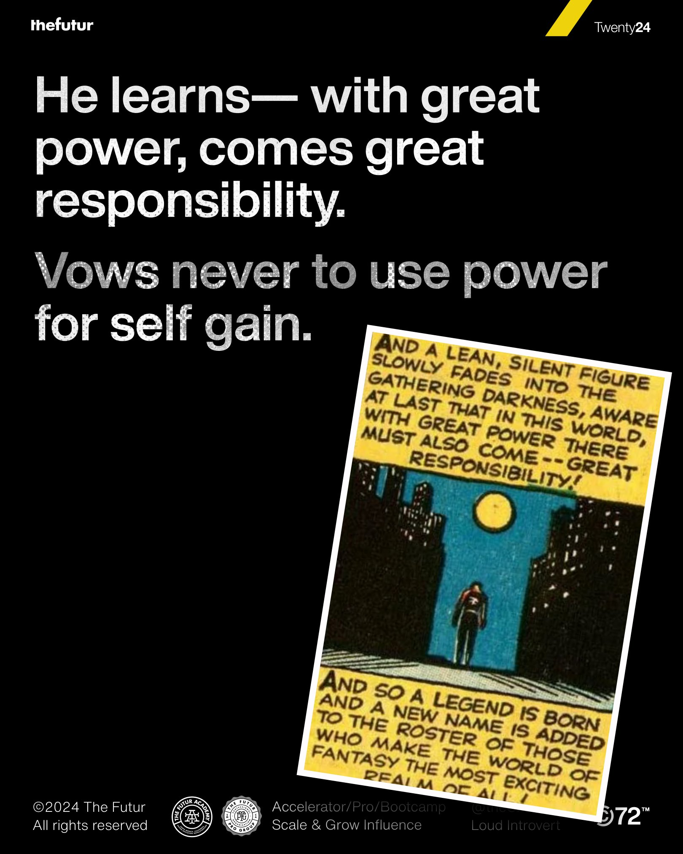 | Extracted editable text  Twenty24  He learns— with great  power, comes great  responsibility.  Vows never to use power  for self gain.  ©2024 The Futur Accelerator/Pro/Bootcamp @theChrisDo  All rights reserved Scale & Grow Influence Loud Introvert

PDF Page 18
 | Extracted editable text  Twenty24  In this moment,  Peter becomes  Spiderman.  ©2024 The Futur Accelerator/Pro/Bootcamp @theChrisDo  All rights reserved Scale & Grow Influence Loud Introvert

PDF Page 19
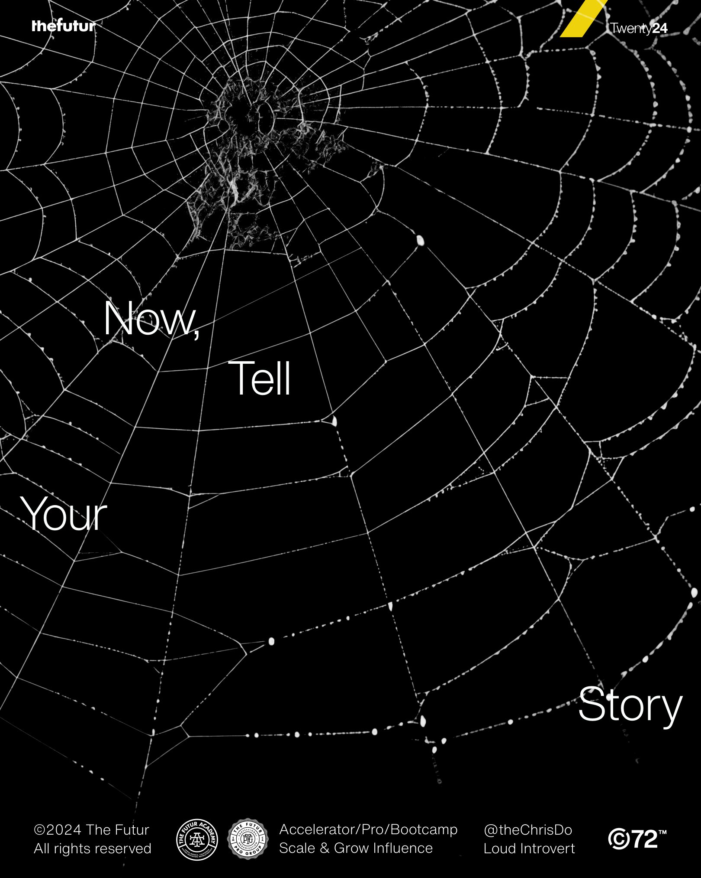 | Extracted editable text  Twenty24  Now,  Tell  Your  Story  ©2024 The Futur Accelerator/Pro/Bootcamp @theChrisDo  All rights reserved Scale & Grow Influence Loud Introvert

PDF Page 20
 | Extracted editable text  Twenty24  Futur Pro Group  If you found this to be  useful, please re-post to  help with reach.  ©2024 The Futur Accelerator/Pro/Bootcamp @theChrisDo  All rights reserved Scale & Grow Influence Loud Introvert

