Database design

Team 05

AI: Kupshah

Team member: emioneal, tianhuan, gprabowo, arifdian

### 

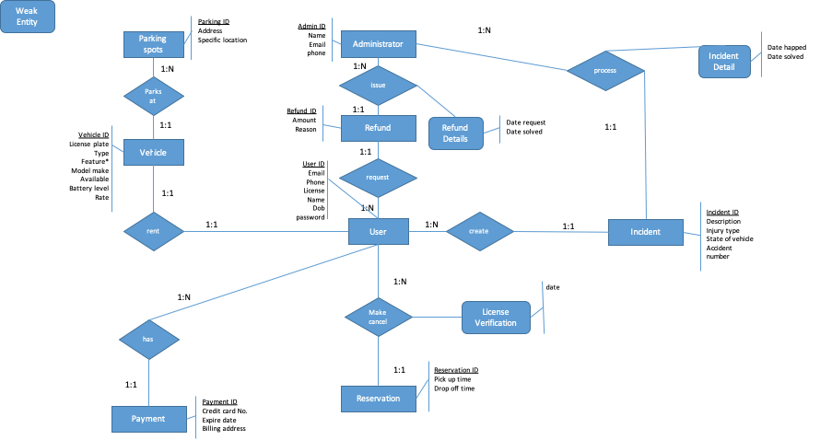

Legend:

**PRIMARY KEY (bold)**

*FOREIGN KEY (italic)*

user(**userID**,*vehicleid*, email, phone, license, name, dob, password)

refund(**refundID**, *userid*, *adminid*, amount, reason)

Refund_details(*refundID,* date_requested, date_resolved)

administrator(**adminID**, name, email, phone)

incident_detail(*adminID*, *incidentID,* date_happened, date_resolved)

incident(**incidentID**, *userID*, description,injury_type,state_of_vehicle, accident_num)

vehicle(**vehicleID**, *parkingID*, license_plate, type, model_make, available, battery_level, rate)

vehicle_feature(*vehicleID*, feature)

parking_spots(**parkingID,** address, specific_location)

license_information(*userID*, *reservationID,* date_verified)

payment(**paymentID**, *userID*, credit_card_no, expire_date, billing_address)