Course syllabus

Welcome to the second course of the Google Data Analytics Certificate! In this part of the program, you will learn how data analysts use structured thinking to tackle business problems. Think of yourself as a great detective who figures out a case by tracking down the evidence and who organizes it into a powerful story to solve the mystery. You will explore how to ask effective questions and use the answers to tell a meaningful story about the data. Plus, you will learn why it is so important to be on the same page as your stakeholders when you define the problem and present the data with an analysis.

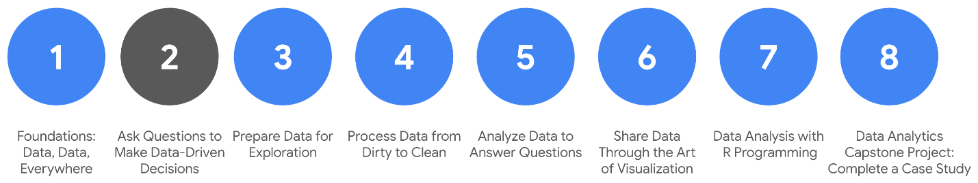

1. [Foundations: Data, Data, Everywhere](https://www.coursera.org/learn/foundations-data/home/welcome)
2. **Ask Questions to Make Data-Driven Decisions** *(this course)*
3. [Prepare Data for Exploration](https://www.coursera.org/learn/data-preparation/home/welcome)
4. [Process Data from Dirty to Clean](https://www.coursera.org/learn/process-data/home/welcome)
5. [Analyze Data to Answer Questions](https://www.coursera.org/learn/analyze-data/home/welcome)
6. [S​hare Data Through the Art of Visualization](https://www.coursera.org/learn/visualize-data/home/welcome)
7. [Data Analysis with R Programming](https://www.coursera.org/learn/data-analysis-r/home/welcome)
8. [Google D​ata Analytics Capstone: Complete a Case Study](https://www.coursera.org/learn/google-data-analytics-capstone/home/welcome)

**Course content**

C​ourse 2 – Ask Questions to Make Data-Driven Decisions

1. **Asking effective questions:** To do the job of a data analyst, you need to ask questions and problem-solve. In this part of the course, you’ll check out some common analysis problems and how analysts solve them. You’ll also learn about effective questioning techniques that can help guide your analysis.
2. **Making data-driven decisions:** In analytics, data drives decision making. In this part of the course, you’ll explore data of all kinds and its impact on decision making. You’ll also learn how to share your data through reports and dashboards.
3. **Mastering spreadsheet basics:** Spreadsheets are an important data analytics tool. In this part of the course, you’ll learn both why and how data analysts use spreadsheets in their work. You’ll also explore how structured thinking can help analysts better understand problems and come up with solutions.
4. **Always remembering the stakeholder:** Successful data analysts learn to balance needs and expectations. In this part of the course, you’ll learn strategies for managing the expectations of stakeholders while establishing clear communication with your team to achieve your objectives.
5. **Completing the Course Challenge:** At the end of this course, you will be able to put everything you have learned into practice with the Course Challenge. The Course Challenge will ask you questions about key principles you have been learning about and then give you an opportunity to apply those principles in three scenarios.

**What to expect**

Each week of this course includes hands-on assignments and projects based on the life of a data analyst. To keep you engaged, each series of lessons offers a lot of different types of learning opportunities, including:

* **V​ideos** of instructors teaching new concepts and demonstrating the use of tools
* **In-video questions** that pop up during or at the end of a video to check your learning
* **Readings** to introduce new ideas and build on the concepts from the videos
* [**Discussion forums**](https://www.coursera.org/learn/ask-questions-make-decisions/discussions) to discuss, explore, and reinforce new ideas for better learning
* **D​iscussion prompts** to promote thinking and engagement in the discussion forums
* **Hands-on activities** to introduce real-world, on-the-job situations, and the tools and tasks to complete assignments
* **Practice quizzes** to prepare you for graded quizzes
* **Graded quizzes** to measure your progress and give you valuable feedback

Hands-on activities promote additional opportunities to build your skills. Try to get as much out of them as possible. Assessments are based on the approach taken by the course to offer a wide variety of learning materials and activities that reinforce important skills. Graded and ungraded quizzes will  help the content sink in. Ungraded practice quizzes are a chance for you to prepare for the graded quizzes. Both types of quizzes can be taken multiple times.

As a quick reminder, this course is designed for all types of learners, with no degree or prior experience required. Everyone learns differently, so the Google Data Analytics Certificate has been designed with that in mind. Personalized deadlines are just a guide, so feel free to work at your own pace. There is no penalty for late assignments. If you prefer, you can extend your deadlines by returning to **Overview** in the navigation pane and clicking **Switch Sessions**.

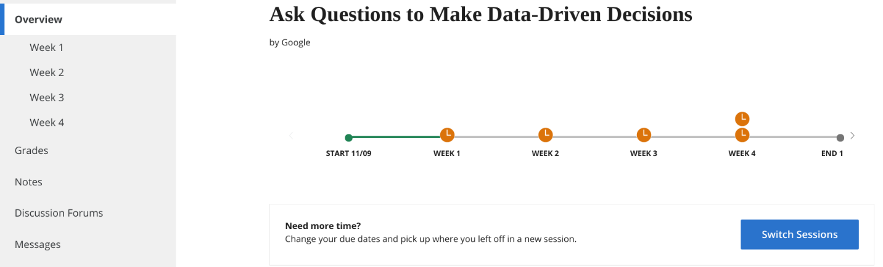

If you already missed previous deadlines, click **Reset my deadlines** instead.

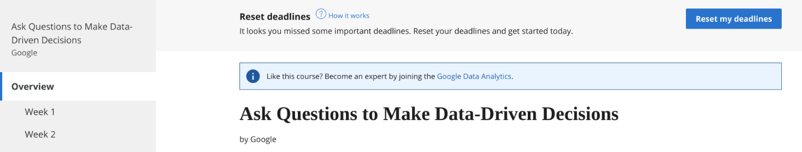

If you would like to review previous content or get a sneak peek of upcoming content, you can use the navigation links at the top of this page to go to another course in the program. When you pass all required assignments, you will be on track to earn your certificate.

And, after you earn the certificate, you will be ready for an entry-level job as a junior or associate data analyst, helping organizations in a variety of industries make decisions with data-driven strategies.

**Optional speed track for those experienced in data analytics**

The Google Data Analytics Certificate provides instruction and feedback for learners hoping to earn a position as an entry-level data analyst. While many learners will be brand new to the world of data analytics, others may be familiar with the field and simply wanting to brush up on certain skills.

If you believe this course will be primarily a refresher for you, we recommend taking the practice diagnostic quiz offered this week. It will enable you to determine if you should follow the speed track, which is an opportunity to proceed to Course 3 after having taken each of the Course 2 Weekly Challenges and the overall Course Challenge. Learners who earn 100% on the diagnostic quiz can treat Course 2 videos, readings, and activities as optional. Learners following the speed track are still able to earn the certificate.

**Tips**

* It is strongly recommended to go through the topics in the course in the order they appear because each new section builds on information and concepts covered in previous ones.
* Take advantage of the additional resources that are linked throughout the course. They are designed to support your learning.
* W​hen you encounter useful links in the course, remember to bookmark them so you can refer to the information for study or review.
* Additional resources are free, but some sites place limits on how many articles can be accessed for free each month. Sometimes you can register on the site for full access, but you can always bookmark a resource and come back to view it later.
* Take part in all learning opportunities to gain as much knowledge and experience as possible.
* If something is confusing, feel free to rewatch a video, revisit a reading, or seek out additional resources.

Get ready to take the next step in your data analytics journey!

# Learning Log: Consider what data means to you



## Overview



This course is all about asking good questions and planning out data analysis projects. You have already started learning about how data can be used to answer questions. Now, you’ll complete an entry in your learning log to track your thinking and reflections about what data means to you and how it relates to problem-solving. By the time you complete this activity, you will have a stronger understanding of data and the problem-solving process. This will be important as you learn to ask questions you can answer with data analysis — and you will encounter these questions again later in this course.

## Data and problem-solving



Pause for a moment and think about the word “data.” What does it mean to you?

Although it’s clear that data is a major part of a data analyst’s job, it’s only part of the big picture. The other part is problem solving. Being a successful data analyst means understanding that each problem is unique and working methodically to solve that problem with data.

By definition, most new problems data analysts face start in unknown territory. It’s up to the data analyst and their problem solving skills to think strategically, ask good questions, and use data to come up with solutions to these problems.

You’ll reflect on some of these questions in your learning log template which is linked below.



### Access your learning log

To use the learning log for this course item, click the link below and select “Use Template.”

Link to learning log template: [Consider what data means to you](https://docs.google.com/document/d/1cOnIGQo-Yymu8Bz7-bvSIiKh1779D0iFl_UAi0LAOSU/template/preview?resourcekey=0-jOCAk1D_j99vHbbk97D_-g)

OR

If you don’t have a Google account, you can download the template directly from the attachment below.

**Learning Log Template\_ Consider what data means to you**DOCX File

[Download file](https://d3c33hcgiwev3.cloudfront.net/IC7vqe5WT9mu76nuVs_ZlQ_2dc09cc744734e788d15f6759e375309_Learning-Log-Template_-Consider-what-data-means-to-you.docx?Expires=1648080000&Signature=Prql0H~-~LY-Dqv2DYGmOBwhyGX1rlhde6MnoA0Pnp-NqImw9Q~1LS~gddwEeoYI9Loy5v9lb2vog94D3vvzCVUyDzX~Kf8YDsJUR2efXthNH32NjkC0f3vmpKr6NNUEvZwFtUM2pNla-aof82bkJ77SP2yK9ZG5YWzL5NoeCts_&Key-Pair-Id=APKAJLTNE6QMUY6HBC5A" \t "_blank)



## Reflection



In your learning log template, write 3-5 sentences (60-100 words) reflecting on what data means to you. Here are some questions to help you get started:

* How would you describe “data” to someone who is unfamiliar with the word?
* What does data represent?
* What is data used for?
* Where does data come from?
* How do you get data?
* How do you feel about data?

Then write 2-3 sentences (40-60 words) reflecting on the problem-solving process by answering each of the questions below:

* When you come across a problem and you aren’t sure of the answer or solution, what do you do?
* How do you identify new and interesting problems to begin with? Is there a process you use to identify problems you want to solve?

When you’ve finished your entry in the learning log template, make sure to save the document so your response is somewhere accessible. This will help you continue applying data analysis to your everyday life. You will also be able to track your progress and growth as a data analyst.

# Deciding if you should take the speed track

**This reading provides an overview of a speed track we offer to those familiar with data analytics.**

**If you are brand new to data analytics, you can skip the diagnostic quiz after this reading, and move directly to the next activity:** [**Data in action**](https://www.coursera.org/learn/ask-questions-make-decisions/lecture/je9iD/data-in-action).

The Google Data Analytics Certificate is a program for anyone. A background in data analysis isn’t required. But you might be someone who has some experience already. If you are this type of learner, we have designed a **speed track** for this course. Learners who opt for the speed track can refresh on the basic topics and take each of the weekly challenges and the Course Challenge at a faster pace.

To help you decide if you’re a good match for the speed trackfor this course:

1. Take the optional [diagnostic quiz](https://www.coursera.org/learn/ask-questions-make-decisions/quiz/fahk8/optional-familiar-with-data-analytics-take-our-diagnostic-quiz).
2. Refer to the [scoring guide](https://www.coursera.org/learn/ask-questions-make-decisions/supplement/zo1ck/your-diagnostic-quiz-score-and-what-it-means) to determine if you’re a good fit for the speed track. A score of 90% or higher is the target goal for someone on the speed track.
3. Based on your individual score, follow the recommendations in the scoring guide for your next steps.

**Important reminder:** If you’re eligible for the speed track, you’re still responsible to complete all graded activities. In order to earn your certificate, you will need an overall score of 80% or higher on all graded materials in the program.

# Optional: Your diagnostic quiz score and what it means

Thank you for taking the optional diagnostic quiz. In order to earn your certificate, you will need an overall score of 80% or higher on the graded materials in this program. Your diagnostic quiz results will help you decide if you should follow the speed track for this course. The speed track allows you to skip over the lesson material and go straight to the weekly challenges and the course challenge, which lead to your overall score. Read on to figure out your next steps based on your quiz score:

**If you scored 100% on the diagnostic quiz:**

* You are probably familiar with the Ask phase of the data analysis process and can take the speed track to move on to Course 3.
* You must take each of the weekly challenges and the course challenge, which will count toward the 80% overall score needed to earn the certificate. To help you find these items more quickly, we’ve identified them with asterisks in the course materials (for example: \*course challenge\*).
* After you complete the weekly challenges and course challenge, proceed to Course 3.
* You are welcome to review videos, readings, and activities throughout the course based on your interests.

**If you scored between 90% and 99% on the diagnostic quiz:**

* You are probably familiar with the Ask phase of the data analysis process and might consider taking the speed track to move on to Course 3.
* However, we still recommend that you go through the Course 2 lesson materials to review areas where you might have some gaps before proceeding to Course 3.
* You must take each of the weekly challenges and the course challenge, which will count toward the 80% overall score needed to earn the certificate. To help you find these items more quickly, we’ve identified them with asterisks in the course materials (for example: \*course challenge\*).
* After you complete the weekly challenges and course challenge, proceed to Course 3.
* You are welcome to review videos, readings, and activities throughout the course based on your interests.

**If you scored between 80% and 89% on the diagnostic quiz:**

* You likely have some background knowledge on the Ask phase of the data analysis process.
* However, we recommend that you go through the Course 2 lesson materials to review areas where you might have some gaps before proceeding to Course 3.
* You must take the weekly challenges and the course challenge, which will count toward the 80% overall score needed to earn the certificate. To help you find these items more quickly, we’ve identified them with asterisks in the course materials (for example: \*course challenge\*).

**If you scored less than 80% on the diagnostic quiz:**

* No problem — this course was made for you!
* We strongly recommend that you go through all of the Course 2 videos, readings, and activities, as the concepts taught are building blocks that will set you up for success on your learning path.
* You must take the weekly challenges and the course challenge, which will count toward the 80% overall score needed to earn the certificate.

# Six problem types

Data analytics is so much more than just plugging information into a platform to find insights. It is about solving problems. To get to the root of these problems and find practical solutions, there are lots of opportunities for creative thinking. No matter the problem, the first and most important step is understanding it. From there, it is good to take a problem-solver approach to your analysis to help you decide what information needs to be included, how you can transform the data, and how the data will be used.

## Data analysts typically work with six problem types

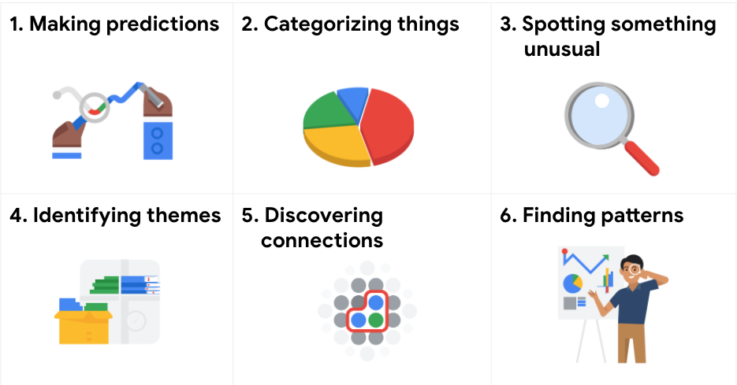1. Making predictions 2. Categorizing things 3. Spotting something unusual 4. Identifying themes 5. Discovering connections 6. Finding patterns

A video, [Common problem types](https://www.coursera.org/learn/ask-questions-make-decisions/lecture/E8HxZ/common-problem-types), introduced the six problem types with an example for each. The examples are summarized below for review.

### **Making predictions**

A company that wants to know the best advertising method to bring in new customers is an example of a problem requiring analysts to make predictions. Analysts with data on location, type of media, and number of new customers acquired as a result of past ads can't guarantee future results, but they can help predict the best placement of advertising to reach the target audience.

### **Categorizing things**

An example of a problem requiring analysts to categorize things is a company's goal to improve customer satisfaction. Analysts might classify customer service calls based on certain keywords or scores. This could help identify top-performing customer service representatives or help correlate certain actions taken with higher customer satisfaction scores.

### **Spotting something unusual**

A company that sells smart watches that help people monitor their health would be interested in designing their software to spot something unusual. Analysts who have analyzed aggregated health data can help product developers determine the right algorithms to spot and set off alarms when certain data doesn't trend normally.

### **Identifying themes**

User experience (UX) designers might rely on analysts to analyze user interaction data. Similar to problems that require analysts to categorize things, usability improvement projects might require analysts to identify themes to help prioritize the right product features for improvement. Themes are most often used to help researchers explore certain aspects of data. In a user study, user beliefs, practices, and needs are examples of themes.

By now you might be wondering if there is a difference between categorizing things and identifying themes. The best way to think about it is: categorizing things involves assigning items to categories; identifying themes takes those categories a step further by grouping them into broader themes.

### **Discovering connections**

A third-party logistics company working with another company to get shipments delivered to customers on time is a problem requiring analysts to discover connections. By analyzing the wait times at shipping hubs, analysts can determine the appropriate schedule changes to increase the number of on-time deliveries.

### **Finding patterns**

Minimizing downtime caused by machine failure is an example of a problem requiring analysts to find patterns in data. For example, by analyzing maintenance data, they might discover that most failures happen if regular maintenance is delayed by more than a 15-day window.

## Key takeaway

As you move through this program, you will develop a sharper eye for problems and you will practice thinking through the problem types when you begin your analysis. This method of problem solving will help you figure out solutions that meet the needs of all stakeholders.

More about SMART questions

Companies in lots of industries today are dealing with rapid change and rising uncertainty. Even well-established businesses are under pressure to keep up with what is new and figure out what is next. To do that, they need to ask questions. Asking the right questions can help spark the innovative ideas that so many businesses are hungry for these days.

The same goes for data analytics. No matter how much information you have or how advanced your tools are, your data won’t tell you much if you don’t start with the right questions. Think of it like a detective with tons of evidence who doesn’t ask a key suspect about it.  Coming up, you will learn more about how to ask highly effective questions, along with certain practices you want to avoid.

**Highly effective questions are SMART questions:**

**Examples of SMART questions**

Here's an example that breaks down the thought process of turning a problem question into one or more SMART questions using the SMART method: **What features do people look for when buying a new car?**

* **Specific**: Does the question focus on a particular car feature?
* **Measurable**: Does the question include a feature rating system?
* **Action-oriented**: Does the question influence creation of different or new feature packages?
* **Relevant**: Does the question identify which features make or break a potential car purchase?
* **Time-bound**: Does the question validate data on the most popular features from the last three years?

Questions should be **open-ended.** This is the best way to get responses that will help you accurately qualify or disqualify potential solutions to your specific problem. So, based on the thought process, possible SMART questions might be:

* On a scale of 1-10 (with 10 being the most important) how important is your car having four-wheel drive?
* What are the top five features you would like to see in a car package?
* What features, if included with four-wheel drive, would make you more inclined to buy the car?
* How much more would you pay for a car with four-wheel drive?
* Has four-wheel drive become more or less popular in the last three years?

**Things to avoid when asking questions**

**Leading questions**: questions that only have a particular response

* Example: **This product is too expensive, isn’t it?**

This is a leading question because it suggests an answer as part of the question. A better question might be, “What is your opinion of this product?” There are tons of answers to that question, and they could include information about usability, features, accessories, color, reliability, and popularity, on top of price. Now, if your problem is actually focused on pricing, you could ask a question like “What price (or price range) would make you consider purchasing this product?” This question would provide a lot of different measurable responses.

**Closed-ended questions**: questions that ask for a one-word or brief response only

* Example: **Were you satisfied with the customer trial?**

This is a closed-ended question because it doesn’t encourage people to expand on their answer. It is really easy for them to give one-word responses that aren’t very informative. A better question might be, “What did you learn about customer experience from the trial.” This encourages people to provide more detail besides “It went well.”

**Vague questions:** questions that aren’t specific or don’t provide context

* Example: **Does the tool work for you?**

This question is too vague because there is no context. Is it about comparing the new tool to the one it replaces? You just don’t know. A better inquiry might be, “When it comes to data entry, is the new tool faster, slower, or about the same as the old tool? If faster, how much time is saved? If slower, how much time is lost?” These questions give context (data entry) and help frame responses that are measurable (time).

Data trials and triumphs

This reading focuses on why accurate interpretation of data is key to data-driven decisions. You have been learning why data is such a powerful business tool and how data analysts help their companies make data-driven decisions for great results. As a quick reminder, the goal of all data analysts is to use data to draw accurate conclusions and make good recommendations. That all starts with having complete, correct, and relevant data.



But keep in mind, it is possible to have solid data and still make the wrong choices. It is up to data analysts to interpret the data accurately. **When data is interpreted incorrectly, it can lead to huge losses. Consider the examples below.**

**Coke launch failure**

In 1985, New Coke was launched, replacing the classic Coke formula. The company had done taste tests with 200,000 people and found that test subjects preferred the taste of New Coke over Pepsi, which had become a tough competitor. Based on this data alone, classic Coke was taken off the market and replaced with New Coke. This was seen as the solution to take back the market share that had been lost to Pepsi.

But as it turns out, New Coke was a massive flop and the company ended up losing tens of millions of dollars. How could this have happened with data that seemed correct? It is because the data wasn’t complete, which made it inaccurate. The data didn't consider how customers would feel about New Coke replacing classic Coke. The company’s decision to retire classic Coke was a data-driven decision based on incomplete data.

**Mars orbiter loss**

In 1999, NASA lost the $125 million Mars Climate Orbiter, even though it had good data. The spacecraft burned to pieces because of poor collaboration and communication. The Orbiter’s navigation team was using the **SI or metric system** (newtons) for their force calculations, but the engineers who built the spacecraft used the **English Engineering Units** **system** (pounds) for force calculations.

No one realized a problem even existed until the Orbiter burst into flames in the Martian atmosphere. Later, a NASA review board investigating the root cause of the problem figured out that the issue was isolated to the software that controlled the thrusters. One program calculated the thrusters’ force in pounds; another program looking at the data assumed it was in newtons. The software controllers were making data-driven decisions to adjust the thrust based on 100% accurate data, but these decisions were wrong because of inaccurate assumptions when interpreting it. A conversion of the data from one system of measurement to the other could have prevented the loss.



**When data is used strategically, businesses can transform and grow their revenue. Consider the examples below.**

**Crate and Barrel**

At Crate and Barrel, online sales jumped more than 40% during stay-at-home orders to combat the global pandemic. Currently, online sales make up more than 65% of their overall business. They are using data insights to accelerate their digital transformation and bring the best of online and offline experiences together for customers.

BigQuery enables Crate and Barrel to "draw on ten times [as many] information sources(compared to a few years ago) which are then analyzed and transformed into actionable insights that can be used to influence the customer’s next interaction. And this, in turn, drives revenue."

Read more about Crate and Barrel's data strategy in [How one retailer’s data strategy powers seamless customer experiences](https://www.thinkwithgoogle.com/future-of-marketing/digital-transformation/crate-and-barrel-digital-customer-experiences/).

**PepsiCo**

Since the days of the New Coke launch, things have changed dramatically for beverage and other consumer packaged goods (CPG) companies.

PepsiCo "hired analytical talent and established cross-functional workflows around an infrastructure designed to put consumers’ needs first. Then [they] set up the right processes to make critical decisions based on data and technology use cases. Finally, [they] invested in the right technology stack and platforms so that data could flow into a central cloud-based hub. This is critical. When data comes together, [they] develop a holistic understanding of the consumer and their journeys."

Read about how PepsiCo is delivering a more personal and valuable experience to customers using data in [How one of the world’s biggest marketers ripped up its playbook and learned to anticipate intent](https://www.thinkwithgoogle.com/marketing-strategies/data-and-measurement/pepsi-digital-transformation/).

**Key skills for triumphant results**

As a data analyst, your own skills and knowledge will be the most important part of any analysis project. It is important for you to keep a data-driven mindset, ask lots of questions, experiment with many different possibilities, and use both logic and creativity along the way. You will then be prepared to interpret your data with the highest levels of care and accuracy. Note that there is a difference between making a decision with incomplete data and making a decision with a small amount of data. You learned that making a decision with incomplete data is dangerous. But sometimes accurate data from a small test can help you make a good decision. Stay tuned. You will learn about how much data to collect later in the program.

# Qualitative and quantitative data in business

T​his reading further elaborates on the meaning of **qualitative** versus **quantitative**.

As you have learned, there are two types of data: qualitative and quantitative.

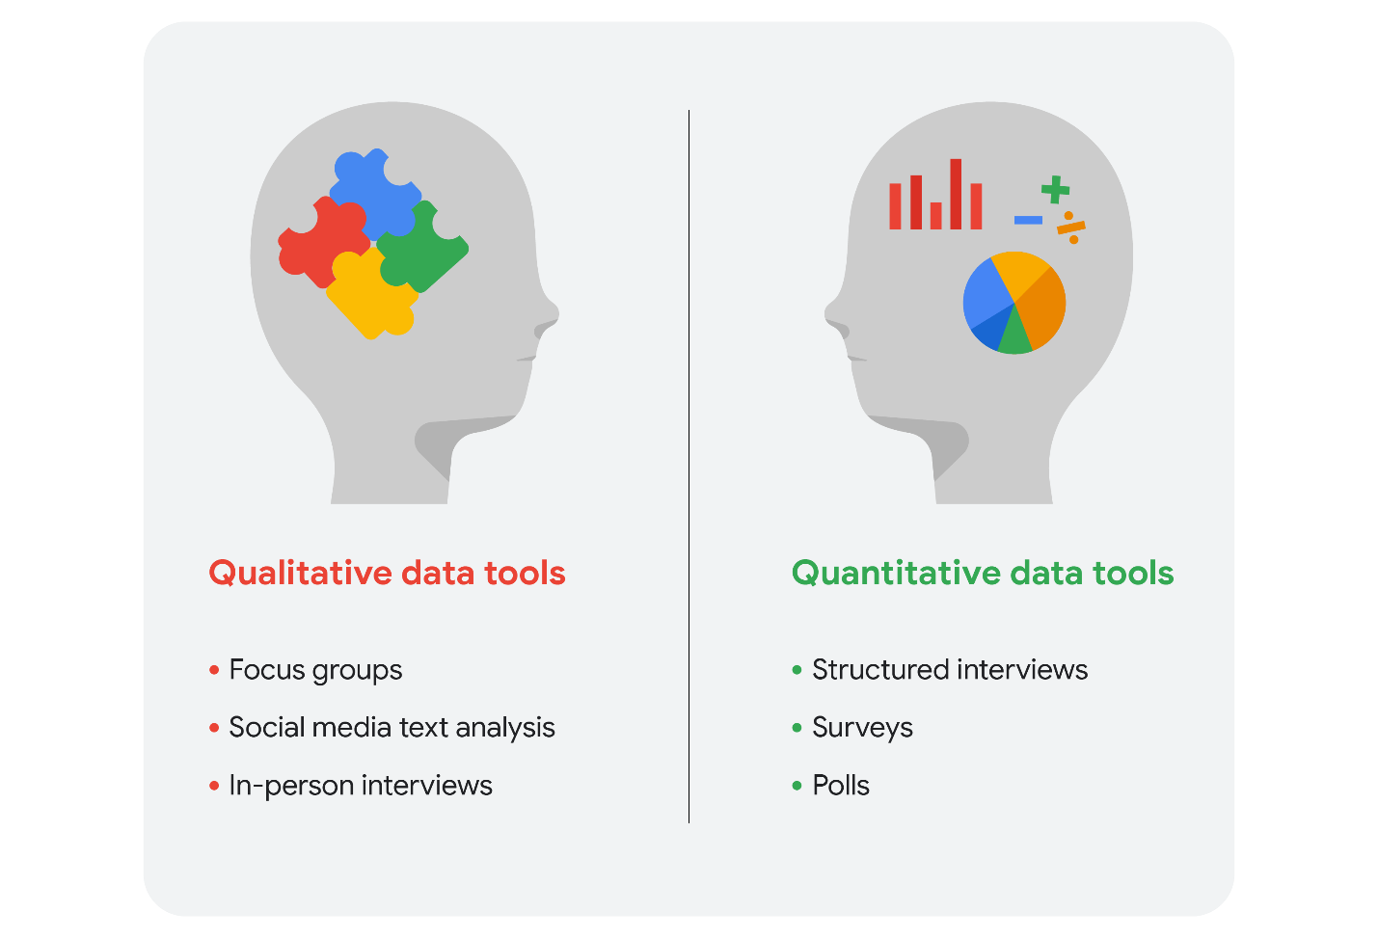Qualitative data tools: focus groups, social media text analysis, and in-person interviews Quantitative data tools: structured interviews, surveys, and polls

We can take a closer look at the data types and data collection tools. Imagine that you are a data analyst for a chain of movie theaters. Your manager wants you to track trends in:

* **Movie attendance over time**
* **Profitability of the concession stand**
* **Evening audience preferences**

In our scenario, we assume quantitative data already exists to monitor all three trends.

## Movie attendance over time



Starting with the historical data the theater has through its loyalty and rewards program, your first step is to investigate what insights you can gain from that data. You look at attendance over the last 3 months. But, because the last 3 months didn’t include a major holiday, you decide it is better to look at a full year’s worth of data. As you suspected, the quantitative data confirmed that average attendance was 550 per month but then rose to an average of 1,600 per month for the months with holidays.

The historical data serves your needs for the project, but you also decide that you will resume the analysis again in a few months after the theater increases ticket prices for evening showtimes.

## Profitability of the concession stand



Profit is calculated by subtracting cost from sales revenue. The historical data shows that while the concession stand was profitable, profit margins were razor thin at less than 5%. You saw that average purchases totaled $20 or less. You decide that you will keep monitoring this on an ongoing basis.

Based on your understanding of data collection tools, you will suggest an online survey of customers so they can comment on the food at the concession stand. This will enable you to gather even more quantitative data to revamp the menu and potentially increase profits.

## Evening audience preferences



Your analysis of the historical data shows that the 7:30 PM showtime was the most popular and had the greatest attendance, followed by the 7:15 PM and 9:00 PM showtimes. You may suggest replacing the current 8:00 PM showtime that has lower attendance with an 8:30 PM showtime. But you need more data to back up your hunch that people would be more likely to attend the later show.

Evening movie-goers are the largest source of revenue for the theater. Therefore, you also decide to include a question in your online survey to gain more insight.

## Qualitative data for all three trends plus ticket pricing

Since you know that the theater is planning to raise ticket prices for evening showtimes in a few months, you will also include a question in the survey to get an idea of customers’ price sensitivity.

Your final online survey might include these questions for qualitative data:

1. What went into your decision to see a movie in our theater today? (movie attendance)
2. What do you think about the quality and value of your purchases at the concession stand? (concession stand profitability)
3. Which showtime do you prefer, 8:00 PM or 8:30 PM, and why do you prefer that time? (evening movie-goer preferences)
4. Under what circumstances would you choose a matinee over a nighttime showing? (ticket price increase)

## Summing it up

Data analysts will generally use both types of data in their work. Usually, qualitative data can help analysts better understand their quantitative data by providing a reason or more thorough explanation. In other words, quantitative data generally gives you the what, and qualitative data generally gives you the why. By using both quantitative and qualitative data, you can learn when people like to go to the movies and why they chose the theater. Maybe they really like the reclining chairs, so your manager can purchase more recliners. Maybe the theater is the only one that serves root beer. Maybe a later show time gives them more time to drive to the theater from where popular restaurants are located. Maybe they go to matinees because they have kids and want to save money. You wouldn’t have discovered this information by analyzing only the quantitative data for attendance, profit, and showtimes.

# Learning Log: Ask SMART questions about real-life data sources



## Overview



In [a previous self-reflection,](https://www.coursera.org/learn/ask-questions-make-decisions/quiz/4MP2O/self-reflection-smart-questions-in-real-life) you prepared for a “data conversation” with someone in your life by creating SMART questions to help you understand more about the data they usually interact with, the limitations of the data they have, and their business goals. Now, you’ll complete an entry in your learning log to reflect on that conversation and how you might approach this data for a real project. By the time you complete this log entry, you will have a stronger understanding of how to use the SMART framework to craft effective questions about real life data. This will be a key skill as you begin to develop your own data analysis projects.

## Review your notes



Before you begin your new entry, take a moment to locate and read the notes you took during your data conversation. Based on the answers to your well-prepared SMART questions, you should have a better context for your target audience now. Review those answers and start thinking about the following:

* Stakeholder’s business goals; in this case, the person you had a conversation with
* Identifying the data needed to answer the SMART questions
* Exploring what data the stakeholder already has
* Determining the data that you don’t have, but need in order to answer the questions

You’ll reflect on how your data conversation went and what you learned in your learning log template which is linked below.



### Access your learning log

To use the template for this course item, click the link below and select “Use Template.”

Link to learning log template: [Ask SMART questions about real life data sources](https://docs.google.com/document/d/1j6K2891rZLbNeUmPurfNv6b2d6MKgAedhxOrr6k_3Nw/template/preview)

OR

If you don’t have a Google account, you can download the template directly from the attachment below.

**Learning Log Template\_ Ask SMART questions about real life data sources**DOCX File

[Download file](https://d3c33hcgiwev3.cloudfront.net/pxouApZjQ6yaLgKWY-OseQ_3a00dfb671c8427b97080a6118e78211_Learning-Log-Template_-Ask-SMART-questions-about-real-life-data-sources.docx?Expires=1648080000&Signature=dSApuvguyrAVnwMz5CXwBlnVKwTYdwLQF0l0FgYtpRN4O-SZKmE-qw6DI~1c1tWWaNHEGIChHbdcshV8pcbH-zsfOL9T0gBtRneIuCGsh4uDvFRBmJdNdYq5juUGOfQCh3ORdJrHtSiFpbVpQhOf6GXj9i9rirI49Vm5NZnv3Ng_&Key-Pair-Id=APKAJLTNE6QMUY6HBC5A" \t "_blank)



## Reflection



Write 5-7 sentences (100-140 words) about data sources discussed during your real-life data conversation.

First, consider your data conversation and how it went. Here are some questions to help you get started:

* Was there anything challenging about getting the conversation started?
* Were there questions you didn’t get to ask?
* Did you manage your time effectively?
* Did you take notes? Are they as detailed as you need them to be?
* Are you missing any information? Is there anything that you still find unclear or vague?
* If you could do the conversation over again, is there anything you would change?

Next, turn your attention to your notes and reflect on what you know about the data itself:

* What are the sources of data available for the project?
* Which data sources were qualitative and which were quantitative? Explain your answer.
* What decisions could you make when considering each data source separately? Could you make different decisions about the data if you combined it? If so, give an example.
* Is there any kind of data that isn’t available, but you would like to find? If so, what is it, and why would you like to know more about it?

When you’ve finished your entry in the learning log template, make sure to save the document so your response is somewhere accessible. This will help you continue applying data analysis to your everyday life. You will also be able to track your progress and growth as a data analyst.

Designing compelling dashboards

*You can save this reading for future reference. Feel free to download a PDF version of this reading below:*

**DAC2 Designing compelling dashboards.pdf**PDF File

[Open file](https://d3c33hcgiwev3.cloudfront.net/IfnpXnRlRhi56V50ZVYYow_3a87f3d18e444bdda63014571e0d9ef1_DAC2-Designing-compelling-dashboards.pdf?Expires=1648080000&Signature=fM5cxIbc2iAEBFPMxy-InR4WNJlHIzw3Zm4YJpkFVFq2ennDMa-e1CKEJdG0p75Rjzzt1cxUZjtRd7ait6kF7dbPFdL3rNg9BS2RV7CxMoLqQBF-SfMR-AnaWzb~3fTVoBT6qf74-ONOrUxxuPR8lay9C-DjJZ8SMFt9sQuD~bw_&Key-Pair-Id=APKAJLTNE6QMUY6HBC5A" \t "_blank)

**The beauty of dashboards**

Dashboards are powerful visual tools that help you tell your data story. A **dashboard** organizes information from multiple datasets into one central location, offering huge time-savings. Data analysts use dashboards to track, analyze, and visualize data in order to answer questions and solve problems. For a basic idea of what dashboards look like, refer to this article: [6 real-world examples of business intelligence dashboards](https://www.tableau.com/learn/articles/business-intelligence-dashboards-examples). Tableau is one tool that is used to create dashboards and is covered later in the program.

The following table summarizes the benefits of using a dashboard for both data analysts and their stakeholders.

| **Benefits** | **For Data Analysts** | **For Stakeholders** |
| --- | --- | --- |
| **Centralization** | Sharing a single source of data with all stakeholders | Working with a comprehensive view of data, initiatives, objectives, projects, processes, and more |
| **Visualization** | Showing and updating live, incoming data in real time\* | Spotting changing trends and patterns more quickly |
| **Insightfulness** | Pulling relevant information from different datasets | Understanding the story behind the numbers to keep track of goals and make data-driven decisions |
| **Customization** | Creating custom views dedicated to a specific person, project, or presentation of the data | Drilling down to more specific areas of specialized interest or concern |

*\* It is important to remember that changed data is pulled into dashboards automatically only if the data structure is the same. If the data structure changes, you have to update the dashboard design before the data can update live.*

**Creating a dashboard**

Here is a process you can follow to create a dashboard:

**1.** **Identify the stakeholders who need to see the data and how they will use it**

To get started with this, you need to ask effective questions. Check out this [Requirements Gathering Worksheet](https://s3.amazonaws.com/looker-elearning-resources/Requirements+Gathering+Worksheet.pdf) to explore a wide range of good questions you can use to identify relevant stakeholders and their data needs. This is a great resource to help guide you through this process again and again.

**2. Design the dashboard (what should be displayed)**

Use these tips to help make your dashboard design clear, easy to follow, and simple:

* Use a clear header to label the information
* Add short text descriptions to each visualization
* Show the most important information at the top

**3. Create mock-ups if desired**

This is optional, but a lot of data analysts like to sketch out their dashboards before creating them.

**4. Select the visualizations you will use on the dashboard**

You have a lot of options here and it all depends on what data story you are telling. If you need to show a change of values over time, line charts or bar graphs might be the best choice. If your goal is to show how each part contributes to the whole amount being reported, a pie or donut chart is probably a better choice.

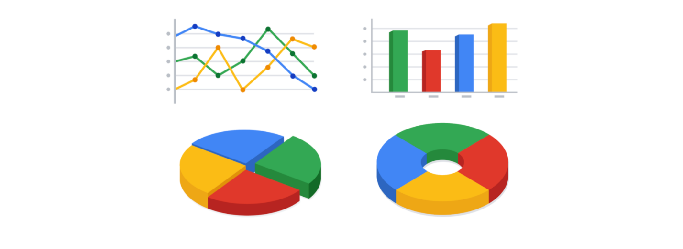

To learn more about choosing the right visualizations, check out Tableau’s galleries:

* For more samples of area charts, column charts, and other visualizations, visit [Tableau’s Viz Gallery](https://www.tableau.com/solutions/gallery). This gallery is full of great examples that were created using real data; explore this resource on your own to get some inspiration.
* Explore [Tableau’s Viz of the Day](https://public.tableau.com/en-us/gallery/?tab=viz-of-the-day&type=viz-of-the-day) to see visualizations curated by the community. These are visualizations created by Tableau users and are a great way to learn more about how other data analysts are using data visualization tools.

**5.** **Create filters as needed**

Filters show certain data while hiding the rest of the data in a dashboard. This can be a big help to identify patterns while keeping the original data intact. It is common for data analysts to use and share the same dashboard, but manage their part of it with a filter. To dig deeper into filters and find an example of filters in action, you can visit Tableau’s page on [Filter Actions](https://help.tableau.com/current/pro/desktop/en-us/actions_filter.htm). This is a useful resource to save and come back to when you start practicing using filters in Tableau on your own.

**Dashboards are part of a business journey**

Just like how the dashboard on an airplane shows the pilot their flight path, your dashboard does the same for your stakeholders. It helps them navigate the path of the project inside the data. If you add clear markers and highlight important points on your dashboard, users will understand where your data story is headed. Then, you can work together to make sure the business gets where it needs to go.

Big and small data

As a data analyst, you will work with data both big and small. Both kinds of data are valuable, but they play very different roles.



Whether you work with big or small data, you can use it to help stakeholders improve business processes, answer questions, create new products, and much more. But there are certain challenges and benefits that come with big data and the following table explores the differences between big and small data.

| **Small data** | **Big data** |
| --- | --- |
| Describes a data set made up of specific metrics over a short, well-defined time period | Describes large, less-specific data sets that cover a long time period |
| Usually organized and analyzed in spreadsheets | Usually kept in a database and queried |
| Likely to be used by small and midsize businesses | Likely to be used by large organizations |
| Simple to collect, store, manage, sort, and visually represent | Takes a lot of effort to collect, store, manage, sort, and visually represent |
| Usually already a manageable size for analysis | Usually needs to be broken into smaller pieces in order to be organized and analyzed effectively for decision-making |

**Challenges and benefits**

Here are some **challenges** you might face when working with big data:

* A lot of organizations deal with data overload and way too much unimportant or irrelevant information.
* Important data can be hidden deep down with all of the non-important data, which makes it harder to find and use. This can lead to slower and more inefficient decision-making time frames.
* The data you need isn’t always easily accessible.
* Current technology tools and solutions still struggle to provide measurable and reportable data. This can lead to unfair algorithmic bias.
* There are gaps in many big data business solutions.

Now for the good news! Here are some **benefits** that come with big data:

* When large amounts of data can be stored and analyzed, it can help companies identify more efficient ways of doing business and save a lot of time and money.
* Big data helps organizations spot the trends of customer buying patterns and satisfaction levels, which can help them create new products and solutions that will make customers happy.
* By analyzing big data, businesses get a much better understanding of current market conditions, which can help them stay ahead of the competition.
* As in our earlier social media example, big data helps companies keep track of their online presence—especially feedback, both good and bad, from customers. This gives them the information they need to improve and protect their brand.

**The three (or four) V words for big data**

When thinking about the benefits and challenges of big data, it helps to think about the three Vs: **volume, variety,** and **velocity.** Volume describes the amount of data. Variety describes the different kinds of data. Velocity describes how fast the data can be processed. Some data analysts also consider a fourth V: **veracity.** Veracity refers to the quality and reliability of the data. These are all important considerations related to processing huge, complex data sets.

| **Volume** | **Variety** | **Velocity** | **Veracity** |
| --- | --- | --- | --- |
| The amount of data | The different kinds of data | How fast the data can be processed | The quality and reliability of the data |

Spreadsheets and the data life cycle

To better understand the benefits of using spreadsheets in data analytics, let’s explore how they relate to each phase of the data life cycle: **plan, capture, manage, analyze, archive,** and **destroy**.

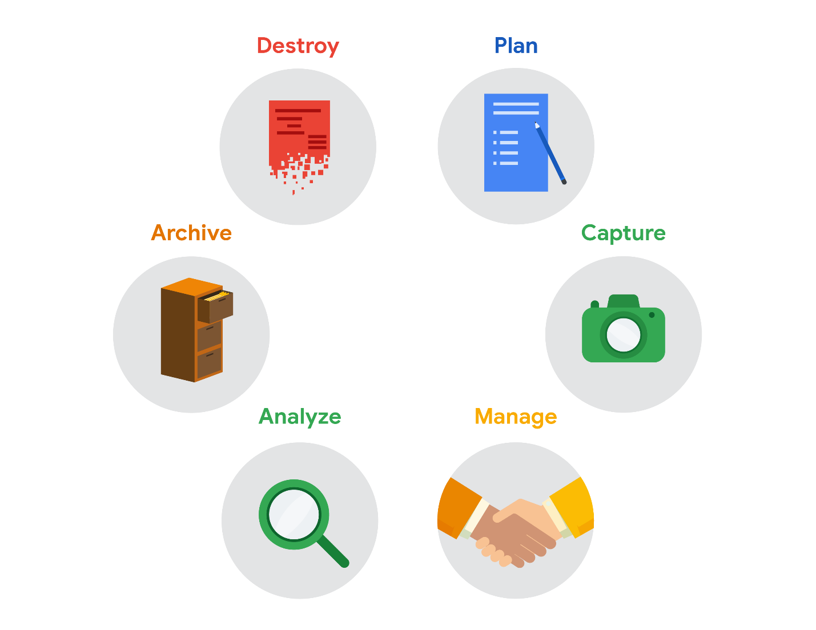

* **Plan** for the users who will work within a spreadsheet by developing organizational standards. This can mean formatting your cells, the headings you choose to highlight, the color scheme, and the way you order your data points. When you take the time to set these standards, you will improve communication, ensure consistency, and help people be more efficient with their time.
* **Capture** data by the source by connecting spreadsheets to other data sources, such as an online survey application or a database. This data will automatically be updated in the spreadsheet. That way, the information is always as current and accurate as possible.
* **Manage** different kinds of data with a spreadsheet. This can involve storing, organizing, filtering, and updating information. Spreadsheets also let you decide who can access the data, how the information is shared, and how to keep your data safe and secure.
* **Analyze** data in a spreadsheet to help make better decisions. Some of the most common spreadsheet analysis tools include formulas to aggregate data or create reports, and pivot tables for clear, easy-to-understand visuals.
* **Archive** any spreadsheet that you don’t use often, but might need to reference later with built-in tools. This is especially useful if you want to store historical data before it gets updated.
* **Destroy** your spreadsheet when you are certain that you will never need it again, if you have better backup copies, or for legal or security reasons. Keep in mind, lots of businesses are required to follow certain rules or have measures in place to make sure data is destroyed properly.

**Resources**

Spreadsheet shortcuts can help you become more efficient with spreadsheets. If you’d like to learn more, you can explore the collection of [Google Sheets shortcuts](https://support.google.com/docs/answer/181110), or visit the [Microsoft Excel shortcuts](https://support.microsoft.com/en-us/office/keyboard-shortcuts-in-excel-1798d9d5-842a-42b8-9c99-9b7213f0040f) page if you are using Excel. Both of these resources contain a list of spreadsheet shortcuts you can save and reference as you work more with spreadsheets on your own.

Learn more about spreadsheet basics

Below, you will find a list that covers two types of spreadsheet programs: **Microsoft Excel** and **Google Sheets**. The list includes quick-start guides, tutorials, and more. The examples in this course use Google Sheets, but you can follow along using Excel or any other spreadsheet application. The user interface might be a little different, but it should look and work similarly.



**Microsoft Excel**

* [Office Quick Starts](https://support.microsoft.com/en-us/office/office-quick-starts-25f909da-3e76-443d-94f4-6cdf7dedc51e#ID0EAADAAA=At_work_or_school): Scroll down to the **Downloadable guides** section to d​ownload the **Excel Quick Start Guide**: This PDF guide begins with a labeled map of Excel that can guide you through the basic tasks you can accomplish in Excel. For tips on starting and opening Excel, this [Microsoft Support page](https://support.microsoft.com/en-us/office/create-a-new-workbook-ae99f19b-cecb-4aa0-92c8-7126d6212a83?wt.mc_id=otc_excel) will show you how to begin a new workbook.
* [Excel video training](https://support.microsoft.com/en-us/office/excel-for-windows-training-9bc05390-e94c-46af-a5b3-d7c22f6990bb?wt.mc_id=otc_home): This is a collection of step-by-step videos to use all sorts of Excel features, including adding and working within rows, columns, and cells; formatting; using formulas and functions; and adding charts and pivot tables.
* [Sort data in a range or table](https://support.microsoft.com/en-us/office/sort-data-in-a-range-or-table-62d0b95d-2a90-4610-a6ae-2e545c4a4654): This page guides you through all of the steps you will need to sort data by number, text, and color. You’ll also have the option to sort by custom list so that you can customize exactly what you want to sort.
* [Filter data in a range or table](https://support.microsoft.com/en-us/office/filter-data-in-a-range-or-table-01832226-31b5-4568-8806-38c37dcc180e): This article has step-by-step instructions on how to filter an Excel spreadsheet to show only the data you want to see. You can also use built-in comparison operators, such as “greater than” and “top 10” to reveal only the most relevant data.
* [Format a worksheet](https://support.microsoft.com/en-us/office/quick-start-format-a-worksheet-d70f75a2-23e6-4c92-83d6-2f219e4ad42e): The guide will help you select and format your Excel spreadsheet, then change the borders, shading, colors, and text. This can help improve your spreadsheet’s readability.

**Pro tip**: If you’re searching for information about using customizable options, check out Microsoft’s [Guidelines for organizing and formatting data on a worksheet](https://support.microsoft.com/en-us/office/guidelines-for-organizing-and-formatting-data-on-a-worksheet-90895cad-6c85-4e02-90d3-8798660166e3). This article provides clear methods for creating easy-to-read spreadsheets.

**Google Sheets**

* [Google Sheets cheat sheet](https://support.google.com/a/users/answer/9300022): The cheat sheet puts all the basics of Sheets on a single page for easy reference. Here, you can learn about customizing your spreadsheet and the data inside; working with rows, columns, and cells; sharing your spreadsheet with others; creating different versions and copies of a spreadsheet; and more.
* [Get started with Sheets: Create and import files](https://support.google.com/a/users/answer/9300311?hl=en&ref_topic=9296423): This guide is a step-by-step guide for working with Sheets. You start by learning how to open a spreadsheet, then move on to adding data.
* [Sort and filter your data](https://support.google.com/docs/answer/3540681?co=GENIE.Platform%3DDesktop&hl=en): This resource can help you organize data in Sheets. Use this guide to sort part or all of a spreadsheet. You can sort by text, number, and color. Then, learn how to create filters to show only certain data while hiding the rest. Finally, the article includes information on creating, saving, and removing a filter view.
* [Edit and format a spreadsheet](https://support.google.com/docs/answer/46973?co=GENIE.Platform%3DDesktop&hl=en&oco=0): This will help you make easy-to-read spreadsheets. You will learn how to assign a color, customize borders around cells, and change the appearance of text. If you’d like to give your spreadsheet a theme, you can scroll to the bottom of the page and find how to apply it to parts of your spreadsheet.

**Tip**: Microsoft Excel and Google Sheets are very similar in terms of calculations, formulas, functions, and many other features. But there are some differences, which can make it tricky to switch from one to the other. If you are moving between Excel and Google Sheets, find a quick list of the differences between the two kinds of spreadsheet applications in [Overview: Differences between Sheets and Excel](https://support.google.com/a/users/answer/9331278?hl=en).

# Quick reference: Formulas in spreadsheets



You have been learning a lot about spreadsheets and all kinds of time-saving calculations and organizational features they offer. One of the most valuable spreadsheet features is a **formula**. As a quick reminder, a formula is a set of instructions that does a specific calculation using the data in a spreadsheet. Formulas make it easy for data analysts to do powerful calculations automatically, which helps them analyze data more effectively. Below is a  quick-reference guide to help you get the most out of formulas.

## Formulas

### **The basics**

* When you write a formula in math, it generally ends with an equal sign (2 + 3 = ?). But with formulas, they always start with one instead (=A2+A3). The equal sign tells the spreadsheet that what follows is part of a formula, not just a word or number in a cell.
* After you type the equal sign, most spreadsheet applications will display an autocomplete menu that lists valid formulas, names, and text strings. This is a great way to create and edit formulas while avoiding typing and syntax errors.
* A fun way to learn new formulas is just by typing an equal sign and a single letter of the alphabet. Choose one of the options that pops up and you will learn what that formula does.

### **Mathematical operators**

* The mathematical operators used in spreadsheet formulas include:
* Subtraction – minus sign ( - )
* Addition – plus sign ( + )
* Division – forward-slash ( / )
* Multiplication – asterisk ( \* )

### **Auto-filling**

The lower-right corner of each cell has a fill handle. It is a small green square in Microsoft Excel and a small blue square in Google Sheets.

* Click the fill handle for a cell and drag it down a column to auto-fill other cells in the column with the same value or formula in that cell.
* Click the fill handle for a cell and drag it across a row to auto-fill other cells in the row with the same value or formula in that cell.
* If you want to create a numbered sequence in a column or row, do the following: 1) Fill in the first two numbers of the sequence in two adjacent cells, 2) Select to highlight the cells, and 3) Drag the fill handle to the last cell to complete the sequence of numbers. For example, to insert 1 through 100 in each row of column A, enter **1** in cell A1 and **2** in cell A2. Then, select to highlight both cells, click the fill handle in cell A2, and drag it down to cell A100. This auto-fills the numbers sequentially so you don't have to type them in each cell.

### **Absolute referencing**

* Absolute referencing is marked by a dollar sign ($). For example, =$A$10 has absolute referencing for both the column and the row value
* Relative references (which is what you normally do e.g. “=A10”) will change anytime the formula is copied and pasted. They are in relation to where the referenced cell is located. For example if you copied “=A10” to the cell to the right it would become “=B10”. With absolute referencing “=$A$10” copied to the cell to the right would remain “=$A$10”. But if you copied $A10 to the cell below, it would change to $A11 because the row value isn't an absolute reference.
* Absolute references will not change when you copy and paste the formula in a different cell. The cell being referenced is always the same.
* To easily switch between absolute and relative referencing in the formula bar, highlight the reference you want to change and press the F4 key; for example, if you want to change the absolute reference, $A$10, in your formula to a relative reference, A10, highlight $A$10 in the formula bar and then press the F4 key to make the change.

### **Data range**

* When you click into your formula, the colored ranges let you see which cells are being used in your spreadsheet. There are different colors for each unique range in your formula.
* In a lot of spreadsheet applications, you can press the F2 (or Enter) key to highlight the range of data in the spreadsheet that is referenced in a formula. Click the cell with the formula, and then press the F2 (or Enter) key to highlight the data in your spreadsheet.

### **Combining with functions**

* COUNTIF() is a formula and a function. This means the function runs based on criteria set by the formula. In this case, COUNT is the formula; it will be executed IF the conditions you create are true. For example, you could use =COUNTIF(A1:A16, “7”) to count only the cells that contained the number 7. Combining formulas and functions allows you to do more work with a single command.

# More about spreadsheet errors and fixes

The PDF file in the attachment below includes topics and content from both the companion video and this reading. You can save this file for future reference:

**DAC2 Spreadsheet Errors and Fixes.pdf**PDF File

[Open file](https://d3c33hcgiwev3.cloudfront.net/fDHAQD8OQX6xwEA_DsF-tw_299c2bf89be04d0bae30bf763b606af1_DAC2-Spreadsheet-Errors-and-Fixes.pdf?Expires=1648080000&Signature=BL0159-qkssLKuNWt6i5AeegKUDlo2CgdV7cphU4mVL7u-SN0uo3jN6Rgi3LV5kmlC2Q1UTXgMLcJ~9HNkUoUvtc6ngSz2q6F8vLdHhFthPwPJQMIVSGODiHoN2TUqNV9v2xD7aiy8CJw3h~aNyuztEgVkvvjb5krj4D8tDusQI_&Key-Pair-Id=APKAJLTNE6QMUY6HBC5A" \t "_blank)

When you are new to data analytics—and sometimes even when you aren't—spreadsheet struggles are real. It never feels good when you type in what you are sure is a perfect formula or function, only to get an error message. Understanding errors and how to fix them is a big part of keeping your data clean, so it’s important to know how to deal with issues as they come up, and more importantly, not to get discouraged.

Remember, even the most advanced spreadsheet users come across problems from time to time.



As a follow-up to what you learned in the previous video, here are a few best practices and helpful tips. These strategies will help you avoid spreadsheet errors to begin with, making your life in analytics a whole lot less stressful:

1. Filter data to make your spreadsheet less complex and busy.
2. Use and freeze headers so you know what is in each column, even when scrolling.
3. When multiplying numbers, use an asterisk (\*) not an X.
4. Start every formula and function with an equal sign (=).
5. Whenever you use an open parenthesis, make sure there is a closed parenthesis on the other end to match.
6. Change the font to something easy to read.
7. Set the border colors to white so that you are working in a blank sheet.
8. Create a tab with just the raw data, and a separate tab with just the data you need.

Now that you have learned some basic ways to avoid errors, you can focus on what to do when that dreaded pop-up does appear. The following table is a reference you can use to look up common spreadsheet errors and examples of each. Knowing what the errors mean takes some of the fear out of getting them.

| **Error** | **Description** | **Example** |
| --- | --- | --- |
| **#DIV/0!** | A formula is trying to divide a value in a cell by 0 (or an empty cell with no value) | =B2/B3, when the cell B3 contains the value 0 |
| **#ERROR!** | (Google Sheets only) Something can’t be interpreted as it has been input. This is also known as a parsing error. | =COUNT(B1:D1 C1:C10) is invalid because the cell ranges aren't separated by a comma |
| **#N/A** | A formula can't find the data | The cell being referenced can't be found |
| **#NAME?** | The name of a formula or function used isn't recognized | The name of a function is misspelled |
| **#NUM!** | The spreadsheet can't perform a formula calculation because a cell has an invalid numeric value | =DATEDIF(A4, B4, "M") is unable to calculate the number of months between two dates because the date in cell A4 falls after the date in cell B4 |
| **#REF!** | A formula is referencing a cell that isn't valid | A cell used in a formula was in a column that was deleted |
| **#VALUE!** | A general error indicating a problem with a formula or with referenced cells | There could be problems with spaces or text, or with referenced cells in a formula; you may have additional work to find the source of the problem. |

If you are working with Microsoft Excel, an interactive page, [How to correct a #VALUE! error](https://support.microsoft.com/en-us/office/how-to-correct-a-value-error-15e1b616-fbf2-4147-9c0b-0a11a20e409e), can help you narrow down the cause of this error. You can select a specific function from a drop-down list to display a link to tips to fix the error when using that function.

## Pro tip: Spotting errors in spreadsheets with conditional formatting

Conditional formatting can be used to highlight cells a different color based on their contents. This feature can be extremely helpful when you want to locate all errors in a large spreadsheet. For example, using conditional formatting, you can highlight in yellow all cells that contain an error, and then work to fix them.

### **Conditional formatting in Microsoft Excel**

To set up conditional formatting in Microsoft Excel to highlight all cells in a spreadsheet that contain errors, do the following:

1. Click the gray triangle above row number 1 and to the left of Column A to select all cells in the spreadsheet.
2. From the main menu, click **Home**, and then click **Conditional Formatting** to select **Highlight Cell Rules > More Rules**.
3. For Select a Rule Type, choose **Use a formula to determine which cells to format**.
4. For Format values where this formula is true, enter **=ISERROR(A1)**.
5. Click the **Format** button, select the Fill tab, select yellow (or any other color), and then click **OK**.
6. Click **OK** to close the format rule window.

To remove conditional formatting, click Home and select Conditional Formatting, and then click Manage Rules. Locate the format rule in the list, click Delete Rule, and then click OK.

### **Conditional formatting in Google Sheets**

To set up conditional formatting in Google Sheets to highlight all cells in a spreadsheet that contain errors, do the following:

1. Click the empty rectangle above row number 1 and to the left of Column A to select all cells in the spreadsheet. In the [Step-by-step in spreadsheets](https://www.coursera.org/learn/ask-questions-make-decisions/lecture/lpuHf/step-by-step-in-spreadsheets) video, this was called the Select All button.
2. From the main menu, click **Format** and select **Conditional Formatting** to open the Conditional format rules pane on the right.
3. While in the Single Color tab, under Format rules, use the drop-down to select **Custom formula is,** enter **=ISERROR(A1)**, select yellow (or any other color) for the formatting style, and then click **Done**.

To remove conditional formatting, click Format and select Conditional Formatting, and then click the Trash icon for the format rule.

## Spreadsheet error resources

To learn more and read about additional examples of errors and solutions, explore these resources:

* [**Microsoft Formulas and Functions**](https://support.microsoft.com/en-us/office/formulas-and-functions-294d9486-b332-48ed-b489-abe7d0f9eda9?ui=en-US&rs=en-US&ad=US#id0eaabaaa=errors)**:** This resource describes how to avoid broken formulas and how to correct errors in Microsoft Excel. This is a useful reference to have saved in case you run into a specific error and need to find solutions quickly while working in Excel.
* [**When Your Formula Doesn’t Work: Formula Parse Errors in Google Sheets**](https://www.benlcollins.com/spreadsheets/formula-parse-error/): This resource is a guide to finding and fixing some common errors in Google Sheets. If you are working with Google Sheets, you can use this as a quick reference for solving problems you might encounter working on your own.

With some practice and investigative determination, you will become much more comfortable handling errors in spreadsheets. Each error you catch and fix will make your data clearer, cleaner, and more useful.

# Quick reference: Functions in spreadsheets

As a quick refresher, a function is a preset command that automatically performs a specific process or task using the data in a spreadsheet. Functions give data analysts the ability to do calculations, which can be anything from simple arithmetic to complex equations. Use this reading to help you keep track of some of the most useful options.

## Functions

### **The basics**

* Just like formulas, start all of your functions with an equal sign; for example =SUM. The equal sign tells the spreadsheet that what follows is part of a function, not just a word or number in a cell.
* After you type the equal sign, most spreadsheet applications will display an autocomplete menu that lists valid functions, names, and text strings. This is a great way to create and edit functions while avoiding typing and syntax errors.
* A fun way to learn new functions is by simply typing an equal sign and a single letter of the alphabet. Choose one of the options that pops up and learn what that function does.

### **Difference between formulas and functions**

* A formula is a set of instructions used to perform a calculation using the data in a spreadsheet.
* A function is a preset command that automatically performs a specific process or task using the data in a spreadsheet.

### **Popular functions**

A lot of people don’t realize that keyboard shortcuts like cut, save, and find are actually functions. These functions are built into an application and are amazing time-savers. Using shortcuts lets you do more with less effort. They can make you more efficient and productive because you are not constantly reaching for the mouse and navigating menus. The following table shows some of the most popular shortcuts, for Chromebook, PC, and Mac:

| **Command** | **Chromebook** | **PC** | **Mac** |
| --- | --- | --- | --- |
| Create new workbook | Control+N | Control+N | Command+N |
| Open workbook | Control+O | Control+O | Command+O |
| Save workbook | Control+S | Control+S | Command+S |
| Close workbook | Control+W | Control+W | Command+W |
| Undo | Control+Z | Control+Z | Command+Z |
| Redo | Control+Y | Control+Y | Command+Y |
| Copy | Control+C | Control+C | Command+C |
| Cut | Control+X | Control+X | Command+X |
| Paste | Control+V | Control+V | Command+V |
| Paste values only | Control+Shift+V | Control+Shift+V | Command+Shift+V |
| Find | Control+Shift+F | Control+F | Command+F |
| Find and replace | Control+H | Control+H | Command+Shift+F |
| Insert link | Control+K | Control+K | Command+K |
| Bold | Control+B | Control+B | Command+B |
| Italicize | Control+I | Control+I | Command+I |
| Underline | Control+U | Control+U | Command+U |
| Zoom in | Control+Plus (+) | Control+Plus (+) | Option+Command+Plus (+) |
| Zoom out | Control+Minus (-) | Control+Minus (-) | Option+Command+Minus (-) |
| Select column | Control+Spacebar | Control+Spacebar | Command+Spacebar |
| Select row | Shift+Spacebar | Shift+Spacebar | Up Arrow+Spacebar |
| Select all cells | Control+A | Control+A | Command+A |
| Edit the current cell | Enter | F2 | F2 |
| Comment on a cell | Ctrl + Alt + M | Alt+I+M | Option+Command+M |
| Insert column to the left | Ctrl + Alt + = (with existing column selected) | Alt+Shift+I, then C | ⌘ + Option + = (with existing column selected) |
| Insert column to the right | Alt + I, then O | Alt+Shift+I, then O | Ctrl + Option + I, then O |
| Insert row above | Ctrl + Alt + = (with existing row selected) | Alt+Shift+I, then R | ⌘ + Option + = (with existing row selected) |
| Insert row below | Alt + I, then R, then B | Alt+Shift+I, then B | Ctrl + Option + I, then B |

### **Auto-filling**

The lower-right corner of each cell has a fill handle. It is a small green square in Microsoft Excel and a small blue square in Google Sheets.

* Click the fill handle for a cell and drag it down a column to auto-fill other cells in the column with the same formula or function used in that cell.
* Click the fill handle for a cell and drag it across a row to auto-fill other cells in the row with the same formula or function used in that cell.

### **Relative, absolute, and mixed references**

* Relative references (cells referenced without a dollar sign, like A2) will change when you copy and paste the function into a different cell. With relative references, the location of the cell that contains the function determines the cells used by the function.
* Absolute references (cells fully referenced with a dollar sign, like $A$2) will not change when you copy and paste the function into a different cell. With absolute references, the cells referenced always remain the same.
* Mixed references (cells partially referenced with a dollar sign, like $A2 or A$2) will change when you copy and paste the function into a different cell. With mixed references, the location of the cell that contains the function determines the cells used by the function, but only the row or column is relative (not both).
* In spreadsheets, you can press the F4 key to toggle between relative, absolute, and mixed references in a function. Click the cell containing the function, highlight the referenced cells in the formula bar, and then press F4 to toggle between and select relative, absolute, or mixed referencing.

### **Data ranges**

* When you click a cell that contains a function, colored data ranges in the formula bar indicate which cells are being used in the spreadsheet. There are different colors for each unique range in a function.
* Colored data ranges help prevent you from getting lost in complex functions.
* In spreadsheets, you can press the F2 key to highlight the range of data used by a function. Click the cell containing the function, highlight the range of data used by the function in the formula bar, and then press F2. The spreadsheet will go to and highlight the cells specified by the range.

### **Data ranges evaluated for a condition**

**COUNTIF** is an example of a function that returns a value based on a condition that the data range is evaluated for. The function counts the number of cells that meet the criteria. For example, in an expense spreadsheet, use COUNTIF to count the number of cells that contain a reimbursement for "airfare."

For more information, refer to:

* [Microsoft Support's page for COUNTIF](https://support.microsoft.com/en-us/office/countif-function-e0de10c6-f885-4e71-abb4-1f464816df34)
* [Google Help Center's documentation for COUNTIF](https://support.google.com/docs/answer/3093480?hl=en) where you can copy a sheet with [COUNTIF examples](https://docs.google.com/spreadsheets/d/1PYoKCYZAkWSaMBsiTyvxZzCCt2WQ-QKOC763RWHMB7c/template/preview) (click "Use Template" if you click the COUNTIF link provided on this page)

## Conclusion

There are a lot more functions that can help you make the most of your data. This is just the start. You can keep learning how to use functions to help you solve complex problems efficiently and accurately throughout your entire career.

## Keyboard shortcuts

You can save these functions for future reference. Feel free to download a PDF version of the functions below:

**DAC2 Keyboard functions 1.pdf**PDF File

[Open file](https://d3c33hcgiwev3.cloudfront.net/UbHnj9LnRlGx54_S5yZRJA_64a50a70b938476c852b172e826e9af1_DAC2-Keyboard-functions-1.pdf?Expires=1648080000&Signature=X6qGfmlApqkJNMlqCOJ2v68cPjJyechT5uIWnE0Z900SCWp8pyFw9jWAoVmhMo63Y3XmxuUSpWhIF-ITkkz7w7lSxhLW5GpDNSBDnCowUhdZkjvV3Y46BkTrusUCO3oMllRK4vUpwreX0MSeNM~VE4iBgZzAuioZQsMZ18dZ4Ns_&Key-Pair-Id=APKAJLTNE6QMUY6HBC5A" \t "_blank)

**DAC2 Keyboard functions 2.pdf**PDF File

[Open file](https://d3c33hcgiwev3.cloudfront.net/9gsOZ_tGTtOLDmf7Rh7T1Q_8a825edae2a94e5e81d880681270acf1_DAC2-Keyboard-functions-2.pdf?Expires=1648080000&Signature=QwdkEYREQ03rEYSFcOSRwwmYzoykp~gTX7ol8-qk~lIkCk4zKvOaqIvYQlhi3u0pFwlCgAjmxjPAj985Biba~cBY3x6Woqzzn31Sycar5JWgBHn-OBadwjz4P2YPdLbRzSxcsupaYdvXrk44mO1m~ATbJtLwuNV4yYZ-F7DDJQQ_&Key-Pair-Id=APKAJLTNE6QMUY6HBC5A" \t "_blank)

## Hands-On Activity: Create a scope of work

**Total points**2

### 1.

**Question 1**



## Activity overview



You have been learning about the role of a data analyst and how to manage, analyze, and visualize data. Now, you will consider a valuable tool to help you practice structured thinking and avoid mistakes: a scope-of-work (SOW).

In this activity, you’ll get practical experience developing an SOW document with the help of a handy template. You will then complete an example SOW for an imaginary project of your choosing and learn how analysts outline the work they are going to perform. By the time you complete this activity, you will be familiar with an essential, industry-standard tool, and gain comfort asking the right questions to develop an SOW.

Before you get started, take a minute to think about the main ideas, goals, and target audiences of SOW documents.

## Scope of work: What you need to know



As a data analyst, it’s hard to overstate the importance of an SOW document. A well-defined SOW keeps you, your team, and everyone involved with a project on the same page. It ensures that all contributors, sponsors, and stakeholders share the same understanding of the relevant details.

### **Why do you need an SOW?**



The point of data analysis projects is to complete business tasks that are useful to the stakeholders. Creating an SOW helps to make sure that everyone involved, from analysts and engineers to managers and stakeholders, shares the understanding of what those business goals are, and the plan for accomplishing them.

Clarifying requirements and setting expectations are two of the most important parts of a project. Recall the first phase of the Data Analysis Process—**asking questions**.

As you ask more and more questions to clarify requirements, goals, data sources, stakeholders, and any other relevant info, an SOW helps you formalize it all by recording all the answers and details. In this context, the word “ask” means two things. Preparing to write an SOW is about asking questions to learn the necessary information about the project, but it’s also about clarifying and defining what you’re being asked to accomplish, and what the limits or boundaries of the “ask” are. After all, if you can’t make a distinction between the business questions you are and aren’t responsible for answering, then it’s hard to know what success means!

### **What is a good SOW?**



There’s no standard format for an SOW. They may differ significantly from one organization to another, or from project to project. However, they all have a few foundational pieces of content in common.

* **Deliverables**: What work is being done, and what things are being created as a result of this project? When the project is complete, what are you expected to deliver to the stakeholders? Be specific here. Will you collect data for this project? How much, or for how long?

Avoid vague statements. For example, “fixing traffic problems” doesn’t specify the scope. This could mean anything from filling in a few potholes to building a new overpass. Be specific! Use numbers and aim for hard, measurable goals and objectives. For example: “Identify top 10 issues with traffic patterns within the city limits, and identify the top 3 solutions that are most cost-effective for reducing traffic congestion.”

* **Milestones**: This is closely related to your timeline. What are the major milestones for progress in your project? How do you know when a given part of the project is considered complete?

Milestones can be identified by you, by stakeholders, or by other team members such as the Project Manager. Smaller examples might include incremental steps in a larger project like “Collect and process 50% of required data (100 survey responses)”, but may also be larger examples like ”complete initial data analysis report” or “deliver completed dashboard visualizations and analysis reports to stakeholders”.

* **Timeline**: Your timeline will be closely tied to the milestones you create for your project. The timeline is a way of mapping expectations for how long each step of the process should take. The timeline should be specific enough to help all involved decide if a project is on schedule. When will the deliverables be completed? How long do you expect the project will take to complete? If all goes as planned, how long do you expect each component of the project will take? When can we expect to reach each milestone?
* **Reports**: Good SOWs also set boundaries for how and when you’ll give status updates to stakeholders. How will you communicate progress with stakeholders and sponsors, and how often? Will progress be reported weekly? Monthly? When milestones are completed? What information will status reports contain?

At a minimum, any SOW should answer all the relevant questions in the above areas. Note that these areas may differ depending on the project. But at their core, the SOW document should always serve the same purpose by containing information that is specific, relevant, and accurate. If something changes in the project, your SOW should reflect those changes.

### **What is in and out of scope?**



SOWs should also contain information specific to what is and isn’t considered part of the project. The scope of your project is everything that you are expected to complete or accomplish, defined to a level of detail that doesn’t leave any ambiguity or confusion about whether a given task or item is part of the project or not.

Notice how the previous example about studying traffic congestion defined its scope as the area within the city limits. This doesn’t leave any room for confusion — stakeholders need only to refer to a map to tell if a stretch of road or intersection is part of the project or not.  Defining requirements can be trickier than it sounds, so it’s important to be as specific as possible in these documents, and to use quantitative statements whenever possible.

For example, assume that you’re assigned to a project that involves studying the environmental effects of climate change on the coastline of a city: How do you define what parts of the coastline you are responsible for studying, and which parts you are not?

In this case, it would be important to define the area you’re expected to study using GPS locations, or landmarks. Using specific, quantifiable statements will help ensure that everyone has a clear understanding of what’s expected.

## Completing your own SOW



Now that you know the basics, you can practice creating your own mock SOW for a project of your choice. To get started, first access the scope-of-work template.

### **What you will need**



To use the template for this course item, click the link below and select “Use Template.”

Link to template: [Data Analysis Project Scope-Of-Work (SOW) Template](https://docs.google.com/document/d/1zqfGwpjZyPAyERNPXNfIUM78YuBxYYj0atIE6_YopLA/template/preview?usp=sharing&resourcekey=0-o9cjeaxYBBm7ZyYe4bpImw)

OR

If you don’t have a Google account, you can download the template directly from the attachment below.

**Scope-Of-Work Template**DOCX File

[Download file](https://d3c33hcgiwev3.cloudfront.net/XPQUWwn0Qum0FFsJ9JLptA_0e743bf026d444819d94d8eb66e100f1_Scope-Of-Work-Template.docx?Expires=1648080000&Signature=Q8JCCVBiQdmhFEaZp9FTOOggt9nGc2ZWBsODbVhOq6i4xlz2WQfXQOj0Hdp14mh-OIhb-nIFeL8o4TmUeUYuZCA3Jw7LoFO-J0yGA9AFqPR46jktYC4dmuF2NRx0hlYwMDkUuT5jK6Gk24Ai0p47NWLiFyfWf8u3fRo-BnFq74Q_&Key-Pair-Id=APKAJLTNE6QMUY6HBC5A" \t "_blank)



### **Fill the template in for an imaginary project**



* Spend a few minutes thinking about a plausible data analysis project.
* Come up with a problem domain, and then make up the relevant details to help you fill out the template.
* Take some time to fill out the template. Treat this exercise as if you were writing your first SOW in your new career as a data analyst. Try to be thorough, specific, and concise!
* The specifics here aren’t important. The goal is to get comfortable identifying and formalizing requirements and using those requirements in a professional manner by creating SOWs.

### **Compare your work to a strong example**



Once you’ve filled out your template, consider the strong example below and compare it to yours.

Link to the strong example: [Data Analysis Project Scope-of-Work (SOW) Strong Example](https://docs.google.com/document/d/16x-E04Nr48Ww1Nlxwa0PNOXyaytKbVCxrF5yRJy6Y70/template/preview?resourcekey=0-X1a531fuUVbtlNKdIA11dQ)

OR

You can download the template directly from the attachment below.

**Scope-Of-Work Exemplar.pdf**PDF File

[Open file](https://d3c33hcgiwev3.cloudfront.net/3_u77YSWT1a7u-2Eli9WMQ_f488afe855a44f9e8f55c678e57f637d_Scope-Of-Work-Exemplar.pdf?Expires=1648080000&Signature=SRb9s1-ehz~E~bfHZYb6Lq34yZc7ftnhonziPfO-kCs~Gpi9UX~zJsgFIdjLdu7IClx5GzpfgrBF17PsJBF1LEQwThrXRIAv10695H017TzwuWPCsq-kzZ0gZo5GupCA2QBMwoe2fCZmXzlBmBUgVnG3d-accAUSv94V4CQmsEs_&Key-Pair-Id=APKAJLTNE6QMUY6HBC5A" \t "_blank)

## Confirmation and reflection



When you created a complete and thorough mock SOW, which foundational pieces of content did you include? Select all that apply.

**1 point**



Milestones



Budget



Reports



Timeline



Deliverables

### 2.

**Question 2**

Now that you have put your scope-of-work knowledge into practice, take a moment to examine and reflect on your completed mock SOW. Then, review your work next to the strong example linked above. In the text box below, write 2-3 sentences (40-60 words) in response to each of the following questions:

* How did you identify and formalize the project’s requirements?
* What questions did you ask in order to update the foundational pieces of content?

The importance of context

**Context** is the condition in which something exists or happens. Context is important in data analytics because it helps you sift through huge amounts of disorganized data and turn it into something meaningful. The fact is, data has little value if it is not paired with context.



Understanding the context behind the data can help us make it more meaningful at every stage of the data analysis process. For example, you might be able to make a few guesses about what you're looking at in the following table, but you couldn't be certain without more context.

|  |  |
| --- | --- |
| 2010 | 28000 |
| 2005 | 18000 |
| 2000 | 23000 |
| 1995 | 10000 |

On the other hand, if the first column was labeled to represent the years when a survey was conducted, and the second column showed the number of people who responded to that survey, then the table would start to make a lot more sense. Take this a step further, and you might notice that the survey is conducted every 5 years. This added context helps you understand why there are five-year gaps in the table.

| **Years (Collected every 5 years)** | **Respondents** |
| --- | --- |
| 2010 | 28000 |
| 2005 | 18000 |
| 2000 | 23000 |
| 1995 | 10000 |

**Context can turn raw data into meaningful information.** It is very important for data analysts to contextualize their data. This means giving the data perspective by defining it. To do this, you need to identify:

* Who: The person or organization that created, collected, and/or funded the data collection
* What: The things in the world that data could have an impact on
* Where: The origin of the data
* When: The time when the data was created or collected
* Why: The motivation behind the creation or collection
* How: The method used to create or collect it



Understanding and including the context is important during each step of your analysis process, so it is a good idea to get comfortable with it early in your career. For example, when you collect data, you’ll also want to ask questions about the context to make sure that you understand the business and business process. During organization, the context is important for your naming conventions, how you choose to show relationships between variables, and what you choose to keep or leave out. And finally, when you present, it is important to include contextual information so that your stakeholders understand your analysis.

# Learning Log: Define problems and ask questions with data



## Overview



In a previous learning log, you reflected on what you learned from the SMART questions you asked during your real life data conversation. Now, you’ll complete an entry in your learning log using notes about your data conversation to explain your initial insights to potential stakeholders. By the time you complete this entry, you will have a stronger understanding of how you might use data to define problems and what information is useful for stakeholders at this stage. This will help you develop formal documents like a scope of work (SOW) as a data analyst in the future.

## Summarize your findings



As a data analyst, part of your job is to communicate the data analysis process and your insights to stakeholders. This often involves defining the problem and summarizing key questions and available data early on. You might include this information in a formal document for stakeholders like a scope of work (SOW) at the beginning of a project. As a reminder, an SOW is an agreed-upon outline of the tasks to be performed during a project; it is important to ensure your stakeholders understand this key information at that stage.

Before you start your learning log entry, take a moment to review your notes and your reflection for Learning Log: Ask SMART questions about real life data. Imagine that you are going to design a data analysis project based on this data conversation.

In the learning log template linked below, you will create a summary of key information you think a stakeholder would need to know about this project. In this case, your stakeholder could be a member of the executive team, like a project manager. Here are some questions to help you get started:

* What is the problem?
* Can it be solved with data? If so, what data?
* Where is this data? Does it exist, or do you need to collect it?
* Are you using private data that someone will need to give you access to, or publicly available data?
* Who are the relevant sponsors and stakeholders for this project? Who is involved, and how?
* What are the boundaries for your project? What do you consider “in-scope?” What do you consider “out-of-scope?”
* Is there any other information you think is relevant to the project?
* Is there any information you need or questions you need answered  before you can begin?

As you think about these questions, it’s likely you’ll discover that you don’t have all the information you need. This is part of the process!

When kicking off data analysis projects, expect to have a lot of conversations. By identifying what you know and what you don’t know, it makes it much easier to plan your next data conversation, so that you can get the answers you need.



### Access your learning log

To use the learning log for this course item, click the link below and select “Use Template.”

Link to learning log template: [Define problems and ask questions with data](https://docs.google.com/document/d/1kooOADIAtWrB6to-klZ_v5mWHXbQ8WJ_UsKFJtbGWuo/template/preview?resourcekey=0-DpVgA8sZGhn-s32LAzCIeA)

OR

If you don’t have a Google account, you can download the template directly from the attachment below.

**Learning Log Template\_ Define problems and ask questions with data**DOCX File

[Download file](https://d3c33hcgiwev3.cloudfront.net/_J8pF3RMRxmfKRd0TFcZFw_b8fba225588f42408f7e9e5e63fedd6a_Learning-Log-Template_-Define-problems-and-ask-questions-with-data.docx?Expires=1648080000&Signature=iyPrMqe9Qoikl5ge26tIbdgSr7w2pfjN-u6zoNHZHdcRGU7~6OT0TbwMb943eQTp8xJz30O-mqfRbX03ZPQLogShVNWbPCdzfv348x0ZKfUVBe3gEDuXb-LFQJzSBnnhBr53zwOppMgi2Q9ZVjfgw5007amGLGKlzybdVpRtWSU_&Key-Pair-Id=APKAJLTNE6QMUY6HBC5A" \t "_blank)



## Reflection



Now that you have started identifying which information would be useful for a potential stakeholder, write 5-7 sentences (100-140 words) summarizing the key questions, the data available, and the answers or insights you have gained so far in your learning log template.

When you’ve finished your entry in the learning log template, make sure to save the document so your response is somewhere accessible. This will help you continue applying data analysis to your everyday life. You will also be able to track your progress and growth as a data analyst.

Working with stakeholders

Your data analysis project should answer the business task and create opportunities for data-driven decision-making. That's why it is so important to focus on project stakeholders. As a data analyst, it is your responsibility to understand and manage your stakeholders’ expectations while keeping the project goals front and center.



You might remember that **stakeholders** are people who have invested time, interest, and resources into the projects that you are  working on. This can be a pretty broad group, and your project stakeholders may change from project to project. But there are three common stakeholder groups that you might find yourself working with: the executive team, the customer-facing team, and the data science team.

Let’s get to know more about the different stakeholders and their goals. Then we'll learn some tips for communicating with them effectively.

**Executive team**

The executive team provides strategic and operational leadership to the company. They set goals, develop strategy, and make sure that strategy is executed effectively. The executive team might include vice presidents, the chief marketing officer, and senior-level professionals who help plan and direct the company’s work. These stakeholders think about decisions at a very high level and they are looking for the headline news about your project first.  They are less interested in the details. Time is very limited with them, so make the most of it by leading your presentations with the answers to their questions. You can keep the more detailed information handy in your presentation appendix or your project documentation for them to dig into when they have more time.

For example, you might find yourself working with the vice president of human resources on an analysis project to understand the rate of employee absences. A marketing director might look to you for competitive analyses. Part of your job will be balancing what information they will need to make informed decisions with their busy schedule.

But you don’t have to tackle that by yourself. Your project manager will be overseeing the progress of the entire team, and you will be giving them more regular updates than someone like the vice president of HR. They are able to give you what you need to move forward on a project, including getting approvals from the busy executive team. Working closely with your project manager can help you pinpoint the needs of the executive stakeholders for your project, so don’t be afraid to ask them for guidance.



**Customer-facing team**

The customer-facing team includes anyone in an organization who has some level of interaction with customers and potential customers. Typically they compile information, set expectations, and communicate customer feedback to other parts of the internal organization. These stakeholders have their own objectives and may come to you with specific asks. It is important to let the data tell the story and not be swayed by asks from your stakeholders to find certain patterns that might not exist.

Let’s say a customer-facing team is working with you to build a new version of a company’s most popular product. Part of your work might involve collecting and sharing data about consumers’ buying behavior to help inform product features. Here, you want to be sure that your analysis and presentation focuses on what is actually in the data-- not on what your stakeholders hope to find.



**Data science team**

Organizing data within a company takes teamwork. There's a good chance you'll find yourself working with other data analysts, data scientists, and data engineers. For example, maybe you team up with a company's data science team to work on boosting company engagement to lower rates of employee turnover. In that case, you might look into the data on employee productivity, while another analyst looks at hiring data. Then you share those findings with the data scientist on your team, who uses them to predict how new processes could boost employee productivity and engagement. When you share what you found in your individual analyses, you uncover the bigger story. A big part of your job will be collaborating with other data team members to find new angles of the data to explore. Here's a view of how different roles on a typical data science team support different functions:

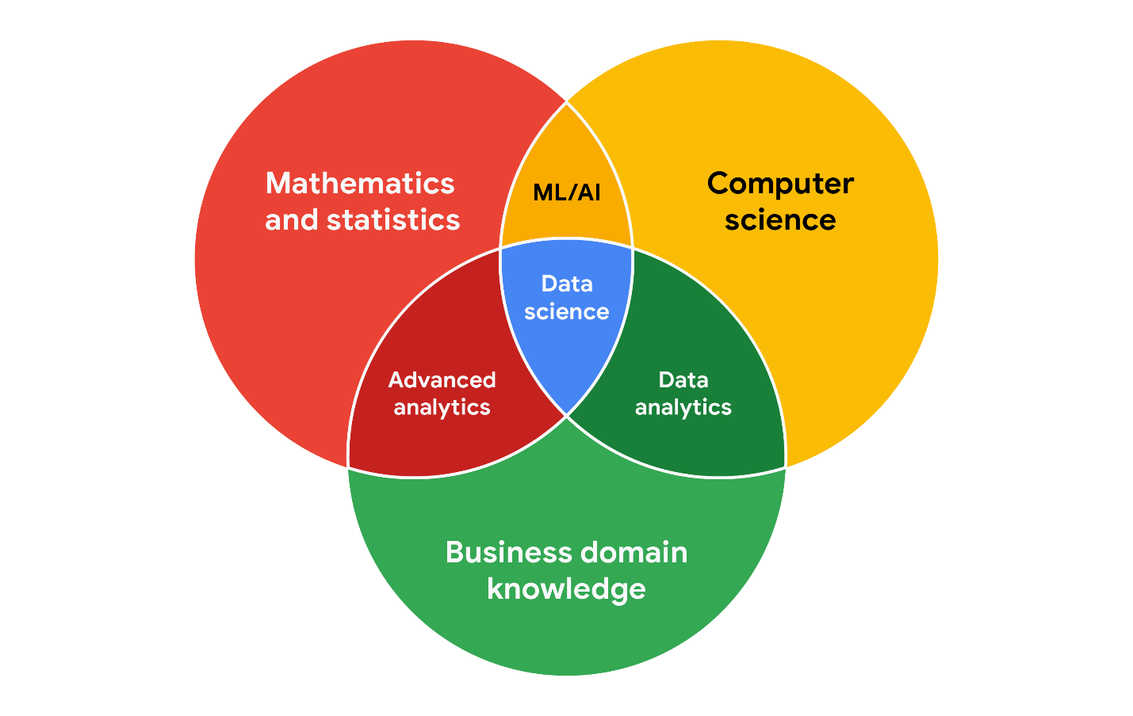

**Working effectively with stakeholders**

When you're working with each group of stakeholders- from the executive team, to the customer-facing team, to the data science team, you'll often have to go beyond the data. Use the following tips to communicate clearly, establish trust, and deliver your findings across groups.

**Discuss goals.** Stakeholder requests are often tied to a bigger project or goal. When they ask you for something, take the opportunity to learn more. Start a discussion. Ask about the kind of results the stakeholder wants. Sometimes, a quick chat about goals can help set expectations and plan the next steps.

**Feel empowered to say “no**.” Let’s say you are approached by a marketing director who has a “high-priority” project and needs data to back up their hypothesis. They ask you to produce the analysis and charts for a presentation by tomorrow morning. Maybe you realize their hypothesis isn’t fully formed and you have helpful ideas about a better way to approach the analysis. Or maybe you realize it will take more time and effort to perform the analysis than estimated. Whatever the case may be, don’t be afraid to push back when you need to.



Stakeholders don’t always realize the time and effort that goes into collecting and analyzing data. They also might not know what they actually need. You can help stakeholders by asking about their goals and determining whether you can deliver what they need. If you can’t, have the confidence to say “no,” and provide a respectful explanation. If there’s an option that would be more helpful, point the stakeholder toward those resources. If you find that you need to prioritize other projects first, discuss what you can prioritize and when. When your stakeholders understand what needs to be done and what can be accomplished in a given timeline, they will usually be comfortable resetting their expectations. You should feel empowered to say no-- just remember to give context so others understand why.

**Plan for the unexpected.** Before you start a project, make a list of potential roadblocks. Then, when you discuss project expectations and timelines with your stakeholders, give yourself some extra time for problem-solving at each stage of the process.

**Know your project.** Keep track of your discussions about the project over email or reports, and be ready to answer questions about how certain aspects are important for your organization. Get to know how your project connects to the rest of the company and get involved in providing the most insight possible. If you have a good understanding about why you are doing an analysis, it can help you connect your work with other goals and be more effective at solving larger problems.

**Start with words and visuals.** It is common for data analysts and stakeholders to interpret things in different ways while assuming the other is on the same page. This *illusion of agreement\**has been historically identified as a cause of projects going back-and-forth a number of times before a direction is finally nailed down. To help avoid this, start with a description and a quick visual of what you are trying to convey. Stakeholders have many points of view and may prefer to absorb information in words or pictures. Work with them to make changes and improvements from there. The faster everyone agrees, the faster you can perform the first analysis to test the usefulness of the project, measure the feedback, learn from the data, and implement changes.

**Communicate often.** Your stakeholders will want regular updates on your projects. Share notes about project milestones, setbacks, and changes. Then use your notes to create a shareable report. Another great resource to use is a change-log, which you will learn more throughout the program. For now, just know that a change-log is a file containing a chronologically ordered list of modifications made to a project. Depending on the way you set it up, stakeholders can even pop in and view updates whenever they want.



*\*Jason Fried, Basecamp,* [*www.inc.com/magazine/201809/jason-fried/illusion-agreement-team-project.html*](https://www.inc.com/magazine/201809/jason-fried/illusion-agreement-team-project.html)

# Data scenarios and responses

Being able to communicate in multiple formats is a key skill for data analysts. Listening, speaking, presenting, and writing skills will help you succeed in your projects and in your career. This reading covers effective communication strategies, including examples of clearly worded emails for common situations.

Here's an important first tip: Know your audience! When you communicate your analysis and recommendations as a data analyst, it's vital to keep your audience in mind.

Be sure to answer these four important questions related to your audience:

1. **Who is your audience?**
2. **What do they already know?**
3. **What do they need to know?**
4. **How can you best communicate what they need to know?**

## Project example

As a data analyst, you'll get plenty of requests and questions through email. Let’s walk through an example of how you might approach answering one of these emails. Assume you're a data analyst working at a company that develops mobile apps. Let's start by reviewing answers to the four audience questions we just covered:



Kiri, Product Development Project Manager



Kiri received updates about our project from its planning stages, including the most recent project report**,** sent two weeks ago.



Kiri needs an update on the analysis project’s progress and needs to know that the executive team approved changes to the data and timeline. You know that adding a new variable to the analysis will impact the current project timeline. Kiri will need to change the project’s milestones and completion date.



You can start by sending an email update to Kiri with the latest timeline for the project, but a meeting might be necessary if she wants to talk through her concerns about missing a deadline.

## Updated timeline email sample

After answering the audience questions, you have the key building blocks you need to write an email to Kiri. Here's an example of how these questions can help organize the flow of the email message:

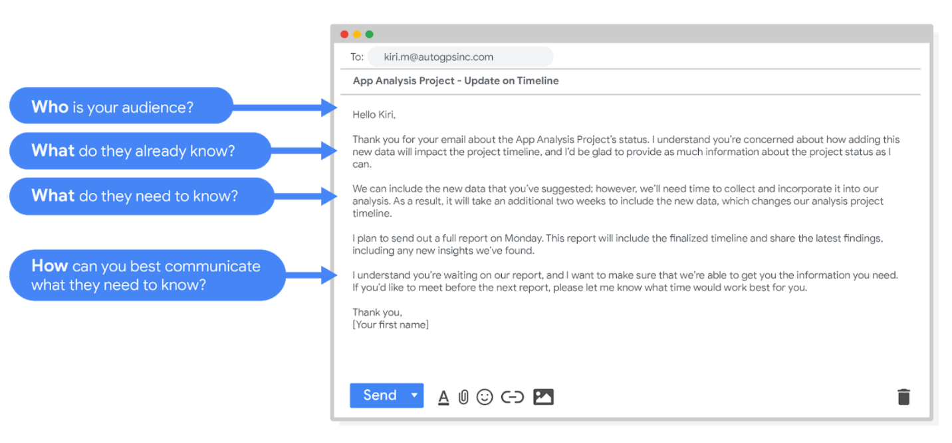Hello Kiri, (who is your audience?) Thank you for your email about the app analysis project's status. I understand you're concerned about how adding this new data will impact the project timeline, and I'd be glad to provide as much information about the project status as I can. (What do they already know? ) We can include the new data that you've suggested however, we'll need time to collect and incorporate it into our analysis. As a result, it will take an additional two weeks to include the new data, which changes our analysis project timeline. (What do they need to know?) I plan to send out a full report on Monday. This report will include the finalized timeline and share the latest findings, including any new insights we've found. I understand you're waiting on our report, and I want to make sure that we're able to get you the information you need. If you'd like to meet before the next report, please let me know what time would work best for you. (How can you best communicate what they need to know?) Thank you, (your first name)

After receiving your email, Kiri will have a clearer view of the changes to the analysis project and will be able to make adjustments to work with the new timeline.

## Project follow-up email sample

After the next report is completed, you can also send out a project update offering more information. The email could look like this:

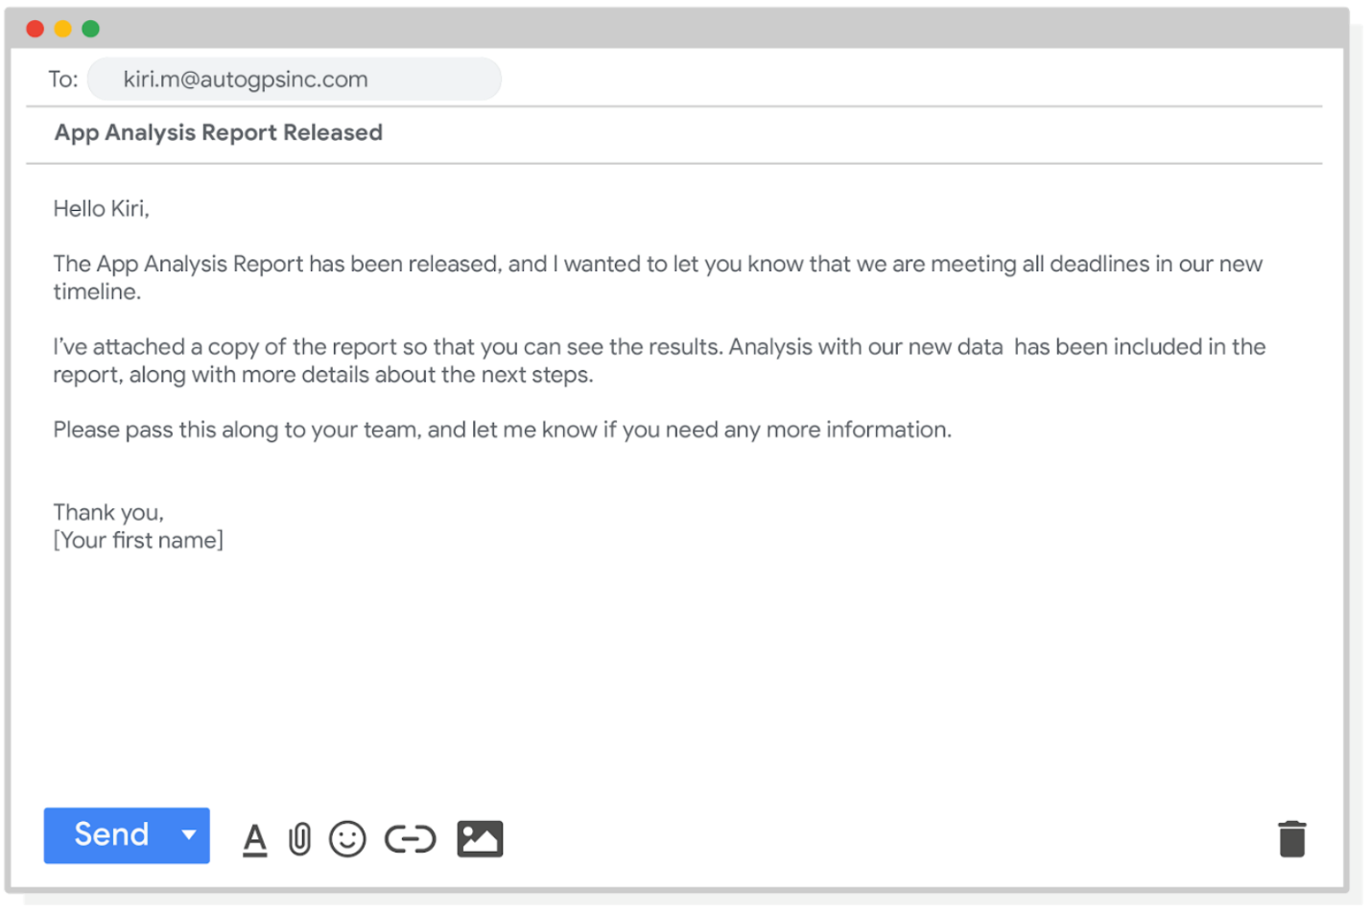Hello Kiri, The app analysis report has been released, and I wanted to let you know that we are meeting all deadlines in our new timeline. I've attached a copy of the report so that you can see the results. Analysis with our new data has been included in the report, along with more details about the next steps. Please pass this along to your team, and let me know if you need any more information. Thank you, [your first name]

Good communication keeps stakeholders updated on progress and ultimately helps prevent problems. Carefully worded responses are key. Whether you gather and address feedback using email, meetings, or reports, everyone you work with will know what to expect. As a result, they will be able to better manage their own schedules, resources, and teams.

Limitations of data

Data is powerful, but it has its limitations. Has someone’s personal opinion found its way into the numbers? Is your data telling the whole story? Part of being a great data analyst is knowing the limits of data and planning for them. This reading explores how you can do that.



If you have incomplete or nonexistent data, you might realize during an analysis that you don't have enough data to reach a conclusion. Or, you might even be solving a different problem altogether! For example, suppose you are looking for employees who earned a particular certificate but discover that certification records go back only two years at your company. You can still use the data, but you will need to make the limits of your analysis clear. You might be able to find an alternate source of the data by contacting the company that led the training. But to be safe, you should be up front about the incomplete dataset until that data becomes available.



If you're collecting data from other teams and using existing spreadsheets, it is good to keep in mind that people use different business rules. So one team might define and measure things in a completely different way than another. For example, if a metric is the total number of trainees in a certificate program, you could have one team that counts every person who registered for the training, and another team that counts only the people who completed the program. In cases like these, establishing how to measure things early on standardizes the data across the board for greater reliability and accuracy. This will make sure comparisons between teams are meaningful and insightful.



Dirty data refers to data that contains errors. Dirty data can lead to productivity loss, unnecessary spending, and unwise decision-making. A good data cleaning effort can help you avoid this. As a quick reminder, data cleaning is the process of fixing or removing incorrect, corrupted, incorrectly formatted, duplicate, or incomplete data within a dataset. When you find and fix the errors - while tracking the changes you made - you can avoid a data disaster. You will learn how to clean data later in the training.



Avinash Kaushik, a Digital Marketing Evangelist for Google, has lots of great tips for data analysts in his [blog: Occam's Razor](http://www.kaushik.net/). Below are some of the best practices he recommends for good data storytelling:

* **Compare the same types of data**: Data can get mixed up when you chart it for visualization. Be sure to compare the same types of data and double check that any segments in your chart definitely display different metrics.
* **Visualize with care**: A 0.01% drop in a score can look huge if you zoom in close enough. To make sure your audience sees the full story clearly, it is a good idea to set your Y-axis to 0.
* **Leave out needless graphs:** If a table can show your story at a glance, stick with the table instead of a pie chart or a graph. Your busy audience will appreciate the clarity.
* **Test for statistical significance:** Sometimes two datasets will look different, but you will need a way to test whether the difference is real and important. So remember to run statistical tests to see how much confidence you can place in that difference.
* **Pay attention to sample size**: Gather lots of data. If a sample size is small, a few unusual responses can skew the results. If you find that you have too little data, be careful about using it to form judgments. Look for opportunities to collect more data, then chart those trends over longer periods.



In any organization, a big part of a data analyst’s role is making sound judgments. When you know the limitations of your data, you can make judgment calls that help people make better decisions supported by the data. Data is an extremely powerful tool for decision-making, but if it is incomplete, misaligned, or hasn’t been cleaned, then it can be misleading. Take the necessary steps to make sure that your data is complete and consistent. Clean the data before you begin your analysis to save yourself and possibly others a great amount of time and effort.

Leading great meetings

One day soon, you might find yourself planning a meeting in your role as a data analyst. Great things can happen when participants anticipate a well-executed meeting. Attendees show up on time. They aren’t distracted by their laptops and phones. They feel like their time will be well spent. It all comes down to good planning and communication of expectations. The following are our best practical tips for leading meetings.



**Before the meeting**

If you are organizing the meeting, you will probably talk about the data. Before the meeting:

* Identify your objective. Establish the purpose, goals, and desired outcomes of the meeting, including any questions or requests that need to be addressed.
* Acknowledge participants and keep them involved with different points of view and experiences with the data, the project, or the business.
* Organize the data to be presented. You might need to turn raw data into accessible formats or create data visualizations.
* Prepare and distribute an agenda. We will go over this next.

**Crafting a compelling agenda**

A solid meeting agenda sets your meeting up for success. Here are the basic parts your agenda should include:

* Meeting start and end time
* Meeting location (including information to participate remotely, if that option is available)
* Objectives
* Background material or data the participants should review beforehand

Here's an example of an agenda for an analysis project that is just getting started:

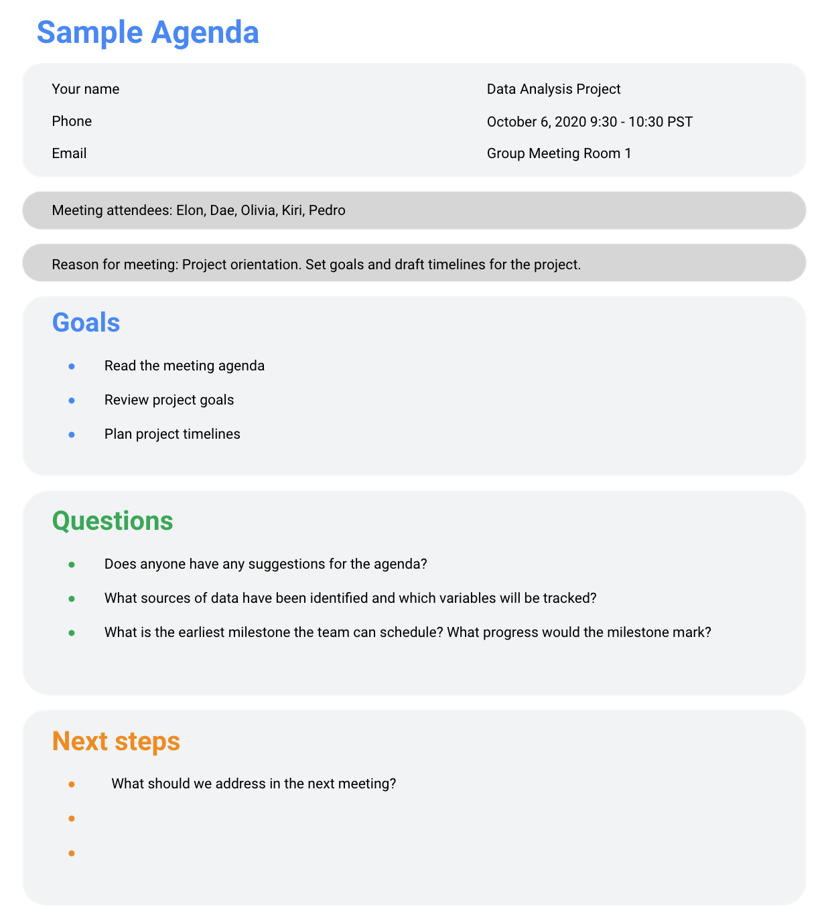

**Sharing your agenda ahead of time**

After writing your agenda, it's time to share it with the invitees. Sharing the agenda with everyone ahead of time helps them understand the meeting goals and prepare questions, comments, or feedback. You can email the agenda or share it using another collaboration tool.

**During the meeting**

As the leader of the meeting, it's your job to guide the data discussion. With everyone well informed of the meeting plan and goals, you can follow these steps to avoid any distractions:

* Make introductions (if necessary) and review key messages
* Present the data
* Discuss observations, interpretations, and implications of the data
* Take notes during the meeting
* Determine and summarize next steps for the group

**After the meeting**

To keep the project and everyone aligned, prepare and distribute a brief recap of the meeting with next steps that were agreed upon in the meeting. You can even take it a step further by asking for feedback from the team.

* Distribute any notes or data
* Confirm next steps and timeline for additional actions
* Ask for feedback (this is an effective way to figure out if you missed anything in your recap)

**A final word about meetings**

Even with the most careful planning and detailed agendas, meetings can sometimes go off track. An emergency situation might steal people’s attention. A recent decision might unexpectedly change requirements that were previously discussed and agreed on. Action items might not apply to the current situation. If this happens, you might be forced to shorten or cancel your meeting. That's all right; just be sure to discuss anything that impacts your project with your manager or stakeholders and reschedule your meeting after you have more information.