**Ariff Jeff**

# 3D Motion Graphics & Simulations

Web Design & Development

## Education

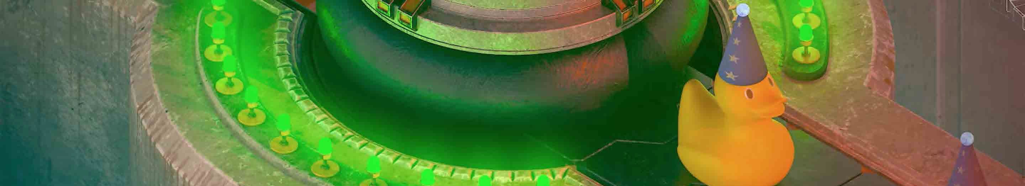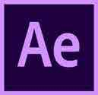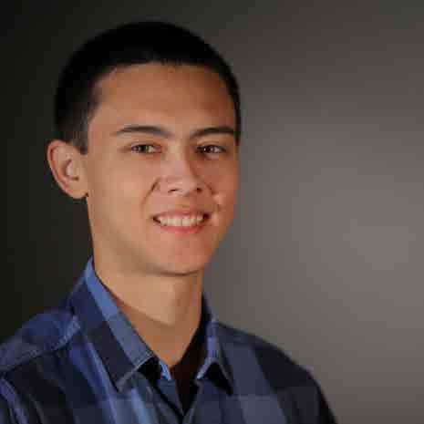

University of Connecticut

2016 - 2019

Bachelor of Arts Digital Media and Design

3D Animation and Visualization New England Scholar (2016) Dean’s List (2016, 2018)

CG Master Academy January - March 2019

Mastering Destruction in Houdini

**Skills**

Cinema 4D, Maya, Houdini, Nuke Substance Painter & Designer Arnold, Octane, Deadline Adobe Creative Cloud Photoshop, Illustrator

After Effects, Premiere Pro 3D Animation, Motion Graphics Simulations: Destruction

Hard surface modeling Retopology, UVs, Texturing Lighting, Rendering, Compositing

Python, JavaScript HTML, CSS, PHP, MySQL

GitHub Desktop MySQL Workbench

Visual Studio Code, Sublime Text

Windows, macOS HTC Vive, Oculus Rift MotionBuilder, OptiTrack Motive Fusion 360, SolidWorks Simplify3D, MakerBot

Bash, C#, Automator FileZilla, Excel, Trello Fencing, Rowing

Computer building and gaming

**Travel**

Los Angeles, Canada, Spain, United Kingdom, Southern Ireland,

Malaysia, France

**Portfolio**

[www.ariffjeff.com](http://www.ariffjeff.com/) [www.ariffjeff.com/demoreel](http://www.ariffjeff.com/demoreel) [www.artstation.com/ariffjeff_3dcg](http://www.artstation.com/ariffjeff_3dcg) [www.instagram.com/ariff_jeff](http://www.instagram.com/ariff_jeff)

**Contact**

[ariff.jeff@uconn.edu](mailto:ariff.jeff@uconn.edu)

+1 860-501-0121

[www.linkedin.com/in/ariffjeff](http://www.linkedin.com/in/ariffjeff) East Lyme, Connecticut

**Work Experience**

One Look Sign Company - Connecticut, September 2019 - Present Graphic Designer, Programmer, Sign Maker

* Develop with JavaScript to streamline repetitive pipeline procedures
* Secure clients’ approvals for sign artwork designed and proofed with Illustrator
* Print, cut, and mount vinyl to vehicles, machinery, coroplast, aluminum, wood
* Maintain workplace efficiency - manage incoming calls, schedule jobs with Trello

Trebel Music/UConn Student Agency, August 2018 - December 2018 3D Animator, Agency Member - Sponsored Dance Event

* Animated and projected giant looping motion graphic (Cinema 4D, Arnold, Deadline) at event
* Increased user engagement of Trebel’s mobile app in Connecticut by 13%
* Trebel achieved a new successful social media marketing strategy and campaign after our agency team presented plans and materials best representative of the Trebel brand

UConn Football Social Media Team, April 2017 - January 2019 2D & 3D Graphic Designer

* Design of 2D & 3D graphics for UConn Football social media (Photoshop, Cinema 4D, Arnold)
* Increased workflow speed of graphic production more than 10-fold with the testing and development of an automatic process to batch create Photoshop graphics
* Produced documentation of automatic batch process for future users

UConn Computer Graphics Club, September 2017 - May 2019 Club Member

* Gained experience and understanding on how to provide technical, constructive critique of 2D/3D artwork to student colleagues
* Learned how to receive the same constructive critique for my own artwork
* Engaged in sessions to learn Maya, Substance Painter, Arnold, Deadline, and After Effects compositing

UConn Blue Line Hockey Social Media Team, November 2017 - May 2018 Treasurer & Manager

* Trained to qualify as a treasurer by the university finance department
* Managed financial records in Excel and signing off transactions
* Liaised with UConn’s finance department for bookkeeping purposes

ns, Faster Than Light, Terraria, Natural Selection 2, Binding of Isaac, XCOM

ACM SIGGRAPH - Los Angeles, California, July 2017 Student Volunteer

* Facilitated presentation of unreleased Oculus Rift virtual reality experience previews to conference attendees
* General volunteer duties, directed attendees, implemented managerial directives

UConn Tasoglu Lab, September 2017 - May 2018 3D Graphic Designer

* Designed 3D medical journal cover graphic - Modeling, shading, lighting, rendering in Cinema 4D

Camp Med-O-Lark - Maine, June 2017 - July 2017 Camp Counselor Staff

* Taught and demonstrated 3D printing, 2D animation, stop motion, virtual reality (HTC Vive) to 8-16 year-old children
* General camp counselor duties, helped organize events, and responsible for children’s safety

East Lyme High School Fencing Team - Connecticut, November 2014 - March 2015 Head Fencing Captain

* Lead and taught fencing to 60-member team
* Director and advisor of fencers at tournaments
* Won 4th place in Eastern Connecticut Conference
* Best Foilist Award 2014 - 2015, Coach’s Award 2014, 2015

Kerbal Space Program, Subnautica, Factorio, Age of Mythology, Rise of