I want to create a new board game. But I can't think of all the details and balance of the game. Need your help to brainstorm. it should be physical board game + web app login to match id with user name for votes.
the story/idea: the spaceship crew knows that there are some aliens in the ship. those aliens can mask themselves as crew, so no one knows who are aliens, except for themselves. the ship has some critical points like engine, steering, oxygen system, etc. crew tries to keep them working normally. their main target is to restore the x-ray machine, which they will then use to check everyone and this machine can say whether a player is a crew or an alien, if its alien he dies. if all aliens are dead crew wins. Who will go to x-ray machine for check is decided by voting. For repairing this machine crew must collect some resources and spend steps on it. when repairing x-ray machine, player can chose to really try to repair it, or sabotage the repair of that day. If he sabotages, then repairing is not progressing. But if player (doesnt matter alien or crew) tries to repair it, its 60% chance that it will be repaired and 40% chance that it will not. So this kinda helps the alien. Also when other critical points are broken (aliens break them secretly), then someone has to spend a step to fix it. Without fix this part can go 3 steps and then whole spaceship crashes, crew dies and aliens win.
There must some sort of a thing like round.
This is very roughly written. lets first think about the storyline, steps, web app control of the whole game. Also there must be a time for everyone to discuss in real life between the rounds.
whole game process is happening turn based and is ruled by the web app. after all players acted, round ends and starts the next round.
One game should go approximately 1 hour.
Thought for 3m 33s
Your worry is right to have, and the answer is interesting. Let me deal with it first, because it changes one rule.
The reactor problem
The problem only exists if breaking a room is free damage. So make it cost exactly one action, never more:
New rule: if a room is broken and people work there, one of them fixes it. Everyone else in that room does their normal job.
So if two crew are in the Reactor and an alien breaks it, the room is fixed and you still get 1 power cell. You lost one cell, not two.
Now look at what this does to the alien's thinking. Breaking a room always costs the crew exactly one action. But breaking a busy room gets fixed automatically, because people are already standing there. Breaking an empty room forces the crew to notice it, remember it, and send someone away from useful work.
So breaking the Reactor is the weakest break in the game. Aliens will break Steering and Oxygen instead, because nobody is there. Your worry solves itself through strategy, not through an extra rule.
There is also a bigger reason aliens will not spam breaks. They only get one sabotage per round for the whole team. Every round they spend breaking a room is a round they are not corrupting the X-ray repair. If aliens break every round, the crew builds the machine in four or five rounds and wins easily. The alien's strongest line is to sit in the Med bay and corrupt — which is also the most dangerous place for them to keep standing.
If it still goes wrong in testing, add this safety rule to the app: a room cannot be broken again in the round right after it was repaired. One line, and it guarantees the Reactor is always free at least every second round.
New map: five rooms
Comms is gone, so Jam is gone too. Movement is also simpler now.
You can move to any room you want. No walking rules.
But sabotage travels through pipes. You can only sabotage the room you are in, or a room connected to yours by a pipe. Corrupt is the exception — you must be inside the Med bay.
The five rooms form a ring, plus one pipe across the middle:
Steering – Reactor – Cargo bay – Med bay – Oxygen – back to Steering, plus a pipe between Reactor and Med bay.
Room | What Work gives you | Can break?
Cargo bay | 2 scrap | no
Reactor | 1 power cell | yes
Med bay | X-ray repair, 60% chance | no
Steering | nothing | yes
Oxygen | nothing | yes
The vote, your version
Step 1. Everyone votes on their phone. You can vote for any living player. All votes appear on the TV with names, so everyone sees who voted for whom.
Step 2. The player with the most votes goes into the X-ray machine.
Step 3. If two or more players are tied, those players go to a second vote. Everyone votes again, but only for the tied players. A tied player cannot vote for themselves.
Step 4. If the second vote is also tied, nobody is scanned and the 2 power cells are not spent.
Two things I would add:
Add a Skip button in the first vote. Sometimes the crew wants to save the power cells for a round when they are more sure. If Skip gets the most votes, nothing happens and nothing is spent.
Decide whether a player may vote for themselves in the first vote. If yes, it becomes a bluff move — an alien can vote for themselves to look brave, knowing nobody will follow. I like it, but it is your call.
The alien screen
Your solution is correct and I would not add anything to it. Aliens use the same screen as everyone else, at the same time, with the same number of taps. Pick a room, pick what you do there.
If both aliens press Sabotage, the app picks one at random and the other one simply works. No private message is needed, because the alien can work it out from the public result. If you pressed "break Oxygen" and Oxygen did not break, your partner acted instead. Silent, invisible, no phone staring.
Now let me show you the TV.
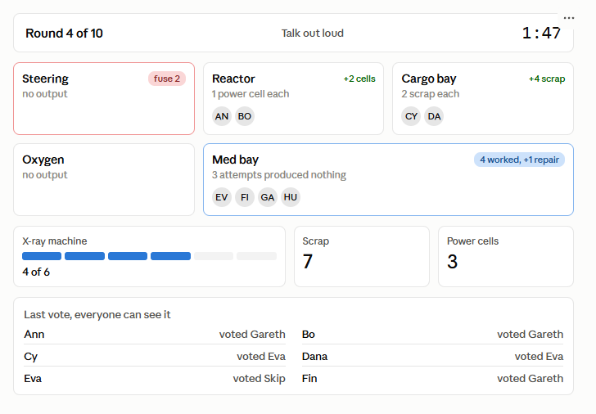
The TV is now the whole game. Each room card shows who is standing there and what that room produced. That is the puzzle in one picture: four people worked on the X-ray machine and only one point of repair came out, so three attempts gave nothing. Bad dice, or a liar in that room.
What the TV must show: round number, phase name, big timer, all five rooms, who is in each room, what each room produced, broken rooms with their fuse number, scrap, power cells, the repair track, and the full vote with names.
What the TV must never show: what any single person chose, who sabotaged, or individual dice results. Only room totals. That rule is the whole game.
What the phone shows: almost nothing. Your secret role at the start, then each round one screen with two questions. Pick a room. Pick what you do. Lock it in. During the vote, a list of names to tap. That is all. Everyone taps the same number of times.
This is actually better than a cardboard board. Everyone looks up at the same screen instead of down at the table, so you keep seeing each other's faces.
Updated alien options
Jam is gone with Comms. Three options left:
Sabotage | Where you must be | What it does
Break | Your room or a room connected by pipe | Steering, Reactor or Oxygen breaks. Fuse starts at 3.
Corrupt | Inside the Med bay only | Spends 1 scrap, no repair progress. Looks like bad luck.
Steal | Cargo bay or Reactor | Destroys 2 scrap or 2 power cells.
Numbers, updated
Thing | Value
Players | 8 (2 aliens)
Rooms | 5
Rounds | 10
Repair track | 6
Repair success | 60%
Scan cost | 2 power cells
Fuse | 3 rounds
Sabotages per round | 1 for the whole alien team
Round length | about 4 minutes
One small warning. Removing Comms took away one place for crew to waste actions, so the crew is now slightly faster than before. If the crew wins too easily in testing, raise the repair track from 6 to 7 before you touch anything else. It is the safest dial.
The next useful thing I can write is the screen-by-screen spec for whoever builds the app: every screen, every button, what the server stores, and the exact order things resolve in each round. Say the word and I will write it as a file you can hand over.
ok, can you write a prompt to create this game? I will pass it to Claude Code Agentic coding. Also write a nice prompt for the image generation, because I want the whole game map to be nice animated style image.
Let it be version 1. You can even create an md file for the prompt
Check which public skills exist before writing markdown files
No markdown skill here, so I'll write these directly.
Created 2 files, shared files
Two files.
The build spec is written as a full brief, not a chat message — drop it in the repo as SPEC.md and tell Claude Code: "Build the app described in SPEC.md. Start with section 19, step 1, and do not write any UI until all tests in section 18 pass." That instruction matters. The game engine is a pure function and it is where every balance bug will live, so it should be testable without a browser.
Two things in the spec I want to flag, because they are the parts an agent is most likely to get wrong:
Section 8, step 4. When a broken room gets repaired, only one worker is consumed and the rest still produce. That is the rule that fixes your reactor worry. An agent will naturally write "broken room produces nothing," which is the intuitive version and the wrong one.
Section 16. Hidden information leaks are silent — the game looks like it works while someone with dev tools open can read every role. That is why there is a snapshot test for it.
For the image, generate the whole map first. If the model keeps scrambling the five-room layout (likely — models are bad at "top row, bottom row" instructions), fall back to the five separate room tiles and let the app draw the pipes. That version is also easier to re-theme later.

