Online Order Management System (OOMS)
(An ERP Module for Buying House)

Group Members

Anupom Roy [011071016]
Rimon Arifin [011081016]
Mahfuzur Rahman [011071017]

Under the supervision of
Suman Ahmmed
Assistant Professor &
Director of Student Affairs
Department of Computer Science and Engineering

United International University
Declaration
This is to certify that this project is our original work. No part of this has been submitted elsewhere partially or fully for the award of any other degree. Any material reproduced in this project has been properly acknowledged.

Student’s Name Signature

Anupam Roy Mahfuzur Rahman

Rimon Arifin

Approval
The Software Project titled “Online Order Management System” has been submitted to the following respected members of the Board of Examiners of the Faculty of Computer Science in partial fulfillment of the requirements for the degree of Bachelor of Science in Computer Science and engineering on 15th September 2012 by the following students and has been accepted satisfactory

Suman Ahmmed
Assistant Professor &
Director of Student Affairs
Department of Computer Science and Engineering
United International University
Index
Introduction
Declaration 2
Approval 3
Acknowledgement 6
Preface
Introduction
- Project Overview
- Overview 9
- Why this Online Order Management System 9
- Overall Descriptions
- Product Perspective 10
- Product Features 10
- User Classes and Characteristics 10
- Operating Environment 11
- Design and Implementation Constraints 11
  - Design Constraints 11
  - Assumptions and Dependencies 11
- System Architecture
- System Architecture 12
- Used Technology Products 13
- UML Diagrams
- Use Case Diagram 14
- Entity Relationship Diagram 18
- Sequence Diagram 23
- Activity Diagram 25
- Class Diagram 26
  - Class Diagram of Profile Controller 26
  - Class Diagram of Category Controller 27
  - Class Diagram of Order Controller 28
  - Class Diagram of Profile Controller 29
  - Class Diagram of Report Controller 30
  - Class Diagram of Chart Controller 31
- UML Diagrams
- Registration Panel 32
- Login Panel 33
- Create Profile By House admin 34
- Create Category By Buyer 35
- Place Master Order With Specification By Buyer 36
- Master Order View 37
- Sub Order 38
- Delivery Info 39
- Report Panel 40
- Delivery Status On Chart 42
- Chart View of Order Value 43
- Limitation And Future Plan
7.1 Limitation 45
7.2 Future Plan 45
- Conclusion
8.1 References 46

Acknowledgement

We are very grateful to our honorable project supervisor Suman Ahmmed for his continuous support, assistance, instruction and encouragement, without which our work would have never been completed.

We would like to give special thanks to Mr. Jahidul Islam (CTO) and Md. Johirul Islam (SA) of Elucidation Corporation Ltd (ECL) for their regardless support through the whole project.

We have individually appreciated being on the “Online Order Management System” team, where we have learned a lot about the inner workings of this project.

Preface

This project is concerned with the Online Order Management System. Our goal is to examine how this project can help Buying Houses to manage their order management system as well as to help the foreign Buyers to get update about their orders at any time from web.
The motivation for this project is to create a web based order management system in contrary to our traditional paper based system.
It was a very critical situation when we were about to start out project. But with due and proper guidelines from our honorable project instructor Mr. Suman Ahmmed, we at last found our motivation and have completed this project. Another name I would like to mention Mr. Jahidul Islam for his regardless support to complete this project.
All the team members of this Online Order Management System express their gratitude to those who have helped gestation of this project.

Introduction

In Bangladesh, Garments sector has broadly emerged. It has a large contribution in our economy. There are more than 500 Buying Houses and more than 3000 Garments factories in our country. As most of the buyers are from foreign countries first problem buying houses face is to contact with buyers and gain their trust. Buyers have to be concern about their order progress. This Online Order Management System is designed to overcome these problems. Here Buyer, Buying House and Factory all three users will interact with each other through internet at any time, which will help everyone to get update. Thus a buyer do not have to be concern about their order progress as he can get update about the order progress at any time at anywhere in the world through internet. As this is the first version of the project it has many lacking like it doesn’t have the account module, HRM module. But we believe further work on this project would lead it to a successful web application in future.
The main objective of this document is to illustrate the requirements of the project “Online Order Management System”. The document gives the detailed description of the both functional and non functional requirements for this web application. The document is developed after a studying the requirement specifications of the Project.

Chapter 1: Objective & Ideal Characteristics of OOMS

- Project Overview

  - Background

In this age of technology, Internet has played a vital role. Many software solutions are now web based rather than desktop based. This is possible because of the convenience that Internet has given us; the ability to access it from anywhere of the world. The mobility and robustness of Internet has motivated us so much that we decided to put our efforts into action and do something useful with this technology. So we picked “Online Order Management System “as our project and tried to make it as user friendly and secure as possible.
The main purpose of the project is to develop an ‘Online Order Management System’ for Buying Houses.

- Why this Online Order Management System

The main objective of this project is to develop a web based ERP system for garments sector. There are many ERP softwares in the market these days. But most of them are desktop based. In garments sector most of the factory use their own ERP system which is desktop based. Our Online management system is designed for web thus a new dimension is opened. Its key feature is a buyer don’t need to concern about his order while it is processing. T hey can get the status of their order at anytime through internet, which wasn’t possible earlier as there was no way to check their order progress status. User will have access to the site from anywhere in the world, all they need is a computer with Internet connection.

2. Overall Descriptions

2.1 Product Perspective

The product is intended to design a web application for Garments sector of our country. Buying House admin is the prime client of this web application. Other users are Factory members and Buyers who will be registered under specific Buying House.

2.2 Project Features
The key features of this project are:
- Buyer can place master order from anywhere in the world for specific buying house.
- Buying house admin can distribute the master order to factory as sub order.
- Factory admin can give the delivery report online against a sub-order.
- Buyer can get delivery progress status at anytime through internet.
- Buying house can get report on commission and master order value.

.

2.3 User Classes and Characteristics

There will be 3 types of users in our project
- Buying House Admin
- Buyer
- Factory Admin

2.4 Operating Environment

The product is developed using ASP.NET 4, C# and SQL server 2008 which can run in .NET Server and SQL Server. The software runs well on almost all available web browsers, including the ones in mobile phones. Namely:

- Internet Explorer
- Fire Fox
- Maxton
- Opera
- Netscape
- Net Front
- Chrome
- Dolphin

2.5 Design and Implementation Constraints

Product is developed using ASP.NET 4. The backend is supported by SQL Server 2008. The product is accomplished with login Employers so that specific function is available to specific user. Also additional security is provided by ASP.NET 4 used during development.
The system requires a database in order to store persistent data. The database should have backup capabilities.
The development of the system will be constrained by the availability of required software such as web servers, database and development tools. Much better results are expected when it will be deployed on the real environment.

2.5.1 Design Constraints
The system must be designed to allow web usability. That is, the system must be designed in such a way that will be easy to use and visible on most of the browsers. The designing was done with long term service and ease of maintainability in mind.

2.5.2 Assumptions and Dependencies
The product needs the following third party libraries and software:
- .Net (ASP.NET 4)
- SQL Server 2008
- JQuery
- Google Chart API
- Java script

- System Architecture

3.1 System Architecture
Our proposed system follows “MVC architecture”. Model–View–Controller (MVC) is a computer software design pattern that separates the representation of information from the user's interaction with it. The model consists of application data and business rules, and the controller mediates input, converting it to commands for the model or view. A view can be any output representation of data, such as a chart or a diagram.
My system architecture is based on MVC 3 architecture:
Model
The Model is the actual data representation (for example, Array vs Linked List) or other objects representing a database.

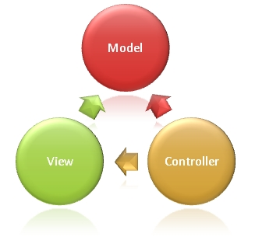
Fig 1: MVC architecture

View
The View is an interface to reading the model.
Controller
The Controller (here implemented in C#) provides the interface of changing or modifying the data, and then selecting the "Next Best View" (NBV).

- Used Technology Products

Listed below technology have been used in these projects proposed:
- ASP.NET framework 4
- C#
- SQL Server 2008
- JavaScript
- JQuery
- Photoshop
- HTML
- CSS

Requirements

- Domain Server for hosting application
- SQL Server 2008 Database
- Third Party Security Software (optional)
- Third Party Server Load Management Tools (optional)
- High Speed Internet Connection
- Power Backup (UPS)

Chapter 2: UML Diagrams
“The UML is a powerful and effective means of describing and managing business and software development projects. A UML tool like Enterprise Architect is the best way to leverage the power and scope of UML 2.3 for all your UML Modeling requirements.”

1. Use Case Diagram

In software and systems engineering, a use case is a list of steps, typically defining interactions between a role or an actor and a system to achieve a goal. The actor can be a human or an external system.

As here we have three types of users
- House Admin
- Factory Admin and
- Buyer
We are going to break down our use-case diagram into three sections for simplicity.

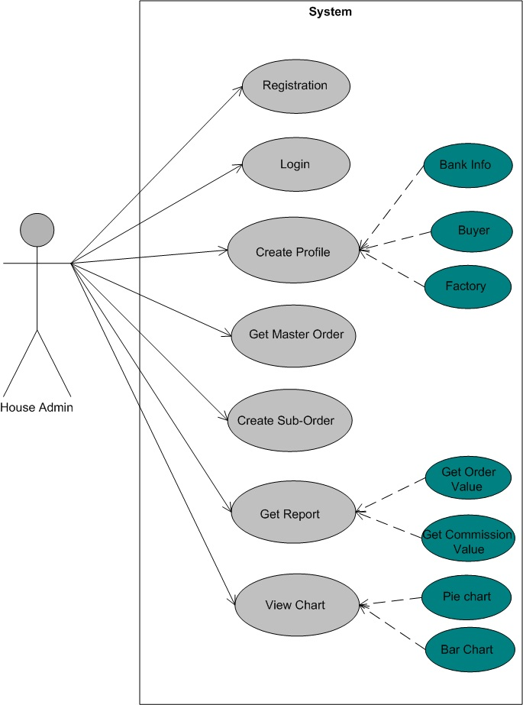
Fig 1.1: Use Case of House Admin

A Buying House is our prime client. House admin have to register first. Then after login he can create different profiles for buyer and factory with which buying house will work. After that his clients (buyer and factory admin) can login and access their own features. House admin also can distribute master order to factories and get some reports like total commission value, total product value.

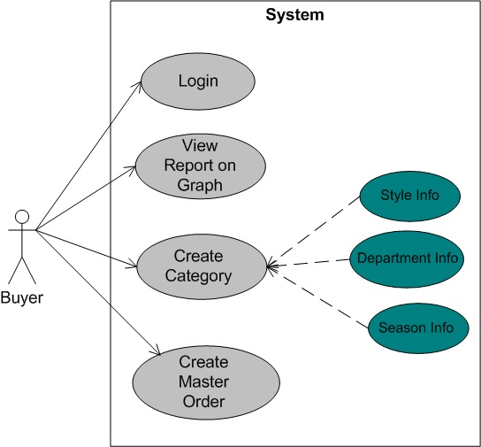
Fig 1.2: Use Case of Buyer

Every buyer in our system is under a specific buying house. All the features of a buyer are associated with one buying house. He have to login to the system to access his features. For a buyer the interface will be different. A buyer can place a master order with its specification for his associated house. He can get the update of delivery report of a specific master order in bar chart graph view, with which he is actually concerned.

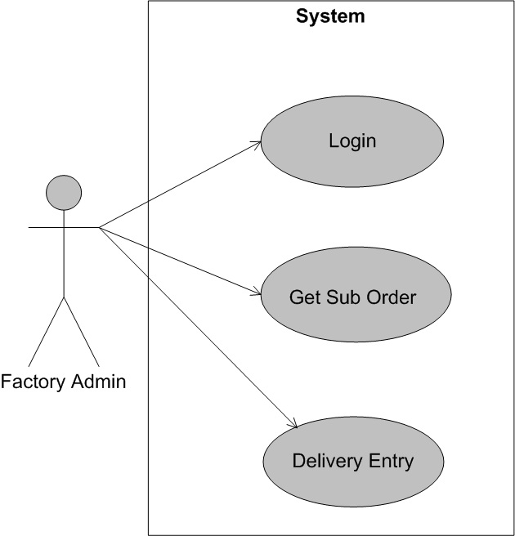
Fig 1.3: Use Case of Factory Admin.

Factory Admin will get all the assigned sub order of a buying house when he will login. Factory admin will not know which sub order is under which master order. And he can give delivery entry for a specific sub order.

2. Entity Relationship Diagram
In Software Engineering, an Entity-Relationship Model is an abstract and conceptual representation of data. Diagrams created by this process are called entity-relationship diagrams or ER diagrams.
Our proposed system’s ER Diagram is given below:

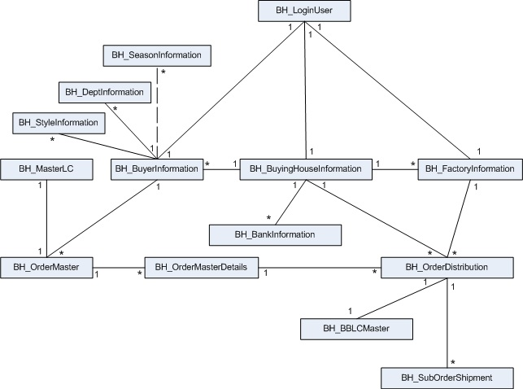
Fig 2.1: ER diagram OOMS

Here we have break down ER diagram of the whole system into four parts.

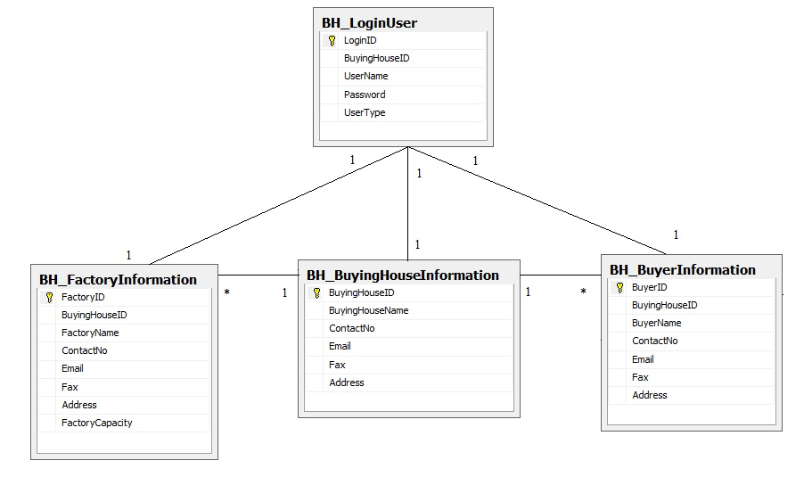

Fig2.2: ER Diagram of 3 types of user

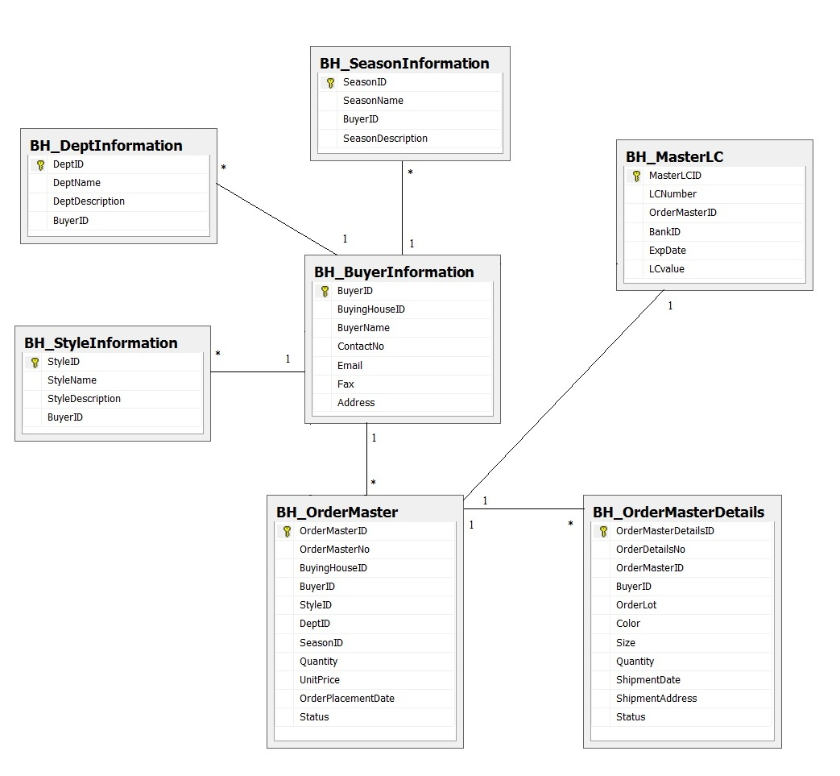

Fig2.3: ER Diagram for Buyer

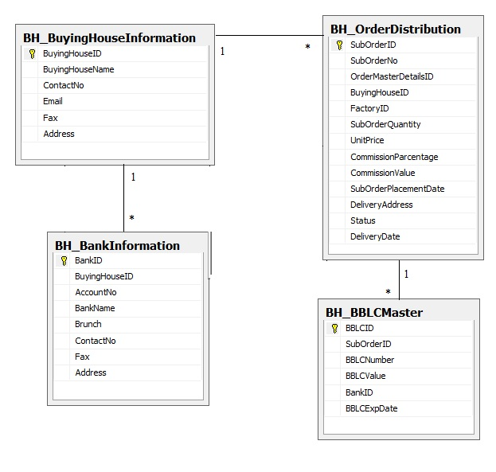
Fig2.4: ER Diagram of Buying House

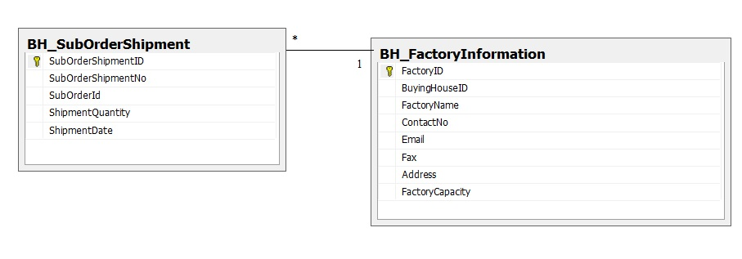

Fig2.5: ER Diagram for Factory

3. Sequence Diagram

A sequence diagram in a Unified Modeling Language (UML) is a kind of interaction diagram that shows how processes operate with one another and in what order. It is a construct of a Message Sequence Chart. A sequence diagram shows object interactions arranged in time sequence. It depicts the objects and classes involved in the scenario and the sequence of messages exchanged between the objects needed to carry out the functionality of the scenario. Sequence diagrams typically are associated with use case realizations in the Logical View of the system under development.

In our system a buying house will first register itself. Then it can get logged into system with his username and password. After that house admin can create profiles of buyer and factory with whom he will work.
The buyer will create some categories information and place a master order for house. House admin will get the order list with specification and will distribute it into factories and create sub-order. When factory admin will logged in he will get the sub-order information and he can entry the delivery information against a specific order. System will update the delivery status or the sub-order and master order.
Buyer can also check the status or his master order at anytime in graph view. As well as house can also check some reports. Total commission value and total order value with filter option and in graph view.

Here is the Sequence diagram of our proposed system.
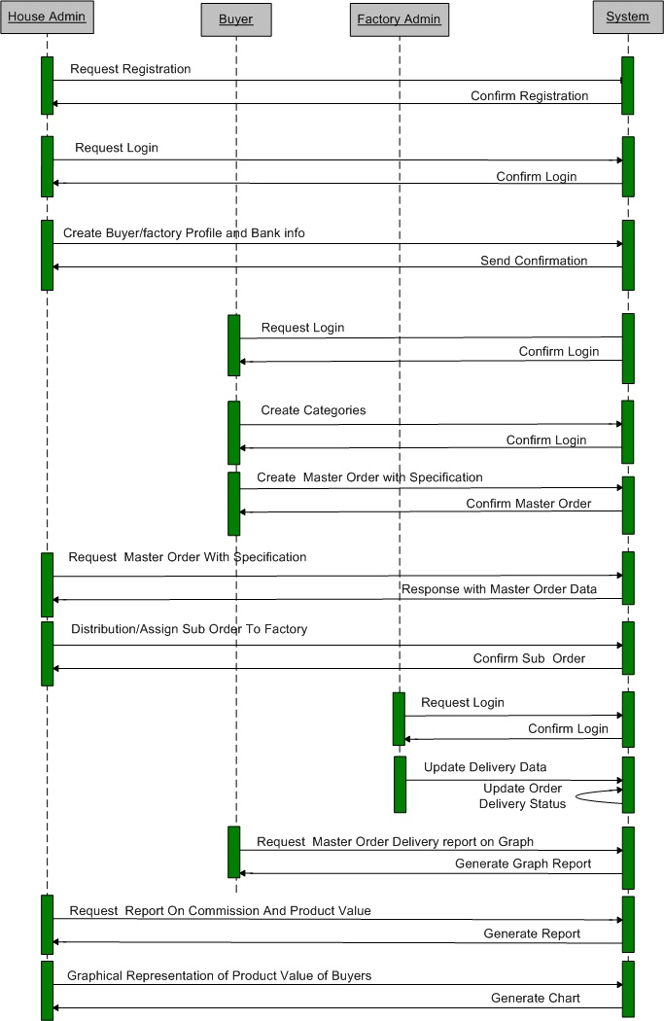

Fig3: Sequence Diagram

4. Activity Diagram
Activity diagrams are graphical representations of workflows of stepwise activities and actions with support for choice, iteration and concurrency. In the UML, activity diagrams can be used to describe the business and operational step-by-step workflows of components in a system.
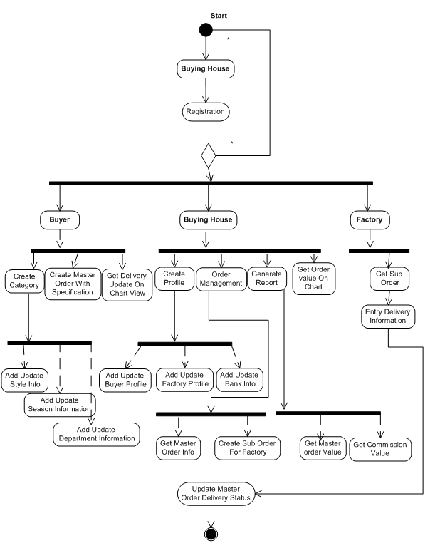

Fig 4: Activity Diagram
5. Class Diagram

In software engineering, a class diagram in the Unified Modeling Language (UML) is a type of static structure diagram that describes the structure of a system by showing the system's classes, their attributes, operations (or methods), and the relationships among the classes.

In MVC architecture Class diagram consist of Model class, Controller class and view.

5.1 Class Diagram of Profile Controller

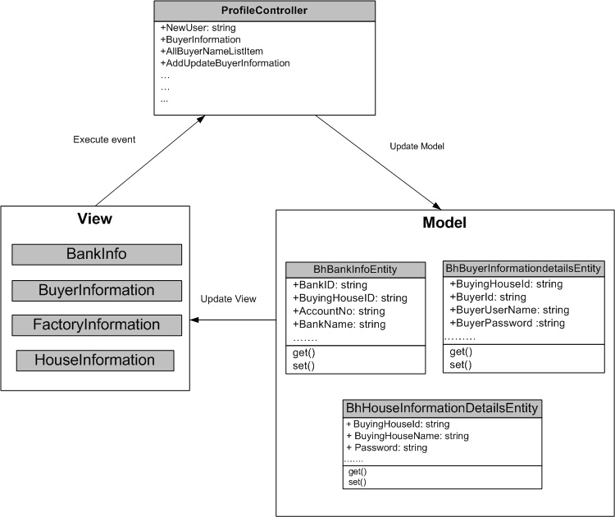

5.2 Class Diagram of Category Controller

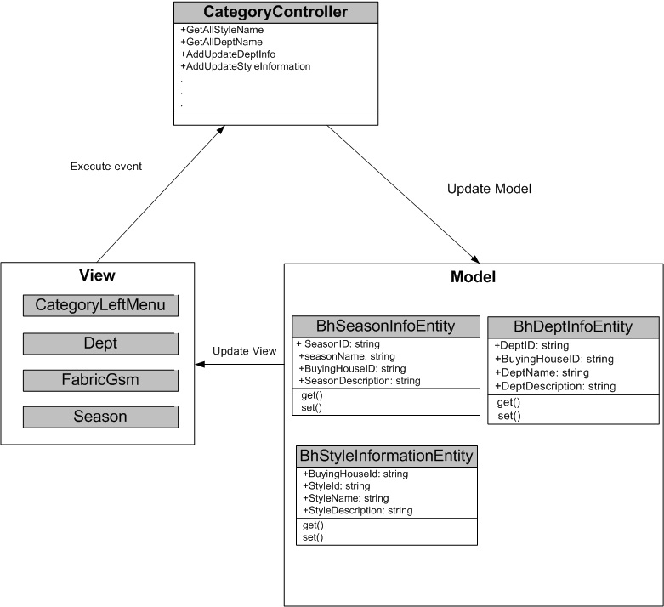

5.3 Class Diagram of Order Controller

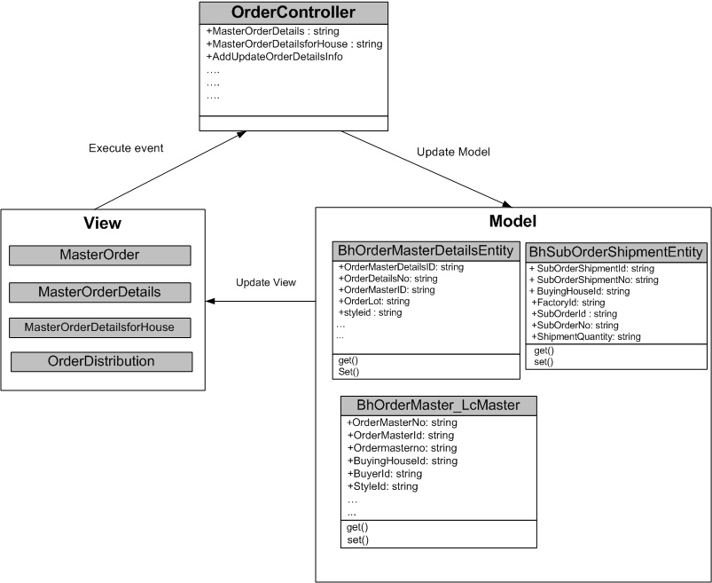

5.4 Class Diagram of Profile Controller

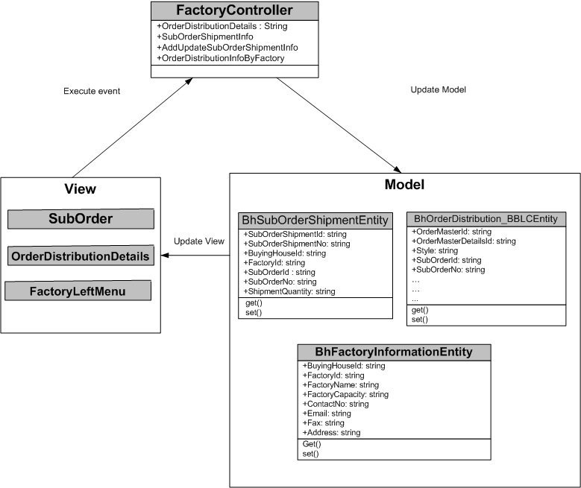

5.5 Class Diagram of Report Controller

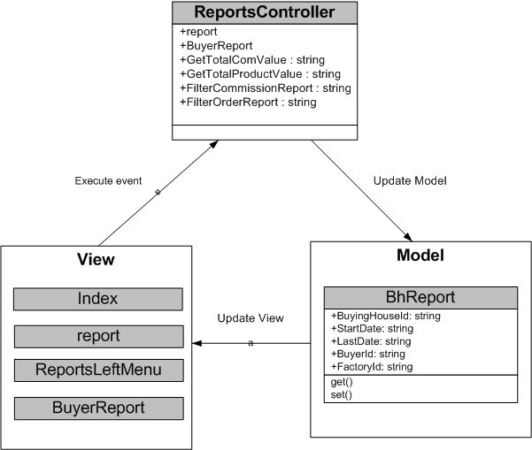

5.6 Class Diagram of Chart Controller

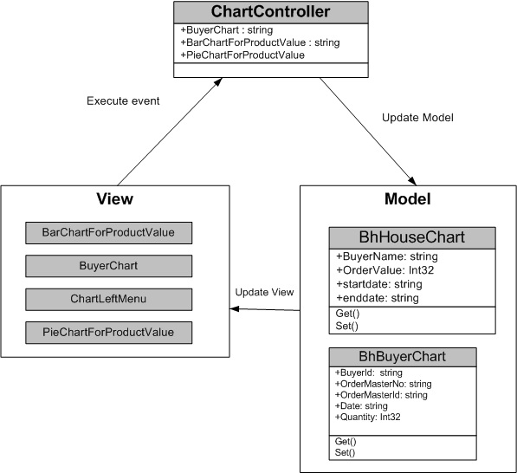

6. UI Design

User Interface or UI is the design of Software Applications with the focus on the user's experience and interaction. The goal of our system’s UI design is to make the user's interaction as simple and efficient as possible, in terms of accomplishing user goals - what is often called “user centered design”
6.1 Registration Panel

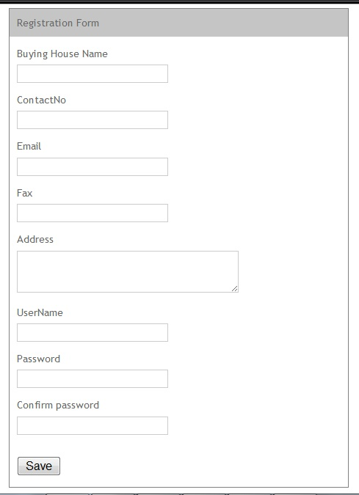
Fig 6.1: Registration page

6.2 Login Panel

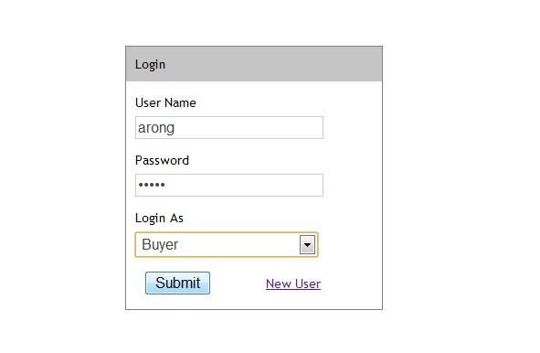

Fig 6.2: Login View page

This is the login panel. Every registered user or profile created by registered user has to be login to access their features. Here a user have to login with a specific user type.

6.3 Create Profile by House Admin

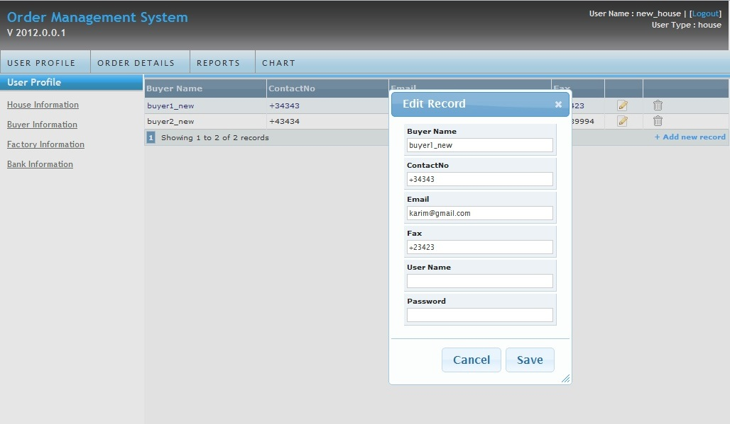

Fig 6.3: Create Buyer/Factory profile

A registered buying house can create Buyer and Factory profile with whom that house will work.
6.4: Create Category by Buyer

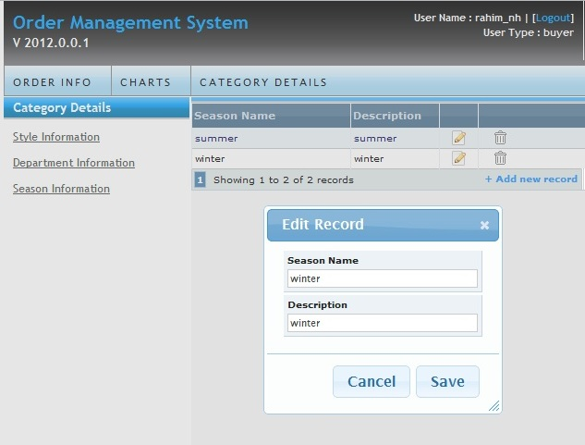
Fig 6.4: Create Category by Buyer

A registered buyer under a specific buying house can create and update category information for his order.

6.5: Place Master Order with Specification by Buyer

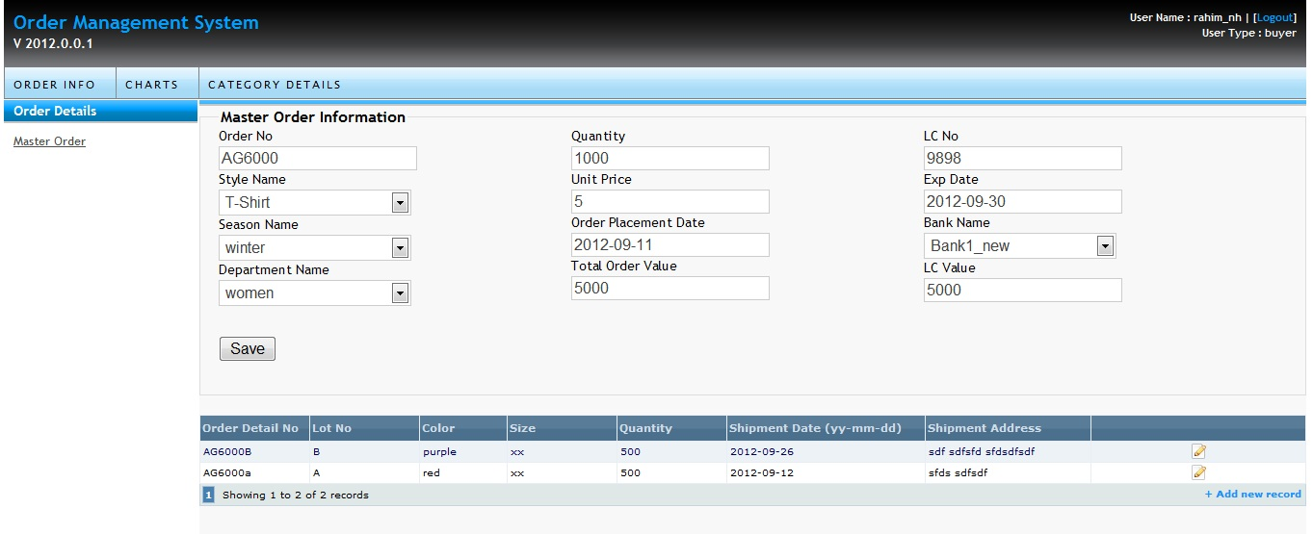

Fig 6.5: Create master order with specification

This panel is used for Placing Master Order with specification. Only Buyer can Place or create an Order and House Admin can Get the information of master order but cannot edit it.
6.6: Master Order View

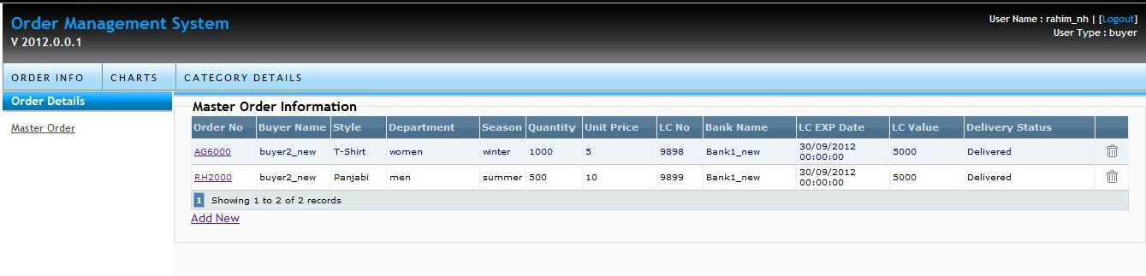
Fig 6.6.1: Master Order list view

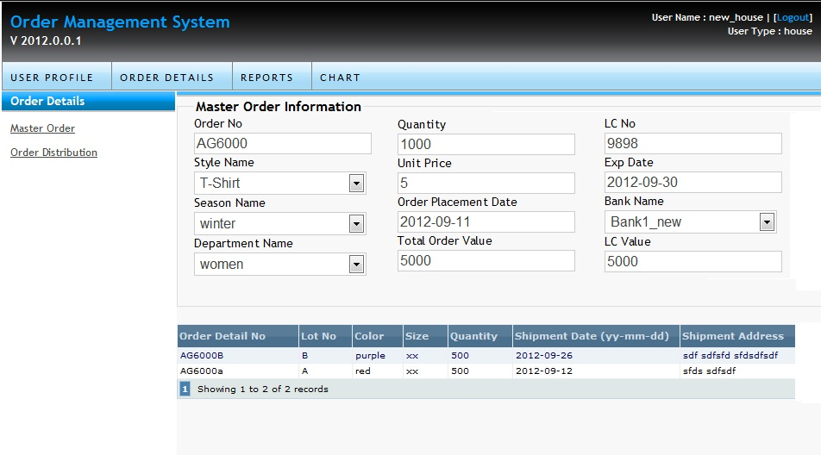
Fig 6.6.2: Master Order Specification view

A master order list will be available for both buyer and buying house though house can’t edit/add/delete any master order. Only buyer has those options to create, delete or edit. When user will click on a specific master order it will come up with its all specifications. Again a house admin can’t edit those specifications.
6.7: Sub Order
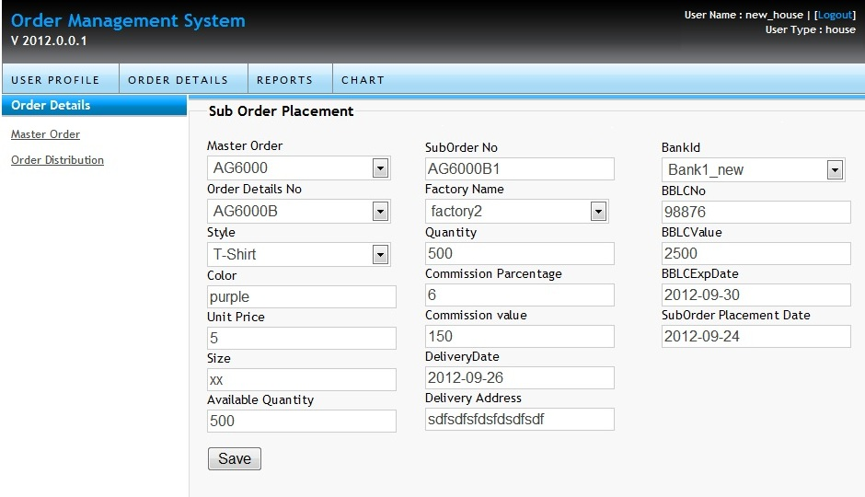
Fig 6.7: Create sub order by House Admin

A buying house admin can create sub order. He can edit the sub orders. Sub order will be created against the order specification for a specific factory with a BBLC.

6.8: Delivery Info
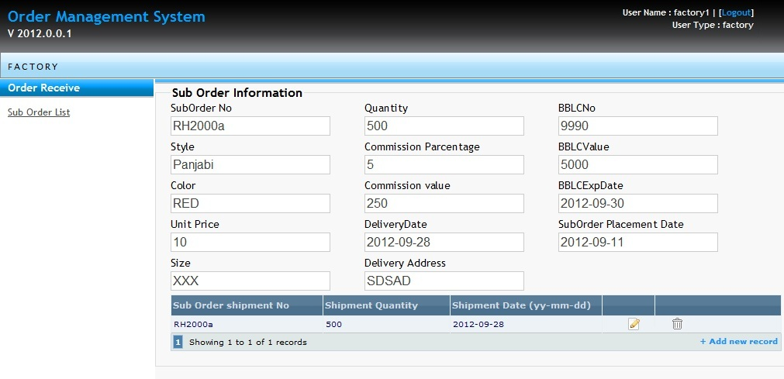
Fig 6.8: Delivery Info Entry

When a factory admin will login he will get the sub orders placed for that specific factory. He can get the list view but can’t edit or delete them. When he will click on the specific sub order he will get all the data of the sub order. Then he can give entry of the delivery information for specific sub order, based on that system will update a master order delivery status.

6.9: Report Panel
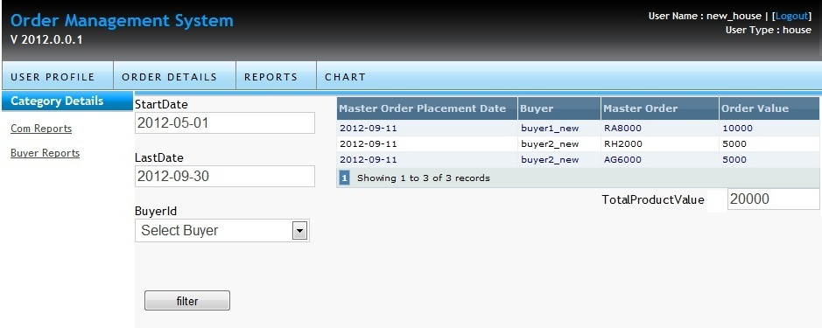
Fig 6.9.1: Total Product value report

System will generate some reports for a buying house. A house admin can get the report of total commission value or total order value. System has features to filter those data based on specific user and within a specific date range.
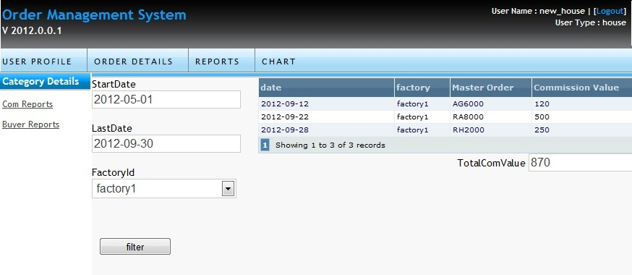
Fig 6.9.2: Total Commission value report
6.10: Delivery Status On Chart.

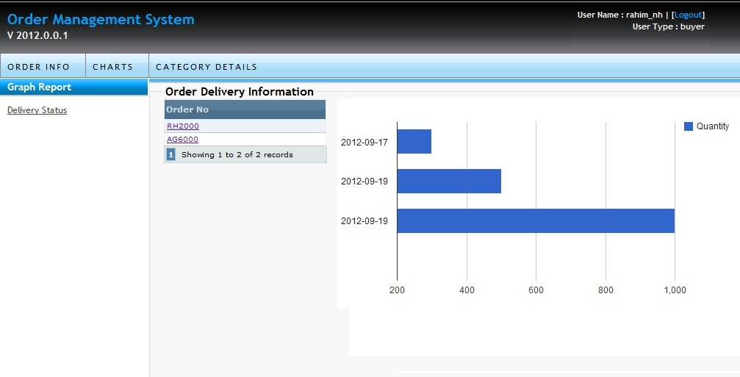
Fig 6.10: Delivery report on graph view

The key part of the application is that a buyer can get the delivery information at any time through internet on a bar chart graph.

6.11: Chart view of order value.

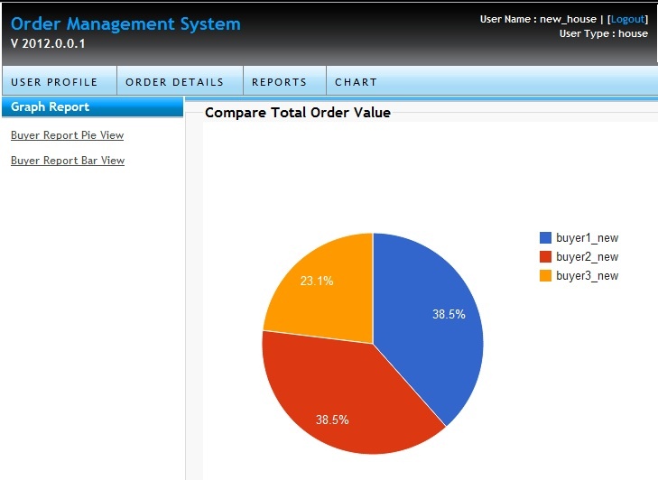

Fig 6.11.1: Total Order value report in pie

There is some other chart view for a house admin to comparison the master order value with different buyers. This part has been done with Google chart view API. It will give a easy understanding look on the order value of different buyers. There is another bar char t as well with filtering option.

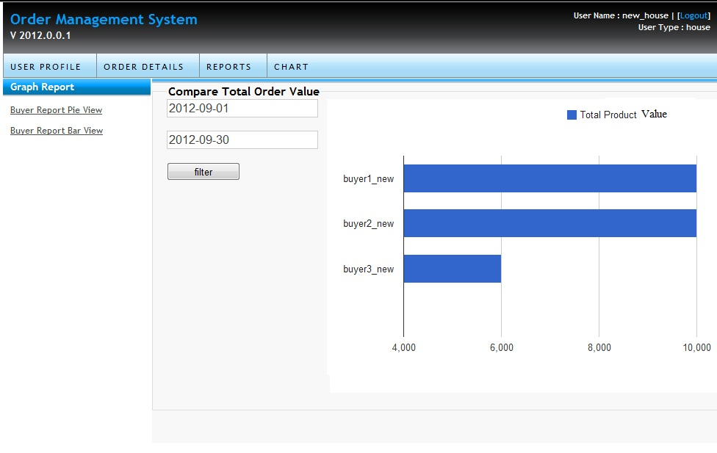 Fig 6.11.2: Total Order value report in bar
Chapter 3: Limitations & future Plan
1. Limitations

To comparison to the ideal characteristics of an ERP module “Order Supply and Management System” there should be the following functional characteristics, which we don’t have yet:

- Customized attributes of order.
- Assign specific role for users.
- Customized Access Control
- Accounts management.
- Generate accounting reports.
- Send registration confirmation to email.
- Custom Validation between jTable plug-in and html form.
- Restriction on deleting data which is on progress.

3. Future Plans

As this is the first version of the project there are many further scopes to work with
- Customization of attributes for an Order.
- Dedicated Order management system for individual buyer
- Buyers and Buying House can get information about each other from the web site before any contract.
- Generate crystal reports.

Chapter 4: Conclusion

References

- Article on - AJAX based CRUD tables using ASP.NET MVC 3 and jTable jQuery plug-in
By Halil Ibrahim Kalkan
- A book Witten by Grady, Rumbaugh, James, Jacobson, Ivar Booch- THE UNIFIED MODELING LANGUAGE USER GUIDE.

- http://www.w3schools.com/aspnet/
- http://www.w3schools.com/js/
- http://www.asp.net/get-started. ASP, March 1, 2012.
- http://www.w3schools.com/css. January 27, 2012.
- http://html5demos.com. January 27, 2012.
- http://stackoverflow.com/
- http://en.wikipedia.org/wiki

----- THE END -----

