

**KOLEJ PERMATA@PINTAR NEGARA UNIVERSITI KEBANGSAAN MALAYSIA  
 DIGITAL INNOVATOR PROGRAMME (DIP)  
 ASSESSMENT 2 SEMESTER 2 2024/2025**

**COMPUTER SCIENCE (CS) SQL EXERCISE  
 WRITTEN REPORT ON LIBRARY DATABASE (10%)**

PREPARED BY: ARIF ALAUDIN 1K5  
DATE OF SUBMISSION: 17 DECEMBER 2024

# 

**GUIDELINES FOR CONTENTS**

A **softcopy** on a report consists of:

i. A pdf format and rename as: *Tang_Chee_Keong_1K5*.pdf

ii. Cover page: Name, Matric, Class

iii. Format style:

Font style: **Times New Roman**

Font size: **12**

Paragraph alignment: **justified**

Line spacing: **1.15**

#### 

#### **TABLE OF CONTENTS**

**TABLE OF CONTENTS 2**

**1.0 TABLE STRUCTURES 2**

1.1 Creating a table 2

**2.0 REQUIRED OPERATIONS 3**

2.1 Data Entry 3

2.2 Basic Queries 4

2.3 Data Manipulation 5

**________________________________________________________________________________________________________**

#### **1.0 TABLE STRUCTURES**

##### **1.1 Creating a table**

To create a table “books” with

* book_id (Primary Key)
* title
* author
* borrowed_date (YYYY-MM-DD)

We can create the following code in HeidiSQL (or any SQL editor like MySQL, etc.)

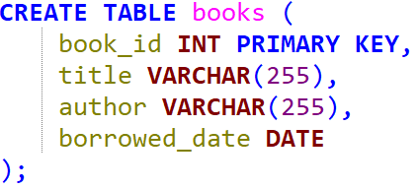

We can also make the primary key to **auto increment** by putting the “AUTO_INCREMENT” keyword inside book_id.

Another keyword we can put is “NOT NULL” inside the title and author to make sure the data inside title and author is not empty.

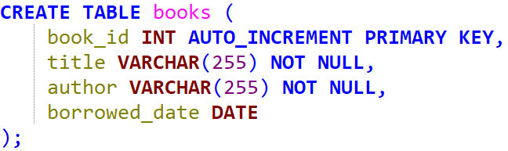

The table will now look like this, with no rows inside.

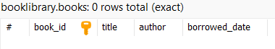

**________________________________________________________________________________________________________**

#### **2.0 REQUIRED OPERATIONS**

##### **2.1 Data Entry**

To add values inside the table “books”, we can use “INSERT INTO books VALUES ()”.

But since we already have auto increment in book_id, we need to specify that we are only adding values into title, author and borrowed_date.

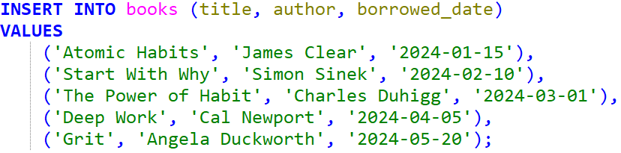

So, our table now looks like this, with additional rows.

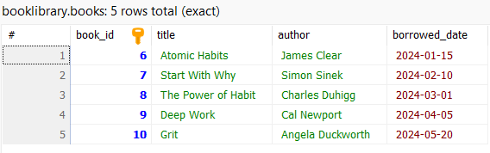

##### **2.2 Basic Queries**

To find and list all books, we can select everything (symbol “ * ”) from the table “books”.

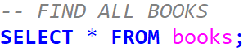

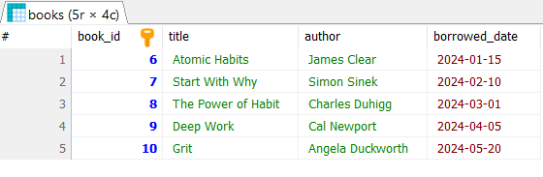

To find books by a specific author, we can select everything from the table (like the example above), but this time having a WHERE clause.



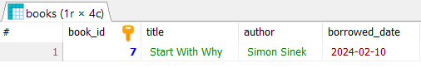

To find books that are borrowed on a specific date, we can use the same method as the above. This time having the WHERE clause in a different column.



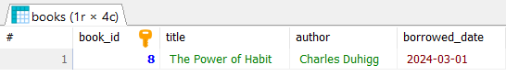

Using the same method as above, we can also find the books borrowed after a specific date, using a different operator “ > “ rather than the equal sign “ = “.



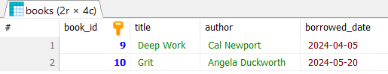

##### 

##### **2.3 Data Manipulation**

To update the borrow date of a book, we can use “UPDATE books”. Then, set the borrow_date to be any date (YYYY-MM-DD)

Make sure to add a WHERE clause to not make the change to all of the books.

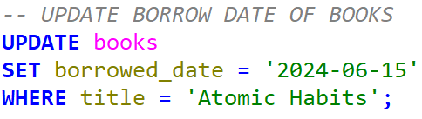

Before updating books:



After updating books:

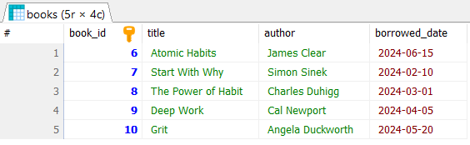

To delete a book, we can use “DELETE FROM books”. Make sure to add a WHERE clause to not delete every book in “books”.

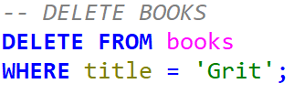

Before deleting from books:



After deleting from books:

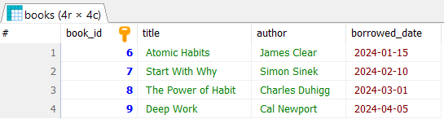

To re-add a deleted book, you can use “INSERT INTO books (title, author, borrowed_date) VALUES ()” and insert the same data again.

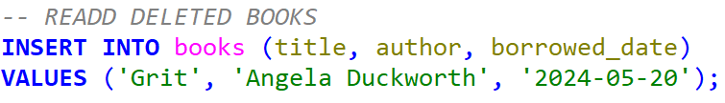

After re-adding the book:

