1. Introduction

Voice morphing means the transition of one speech signal into another. Like image morphing, speech morphing aims to preserve the shared characteristics of the starting and final signals, while generating a smooth transition between them. Speech morphing is analogous to image morphing. In image morphing the in-between images all show one face smoothly changing its shape and texture until it turns into the target face. It is this feature that a speech morph should possess. One speech signal should smoothly change into another, keeping the shared characteristics of the starting and ending signals but smoothly changing the other properties. The major properties of concern as far as a speech signal is concerned are its pitch and envelope information. These two reside in a convolved form in a speech signal. Hence some efficient method for extracting each of these is necessary. We have adopted an uncomplicated approach namely cepstral analysis to do the same. Pitch and formant information in each signal is extracted using the cepstral approach. Necessary processing to obtain the morphed speech signal include methods like Cross fading of envelope information, Dynamic Time Warping to match the major signal features (pitch) and Signal Re-estimation to convert the morphed speech signal back into the acoustic waveform.

2. An Introspection of the Morphing Process

Speech morphing can be achieved by transforming the signal’s representation from the acoustic waveform obtained by sampling of the analog signal, with which many people are familiar with, to another representation. To prepare the signal for the transformation, it is split into a number of 'frames' - sections of the waveform. The transformation is then applied to each frame of the signal. This provides another way of viewing the signal information. The new representation (said to be in the frequency domain) describes the average energy present at each frequency band.

Further analysis enables two pieces of information to be obtained: pitch information and the overall envelope of the sound. A key element in the morphing is the manipulation of the pitch information. If two signals with different pitches were simply cross-faded it is highly likely that two separate sounds will be heard. This occurs because the signal will have two distinct pitches causing the auditory system to perceive two different objects. A successful morph must exhibit a smoothly changing pitch throughout. The pitch information of each sound is compared to provide the best match between the two signals' pitches. To do this match, the signals are stretched and compressed so that important sections of each signal match in time. The interpolation of the two sounds can then be performed which creates the intermediate sounds in the morph. The final stage is then to convert the frames back into a normal waveform.

However, after the morphing has been performed, the legacy of the earlier analysis becomes apparent. The conversion of the sound to a representation in which the pitch and spectral envelope can be separated loses some information. Therefore, this information has to be re-estimated for the morphed sound. This process obtains an acoustic waveform, which can then be stored or listened to.

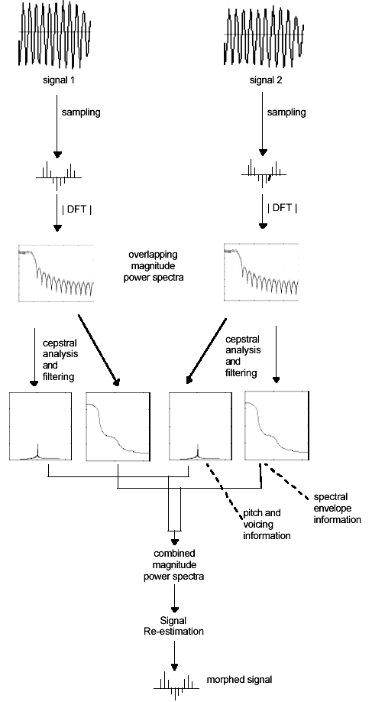
Figure 2.1 Schematic block diagram of the speech morphing process

3. Morphing Process: A Comprehensive Analysis

The algorithm to be used is shown in the simplified block diagram given below. The algorithm contains a number of fundamental signal processing methods including sampling, the discrete Fourier transform and its inverse, cepstral analysis. However the main processes can be categorized as follows.

- Preprocessing or representation conversion: This involves processes like signal acquisition in discrete form and windowing.
- Cepstral analysis or Pitch and Envelope analysis: This process will extract the pitch and formant information in the speech signal.
- Morphing which includes Warping and interpolation.
- Signal re-estimation.

Envelope
Morph

Speech signal 2
Speech signal 1
Envelope
Pitch

Pitch

Representation
Conversion

Cepstral
Analysis
Cepstral
Analysis

Morphing

Signal estimation
Representation
Conversion

Fig 3.1: Block diagram of the simplified speech morphing algorithm.

3.1 Acoustics of speech production

Speech production can be viewed as a filtering operation in which a sound source excites a vocal tract filter. The source may be periodic, resulting in voiced speech, or noisy and a periodic, causing unvoiced speech. As a periodic signal, voiced speech has a spectra consisting of harmonics of the fundamental frequency of the vocal cord vibration; this frequency often abbreviated as F0, is the physical aspect of the speech signal corresponding to the perceived pitch. Thus pitch refers to the fundamental frequency of the vocal cord vibrations or the resulting periodicity in the speech signal. This F0 can be determined either from the periodicity in the time domain or from the regularly spaced harmonics in the frequency domain.
3.2 Preprocessing

This section shall introduce the major concepts associated with processing a speech signal and transforming it to the new required representation to affect the morph. This process takes place for each of the signals involved with the morph.

3.2.1 Signal Acquisition
Before any processing can begin, the sound signal that is created by some real-world process has to be ported to the computer by some method. This is called sampling. A fundamental aspect of a digital signal (in this case sound) is that it is based on processing sequences of samples. When a natural process, such as a musical instrument, produces sound the signal produced is analog (continuous-time) because it is defined along a continuum of times. A discrete-time signal is represented by a sequence of numbers - the signal is only defined at discrete times. A digital signal is a special instance of a discrete-time signal - both time and amplitude are discrete. Each discrete representation of the signal is termed a sample.
Serial Buffered
Port
Discrete speech signal
CODEC-
Sampling at
8000 Hz

Speech signal

Fig 3.2: Signal acquisition

The input speech signals are taken using MIC and CODEC. The analog speech signal is converted into the discrete form by the inbuilt CODEC TLC320AD535 present onboard and stored in the processor memory. This completes the signal acquisition phase.

3.2.2 Windowing
A DFT (Discrete Fourier Transformation) can only deal with a finite amount of information. Therefore, a long signal must be split up into a number of segments. These are called frames. Generally, speech signals are constantly changing and so the aim is to make the frame short enough to make the segment almost stationary and yet long enough to resolve consecutive pitch harmonics. Therefore, the length of such frames tends to be in the region of 25 to 75 milli seconds. There are a number of possible windows. A selection is:

The Hanning window
W (n) = 0.5 - 0.5 cos (2 π n /N) when 0<= n <= N,
=0 otherwise ……………………. 3.1

Overlapping
Hanning window

Framed Signal
For Processing
Discrete signal

Fig 3.3: Windowing

The frequency-domain spectrum of the Hamming window is much smoother than that of the rectangular window and is commonly used in spectral analysis. The windowing function splits the signal into time-weighted frames.

3.3 Morphing

3.3.1 Matching and Warping: Background theory
Both signals will have a number of 'time-varying properties'. To create an effective morph, it is necessary to match one or more of these properties of each signal to those of the other signal in some way. The property of concern is the pitch of the signal - although other properties such as the amplitude could be used - and will have a number of features. It is almost certain that matching features do not occur at exactly the same point in each signal. Therefore, the feature must be moved to some point in between the position in the first sound and the second sound. In other words, to smoothly morph the pitch information, the pitch present in each signals needs to be matched and then the amplitude at each frequency cross-faded. To perform the pitch matching, a pitch contour for the entire signal is required. This is obtained by using the pitch peak location in each cepstral pitch slice.

Consider the simple case of two signals, each with two features occurring in different positions as shown in the figure below.
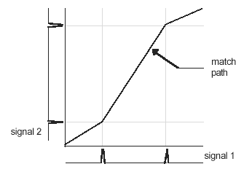

Figure 3.4: The match path between two signals with differently located features

The match path shows the amount of movement (or warping) required in order aligning corresponding features in time. Such a match path is obtained by Dynamic Time Warping (DTW).

4. Morphing Stage

Now we shall give a detailed account of how the morphing process is carried out. The overall aim in this section is to make the smooth transition from signal 1 to signal 2. This is partially accomplished by the 2D array of the match path provided by the DTW. At this stage, it was decided exactly what form the morph would take. The implementation chosen was to perform the morph in the duration of the longest signal. In other words, the final morphed speech signal would have the duration of the longest signal. In order to accomplish this, the 2D array is interpolated to provide the desired duration.

However, one problem still remains: the interpolated pitch of each morph slice. If no interpolation were to occur then this would be equivalent to the warped cross-fade which would still be likely to result in a sound with two pitches. Therefore, a pitch in- between those of the first and second signals must be created. The precise properties of this manufactured pitch peak are governed by how far through the morph the process is. At the beginning of the morph, the pitch peak will take on more characteristics of the signal 1 pitch peak - peak value and peak location - than the signal 2 peak. Towards the end of the morph, the peak will bear more resemblance to that of the signal 2 peaks. The variable l is used to control the balance between signal 1 and signal 2. At the beginning of the morph, l has the value 0 and upon completion, l has the value 1. Consider the example in Figure 4.6. This diagram shows a sample cepstral slice with the pitch peak area highlighted. Figure 4.7 shows another sample cepstral slice, again with the same information highlighted. To illustrate the morph process, these two cepstral slices shall be used.

There are three stages:
- Combination of the envelope information;
- Combination of the pitch information residual - the pitch information excluding the pitch peak;
- Combination of the pitch peak information.
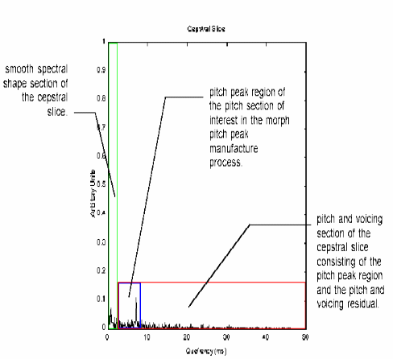
Figure 4.1. A second sample cepstral slice with the pitch p
5. Summarized Block Diagram

The whole morphing process is summarized using the detailed block diagram shown below (figure 6.1).

CODEC-sample
at 8000 Hz.
Apply overlapping hanning window
CODEC-sample
at 8000 Hz.
Apply overlapping hanning window
A
B
Framed signal
Speech Signal 1
Apply DFT
(N=256)
Take Logarithm &
Store phase
Apply IDFT
(N=256)
Cepstrum 1

Speech Signal 2
Framed signal
Apply DFT
(N=256)
Take Logarithm &
Store phase

Apply IDFT
(N=256)
Cepstrum 2

Liftering
Cutoff=900Hz

Liftering
Cutoff=900Hz

Extract pitch
&
Formant
A
B
Extract pitch
&
Formant
Store Pitch Peak
&
Pitch Peak location
of both

Apply DFT
Apply DFT
Take
Anti logarithm
Take
Anti logarithm
Cross fade formants (1& 2),
Pitch peaks (1&2) &
Pitch residues (1&2)

Transform to
Cepstral Domain
Find new pitch peak location using DTW
Combine
Transform to
Frequency Domain
Signal re estimation
CODEC
Morphed Signal

Formant, Pitch residual & Pitch peak information(1)

Formant, Pitch residual & Pitch peak information(1)

7. CONCLUSION

The approach we have adopted separates the sounds into two forms: spectral envelope information and pitch and voicing information. These can then be independently modified. The morph is generated by splitting each sound into two forms: a pitch representation and an envelope representation. The pitch peaks are then obtained from the pitch spectrograms to create a pitch contour for each sound. Dynamic Time Warping of these contours aligns the sounds with respect to their pitches. At each corresponding frame, the pitch, voicing and envelope information are separately morphed to produce a final morphed frame. These frames are then converted back into a time domain waveform using the signal re-estimation algorithm.

In this seminar, only one type of morphing has been discussed - that in which the final morph has the same duration as the longest signal. Also we discuss the case of speech morphing in this seminar. But the work can be extended to include audio sounds as well. The longest signal is compressed and the morph has the same duration as the shortest signal (the reverse of the approach described here). If one signal is significantly longer than the other, two possibilities arise. However, according to the eventual use of the morph, a number of other types could be produced.

