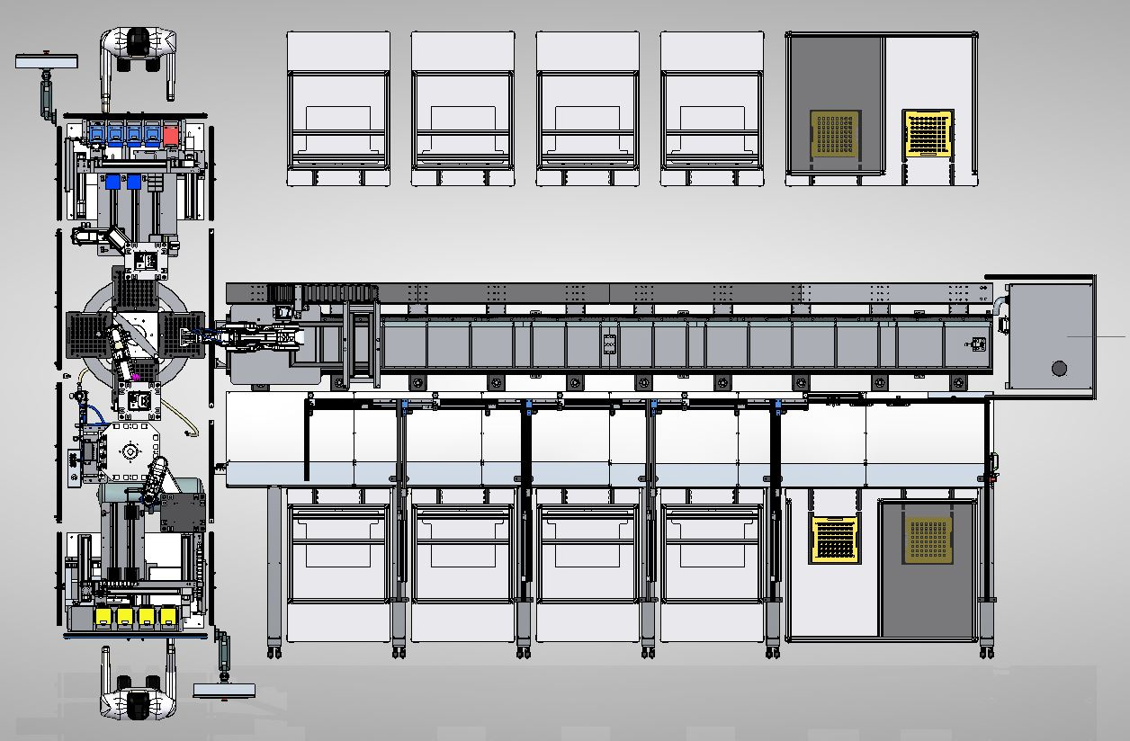

JIG ID

On/Off

JIG ID

On/Off

On/Off

JIG ID

On/Off

JIG ID

On/Off

JIG ID

On/Off

JIG ID

On/Off

JIG ID

On/Off

JIG ID

JIG ID

On/Off

JIG ID

On/Off

JIG ID

On/Off

JIG ID

On/Off