**List Of John Deere Available Apis**

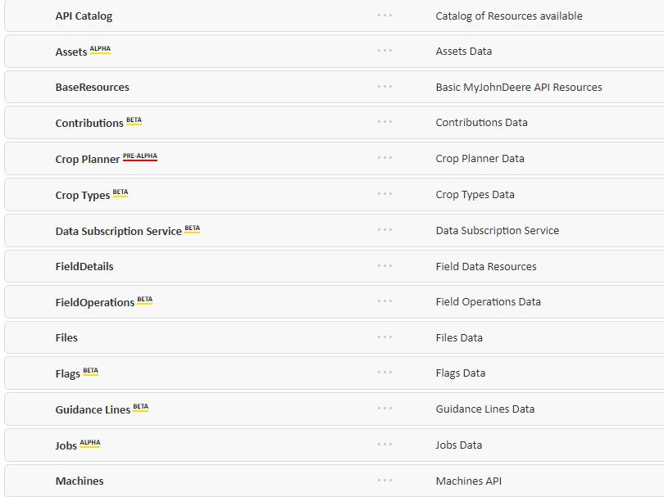

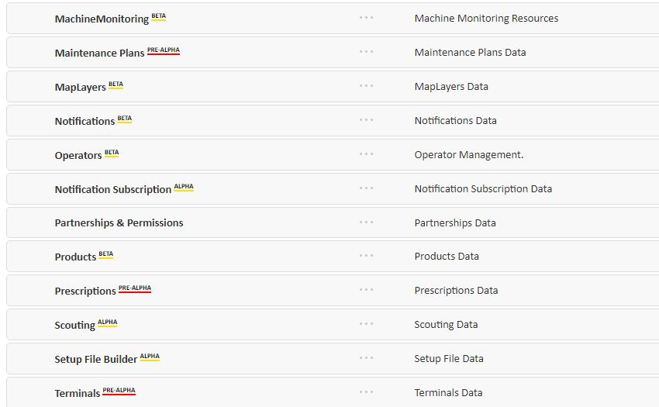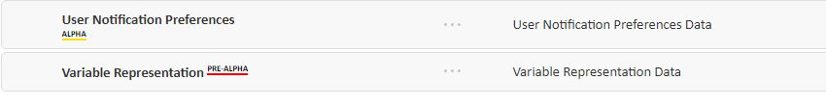

**My Field Operations Api.**

Using the Field Operations API's, you can access:

* Metadata about each Field Operation
* Totals showing the area worked and the total amount planted, applied, or harvested.
* Map images, including legends, that show what happened in each part of the field.
* Point-level data, available via a [shapefile export](https://developer.deere.com/" \l "!documentation&doc=.%2Fmyjohndeere%2FshapefilesOverview.htm&anchor=).

|  |
| --- |
| **Field Operations** |

|  |  |  |  |  |  |  |  |  |  |  |  |  |  |  |
| --- | --- | --- | --- | --- | --- | --- | --- | --- | --- | --- | --- | --- | --- | --- |
| |  |  | | --- | --- | | **GET**/organizations/{orgID}/fields/{fieldsID}/fieldOperations | List Field Operations | | **GET** /fieldOperations/{operationID} | View a Field Operation | | **GET** /fieldOps/{operationID} | Asynchronous Shapefile Download | | **GET** /fieldOperations/{operationID}/measurementTypes | Field Operation Measurement Types | | **GET** /fieldOperations/{operationID}/measurementTypes/{measurementType} | Field Operation Measurements | | **GET** /fieldOperations/{operationID}/measurementTypes/{measurementType} | View Map Image | | | |
| Field Operations by Machine **INTERNAL** |
| |  |  | | --- | --- | | **GET**/fieldOperations/{operationID}/fieldOperationMachines | View Machines for a Field Operation | |

|  |
| --- |
| Crop Season Summaries **INTERNAL** |
| |  |  | | --- | --- | | **GET**/organizations/{orgId}/cropSeasonSummaries | View Recent Crop Season Summaries for an Organization | |

Field Details

|  |
| --- |
| Access Points **ALPHA** |
| |  |  | | --- | --- | | **GET** /organizations/{orgId}/fields/{fieldId}/accessPoints | View an Access Point | |  |  | | **POST** /organizations/{orgId}/fields/{fieldId}/accessPoints | Create an Access Point | |  |  | | **DELETE** /accessPoints/{accessPointId} | Delete/Remove an Access Point | |  |  | |
| Boundaries |
| |  |  | | --- | --- | | **GET**/organizations/{orgID}/boundaries | View Boundaries in an Org | | **GET** /organizations/{orgID}/fields/{fieldId}/boundaries | View the Boundaries of a Field | | **GET** /organizations/{orgID}/fields/{fieldId}/boundaries/{id} | Get a specific Boundary | |

|  |  |  |  |  |
| --- | --- | --- | --- | --- |
| |  |  | | --- | --- | | **POST** /organizations/{orgID}/fields/{fieldId}/boundaries | Create a Boundary**BETA** | | **PUT** /organizations/{orgID}/fields/{fieldId}/boundaries/{boundaryId} | Update a Boundary**BETA** | |

|  |  |  |
| --- | --- | --- |
| |  |  | | --- | --- | | **DELETE** /organizations/{orgID}/fields/{id}/boundaries/{boundaryId} | Delete a boundary**ALPHA** | |
| Clients |
| |  |  | | --- | --- | | **GET**/organizations/{orgID}/clients | List Clients in an Org | | **GET**/organizations/{orgID}/clients/{id} | View a Client | | **GET** /organizations/{orgID}/fields/{id}/clients | View Clients in a Field | | **GET** /organizations/{orgID}/farms/{id}/clients | View a Farm's Clients | |

|  |  |  |
| --- | --- | --- |
| Farms | | |
| |  |  | | --- | --- | | **GET** /organizations/{orgID}/farms | View Farms in an Org | | **GET** /organizations/{orgID}/farms/{id} | View a Farm | | **GET** /organizations/{orgID}/clients/{id}/farms | View a Client’s Farms | | **GET** /organizations/{orgID}/fields/{id}/farms | View Farms in a Field | | | |
| Fields |
| |  |  | | --- | --- | | **GET** /organizations/{orgID}/fields | View Fields in an Org | | **GET** /organizations/{orgID}/fields/{id} | View a Field | | **GET**/organizations/{orgID}/clients/{id}/fields | View a Client's Field | | **GET** /organizations/{orgID}/farms/{id}/fields | View a Farm's Field | |

|  |  |  |  |  |  |  |
| --- | --- | --- | --- | --- | --- | --- |
| |  |  | | --- | --- | | **POST** /organizations/{orgID}/fields | Create field **BETA** | | **PUT** /organizations/{orgID}/fields/{id} | Update field **BETA** | |  |  | |

|  |  |  |
| --- | --- | --- |
| |  |  | | --- | --- | | **DELETE**/organizations/{orgID}/fields/{id} | Delete field **ALPHA** | |
| Field Searches **PRE-ALPHA** |
| |  |  | | --- | --- | | **POST**/organizations/{orgId}/fieldsSearches | Search Fields | |

|  |
| --- |
| **Flags -** |

|  |
| --- |
| Flags Attachments **INTERNAL** |
| |  |  | | --- | --- | | **GET** /flags/{flagId}/fileResources | View flag references | | **POST** /flags/{flagId}/fileResources | Create a file reference | | **GET** /flagResources/{id} | View/Download file Resource | | **PUT** /flagResources/{id} | Update file resource | | **DELETE** /flagResources/{id} | View/Download file Resource | |
| Flags |
| |  |  | | --- | --- | | **GET** /flags/{flagId} | List a flag by Id | | **PUT** /flags/{flagId} | Update flag by Id | | **POST** /organizations/{orgId}/flags | Create a flag | | **GET** /organizations/{orgId}/flags | View flags list | | **DELETE** /flags/{flagId} | Delete a flag | | **GET** /organizations/{orgId}/fields/{fieldId}/flags | List flags for the field | |

|  |
| --- |
| Flag Categories |
| |  |  | | --- | --- | | **GET**/flagCategories/{categoryId} | List flag category by id | | **PUT**/flagCategories/{categoryId} | Update flag category by Id | | **DELETE**/flagCategories/{categoryId} | Delete a flag category | | **GET**/organizations/{orgId}/flagCategories | List Flags Category Collection | | **POST**/organizations/{orgId}/flagCategories | Create a custom category | |
| Flag Categories Preferences |
| |  |  | | --- | --- | | **GET**/flagCategories/{categoryId}/flagCategoryPreferences | List collection of FlagCategoryPreference | | **GET**/flagCategoryPreferences/{flagCategoryPreferencesId} | View preferences object for a category | | **PUT**/flagCategoryPreferences/{flagCategoryPreferencesId} | Update flag category preferences | |

**Available Agronomic Data John Deere Apis provide:**

|  |  |  |  |  |
| --- | --- | --- | --- | --- |
| GET | /organizations/{orgID}/clients |  | List Clients in an Org |  |

|  |  |  |  |  |
| --- | --- | --- | --- | --- |
| GET | /organizations/{orgID}/clients/{id} |  | View a Client |  |

|  |  |  |  |  |
| --- | --- | --- | --- | --- |
| GET | /organizations/{orgID}/fields/{id}/clients |  | View Clients that Own a Field |  |

|  |  |  |  |
| --- | --- | --- | --- |
| GET | /organizations/{orgID}/farms/{id}/clients |  | View Clients that Own a Farm |

|  |
| --- |
| **List Clients in an Org** |
| View a list of clients in a specified organization. For each client, the response will include links to the following resources: |
| * **fields**: View the fields associated with the client. * **farms**: View the farms associated with the client. * **owningOrganization**: View details about the client's organization. |

|  |
| --- |
| **View a Client** |
| View a client's details. For each client, the response will link to the following resources: |
| * **fields**: View the field the client belongs to. * **farms**: View the farm belonging to the client. * **owningOrganization**: View the org that owns the client. |

|  |
| --- |
| **View Clients that Own a Field** |
| View details about the client that owns the field. The response will link to the following resources: |
| * **fields**: View the field the client belongs to. * **farms**: View the farms belonging to the client. * **owningOrganization**: View the org that owns the field. |

|  |
| --- |
| **View Clients that Own a Farm** |
| View details about the client that owns the farm. The response will link to the following resources: |
| * **fields**: View the field that the client belongs to. * **farms**: View the farms belonging to this client. * **owningOrganization**: View the org that owns the client. |