**IOS Application Testing Checklist**

1. Check the installation time taken by the application onto the device. After installation whether the application has app icon and name.
2. Check whether the app supports both landscape and portrait orientations
3. Without an internet connection, launch the application. Make sure that app behaves as designed/desired.
4. If the application uses location services, then check whether location permission alert is displayed or not.
5. Close the application by tapping over Home button of the device and open the app again. Check whether the app works as designed/desired.
6. Once installed, check whether the app is listed in iPhone's settings app.
7. After the application is made live, check whether the application can be found in “App Store." There will be supported OS version for the application. So, make sure the application can be found in those supported OS version device's "App Store." Also, the application should not be listed in unsupported OS version device's "App Store."
8. Check whether the application goes to sleep mode when running in the background to prevent battery drain.

**Why we used :**

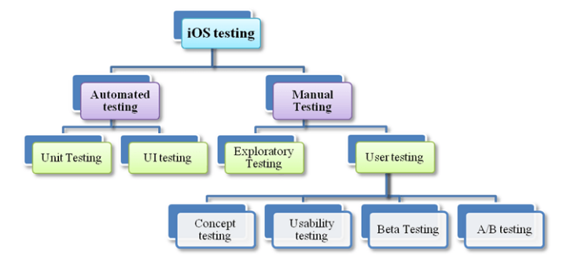

**UI testing:**

**UI**

Smooth Animation

Landscape

User friendly

Portrait