Lab 2: Interactive Portfolio Enhancements
Lab 2 Project Report | Target Grade: 3
Student name | Syed Arif Rahman
Student ID | Syed Arif Rahman 0004
University email | syed_arif.rahman0004@stud.hkr.se
Repository | https://github.com/arifovi/personal-portfolio-lab2
Submission date | 2 November 2026

1. Project Overview
This project builds on my Lab 1 personal portfolio by adding a separate interactive feedback page. The aim of Lab 2 was to use JavaScript to make the page respond to user input, provide understandable validation feedback, and improve the overall user experience. The site uses HTML, CSS, and JavaScript and can be opened directly in a web browser.

2. Implemented Features (Grade 3)
- A feedback form with Full Name, Email, Topic of Interest, Comments, and optional Website fields.
- Validation for required fields: a name of at least two characters, a plausible email address, a selected topic, and comments of at least 15 characters. The optional website is checked for URL validity when provided.
- Field-specific error messages and red borders for invalid input; green borders for valid fields after validation.
- A live character counter that changes appearance when the comments reach the 15-character minimum.
- A personalised success message after a valid submission, followed by a form reset; the message disappears after approximately four seconds.
- A Clear button that resets field values, error messages, validation styles, and the character counter.
- Responsive styling, associated labels, keyboard focus indicators, and accessible feedback/status text.
- Navigation from the portfolio homepage to the Feedback page and back to Home.

3. JavaScript Interaction and Code Explanation
The JavaScript selects the form elements and uses separate validation functions for the name, email, topic, comments, and website fields. This makes the checks easier to understand and maintain. Each function evaluates the relevant input, updates the nearby error message, and changes the field’s visual state.
The submit event listener calls preventDefault() so the browser does not reload the page. It then validates all fields. If any field is invalid, the user stays on the form and sees specific feedback. If all fields are valid, the script displays “Thanks for your feedback, [Full Name]!”, resets the form and validation state, and removes the success message after about four seconds using a timer.
Input and change event listeners update feedback during editing after a field has been checked. The comments counter updates live while typing. The Clear button also resets the form and cancels any pending success-message timer. The feedback form runs only in the browser; it does not send data to a server or email address.

4. Testing and Screenshot Evidence
The following figures document the default, invalid, and successful states of the feedback form. Replace each placeholder with the corresponding saved screenshot before submission.

Figure 1
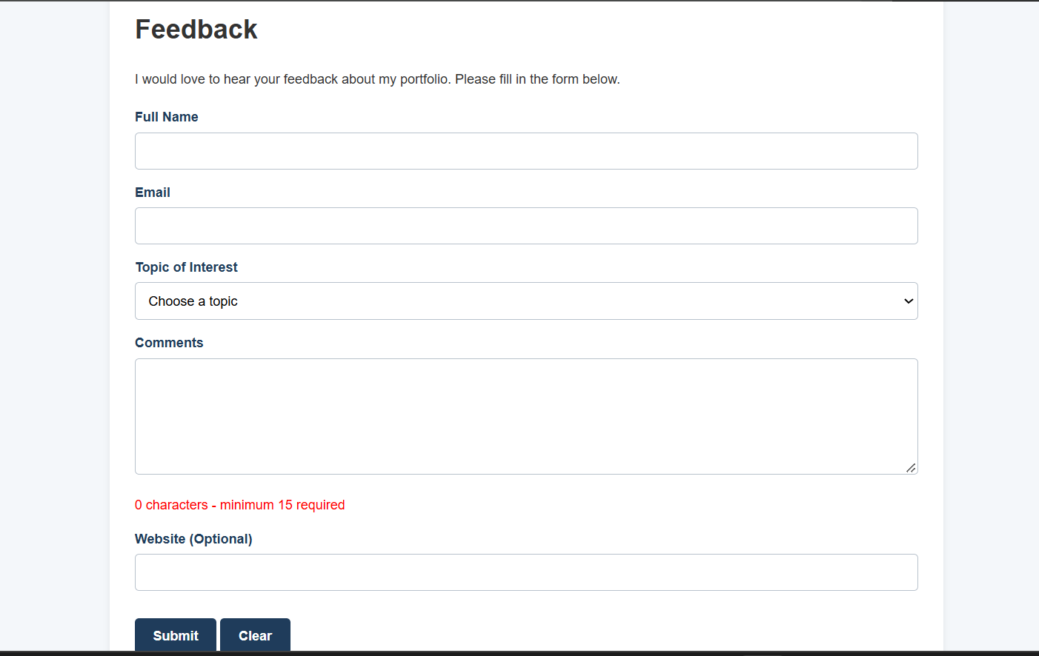
Figure 1. Normal state before interaction: the form fields have default styling, and the comments counter starts at zero.

Figure 2
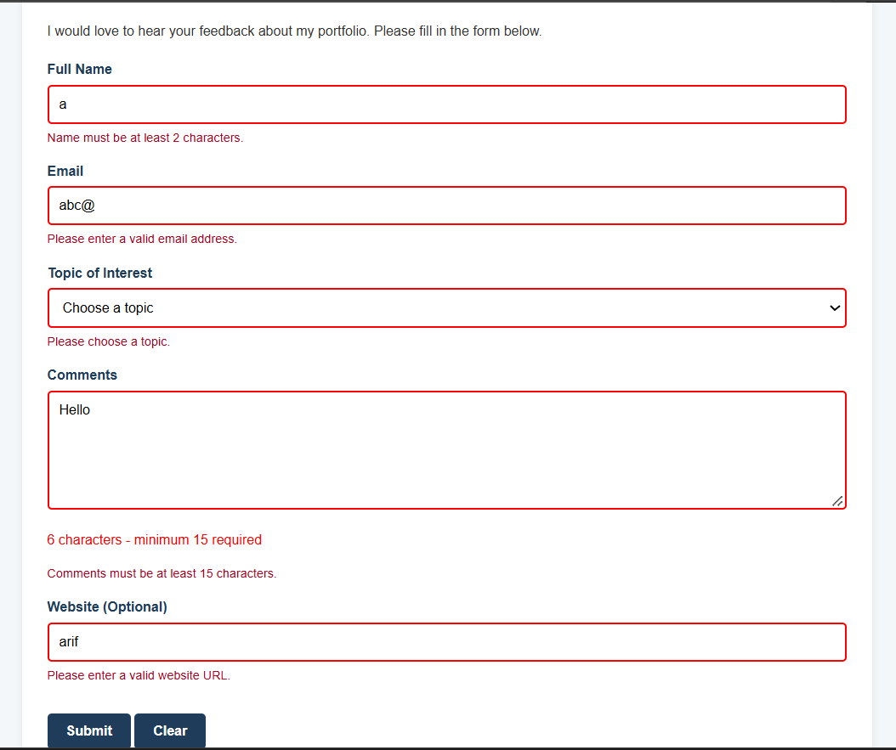
Figure 2. Error state after invalid submission: field-specific messages and red borders explain what needs correction.

Figure 3
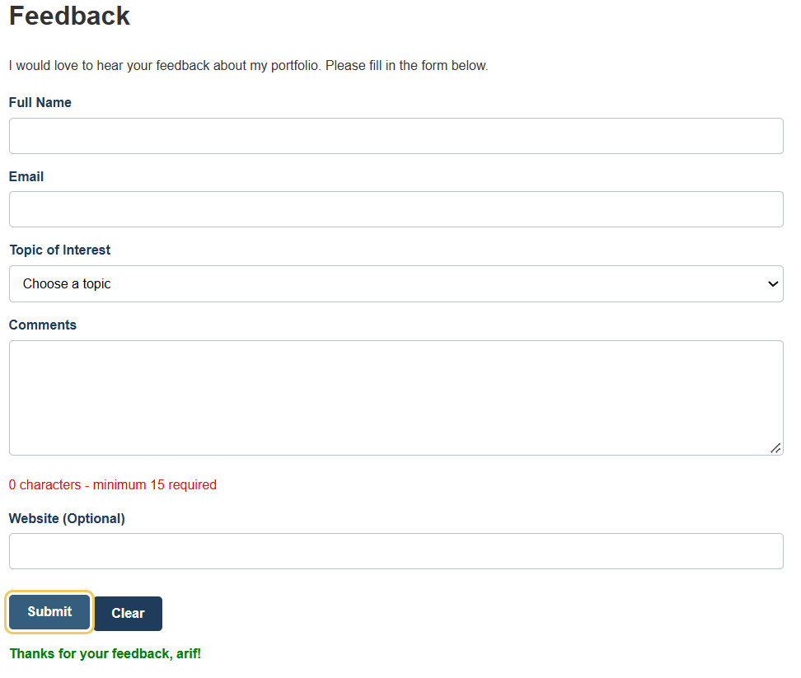
Figure 3. Successful submission: the personalised confirmation message is displayed and the form fields are reset.

5. Development Problem and Solution
One challenge was making email validation reject incomplete addresses while still giving clear feedback. A simple check for the “@” symbol was not enough, because an address could contain “@” without a proper domain. I improved the email field by using browser email validity together with a more specific pattern. I also adjusted the validation behaviour so that input states update consistently as users correct their entries. This helped make the form more predictable.

6. Reflection

6.1 Which interaction can I explain most confidently, and why?
I can explain the form submission and validation process most confidently. I understand how the submit event is handled, why preventDefault() is used, and how separate functions check each field before a success message is shown. The visible error and success states make it easy to demonstrate the JavaScript behaviour.

6.2 How does the Git history show the development process?
My Git history records incremental changes rather than one large final upload. The commits show how I developed the validation rules, improved accessible feedback, refined the success-message timing, adjusted responsive styling, added navigation, and prepared the documentation. This makes it possible to follow how the project improved over time.

6.3 What would I improve or test with one more session?
With one more session, I would test the form on additional mobile screen sizes and browsers, including keyboard-only navigation and different international names and email addresses. I would also review the wording of error messages to make them as clear and consistent as possible.

7. How to Run and Demonstrate
Open index.html in a web browser and choose Feedback from the main navigation. To demonstrate validation, submit incomplete or invalid values and observe the error messages. Type into Comments to show the live counter. Then enter valid values and submit to show the personalised success message and automatic reset. The Home link returns to index.html.

