Development Documentation
Personal Portfolio - Syed Arif Rahman
Assigned Seed: Gentle Focus
Date: 22/09/2026

1. Design Iteration Log
My initial idea was to create a simple one-page personal portfolio where I could introduce myself as a student and show my background, learning progress, interests, projects, future goals, and contact information. The main audience is my teacher and other visitors who may want to understand what I am learning. I wanted the page to be clear and easy to navigate, but I also wanted it to become more personal as I developed it.
One of my biggest design changes was how I used visuals. At first, I considered putting my photographs and project image together in a separate gallery. While working on the page, I felt that this made the images feel disconnected from the content. I changed the layout so that visuals appear beside related information. For example, my photo is connected to About Me and my workspace supports the Gentle Focus section. I used Flexbox for the side-by-side layout and media queries so the content stacks on smaller screens. This choice was better because each visual has a clear reason for being there.
My second major change was how I used my assigned seed, “Gentle Focus.” At first, it mainly appeared in its own section. Later, I connected it to my introduction, personal growth, and future goals and created a reusable CSS class to highlight the phrase. This made the seed feel like part of the portfolio rather than an isolated requirement.
During my final review, I made further refinements. I changed the Learning Snapshot caption to an h3 heading and redesigned the Privacy and Terms area so the cards sit side by side on larger screens but stack on mobile. I also replaced the earlier Creative Design interest with AI Content Creation. I used a preview image from my recent AI-assisted video and made it clickable, giving visitors a relevant external link to the video.
Overall, the final portfolio is more personal, responsive, and connected than my first idea.

Dated early design evidence
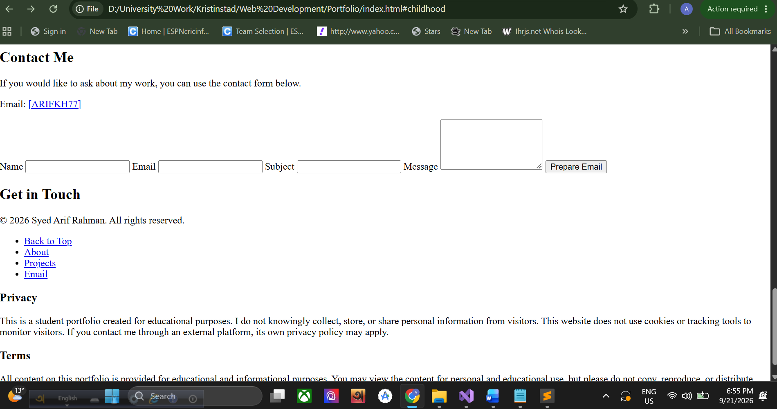

2. Three Technical Challenges

Challenge 1 - Privacy and Terms text was difficult to read
Problem: During final testing, the Privacy and Terms cards had a light background but their text was difficult to read because footer styling was affecting the content inside them.
What I tried and what solved it: I checked the general footer and section rules and then added more specific CSS for sections inside the footer. Setting the text and heading colours directly solved the contrast problem.
What I learned: I learned that inherited CSS can affect nested elements and that a more specific selector can correct styling in one part of a page without changing every section.
footer section {
background-color: #ffffff;
color: #333333;
}
footer section h3 {
color: #1f3c5b;
}

Challenge 2 - Keeping text and images responsive
Problem: I wanted related text and images to sit side by side on larger screens, but the same layout became too narrow on mobile.
What I tried and what solved it: I used Flexbox for the desktop layout and then changed the flex direction inside my existing media query. This allowed the same content to stack vertically on smaller screens.
What I learned: I learned that responsive design sometimes needs a change in layout direction, not only smaller fonts and spacing.
.content-row {
display: flex;
gap: 35px;
}
@media screen and (max-width: 768px) {
.content-row {
flex-direction: column;
}
}

Challenge 3 - Privacy and Terms layout on different screen sizes
Problem: After I placed Privacy and Terms side by side on desktop, the cards became too narrow when the screen width was reduced.
What I tried and what solved it: I kept the horizontal Flexbox layout for larger screens but used the mobile media query to stack the two cards vertically.
What I learned: I learned that the best desktop arrangement is not always the best mobile arrangement. Media queries let me keep both versions readable.
.footer-info {
display: flex;
gap: 20px;
}
@media screen and (max-width: 768px) {
.footer-info {
flex-direction: column;
}
}

3. Personal Reflection
One thing that surprised me was how much small CSS and content changes could affect the overall feel of the site. I expected most of the work to be writing HTML, but testing showed me that spacing, contrast, layout, links, and responsive behaviour can make a large difference.
The CSS technique that caused me the most difficulty was combining Flexbox with media queries. I wanted content to sit side by side on larger screens but remain comfortable to read on mobile. Understanding when to change flex-direction took some testing, and I later used the same idea for the Privacy and Terms layout.
My final portfolio is more personal than my first idea. Instead of keeping visuals in a separate gallery, I connected them to relevant content. Gentle Focus developed from a separate seed section into a recurring theme. I also changed one interest to AI Content Creation and connected a recent AI-assisted video preview to an external link. The final version has clearer hierarchy, stronger visual context, and better responsive behaviour.

