Python – mini Course project (IITM P14)

submission by arif p kassim

# 1.Write a program to find out the prime numbers

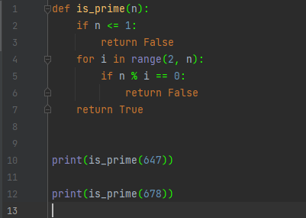

This code defines a function is_prime(n) that takes an integer n as input and returns a boolean value that indicates whether n is a prime number or not.

The function checks if n is less than or equal to 1. If it is, it returns False, since 1 is not a prime number. Otherwise, the function loops through all the numbers between 2 and n-1 and checks if n is divisible by any of them. If it is, the function returns False, since n is not a prime number. If the loop completes without finding any divisors of n, the function returns True, indicating that n is a prime number.

The code then calls the is_prime() function twice, passing in the integers 647 and 678 as arguments, respectively, and prints the output of each call. The first call returns True, indicating that 647 is a prime number, while the second call returns False, indicating that 678 is not a prime number.

# 2.write a program to create the equation (a+b+c) * (a-b-c) * ab + a^2 + b ^2 + (abc)^3

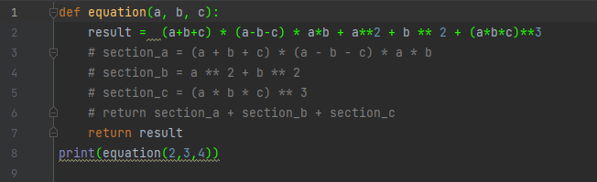

This code defines a function called equation(a, b, c) that takes three input parameters, a, b, and c. It uses these parameters to calculate a result based on the given mathematical expression, and returns the result.

The mathematical expression used in the function involves multiple operations, such as addition, subtraction, multiplication, and exponentiation. The function first calculates (a+b+c) * (a-b-c) * a*b, which involves multiplying the sum of a, b, and c by the difference of a, b, and c, then multiplying the result by a and b. The function then calculates a**2 and b**2, which involve squaring the values of a and b, respectively. Finally, the function calculates (a*b*c)**3, which involves cubing the value of a*b*c.

The function returns the sum of all the values calculated above, which is the result of the mathematical expression.

The code then calls the equation() function with a = 2, b = 3, and c = 4 as arguments, and prints the result of the function call, which is 13567.

# 3. urlist = ['wood','knife','axe'] , mylist = ['tree', 'apple', 'mango', 'melon'] –

# combine two lists

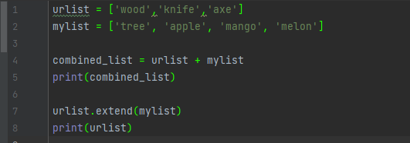

This code defines two lists: urlist and mylist. urlist contains three strings: 'wood', 'knife', and 'axe'. mylist contains four strings: 'tree', 'apple', 'mango', and 'melon'.

The code then creates a new list called combined_list by concatenating urlist and mylist using the + operator. This means that the resulting list will contain all the elements of urlist, followed by all the elements of mylist.

Finally, the code prints the combined_list using the print() function, which will output the following list of strings:

['wood', 'knife', 'axe', 'tree', 'apple', 'mango', 'melon']

# 4.write a program for natural number based on user input

This code prompts the user to enter a number by displaying the message "Enter a number: ", and waits for the user to input a value. The input() function is used to get the user's input, and the int() function is used to convert the input value to an integer. The resulting integer is then stored in the variable n.

The code then uses a for loop to iterate over the numbers from 1 to n (inclusive), using the range() function. In each iteration of the loop, the code prints the value of the loop variable i using the print() function. The print() function outputs the value of i to the console, followed by a newline character, so each value of i is printed on a separate line.

# 5.write class and function for the equation sqrt(x1-x2) ^ 2 + sqrt( y1 – y2 ) ^2

# using try except handling

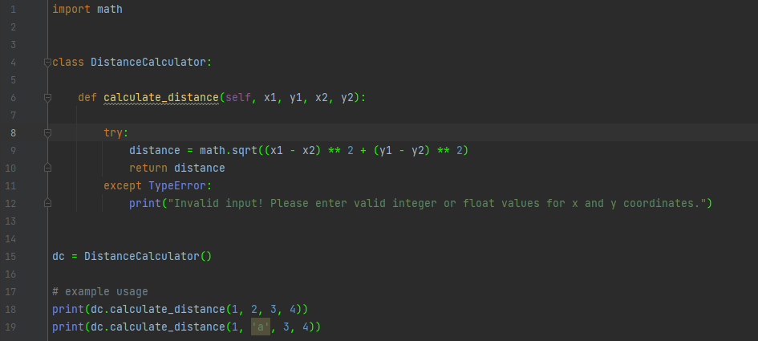

This code defines a Python class named DistanceCalculator, which contains a method calculate_distance that calculates the distance between two points in a two-dimensional space. The method takes four arguments: x1 and y1 are the coordinates of the first point, and x2 and y2 are the coordinates of the second point.

Inside the calculate_distance method, the code first calculates the distance between the two points using the distance formula, which is: distance = sqrt((x1 - x2) ** 2 + (y1 - y2) ** 2)

The method then returns the calculated distance.

If the input values provided for x and y are not numeric (integer or float), the code inside the try block will raise a TypeError exception. In that case, the code inside the except block will execute and print an error message to the console: "Invalid input! Please enter valid integer or float values for x and y coordinates.".

The code also creates an instance of the DistanceCalculator class named dc, and uses it to call the calculate_distance method twice: first with the arguments (1, 2, 3, 4), and then with the arguments (1, 'a', 3, 4). The first call should return the result 2.8284271247461903, while the second call should print the error message mentioned earlier and return None.

# 6. Name = “Guvi python” - write a program to get “python” word from the string

This code takes the string "Guvi python" and splits it into a list of substrings based on whitespace characters (spaces and tabs) using the split() method. It then retrieves the second element of the resulting list (which is "python") and assigns it to the variable split_name. Finally, it prints the value of split_name. Essentially, this code extracts the second word in the original string "Guvi python".

# 7.Using class and function - Write a program for palindrome Ex. Madam

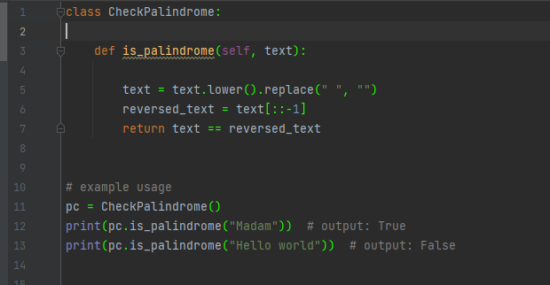

This code defines a class called CheckPalindrome that has a method is_palindrome() which takes a string as an argument and checks whether the string is a palindrome. It first converts the string to lowercase using the lower() method and removes any whitespace characters using the replace() method. It then reverses the resulting string using slicing notation ([::-1]) and assigns the reversed string to the variable reversed_text. Finally, it checks whether the original string is equal to the reversed string, and returns a boolean value accordingly.

The code also provides an example usage of the class and its method, where an instance of the CheckPalindrome class is created (pc), and the is_palindrome() method is called with two different strings as arguments. The first string ("Madam") is a palindrome, so the method returns True, while the second string ("Hello world") is not a palindrome, so the method returns False.

# 8.using file handling – write a text file in ur system with “hello world”

This code creates a new file named test.txt if it doesn't exist in the current working directory, or replaces the content of the file if it already exists. The 'w' parameter passed to the open() function means that we want to write to the file.

The with statement ensures that the file is properly closed after the writing is done, even if an exception is raised during the writing process. The code then writes the string "Hello World" to the file using the write() function, which writes the given string to the file.

# 9.create option button using tkinter GUI in python

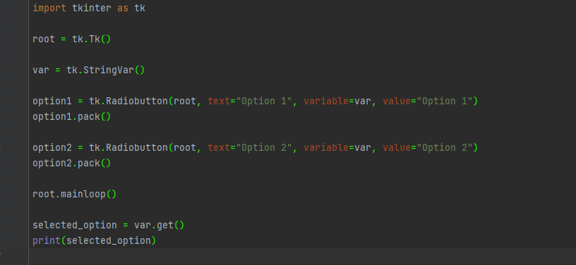

This is a Python code snippet that creates a GUI using the tkinter library. The GUI consists of two radio buttons labeled "Option 1" and "Option 2" and a text label. When the user selects one of the radio buttons, the value associated with the selected button is displayed in the text label.

The first few lines of the code import the tkinter module and create a root window. A StringVar object is created and assigned to the variable 'var'. This will store the value associated with the currently selected radio button.

Two radio buttons, 'option1' and 'option2', are then created using the Radiobutton class, and assigned to the variable 'option1' and 'option2' respectively. The text option is set to "Option 1" and "Option 2", the variable is set to 'var', and the value is set to "Option 1" and "Option 2" respectively.

The 'pack()' method is called on each radio button object to place them in the window.

The root window is displayed using the 'mainloop()' method.

Finally, the value of the currently selected radio button is retrieved using the 'get()' method of the StringVar object, and printed to the console.

# 10.Keep only numbers from the following string

# x = “ 89e9jcd^o38829@3%3,/mkl$w1”

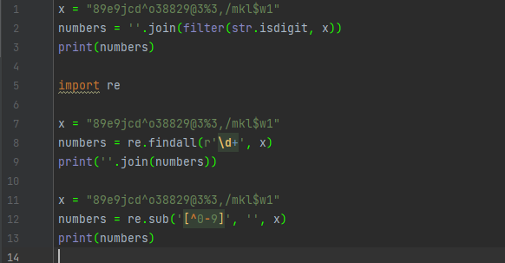

The three code snippets perform the same operation of extracting only the numbers from a given string:

The first code snippet uses the filter() method to iterate through each character in the given string and checks if it is a digit. It then joins all the digits and stores it in the variable numbers.

The second code snippet uses the re.findall() method which searches for all occurrences of one or more digits in the given string using the regular expression r'\d+'. It then joins all the digits and stores it in the variable numbers.

The third code snippet also uses the re.sub() method which replaces all characters that are not digits with an empty string. It then stores the resulting string containing only digits in the variable numbers.