

**CS 319**

**Object-Oriented Software**

**Engineering Project**

**Design Report**

Section 1 / Group 1H

Ece Altınyollar

Arif Can Terzioğlu

Raza Faraz

Emin Tosun

Instructor: Bora Güngören

**TABLE OF CONTENTS**

**1) Design Goals**

**1.1)User**

**1.1.1) Well-Defined Interface**

**1.1.2) Ease of Use/ Learn**

**1.1.3) Performance**

**1.2) Maintenance**

**1.2.1) Understandability**

**1.2.2) Modifiability**

**1.2.3) Good Documentation**

**1.2.4) Portability**

**1.2.5) Reliability**

**1.3) Trade off**

**1.3.1) Portability vs Reliability**

**1.3.2) Development Time vs Performance**

**2) Software Architecture**

**2.1) Overview**

**2.2) Architecture Style**

**2.2.1) Type of Architecture**

**2.3) Subsystem Decomposition**

**2.3.1)First Layer**

**2.3.2)Second Layer**

**2.3.3)Third Layer**

**2.4) Hardware / Software Management**

**2.5) Persistent Data Management**

**2.6) Access Control and Security**

**2.7) Boundary conditions**

**3) Subsystem Services**

**3.1) Façade Design Pattern**

**3.2) Character**

**3.3) Input Manager**

**3.4) Interaction**

**3.5) User Interface**

**3.6) Game Manager**

**3.7) Menu Data**

**3.8) Database**

**4)Low-Level Design**

**4.1) Object Design TradeOffs**

**4.1.1)Functional Decomposition vs code length**

**4.1.2)Performance vs complexity**

**4.2)Final Object Design**

**4.3)Packages**

**4.4) Class Descriptions**

**4.4.1) User Interface Class**

**4.4.1.1) GUI Manager**

**4.4.2) Input Manager Class**

**4.4.2.1)Input Manager**

**4.4.3) Character Classes**

**4.4.3.1) Game Object**

**4.4.3.2) Player**

**4.4.3.3) Enemy**

**4.4.3.4) Weapon**

**4.4.3.5) EnemyWeapons**

**4.4.4) Game Manager Class**

**4.4.4.1) Game Manager**

**4.4.5) Menu Data Classes**

**4.4.5.1) Help Class**

**4.4.5.2) Credits Class**

**4.4.5.3) Settings Class**

**4.4.5.4) High Score Class**

**4.4.6) Database Classes**

**4.4.6.1) Database**

**1) Design Goals**

**1.1) User**

**1.1.1) Well-Defined Interface**

User interface is one of the most important thing for a game to make it desirable for the users. Because of this reason we planned for Battle for Middle Earth some simple interactable objects. Buttons locations and the description of buttons are going to be clear and understandable for the user. Also the clear guidance is going to be provided for the comfort of players. The backgrounds of the screens will be the Middle Earth theme. Also while the players play Battle for Middle Earth, they will have characters and enemies with middle earth theme. These features make the game more realistic and desirable for the players.

**1.1.2) Ease of Use/ Learn**

Easiness of usage and learning a program to a user is one of the purpose for creators. Since the users do not want such a programs which have difficult usage and hard to learn how to use. For the usage purpose the screens that user has to pass over are going to visualized before the game start. The users can do easily the required parts to start the game. Also the help section will be available for learning how to play Battle for Middle Earth. In the help section control of the character, fire controller and power-ups will be explained. With these features we are going to reach this purpose.

**1.1.3) Performance**

The performance of a program affects the quality of a game. So we will make Battle for Middle Earth as a high performance game. First of all the passes between the screens will be smooth. Because of this is an interactive program the game also will have response time as short as possible. With these Battle for Middle Earth will work nicely without any glitches. These features make the game more qualified.

**1.2) Maintenance**

**1.2.1) Understandability**

Each part of our project will be understandable for anyone who uses and analyses our project. In order to provide this opportunity to people we design our reports very simple and clearly. We also focus on completeness of the project. The coding part also will be clear and much more commented for increasing project’s understandability.

**1.2.2) Modifiability**

When project needs to be modified, change in one part should not affect other parts of the program. In order to achieve this goal, we need to keep coupling at the minimum level, so that change in one part of the code, the whole project would not be affected too much. We will have some subsystems. These subsystems will share less data because modifiability of the project could be higher.

**1.2.3) Good Documentation**

We will keep our documentation standards as high as we can. By providing good documentation, we make our project more understandable and more clear. The completeness of reports and their relations with each other will be taking into consideration more seriously. This will also increase our projects understandability.

**1.2.4) Portability**

Since there are many different types of devices, operating systems and versions, our program may encounter such a problem that platform dependence or support issues. To ensure portability and have a stable performance between these environments, our development language will be JAVA which is supported widely by MAC OS, WINDOWS and LINUX… Thus, game will be played for most of the systems that can run JVM.

Also, by using SQL, our database will be managed between relational database management systems.

**1.2.5) Reliability**

Our game will be produced with the principle of reliability. To achieve this, it will be ensured that program will not be crushed under any users’ input. Possible error cases will be determined during the design stage. To handle these errors, exceptions and user based solutions (giving error message and showing options to user) will be used. The exceptions will then redirect the program to normal operating way.

**1.3) Trade off**

**1.3.1) Portability vs Reliability**

To achieve the portability goals, we will use JAVA environment for implementation. JAVA has its own bytecodes which is known for its ability to produce byte codes which can run on any processor architecture. However, this byte codes only work in JAVA Virtual Machine (JVM).  Thus, all users have to install JAVA to their computer.  On the other hand, compared to pure compilation languages, JAVA does not have a good running time performance as much as them.  Due to game is not complex too much; this trade-off will not be too much problem.

By using JAVA, due to compilation time checks, our software will be aimed error free as much as possible.

**1.3.2) Development Time vs Performance**

To decrease the development time of this game, the  implementation project will be in java.The reason being Java offers much better and readily available GUI libraries, specific to our needs. Additionally we do not have to worry about possible memory leaks, which will not only decrease the development time of the game ,but in a way increase the performance of the game for example if  inefficient  memory management happens the game might store garbage or redundant values which will  increase the space taken during the game,thus reducing the game performance.

**2) Software Architecture**

**2.1) Overview**

In this section, we are detailing the composition pur system from higher level to lower. While dividing our program, we decided to use 3-tier design architecture because it is suitable for our project. The layers will be explained in this section but more details of subsystems will be in other sections.

**2.2) Architecture Style**

We have chosen the three tier architecture style for our project. In this style, program will be divided into three layers. First layer is presentation layer. The presentation layer is responsible for managing the interaction between user and program. It shows graphics to the user with data coming from program and it also transmits the user’s inputs to the program. The second layer of the architecture is application layer. Its duty is creating the applications data and process the data coming from user or database. The last layer is data layer. This layer is responsible for data management. It transmits data which needs to be stored to the database and it also conveys the data from database to the program itself.

**2.2.1) Type of Architecture**

For this project, we chose the closed architecture instead of open architecture. The close architecture minimizes the coupling. It makes easier to develop the game. Adding new things to the game will not require to change whole code of it. We can add new things by changing only related parts.

**2.3) Subsystem Decomposition**

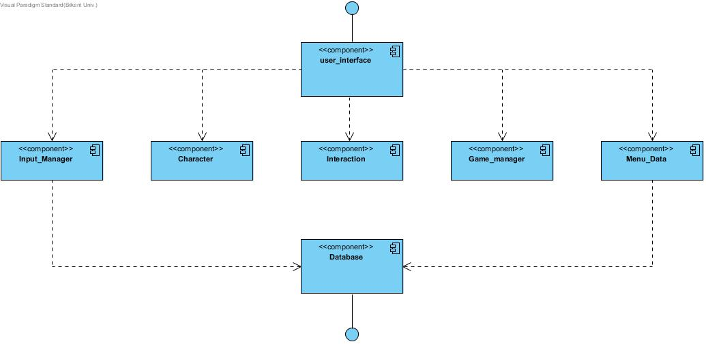

**2.3.1)First Layer**

In the first layer, we have UI classes and UI Manager class. This layer is responsible for managing interaction with user and the program. It will get data from second layer which handles the business logic and it will be updated with new coming data.

**2.3.2)Second Layer**

The second layer of architecture is responsible for program’s business logic. It will produce game data and send it to first layer which handles the interaction with user. This layer also manages data coming from database. This layer is like a bridge between database and UI. Whole game data processing will be handled with this layer’s components.

**2.3.3)Third Layer**

Third layer of architecture is data management layer. This layer has the database controller component. This component provides data,which is coming from database, to the second layer of architecture which uses this data. It is also responsible for saving data coming from program itself or user.

**2.4) Hardware / Software Management**

Our game BattleForMiddleEarth will be coded in JAVA environment since JAVA 8 provides us for beneficial libraries such JAVA FX GUI library. Also, account information and high scores will be saved via MySQL. Storing images and sounds will be in the .png and .wav formats respectively, the operating system should support them.

On the hardware configuration part, game will need a basic keyboard controls that are space and arrow keys.  Our game will not require too much system specification such as high RAM etc. In addition, at the beginning of the game, keyboard inputs will be necessary for create or login account.

Any platform such as Windows/macOS/Linux supports the JAVA can run our game with these hardware and software requirements.

**2.5) Persistent Data Management**

External database will be used to hold user’s latest level, high scores, account information and user’s preferences like character type. To load the latest point of players in the game, this information will be taken later.

Changes on data will be reflecting immediately to maintain data flow fluently. Database will have MySQL management system and SQL language will be the used to create query for database operations. Other files such as pictures, sounds will be stored locally.

**2.6) Access Control and Security**

Our game will require a connection to database. The username and password will be taken when user enters the game first time and transfer to database. Although game has no internet connection, it is aimed that different accounts will enable user to play with more than one player without losing without other characters’ data. In other words, access control will be used to differentiate user’s characters. Our program will be coded in a way that only our program can access it.

**2.7) Boundary conditions**

**2.7.1)Initialization**

Battle for Middle earth will not require any installation as the game would be available as executable .JAR file. During the stage when the .JAR file is clicked and the program opens, appropriate Graphical Interface will be loaded such as game images etc ; thus the game would be brought to an initializing state.

**2.7.2)Termination**

There are multiple possible ways for the termination of the program. Standard procedure includes clicking on the ‘Exit’ button present in the ‘Main Menu’ Screen and ‘Paused’ game screen. Additional method includes clicking on the ‘X’ present at the top left corner of the screen of using Task Manager

**2.7.3)Failure**

Possible Failure would result from missing program files in which a dedicated error message will be produced. Other Possible Failure includes absence of .JDK file or updated .JDK file which would cause the game to crash , thus displaying an appropriate error message

**3) Subsystem Services**

**3.1) Façade Design Pattern:**

In our design pattern the Façade class is the ‘game manager’ class, as this class handles most of the main functions of the game. By using this class as our façade class , it would be easier for future or current developers to maintain , reuse and extend the functionalities of the game. This is because most of the classes are linked with this class thus any alteration to this façade class will directly have an effect on the other components of this subsystem.

**3.2) Character**

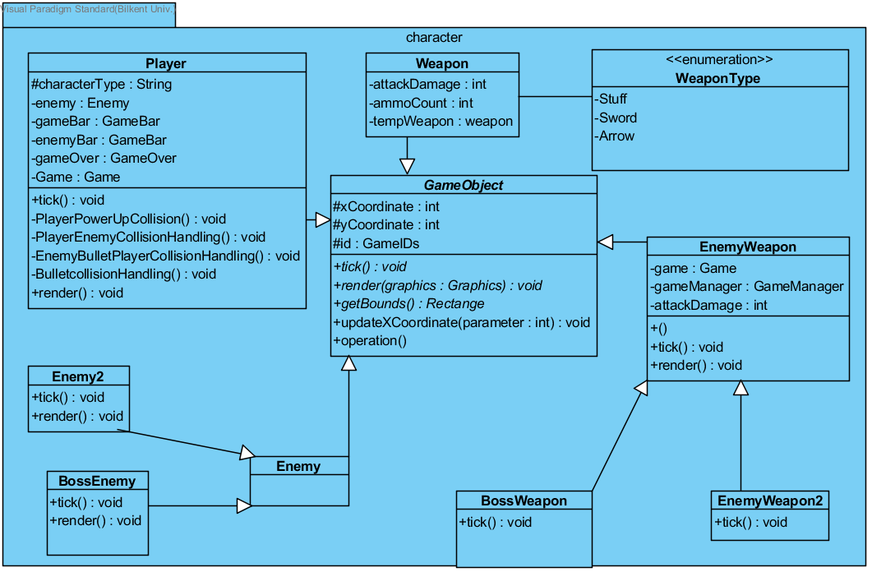

The character component is in the second layer of our three-tier architecture. This component includes Account, Player, Weapon classes and Elf, Human, Wizard subclasses. The data about account and the features of characters that player choose is in this component. The character component interacts with interaction and database components. Link between Interaction component and character component provide the data about levels that account has. Character component takes the data that about the passed level and it provides data about current level to interaction component. The character component also provides the login informations of the account to database component and takes the account information from the database component.

**3.3) Input Manager**

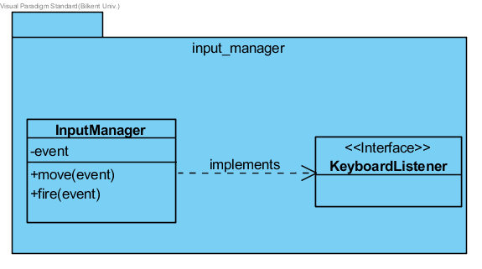

Input manager component is in the second layer of our three-tier architecture. The interaction manager component handles the hardware inputs. It gets inputs from mouse and keyboard. Then it provides the data that includes these inputs to user interface component.

**3.4) Interaction**

Interactions component is in the second layer of the three-tier architecture. It includes Collision, Power-up, Level and Enemy classes. The data about interactions that player has during the game play is in the interaction component. It interacts with game manager and character component. The interaction component provides the data about levels that is passed to character component and takes data about the current data from this component. The interaction component also provides the data about game to game manager component.

**3.5) User Interface**

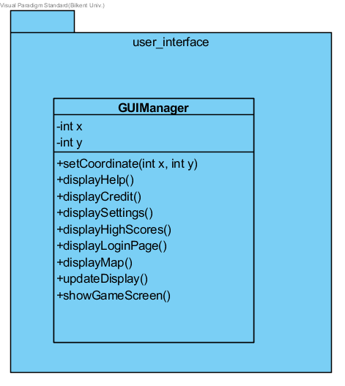

The user interface component is in the first layer of our three-tier architecture. This component takes data from all other components on condition that direct and indirect. Input manager, game manager and menu data components has the direct interaction with user interface component. The input manager provides hardware inputs to the user interface component. The menu data and game manager component also provides the data to user interface component. The menu data shares the menu interaction of the player to user interface. The game manager component  provides the game data to the user interface component.

**3.6) Game Manager**

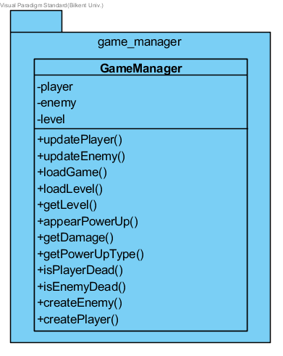

The game manager is in the second layer of the three-tier architecture. It handless all the game play features. The game manager interacts with interaction and user interface components. It takes the game data from interaction component and sends the data of the game to user interface component.

**3.7) Menu Data**

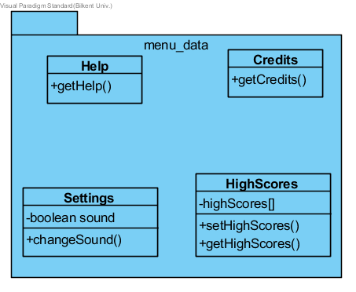

Menu Data package will place in the second layer of our three tier architecture. This system consists of Help, Credits, Setting and HighScore classes. Menu Data component works connected with Database system to get High Scores’ of player. Also, reflecting changes of settings and transition between screens, Menu Data provides information for different menu screens to user interface component.

**3.8) Database**

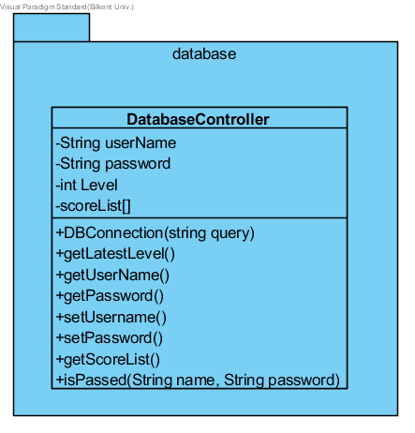

Database component takes place in the third layer of our three-tier architecture. This part contains the databaseController class. Basically this system established the connection between database and our game at the bottom layer.  User’s latest level, high scores, account information and user’s preferences like character type transferred via this system. Also, changes on data reflect on the database within this package.

**4)Low-Level Design**

**4.1) Object Design TradeOffs**

**4.1.1)Functional Decomposition vs code length**

In our design report, we have aimed at dividing the code into individual modules. By doing so, maintenance and updation of the code can be done in a less strenuous manner and in a more efficient way, but at the cost of increased volume of lines of code.

**4.1.2)Performance vs complexity**

We have implemented the project by using a three-tier architecture. By doing so we have separated the game’s Graphical User Interface from the Business logic layer of the game, in this case, the game manager which control running of the game. Though the adoption of this architecture the complexity of the game design would decrease which would ultimately ease the implementation of the game, as a complex design results in a complex and hard-to-do implementation.

**4.2)Final Object Design**

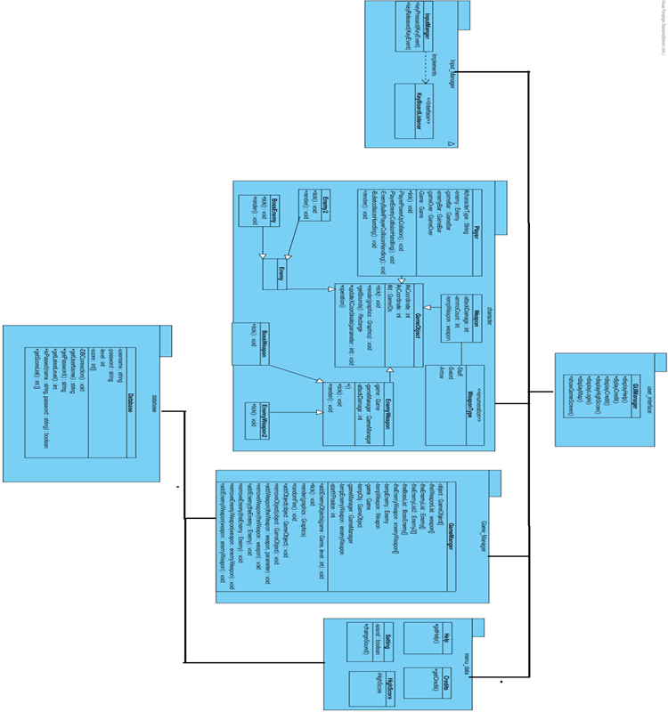

**4.3)Packages**

We have seven packages. We are using 3-tier architectural style. In view layer of the architecture, we have user_interface package. This package controls the interaction between program and user. In the second layer, we have 5 packages. Input_manager package is for transferring inputs to the control of the software. Character package is for organising user’s data. Interaction package is for controlling interaction between objects in the game. Game_manager is the central package of the game. It is basically for whole game process. Menu_data package is for providing menus’ data to the GUIManager package. Finally the Database package provides connection between software and database.

**4.4) Class Descriptions**

**4.4.1)  User Interface Class**

**4.4.1.2) GUI Manager**

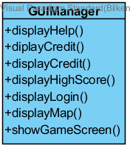

**Operations :**

**public** void displayHelp() : Displays Help Screen.

**public** void displayCredit() : Displays Credit Screen.

**public** void displaySettings() : Displays Settings Screen.

**public** void displayHighscores() : Displays High Scores Screen.

**public** void displayLoginPage(): Display Login page.

**public** void displayMap():Display Map Screen.

**public** void *updateDisplay*(): Update the current view.

**public** void *showGameScreen(int level)*: Displays the game screen with chosen level.

**4.4.2) Input Manager Class**

**4.4.2.1) Input Manager**

**https://lh3.googleusercontent.com/agX5kdiDFV_tS1KPPCaCcLUBC1MepIWXmOecX9_szgV0CQ64X-N4CR7D9WOm0MHtqEDi3_QGtFDNpzyayJpbyMrPL_a-iDwHxu3wSscXV6WzVhWxe6dATQtt-HsK5MkuC01GI36W**

This class is for taking input from the keyboard and it implements the KeyBoardListener interface.

**Operations :**

**public** boolean *keyPressed( KeyEvent )*: Checks the key if it is pressed or not.

**public** boolean *keyReleased( KeyEvent )*: Checks the key if it is released or not.

**4.4.3)Character Classes**

**4.4.3.1) GameObject**

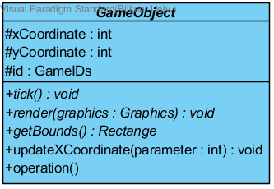

**Attributes:**

**protected** int *xCoordinate*: Object which indicates x coordinate

**protected i**nt *yCoordinate*: Object which indicates y coordinate.

**protected** GameIDs *GameIDs*: Game ID object to get enumeration type.

**Operations :**

**public** void *tick()*:

**public** void *render*:  This method determines the enumerated object’s location during the game play.

**public** Rectangle *getBounds*:  Getting the bounds of the rectangle which these rectangles are either player, enemy or bullet.

**public** void *updateXCoordinate(int parameter)*:  Updates the x coordinate of the enumerated type.

**4.4.3.2) Player**

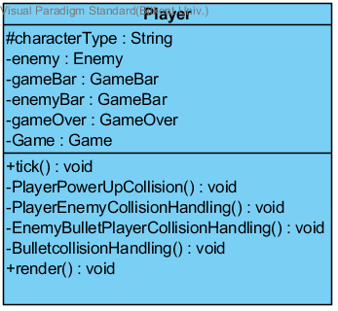

This class handles character preferences of user during the game.

**Attributes:**

**private** Enemy *enemy*: Enemy object.

**private** GameBar *gameBar*: Game bar object.

**private** GameBar *enemyBar*: Enemy bar object.

**private** GameOver *gameOver*: Game over object.

**private** Game *game*: Game object.

**Operations :**

**public** void *tick()*:

**private** void *playerPowerUpCollision()*:  This method determines the collision between player and power-up.

**private** void *playerEnemyCollisionHandling()*:  This method determines the collision between player and enemy and decrease the health of the player if it is collide.

**private** void *bulletCollisionHandling()*:  This method determines the collision between player bullet and enemy and decrease the health of the enemy if it is collide.

**private** void *enemyBulletPlayerCollisionHandling()*:  This method determines the collision between player and enemy bullet and decrease the health of the player if it is collide.

**public** void *render()*:  This method determines the player’s location during the game play.

**4.4.3.3) Enemy**

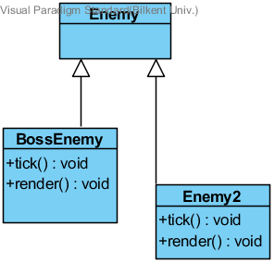

This class is for the creating the enemies. There are two types of enemies, which is the child class of the Enemy class, BossEnemy and Enemy2. These child classes are smilar.

**Operations :**

**public** void *tick()*:

**public** void render*()*:  Renders the enemy.

**4.4.3.4) Weapon**

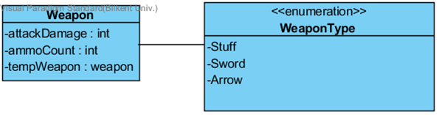

This class is the child class of GameObject class. It has enumeration which holds Stuff, Sword and Arrow for the Weapon class.

**Attributes:**

**private** int *attackDamage*: This attributes holds the damage as an integer.

**private** int *ammoCount*: Holds ammo count as an integer .

**private** weapon *tempWeapon*:Temp object which holds weapon object.

**4.4.3.5) EnemyWeapons**

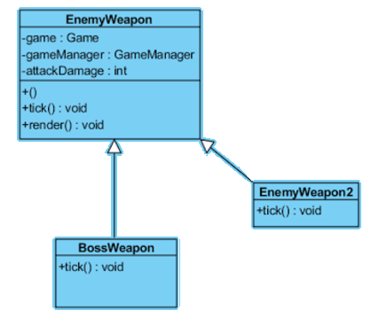

The EnemyWeapon class is for the creating the enemies weapons. It has two children which are BossWeapon and EnemyWeapon2. These chld classes are smilar with each other.

**Attributes:**

**private** Game *game*: The game object.

**private** GameManager *gameManager*: The game manager object.

**private** int *attackDamage:* The object to count the attack damage.

**Operations:**

**public** void *tick()*:

**public** void render*()*:  Renders the enemy weapon.

**4.4.4) Game Manager Class**

**4.4.4.1) Game Manager**

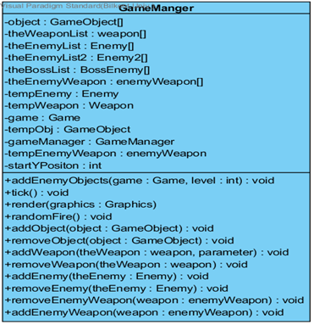

The GameManager class is for handling all the game play features.

**Attributes:**

**private** GameObject[] *object*: The list of game objects.

**private** weapon[] *theWeaponList*: The list of weapons.

**private** Enemy[] *theEnemyList:* The list of enemies for level 1.

**private** Enemy2[] *theEnemyList2*: The list of enemies for level 2.

**private** BossEnemy[] *theBossList*: The list of boss enemy list for level 3.

**private** enemyWeapon[] *theEnemyWeapon*: The list of the enemy weapon object for bullets.

**private** Enemy *tempEnemy*: Temp object for enemy.

**private** Weapon *tempWeapon*: Temp object for weapon.

**private** Game *game*: The game object.

**private** GameObject *tempObj*: A temp object for game object.

**private** GameManager *gameManager*: The game manager object.

**private** enemyWeapon *tempEnemyWeapon*: The temp enemy weapon object.

**private** int *startYposition*: The starting point.

**Operations:**

**public** void *tick()*:

**public** void addEnemyObjects*(Game game, int level)*:  This method adds enemy object for the specific level.

**public** void render*(Graphics graphics)*:  Renders the graphics objects.

**public** void randomFire*()*:  This method is for make the enemy randomly fire to the player.

**public** void addObject*(GameObject object)*: Adds object into the game play.

**public** void removeObject*(GameObject object)*:  Removes object from the game play.

**public** void addWeapon*(weapon theWeapon, int parameter)*:  Adds the weapon into the game play.

**public** void removeWeapon*(weapon theWeapon)*: Removes the weapon from the game play.

**public** void addEnemy*(Enemy theEnemy)*:  Adds enemy into the game play.

**public** void rrmoveEnemy*(Enemy theEnemy)*:  Removes enemy from the game play after its health finishes.

**public** void removeEnemyWeapon*(enemyWeapon weapon)*:  Removes the enemy weapon forn the game play.

**public** void addEnemyWeapon*(enemyWeapon weapon)*: Adds the enemy weapon into the game play.

**4.4.5) Menu Data Classes**

**4.4.5.1) Help Class**

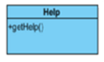

Help class allows to get the game information that we will write.

**Operations :**

**public** String *getHelp*(): This method is for getting help information.

**4.4.5.2) Credits Class**

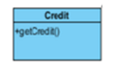

Credit class allows to get the information about developers that we will write.

**Operations :**

**public** String *getCredit*(): This method is for getting credit informations.

**4.4.5.3) Settings Class**

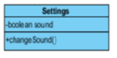

Settings class allows to make changes the sound settings.

**Attributes:**

**private** boolean *sound*: Holds a boolean object that shows the sound open or close.

**Operations :**

**public** void *chageSound(sound)*: This method is for close or open the sound.

**4.4.5.4) High Score Class**

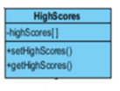

High Scores class deals with the setting and getting high score values.

**Attributes:**

**private** int *highScores*[]: The array that holds the high scores.

**Operations :**

**public** void *setHighScores*(): This method is for setting the high scores the player has during the game play.

**public** int *getHighScores*(): This method is for getting high score informations.

**4.4.6) DataBase Class**

**4.4.6.1) DataBase**

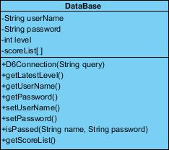

This class handles the connection part between game and database such as retrieving and sending data.

**Attributes:**

**private** String *username*: Holds the username.

**private** String *password*: Holds the user’s password.

**private** int *level*: Lates level played.

**private** int [] *scores*: List of high scores.

**Operations :**

**private** void *DBConnection(String query)*: Ensure the connection between MySQL database and our program.

**public** int *getLatestLevel*(): Retrieve the last level player played.

**public** String *getUsername*(): Return username.

**public** String *getPassword*(): Return password.

**public** String *setPassword*(): Change the current account’s password.

**public** String *setUsername*():Change the current account’s username.

**public** int[] *getScorelist*(): Return the list of high scores of the current player.

**public** String [] *getLatestCharacter(Account user)*: List of preferences of character( type, damage…) lastly modified by user.

**public** Boolean *levelAvailable(int level)*: Check the availability of the level.

**public** Boolean *isPassed(String name, String password )*: If given information is matched, it gives the permission.