

**CS 319**

**Object-Oriented Software**

**Engineering Project**

**Design Report**

Section 1 / Group 1H

Ece Altınyollar

Arif Can Terzioğlu

Raza Faraz

Emin Tosun

Instructor: Bora Güngören

**TABLE OF CONTENTS**

**1) Design Goals**

**1.1)User**

**1.1.1) Well-Defined Interface**

**1.1.2) Ease of Use/ Learn**

**1.1.3) Performance**

**1.2) Maintenance**

**1.2.1) Understandability**

**1.2.2) Modifiability**

**1.2.3) Good Documentation**

**1.2.4) Portability**

**1.2.5) Reliability**

**1.3) Trade off**

**1.3.1) Portability vs Reliability**

**1.3.2) Development Time vs Performance**

**2) Software Architecture**

**2.1) Overview**

**2.2) Architecture Style**

**2.2.1) Type of Architecture**

**2.3) Subsystem Decomposition**

**2.3.1)First Layer**

**2.3.2)Second Layer**

**2.3.3)Third Layer**

**2.4) Hardware / Software Management**

**2.5) Persistent Data Management**

**2.6) Access Control and Security**

**2.7) Boundary conditions**

**3) Subsystem Services**

**3.1) Façade Design Pattern**

**3.2) Character**

**3.3) Input Manager**

**3.4) Interaction**

**3.5) User Interface**

**3.6) Game Manager**

**3.7) Menu Data**

**3.8) Database**

**4)Low-Level Design**

**4.1) Object Design TradeOffs**

**4.1.1)Functional Decomposition vs code length**

**4.1.2)Performance vs complexity**

**4.2)Final Object Design**

**4.3)Packages**

**4.4) Class Descriptions**

**4.4.1) Character Classes**

**4.4.1.1) Account**

**4.4.1.2) Weapon**

**4.4.1.3) Player**

**4.4.1.4) Elf- Human- Wizard**

**4.4.2) Interaction Classes**

**4.4.2.1)Collision**

**4.4.2.2) Power-Up**

**4.4.2.3) Enemy**

**4.4.2.4) Level**

**4.4.3) Input Manager Classes**

**4.4.3.1) Input Manager Class**

**4.4.4) Game Manager Classes**

**4.4.4.1) Game Manager Class**

**4.4.5) Menu Classes**

**4.4.5.1) Help Class**

**4.4.5.2) Credits Class**

**4.4.5.3) Settings Class**

**4.4.5.4) High Score Class**

**4.4.6) Database Classes**

**4.4.6.1) DatabaseController**

**4.4.7) GUI-Manager Classes**

**4.4.7.1) GUIManager**

**1)Design Goals**

**1.1) User**

**1.1.1) Well-Defined Interface**

User interface is one of the most important thing for a game to make it desirable for the users. Because of this reason we planned for Battle for Middle Earth some simple interactable objects. Buttons locations and the description of buttons are going to be clear and understandable for the user. Also the clear guidance is going to be provided for the comfort of players. The backgrounds of the screens will be the Middle Earth theme. Also while the players play Battle for Middle Earth, they will have characters and enemies with middle earth theme. These features make the game more realistic and desirable for the players.

**1.1.2) Ease of Use/ Learn**

Easiness of usage and learning a program to a user is one of the purpose for creators. Since the users do not want such a programs which have difficult usage and hard to learn how to use. For the usage purpose the screens that user has to pass over are going to visualized before the game start. The users can do easily the required parts to start the game. Also the help section will be available for learning how to play Battle for Middle Earth. In the help section control of the character, fire controller and power-ups will be explained. With these features we are going to reach this purpose.

**1.1.3) Performance**

The performance of a program affects the quality of a game. So we will make Battle for Middle Earth as a high performance game. First of all the passes between the screens will be smooth. Because of this is an interactive program the game also will have response time as short as possible. With these Battle for Middle Earth will work nicely without any glitches. These features make the game more qualified.

**1.2) Maintenance**

**1.2.1) Understandability**

Each part of our project will be understandable for anyone who uses and analyses our project. In order to provide this opportunity to people we design our reports very simple and clearly. We also focus on completeness of the project. The coding part also will be clear and much more commented for increasing project’s understandability.

**1.2.2) Modifiability**

When project needs to be modified, change in one part should not affect other parts of the program. In order to achieve this goal, we need to keep coupling at the minimum level, so that change in one part of the code, the whole project would not be affected too much. We will have some subsystems. These subsystems will share less data because modifiability of the project could be higher.

**1.2.3) Good Documentation**

We will keep our documentation standards as high as we can. By providing good documentation, we make our project more understandable and more clear. The completeness of reports and their relations with each other will be taking into consideration more seriously. This will also increase our projects understandability.

**1.2.4) Portability**

Since there are many different types of devices, operating systems and versions, our program may encounter such a problem that platform dependence or support issues. To ensure portability and have a stable performance between these environments, our development language will be JAVA which is supported widely by MAC OS, WINDOWS and LINUX… Thus, game will be played for most of the systems that can run JVM.

Also, by using SQL, our database will be managed between relational database management systems.

**1.2.5) Reliability**

Our game will be produced with the principle of reliability. To achieve this, it will be ensured that program will not be crushed under any users’ input. Possible error cases will be determined during the design stage. To handle these errors, exceptions and user based solutions (giving error message and showing options to user) will be used. The exceptions will then redirect the program to normal operating way.

**1.3) Trade off**

**1.3.1) Portability vs Reliability**

To achieve the portability goals, we will use JAVA environment for implementation. JAVA has its own bytecodes which is known for its ability to produce byte codes which can run on any processor architecture. However, this byte codes only work in JAVA Virtual Machine (JVM). Thus, all users have to install JAVA to their computer. On the other hand, compared to pure compilation languages, JAVA does not have a good running time performance as much as them. Due to game is not complex too much; this trade-off will not be too much problem.

By using JAVA, due to compilation time checks, our software will be aimed error free as much as possible.

**1.3.2) Development Time vs Performance**

To decrease the development time of this game, the implementation project will be in java.The reason being Java offers much better and readily available GUI libraries, specific to our needs. Additionally we do not have to worry about possible memory leaks, which will not only decrease the development time of the game ,but in a way increase the performance of the game for example if inefficient memory management happens the game might store garbage or redundant values which will increase the space taken during the game,thus reducing the game performance.

**2) Software Architecture**

**2.1) Overview**

In this section, we are detailing the composition pur system from higher level to lower. While dividing our program, we decided to use 3-tier design architecture because it is suitable for our project. The layers will be explained in this section but more details of subsystems will be in other sections.

**2.2) Architecture Style**

We have chosen the three tier architecture style for our project. In this style, program will be divided into three layers. First layer is presentation layer. The presentation layer is responsible for managing the interaction between user and program. It shows graphics to the user with data coming from program and it also transmits the user’s inputs to the program. The second layer of the architecture is application layer. Its duty is creating the applications data and process the data coming from user or database. The last layer is data layer. This layer is responsible for data management. It transmits data which needs to be stored to the database and it also conveys the data from database to the program itself.

**2.2.1) Type of Architecture**

For this project, we chose the closed architecture instead of open architecture. The close architecture minimizes the coupling. It makes easier to develop the game. Adding new things to the game will not require to change whole code of it. We can add new things by changing only related parts.

**2.3) Subsystem Decomposition**

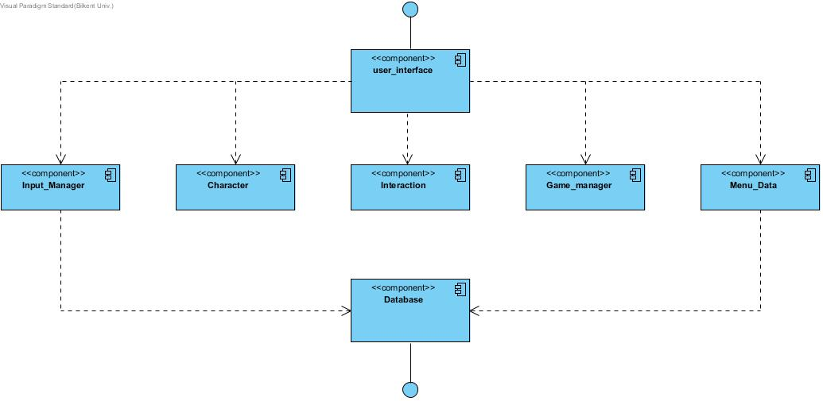

**2.3.1)First Layer**

In the first layer, we have UI classes and UI Manager class. This layer is responsible for managing interaction with user and the program. It will get data from second layer which handles the business logic and it will be updated with new coming data.

**2.3.2)Second Layer**

The second layer of architecture is responsible for program’s business logic. It will produce game data and send it to first layer which handles the interaction with user. This layer also manages data coming from database. This layer is like a bridge between database and UI. Whole game data processing will be handled with this layer’s components.

**2.3.3)Third Layer**

Third layer of architecture is data management layer. This layer has the database controller component. This component provides data,which is coming from database, to the second layer of architecture which uses this data. It is also responsible for saving data coming from program itself or user.

**2.4) Hardware / Software Management**

Our game BattleForMiddleEarth will be coded in JAVA environment since JAVA 8 provides us for beneficial libraries such JAVA FX GUI library. Also, account information and high scores will be saved via MySQL. Storing images and sounds will be in the .png and .wav formats respectively, the operating system should support them.

On the hardware configuration part, game will need a basic keyboard controls that are space and arrow keys. Our game will not require too much system specification such as high RAM etc. In addition, at the beginning of the game, keyboard inputs will be necessary for create or login account.

Any platform such as Windows/macOS/Linux supports the JAVA can run our game with these hardware and software requirements.

**2.5) Persistent Data Management**

External database will be used to hold user’s latest level, high scores, account information and user’s preferences like character type. To load the latest point of players in the game, this information will be taken later.

Changes on data will be reflecting immediately to maintain data flow fluently. Database will have MySQL management system and SQL language will be the used to create query for database operations. Other files such as pictures, sounds will be stored locally.

**2.6) Access Control and Security**

Our game will require a connection to database. The username and password will be taken when user enters the game first time and transfer to database. Although game has no internet connection, it is aimed that different accounts will enable user to play with more than one player without losing without other characters’ data. In other words, access control will be used to differentiate user’s characters. Our program will be coded in a way that only our program can access it.

**2.7) Boundary conditions**

**2.7.1)Initialization**

Battle for Middle earth will not require any installation as the game would be available as executable .JAR file. During the stage when the .JAR file is clicked and the program opens, appropriate Graphical Interface will be loaded such as game images etc ; thus the game would be brought to an initializing state.

**2.7.2)Termination**

There are multiple possible ways for the termination of the program. Standard procedure includes clicking on the ‘Exit’ button present in the ‘Main Menu’ Screen and ‘Paused’ game screen. Additional method includes clicking on the ‘X’ present at the top left corner of the screen of using Task Manager

**2.7.3)Failure**

Possible Failure would result from missing program files in which a dedicated error message will be produced. Other Possible Failure includes absence of .JDK file or updated .JDK file which would cause the game to crash , thus displaying an appropriate error message

**3) Subsystem Services**

### **3.1) Façade Design Pattern:**

In our design pattern the Façade class is the ‘game manager’ class, as this class handles most of the main functions of the game. By using this class as our façade class , it would be easier for future or current developers to maintain , reuse and extend the functionalities of the game. This is because most of the classes are linked with this class thus any alteration to this façade class will directly have an effect on the other components of this subsystem.

**3.2) Character**

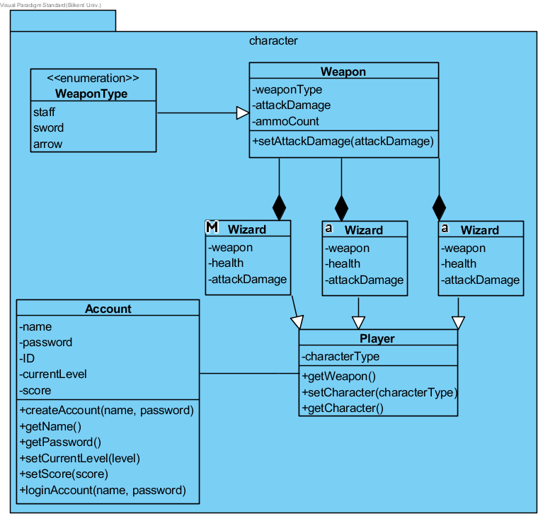

The character component is in the second layer of our three-tier architecture. This component includes Account, Player, Weapon classes and Elf, Human, Wizard subclasses. The data about account and the features of characters that player choose is in this component. The character component interacts with interaction and database components. Link between Interaction component and character component provide the data about levels that account has. Character component takes the data that about the passed level and it provides data about current level to interaction component. The character component also provides the login informations of the account to database component and takes the account information from the database component.

**3.3) Input Manager**

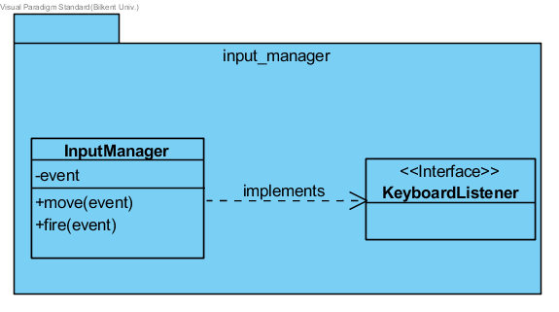

Input manager component is in the second layer of our three-tier architecture. The interaction manager component handles the hardware inputs. It gets inputs from mouse and keyboard. Then it provides the data that includes these inputs to user interface component.

**3.4) Interaction**

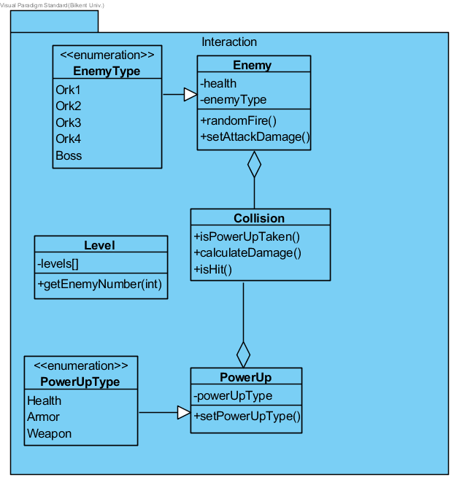

Interactions component is in the second layer of the three-tier architecture. It includes Collision, Power-up, Level and Enemy classes. The data about interactions that player has during the game play is in the interaction component. It interacts with game manager and character component. The interaction component provides the data about levels that is passed to character component and takes data about the current data from this component. The interaction component also provides the data about game to game manager component.

**3.5) User Interface**

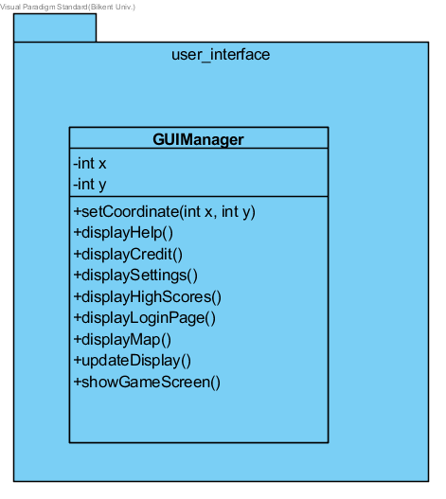

The user interface component is in the first layer of our three-tier architecture. This component takes data from all other components on condition that direct and indirect. Input manager, game manager and menu data components has the direct interaction with user interface component. The input manager provides hardware inputs to the user interface component. The menu data and game manager component also provides the data to user interface component. The menu data shares the menu interaction of the player to user interface. The game manager component provides the game data to the user interface component.

**3.6) Game Manager**

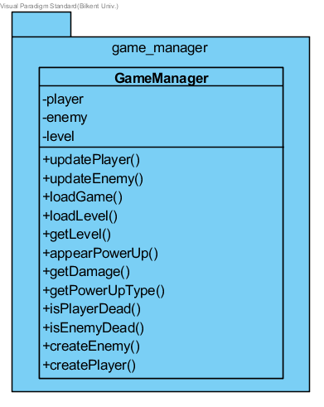

The game manager is in the second layer of the three-tier architecture. It handless all the game play features. The game manager interacts with interaction and user interface components. It takes the game data from interaction component and sends the data of the game to user interface component.

**3.7) Menu Data**

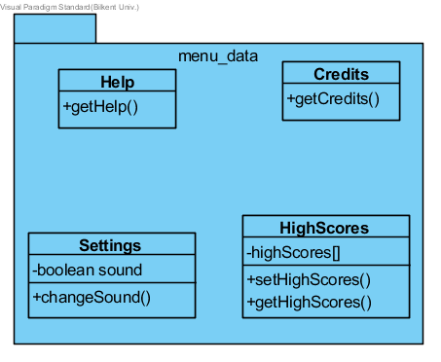

Menu Data package will place in the second layer of our three tier architecture. This system consists of Help, Credits, Setting and HighScore classes. Menu Data component works connected with Database system to get High Scores’ of player. Also, reflecting changes of settings and transition between screens, Menu Data provides information for different menu screens to user interface component.

**3.8) Database**

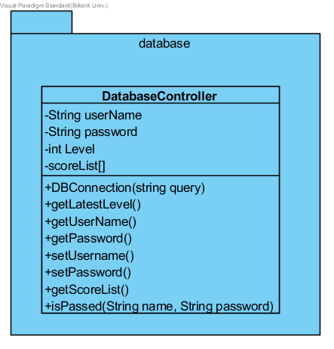

Database component takes place in the third layer of our three-tier architecture. This part contains the databaseController class. Basically this system established the connection between database and our game at the bottom layer. User’s latest level, high scores, account information and user’s preferences like character type transferred via this system. Also, changes on data reflect on the database within this package.

**4)Low-Level Design**

**4.1) Object Design TradeOffs**

**4.1.1)Functional Decomposition vs code length**

In our design report, we have aimed at dividing the code into individual modules. By doing so, maintenance and updation of the code can be done in a less strenuous manner and in a more efficient way, but at the cost of increased volume of lines of code.

**4.1.2)Performance vs complexity**

We have implemented the project by using a three-tier architecture. By doing so we have separated the game’s Graphical User Interface from the Business logic layer of the game, in this case, the game manager which control running of the game. Though the adoption of this architecture the complexity of the game design would decrease which would ultimately ease the implementation of the game, as a complex design results in a complex and hard-to-do implementation.

**4.2)Final Object Design**

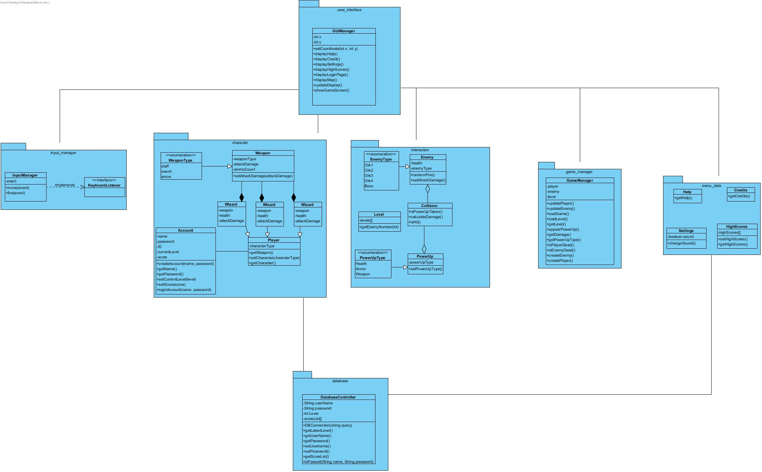

**4.3)Packages**

We have seven packages. We are using 3-tier architectural style. In view layer of the architecture, we have user_interface package. This package controls the interaction between program and user. In the second layer, we have 5 packages. Input_manager package is for transferring inputs to the control of the software. Character package is for organising user’s data. Interaction package is for controlling interaction between objects in the game. Game_manager is the central package of the game. It is basically for whole game process. Menu_data package is for providing menus’ data to the GUIManager package. Finally the Database package provides connection between software and database.

**4.4) Class Descriptions**

**4.4.1) Character Classes**

**4.4.1.1) Account**

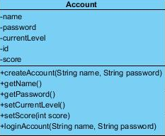

This class will be created when user enters the game to bring and hold user's information.

**Attributes:**

**private** String *name*: This attributes holds the user name.

**private** String *password*: This attributes holds the user's password.

**private** int *currentLevel*: Latest level players played.

**private** int *id*: ID number of the account.

**private** int *score*: Latest score of the game user played.

**private** int[] *scores*: High scores holding in the Database transfers to here.

**Operations :**

**public** void *createAccount(String name, String password)*: Create a new user with taken information

**public**  String *getName()*: Get the current user's name.

**public** String *getPassword()*: Get the current user's password.

**public** String *setPassword()*: Set the current user's password.

**public** void *setCurrentLevel()*: Set the current level player played.

**public** void *setScoreList(int score)*: Score of the player during the game.

**4.4.1.2) Weapon**

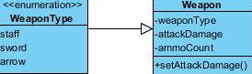

This class holds the information of characters' weapons based on types.

**Attributes:**

**private** enum *weaponType* : Enumeration type storing the different type of weapon type.

**private** String *type*: Holds the type of weapon comes from enum such as sword, arrow or stuff.

**private** int *attackDamage*: Damage amount of the current weapon.

**private** int *ammoCount*: Number of remaining ammo amount of weapon.

**Operations :**

**public** void *setAttackDamage(int damage)*: Based on power-ups and extra gains, damage of the weapon will change via this function.

**4.4.1.3) Player**

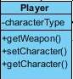

This class handles character preferences of user during the game.

**Attributes:**

**private** String *characterType*: Holds the type of character( elf, human or wizard).

**Operations :**

**public** Weapon *getWeapon()*: Returns the weapon type.

**public** void *setCharacter()*: Changes the type of character.

**public** String *getCharacter()*: Returns the character type.

**4.4.1.4) Elf- Human- Wizard**

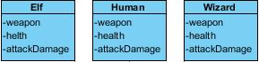

These classes hold the character types.

**Attributes:**

**private** Weapon *weapon*: Holds the weapon type of character.

**private** int *health*: Keep the health.

**private** int *attackDamage*: Attack damage amount of the weapon.

**4.4.2) Interaction Classes**

**4.4.2.1)Collision**

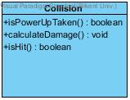

The purpose of this class is to calculate whether a collision between two game objects have occurred or not, meaning the objects pixels intersecting. If Collision indeed occurs, this class will calculate the whether that collision is between the player and an enemy’s bullet, where damage is calculated or the player and a power , where it is send to an appropriate class for further handling.

**Operations :**

**public** boolean *IsPowerUpTaken()* : This method interprets whether the collision that happened is between the player object and a power-up object. Return true if this condition is met.

**public** void *calculateDamage()* : depending on the ammo type this method calculates the damage taken by the enemy

**public** boolean *isHit()* : Calculates whether a collision has indeed happened between different game objects

**4.4.2.2) Power-Up**

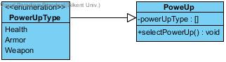

The following Class interprets the type of powerUp taken by the user and implements that specific power up on the player

**Attributes:**

**private** enum *powerUpType* : Enumeration type storing the different type of power-up

**Operations :**

**public** void *selectPowerUP()*: This method implements the taken power-up on the player objects and implements the player object attributes accordingly

**4.4.2.3) Enemy**

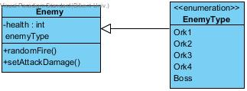

The following class represents the enemy object in the game. These Enemies objects range from ‘level1 ork’ enemy type to ‘Boss’ enemy type.

**Attributes:**

**private** int *Health* : This Attribute represents the enemy’s health

**private** *EnemyType* : This Attribute represents the enemy type; whether it a level 1 ork , level 2 ork , boss etc.

**Operations :**

**public** void *randomFire()* : This method will allow the enemies to fire in a random succession

**public** void *setAttackDamage()* : This method represents each bullet’s damage of the enemy object .For example, different enemy level will have different attack Damage

**4.4.2.4) Level**



The Following class represent the individual levels in the game. This is where each individual level property are defined ,such as number of enemies present on each level.

**Attributes:**

**private** int[] *levels[]* : This attribute represents the current 5 levels of the game in a list.

**Operations :**

**public** int *getEnemyNumber()* : The following method calculates the number of enemies to respawn(create) in a specific level. Enemy count is depended on the level number received from the levels list.

**4.4.3) Input Manager Classes**

**4.4.3.1) Input Manager Class**

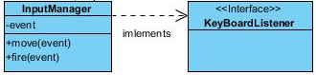

The inputManager class takes input from GUI manager class and it controls the character movement and fire action. Keyboard Listener interface allows InputManager to recognize and process keyboard input to move the character and shot the current gun. In the menu keyboard event do not create any change. However, in the game screen if “esc” is pressed, this event creates an even that pause the game.Also, if it is used in the pause menu, player return to the game play. In menu, “Esc” button provides go back option.

**Attributes:**

**private** String *event:* Event is going to be use for take keyboard events.

**Operations :**

**public** void *move(event)*: The method move is going to take the input for moving the character

**public** void *fire(event)*: The method fire is going to take the input event for the character fires.

**4.4.4) Game Manager Classes**

**4.4.4.1) Game Manager Class**

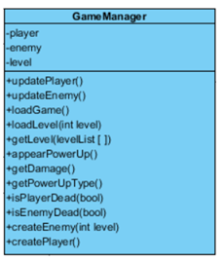

The game manager class is the main class for the game play. The methods that this class use, make possible for the class handless all the game play features.

**Attributes:**

**private** String *player*: Shows the current player.

**private** String *enemy:* Shows the enemies.

**private** int *level:* Shows the current level.

**Operations :**

**public** void *updatePlayer(player)*: This method is for updating the current character’s health, armor and weapon after the power-up taken or taking a damage.

**public** void *updateEnemy(level)*: This method is for updating the enemies health while the user shoot the enemy.

**public** void *loadGame*(): This method is for loading the game for the specific user.

**public** int *loadLevel(level)*: This method is for loading the current level and unlock the next level.

**public** int *getLevel(levelList)*: This method is for getting whole levels.

**public** void *appearPowerUp*(): This method is for occuring the power-ups during the game randomly.

**public** int *getDamage*(): This method is for getting the damage that character had.

**public** String *getPowerUpType*(): This method is for getting power-up types.

**public** boolean *isPlayerDead*(): This method is for dealing with whether the character dead or not.

**public** boolean *isEnemyDead*(): This method is for dealing with the enemy is dead or not.

**public** void *createEnemy(level)*: This method is for creating enemies by depending on the level that player play.

**public** void *createPlayer*(): This method is for creating a character for the player.

**4.4.5)Menu Classes**

**4.4.5.1) Help Class**

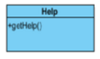

Help class allows to get the game information that we will write.

**Operations :**

**public** String *getHelp*(): This method is for getting help information.

**4.4.5.2) Credits Class**

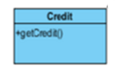

Credit class allows to get the information about developers that we will write.

**Operations :**

**public** String *getCredit*(): This method is for getting credit informations.

**4.4.5.3) Settings Class**

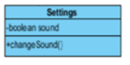

Settings class allows to make changes the sound settings.

Attributes:

private boolean *sound*: Holds a boolean object that shows the sound open or close.

**Operations :**

**public** void *chageSound(sound)*: This method is for close or open the sound.

**4.4.5.4) High Score Class**

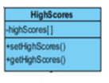

High Scores class deals with the setting and getting high score values.

**Attributes:**

**private** int *highScores*[]: The array that holds the high scores.

**Operations :**

**public** void *setHighScores*(): This method is for setting the high scores the player has during the game play.

**public** int *getHighScores*(): This method is for getting high score informations.

**4.4.6) Database Classes**

**4.4.6.1) DatabaseController**

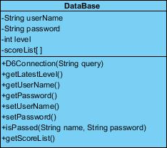

This class handles the connection part between game and database such as retrieving and sending data.

**Attributes:**

**private** String *username*: Holds the username.

**private** String *password*: Holds the user’s password.

**private** int *level*: Lates level played.

**private** int [] *scores*: List of high scores.

**Operations :**

**private** void *DBConnection(String query)*: Ensure the connection between MySQL database and our program.

**public** int *getLatestLevel*(): Retrieve the last level player played.

**public** String *getUsername*(): Return username.

**public** String *getPassword*(): Return password.

**public** String *setPassword*(): Change the current account’s password.

**public** String *setUsername*():Change the current account’s username.

**public** int[] *getScorelist*(): Return the list of high scores of the current player.

**public** String [] *getLatestCharacter(Account user)*: List of preferences of character( type, damage…) lastly modified by user.

**public** Boolean *levelAvailable(int level)*: Check the availability of the level.

**public** Boolean *isPassed(String name, String password )*: If given information is matched, it gives the permission.

**4.4.7) GUI-Manager Classes**

**4.4.7.1) GUIManager**

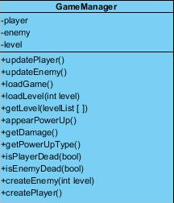

**Attributes:**

**private** int x: X coordinate.

**private** int y: Y coordinate.

**Operations :**

**public** void setCoordinates*(int x , int y)*: Change the current coordinate values form points which power-ups come up.

**public** void displayHelp() : Displays Help Screen.

**public** void displayCredit() : Displays Credit Screen.

**public** void displaySettings() : Displays Settings Screen.

**public** void displayHighscores() : Displays High Scores Screen.

**public** void displayLoginPage(): Display Login page.

**public** void displayMap():Display Map Screen.

**public** void *updateDisplay*(): Update the current view.

**public** void *showGameScreen(int level)*: Displays the game screen with chosen level.