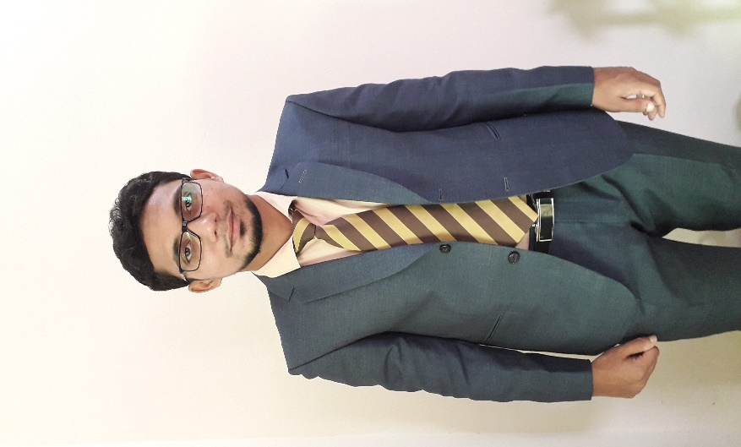

**Career Objectives:**

* To build up a career in the private sector enterprises employing my honesty, experience, devotion, high ambition, loyalty and self-motivation.
* To work under pressure and challenging environment.
* To pursue a career that offers opportunity for self- development .

Learn more online Marketing.

**Experience:**

* Designation: Agent User Call Center Operator at Bank Asia Limited (Agent Banking Division), Since Jun 11, 2014 to July 15, 2015.
* Marketing Team Leader (OM Bazar.com), Since Aug 11, 2019 to Dec 15, 2020.

Dadpur, Sahebganj-6720, Salanga, Sirajganj.

**MD ARIFUL ISLAM**

HOBBIES

LANGUAGE

Bangla ⏹⏹⏹⏹⏹⏹⏹

English ⏹⏹⏹⏹⏹⏹⏹

Web Development

⏹⏹⏹⏹⏹⏹⏹⏹⏹

Signature

Date: 17.03.2021 Md. Ariful Islam

Web Design

⏹⏹⏹⏹⏹⏹⏹⏹⏹

Facebook Marketing

⏹⏹⏹⏹⏹⏹⏹⏹⏹

MS Word, MS Excel

⏹⏹⏹⏹⏹⏹⏹⏹⏹

SKILL

Traveling

Programming

**Secondary School Certificate (S.S.C):**

Ghurka Adarsha M/L High School (2010-2011).

Group : Science.

GPA : 4.75.

Board : Rajshahi.

**Higher Secondary School Certificate (H.S.C):**

Dadpur G.R Degree College (2013-2014).

Group : Science.

GPA : 3.40.

Board : Rajshahi.

**Education:**

**B.Sc:**

National University, Bangladesh. (2015-2016).

Institute : Sirajganj Govt. College.

Subject : Botany.

Result : Appearing.

Year : Final Year.

CONTACT



→

arif22noyon@gmail.com

+8801738640546



